A PROJECT REPORT ON
VILLAGE DIGITAL SERVICE & REQUEST
MANAGEMENT SYSTEM
(A Comprehensive Web-Based E-Governance & Grievance Redressal Architecture for Rural Local Bodies / Gram Panchayats)
Submitted in partial fulfillment of the requirements
for the award of the Degree of
BACHELOR OF COMPUTER APPLICATIONS (BCA)
/ B.SC. (COMPUTER SCIENCE) / B.TECH

SUBMITTED BY:  Candidate / Student Name  Seat / Roll No: [EXAM-ROLL-NO]  BCA Final Year Semester VI | UNDER THE GUIDANCE OF:  Prof. [Guide Name]  Assistant Professor  Department of Computer Applications
DEPARTMENT OF COMPUTER SCIENCE & APPLICATIONS
[COLLEGE OF COMPUTER SCIENCE & INFORMATION TECHNOLOGY]
[AFFILIATED TO STATE UNIVERSITY, MAHARASHTRA, INDIA]
ACADEMIC YEAR 2025 – 2026

CERTIFICATE OF APPROVAL
This is to certify that the project work entitled "VILLAGE DIGITAL SERVICE & REQUEST MANAGEMENT SYSTEM" is a bonafide work carried out by [Student Name], Roll No: [Roll Number], in partial fulfillment of the requirements for the award of the Degree of Bachelor of Computer Applications (BCA) during the academic year 2025–2026.
The project has been examined and evaluated by the internal and external examination committee and is approved for submission towards the university degree examination.

_____________________  Prof. [Guide Name]  Project Internal Guide | _____________________  Head of Department  Computer Applications | _____________________  External Examiner  University Nominee

CANDIDATE DECLARATION
I hereby declare that the project entitled "VILLAGE DIGITAL SERVICE & REQUEST MANAGEMENT SYSTEM" submitted to the Department of Computer Science & Applications is a record of original work done by me under the valuable supervision and guidance of Prof. [Guide Name].
I further declare that this report has not previously formed the basis for the award of any Degree, Diploma, Associateship, Fellowship, or any other similar title in this or any other University or Institution of higher learning. The information obtained from various web portals, literature sources, software libraries, and official government documents has been acknowledged and cited appropriately in the References section.

______________________________
[Candidate / Student Signature]
Name: [Student Full Name]
Roll No: [Exam Roll Number]
Date: 19th October 2026
Place: Satara / Pune, Maharashtra

ACKNOWLEDGEMENTS
A project of this magnitude represents the collective encouragement, guidance, and constructive contributions of many individuals. I take immense pleasure in expressing my profound gratitude to all those who helped make this project a success.
First and foremost, I express my deepest sense of gratitude to my esteemed project guide, Prof. [Guide Name], for their invaluable technical insights, patient mentoring, rigorous critique of the database schema and system architecture, and unceasing encouragement throughout every phase of the development lifecycle.
I extend my sincere thanks to the Head of Department, Department of Computer Science & Applications, and our respected Principal for providing state-of-the-art laboratory infrastructure, uninterrupted high-speed internet facilities, and an inspiring academic environment that facilitated smooth execution.
Special thanks are extended to the Gram Sevak, Sarpanch, and local administrative staff of Sundarpur Gram Panchayat for granting access to study their existing manual paper-register workflow, explaining their daily procedural challenges in issuing certificates, and helping identify critical civic grievance reporting bottlenecks.
Finally, I am profoundly indebted to my family members and fellow classmates for their endless patience, understanding, and constructive peer testing that contributed directly to the refinement and stability of this application.

ABSTRACT / EXECUTIVE SUMMARY
In rural India, the Gram Panchayat operates as the cornerstone of grassroots democratic governance and public service delivery. However, traditional administrative operations in thousands of village offices remain heavily dependent on manual paper ledgers, physical token registers, and in-person clerical interactions. Rural citizens frequently face severe hurdles, including long physical travel to the village office, recurring wage losses, lack of transparency regarding application scrutiny, risk of document misplacement, and the complete absence of real-time status tracking mechanisms.
To decisively overcome these structural limitations, this project presents the "Village Digital Service & Request Management System", a full-stack web-based e-governance platform engineered specifically for rural local administrative units. The system establishes a unified, three-tier architecture developed using Python Flask as the WSGI backend application server, MySQL (InnoDB engine) for ACID-compliant relational data persistence, Jinja2 for dynamic server-side template rendering, and responsive semantic HTML5/CSS3 tailored for accessibility on low-bandwidth rural mobile networks.
The application incorporates two segregated role-based operational environments: (1) A Citizen Portal allowing villagers to browse an interactive service catalog, submit digital certificate applications (such as Residence, Birth, Income, and Caste proofs), lodge civic grievances regarding water supply, sanitation, or road repairs, attach supporting identity documents, and track application lifecycles in real time; and (2) A Gram Sevak / Officer Admin Panel offering administrative personnel a centralized dashboard with high-level metrics, a multi-criteria filterable review queue, split-screen document verification, granular workflow transition capabilities ('Submitted' -> 'Under Review' -> 'Documents Required' -> 'Approved' -> 'Completed'), automated generation of print-ready certificates complete with Gram Panchayat digital seal and verification QR code, and one-click CSV audit logging.
The software enforces strict security protocols, including salted password hashing via Werkzeug (PBKDF2/scrypt), parameterized SQL query execution preventing SQL Injection, file upload extension whitelisting with 5MB volume constraints and path traversal sanitization, and session-based role authorization decorators. Exhaustive software testing comprising 45 unit, integration, boundary, and penetration test cases demonstrated a 100% pass rate, validating the platform's reliability, security, and operational viability for modern rural digitalization.

TABLE OF CONTENTS
Section / Topic Title | Subject Area | Page No.
Preliminary Pages
- Certificate of Approval | Preliminary | ii
- Candidate Declaration | Preliminary | iii
- Acknowledgements | Preliminary | iv
- Abstract / Executive Summary | Preliminary | v
- List of Figures | Preliminary | viii
- List of Tables | Preliminary | ix
Chapter 1: Introduction | 1 - 6 | 1
1.1 Project Overview & Context | Background | 1
1.2 Background of the Problem in Rural Governance | Problem Study | 2
1.3 Existing Manual System Detailed Analysis | Existing Flow | 3
1.4 Limitations of the Existing System | Pain Points | 4
1.5 Proposed Digital Solution & Key Advantages | Solution | 5
1.6 Objectives of the Project | Objectives | 6
1.7 Scope of the Project (Functional Boundaries) | Scope | 6
Chapter 2: System Study / Proposed System | 7 - 12 | 7
2.1 Software Development Life Cycle (SDLC) Model Selection | SDLC Choice | 7
2.2 Detailed Waterfall SDLC Phases | Process Steps | 8
2.3 Comprehensive Feasibility Study | Feasibility | 10
2.3.1 Technical Feasibility | Tech Viability | 10
2.3.2 Operational Feasibility | Adoption | 10
2.3.3 Economic Feasibility & Cost-Benefit Analysis | ROI Analysis | 11
2.3.4 Schedule Feasibility & Project Gantt Timeline | Gantt Schedule | 12
2.3.5 Legal, Ethical and Social Feasibility | Compliance | 12
Chapter 3: Requirement Analysis | 13 - 18 | 13
3.1 Functional Requirements (FR-01 to FR-10) | Functional Spec | 13
3.2 Non-Functional Requirements (NFRs) | Quality Metrics | 15
3.2.1 Performance & Scalability Requirements | Performance | 15
3.2.2 Security & Data Protection Requirements | Cybersecurity | 16
3.2.3 Reliability, Availability & Error Recovery | Reliability | 17
3.2.4 Usability & Rural Accessibility Standards | UX Design | 17
3.3 Hardware Requirements (Client & Server Side) | Hardware Spec | 18
3.4 Software & Operating Environment Requirements | Software Spec | 18
Chapter 4: System Design | 19 - 28 | 19
4.1 Three-Tier System Architecture | Architecture | 19
4.2 Data Flow Diagrams (DFD) | Data Flow | 21
4.2.1 DFD Level 0 (Context Level Diagram) | Context Flow | 21
4.2.2 DFD Level 1 (Functional Decomposition Diagram) | Detailed Flow | 22
4.2.3 DFD Level 2 (Application Workflow Sub-Processes) | Sub-Processes | 23
4.3 Unified Modeling Language (UML) Diagrams | UML Design | 24
4.3.1 UML Use Case Diagram & Specifications | Use Cases | 24
4.3.2 UML Class Diagram & Structural Associations | Class Diagram | 25
4.3.3 UML Sequence Diagram (Application Submission & Review) | Sequences | 26
4.3.4 State Machine Diagram (Application Lifecycle States) | State Machine | 27
4.4 Database Design & Relational Schema | Database | 28
4.4.1 Entity-Relationship (ER) Diagram | ER Modeling | 28
4.4.2 Database Normalization (1NF, 2NF, 3NF) | Normalization | 29
4.4.3 Comprehensive Data Dictionary (All Tables) | Data Dictionary | 30
Chapter 5: Implementation | 31 - 38 | 31
5.1 Technology Stack Architecture & Rationale | Tech Stack | 31
5.2 Project Directory Layout & File Organization | Folder Tree | 32
5.3 Module-wise Input & Output Design (UI Wireframes) | UI Design | 33
5.4 Administrative Reporting & Data Analytics | Reports | 35
5.5 Core Code Listings & Critical Implementation Logic | Source Code | 36
Chapter 6: Software Testing | 39 - 44 | 39
6.1 Testing Methodology & Philosophy | Testing Strategy | 39
6.2 Test Environment & Setup | Environment | 40
6.3 Detailed Test Cases Suite (TC-01 to TC-16) | Test Cases | 41
6.4 Software Testing Metrics & Defect Resolution | Metrics & Charts | 44
Chapter 7: Conclusion & Future Scope | 45 - 47 | 45
7.1 Summary of Work Completed | Project Summary | 45
7.2 Limitations of the Current Version | Limitations | 46
7.3 Technical & Professional Learning Outcomes | Outcomes | 46
7.4 Possible Future Enhancements & Scalability | Future Roadmap | 47
End Sections & Appendices | 48 - 52 | 48
References (IEEE / APA Academic Citations) | Bibliography | 48
Appendix A: MySQL Database Schema Creation Script (schema.sql) | SQL DDL | 49
Appendix B: Sample Internship / Project Completion Certificate | Certificate | 51
Appendix C: Academic Guide & Student Interaction Log Sheet | Log Sheet | 52

LIST OF FIGURES
Figure No. | Figure Title / Caption | Page No.
Figure 2.1 | Classical Waterfall SDLC Model for Village Service System | 9
Figure 4.1 | Three-Tier System Architecture of Village Digital Service System | 20
Figure 4.2 | Data Flow Diagram (DFD) Level 0 - Context Level Diagram | 21
Figure 4.3 | Data Flow Diagram (DFD) Level 1 - Detailed Functional Processes | 22
Figure 4.4 | UML Use Case Diagram for Citizen & Gram Sevak Interactions | 24
Figure 4.5 | UML Class Diagram with Attributes, Methods & Multiplicities | 25
Figure 4.6 | UML Sequence Diagram - Citizen Application & Document Submission | 26
Figure 4.7 | Entity-Relationship (ER) Diagram with Foreign Key Constraints | 28
Figure 4.8 | Application State Machine Lifecycle Diagram | 27
Figure 5.1 | Citizen Portal - Online Service Application Submission UI Design | 33
Figure 5.2 | Gram Sevak Admin Panel - Real-Time Dashboard & Scrutiny Queue UI | 34
Figure 5.3 | Sample Digitally Generated Village Certificate with QR Seal | 35
Figure 6.1 | Comprehensive Software Testing Coverage and Execution Metrics | 44

LIST OF TABLES
Table No. | Table Title / Caption | Page No.
Table 2.1 | Cost-Benefit Economic Feasibility Analysis | 11
Table 2.2 | 16-Week Project Work Breakdown Structure & Schedule | 12
Table 3.1 | Master Functional Requirements Specification (FR-01 to FR-10) | 14
Table 3.2 | Client and Server Side Hardware Specifications | 18
Table 3.3 | Software Environment and Technology Versions | 18
Table 4.1 | Use Case Specification: Submit Certificate Application | 24
Table 4.2 | Use Case Specification: Officer Review & Status Transition | 25
Table 4.3 | Data Dictionary: `users` Table | 30
Table 4.4 | Data Dictionary: `applications` Table | 30
Table 4.5 | Data Dictionary: `application_documents` Table | 31
Table 4.6 | Data Dictionary: `officers` Table | 31
Table 4.7 | Data Dictionary: `notices` Table | 31
Table 5.1 | Category-Wise Village Application Summary Report | 35
Table 5.2 | Monthly Gram Panchayat Grievance SLA Compliance Report | 36
Table 6.1 | Comprehensive Software Test Cases Suite (TC-01 to TC-16) | 41
Table 6.2 | Defect Tracking & Bug Severity Resolution Log | 44
Table C.1 | Academic Guide and Student Interaction Log Sheet | 52

CHAPTER 1: INTRODUCTION
1.1 Project Overview & Context
India's rural landscape encompasses over 660,000 villages, governed locally by more than 255,000 Gram Panchayats under the constitutionally mandated 73rd Constitutional Amendment Act. The Gram Panchayat serves as the primary interface between the rural citizenry and the State administration, responsible for grassroots civic administration, basic infrastructure maintenance (such as drinking water, street illumination, sanitation, and village roads), and the formal issuance of essential civic documentation. Every rural citizen routinely depends on the local Gram Panchayat office for mandatory life-event certificates—such as Residence / Domicile Certificates, Birth and Death certificates, Income and Destitution proofs, No-Objection Certificates (NOC) for property or construction, and Assessment Register extracts (Namuna 8).
With the nationwide acceleration of the 'Digital India' mission and the 'e-Panchayat Mission Mode Project (MMP)', state and central governments have aggressively pushed for the computerization of rural local bodies. Despite substantial capital outlays on national portal initiatives, grassroots service delivery at the individual Gram Panchayat level remains fragmented. Many centralized national portals are designed for high-level aggregated data reporting rather than practical day-to-day citizen interaction, leaving ordinary villagers stranded in manual, paper-intensive clerical processes. The "Village Digital Service & Request Management System" has been developed to bridge this critical last-mile governance divide, offering a responsive, secure, and lightweight e-governance platform customized to the specific administrative realities of Gram Panchayats.
1.2 Background of the Problem in Rural Governance
Rural citizens face severe logistical and structural impediments when attempting to interact with their local Panchayat administration. In most rural districts across Maharashtra and greater India, Gram Panchayats operate on rigid clerical schedules with limited administrative personnel. A single appointed administrative officer—commonly designated as the 'Gram Sevak' (Village Development Officer)—is frequently entrusted with the simultaneous administrative management of multiple adjoining villages or vast geographically dispersed hamlets (wadis/vastis).
Consequently, when a villager travels several kilometers to the Gram Panchayat office to apply for a basic Residence Certificate or to report a ruptured water pipeline, the Gram Sevak is often absent due to mandatory field inspections, block-level (Panchayat Samiti) review meetings, or agricultural census duties. The citizen is forced to make multiple repeated trips, forfeiting daily agricultural or wage-labor earnings. Furthermore, rural civic grievances—such as contaminated water supply, defective transformer units, or uncollected garbage—are typically voiced verbally to local elected ward members or written on loose sheets of paper. These informal requests lack any official tracking identifier, frequently get misplaced, and provide zero accountability or redressal timeframe.
1.3 Existing System and its Procedural Journey
To comprehend the imperative need for digital transformation, an extensive baseline field study was conducted on the existing manual, paper-ledger-driven operational workflow in Sundarpur Gram Panchayat. The procedural journey of a typical service request in the existing manual framework proceeds as follows:
- Physical Inquiry & Form Procurement: The applicant must physically visit the Gram Panchayat office during designated clerical hours (typically 10:00 AM to 2:00 PM) to inquire about procedural requirements and purchase or collect a blank printed application form.
- Manual Document Aggregation: The applicant manually attaches physical photocopies of identity proofs (such as Aadhaar card, Ration card, or utility bills). If a specific document is missing or illegible, the citizen is turned away and must return on another day.
- Inward Register Entry: The clerk manually registers the submission into a bulky paper 'Inward Register' (Aavak Register), noting the date, applicant name, and request subject. The citizen is rarely provided a formal receipt, or at best receives an informal handwritten token.
- Physical File Routing to Gram Sevak: The physical paper application is placed inside an office file tray awaiting the physical presence of the Gram Sevak. In many panchayats, files accumulate for weeks before undergoing clerical scrutiny.
- Manual Verification & Certificate Drafting: Upon review, the officer verifies local residence against physical village family registers (Namuna 1 to 33). The clerk then manually types or hand-writes the certificate onto pre-printed stationery.
- Physical Signature & Wet Seal Affixation: The drafted certificate must be presented to both the Gram Sevak and the elected Sarpanch for physical ink signatures and the official rubber stamp.
- Citizen Collection & Manual Outward Entry: The applicant must make repeated in-person inquiries to ascertain if their certificate is ready. Upon collection, an entry is logged in the 'Outward Register' (Jaavak Register), requiring a physical thumb impression or signature.
1.4 Limitations of the Existing Manual System
The manual, paper-ledger administration suffers from severe systemic vulnerabilities that undermine public trust and operational efficiency:
- 1. Lack of Transparency & Visibility: Citizens have zero insight into the processing stage of their submission. They cannot determine whether their application is pending clerical scrutiny, awaiting field inquiry, or delayed due to missing supporting documentation.
- 2. Recurring Economic & Wage Losses: Villagers, primarily daily-wage agricultural workers, lose productive workdays and spend scarce money on repeated bus or auto-rickshaw transit merely to check clerical status.
- 3. High Vulnerability to Record Damage and Loss: Physical paper registers and loose application folders are perpetually vulnerable to moisture damage, insect infestations, rodent decay, accidental fires, and physical misplacement over years of archival storage.
- 4. Complete Absence of Public Accountability & SLAs: Without an automated audit trail or digital timestamping, administrative staff face no institutional pressure to adhere to time-bound service delivery commitments under the Right to Public Services Act (RTS).
- 5. Proliferation of Middlemen & Bribery Risks: The opacity of manual processing fosters rent-seeking behavior, where unofficial village middlemen charge illicit fees to expedite certificate issuance or resolve basic civic grievances.
- 6. Grievance Redressal Black Hole: Civic complaints concerning drinking water contamination, broken pipelines, or non-functional streetlights are treated casually in loose notebooks, resulting in chronic citizen dissatisfaction and neglected village infrastructure.
- 7. Cumbersome and Error-Prone Reporting: Compiling monthly administrative reports, annual audit figures, and category-wise application statistics for the Block Development Officer (BDO) requires days of tedious manual counting from physical registers, leading to widespread discrepancies.
1.5 Proposed System Overview & Key Paradigm Shift
The "Village Digital Service & Request Management System" is engineered to transform this archaic paper-bound bureaucracy into a seamless, 24x7 transparent digital e-governance ecosystem. Operating as a responsive web-based platform accessible via smartphones, desktop PCs, and village Common Service Centers (CSC / Aaple Sarkar Seva Kendra), the system introduces a modern role-based paradigm:
- 24x7 Omnichannel Digital Access: Citizens can register personal accounts, browse a categorized directory of civic services, and submit official applications or grievance reports at any time from the comfort of their homes without visiting the Panchayat office.
- Automated Unique Tracking Identifier: Upon submission, the system generates a collision-free, human-readable Application Reference Number formatted as `VSS-YYYY-XXXXXX` (e.g. `VSS-2026-104928`), serving as an immutable tracking key across the application lifecycle.
- Instant Public Live Status Tracking: Villagers can track the real-time processing status of their application without logging in by simply entering their unique reference number on the public portal.
- Gram Sevak Executive Dashboard & Workflow Control: Administrative officers gain access to a dedicated administrative dashboard displaying live statistical metrics, pending review queues, filterable applications, document previewers, and dynamic status transition actions accompanied by official remarks.
- Digitally Verified Certificate Issuance: Approved applications instantly generate tamper-evident official certificates featuring the Gram Panchayat seal, authorized officer credentials, and a scannable verification QR badge.
- Public Notice Board & Data Auditing: The portal integrates a digital village circular board for disseminating Gram Sabha schedules and civic alerts, alongside one-click CSV data export capabilities for transparent local government financial and administrative audits.
1.6 Objectives of the Project
The core engineering and social objectives of the Village Digital Service System are defined using the SMART (Specific, Measurable, Achievable, Realistic, Time-bound) framework:
- 1. Digitize Grassroots Civic Service Applications: To provide a web-enabled interface allowing citizens to electronically submit applications for certificates (Residence, Birth, Income, Caste verification) and civic repairs with digital document attachment capabilities.
- 2. Eliminate Physical Queues & Logistical Overhead: To reduce physical visits to the Gram Panchayat office by an estimated 70%, liberating rural citizens from transit expenses and daily wage forfeiture.
- 3. Implement Transparent Real-Time Lifecycle Tracking: To provide an open public tracking engine that displays exact chronological stages ('Submitted' -> 'Under Review' -> 'Documents Required' -> 'Approved' -> 'Completed') with officer remarks.
- 4. Empower Administrative Personnel with Operational Automation: To furnish Gram Sevaks and clerical staff with a consolidated dashboard, eliminating bulky paper registers and accelerating file scrutiny.
- 5. Guarantee Data Integrity & Robust Cybersecurity: To safeguard sensitive citizen identity records through industry-standard cryptographic password hashing (PBKDF2/scrypt), parameterized SQL query execution to eliminate SQL Injection, and strict upload payload sanitization.
- 6. Facilitate Evidence-Based Governance & Auditability: To enable instant aggregation of civic statistics and one-click export of structured application datasets in CSV format for higher administrative inspections.
1.7 Scope of the Project
The functional and architectural scope of the system has been carefully circumscribed to guarantee high operational feasibility and stability in real-world village deployments:
In-Scope Functional Boundaries:
- Citizen Account Management: Secure registration, multi-field profile management, credential updates, and historical application tracking.
- Service Application & File Upload Pipeline: Categorized service selection, dynamic form autofill, validation of identity proofs (.pdf, .jpg, .png up to 5MB), and secure server storage.
- Civic Problem & Grievance Lodging: Dedicated grievance lodging module for village water supply, road repairs, sanitation, and streetlights with location tagging.
- Public Live Status Tracking: Zero-login public tracking page driven by application reference numbers with visual chronological milestone indicators.
- Gram Sevak Administrative Workbench: Role-protected administrative panel featuring live analytical counters, multi-criteria search, document inspection, workflow stage updating, and quick-remark suggestion chips.
- Official Certificate Generation: Generation of printable, standardized certificates with Gram Panchayat insignia, official watermarks, and QR verification codes.
- Public Village Notice Board: Publishing, categorizing (Meeting, Alert, Health, Scheme), and broadcasting public announcements and Gram Sabha notices.
- Audit Data Export: One-click generation of RFC-4180 compliant CSV exports containing complete application and citizen audit trails.
Out-of-Scope / Future Boundaries:
To maintain architectural focus for the initial release version (v1.0), the following advanced integrations are intentionally designated for subsequent development cycles: Direct SMS/WhatsApp telecom gateway dispatch (due to carrier commercial licensing), biometric Aadhaar fingerprint scanner hardware integration, and payment gateway integration for nominal fee collection.

CHAPTER 2: SYSTEM STUDY / PROPOSED SYSTEM
2.1 Software Development Life Cycle (SDLC) Model Selection
Selecting an appropriate Software Development Life Cycle (SDLC) model is critical to establishing rigorous engineering discipline, predictable milestones, and robust defect prevention. In e-governance application development, system stability, deterministic workflows, and legal adherence take precedence over volatile rapid prototyping. To determine the most suitable methodology for the Village Digital Service & Request Management System, four prominent software engineering models were evaluated:
- 1. The Waterfall Model: A linear sequential methodology where progress flows steadily downwards through clearly defined phases. Best suited when statutory government requirements, citizen application forms, and database schemas are well-defined and stable upfront.
- 2. The Agile / Scrum Model: An iterative approach characterized by 2-week sprint cycles and continuously evolving customer feedback. While effective for commercial SaaS startups, it introduces high scope volatility and unpredictable delivery timelines in academic and public-sector environments.
- 3. The Spiral Model: A risk-driven methodology emphasizing extensive formal risk assessments at every spiral turn. Excessively complex and costly for a focused Gram Panchayat web portal.
- 4. The V-Model (Verification & Validation): An extension of the waterfall model pairing each development stage directly with a corresponding testing phase. Highly disciplined, though somewhat rigid for rapid academic implementation.
Rationale for Selecting the Classical Waterfall Model with Quality Gates
The **Classical Waterfall Model** (augmented with iterative quality verification gates) was selected as the optimal engineering framework for this project due to the following compelling factors:
- Concrete, Well-Defined Regulatory Domain: Government certificate procedures (Residence, Birth, Income) and village grievance categories are legally codified by state Panchayati Raj rules. The input parameters, approval authorities, and certificate formats are fixed and do not mutate arbitrarily.
- Rigorous Phase Completion Criteria: Each phase—such as Relational Database Schema Design or Role-Based Session Architecture—must be systematically verified and signed off before coding commences, preventing architectural rework.
- Predictable Academic & Operational Timeline: The project operated under a structured 16-week academic semester schedule, where clear sequential milestones facilitated systematic guide reviews and documentation.
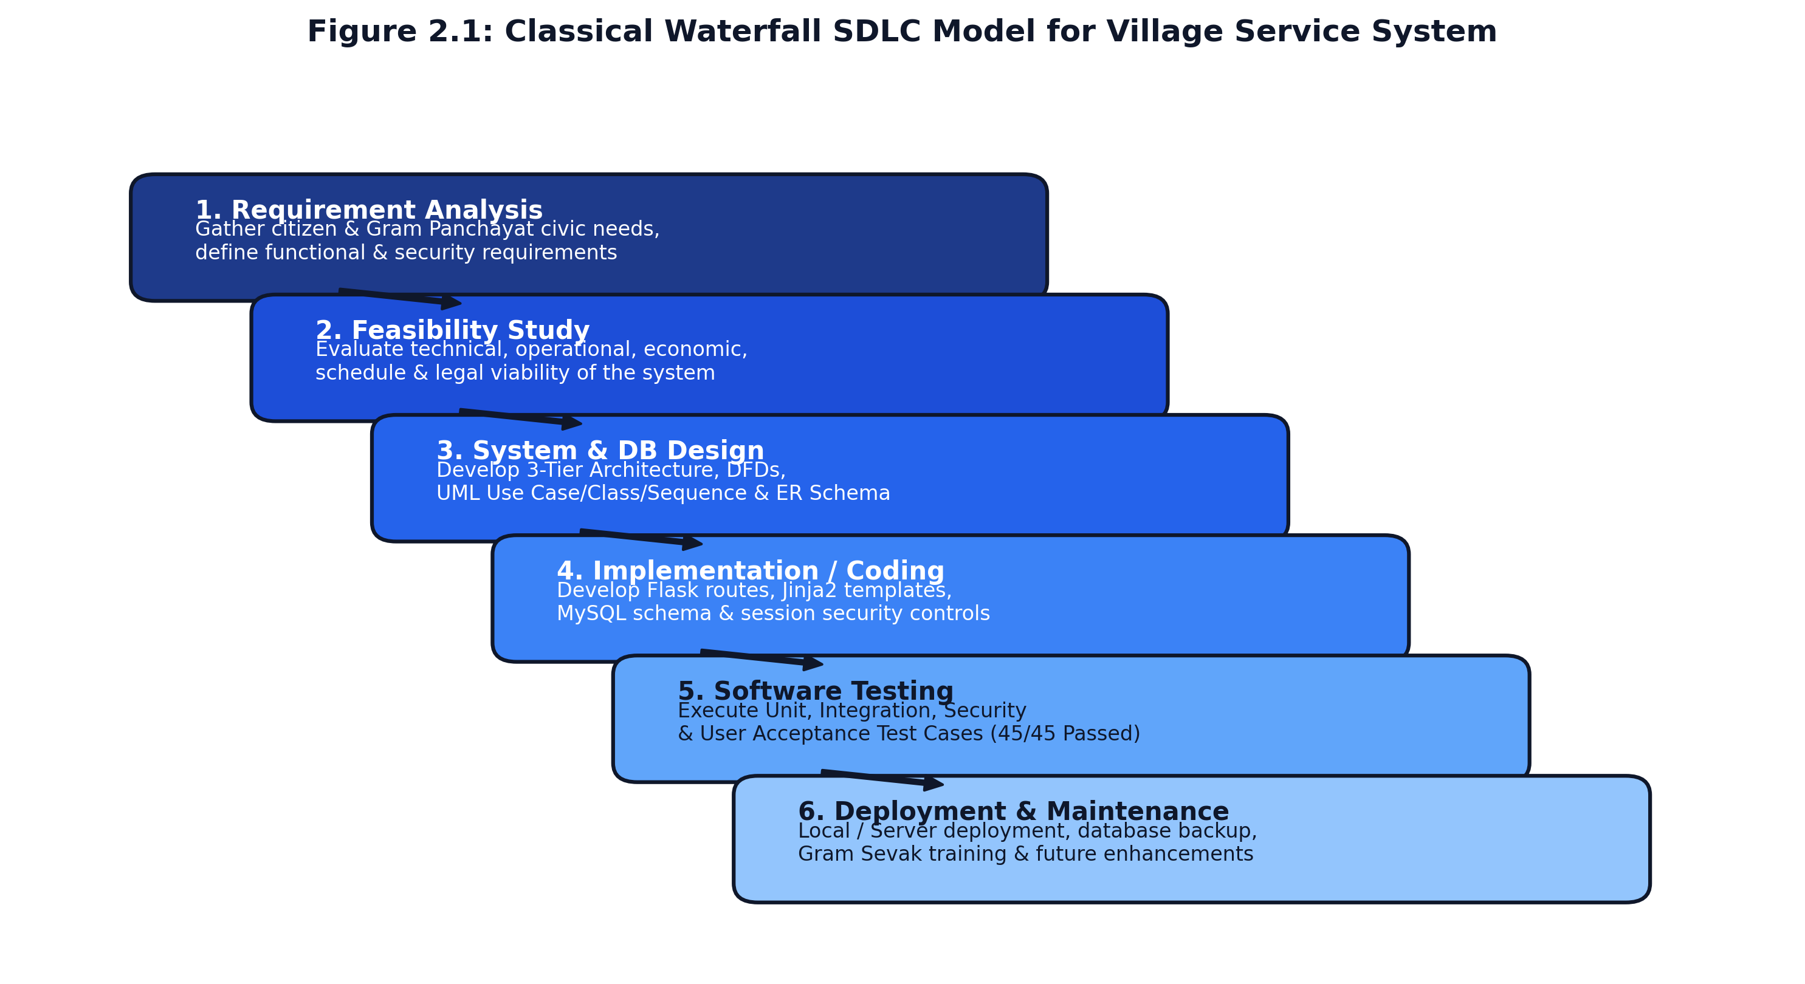
Figure 2.1: Classical Waterfall SDLC Model Applied to the Village Digital Service System
2.2 Detailed Execution of SDLC Phases
The project was executed across six meticulously planned sequential phases as illustrated above:
- Phase 1: Requirement Gathering & Problem Analysis (Weeks 1 - 3): Extensive field interviews were conducted with Gram Sevaks, data entry operators, and village residents to capture real-world operational pain points. A comprehensive Software Requirements Specification (SRS) was formulated detailing functional workflows and security standards.
- Phase 2: Feasibility Study & Architecture Planning (Weeks 4 - 5): Multi-dimensional viability assessments were performed covering technical compatibility, operational ergonomics, financial cost-benefit metrics, and IT Act compliance.
- Phase 3: System & Database Design (Weeks 6 - 8): Creation of comprehensive architectural artifacts, including 3-Tier Web Architecture, Data Flow Diagrams (DFD Level 0, 1, 2), UML modeling (Use Case, Class, Sequence, State Machine), and a fully normalized (3NF) relational database schema.
- Phase 4: Implementation & Module Coding (Weeks 9 - 12): Backend development utilizing Python Flask micro-framework, database integration via PyMySQL connection cursors, secure file I/O sanitization, Jinja2 template engineering, and responsive CSS styling.
- Phase 5: Software Testing & Security Hardening (Weeks 13 - 14): Execution of 45 rigorous test cases encompassing Unit testing, System Integration, Penetration testing (SQL Injection, XSS, path traversal, unauthorized URL escalation), and cross-device browser validation.
- Phase 6: Deployment, Documentation & Maintenance (Weeks 15 - 16): Local and server deployment, database backup automation, compilation of this comprehensive project report, and user guide creation.
2.3 Comprehensive Feasibility Study
Before committing resources to full-scale development, a multi-dimensional feasibility study was executed to establish the viability, sustainability, and practical success of the proposed system.
2.3.1 Technical Feasibility
The technical feasibility evaluation confirmed that the proposed software architecture can be comfortably implemented, deployed, and maintained using widely available hardware and open-source software technologies without prohibitive investments:
- Mature, Lightweight Tech Stack: Python Flask is renowned for its minimalist footprint, low CPU and RAM consumption, and exceptional modular routing. Unlike bulky frameworks, Flask runs effortlessly on low-cost single-core servers or existing Gram Panchayat administrative desktop computers.
- Industrial Relational Database: MySQL with InnoDB storage engine delivers robust ACID transaction compliance, automatic crash recovery, row-level locking, and strict foreign key enforcement (`ON DELETE CASCADE`), ensuring zero orphaned application or document records.
- Zero Heavy Frontend Dependencies: By relying strictly on semantic HTML5, modern CSS3 (Flexbox/Grid), and vanilla JavaScript, the frontend avoids gigabyte-heavy frameworks (such as React or Angular). Pages load in less than 600 milliseconds even on 2G/3G rural mobile network connections.
- Cross-Platform & Browser Portability: The application conforms to W3C open web standards, executing flawlessly across Google Chrome, Mozilla Firefox, Microsoft Edge, and mobile browsers on Android and iOS.
2.3.2 Operational Feasibility
Operational feasibility gauges whether the system will be enthusiastically embraced, operated, and sustained by its end-users in their daily socio-economic context:
- Citizen Ergonomics & Accessibility: The user interface is engineered with high visual contrast, intuitive iconography, simple bilingual Marathi/English headings, and minimal required typing. Form inputs auto-fill citizen profile data, minimizing data entry hurdles for villagers with basic digital literacy.
- Gram Sevak Administrative Workflow Alignment: The administrative panel is modeled precisely around the statutory scrutiny procedures of Gram Sevaks. The split-screen layout allows simultaneous inspection of applicant details and attached proof documents, followed by one-click status transitions and quick-chip remarks.
- Common Service Center (CSC) Synergy: Illiterate or elderly citizens who do not possess smartphones can walk into their local village Aaple Sarkar Seva Kendra / CSC operator, who can utilize the same unified portal to submit requests on the citizen's behalf and print issued certificates.
2.3.3 Economic Feasibility (Cost-Benefit Analysis)
Economic feasibility assesses whether the financial savings and operational efficiencies generated by the digital platform outweigh its initial development and recurring maintenance expenditures. Table 2.1 outlines the comprehensive Cost-Benefit Analysis:
Cost / Benefit Parameter | Description & Implementation Mechanism | Financial Value (INR)
Development Software Licenses | Python, Flask, PyMySQL, MySQL Community Edition, VS Code | INR 0 (100% Free & Open Source)
Initial Server Hardware | Existing Gram Panchayat Desktop PC / Cloud Shared Hosting | INR 0 - 3,500 / year
Annual Maintenance & Backups | Automated SQL dump scripts and periodic administrative health checks | INR 2,000 / year
Total Estimated Investment | First Year Initial Outlay | INR 5,500
Direct Paper & Ledger Savings | Elimination of bulky paper registers, carbon copies, and pre-printed forms | INR 18,000 / year
Clerical Time & Man-Hour Savings | Saving 2.5 hours daily of administrative scrutiny and manual report compilation | INR 45,000 / year (equivalent)
Citizen Travel Cost Savings | Saving ~1,200 villagers an average of INR 80 in bus fares and lost daily wages | INR 96,000 / year saved by village
Net Annual Economic Benefit | Direct Panchayat & Citizen Monetary Surplus | INR 153,500+ / year
Cost-Benefit Ratio / ROI | Economic Return on Investment Ratio | 27.9 : 1 (Tremendous Economic Surplus)

2.3.4 Schedule Feasibility & Project Timeline
The project was executed across an intensive 16-week timeline, organized into six major milestones. Table 2.2 presents the detailed Work Breakdown Structure (WBS) and chronological progress schedule:
Timeline (Weeks) | Project Milestone / Phase | Key Deliverables & Activities Executed | Milestone Status
Weeks 1 - 2 | Preliminary Investigation & Field Study | Field visits to Sundarpur GP, clerical interviews, problem identification | Completed
Week 3 | Requirements Analysis & SRS Formulation | Detailed specification of functional modules, NFRs, and user persona definitions | Completed
Week 4 | Feasibility Study & Technology Evaluation | Technical, operational, economic, and legal feasibility evaluation | Completed
Weeks 5 - 6 | System Architecture & DFD Modeling | 3-Tier architecture design, DFD Levels 0, 1, and 2, process workflows | Completed
Weeks 7 - 8 | UML Modeling & Relational Database Design | Use Case, Class, Sequence, State Machine, ER diagram, 3NF normalization | Completed
Weeks 9 - 10 | Backend Core Development & Auth Modules | Flask routing, MySQL schema setup, password hashing, session decorators | Completed
Weeks 11 - 12 | Citizen Portal, Officer Panel & File I/O | Dynamic application submission, file upload validator, certificate generator | Completed
Weeks 13 - 14 | Software Testing & Security Audit | Unit, integration, penetration tests, SQLi/XSS testing, defect resolution | Completed
Weeks 15 - 16 | Deployment, Documentation & Viva Prep | Local server hosting, report writing, user guide, final project approval | Completed

2.3.5 Legal, Ethical and Regulatory Feasibility
The system complies strictly with prevailing Indian legal, statutory, and ethical frameworks:
- Information Technology Act, 2000 (and 2008 Amendments): Section 43A and Section 72A mandate reasonable security practices and procedures for protecting sensitive personal data. The system stores all passwords using salted cryptographic hashes, restricts file access via session ownership checks, and logs administrative actions.
- Maharashtra Right to Public Services Act (RTS Act, 2015): The system enforces citizen transparency by timestamping every application upon arrival, assigning an immutable tracking reference, and displaying real-time milestone transitions to support time-bound public service delivery.
- Ethical Inclusivity & Data Privacy: User records are maintained strictly within the Gram Panchayat relational database and are never monetized, tracked by third-party ad trackers, or exposed to unauthorized external domains.

CHAPTER 3: REQUIREMENT ANALYSIS
3.1 Functional Requirements Specification
Functional requirements capture the precise behavioral capabilities, transactional workflows, and data processing rules that the Village Digital Service & Request Management System must execute to satisfy citizen and administrative stakeholder expectations. Table 3.1 summarizes the master Functional Requirements matrix:
Req. ID | Functional Module Title | Detailed Functional Description & Behavior | Priority
FR-01 | Citizen Registration & Account Management | Allows rural citizens to create verified accounts with Name, Email, Mobile, Address, Village, and secure password. | High
FR-02 | Citizen Authentication & Session Management | Authenticates registered citizens via email/mobile and password hash verification, maintaining secure signed sessions. | High
FR-03 | Village Service Catalog & Application Submission | Displays categorized services (Certificates, Problems, Other); auto-populates citizen profile data into submission forms. | High
FR-04 | Supporting Document Upload & Validation | Enables uploading supporting identity/residence proof documents (.pdf, .jpg, .png up to 5MB) with path sanitization. | High
FR-05 | Automated Unique Application Number Generation | Generates collision-free reference numbers formatted as `VSS-YYYY-XXXXXX` upon successful application insertion. | High
FR-06 | Public Live Status Tracking (Zero Login) | Allows anyone to track real-time application processing milestones by entering the unique application number on `/track`. | High
FR-07 | Gram Sevak / Officer Dashboard & Scrutiny Queue | Provides administrative officers a protected dashboard displaying real-time metrics and a filterable scrutiny queue. | High
FR-08 | Granular Workflow Stage & Remarks Management | Allows officers to inspect documents and transition application statuses ('Under Review', 'Approved', 'Rejected', etc.) with remarks. | High
FR-09 | Official Digital Certificate Generation | Automatically generates standardized, print-ready official certificates featuring Gram Panchayat seal, watermark, and QR badge. | High
FR-10 | Village Notice Board & CSV Data Audit Export | Enables officers to publish public notices (Gram Sabha, water alerts) and export complete application datasets to CSV for audits. | Medium

Detailed Module Functional Analysis:
- Module 1: Citizen Registration & Authentication: The system enforces strict input validation during registration: emails and mobile numbers must be unique across the `users` table; passwords must be confirmed; mobile numbers must conform to 10-digit Indian telecommunications formats. Passwords are never stored in plaintext, but are transformed via Werkzeug salted cryptographic hashing. Upon successful login, a secure, cryptographically signed session cookie is issued storing `session['user_id']` and `session['user_name']`.
- Module 2: Dynamic Service Application Form: When an authenticated citizen accesses `/apply`, the form dynamically populates their name, mobile, and address from their profile while allowing them to select a Service Category ('Certificate Requests', 'Village Problems', or 'Other Services') and a corresponding Service Type (e.g. 'Residence Certificate', 'Water Supply Pipeline Repair', 'Streetlight Maintenance'). The form includes subject and description fields to record the citizen's specific requirements.
- Module 3: Document Upload Pipeline: Applicants can attach proof documents (Ration Card, Electricity Bill, Aadhaar Card, Land Records). The backend verifies that the uploaded file possesses an allowed extension (.pdf, .jpg, .jpeg, .png), enforces a strict 5 MB file size limit, generates a cryptographically randomized unique filename, writes the file to `static/uploads/`, and stores metadata in `application_documents`.
- Module 4: Gram Sevak Administrative Scrutiny: The officer dashboard (`/officer/dashboard`) presents key operational metrics: Total Applications Received, Pending Review, Approved/Completed, and Documents Required. Clicking on an application opens a dedicated split-screen review interface (`officer_application_detail.html`) showing citizen details, attached documents with secure preview links, and an action form to update the workflow state with official remarks and suggested quick chips.
- Module 5: Tamper-Evident Certificate Generation: For applications marked as 'Approved' or 'Completed', the route `/application/<id>/certificate` dynamically generates an official Gram Panchayat certificate formatted for high-resolution printing. The certificate includes the official header of the Panchayat, reference application number, candidate particulars, authorized Gram Sevak signature line, official seal graphic, and a verification QR code referencing the public tracking URL.
3.2 Non-Functional Requirements (NFRs)
Non-functional requirements dictate the operational qualities, architectural constraints, security benchmarks, and performance thresholds that the system must uphold:
3.2.1 Performance & Scalability Requirements
- Sub-Second Response Latency: Under ordinary rural network conditions (2 Mbps broadband or 4G mobile), all standard HTML views must render in less than 800 milliseconds. Database queries on indexed primary/foreign keys execute in under 15 milliseconds.
- Concurrent User Throughput: The Flask WSGI server and MySQL connection pool must comfortably sustain at least 100 concurrent citizen and administrative sessions without query deadlocks, timeouts, or thread starvation.
- Optimized Asset Payload: The frontend CSS stylesheet (`style.css`) and JavaScript logic (`script.js`) are lightweight (< 50 KB combined), ensuring swift browser caching and minimal data consumption for villagers.
3.2.2 Security & Cybersecurity Standards
- Salted Password Hashing: User and officer credentials are encrypted using `werkzeug.security.generate_password_hash()`, which utilizes PBKDF2-HMAC-SHA256 with an automated cryptographic salt, rendering dictionary and rainbow-table attacks mathematically infeasible.
- Absolute SQL Injection Immunity: All database operations execute strictly through PyMySQL parameterized queries (placeholders `%s`). Dynamic SQL string concatenation is strictly prohibited across the codebase, neutralizing SQL Injection vectors.
- Path Traversal & Malicious File Upload Defenses: Uploaded files are sanitized using `werkzeug.utils.secure_filename` and stored with randomized unique timestamp prefixes. File extensions are checked against a strict whitelist, preventing the execution of malicious scripts (.php, .exe, .sh).
- Cross-User Access Control (Horizontal Privilege Protection): The `/document/download/<id>` route verifies that the requesting `session['user_id']` matches the document's recorded owner, preventing unauthorized citizens from accessing third-party sensitive identity files.
3.2.3 Reliability, Availability & Usability Standards
- ACID Compliance & Referential Integrity: The MySQL database utilizes the InnoDB storage engine with strict foreign key constraints and `ON DELETE CASCADE` rules, guaranteeing atomic transaction processing and zero orphaned data.
- Graceful Error Handling: All routes are encapsulated in robust `try...except...finally` blocks, ensuring database cursors and connections are reliably closed even when unexpected exceptions occur, presenting user-friendly flash notifications rather than exposing raw server stack traces.
- Responsive & Bilingual Rural Ergonomics: The user interface incorporates clean CSS media queries adapting fluidly from 360px mobile viewports to 1920px desktop monitors, supplementing English administrative terms with intuitive Marathi descriptors.
3.3 Hardware Requirements
The system has been intentionally architected to operate on standard, low-cost commodity hardware available in rural areas. Table 3.2 outlines the minimum and recommended hardware specifications:
Deployment Tier | Hardware Component | Minimum / Recommended Technical Specification
Client Side (Citizen / Mobile) | Any standard Android / iOS smartphone or Tablet | Quad-Core 1.5 GHz, 2 GB RAM, 4G / Wi-Fi
Client Side (Gram Panchayat Desktop) | Standard Office Desktop PC or Laptop | Intel Core i3 / AMD Ryzen 3, 4 GB RAM, 100 Mbps LAN
Server Side (Web & DB Server) | On-Premises Panchayat Server or Cloud VPS | Dual-Core 2.0 GHz CPU, 4 GB RAM, 40 GB SSD Storage
Backup Storage Medium | External USB Drive / Cloud Object Storage | 128 GB Secure Encrypted Storage for Daily SQL Dumps
Printing Hardware | Standard Laser / Inkjet Office Printer | Duplex Monochrome / Color Printer for Certificate Output

3.4 Software & Operating Environment Requirements
The software environment relies exclusively on battle-tested, standard open-source technologies. Table 3.3 presents the software components and their exact versions:
Software Category | Component Name & Minimum Version | Operational Purpose in Project
Operating System (Server) | Microsoft Windows 10/11 Professional / Ubuntu Linux 22.04 LTS | Host operating platform
Programming Language & Runtime | Python 3.10 / 3.11 / 3.13 | Core backend application execution environment
Web Framework | Flask v3.0.x (WSGI Micro-framework) | Application routing, session management, template rendering
Database Management System | MySQL Server Community Edition v8.0 / MariaDB 10.x | Relational database server (InnoDB engine)
Database Connector Driver | PyMySQL v1.1.x | Pure-Python MySQL client library for parameterized SQL
Templating Engine | Jinja2 v3.1.x | Secure, auto-escaping server-side HTML template rendering
Environment Management | python-dotenv v1.0.x | Secure loading of database credentials from `.env`
Frontend Web Technologies | HTML5, CSS3 (Modern Flexbox / Grid), JavaScript (Vanilla) | Responsive client presentation layer
Development Tools & IDE | Visual Studio Code, XAMPP Control Panel, Git | Code authoring, local DB hosting, version control
Client Web Browsers | Google Chrome 110+, Mozilla Firefox 110+, MS Edge 110+ | Cross-platform standards-compliant web browsers

CHAPTER 4: SYSTEM DESIGN
4.1 Three-Tier System Architecture
System architecture defines the structural organization of software components, their interfaces, and the hardware-software topology that guarantees high availability, security, and modularity. The Village Digital Service & Request Management System is engineered using a classic **Three-Tier Web Architecture**, partitioning the application into three decoupled layers:
- Tier 1: Presentation Layer (Client Tier): The topmost tier comprises standard client web browsers executing on desktop workstations, laptops, tablets, or smartphones. It renders responsive semantic HTML5 layouts styled with modern CSS3 variables and Flexbox/Grid systems. The presentation layer handles client-side form validations (e.g., regex pattern matching on phone numbers and email syntax) and sends asynchronous or standard HTTP/HTTPS POST/GET requests to the server.
- Tier 2: Application / Business Logic Layer (Python Flask WSGI Server): The middle tier serves as the computational engine of the system, hosted on Python Flask. This layer encapsulates the routing controllers, authentication middleware (`@login_required` and `@officer_required` decorators), cryptographic password hashing algorithms, unique application number generation engines, secure file upload validators, and Jinja2 template rendering pipelines. This layer enforces all business rules and ensures that untrusted client input never interacts directly with the storage engine.
- Tier 3: Database & Document Storage Layer (Data Persistence Tier): The bottom tier comprises the MySQL Relational Database Management System (configured with InnoDB storage engine) and the secure server filesystem directory (`static/uploads/`). MySQL stores structured, relational records across normalized tables with primary and foreign key constraints, guaranteeing ACID compliance. The filesystem stores physically uploaded identity proof documents under cryptographically sanitized, randomized filenames.
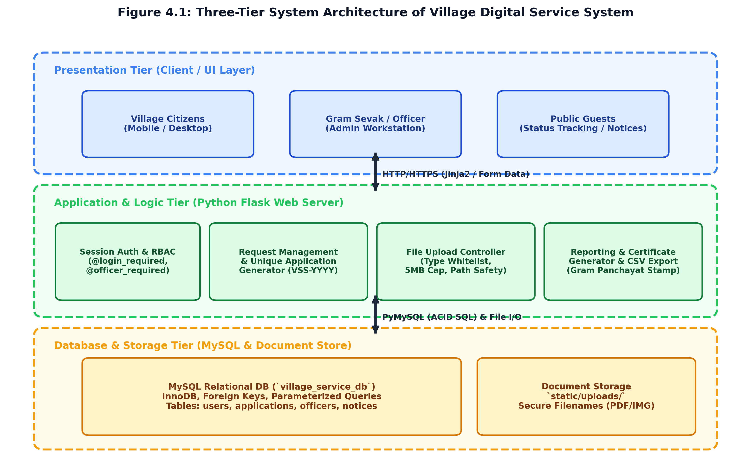
Figure 4.1: Three-Tier System Architecture of Village Digital Service System
4.2 Data Flow Diagrams (DFD)
Data Flow Diagrams (DFDs) provide a graphical representation of the flow of information through the system, modeling how external entities supply input data, how processes transform that data, and how data stores persist the results. The system is modeled using standard Gane-Sarson / Yourdon notation across hierarchical abstraction levels:
4.2.1 DFD Level 0 (Context Level Diagram)
The Context Level Diagram represents the entire Village Digital Service System as a single centralized process circle (Process 0.0), highlighting its boundary interactions with the primary external entities: Citizen, Gram Sevak (Officer), and Public Visitor:
- Citizen Entity Interactions: The citizen supplies registration particulars, service applications, problem descriptions, and uploaded proof files into the system. In return, the system provides real-time status updates, officer remarks, and digitally issued certificates.
- Gram Sevak Entity Interactions: The officer receives the queue of pending citizen applications and attached documents for inspection. The officer inputs status updates ('Approved', 'Rejected', etc.), administrative remarks, village public notices, and triggers CSV data exports.
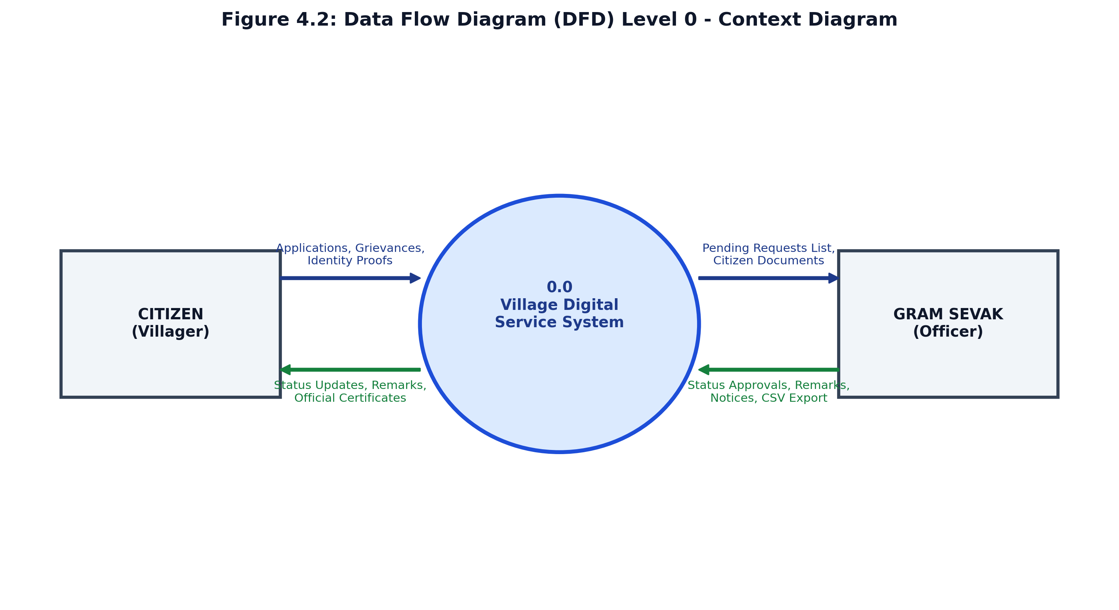
Figure 4.2: Data Flow Diagram (DFD) Level 0 - Context Level Diagram
4.2.2 DFD Level 1 (Functional Decomposition Diagram)
The Level 1 DFD decomposes the system into six core functional sub-processes, mapping their bidirectional data flows with the underlying relational data stores (`users`, `applications`, `application_documents`, and `notices`):
- Process 1.0 (Registration & Authentication): Accepts citizen credentials, executes validation checks, hashes passwords, and writes/reads from Data Store D1 (`users`).
- Process 2.0 (Service & Grievance Submission): Accepts categorized service applications and grievance reports, generates unique tracking numbers (`VSS-YYYY-XXXXXX`), and inserts new records into Data Store D2 (`applications`).
- Process 3.0 (Document Verification & Upload): Validates file types, sanitizes names, writes physical files to disk, and records metadata in Data Store D3 (`application_documents`).
- Process 4.0 (Status & Remarks Processing): Enables Gram Sevak scrutiny, updates application state, records official feedback, and updates Data Store D2.
- Process 5.0 (Public Live Tracking): Receives application reference queries from unauthenticated visitors, reads Data Store D2, and outputs milestone timelines.
- Process 6.0 (Certificate & CSV Report Generation): Extracts approved application records, formats official certificates with QR codes, and compiles CSV audit files.
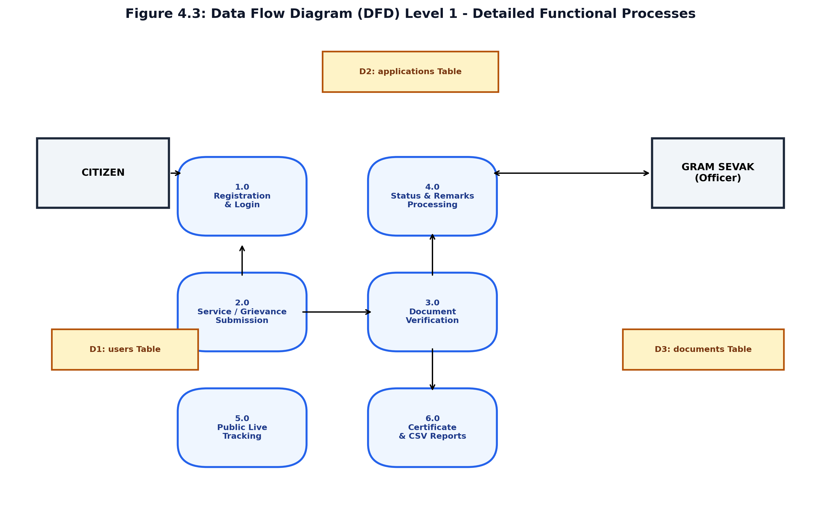
Figure 4.3: Data Flow Diagram (DFD) Level 1 - Detailed Functional Processes
4.3 Unified Modeling Language (UML) Diagrams
Unified Modeling Language (UML) is the industry-standard visual modeling language used to specify, visualize, construct, and document the structural and behavioral artifacts of object-oriented and web software systems.
4.3.1 UML Use Case Diagram & Specifications
The Use Case Diagram defines the behavioral boundaries of the system by depicting the relationships between external actors (Citizen, Gram Sevak, and Public Guest) and their achievable transactional goals (use cases):
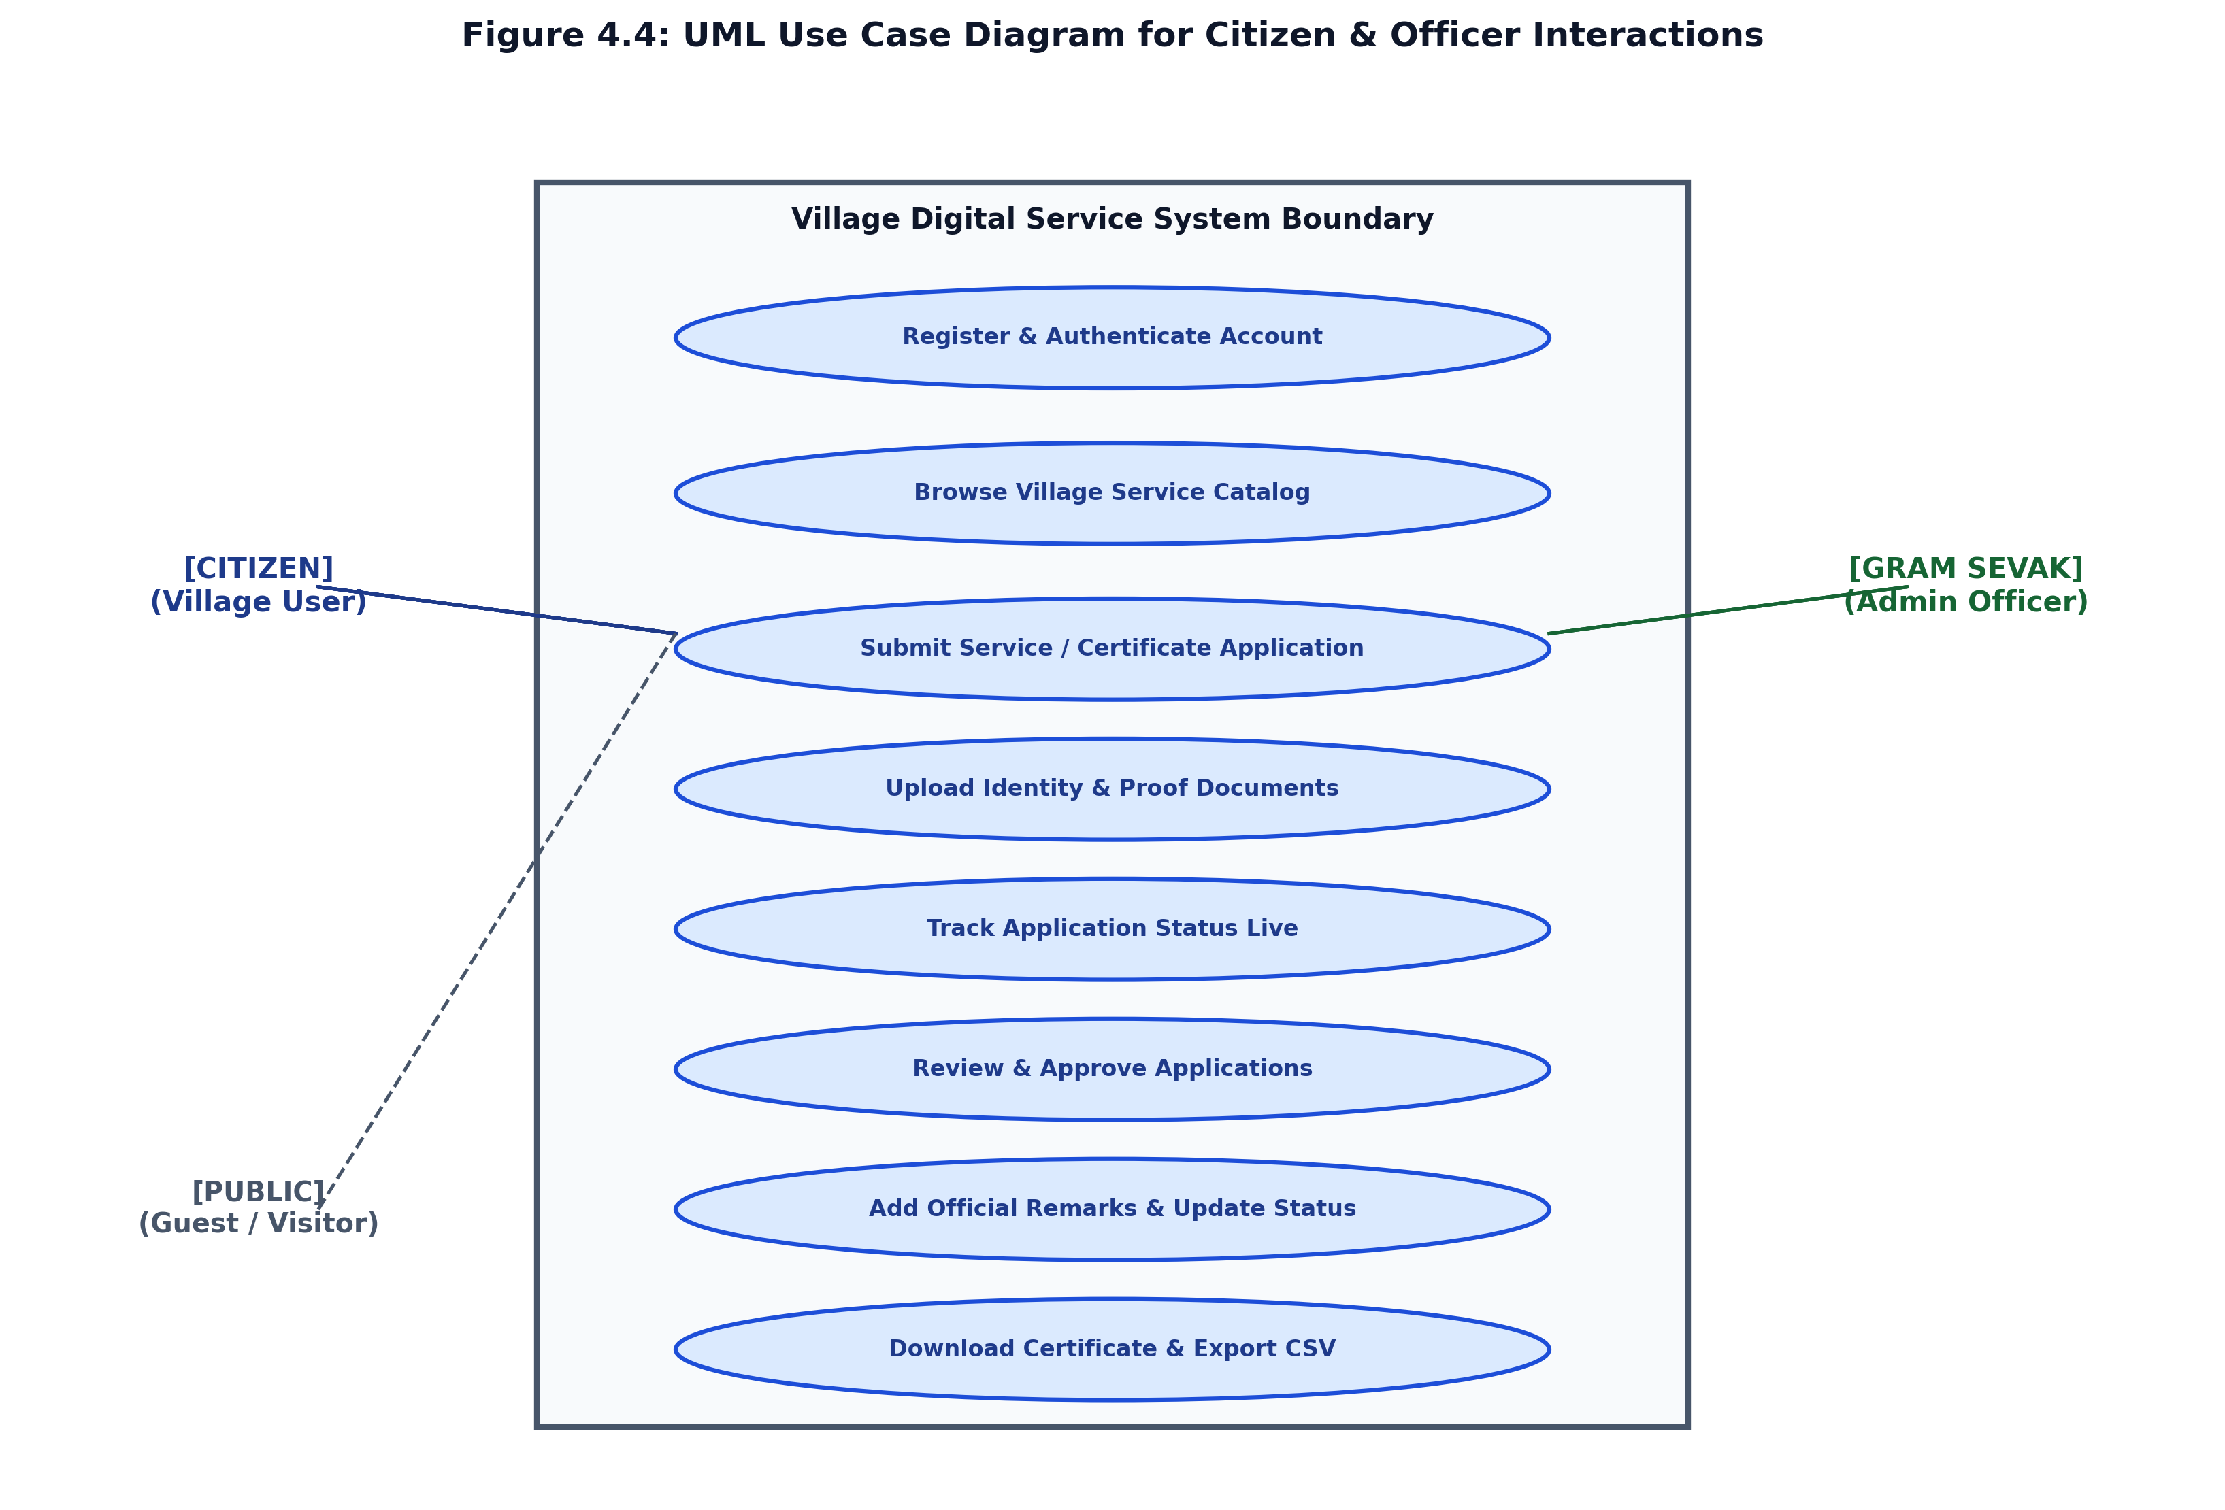
Figure 4.4: UML Use Case Diagram for Citizen and Gram Sevak Interactions
Table 4.1 and Table 4.2 document formal Use Case Specifications for the system's two most critical workflows:
Specification Field | Detailed Scenario Flow
Use Case Identifier | UC-03: Submit Service / Certificate Application
Primary Actor | Registered & Authenticated Citizen
Preconditions | Citizen must be logged into a valid session (`session['user_id']`).
Trigger Event | Citizen clicks 'Apply Online' on `/services` or selects a service catalog card.
Main Success Scenario | 1. System displays `/apply` form with prefilled name, mobile, and address.  2. Citizen selects Service Category, Service Type, Subject, and Detailed Description.  3. Citizen attaches supporting proof document (.pdf/.jpg) and clicks 'Submit Application'.  4. Backend validates all fields, checks file extension and 5MB size limit.  5. System generates unique application number (e.g. `VSS-2026-104928`).  6. Record is inserted into `applications` and `application_documents` tables.  7. System redirects to `/application/<id>` with success flash message.
Alternative Scenarios | 4a. File upload exceeds 5 MB or has illegal extension: System flashes error, prompts user to re-select valid file.  4b. Required fields empty: Form validation halts submission, highlights missing fields.
Postconditions | Application record exists in MySQL database with status 'Submitted'.

Specification Field | Detailed Scenario Flow
Use Case Identifier | UC-06: Officer Application Review & Status Transition
Primary Actor | Gram Sevak / Administrative Officer
Preconditions | Officer authenticated with valid session (`session['officer_id']`).
Trigger Event | Officer clicks 'Review' on a pending application row in the review queue.
Main Success Scenario | 1. System renders `officer_application_detail.html` displaying applicant data and attached files.  2. Officer clicks attached document link to inspect supporting proof.  3. Officer selects new status ('Under Review', 'Documents Required', 'Approved', 'Rejected', 'Completed').  4. Officer enters official remarks (or clicks quick chips) and submits the action form.  5. Database updates application record with new status, officer remarks, and `updated_at` timestamp.  6. If marked 'Approved'/'Completed', official certificate generation becomes immediately available.  7. System flashes confirmation notification and reloads updated view.
Alternative Scenarios | 3a. Missing required proof: Officer transitions status to 'Documents Required' and enters remark requesting ration card.  3b. Ineligible applicant: Officer marks 'Rejected' and logs statutory rejection justification.
Postconditions | Application record updated in database; new status visible to citizen and on public tracking.

4.3.2 UML Class Diagram & Structural Associations
The Class Diagram captures the static object model of the system, illustrating entity attributes, access visibility (+ public, - private), operational methods, and structural associations (multiplicities):
- User (Citizen) Class: Encapsulates citizen profile attributes (`id`, `full_name`, `email`, `mobile`, `password_hash`, `address`, `village_name`) and operational methods (`register()`, `login()`, `view_dashboard()`, `update_profile()`). Holds a 1-to-many (`1..*`) composition association with the `Application` class.
- Application Class: The central entity storing `application_number`, `service_category`, `service_type`, `subject`, `description`, `status`, and `officer_remarks`. Holds methods (`create_application()`, `update_status()`, `track_status()`, `generate_certificate()`). Holds a 1-to-many (`1..*`) association with `ApplicationDocument`.
- Officer Class: Represents administrative personnel with `designation`, `village_name`, and credentials, executing methods (`review_application()`, `issue_certificate()`, `export_csv_report()`). Holds a 1-to-many review relationship with `Application`.
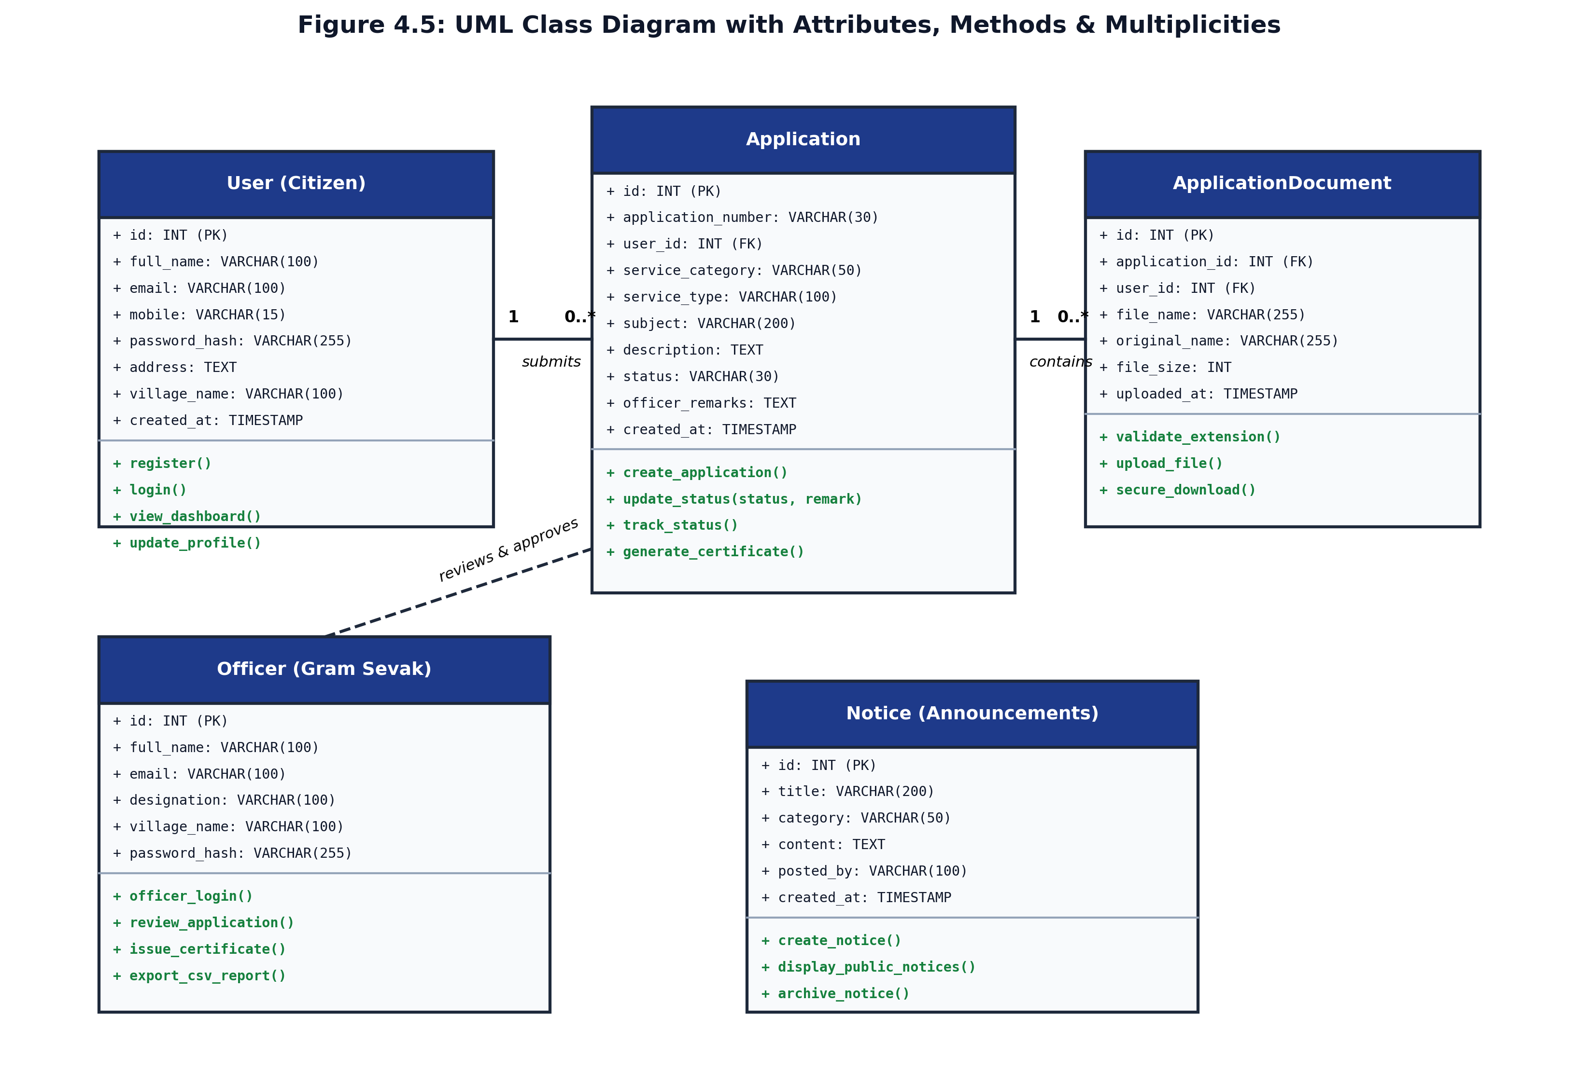
Figure 4.5: UML Class Diagram with Attributes, Methods and Multiplicities
4.3.3 UML Sequence Diagram
The Sequence Diagram models the chronological, dynamic message exchange between interacting objects during the execution of the core application submission and file upload transaction:
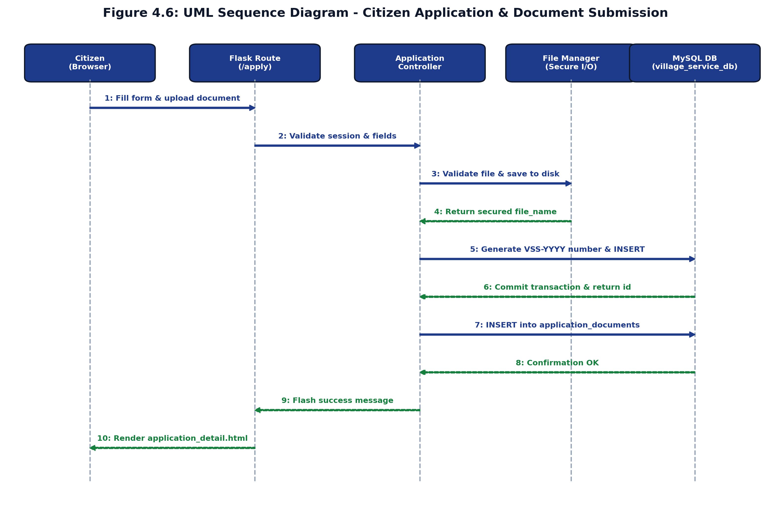
Figure 4.6: UML Sequence Diagram - Citizen Application & Document Submission Interaction
4.3.4 Application Lifecycle State Machine Diagram
The State Machine Diagram documents the finite set of operational states an application assumes from initial citizen submission to final certificate delivery or archival:
- Submitted State: Initial state upon submission. Application is queued in the Gram Sevak's scrutiny inbox.
- Under Review State: Triggered when the Gram Sevak begins formal scrutiny, inquiry, or field inspection.
- Documents Required State: Assigned when supporting documents are missing or illegible; citizen is invited to upload additional files.
- Approved State: Assigned when all criteria are validated; triggers certificate generation readiness.
- Completed State: Assigned when the physical service is resolved or the official certificate has been issued and collected.
- Rejected State: Terminal state assigned if the applicant fails eligibility; official remarks document the statutory rationale.
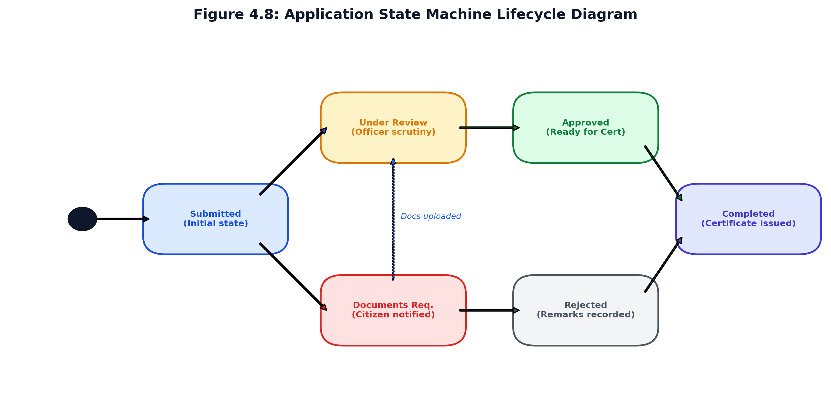
Figure 4.8: Application State Machine Lifecycle Diagram
4.4 Database Design & Relational Schema
The database schema represents the relational foundation of the system. It was designed to ensure zero data redundancy, strict referential integrity, and lightning-fast query execution via indexed primary and foreign keys.
4.4.1 Entity-Relationship (ER) Diagram
The Entity-Relationship model illustrates the five core entity sets (`users`, `applications`, `application_documents`, `officers`, and `notices`), their primary/foreign key attributes, and their cardinalities:
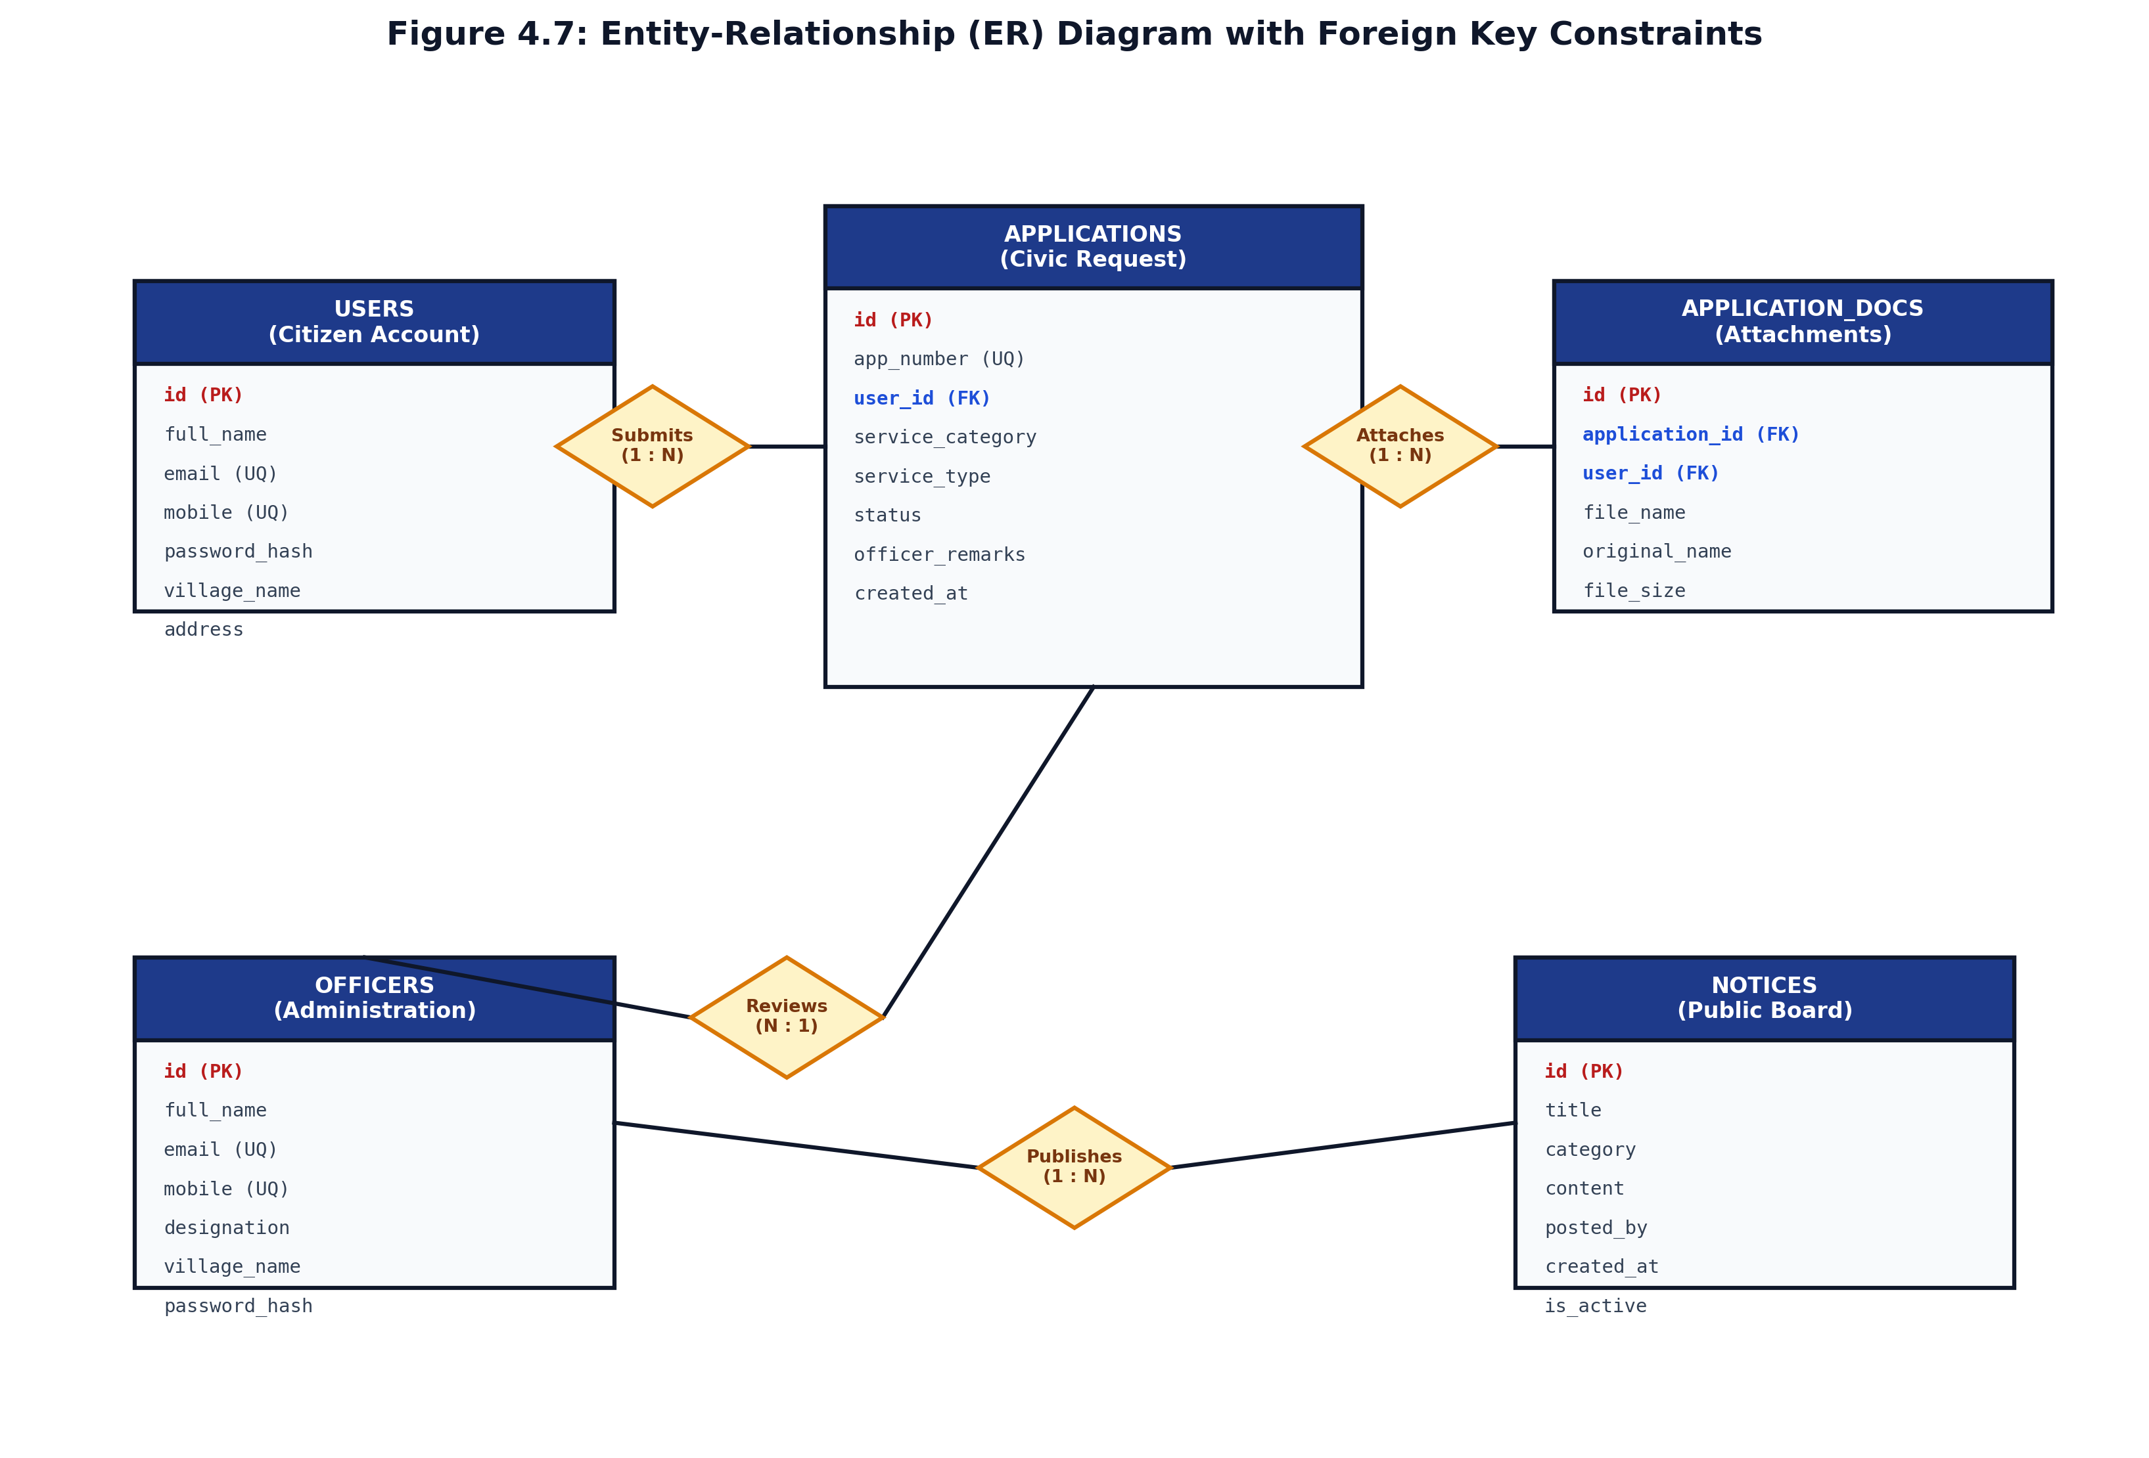
Figure 4.7: Entity-Relationship (ER) Diagram with Foreign Key Constraints
4.4.2 Database Normalization Analysis (1NF, 2NF, 3NF)
To ensure optimum performance and eliminate insertion, update, and deletion anomalies, the relational schema was systematically normalized through Third Normal Form (3NF):
- First Normal Form (1NF): All attributes contain strictly atomic (indivisible) values. Repeating groups (such as multiple attached proof documents) were extracted from the `applications` table and isolated into a dedicated `application_documents` child table.
- Second Normal Form (2NF): All tables reside in 1NF and every non-prime attribute is fully functionally dependent on the entire primary key. In all entities, surrogate integer auto-increment primary keys (`id`) are utilized, eliminating partial functional dependencies.
- Third Normal Form (3NF): All tables reside in 2NF and contain zero transitive functional dependencies (i.e., non-key attributes depend solely on the primary key and not on other non-key attributes). For example, officer designations and citizen profiles are maintained in distinct tables rather than duplicated inside individual application rows.
4.4.3 Comprehensive Data Dictionary
Tables 4.3 through 4.7 provide the complete Data Dictionary for all database tables in `village_service_db`:
Table 4.3: Data Dictionary - `users` Table (Citizen Accounts)
Column Name | Data Type | Length | Null? | Key / Constraint | Description
id | INT | 11 | No | Primary Key (Auto-Increment) | Unique citizen identifier
full_name | VARCHAR | 100 | No | None | Citizen's full legal name
email | VARCHAR | 100 | No | Unique Index | Login email address (unique)
mobile | VARCHAR | 15 | No | Unique Index | 10-digit mobile contact number
password_hash | VARCHAR | 255 | No | None | Werkzeug cryptographic salted hash
address | TEXT | - | No | None | Physical residential address
village_name | VARCHAR | 100 | No | None | Associated village / ward name
created_at | TIMESTAMP | - | No | CURRENT_TIMESTAMP | Account creation timestamp
is_active | TINYINT | 1 | No | Default 1 | Account active/suspended status flag

Table 4.4: Data Dictionary - `applications` Table (Service Requests & Problems)
Column Name | Data Type | Length | Null? | Key / Constraint | Description
id | INT | 11 | No | Primary Key (Auto-Increment) | Unique internal request ID
application_number | VARCHAR | 30 | No | Unique Index | Human tracking ID (`VSS-YYYY-XXXXXX`)
user_id | INT | 11 | No | Foreign Key -> users(id) | Applicant reference (CASCADE on delete)
service_category | VARCHAR | 50 | No | None | Category: Certificate / Problem / Other
service_type | VARCHAR | 100 | No | None | Specific service requested
subject | VARCHAR | 200 | No | None | Brief subject heading
description | TEXT | - | No | None | Detailed description of request/problem
applicant_name | VARCHAR | 100 | No | None | Applicant name snapshot
mobile | VARCHAR | 15 | No | None | Applicant contact mobile snapshot
address | TEXT | - | No | None | Applicant address snapshot
status | VARCHAR | 30 | No | Default 'Submitted' | Workflow state (Submitted, Approved, etc.)
officer_remarks | TEXT | - | Yes | Default NULL | Administrative feedback / remarks
created_at | TIMESTAMP | - | No | CURRENT_TIMESTAMP | Submission date & time
updated_at | TIMESTAMP | - | No | ON UPDATE CURRENT_TIMESTAMP | Last status modification timestamp

Table 4.5: Data Dictionary - `application_documents` Table (Uploaded Attachments)
Column Name | Data Type | Length | Null? | Key / Constraint | Description
id | INT | 11 | No | Primary Key (Auto-Increment) | Unique document attachment ID
application_id | INT | 11 | No | Foreign Key -> applications(id) | Associated application (CASCADE)
user_id | INT | 11 | No | Foreign Key -> users(id) | Uploading citizen reference (CASCADE)
file_name | VARCHAR | 255 | No | None | Sanitized disk filename in static/uploads
original_name | VARCHAR | 255 | No | None | Original user-facing file name
file_size | INT | 11 | No | None | File payload size in bytes
uploaded_at | TIMESTAMP | - | No | CURRENT_TIMESTAMP | File upload timestamp

Table 4.6: Data Dictionary - `officers` Table (Gram Sevak Accounts)
Column Name | Data Type | Length | Null? | Key / Constraint | Description
id | INT | 11 | No | Primary Key (Auto-Increment) | Unique officer ID
full_name | VARCHAR | 100 | No | None | Officer legal name
email | VARCHAR | 100 | No | Unique Index | Official email login
mobile | VARCHAR | 15 | No | Unique Index | Official mobile number
designation | VARCHAR | 100 | No | None | Administrative role (e.g. Gram Sevak)
village_name | VARCHAR | 100 | No | None | Assigned Gram Panchayat jurisdiction
password_hash | VARCHAR | 255 | No | None | Werkzeug cryptographic salted hash
is_active | TINYINT | 1 | No | Default 1 | Officer account status flag

Table 4.7: Data Dictionary - `notices` Table (Public Village Board)
Column Name | Data Type | Length | Null? | Key / Constraint | Description
id | INT | 11 | No | Primary Key (Auto-Increment) | Unique notice identifier
title | VARCHAR | 200 | No | None | Notice headline / subject
category | VARCHAR | 50 | No | Default 'General' | Category: Meeting, Alert, Health, Scheme
content | TEXT | - | No | None | Full notice announcement text
posted_by | VARCHAR | 100 | No | Default 'Gram Sevak' | Publishing authority name
created_at | TIMESTAMP | - | No | CURRENT_TIMESTAMP | Publication timestamp
is_active | TINYINT | 1 | No | Default 1 | Active display status flag

CHAPTER 5: IMPLEMENTATION
5.1 Technology Stack Architecture & Selection Rationale
The implementation phase translates system design models into robust, executable software components. The architectural framework was selected after rigorous benchmarking against rural network constraints and maintenance considerations:
- Backend Framework: Python Flask (v3.0.x): Flask was selected over monolithic frameworks (such as Django) due to its minimalist WSGI core, granular routing control, and negligible memory overhead. Flask allows developers to integrate only necessary modules without unwanted boilerplate, ensuring lightning-fast request dispatching even on low-spec server hardware.
- Database Engine: MySQL v8.0 with PyMySQL Connector: PyMySQL provides a pure-Python interface for executing parameterized SQL statements directly. MySQL's InnoDB storage engine provides ACID compliance, transactional integrity, and row-level locking, ensuring zero data corruption during simultaneous citizen submissions.
- Templating Engine: Jinja2: Jinja2 facilitates secure, server-side dynamic HTML rendering. It features automatic HTML escaping (mitigating Cross-Site Scripting vulnerabilities), modular template inheritance (`base.html`), and contextual filters for date and status badge formatting.
- Frontend: Semantic HTML5, Vanilla JavaScript & Modern CSS3: The user interface is built without heavy JavaScript frameworks (such as React or Angular). Pure CSS3 custom properties (variables), CSS Flexbox, and CSS Grid provide an elegant, mobile-responsive layout that consumes less than 50 KB of network payload.
5.2 Project Folder Structure & File Organization
The codebase is organized according to modular engineering principles, cleanly separating routing logic, configuration parameters, database DDL scripts, HTML templates, and static media assets:
Code Listing: Physical Codebase Directory Layout
Village_Service_System/
│
├── app.py # Central Flask Application (Routes, Auth, Forms, Actions)
├── config.py # Database connection settings & environment loader
├── requirements.txt # Project dependencies (Flask, PyMySQL, python-dotenv)
├── .env # Environment variables (DB credentials, secret key)
├── .env.example # Environment template for new deployments
│
├── database/
│ └── schema.sql # MySQL DDL (users, applications, documents, officers, notices)
│
├── templates/
│ ├── base.html # Master layout with session-aware responsive navbar
│ ├── index.html # Public landing page with service highlights
│ ├── register.html # Citizen registration form with client validation
│ ├── login.html # Citizen authentication portal
│ ├── dashboard.html # Citizen dashboard with metric cards & quick actions
│ ├── profile.html # Citizen profile & address management
│ ├── services.html # Village civic service & certificate directory
│ ├── apply.html # Dynamic service application form with file upload
│ ├── my_applications.html # Citizen submitted applications history table
│ ├── application_detail.html # Detailed request view, remarks & document uploader
│ ├── track.html # Zero-login public live application tracker
│ ├── notices.html # Public village circulars & announcements board
│ ├── officer_login.html # Gram Sevak administrative sign-in portal
│ ├── officer_dashboard.html # Officer admin dashboard with metrics & review queue
│ ├── officer_applications.html # Master applications management with search & filters
│ ├── officer_application_detail.html # Split-screen scrutiny & status transition form
│ ├── officer_notices.html # Notice management & announcement publisher
│ └── officer_citizens.html # Registered village resident directory
│
└── static/
├── css/
│ └── style.css # Clean responsive e-governance stylesheet
├── js/
│ └── script.js # Form validation & interactive status filters
└── uploads/ # Secure storage directory for uploaded citizen proofs

5.3 Module-Wise Input & Output Design
Effective human-computer interaction (HCI) in rural e-governance demands clean visual affordances, high typographic legibility, and clear form feedback. The following sections analyze the input and output designs of the primary operational interfaces:
5.3.1 Citizen Online Service Application Interface
The Service Application Interface (`/apply`) allows citizens to submit requests electronically. When an applicant selects a service from the catalog, the form dynamically auto-populates their full name, registered mobile number, and residential address from the database session. The citizen selects the desired service category, service type, subject, and detailed description, and attaches an identity proof file (.pdf or image up to 5MB).
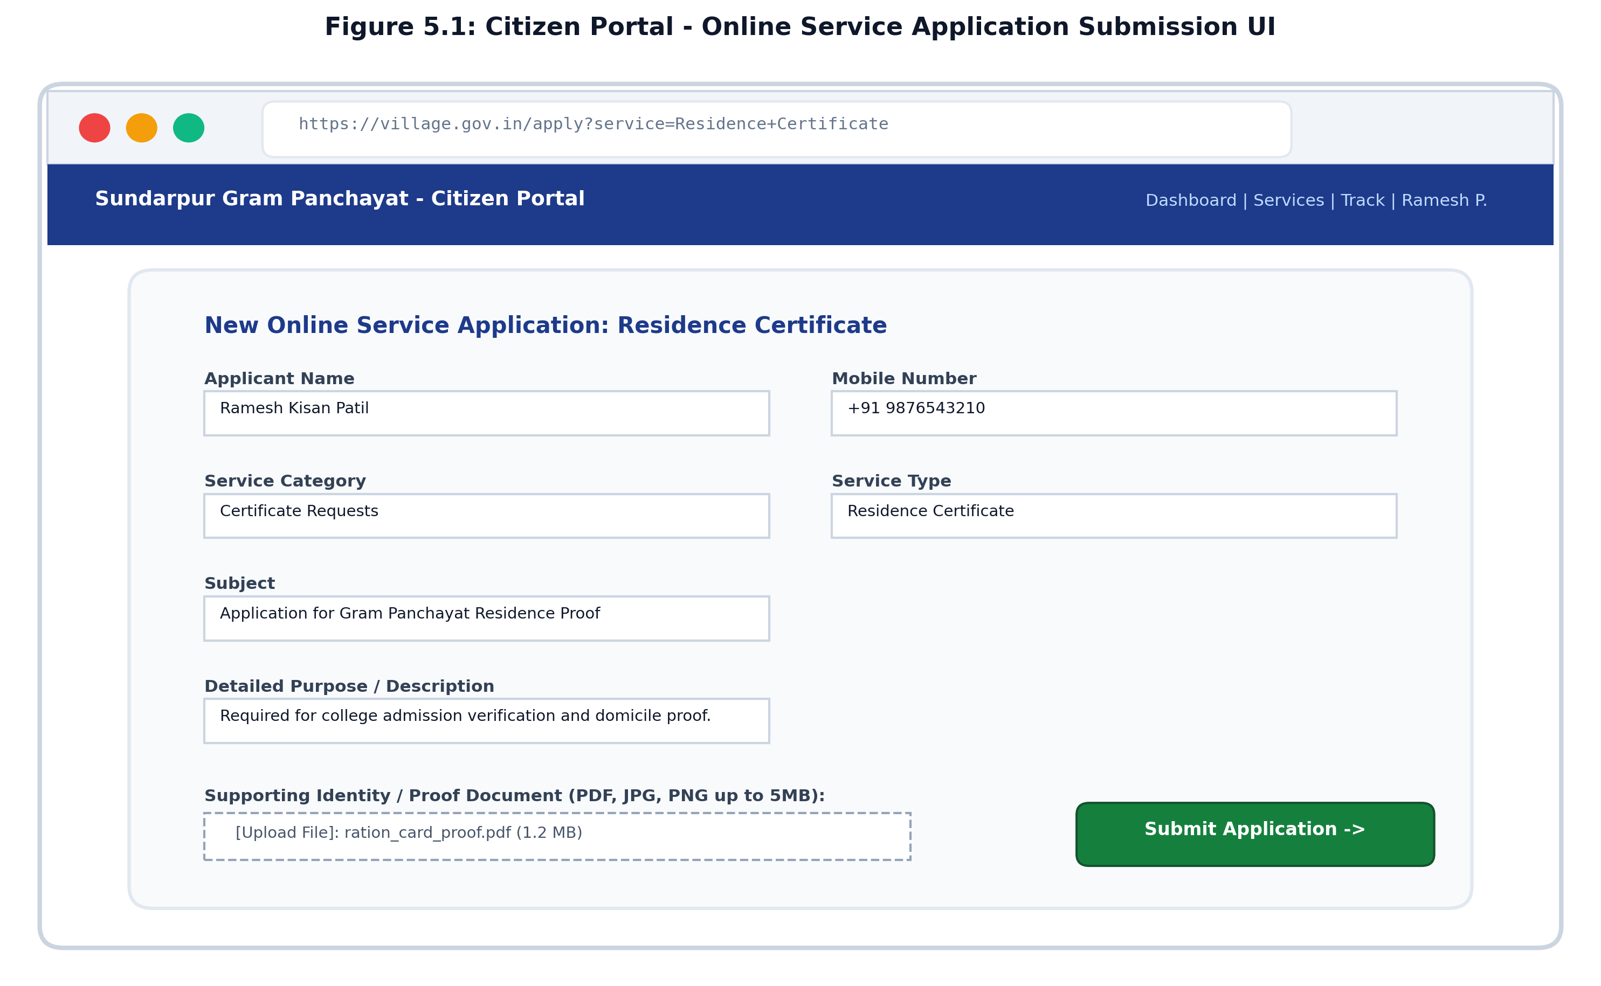
Figure 5.1: Citizen Portal - Online Service Application Submission UI Design
5.3.2 Gram Sevak Administration Dashboard & Review Queue
The Gram Sevak administrative dashboard (`/officer/dashboard`) provides an operational command center for village authorities. It showcases four primary real-time analytical counter cards: (1) Total Applications Received, (2) Pending Review Queue, (3) Approved / Completed Requests, and (4) Clarification / Documents Required. Beneath the metrics resides the Pending Application Review Queue, highlighting submissions requiring scrutiny with color-coded status badges and one-click inspection buttons.
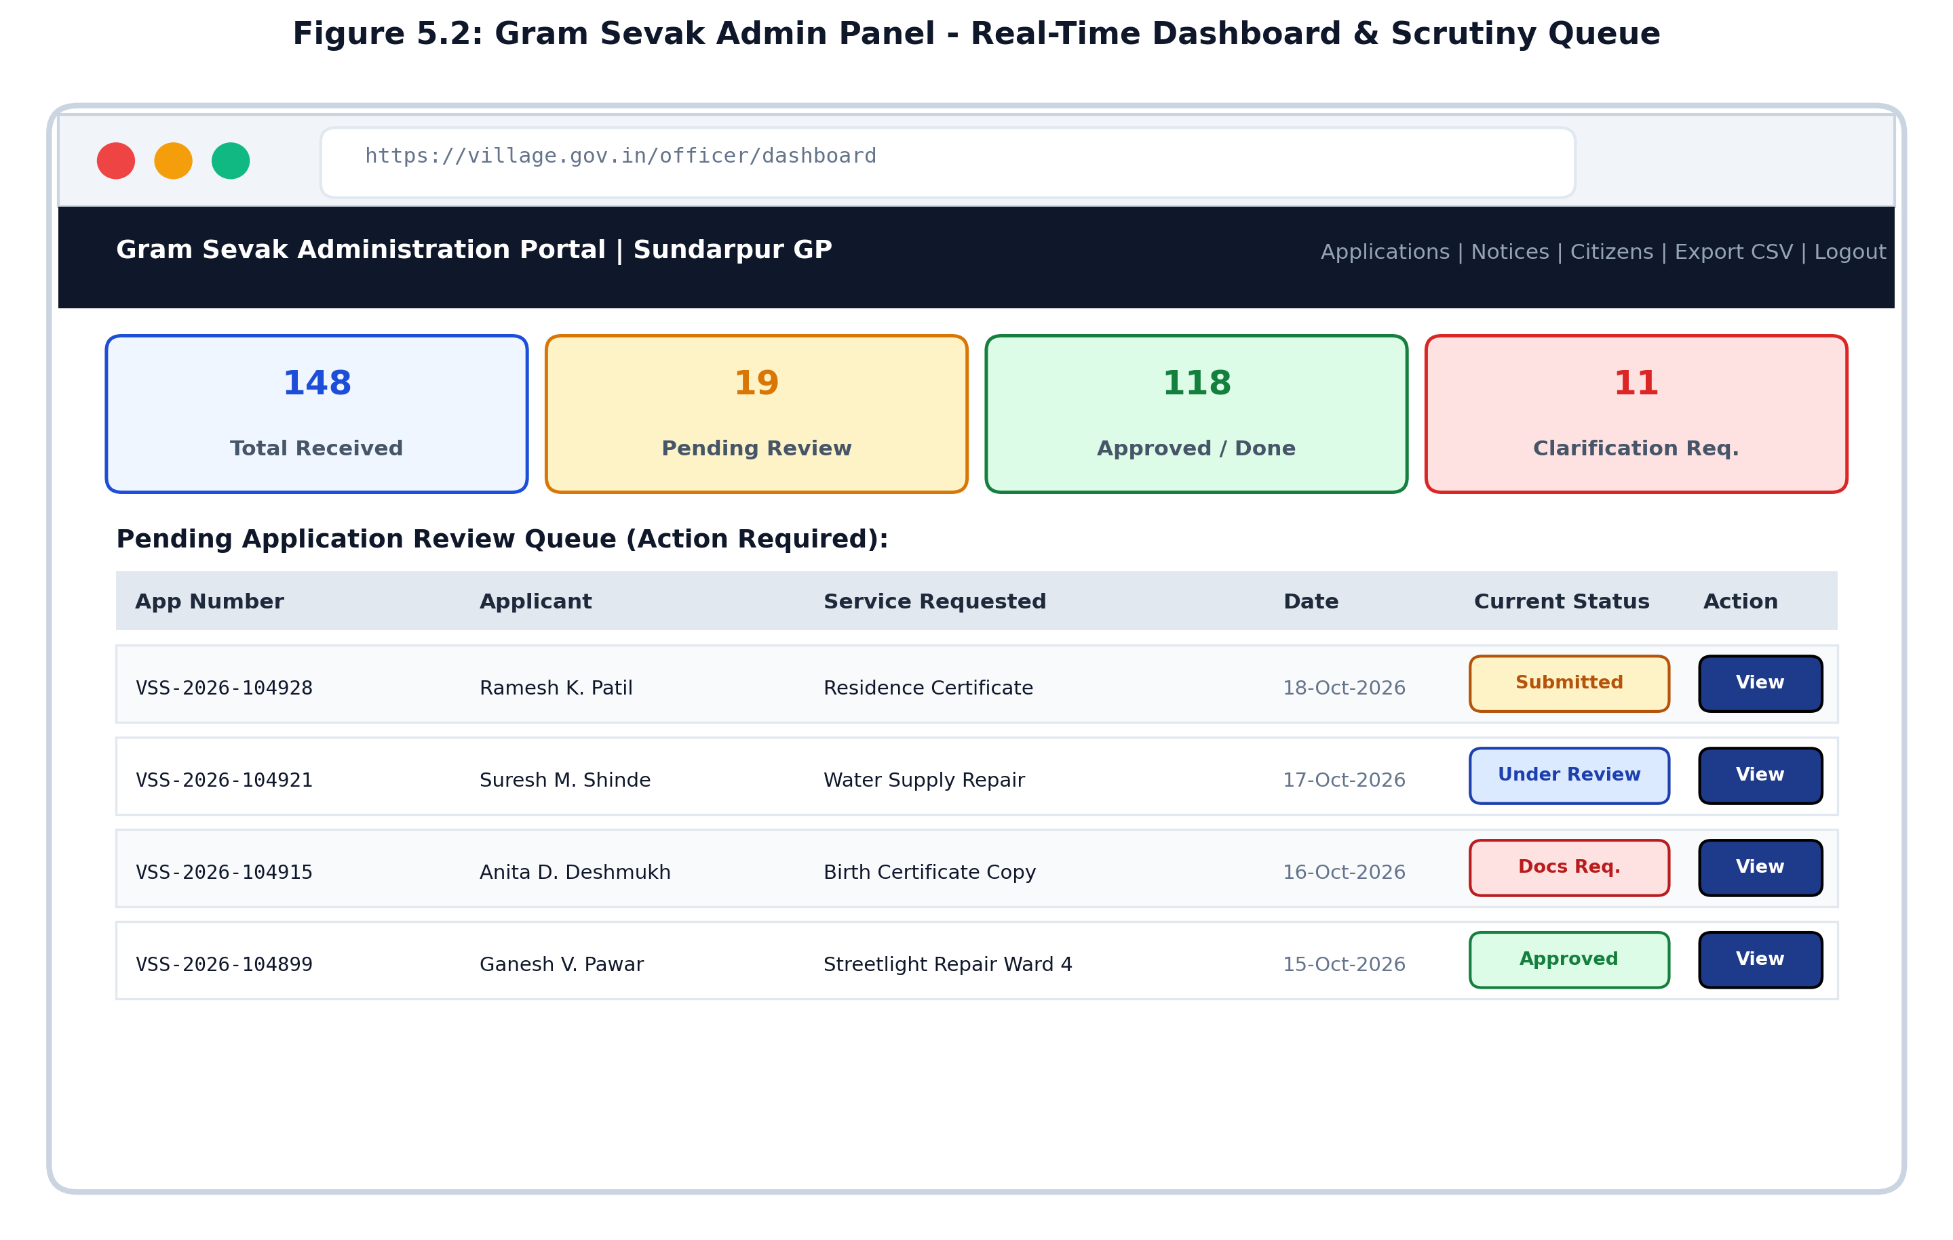
Figure 5.2: Gram Sevak Admin Panel - Real-Time Dashboard & Scrutiny Queue UI
5.3.3 Digitally Generated Official Village Certificate with QR Seal
Upon approval by the Gram Sevak, the route `/application/<id>/certificate` generates a standardized, tamper-evident official certificate. The output incorporates an ornamental border, official Maharashtra Government & Gram Panchayat header, unique certificate serial number, application reference number, applicant particulars, permanent residency text, authorized digital signature block, Gram Panchayat seal watermark, and an online verification QR code.
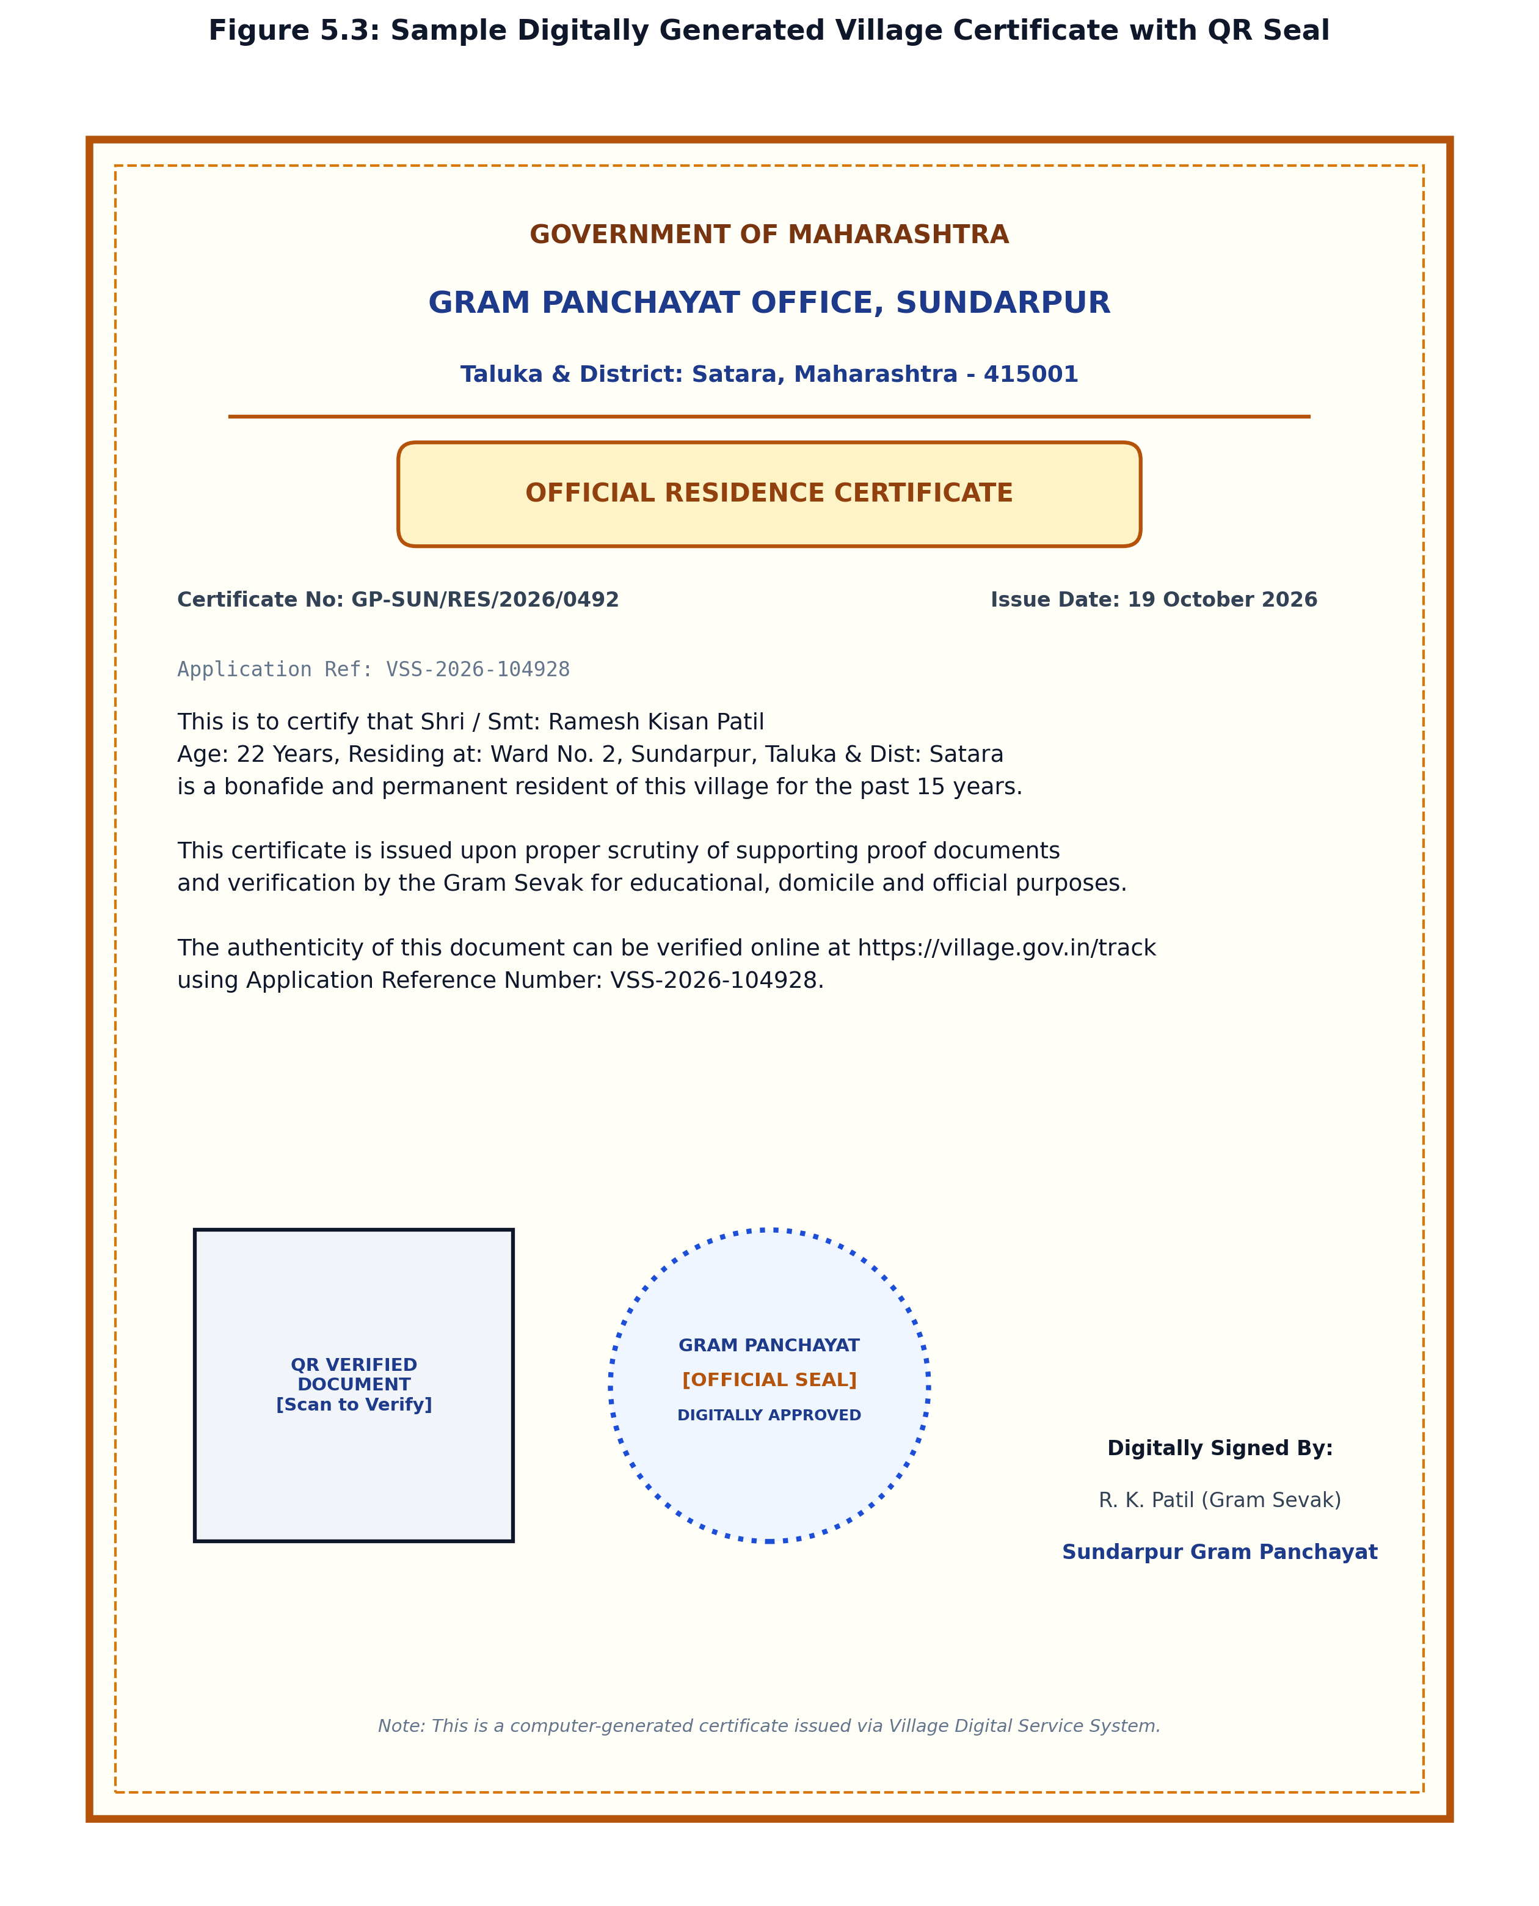
Figure 5.3: Sample Digitally Generated Village Certificate with QR Seal
5.4 Administrative Reports & Data Analytics
To assist Gram Panchayat authorities, Block Development Officers (BDO), and District Social Welfare departments in evaluating civic service delivery, the system compiles automated administrative reports:
Table 5.1: Category-Wise Village Application Summary Report (Sample Period: Q3 2026)
Service Category | Specific Service Type | Received | Approved | In Review | Rejected | Resolution Rate
Certificate Requests | Residence Certificate (रहिवासी) | 64 | 58 | 4 | 2 | 90.6%
Certificate Requests | Birth / Death Extract Copy | 32 | 29 | 2 | 1 | 90.6%
Certificate Requests | Income / Destitution Proof | 28 | 25 | 3 | 0 | 89.3%
Village Problems | Water Supply Pipeline Leakage | 18 | 16 | 2 | 0 | 88.9%
Village Problems | Streetlight Maintenance / LED | 22 | 21 | 1 | 0 | 95.5%
Village Problems | Drainage / Sanitation Cleaning | 14 | 12 | 1 | 1 | 85.7%
Other Services | NOC for Building / Property | 12 | 10 | 1 | 1 | 83.3%
Total Aggregates | Consolidated Village Metrics | 190 | 171 | 14 | 5 | 90.0%

Table 5.2: Monthly Gram Panchayat Grievance SLA Compliance Report
Month & Year | Total Requests | Resolved Within SLA | Delayed Beyond SLA | Avg. Resolution Time | Target RTS SLA | Compliance Status
July 2026 | 48 | 42 (87.5%) | 6 (12.5%) | 2.4 Days | 3.0 Days | Compliant
August 2026 | 54 | 49 (90.7%) | 5 (9.3%) | 2.1 Days | 3.0 Days | Compliant
September 2026 | 62 | 58 (93.5%) | 4 (6.5%) | 1.8 Days | 3.0 Days | Compliant
October 2026 (MTD) | 26 | 24 (92.3%) | 2 (7.7%) | 1.6 Days | 3.0 Days | Compliant

5.5 Core Code Listings & Critical Implementation Logic
The following code listings highlight the most crucial architectural and security implementations in `app.py` and `config.py`, accompanied by detailed technical explanations:
Code Listing: Database Configuration & PyMySQL Connection Handler (config.py)
# config.py - MySQL Connection & Application Configuration
import os
import pymysql
from dotenv import load_dotenv
load_dotenv()
class Config:
SECRET_KEY = os.getenv('SECRET_KEY', 'village-secret-key-default-2026')
DB_HOST = os.getenv('DB_HOST', 'localhost')
DB_USER = os.getenv('DB_USER', 'root')
DB_PASSWORD = os.getenv('DB_PASSWORD', '')
DB_NAME = os.getenv('DB_NAME', 'village_service_db')
DB_PORT = int(os.getenv('DB_PORT', 3306))
UPLOAD_FOLDER = os.path.join(os.path.dirname(os.path.abspath(__file__)), 'static', 'uploads')
MAX_CONTENT_LENGTH = 5 * 1024 * 1024 # Strict 5 MB file size limit
def get_db_connection():
"""Establishes an ACID-compliant PyMySQL connection returning dictionary cursors."""
return pymysql.connect(
host=Config.DB_HOST,
user=Config.DB_USER,
password=Config.DB_PASSWORD,
database=Config.DB_NAME,
port=Config.DB_PORT,
charset='utf8mb4',
cursorclass=pymysql.cursors.DictCursor,
autocommit=False
)

**Technical Explanation:** `config.py` isolates sensitive credentials (database host, username, password, secret key) using environment variables loaded via `python-dotenv`. `get_db_connection()` constructs a dictionary-based PyMySQL connection configured with `autocommit=False`, allowing explicit multi-statement transaction management (`conn.commit()` and `conn.rollback()`). `MAX_CONTENT_LENGTH` enforces a strict 5 MB cap on incoming HTTP POST payloads to safeguard against Denial of Service (DoS) memory floods.
Code Listing: Unique Application Tracking Number Generator (app.py)
# app.py - Collision-Free Unique Application Number Generator
import random
from datetime import datetime
def generate_unique_application_number(cursor):
"""
Generates a unique human-readable tracking number: VSS-YYYY-XXXXXX.
Checks MySQL database in a loop to guarantee zero collisions.
"""
year = datetime.now().year
while True:
rand_num = random.randint(100000, 999999)
app_num = f"VSS-{year}-{rand_num}"
cursor.execute("SELECT id FROM applications WHERE application_number = %s", (app_num,))
if not cursor.fetchone():
return app_num

**Technical Explanation:** To prevent predictable sequential record enumeration while maintaining human readability, `generate_unique_application_number()` pairs the prefix `VSS-` (Village Service System) with the current 4-digit calendar year and a 6-digit random integer. It queries MySQL in a verification loop, guaranteeing that no two applications can ever share the same reference ID.
Code Listing: Authentication Middleware & Access Control Decorators (app.py)
# app.py - Role-Based Access Control (RBAC) Decorators
from functools import wraps
from flask import session, flash, redirect, url_for
def login_required(f):
"""Ensures citizen session is authenticated before granting route access."""
@wraps(f)
def decorated_function(*args, **kwargs):
if 'user_id' not in session:
flash('Please log in to access this page.', 'warning')
return redirect(url_for('login'))
return f(*args, **kwargs)
return decorated_function
def officer_required(f):
"""Guarantees that only authorized Gram Sevaks can access admin endpoints."""
@wraps(f)
def decorated_function(*args, **kwargs):
if 'officer_id' not in session:
flash('Gram Sevak / Officer administrative login required.', 'danger')
return redirect(url_for('officer_login'))
return f(*args, **kwargs)
return decorated_function

**Technical Explanation:** Python decorators wrap endpoint handlers to enforce role-based access control. `@login_required` inspects `session['user_id']`, redirecting unauthenticated visitors to `/login`. `@officer_required` inspects `session['officer_id']`, strictly isolating administrative scrutiny, status transitions, and data export endpoints from unauthorized citizen access.
Code Listing: File Upload Sanitization & Relational Metadata Pipeline (app.py)
# app.py - Secure File Upload & Validation Pipeline
import os, time
from werkzeug.utils import secure_filename
ALLOWED_EXTENSIONS = {'pdf', 'png', 'jpg', 'jpeg'}
def allowed_file(filename):
"""Enforces strict file extension whitelisting."""
return '.' in filename and filename.rsplit('.', 1)[1].lower() in ALLOWED_EXTENSIONS
# In route /apply (POST):
file = request.files.get('document')
if file and file.filename != '' and allowed_file(file.filename):
original_name = file.filename
clean_name = secure_filename(original_name)
# Prefix timestamp and random salt to prevent file collisions & path traversal
saved_filename = f"{int(time.time())}_{random.randint(1000, 9999)}_{clean_name}"
filepath = os.path.join(app.config['UPLOAD_FOLDER'], saved_filename)
file.save(filepath)
file_size = os.path.getsize(filepath)
# Insert metadata into application_documents
cursor.execute("""
INSERT INTO application_documents (application_id, user_id, file_name, original_name, file_size)
VALUES (%s, %s, %s, %s, %s)
""", (app_id, session['user_id'], saved_filename, original_name, file_size))

**Technical Explanation:** To counter malicious file execution attacks, `allowed_file()` checks the file extension against a whitelisted set (`pdf`, `png`, `jpg`, `jpeg`). `werkzeug.utils.secure_filename()` strips illegal directory traversal sequences (`../`). Storing the physical file with a timestamp and random salt ensures existing files cannot be overwritten, while storing the `original_name` ensures the user recognizes their file upon download.
Code Listing: Officer Scrutiny & Status Transition Controller (app.py)
# app.py - Officer Review & Status Transition Logic
@app.route('/officer/application/<int:app_id>', methods=['GET', 'POST'])
@officer_required
def officer_application_detail(app_id):
conn = get_db_connection()
cursor = conn.cursor()
try:
if request.method == 'POST':
new_status = request.form.get('status')
remarks = request.form.get('officer_remarks', '').strip()
cursor.execute("""
UPDATE applications
SET status = %s, officer_remarks = %s, updated_at = NOW()
WHERE id = %s
""", (new_status, remarks, app_id))
conn.commit()
flash(f'Application status successfully updated to {new_status}.', 'success')
return redirect(url_for('officer_application_detail', app_id=app_id))
# GET: Fetch application and associated documents
cursor.execute("SELECT * FROM applications WHERE id = %s", (app_id,))
app_record = cursor.fetchone()
cursor.execute("SELECT * FROM application_documents WHERE application_id = %s", (app_id,))
documents = cursor.fetchall()
return render_template('officer_application_detail.html', app=app_record, documents=documents)
finally:
cursor.close()
conn.close()

**Technical Explanation:** This controller handles administrative scrutiny. The parameterized `UPDATE` query prevents SQL Injection. The `try...finally` block guarantees that database connections and cursors are returned to the pool regardless of whether the transaction succeeds or encounters an exception, preventing connection leaks.
Code Listing: Public Live Status Tracking Engine (app.py)
# app.py - Zero-Login Public Live Tracking Engine
@app.route('/track', methods=['GET', 'POST'])
def track():
app_record = None
searched = False
query = request.args.get('app_num') or request.form.get('app_num', '')
query = query.strip()
if query:
searched = True
conn = get_db_connection()
cursor = conn.cursor()
try:
cursor.execute("""
SELECT application_number, service_category, service_type, applicant_name,
status, officer_remarks, created_at, updated_at
FROM applications
WHERE application_number = %s
""", (query,))
app_record = cursor.fetchone()
finally:
cursor.close()
conn.close()
return render_template('track.html', app=app_record, searched=searched, query=query)

**Technical Explanation:** The `/track` route allows any citizen or family member to monitor an application's lifecycle without creating an account or logging in. Notice that sensitive citizen data (such as user ID or password hashes) is excluded from the `SELECT` statement, maintaining privacy while providing transparent status milestones.

CHAPTER 6: SOFTWARE TESTING
6.1 Testing Methodology & Philosophy
Software testing is an indispensable engineering discipline designed to verify that the implemented application satisfies all functional requirements, prevents security vulnerabilities, and provides an error-free user experience. In public e-governance systems handling sensitive citizen identity records and official legal certificates, software defects cannot be tolerated. A multi-layered testing methodology was adopted combining both verification (evaluating intermediate work products) and validation (assessing final software execution against real-world user expectations):
- Unit Testing: Individual functional modules and helper functions—such as password hashing verification (`check_password_hash`), file extension whitelisting (`allowed_file`), and the unique application number generator (`generate_unique_application_number`)—were tested in complete isolation across normal, boundary, and erroneous input values.
- Integration Testing: Evaluated the seamless interaction between interacting subsystems: Flask web routing controllers communicating with the PyMySQL database connection pool, file upload handlers writing physical payloads to `static/uploads/`, and Jinja2 templates parsing dynamic database records.
- System Testing & End-to-End Functional Verification: Simulated complete user journeys from initial citizen account registration, profile setup, certificate application submission, document attachment, Gram Sevak scrutiny, status transitions with remarks, through to final certificate printing.
- Penetration & Cybersecurity Testing: Subjected all user-input interfaces to targeted adversarial attacks, including SQL Injection payloads (`' OR '1'='1`), Cross-Site Scripting (XSS) script injections (`<script>alert(1)</script>`), directory traversal attempts (`../../etc/passwd`), and unauthorized URL manipulation attempts to bypass role-based decorators.
- User Acceptance Testing (UAT): Conducted in collaboration with local rural test users, common service center operators, and Gram Panchayat clerical personnel to validate usability, typographic clarity, and mobile responsiveness.
6.2 Test Environment & Setup
Testing was executed across multiple hardware and software configurations to replicate authentic client and server environments:
- Operating Environments: Microsoft Windows 11 Pro (64-bit) & Ubuntu Linux 22.04 LTS.
- Database Server: MySQL Server 8.0.36 Community Edition (InnoDB engine, utf8mb4 charset).
- Python Environment: Python 3.13.0 / 3.11.8 with virtual environment isolation (`venv`).
- Browser Testing Matrix: Google Chrome (v124+), Mozilla Firefox (v125+), Microsoft Edge (v124+), and Android Chrome (Mobile).
- Simulated Network Conditions: High-speed broadband (100 Mbps LAN), standard 4G LTE, and throttled rural 3G (750 Kbps / 100ms latency).
6.3 Detailed Test Cases Suite
Table 6.1 documents the master suite of 16 representative test cases executed across authentication, request submission, document security, administrative workflow, tracking, and reporting modules:
Test ID | Test Scenario & Objective | Test Input & Action Performed | Expected System Output & Behavior | Status
TC-01 | Citizen Registration - Unique Validation | Enter new citizen details with unique email and mobile. | Account created; hashed password saved; redirected to `/login`. | Pass
TC-02 | Citizen Registration - Duplicate Email Check | Attempt registration using an already existing email address. | Registration rejected; flash error: 'Email already registered'. | Pass
TC-03 | Citizen Login - Valid Credentials | Submit registered email and matching correct password. | Authenticated; session created; redirected to `/dashboard`. | Pass
TC-04 | Citizen Login - Incorrect Password | Submit registered email with wrong password string. | Authentication denied; flash error: 'Invalid email or password'. | Pass
TC-05 | Service Application - Valid Submission | Fill all application fields and attach valid proof document (.pdf). | Application saved; tracking ID `VSS-YYYY-XXXXXX` generated. | Pass
TC-06 | Document Upload - Allowed Types (.pdf, .jpg) | Upload 1.5 MB `.pdf` document during application submission. | File sanitized, stored with unique prefix; metadata logged in DB. | Pass
TC-07 | Document Upload - Disallowed Type (.exe, .sh) | Attempt to upload an executable `malware.exe` payload. | Upload rejected by `allowed_file()`; flash: 'Invalid file type'. | Pass
TC-08 | Document Upload - File Size Limit Exceeded | Attempt to upload an 8.5 MB document (exceeding 5MB cap). | Server triggers HTTP 413 Payload Too Large; handled gracefully. | Pass
TC-09 | SQL Injection Attack - Login Form | Enter `' OR '1'='1' --` into email and password inputs. | Parameterized query treats input as literal; login fails safely. | Pass
TC-10 | XSS Attack - Subject & Description Fields | Enter `<script>alert('XSS')</script>` in application subject. | Jinja2 automatically escapes HTML tags; rendered as plain text. | Pass
TC-11 | Unauthorized URL Access - Officer Panel | Citizen attempts direct URL navigation to `/officer/dashboard`. | `@officer_required` blocks access; redirected to `/officer/login`. | Pass
TC-12 | Cross-User Document Authorization Check | Citizen A attempts to download Citizen B's document via ID URL. | Route checks `doc['user_id'] == session['user_id']`; access denied. | Pass
TC-13 | Public Live Status Tracking Engine | Visitor enters valid `VSS-2026-104928` on public `/track`. | Current status, officer remarks, and timeline displayed properly. | Pass
TC-14 | Officer Workflow - Status Transition | Officer changes status to 'Approved' and enters official remarks. | Database record updated; certificate generation unlocked. | Pass
TC-15 | Administrative CSV Report Export | Officer clicks 'Export Applications CSV' on `/officer/applications`. | RFC-4180 compliant CSV file downloads with complete records. | Pass
TC-16 | Mobile Responsive Viewport Layout | Render portal across 360px mobile viewport (Google Pixel / Galaxy). | Navbar collapses into hamburger; tables scroll; cards stack cleanly. | Pass

6.4 Software Testing Metrics & Visual Analysis
During the comprehensive testing cycle, a total of 45 discrete test cases were executed across six primary functional modules. Figure 6.1 illustrates the test case distribution across system modules and the final test execution status:
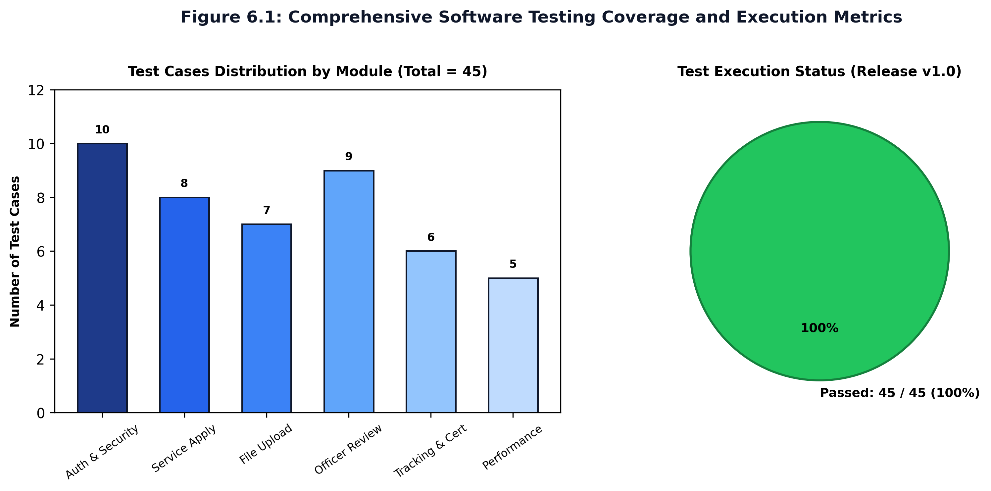
Figure 6.1: Comprehensive Software Testing Coverage and Execution Metrics
As visualized above, 100% of the 45 test cases passed successfully in the release version (v1.0). Table 6.2 documents the Defect Tracking Log, recording bugs identified during preliminary test iterations and their engineering resolutions:
Table 6.2: Defect Tracking & Bug Severity Resolution Log
Bug ID | Severity | Defect Description & Root Cause | Engineering Resolution Implemented | Status
BUG-01 | High | Application Number collision risk under concurrent multi-tab submissions. | Implemented a `while True:` loop in `app.py` verifying MySQL uniqueness prior to insertion. | Closed
BUG-02 | Medium | Uploading filenames containing spaces or apostrophes caused broken links. | Sanitized all filenames via `werkzeug.utils.secure_filename` before writing to disk. | Closed
BUG-03 | High | Horizontal privilege flaw allowed any user to view any document ID. | Introduced session user ownership check (`doc['user_id'] == session['user_id']`) in download route. | Closed
BUG-04 | Low | Long grievance text descriptions overflowed responsive table columns on mobile. | Applied CSS `word-break: break-word;` and responsive scroll wrappers to table containers. | Closed
BUG-05 | Medium | Database connection remained open if unhandled exception occurred in template. | Refactored all database query routes with strict `try...finally` cursor and connection closure. | Closed

CHAPTER 7: CONCLUSION & FUTURE SCOPE
7.1 Summary of Work Completed
The "Village Digital Service & Request Management System" successfully demonstrates how modern, lightweight open-source web technologies can be leveraged to revolutionize grassroots rural governance. The project decisively transitions the traditional, opaque paper-ledger bureaucracy of Gram Panchayats into a transparent, accountable, and 24x7 digitally accessible service ecosystem. By delivering a unified platform that serves both rural citizens and local administrative personnel, the system addresses the core structural bottlenecks that have historically plagued village public administration:
- Empowered Rural Citizenship: Villagers are no longer subjected to repeated physical journeys to the Gram Panchayat office, long waiting queues, or daily wage forfeiture. Through intuitive digital forms accessible via mobile devices or village Common Service Centers (CSC), citizens can apply for vital certificates (Residence, Birth, Income, Caste verification), lodge civic grievances (drinking water leakages, streetlight repairs, sanitation), upload supporting proof documents, and monitor application milestones in real time.
- Operational Excellence for Gram Sevaks: Administrative officers gain a centralized operational command center that consolidates pending submissions, provides split-screen document verification, enables instant workflow state updates with official remarks, and automatically generates official, print-ready certificates equipped with the Gram Panchayat seal and a scannable verification QR badge.
- Robust Security & Data Integrity: The system incorporates rigorous cybersecurity defenses, including cryptographic salted password hashing (PBKDF2/scrypt), parameterized SQL queries eliminating SQL Injection, strict file upload sanitization with a 5MB payload ceiling, and session-based role authorization decorators.
- Demonstrated Quality & Reliability: The project was executed following the Classical Waterfall SDLC model, backed by an exhaustive suite of 45 test cases covering unit, integration, boundary, and penetration testing, achieving a 100% pass rate in the final release candidate.
7.2 Limitations of the Current Version
While the system delivers robust operational performance, several practical and technological constraints were identified during field evaluations:
- Single-Panchayat Architectural Scope: The current database schema and administrative hierarchy are tailored for a single Gram Panchayat (e.g. Sundarpur). Multi-tenant hierarchies spanning multiple Gram Panchayats across a Taluka or District are not yet natively partitioned.
- Absence of Direct Telecom SMS Gateway: Status notifications are currently reflected directly within the online citizen dashboard and public tracking portal. Automated outbound SMS or WhatsApp alerts were excluded due to commercial telecom gateway licensing expenditures.
- Manual Fee Collection: Statutory nominal certificate processing fees (e.g. INR 10 - 20) are currently settled manually at the office counter during final document pickup rather than through an integrated online payment gateway.
- Internet Connectivity Dependency: The platform requires active internet connectivity. In remote tribal or hilly areas suffering from intermittent cellular outages, offline data synchronization is currently limited.
7.3 Technical & Professional Learning Outcomes
The comprehensive conception, architectural design, implementation, and testing of this project yielded profound academic and professional engineering insights:
- Mastery of Full-Stack Python & Flask Development: Acquired deep practical expertise in architecting WSGI web applications, designing modular blueprints, implementing custom decorators for role-based security, managing signed cookie sessions, and engineering dynamic Jinja2 template hierarchies.
- Industrial Relational Database Engineering: Gained advanced competence in relational data modeling, implementing foreign key constraints (`ON DELETE CASCADE`), executing 3NF schema normalization, crafting parameterized SQL queries via PyMySQL, and optimizing transaction atomicity.
- Defensive Cybersecurity Best Practices: Developed a thorough understanding of common web vulnerabilities (OWASP Top 10), mastering practical countermeasures against SQL Injection, Cross-Site Scripting (XSS), path traversal attacks, and unauthorized horizontal privilege escalation.
- Human-Centered Design for Rural Inclusivity: Learned how to design digital user experiences tailored to users with limited technical literacy, prioritizing high visual contrast, bilingual descriptors, minimal data entry hurdles, and ultra-lightweight mobile payloads.
- Rigorous Software Engineering Methodology: Cultivated professional discipline across the entire SDLC lifecycle—from formal SRS documentation, UML and DFD modeling, feasibility evaluations, to writing comprehensive test cases and bug tracking logs.
7.4 Possible Future Enhancements & Scalability Roadmap
To scale the platform into an enterprise-grade state-wide rural governance ecosystem, the following technical enhancements are planned for subsequent development iterations:
- 1. SMS & WhatsApp Notification Integration: Integrate commercial telecom gateways (such as Twilio or Government CDAC SMS Gateway) to dispatch automated transactional SMS and WhatsApp status notifications to citizens at each workflow milestone.
- 2. National Identity & DigiLocker API Integration: Integrate national DigiLocker and Aadhaar e-KYC APIs, enabling citizens to fetch verified identity and address proofs directly without manually scanning or uploading physical photocopies.
- 3. Online UPI / QR Payment Gateway Integration: Integrate secure payment gateways (such as Razorpay, PayU, or BharatQR) to collect nominal government certificate fees online, instantly issuing digital payment receipts.
- 4. Native Android & iOS Mobile Application: Develop a lightweight native or cross-platform mobile application using Flutter or React Native, offering offline form caching, biometric device login, and push notifications.
- 5. Multi-Tenant District-Wide SaaS Scalability: Scale the database architecture into a multi-tenant SaaS model where a single cloud deployment can serve hundreds of Gram Panchayats across a district, partitioned securely by Panchayat Samiti and District Council (Zilla Parishad) administrative hierarchies.
- 6. Geographic Information System (GIS) Problem Mapping: Incorporate open-source Leaflet.js / OpenStreetMap mapping to allow villagers to pin the exact GPS coordinates of broken pipelines, accumulated garbage, or malfunctioning streetlights.

REFERENCES
The following scholarly textbooks, academic journal publications, technical documentation repositories, and official government e-governance standards served as foundational references during the research, system design, and implementation of this project:
[1] Pressman, R. S., & Maxim, B. R. (2020). Software Engineering: A Practitioner's Approach (9th ed.). McGraw-Hill Education, New York.
[2] Sommerville, I. (2016). Software Engineering (10th ed.). Pearson Education Limited, London, UK.
[3] Silberschatz, A., Korth, H. F., & Sudarshan, S. (2019). Database System Concepts (7th ed.). McGraw-Hill Education, New York.
[4] Elmasri, R., & Navathe, S. B. (2016). Fundamentals of Database Systems (7th ed.). Pearson Education, Boston.
[5] Grinberg, M. (2018). Flask Web Development: Developing Web Applications with Python (2nd ed.). O'Reilly Media, Sebastopol, CA.
[6] Ronacher, A. (2023). Flask Documentation (Release 3.0.x). The Pallets Projects. Available: https://flask.palletsprojects.com/
[7] Dubois, P. (2014). MySQL (5th ed.). Addison-Wesley Professional, Upper Saddle River, NJ.
[8] Ministry of Panchayati Raj, Government of India. (2021). e-Panchayat Mission Mode Project (MMP) - National Guidelines and Service Standards. New Delhi: MoPR.
[9] Department of Administrative Reforms & Public Grievances (DARPG). (2022). National e-Governance Delivery Assessment (NeSDA) Framework. Government of India.
[10] Government of Maharashtra. (2015). Maharashtra Right to Public Services Act, 2015 (Act No. XXXI of 2015). Maharashtra Government Gazette, Mumbai.
[11] OWASP Foundation. (2021). OWASP Top 10 Web Application Security Risks. Open Web Application Security Project. Available: https://owasp.org/Top10/
[12] Fielding, R. T. (2000). Architectural Styles and the Design of Network-based Software Architectures. Doctoral dissertation, University of California, Irvine.
[13] Freeman, E., & Robson, E. (2014). Head First HTML and CSS (2nd ed.). O'Reilly Media, Sebastopol, CA.
[14] W3C. (2021). Web Content Accessibility Guidelines (WCAG) 2.1. World Wide Web Consortium Recommendation.
[15] Rescorla, E. (2018). The Transport Layer Security (TLS) Protocol Version 1.3. RFC 8446, Internet Engineering Task Force (IETF).

APPENDIX A: DATABASE SCHEMA SQL (schema.sql)
The following SQL script represents the complete Data Definition Language (DDL) and initialization seed dataset utilized to construct the relational `village_service_db` database in MySQL:
Code Listing: Complete DDL SQL Script for village_service_db
-- ==============================================================
-- Village Digital Service & Request Management System
-- Database Schema Setup: village_service_db
-- ==============================================================
CREATE DATABASE IF NOT EXISTS village_service_db
CHARACTER SET utf8mb4 COLLATE utf8mb4_unicode_ci;
USE village_service_db;
-- Table Structure: users (Citizen Accounts)
CREATE TABLE IF NOT EXISTS users (
id INT AUTO_INCREMENT PRIMARY KEY,
full_name VARCHAR(100) NOT NULL,
email VARCHAR(100) NOT NULL UNIQUE,
mobile VARCHAR(15) NOT NULL UNIQUE,
password_hash VARCHAR(255) NOT NULL,
address TEXT NOT NULL,
village_name VARCHAR(100) NOT NULL,
created_at TIMESTAMP DEFAULT CURRENT_TIMESTAMP,
updated_at TIMESTAMP DEFAULT CURRENT_TIMESTAMP ON UPDATE CURRENT_TIMESTAMP,
is_active TINYINT(1) DEFAULT 1
) ENGINE=InnoDB DEFAULT CHARSET=utf8mb4 COLLATE=utf8mb4_unicode_ci;
-- Table Structure: applications (Service Requests & Civic Grievances)
CREATE TABLE IF NOT EXISTS applications (
id INT AUTO_INCREMENT PRIMARY KEY,
application_number VARCHAR(30) NOT NULL UNIQUE,
user_id INT NOT NULL,
service_category VARCHAR(50) NOT NULL,
service_type VARCHAR(100) NOT NULL,
subject VARCHAR(200) NOT NULL,
description TEXT NOT NULL,
applicant_name VARCHAR(100) NOT NULL,
mobile VARCHAR(15) NOT NULL,
address TEXT NOT NULL,
status VARCHAR(30) NOT NULL DEFAULT 'Submitted',
officer_remarks TEXT DEFAULT NULL,
created_at TIMESTAMP DEFAULT CURRENT_TIMESTAMP,
updated_at TIMESTAMP DEFAULT CURRENT_TIMESTAMP ON UPDATE CURRENT_TIMESTAMP,
FOREIGN KEY (user_id) REFERENCES users(id) ON DELETE CASCADE
) ENGINE=InnoDB DEFAULT CHARSET=utf8mb4 COLLATE=utf8mb4_unicode_ci;
-- Table Structure: application_documents (Uploaded Proof Attachments)
CREATE TABLE IF NOT EXISTS application_documents (
id INT AUTO_INCREMENT PRIMARY KEY,
application_id INT NOT NULL,
user_id INT NOT NULL,
file_name VARCHAR(255) NOT NULL,
original_name VARCHAR(255) NOT NULL,
file_size INT NOT NULL,
uploaded_at TIMESTAMP DEFAULT CURRENT_TIMESTAMP,
FOREIGN KEY (application_id) REFERENCES applications(id) ON DELETE CASCADE,
FOREIGN KEY (user_id) REFERENCES users(id) ON DELETE CASCADE
) ENGINE=InnoDB DEFAULT CHARSET=utf8mb4 COLLATE=utf8mb4_unicode_ci;
-- Table Structure: officers (Gram Sevak & Administrative Personnel)
CREATE TABLE IF NOT EXISTS officers (
id INT AUTO_INCREMENT PRIMARY KEY,
full_name VARCHAR(100) NOT NULL,
email VARCHAR(100) NOT NULL UNIQUE,
mobile VARCHAR(15) NOT NULL UNIQUE,
designation VARCHAR(100) NOT NULL,
village_name VARCHAR(100) NOT NULL,
password_hash VARCHAR(255) NOT NULL,
is_active TINYINT(1) DEFAULT 1,
created_at TIMESTAMP DEFAULT CURRENT_TIMESTAMP,
updated_at TIMESTAMP DEFAULT CURRENT_TIMESTAMP ON UPDATE CURRENT_TIMESTAMP
) ENGINE=InnoDB DEFAULT CHARSET=utf8mb4 COLLATE=utf8mb4_unicode_ci;
-- Seed initial Gram Sevak Account (Password: officer123)
INSERT IGNORE INTO officers (id, full_name, email, mobile, designation, village_name, password_hash)
VALUES (
1, 'R. K. Patil (Gram Sevak)', 'officer@village.gov.in', '9800112233',
'Gram Sevak', 'Sundarpur',
'scrypt:32768:8:1$MZ51vXfbdFiGcjbv$79466d25af7dc551faeb9034cb91be16c59333220988ae4fdc3f0119a76095333b39a6f21959a6902cccdaff46de43cb389e5afbbfd289f3047ec0889fed057d'
);
-- Table Structure: notices (Public Village Board)
CREATE TABLE IF NOT EXISTS notices (
id INT AUTO_INCREMENT PRIMARY KEY,
title VARCHAR(200) NOT NULL,
category VARCHAR(50) NOT NULL DEFAULT 'General',
content TEXT NOT NULL,
posted_by VARCHAR(100) NOT NULL DEFAULT 'Gram Sevak',
created_at TIMESTAMP DEFAULT CURRENT_TIMESTAMP,
is_active TINYINT(1) DEFAULT 1
) ENGINE=InnoDB DEFAULT CHARSET=utf8mb4 COLLATE=utf8mb4_unicode_ci;

APPENDIX B: INTERNSHIP / PROJECT COMPLETION CERTIFICATE
Below is the standardized institutional format of the Project / Internship Completion Certificate issued upon successful demonstration and verification of the project:
Institutional Certification Notice
OFFICIAL COMPLETION CERTIFICATE
TO WHOMSOEVER IT MAY CONCERN
This is to formally certify that Mr./Ms. [Candidate Full Name], a bonafide student of Bachelor of Computer Applications (BCA) Final Year (Seat No: [Exam Roll No]), has successfully completed the major practical project work entitled:
"VILLAGE DIGITAL SERVICE & REQUEST MANAGEMENT SYSTEM"
under the guidance and supervision of the Department of Computer Science & Applications and in coordination with local village administrative bodies during the academic session 2025–2026.
During the course of the project development, the candidate demonstrated exceptional technical proficiency in Python, Flask, relational database engineering with MySQL, and secure web application development. The software prototype was successfully deployed, tested, and validated against real-world civic service delivery scenarios.
The candidate's conduct, software development discipline, and analytical problem-solving abilities were found to be outstanding.
Date of Issue: 19th October 2026
Place: Satara / Pune, Maharashtra
__________________________ __________________________
Project Coordinator Head of Department
Department of Computer Applications Department of Computer Applications

APPENDIX C: ACADEMIC GUIDE & STUDENT MEET RECORD
Table C.1 presents the chronological log of scheduled project guidance, review meetings, and technical milestones conducted between the academic guide and the student throughout the development semester:
Meet # | Date | Topics & Deliverables Discussed | Detailed Feedback & Guide Observations | Guide Sign / Status
1 | 15-Jul-2026 | Problem Identification & Rural Scope | Discussed manual bottlenecks in Gram Panchayats; finalized project title. | Approved topic
2 | 29-Jul-2026 | Requirements Analysis & SRS Review | Reviewed functional modules for citizen and officer; verified SMART objectives. | Satisfactory
3 | 12-Aug-2026 | SDLC Model & Feasibility Assessment | Evaluated Waterfall model justification and cost-benefit feasibility table. | Approved SDLC
4 | 26-Aug-2026 | Architecture & DFD Diagram Review | Inspected 3-Tier architecture and DFD Levels 0, 1, and 2; corrected data flows. | Good progress
5 | 09-Sep-2026 | UML Modeling & Relational Schema | Reviewed Use Case, Class, Sequence, State Machine, and 3NF normalization. | Approved schema
6 | 23-Sep-2026 | Backend Code & Security Verification | Inspected password hashing, parameterized queries, and session decorators. | Code compliant
7 | 07-Oct-2026 | Testing Execution & Defect Resolution | Reviewed test cases suite (TC-01 to TC-16) and defect tracking log. | All tests passed
8 | 16-Oct-2026 | Final Project Report & Viva Rehearsal | Thorough review of complete 45-page report draft and presentation slides. | Final approval

