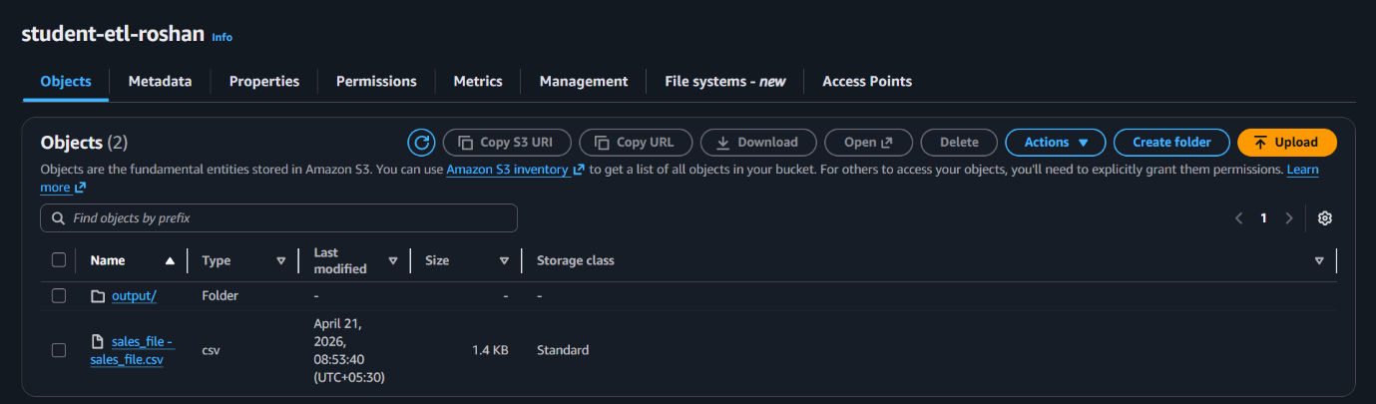

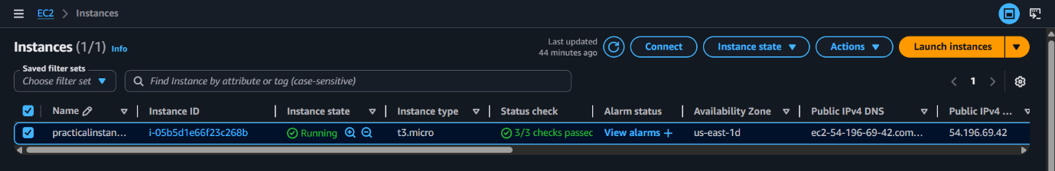

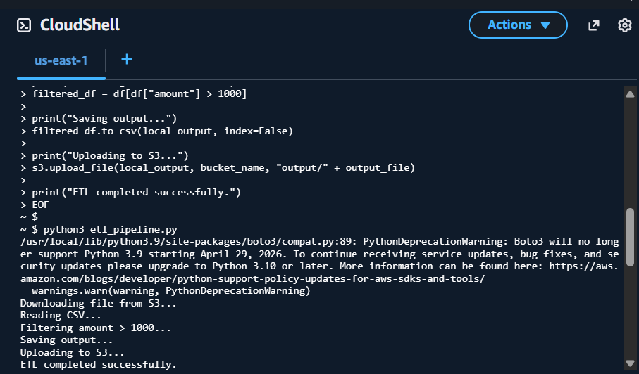

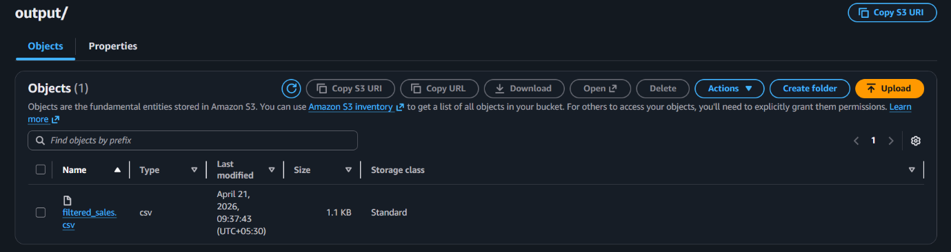

QUESTION 1 PYTHON ETL SCRIPT:

cat > etl_pipeline.py <<EOF
import boto3
import pandas as pd

bucket_name = "student-etl-roshan"
input_file = "sales_file - sales_file.csv"
output_file = "filtered_sales.csv"

local_input = "/tmp/sales.csv"
local_output = "/tmp/filtered_sales.csv"

s3 = boto3.client("s3")

print("Downloading file from S3...")
s3.download_file(bucket_name, input_file, local_input)

print("Reading CSV...")
df = pd.read_csv(local_input)

print("Filtering records where amount > 1000...")
filtered_df = df[df["amount"] > 1000]

print("Saving output file...")
filtered_df.to_csv(local_output, index=False)

print("Uploading output to S3...")
s3.upload_file(local_output, bucket_name, "output/" + output_file)

print("ETL completed successfully.")
EOF

