TASK 2: Classification Analysis - Breast Cancer Dataset
Submitted By
Student Name: Roshan Joshi
Student Number: 2402361

Table of Contents
1. Introduction 2
2. Dataset & Preprocessing 2
3. Logistic Regression 3
4. Support Vector Machine (SVM) 4
5. Neural Network 5
6. Model Comparison & Improvement Discussion 6
7. Conclusion 6
8. References 7

1. Introduction
The classification is another core machine learning example task that is aimed at labeling new data pieces with predefined labels. Classification of models is widely used in the healthcare sector in aiding the disease diagnosis and clinical decision-making. In this activity, the researcher aims at classifying the tumours of breast cancer as being benign or malignant based on the dataset available as Breast Cancer Wisconsin. The data set has a number of numeric variables that were derived based on digitised images of mass biopsies in the breast. This task will attempt to apply and compare three classification algorithms, namely Logistic Regression, Support Vector Machine (SVM), and a Neural Network, by estimating their predictive accuracy as well as the effect of preprocessing and hyperparameter optimization on classification accuracy.

2. Dataset & Preprocessing
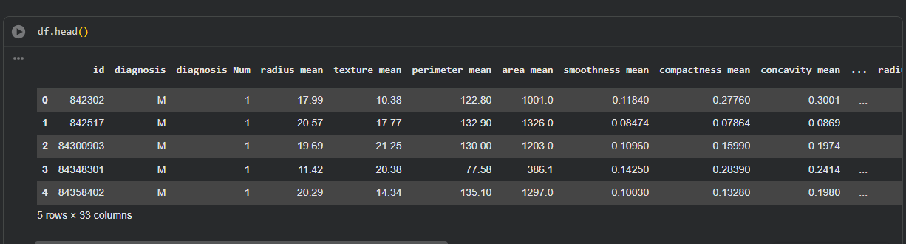
Breast Cancer Wisconsin is a collection of 569 cases where the data were expressed numerically with a description of the tumour like radius, texture, perimeter, smoothness, and concavity. Target variable diagnosis Num.< -binary class labels, 0 benign tumours and 1 malignant tumours. Attributes that were not informative like patient ID and the categorical label of diagnosis were eliminated before modelling. Since most classification algorithms are sensitive to the scale of features, data normalisation was done using StandardScaler to normalise all the numerical features. They then divided the dataset into training and testing sets in the proportion of 80:20 with a fixed random state to be able to reproduce results. These preprocessing measures enhanced convergence of models and a fair comparison was observed between classifiers (Morr et al., 2022).
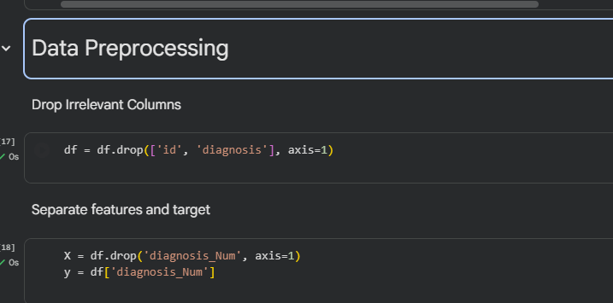

3. Logistic Regression
The use of Logistic Regression as a baseline classification model was because it is relatively simple and easy to interpret. In comparison with linear regression, Logistic Regression assigns the probabilities of zero and one to linear combinations of the features that are used as inputs, as the Logistic Regression employs the sigmoid function to fit the linear combinations. The model predicts the membership to the class through the application of a decision boundary through the weighted features that are learned (Schober and Vetter, 2021).
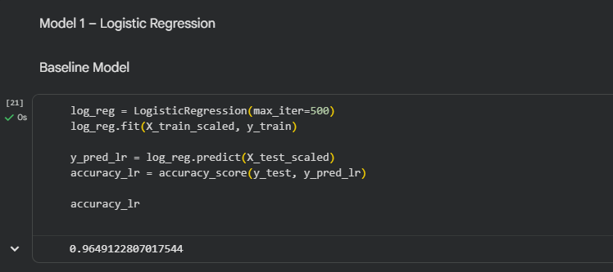
Here, the training of Logistic Regression was done on scaled data, and additionally tuning of various hyperparameters, especially the strength of regularisation. The tuned model was 96 % accurate concerning the testing data. The confusion matrix had minimal misclassifications whereby both benign and the malignant had high precision and recall. The values of F1-score also affirmed the even performance of classes. Although Logistic Regression worked well, it has a linear decision boundary and therefore it fails to capture complex non-linear relationships that exist in medical data. However, due to its good performance and interpretability, it is a good baseline classifier.

4. Support Vector Machine (SVM)
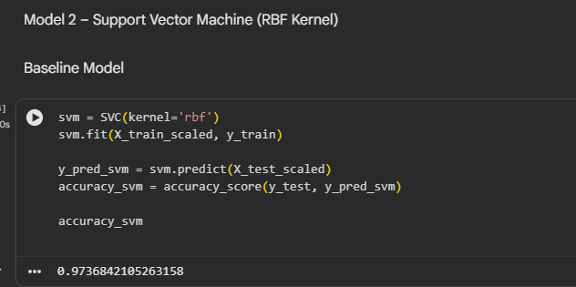
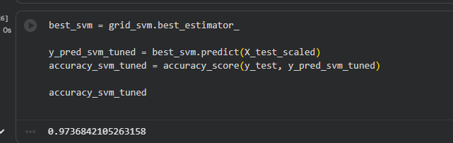
Support Vector Machines are effective methods of classification that attempt to identify an ideal decision boundary that maximises the gap between classes. Through kernel functions, the SVMs have the ability to model non-linear decision boundaries in high dimensional feature spaces. The SVM used in this task was a radial basis function (RBF) kernel since it is flexible and suitable when working with medical data (López, López and Crossa, 2022).
Scaling of features was also necessary before training, as the SVM performance is very sensitive despite feature magnitudes. The hyperparameters that were tuned were the regularisation parameter C and the kernel coefficient gamma. The tuned SVM obtained accuracy of about 96-97% which was slightly above the Logistic Regression. The confusion matrix presented almost perfect classification of benign cases and few false negative of malignant cases, which is also important in the healthcare implementation. Large recall, precision and F1-score suggest strong generalisation. These outcomes prove that SVMs are effective in learning complex patterns and that the selection of the kernels and parameter optimisation is significant.

5. Neural Network
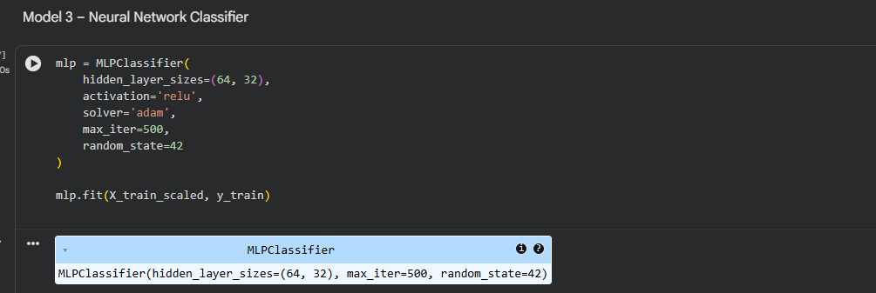
Neural Network classifier was introduced to continue the investigation on the non-linear learning properties. Neural networks are interconnected networks of neurons that are governed by the weighted connections and activation functions to learn complex representations of features. Here, an architecture based on Multi-Layer Perceptron (MLP) was employed, having an input layer, layers that are one or more hidden layers with an activation function of ReLU and finally an output layer with a sigmoid activation function at the output to perform binary classification (Tsingalis and Kotropoulos, 2025).
Before training, the feature scaling was done because neural networks are very sensitive to changes in features scale. The network has been trained through backpropagation and adaptive optimisation algorithms. Hyper parameters like the number of hidden neurons and number of maximum iterations were changed to enhance convergence and to avoid underfitting. The trained Neural Network attained the level of about 96% accuracy, and it works similarly to the SVM model. The confusion weakened the interpretation of the results since the benign cases were strongly classified and the recalls of the malignant cases were weakened, which is why it is important to tune the results to the lowest false negatives. Neural networks are highly predictive and hard to interpret as compared to traditional models, although they need to be carefully tuned.

6. Model Comparison & Improvement Discussion

The three models of classification were highly accurate and indicated that the dataset was appropriate in supervised learning. Logistic Regression came with high interpretability and good baseline scores. SVM marginally hovered over other models because it is capable of modeling non-linearities that are complex to model. The Neural Network obtained similar level of accuracy but scaling and tuning was necessary. Standardisation and hyperparameter optimisation led to better performance upon underlining the significance of preprocessing and validation in a classification task.

7. Conclusion
This classification exercise proved that machine learning methods are useful in forecasting the occurrence of breast cancer based on numerical tumour characteristics. The usefulness of Logistic Regression was its reliable and interpretable baseline whereas the Support Vector machines produced the best overall accuracy since it modeled non-linear relationships. The Neural Network was competitive but had to be tuned on parameters carefully and was incomprehensible. In general, the findings show consideration of feature scaling, model selection, and hyperparameter optimisation as critical in the creation of classification models in healthcare applications. The enhancement of performance and transparency could be investigated in future work by way of ensemble techniques or explainable AI.

8. References
López, O.A.M., López, A.M. and Crossa, J. (2022) 'Support Vector Machines and Support Vector Regression,' in Multivariate Statistical Machine Learning Methods for Genomic Prediction, pp. 337–378. https://doi.org/10.1007/978-3-030-89010-0_9.
Morr, C.E. et al. (2022) 'Data preprocessing,' in International series in management science/operations research/International series in operations research & management science, pp. 117–163. https://doi.org/10.1007/978-3-031-16990-8_4.
Schober, P. and Vetter, T.R. (2021) 'Logistic regression in medical research,' Anesthesia & Analgesia, 132(2), pp. 365–366. https://doi.org/10.1213/ane.0000000000005247.
Tsingalis, I. and Kotropoulos, C. (2025) 'On combining deep neural network classifiers for source device identification,' IEEE Access, 13, pp. 58425–58441. https://doi.org/10.1109/access.2025.3555141.

