TASK 1: Regression Analysis – Wine Quality Dataset
Submitted By
Student Name: Roshan Joshi
Student Number: 2402361

Table of Contents
1. Introduction & Dataset Description 1
2. Data Exploration & Visualisation 1
3. Multiple Linear Regression 3
4. Random Forest Regressor 4
5. Neural Network Regressor 5
6. Model Comparison & Improvement Discussion 6
7. Conclusion 7
8. References 7

1. Introduction & Dataset Description
Predictive modelling tasks such as regression with continuous target variables are common applications of methods of artificial intelligence and machine learning. This assignment is aimed at estimating the quality of wine based on the White Wine Quality data, where the target variable quality is a numerical score that is given on the basis of sensory evaluation. The data is made of the physicochemical properties, which include alcohol content, acidity, density and residual sugar. These characteristics have an effect on the quality of wine and are capable of being regressed. The aim of this assignment is to use and compare several regression models, such as Linear Regression, Random Forest Regressor and a Neural Network Regressor to compare their prediction abilities and determine the most convenient model.

2. Data Exploration & Visualisation
Primary data examination was done to learn the composition and nature of the data. There are no missing values and all the variables in the dataset are numbers, therefore, it can be used without a lot of data cleaning to perform regression modelling. To develop the range and distribution of each attribute analysed, the summary statistics were analysed and found that the scale of each of the attributes would differ, e.g. alcohol content and residual sugar (Patel et al., 2022).
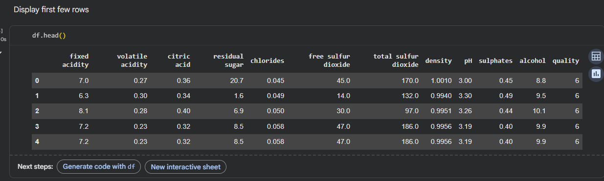
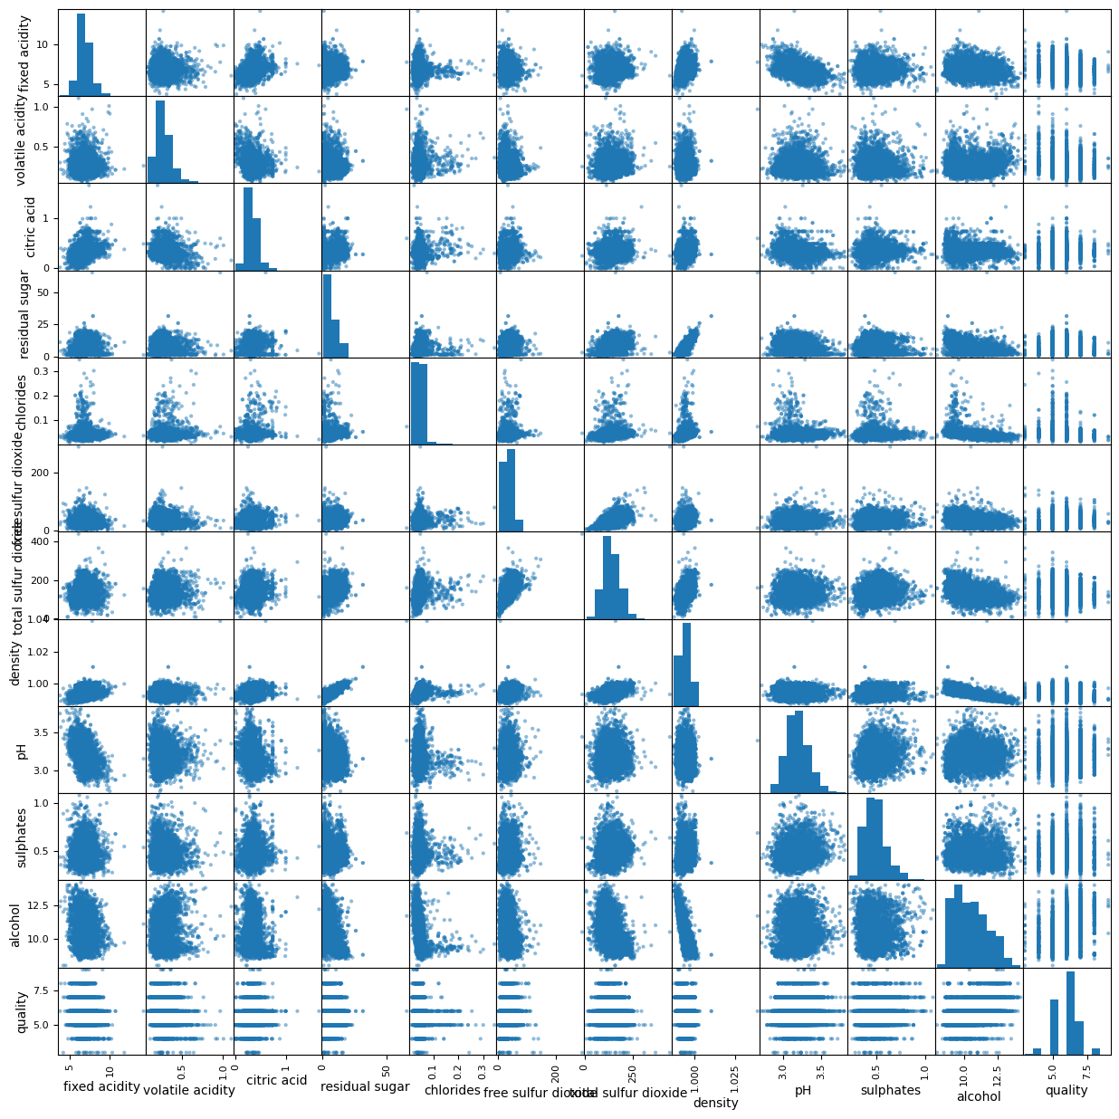
Scatter plot was employed to study the relationships among numerical variables and the target variable to identify possible linear and non-linear relationships. The correlation heatmap was created to determine the relationship between features and wine quality. The correlation between alcohol and quality was positive, but not as high and the correlation between density was negative. Also, importance features of alcohol, density and residual sugar were plotted using histogram to study their distributions. These illustrations facilitated the selection of the model during informed choices and rational realisation of utilisation of non-linear models due to enhanced performance.
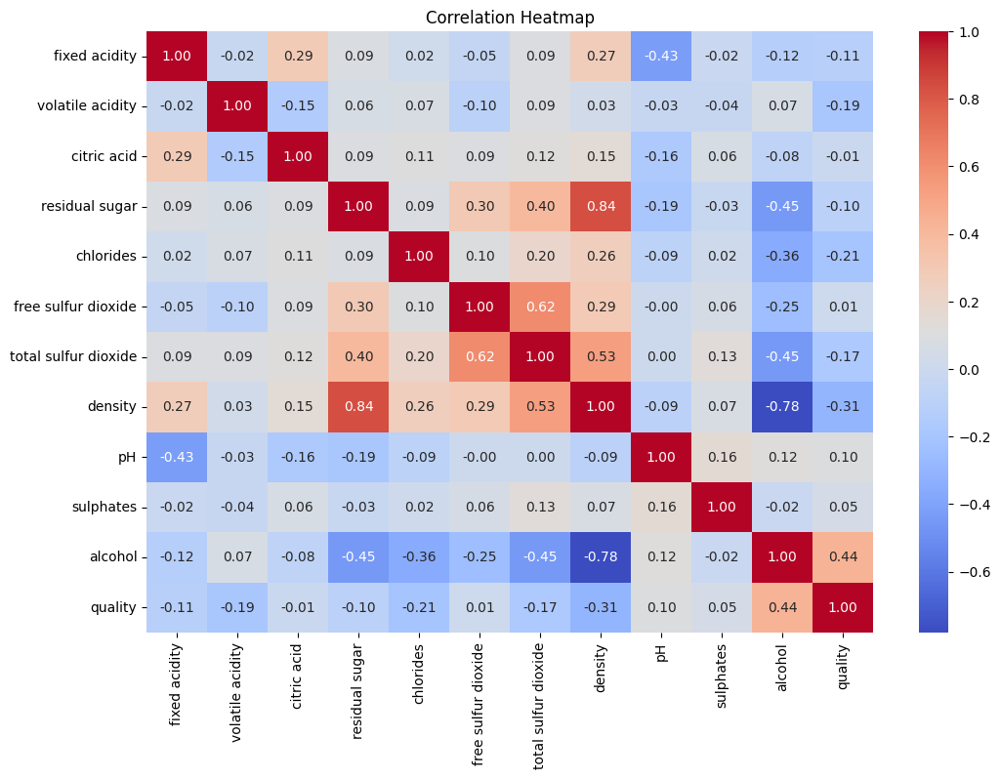

3. Multiple Linear Regression
A single portfolio Linear Regression was used as a control regression model to determine the initial predictive performance. The model makes the assumption of the linear relationship between the input and the target variable. It is easy, interpretable and computationally economical, which is a significant advantage since it can be used as a benchmark with more difficult models.
The model was trained on the training data and tested on the test data based on the R 2 and the root mean squared error (RMSE). The findings showed that Linear Regression only partially detected any underlying trends in data but it could not be used as an effective model of more complex relationships between features and quality of the wine. The low score of R² and the large RMSE imply that the model is constrained by the linear assumptions, which prevents its predictive ability. Nevertheless, Linear Regression assists in understanding the effect of features and can be used to give a good starting point in assessing the performance of more complex models (Hesamian et al., 2024).
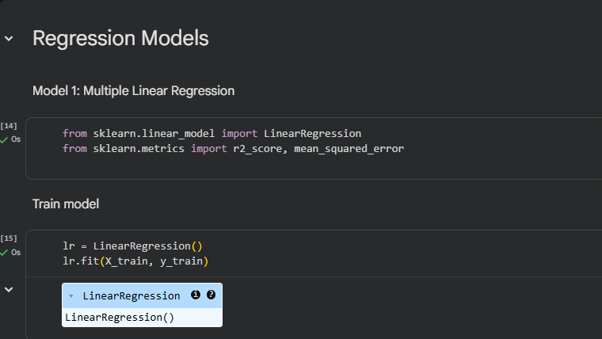

4. Random Forest Regressor
Random Forest Regressor was used to be able to get non-linear relations inside the data. Random Forest A random forest is an ensemble learning algorithm which is a collection of decision trees to reduce overfitting and enhance generalisation. This model does not assume linearity as compared to Linear Regression and is quite appropriate in tabular structured data (Zhou, Qiu and Zhang, 2023).
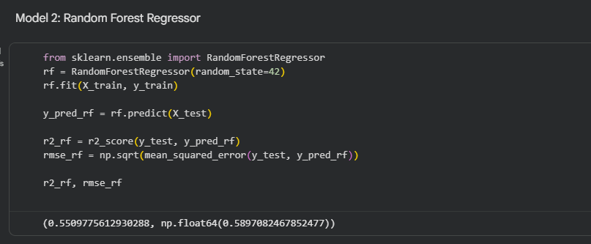
The first Random Forest was trained with the default settings and, even at that, it was already proven that its predictive performance has significantly increased in contrast to Linear Regression. Further performance improvement involved tuning was performed by varying the number of trees (n_estimators) and maximum depth of trees (max depth). The model performed better in tuning with a greater R 2 and smaller RMSE which represents better accuracy and less error in prediction. It indicates the usefulness of ensemble techniques in finding difficult features interactions and continues to show the significance of hyperparameter optimisation in regression settings.

5. Neural Network Regressor
A Neural Network Regressor was joined to create more in-depth research of non-linear modelling. Neural networks comprise a number of interlinked networks of neurons that are trained to identify intricate patterns with the assistance of weighted links and activation functions. StandardScaler was used in feature scaling before training because the neural networks can be sensitive to variations in the magnitude of features (Sirsant et al., 2024).
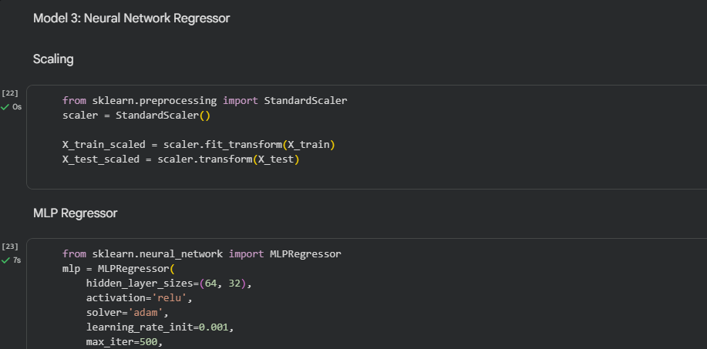
The model structure consisted of a layer of input, two layers of hidden with ReLU activation functions and a linear output layer which is applicable in regression. The network was trained with a set number of iterations and hyperparameters including the number of neurons and the learning rate were used to optimize the network. The Neural Network had competitive performance, and it performs better than Linear Regression but at similar levels to the tuned version of the Random Forest. Nevertheless, care needed to be taken when choosing parameters in case of overfitting. This marks the conflict between the complexity and interpretability of models in case of the neural networks.

6. Model Comparison & Improvement Discussion

Comparative analysis of three regression models reveals there are apparent disparities in predictive ability and modelling strength. Multiple Linear Regression was also a handy starting point but limited by the fact that it assumed that the relationships between there were linear, and thus, less accurate. The highest performance was determined by the Random Forest Regressor where it is capable of modeling complex and non-linear feature interactions and it is also strong against noises in the data. The hyperparameter tuning, especially the number of trees and the tree depth have led to performance improvements. The Neural Network also was seen to be excellent in prediction once feature scaling and architecture optimization, but it takes more computation and needed to adjust the parameters. All in all, the use of model optimisation and meaningful preprocessing were important in improving the accuracy of prediction.

7. Conclusion
The given regression analysis showed the usefulness of utilizing the various machine learning methods to the wine quality regression using the physicochemical properties. Linear Regression was easy to interpret and gave a point to compare, but there were linear assumptions and this restricted its performance. On the other hand, the performance of the Random Forest Regressor was even better, as it was able to capture non-linear relationships between variables in the data. The Neural Network provided competitive results though it had to feature scale and fine tune it to avoid overfitting. The findings reveal the significance of data visualisation, model selection and hyperparameter optimisation in regressions activities. Further work on future may include proposing developments in dendrites or feature engineering to enhance prediction accuracy further.

8. References
Hesamian, G. et al. (2024) 'A learning system-based soft multiple linear regression model,' Intelligent Systems With Applications, 22, p. 200378. https://doi.org/10.1016/j.iswa.2024.200378.
Patel, H. et al. (2022) 'Advances in exploratory data analysis, visualisation and quality for data centric AI systems,' Proceedings of the 28th ACM SIGKDD Conference on Knowledge Discovery and Data Mining, pp. 4814–4815. https://doi.org/10.1145/3534678.3542604.
Sirsant, S. et al. (2024) 'A hybrid convolutional neural network model coupled with AdaBoost regressor for flood mapping using geotagged flood photographs,' Natural Hazards, 121(5), pp. 5799–5819. https://doi.org/10.1007/s11069-024-07041-x.
Zhou, Z., Qiu, C. and Zhang, Y. (2023) 'A comparative analysis of linear regression, neural networks and random forest regression for predicting air ozone employing soft sensor models,' Scientific Reports, 13(1), p. 22420. https://doi.org/10.1038/s41598-023-49899-0.

