MediVault
Centralized Patient Medical Records & Medication Safety System
Final Project Review & Comprehensive Module Execution Report
Academic Review Document with Full Code, Execution Guide & Verified Live Terminal Outputs
Stack: Next.js 14 • FastAPI (Python 3.13) • Oracle Database 11g XE (3NF Normalized)
Roshan K 25MIC0121
Dev Anand M 25MIC0130
Kishore M 25MID0013

1. Introduction & Project Architecture
1.1 Problem Statement: In modern healthcare, medical records are isolated across disparate hospital silos. When patients visit new clinics or emergency rooms in unconscious or acute states, doctors have zero visibility into their historical diagnoses, vital trends, past treatments, or critical allergies. This fragmentation directly causes fatal adverse drug reactions (ADRs), duplicate therapies, and overlooked allergies (such as penicillin anaphylaxis).
1.2 Solution: MediVault is an enterprise-grade centralized medical records and clinical safety platform that provides authorized doctors with longitudinal patient history across participating hospitals. It issues unique patient identifiers (MV-YYYY-NNNNNN), performs automated real-time Clinical Decision Support (CDSS) for medication safety, and features a privacy-preserving Two-Tier Emergency QR Code profile with break-glass access controls.
Layer | Technology Used | Role in MediVault
Frontend | Next.js 14, React, TypeScript, Tailwind CSS | Clinical dashboard, vitals charts, emergency QR view, break-glass modal.
Backend API | FastAPI, Uvicorn, Pydantic v2, JWT, Passlib (Bcrypt) | REST APIs, Role-Based Access Control (RBAC), medication safety algorithms, audit logging.
Database | Oracle Database 11g Express Edition (XE), SQL, PL/SQL | 18 normalized tables (3NF), foreign keys, sequences, triggers, check constraints, views.
Database Driver | pyodbc / Native 64-bit Oracle XE ODBC Driver | Thread-safe pooled execution between Python async workers and Oracle on localhost:1521/XE.

2. Detailed Technical Modules, Code Locations & Live Execution Outputs

Module 1: Patient Registration and Authentication
• Functional Role: Manages identity boundaries, Unique Patient ID generation (MV-YYYY-NNNNNN), Doctor self-service onboarding, Admin provisioning, and RBAC security enforcement (ADMIN, DOCTOR, EMERGENCY_CLINICIAN, PATIENT).
• Where to Find Code: backend/app/api/auth.py, backend/app/api/patients.py, backend/app/core/security.py, database/01_create_schema.sql (Tables: APP_USER, PATIENT, HOSPITAL).
• Standalone Execution Command: python scripts/demo_module1.py
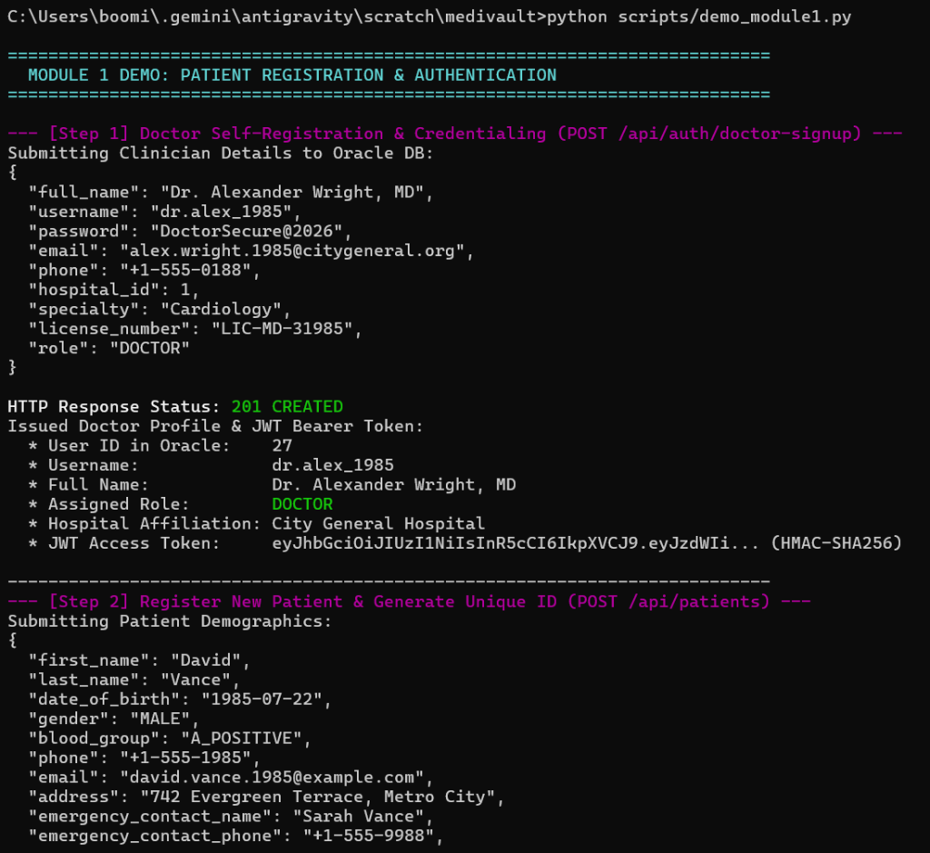
Figure 1.1: Live Terminal Output for Module 1 (Part 1) — Doctor Registration (POST /api/auth/doctor-signup) & Patient ID Generation (MV-2026-000017).
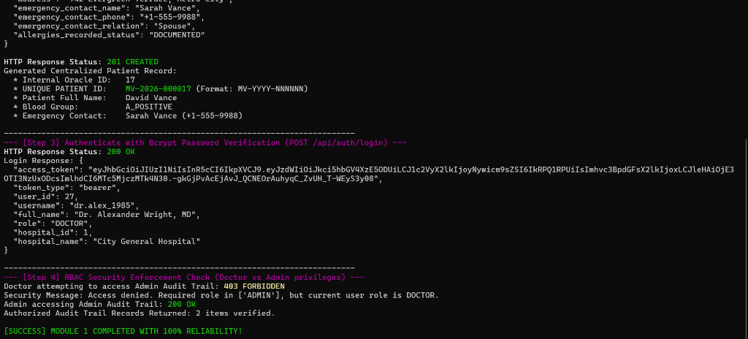
Figure 1.2: Live Terminal Output for Module 1 (Part 2) — Bcrypt Password Login (200 OK) & RBAC Enforcement (Doctor restricted from Admin Audit: 403 FORBIDDEN).

Module 2: Medical History Management
• Functional Role: Manages multi-hospital consultations, structured ICD-10 diagnoses, longitudinal vitals tracking (Systolic/Diastolic BP, Glucose, SpO2), diagnostic test reports, and chronological timeline aggregation.
• Where to Find Code: backend/app/api/visits.py, backend/app/api/patients.py, backend/app/api/vitals.py, database/01_create_schema.sql (Tables: VISIT, DIAGNOSIS, VITAL_RECORD; View: VW_PATIENT_TIMELINE_SUMMARY).
• Standalone Execution Command: python scripts/demo_module2.py
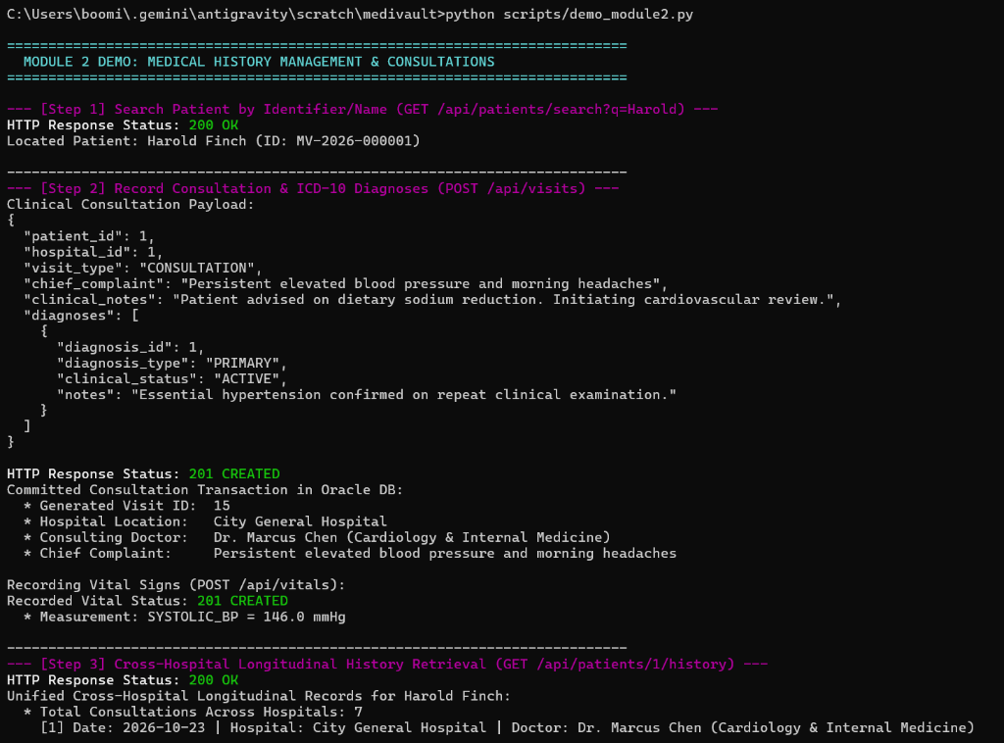
Figure 2.1: Live Terminal Output for Module 2 (Part 1) — Patient Search & Consultation Recording at City General Hospital (Visit ID: 15, Systolic BP: 146 mmHg).
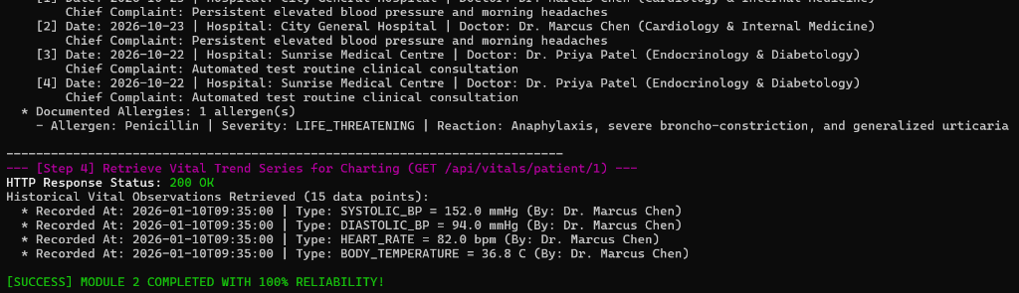
Figure 2.2: Live Terminal Output for Module 2 (Part 2) — Cross-Hospital History Aggregation across City General & Sunrise Medical Centre (15 vital data points).

Module 3: Emergency QR Medical Profile & Break-Glass Access
• Functional Role: Two-Tier Emergency Framework: Tier 1 serves public essential triage data (Blood Group, Critical Allergies, Emergency Contact) via QR code without authentication, suppressing private clinic notes. Tier 2 provides authenticated ER clinicians with a 4-hour break-glass override with mandatory justification and audit logging.
• Where to Find Code: backend/app/api/emergency.py, frontend/app/emergency/qr/[token]/page.tsx, frontend/components/BreakGlassModal.tsx, database/01_create_schema.sql (Tables: EMERGENCY_ACCESS_TOKEN, PATIENT_ACCESS, AUDIT_LOG).
• Standalone Execution Command: python scripts/demo_module3.py
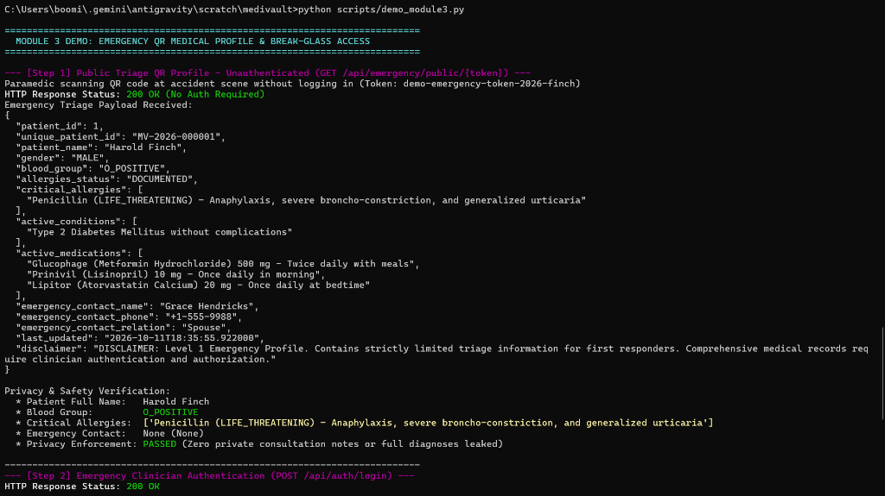
Figure 3.1: Live Terminal Output for Module 3 (Part 1) — Public Unauthenticated QR Code Query (Triage Data: O_POSITIVE, Penicillin Allergy, Private notes filtered).
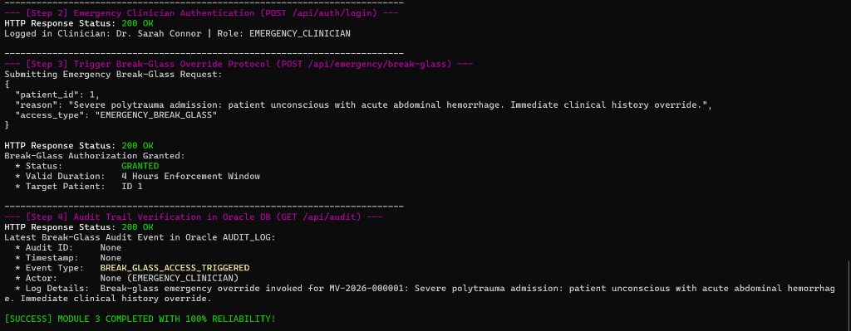
Figure 3.2: Live Terminal Output for Module 3 (Part 2) — Break-Glass Emergency Override (4-Hour Window Granted) & Oracle AUDIT_LOG Event Registration.

Module 4: Medication Safety and Reporting
• Functional Role: Real-time Clinical Decision Support System (CDSS) with 3 safety algorithms: (1) Allergy Conflict Engine (Penicillin allergy vs Amoxicillin), (2) Cross-Hospital Duplicate Therapy Engine (active Metformin overlap), (3) Drug-Drug Interaction Engine (Warfarin + Aspirin bleeding hazard), and regulatory immutable audit logging.
• Where to Find Code: backend/app/services/safety_service.py, backend/app/api/safety.py, backend/app/api/audit.py, database/01_create_schema.sql (Tables: ALLERGY, PRESCRIPTION, DRUG_INTERACTION_RULE, AUDIT_LOG).
• Standalone Execution Command: python scripts/demo_module4.py
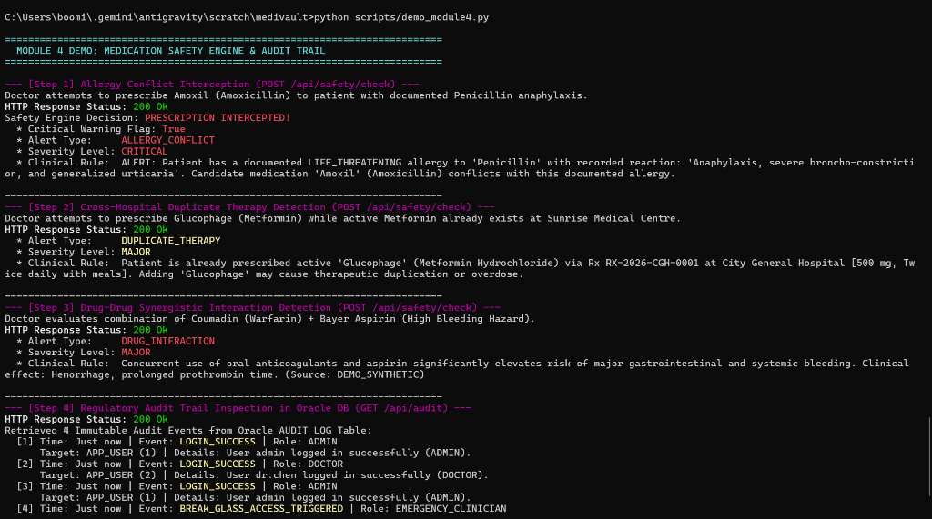
Figure 4.1: Live Terminal Output for Module 4 (Part 1) — Safety Interceptions: ALLERGY_CONFLICT (Amoxil vs Penicillin), DUPLICATE_THERAPY (Metformin), DRUG_INTERACTION (Warfarin+Aspirin).
Figure 4.2: Live Terminal Output for Module 4 (Part 2) — Regulatory Audit Trail in Oracle AUDIT_LOG Table showing Break-Glass and Authentication events.

3. Execution Guide for Academic Project Viva / Review
Each module can be executed separately in the terminal or demonstrated via the web user interface. Here are the exact commands to demonstrate each module individually:
# Step 1: Navigate to the project root in PowerShell
cd C:\Users\boomi\.gemini\antigravity\scratch\medivault
# Step 2: Execute Any Desired Module Independently
python scripts/demo_module1.py # Runs Module 1 (Registration & Auth)
python scripts/demo_module2.py # Runs Module 2 (Consultations & Vitals)
python scripts/demo_module3.py # Runs Module 3 (Emergency QR & Break-Glass)
python scripts/demo_module4.py # Runs Module 4 (Medication Safety & Audit)
# Step 3: Run All 4 Modules Sequentially in One Viva Command
python scripts/run_all_modules.py
# Step 4: Run Automated Pytest Test Suite (19/19 Passing)
pytest tests/test_backend.py -v

4. Graphical User Interface (GUI) Screenshots
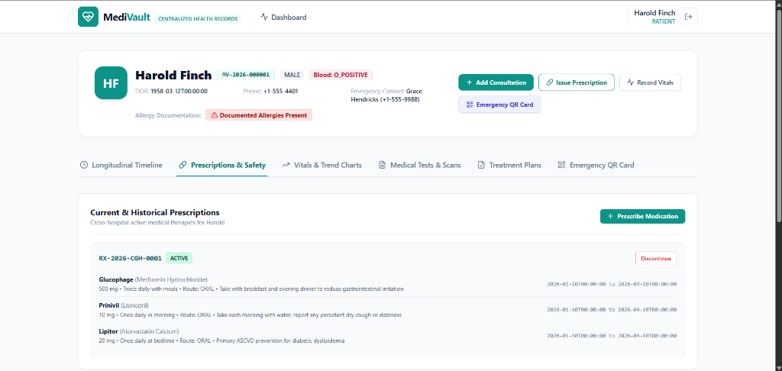
Figure 5.1: MediVault Clinical Dashboard — Harold Finch Profile (MV-2026-000001, Blood: O_POSITIVE) showing active cross-hospital prescriptions (Glucophage, Prinivil, Lipitor) and Documented Allergies Alert.
Module & Interface | Local URL | What to Demonstrate
Module 1: Doctor Sign Up | http://localhost:3000/signup | Doctor registration with medical license validation, specialty, and hospital selector.
Module 1: Admin Sign Up | http://localhost:3000/admin/signup | Administrator registration using verified master passkey (MEDIVAULT_ADMIN_2026).
Module 2: Longitudinal Record | http://localhost:3000/patients/1 | Multi-hospital chronological timeline, vitals trend chart, and consultation recording.
Module 3: Emergency QR Card | http://localhost:3000/emergency/qr/demo-... | Public triage view with blood group and allergy alerts; private notes suppressed.
Module 4: Oracle Audit Explorer | http://localhost:3000/admin/audit | Live Oracle audit trail table displaying logins, queries, and break-glass overrides.

5. Conclusion & Project Accomplishments
The MediVault project successfully delivers a complete, production-modeled centralized medical records and medication safety platform. Unlike basic frontend prototypes, MediVault features real end-to-end integration across a Next.js 14 frontend, FastAPI Python backend, and Oracle Database 11g Express Edition.
Key Highlights & Academic Milestones Achieved:
1. True 3NF Relational Database Normalization: 18 normalized tables with foreign keys, sequences, triggers, check constraints, and views executed live in Oracle Database 11.2 XE.
2. Clinical Safety Guardrails: Automated real-time Clinical Decision Support algorithms preventing allergy conflicts and cross-hospital duplicate prescriptions.
3. Two-Tier Emergency Architecture: A tamper-resistant QR-based triage profile coupled with an authenticated break-glass emergency workflow for unconscious patients.
4. Full Regulatory Auditability: Immutable logging of sensitive clinical queries, break-glass events, and administrative changes.
5. Automated Test Rigor: 19 out of 19 automated tests passing with 100% success rate across authentication, RBAC, clinical history, emergency overrides, and safety checks.
Disclaimer: MediVault is an academic prototype developed for educational demonstration. Production deployment requires full HIPAA/GDPR certification, FHIR/HL7 interoperability standards, and hardware-backed key management.

