Bagging, Boosting, Random Forest, Boot Strap, and other machine learning regressions via one Application.

To make machine learning operation easy for new students or any individual that wants to see the prediction outcome on his/her data.

This application will be a web based application, primary running on R Studio webpage.

1. This shiny application will give user the option to upload their data in text/csv', 'text/comma-separated-values', 'text/tab-separated-values', 'text/plain', '.csv' or '.tsv' format.

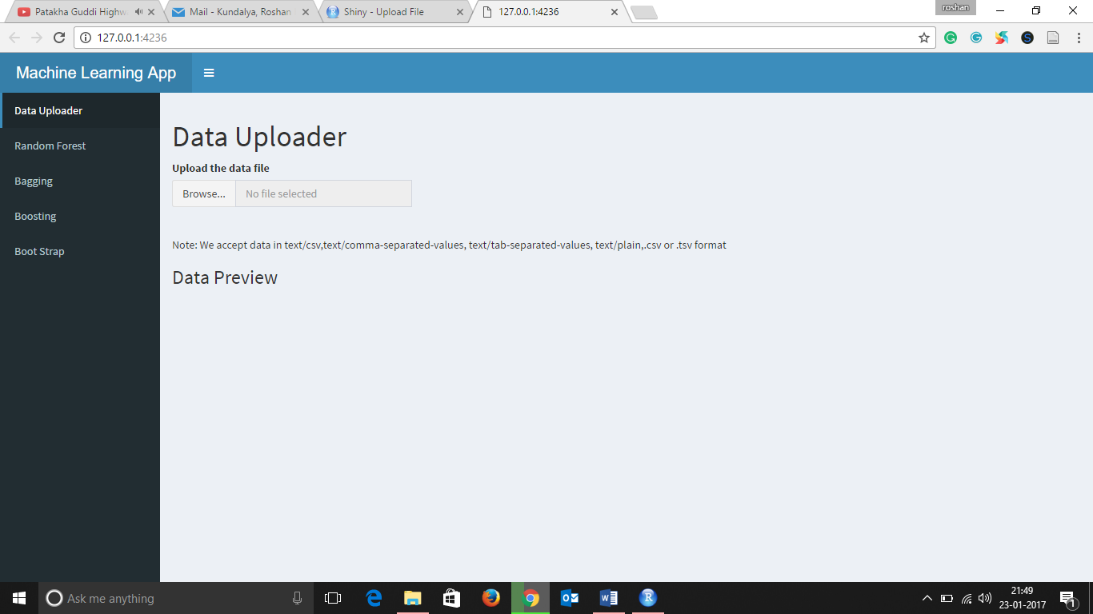

1. The application will further provide a preview of data as a table to ensure user that data is loaded accurately.

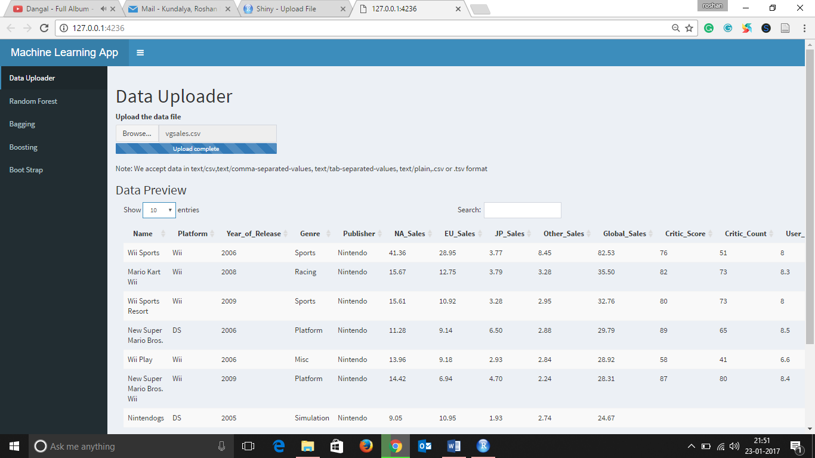

1. The user can then go to the tab based on type of machine learning technique (Boosting, Bagging, Random Forest, etc.) they want to apply on their data.

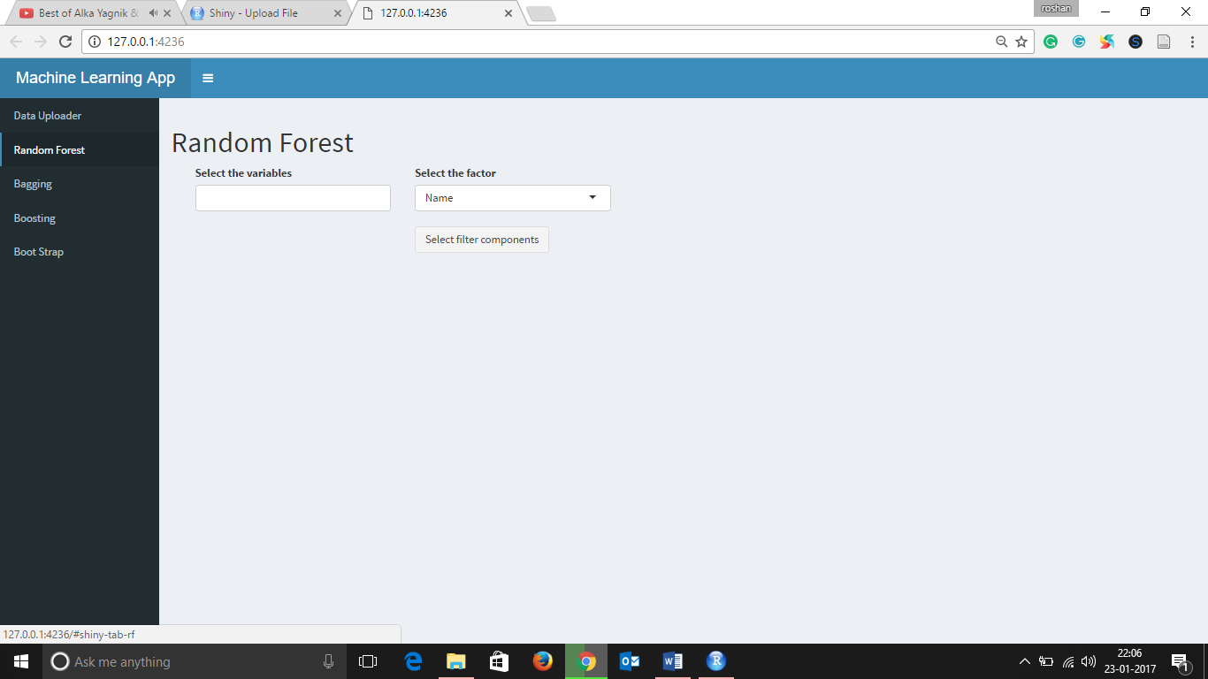

1. The user can then pick the variables from the multi selection drop down menu generated from the column names of the data.
2. The user will further pick the factor variable from the data.

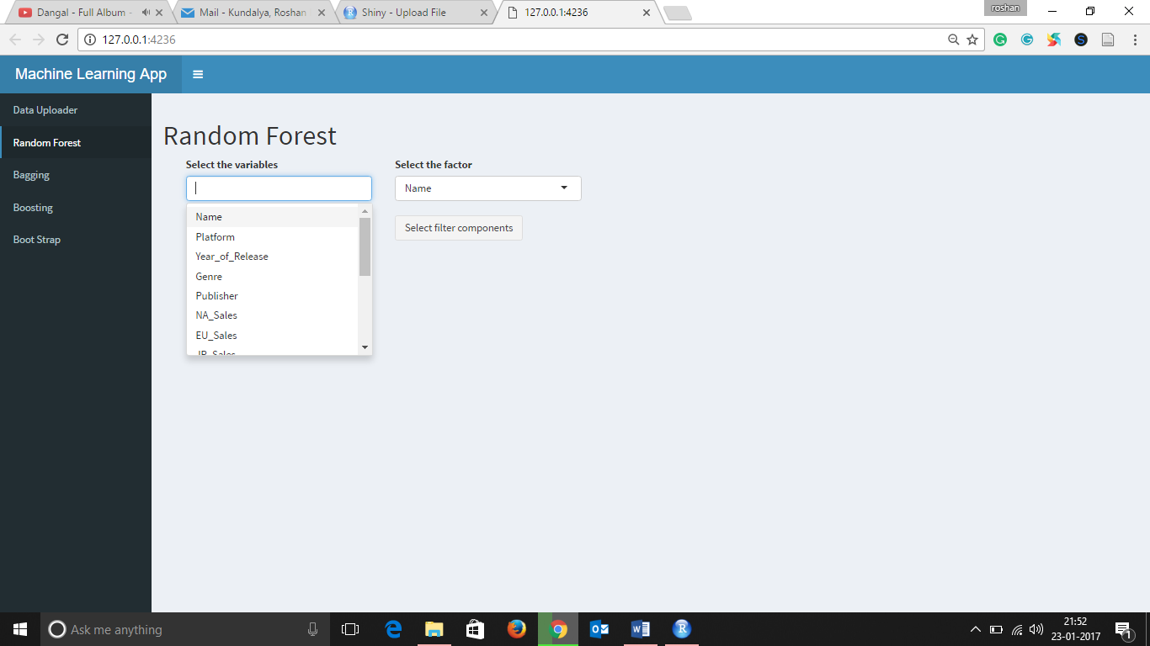

1. Once the variables and factor is selected, the user will get two drop down menus to pick any two-factor variable in case if the data has multiple factors to choose. Since most of the machine learning algorithm applies on to binary variable i.e. (0 or 1, “action” or “romance”).
2. Based on selected machine learning technique the user will also get option to modify the variables such as ntree.
3. Once the user click on “Apply Variables”, the prediction value will be displayed in the bottom of page.

