Css Notes

Selectors- they are used to select elements from the html
Ways to include css-
1)external css:
<link rel=”stylesheet” href=”path here ”>
2)internal css:
<style>
Color:red;
</style>
3)inline css:
<h1 style=”color:red”>this is a heading</h1>
Inline css has more precedence over external ones so preferred if both are applied in some element.

Color property:
Used to set the color of foreground. There are 2 frames in any webpage- foreground and the background.
Ex-
h1{
color:blue;
}
Text properties :=
Text-Align property:
Align the text left/right/center;
By default it is length
Works upon parent, changes alignment in relation with the parent.
Eg-if we have a para tag under a div, then div is a parent of the para
Text-align: center/left/right
TEXT-DECORATION
H1{
text-decoration: underline/overline/line-through
eg –
text-decoration:red wavy underline;
text-decoration-color:rgb(215, 84, 156); //hot pink color rgb code
what will be the final color here ?
it will be hotpink as it is applied later.
Set it to none if you want to remove underline in any element, like in anchor tags or links
Eg- a{
Text-decoration: none;
}
Font-weight:
Can also be set as lighter, light, bolder, bold.
Range from 100-900. And the lightest is 100 and highest value is 900.
Bold is set at – 400.
Eg – font-weight: 250 ;
Font – family: denotes the style of text or font of text.
Arial, roboto,
Tip – use inspect to figure out the css of any page, write css in element.style after selecting a style. These changes are temporary at reloads.
E.g.- font – family: Impact, Haettenschweiler, 'Arial Narrow Bold', sans-serif;
This is called fault back mechanism, basically if Impact font family is supported by a browser, it will be applied, if not then Haettenschweiler will be applied, then next and so on.
There are 2 types of font families-
Generic font families and specific
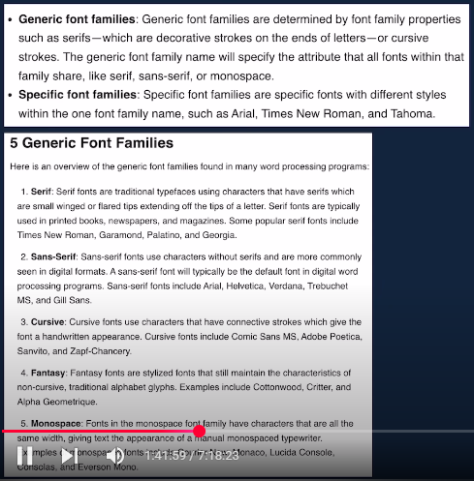

Units in css
Two types of measurement – absolute and relative units.
Absolute units
To measure size, in absolute units, few units that are used are – cm, inch, mm, but most common is pixels (px).
1inch = 2.54cm = 96px

E.g.= text-weight : 2px

Line Height
Sets the height of each line and is set in pixels like –
#one{
Line-height: 12px;
}
Default value is normal, so instead of px , can also write normal.

Text-transform
Text-transform: uppercase/lowercase/capitalize/none (invalidate all ).

Box Model:
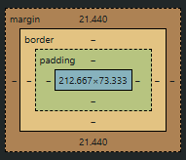

blue color is for our content and orang-ish color is for the outline box.
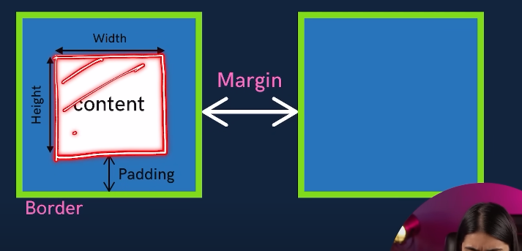

Height, padding, border, width, margin
height:
width:

border : can be set with border
padding: 50px // applies this padding on all 4 directions.

How to make 2 component come to the same line in css
Like -
While the above can be achieved by anchor tags solely, the theory behind them is
2 types of display elements are present in html –block (take 100%of the width ) and inline which take only the required amount
Block- div, h1,
Inline - button, span
We can change the property of a div tag to behave as a inline as follows –
Write – display : inline;
Similarly we can make inline elements behave as block –
button {
display : block;
}
Note: margin-top and margin-bottom, content width and height cannot be set for inline elements, for that we have inline-block. For that we can set everything-padding, margin, width, content-area.
Display:none – completely removes that element and no space is left for it
But , visibility: hidden – space is left but element is not shown .

Alpha channel
Defines the opacity of element.
Opacity between – [0 , 1]
- Zero opacity (no show)
- Full opacity,(dark)

