**TK3163-Compiler Construction**

**Sem 2 2022/2034, 2023**

**Name : Roshan Lau Jee Van**

**Matric No. : A189629**

**Major : Software Technology (ST)**

**Project : Lexical Analysis using JFlex.**

**Introduction**

This project is about creating a lexical analysis for a ruby language program using JFlex. Jflex is a lexical analysis generator which takes input requirement with a set of regular expressions and corresponding actions. It will then create a java file that can be use by the user to read other file for this case is ruby file.

**Code**

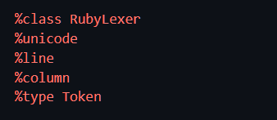

The code is initialized with the class name RubyLexer.

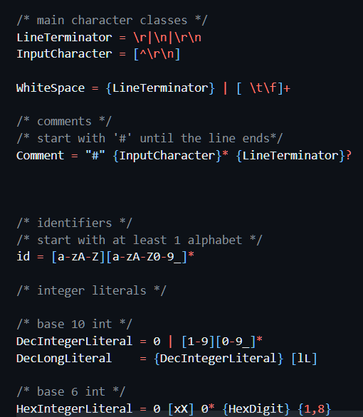

Some macroidentifier is declare in the code for easier management and readability of the code.

Eg: LineTerminator, InputCharacter, WhiteSpace, comment, id, and etc.

**Reference**

* <https://www.jflex.de/>
* <https://www.youtube.com/watch?v=IV1Rwq7ERR4>
* <https://jflex.de/manual.html>
* <https://www.jflex.de/docu.html>
* <https://github.com/jflex-de/jflex/blob/master/jflex/src/main/jflex/LexScan.flex>
* <https://docs.ruby-lang.org/en/3.0/syntax/methods_rdoc.html>