
Dear Customer,  Congratulation on your purchase of Heatout Ceilings. We did our best to ensure that our products fully meet your requirements and that the quality corresponds to the highest world standards.  We strongly recommend that you read this document thoroughly to ensure you are well-informed about the warranty coverage of your purchase.  Limitation of Warrantor's Liability  The Warrantor shall not be liable for physical defects or damage to the Product resulting from external factors that occurred after the Product was delivered to the Purchaser (the Warrantor recommends insuring the Product, subject to this Warranty, against the effects of external factors), particularly related to:  - Use of the Product contrary to its intended purpose or improper storage and transport prior to installation.  - Installation contrary to the Product installation and use manual.  - Use of accessories not provided for in the Product installation and use manual.  - Impact of foreign bodies that exceed the level specified in the Document mentioned in § 1(1).  - Fire, earthquake, flooding, lightning, strong wind, hail, abnormally high or low air temperatures, or other occurrences that may be classified as force majeure.  - Faults, defects, or other damage to the building or material where the Product is installed, caused in particular by movement, deformation, fractures, or subsidence of walls, materials, or foundations of the building.  - The Warrantor shall only be liable for defects resulting from reasons attributable to the Product. The Warrantor shall not be liable for discoloration that exceeds the range of allowable discolorations specified in the Product installation and use manual, or for other discoloration caused, most likely by air pollution (including by metal oxides or particles), mold, or exposure to harmful chemicals.  - This Warranty shall not apply to any Product covered by the Purchaser with any other improvised coating (e.g., paint, varnish, or plaster) or otherwise modified/changed. In the event the Product or any element thereof is replaced under this Warranty, where the Product installed by the Purchaser is no longer manufactured or has been modified by the Warrantor, the Warrantor may apply elements that are the closest equivalents (in terms of type) to the Product originally installed. | Obligations of the Warranty Holder  The Warranty Holder should notify the Warrantor of any detected physical defects of the Product immediately after detecting a defect that forms the basis for a claim under the Warranty.  - Any claims made under the Warranty shall be lodged with the Warrantor through the seller from whom the Product was purchased.  - A claim made under the Warranty should include: a description of the defect, the address of the Product installation site, the claimant's contact details (full name, address, phone number, email address - if applicable), and photographs proving the defect.  - A claim made under the Warranty may be considered if it is submitted together with this document bearing the stamp and signature of the seller (distributor) of the Product, including the name of the seller, as well as the place and date when the Product was sold.  - The Warrantor shall provide, by email or in writing, information on the manner of considering the claim no later than 14 days from the date when the Warrantor received the claim (if the information is provided in writing, the period shall be counted from the date of the postmark). The Warrantor stipulates that the consideration of the claim may require inspection of the Product on-site, which implies the Purchaser's obligation to make available the immovable property where the Product covered by this Warranty is installed. In such an event, the Warrantor shall contact the Purchaser promptly in order to set the date of inspection, and the above-mentioned period of 14 days shall be counted from the date when the inspection is completed. The inspection shall be performed by an authorized representative of the Warrantor. The Purchaser shall provide the Warrantor with all information and documents necessary for the proper preparation and performance of the inspection.  - Where the Purchaser's claim is deemed justified, the Warrantor shall perform its obligations specified in §1 hereof within 60 days from the date when the Purchaser was provided with the information on the manner of considering the claim, specified in sub-clause 5. At the same time, the Warrantor stipulates that, due to the specific nature of the manufacturing process, the aforementioned period of 60 days may be extended by the time necessary to produce and deliver the elements needed to replace the Product.  - All parts and elements of the Product replaced hereunder shall become the Warrantor's property upon the day they are replaced with other parts and elements.

This warranty shall be valid for period specified in document counted from the date when purchaser purchased the product stated in the warranty certificate or another document which makes the purchase possible with the stipulation that warned us liability shall be proportional to the period when the product was in use in accordance with this following rules
color warranty - 10 years (exterior color warranty - 5 years)
Years of use counted from the purchase date | Share of the Warrantor liability in % of the purchase price for the replaced product element and the cost of its installation / cost of repairing the product or an element thereof / price paid for the product which price is to be reimbursed
0-10 years | 100%
10-12 years | 50%
12-18 years | 40%
18-20 years | 30%
20-21 years | 20%
21-25 years | 10%

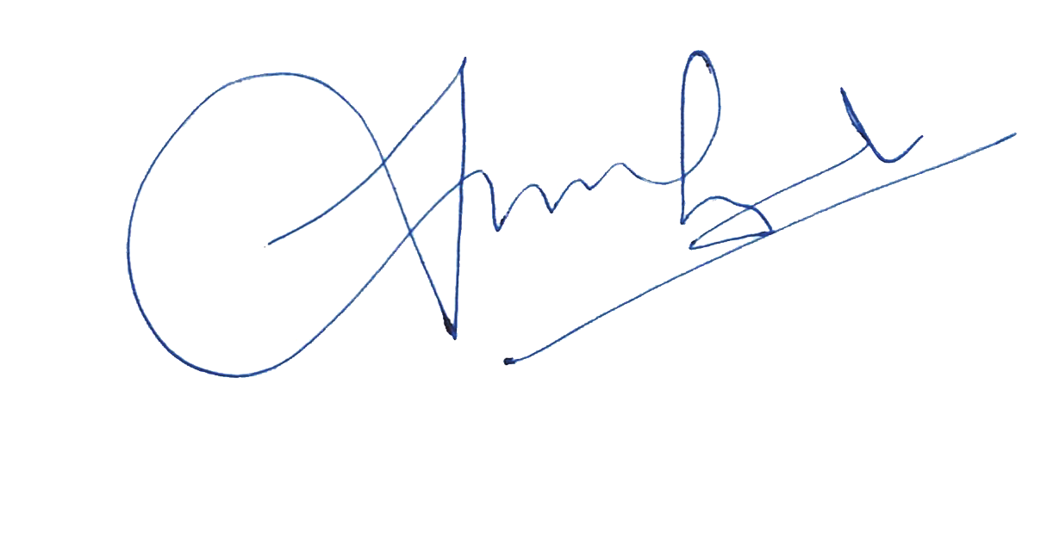

Address: Salim P P , "Mannat" Near Federal Bank, Walkway Mahe , 9633707686 , Pin 673310
The name of the sold products (complete, including color) veeti
Date: 23/5/2026

Seller's Name & Signature RAMSHAD


Dear Customer,  Congratulation on your purchase of NJ Laminated shingle. We did our best to ensure that our products fully meet your requirements and that the quality corresponds to the highest world standards.  We strongly recommend that you read this document thoroughly to ensure you are well-informed about the warranty coverage of your purchase.  1. Product Information:  The purpose of the product: The roofing piece material NJ Laminated is intended for use on pitched roofs of buildings and constructions with a roof slope from 12 to 90 degrees. Products are manufactured as individual sheets of shingles and supplied in bundles.  2. The quality of products and their safety are confirmed by:  • Certificate of conformity GOST R  • Certificate of Fire Safety  • Declaration of Performance (DoP) Certificate  3. Warranty terms and conditions:  The warranty period is calculated from the moment the product was sold, the date of which is indicated in the warranty certificate. If the date of sale is impossible to establish, the warranty period is calculated from the date of manufacture. The defects that could be detected before the installation work are not subject to compensation.  4. The warranty is valid under all of the following conditions:  - 10 Year service Warranty  - Fully completed warranty certificate, including the STAMP of the trading organization and the buyer's signature.  - The products were used for the purpose that corresponds to their intended purpose.  - Products were mounted only with the use of original components: starter/ridge, valley membrane; mastics; underlayment used on the entire surface of the roof.  - The products were used in full compliance with the manufacturer NJ Laminated Installation manual, Which was valid at the time of installation. | 5. The warranty does not apply to products:  • Damaged because of force major circumstances, including a hurricane, lightning, earthquake, etc.  • Installed in violation of the NJ Laminated Manual  • Damaged because of violation of the rules of storage and operation, which are specified in the producer installation manual.  • Damaged because of deformations resulting from the natural shrinkage of buildings or structures, as well as errors made during construction, warranty not available for installation mistake  The Manufacturer guarantees to the final buyer:  • Conformity of products to EN 544:2011(GOST 32806-2014) Asphalt Shingles standard  • Compliance with fire safety standards  • Water - resistance subject to fulfillment of part 4 of this warranty certificate.  • Color stability*  *Color stability - Even color change caused by the influence of climatic factors. If the material, which is to be replaced at the time of the claim has been changed in color or discontinued, will be replaced by the manufacturer with the similar one  •Company Name: NJ INDIA Trading Pvt. Ltd.  •Address: Bypass Road, Ramanattukara  •Seal & Sign:  

Warranty Period
Series | Duration, Years

Address:
Product Name & Color:
Date: | Trading Organization: NOUFAL & JABBAR INTERNATIONAL LLP
Seller's Name & Signature


Dear Customer,  Congratulation on your purchase of NJ Stone Coated Roof Tiles. We did our best to ensure that our products fully meet your requirements and that the quality corresponds to the highest world standards.  We strongly recommend that you read this document thoroughly to ensure you are well-informed about the warranty coverage of your purchase.  NJ India Specifically Warrants  - 10 Year Service Warranty  - 1) The product will maintain its surface coating Appearance Except for normal weather (Normal weather may include minor granule loss or minor fading)  - 2) The product will withstand winds of upto 120 mph  - 3) The product will not wrap, lift or curl when installed in accordance with the applicable local code and NJ India's installation standards and instructions found at www.njindia.in  - 4) The product will not be penetrated by hailstones less than 2 and half inches diameter  Remedy  If any product is found to exhibit the specified defects covered under this warranty, NJ India shall, at its option, only repair or maintain the product, and NJ India's liability shall be limited.  - 1) For the first 10 years of the warranty period, NJ India will furnish servicing products for each defective product and the reasonable cost of labour for the damaged defective products. The product is covered by a ten-years warranty on surface granule retention  - 2) For years 11 through 50 of the warranty period, NJ India will furnish replacement. NJ India reserves the right to remove or have removed sufficient undamaged products for examination before providing any replacement product or reimbursement. Fifty-years warranty against corrosion and rust perforation, subject to standard terms and conditions. | Registration & Transfer:  This warranty automatically transfers to any subsequent owners of the property during the term of the warranty. But the sale or transfer of the property does not obviate any of the terms or conditions set out here in order to obtain or maintain warranty coverage.  Specific Exclusions: This warranty does not cover  Damage to products occurs during installation or by improper installation, including but not limited to failure to install in accordance with appropriate local building codes and acceptable trade practises in the specified area and failure to follow NJ India's instructions.  - 1) Damage to the products caused by roof traffic or foreign objects falling onto the roof.  - 2) Damage to products or property caused by hurricanes or tornadoes with wind speeds in excess of 120 mph, or damage costs to products. Frontal debris contact resulting from hurricane or tornado force wind  - 3) Damage to products caused by other acts of God, such as climate-specific conditions. Including, but not limited to, mould, mildew, or other growth  - 4) Damage to products caused by any failure or movement of any structural elements of the property. Colour fading, colour changes, or variations of the colour hue due to physical deterioration of the colour for any reason, including but not limited to weathering, oxidation, colour pollutants, air pollutants, or improper cleaning. Warranty not available for installation mistake  THE FOREGOING IS THE ENTIRE EXPRESS LIMITED PRODUCT WARRANTY OF NJ INDIA FOR THE PRODUCTS. NJ AND INDIA HEREBY DISCLAIM ALL OTHER EXPRESS IMPLIED AND STATUTORY WARRANTIES ALLOWABLE BY LAW FOR THE PRODUCTS, INCLUDING THE IMPLIED WARRANTIES OF MERCHANTABILITY AND FITNESS FOR A PARTICULAR PURPOSE. LIMITATIONS ON LIABILITY NJ AND INDIA SHALL NOT BE LIABLE UNDER ANY CIRCUMSTANCES FOR INDIRECT, INCIDENTAL, OR CONSEQUENTIAL DAMAGES.  Claims under this warranty will be honoured only if the following conditions are met: Proof of purchase is provided to NJ India, which is notified 30 days after the facts on which the claim is based became known, and NJ India has the opportunity to investigate and approve the claim.  

Address:
The name of the sold products (complete, including color)
Date: | Trading Organization: NOUFAL & JABBAR INTERNATIONAL LLP
Seller's Name & Signature


Dear Customer,  Congratulation on your purchase of Docke PIE Bitumen Shingle. We did our best to ensure that our products fully meet your requirements and that the quality corresponds to the highest world standards.  We strongly recommend that you read this document thoroughly to ensure you are well-informed about the warranty coverage of your purchase.  Manufacturer: OOO'DHS"INN (Taxpayer Identification Number) 7713741050  Location: 601021, Russia, Vladimir Region, Kirzhachsky District, Fedorovskoe Village, Selskya Street, 51/1  1. Product Information:  The purpose of the product: The roofing piece material Bitumen Shingles DOcke PIE is intended for use on pitched roofs of buildings and constructions with a roof slope from 12 to 90 degrees. Products are manufactured as individual sheets of shingles and supplied in bundles.  2. The quality of products and their safety are confirmed by:  • Certificate of conformity GOST R  • Certificate of Fire Safety  • Declaration of Performance (DoP) Certificate  3. Warranty terms and conditions:  - 10 Year Service Warranty  The warranty period is calculated from the moment the product was sold, the date of which is indicated in the warranty certificate. If the date of sale is impossible to establish, the warranty period is calculated from the date of manufacture. The defects that could be detected before the installation work are not subject to compensation.  4. The warranty is valid under all of the following conditions:  - Fully completed warranty certificate, including the STAMP of the trading organization and the buyer's signature.  - The products were used for the purpose that corresponds to their intended purpose.  - Products were mounted only with the use of original components: starter/ridge, valley membrane; mastics; underlayment used on the entire surface of the roof.  - The products were used in full compliance with the manufacturer Docke PIE Installation manual, Which was valid at the time of installation. Warranty not available for installation mistake | 5. The warranty does not apply to products:  • Damaged because of force major circumstances, including a hurricane, lightning, earthquake, etc.  • Installed in violation of the Docke PIE Manual  • Damaged because of violation of the rules of storage and operation, which are specified in the producer installation manual.  • Damaged because of deformations resulting from the natural shrinkage of buildings or structures, as well as errors made during construction  The Manufacturer guarantees to the final buyer:  • Conformity of products to EN 544:2011(GOST 32806-2014) Asphalt Shingles standard  • Compliance with fire safety standards  • Water - resistance subject to fulfillment of part 4 of this warranty certificate.  • Color stability*  *Color stability - Even color change caused by the influence of climatic factors. If the material, which is to be replaced at the time of the claim has been changed in color or discontinued, will be replaced by the manufacturer with the similar one  •Company Name: NJ INDIA Trading Pvt. Ltd.  •Address: Bypass Road, Ramanattukara  •Seal & Sign:  

Warranty Period
Series | Duration, Years

Address:
Product Name & Color: | Batch Number:
Date: | Trading Organization: NOUFAL & JABBAR INTERNATIONAL LLP
Seller's Name & Signature


Dear Customer,  Congratulation on your purchase of NJ premium ceramic roof tiles. We did our best to ensure that our products fully meet your requirements and that the quality corresponds to the highest world standards.  We strongly recommend that you read this document thoroughly to ensure you are well-informed about the warranty coverage of your purchase  Company Details : NJ  Company Name : NJ INDIA  Address : KNH Building, Near Neelithod Bridge,  NH66 Service Road, Ramanattukara,  Calicut - Kerala 673633  Certificate : ISO 9001 : 2015  ISO 14001 : 2015 :, CE | The warranty does not apply to products:  • Damaged because of force major circumstances, including a hurricane, lightning, earthquake, etc.  • Installed in violation of the Ceramic tile installation manual  • Damaged because of violation of the rules of storage and operation, which are specified in the producer installation manual.  • Damaged because of deformations resulting from the natural shrinkage of buildings or structures, as well as errors made during construction warranty not available for installation mistake  The Manufacturer guarantees to the final buyer:  • Compliance with fire safety standards  • Water - resistance subject to fulfillment of part 4 of this warranty certificate.  • Color stability*  *Color stability - Even color change caused by the influence of climatic factors. If the material, which is to be replaced at the time of the claim has been changed in color or discontinued, will be replaced by the manufacturer with the similar one

Warranty Period :
Series | Duration, Years

Address:_____________________________________________
The name of the sold products (complete, including color)
Batch Number (see on the packaging)
Trading Organization: NOUFAL & JABBAR INTERNATIONAL LLP
Seller's Name & Signature


Date: 20/19/2025

