PROJECT REPORT
Customer Shopping Behavior Analysis
A Data Analytics Project using Python, SQL, and Power BI
Uncovering customer purchasing patterns, segments, and revenue drivers from 3,900 transaction records to support data-driven business decisions.
Tools Used | Python, SQL, Power BI, Excel
Dataset Size | 3,900 records | 18 columns
Date | August 2026

1. Introduction
In today's competitive retail environment, understanding customer purchasing behavior is essential for driving revenue growth, improving customer retention, and designing effective marketing strategies. This project presents an end-to-end data analytics workflow — from raw data cleaning in Python, to advanced querying in SQL, to interactive visualization in Power BI — applied to a real-world customer shopping behavior dataset.
The dataset consists of 3,900 individual purchase transactions capturing customer demographics, product categories, purchase amounts, discounts, shipping preferences, subscription status, and review ratings. The goal of this analysis is to identify spending patterns, segment customers meaningfully, and translate these findings into actionable business recommendations.

1.1 Objective
- Clean and prepare raw transactional data for analysis using Python (Pandas).
- Answer key business questions using SQL queries on a PostgreSQL database.
- Build an interactive Power BI dashboard to visualize customer behavior.
- Segment customers and identify high-value groups and revenue drivers.
- Provide data-backed business recommendations.

1.2 Tools & Technologies
Category | Tools Used
Programming | Python (Pandas, NumPy)
Database | PostgreSQL, SQL (Joins, CTEs, Window Functions, Aggregations)
Visualization | Power BI, Excel
Environment | Jupyter Notebook, pgAdmin

2. Dataset Overview
The dataset contains 3,900 transaction-level records with 18 attributes describing customer demographics and purchase behavior. It includes fields such as Age, Gender, Item Purchased, Category, Purchase Amount, Location, Review Rating, Subscription Status, Shipping Type, Discount Applied, Previous Purchases, Payment Method, and Frequency of Purchases.
3,900  Transactions | 18  Columns | 37  Missing Values (Review Rating) | 50  Unique Locations

2.1 Key Features
- Demographics: Age, Gender, Location
- Purchase details: Item Purchased, Category, Purchase Amount, Payment Method
- Engagement: Subscription Status, Previous Purchases, Frequency of Purchases
- Experience: Review Rating, Shipping Type, Discount Applied, Promo Code Used

3. Data Preparation in Python
The raw dataset was loaded and cleaned using Python's Pandas library inside a Jupyter Notebook. The data preparation workflow followed four main stages: loading & exploring the data, cleaning & standardizing it, engineering new features, and finally exporting the cleaned dataset into a PostgreSQL database for SQL analysis.

3.1 Load & Explore
The dataset was imported using pandas.read_csv() and explored using df.head(), df.info(), and df.describe() to understand structure, data types, and summary statistics.
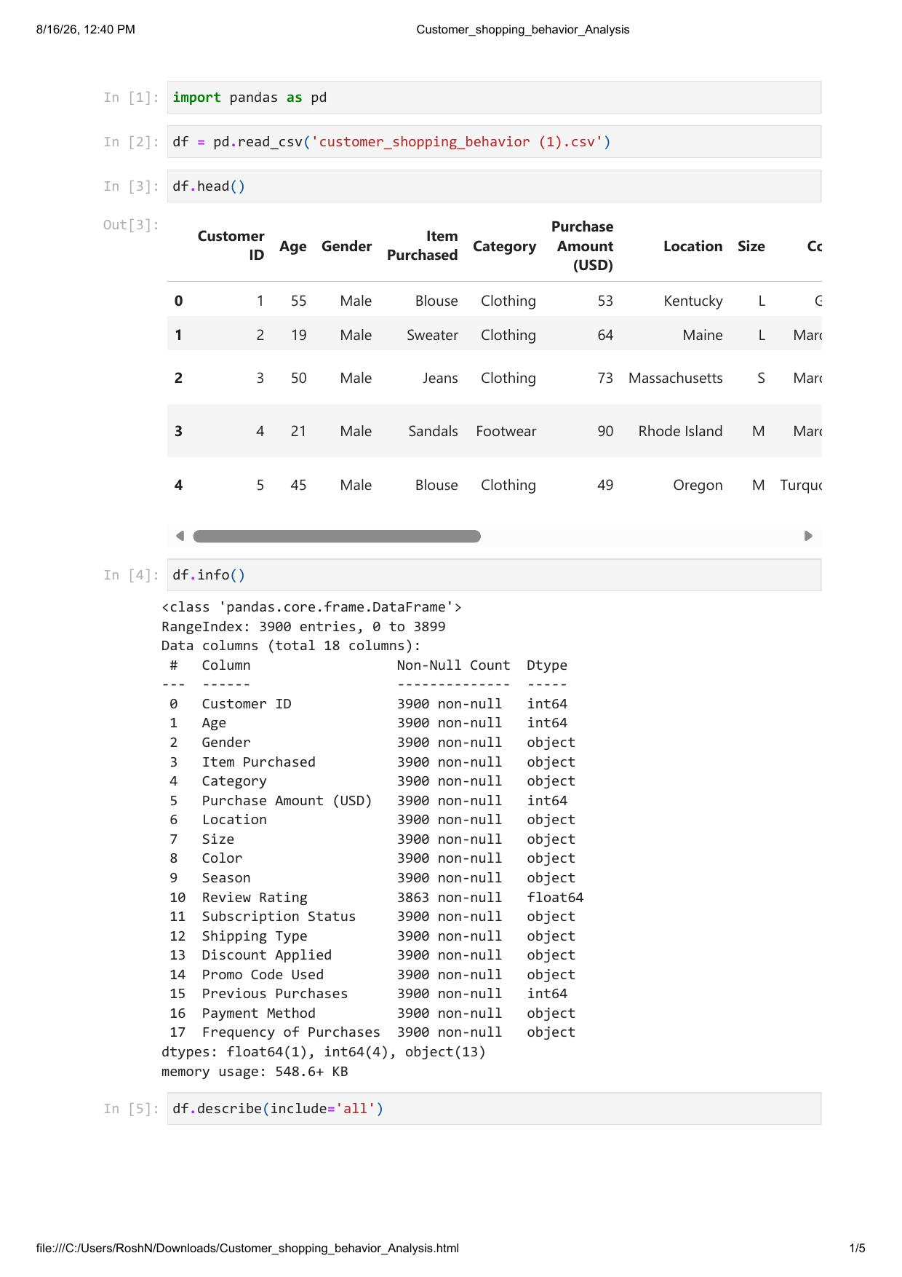
Fig 3.1 — Jupyter Notebook: Loading the dataset and inspecting structure with df.info() and df.describe()

3.2 Clean & Standardize
The Review Rating column had 37 missing values. These were imputed using the median rating within each product category, preserving category-level rating patterns rather than skewing the overall distribution. Column names were also standardized to lowercase snake_case for consistency (e.g., 'Purchase Amount (USD)' → 'purchase_amount').

3.3 Feature Engineering
- age_group — customers segmented into Young Adult, Adult, Middle-aged, and Senior using quartile-based binning (pd.qcut).
- purchase_frequency_days — the categorical 'Frequency of Purchases' field (Weekly, Monthly, Annually, etc.) was mapped to a numeric day-count for trend analysis.
- Dropped the redundant 'promo_code_used' column after confirming it was identical to 'discount_applied' in every row.
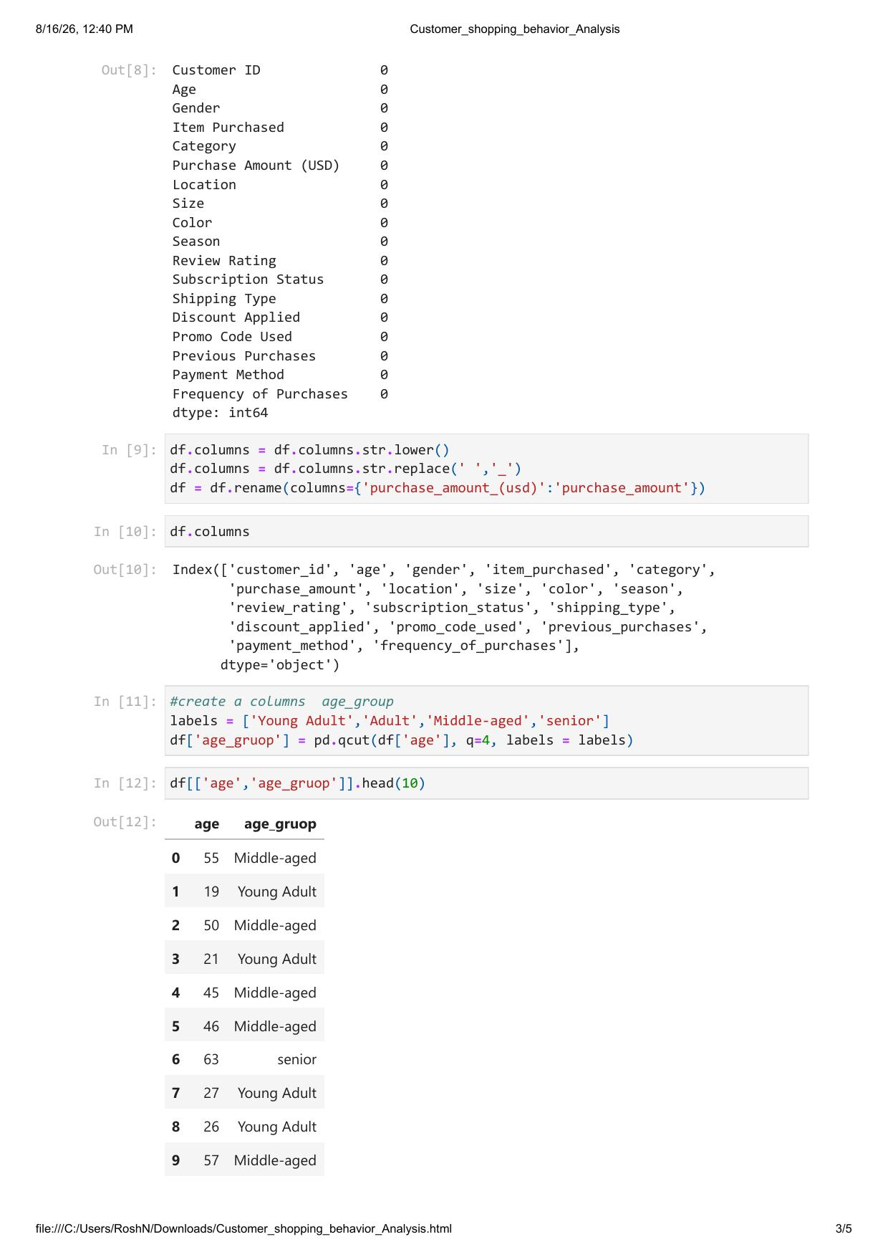
Fig 3.2 — Jupyter Notebook: Cleaning column names and engineering the age_group feature

3.4 Loading Cleaned Data into PostgreSQL
Once cleaned, the DataFrame was exported directly into a PostgreSQL database using SQLAlchemy's create_engine and df.to_sql(), making it available for SQL-based analysis.
import pandas as pd
from sqlalchemy import create_engine

# Connect to PostgreSQL
engine = create_engine(
f"postgresql+psycopg2://{username}:{password}@{host}:{port}/{database}"
)

# Load cleaned DataFrame into PostgreSQL
table_name = "customer"
df.to_sql(table_name, engine, if_exists="replace", index=False)

print(f"Data successfully loaded into table '{table_name}'")
Fig 3.3 — Python script used to load the cleaned dataset into PostgreSQL

4. SQL Analysis
With the cleaned data loaded into PostgreSQL, a series of SQL queries were written to answer specific business questions — ranging from revenue breakdowns to customer segmentation using CTEs and window functions. Selected queries are shown below.

4.1 Revenue by Gender
SELECT gender, SUM(purchase_amount) AS revenue
FROM customer
GROUP BY gender;

4.2 High Spenders Who Used Discounts
SELECT customer_id, purchase_amount
FROM customer
WHERE discount_applied = 'Yes'
AND purchase_amount >= (SELECT AVG(purchase_amount) FROM customer);

4.3 Customer Segmentation (New / Returning / Loyal)
WITH customer_type AS (
SELECT customer_id, previous_purchases,
CASE
WHEN previous_purchases = 1 THEN 'NEW'
WHEN previous_purchases BETWEEN 2 AND 10 THEN 'returning'
ELSE 'Loyal'
END AS customer_segment
FROM customer
)
SELECT customer_segment, COUNT(*) AS number_of_customers
FROM customer_type
GROUP BY customer_segment;

4.4 Top 3 Products per Category (Window Function)
WITH item_counts AS (
SELECT category, item_purchased,
COUNT(customer_id) AS total_orders,
ROW_NUMBER() OVER (
PARTITION BY category ORDER BY COUNT(customer_id) DESC
) AS item_rank
FROM customer
GROUP BY category, item_purchased
)
SELECT item_rank, category, item_purchased, total_orders
FROM item_counts
WHERE item_rank <= 3;

4.5 Subscribers vs Non-Subscribers
SELECT subscription_status,
COUNT(customer_id) AS total_customers,
ROUND(AVG(purchase_amount),2) AS avg_spend,
ROUND(SUM(purchase_amount),2) AS total_revenue
FROM customer
GROUP BY subscription_status;
Additional queries covered average purchase amount by shipping type, top 5 highest-rated products, top 5 most-discounted products, revenue contribution by age group, and the relationship between repeat purchases and subscription status. The full query set is included in the supporting SQL file.

5. Power BI Dashboard
An interactive Power BI dashboard was built on top of the cleaned dataset to allow dynamic, filterable exploration of customer behavior. The dashboard includes KPI cards, category and age-group breakdowns, and subscription status distribution, with slicers for Gender, Category, Subscription Status, and Shipping Type.
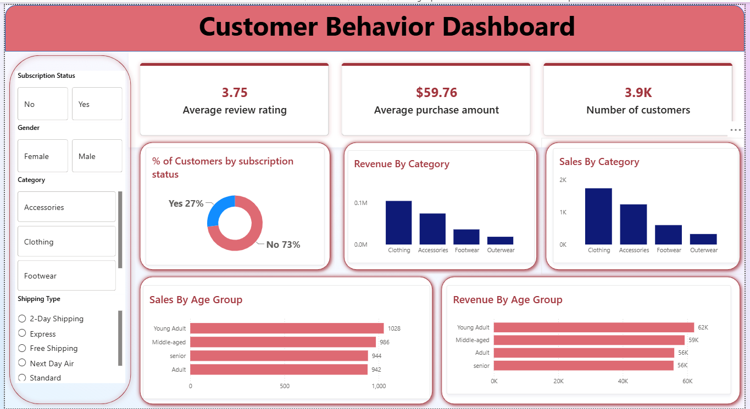
Fig 5.1 — Customer Behavior Dashboard built in Power BI

5.1 Dashboard Highlights
- 3.9K customers analyzed with an average purchase amount of $59.76 and average review rating of 3.75.
- Clothing is the dominant category, contributing the highest revenue and sales volume.
- Only 27% of customers are subscribed, shown clearly via the donut chart.
- Young Adults lead in both sales volume (1,028 orders) and revenue ($62K) across age groups.
- Fully interactive filters allow drill-down by Subscription Status, Gender, Category, and Shipping Type.

6. Key Findings & Insights

6.1 Revenue by Gender
Male customers generated 2.1× more revenue than female customers ($157,890 vs $75,191), driven primarily by purchase volume (2,652 vs 1,248 transactions) rather than higher spend per transaction.

6.2 Discount Behavior
- 839 customers used a discount while still spending above the average purchase amount — showing discounts do not always indicate price-sensitive, low-value customers.
- Hat (50%), Sneakers (49.7%), and Coat (49.1%) have the highest discount application rates among all products.
- Express shipping customers spend marginally more on average ($60.48) than Standard shipping customers ($58.46).

6.3 Subscription Gap
Only 27% of customers (1,053) are subscribed, yet average spend between subscribers and non-subscribers is nearly identical ($59.87 vs $59.49). Notably, 958 repeat buyers with more than 5 previous purchases are NOT subscribed — representing a significant conversion opportunity.

6.4 Customer Segmentation
Customers were segmented into three tiers based on purchase history:
Segment | Count & Share
Loyal (>10 purchases) | 3,116 customers — 80% of the customer base
Returning (2–10 purchases) | 701 customers — 18% of the customer base
New (1 purchase) | 83 customers — 2% of the customer base

6.5 Age Group & Product Performance
- Young Adults generate the highest revenue among all age groups, followed closely by Middle-aged and Adult customers.
- Gloves (3.86★), Sandals (3.84★), and Boots (3.82★) are the top-rated products overall.

7. Business Recommendations

7.1 Boost Subscriptions
Promote exclusive subscriber benefits and target the 958 unsubscribed repeat buyers directly — this segment already demonstrates loyalty and is the most likely to convert.

7.2 Strengthen Loyalty Programs
Introduce tiered loyalty rewards to help move the 701 'Returning' customers into the 'Loyal' segment, increasing long-term customer lifetime value.

7.3 Review Discount Policy
Since high-discount categories (Hats, Sneakers, Coats) approach a 50% discount rate, margins on these items should be reviewed to balance sales lift against profitability.

7.4 Targeted Marketing
Focus marketing spend on Young Adults and Express-shipping users, and feature top-rated products (Gloves, Sandals, Boots) more prominently, as they correlate with higher customer satisfaction.

8. Conclusion
This project demonstrates a complete data analytics pipeline — from raw data cleaning in Python, through relational analysis in SQL, to interactive storytelling in Power BI. The analysis revealed meaningful patterns in customer spending, discount behavior, and subscription engagement, translating directly into actionable business recommendations around loyalty, subscription growth, and targeted marketing.
Working on this project strengthened practical skills across the full analytics stack — including Advanced Excel, Power BI, Tableau, Python, SQL, statistics, data visualization, and end-to-end data analysis — and reflects the kind of real-world, business-oriented problem solving expected of a Data Analyst.

