PROJECT REPORT
IMDb Movie Rating Analysis
Predicting IMDb Scores using Machine Learning Regression Models

Submitted by
Muhammad Roshan N J
Data Analytics Course
Kollam, Kerala
2026

Table of Contents

Abstract
Online platforms such as IMDb accumulate vast amounts of metadata about films, including cast, crew, budget, genre, and audience engagement. This project investigates whether that metadata can be used to predict a movie's IMDb score before or independent of its actual audience rating. Using a dataset of 5,043 movies and 28 attributes sourced from Kaggle's Movie Metadata collection, the data was cleaned, encoded, and used to train three regression models — Linear Regression, Decision Tree Regressor, and Random Forest Regressor. The Random Forest model achieved the best performance, explaining 94.4% of the variance in IMDb scores (R² = 0.944) with a mean absolute error of approximately 0.41 points. The analysis also identifies the features that most strongly influence a movie's rating, with budget and director reputation emerging as the leading predictors.

1. Introduction
The film industry generates enormous volumes of structured data through platforms like IMDb — covering cast and crew details, box-office performance, critical reception, and audience engagement. Predicting a movie's rating from such metadata has practical value for studios, distributors, and streaming platforms when assessing a project's likely reception, and it offers a useful case study in applied regression modelling. This report documents the second data analytics project undertaken as part of the Data Analytics course, focusing on predicting IMDb scores using supervised machine learning.

2. Project Objectives
- Predict IMDb scores using attributes such as genre, director, actors, language, and country.
- Identify which movie attributes most strongly influence the final rating (feature importance).
- Evaluate and compare three regression algorithms using MSE, MAE, and R² metrics.
- Perform exploratory data analysis (EDA) to uncover trends via histograms, bar charts, box plots, and pie charts.

3. Dataset Description
The dataset used is the Movie Metadata CSV sourced from Kaggle, containing:
- 5,043 movie records across 28 columns of metadata.
- Key features: director name, actor names and Facebook likes, genres, language, country, content rating, budget, gross revenue, duration, number of critic/user reviews, and social-media engagement metrics.
- Target variable: imdb_score, a continuous rating from 0 to 10.
After removing rows with missing critical values, 3,755 complete records remained for the descriptive statistics stage, with the full preprocessing pipeline (described below) applied before model training.

4. Data Preprocessing
A structured preprocessing pipeline was applied to prepare the raw metadata for modelling:
- Handling missing values — numeric columns were imputed with the column median; rows with missing director, language, or country values were dropped.
- Encoding categorical variables — columns such as color, director_name, actor names, language, country, and content_rating were label-encoded using Scikit-learn's LabelEncoder.
- Multi-label encoding — the genres and plot_keywords columns (pipe-separated, multi-valued fields) were expanded into binary indicator columns using MultiLabelBinarizer.
- Feature selection — non-predictive identifier columns (movie_imdb_link, movie_title, aspect_ratio) were dropped.
- Train-test split — the cleaned feature set was split into 80% training and 20% testing data using a fixed random_state of 42 for reproducibility.

5. Exploratory Data Analysis

5.1 Score Distribution
The distribution of IMDb scores is approximately bell-shaped with a slight right skew, peaking in the 7.0–7.5 range. The majority of movies in the dataset score between 5 and 8, and very few titles fall below 3 or above 9.
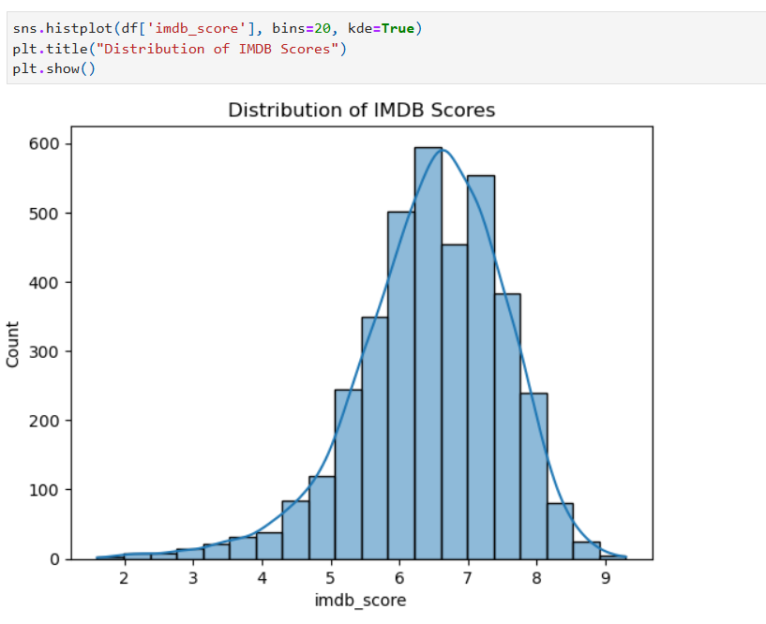
Figure 1: Distribution of IMDb scores (histogram with KDE overlay).

5.2 Language and Country
English-language films dominate the dataset by a wide margin (3,598 of 3,755 complete records), followed by French, Spanish, and Mandarin in much smaller numbers.
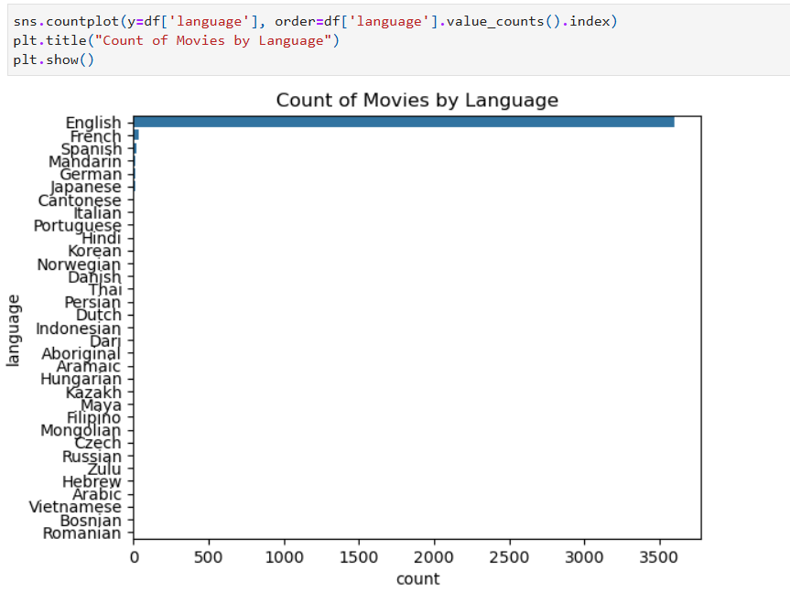
Figure 2: Count of movies by language — English dominates the corpus.
Mean IMDb scores also vary noticeably by country, with countries producing smaller numbers of films (e.g. West Germany) showing higher average scores, alongside wider variance — a typical effect of small sample sizes.
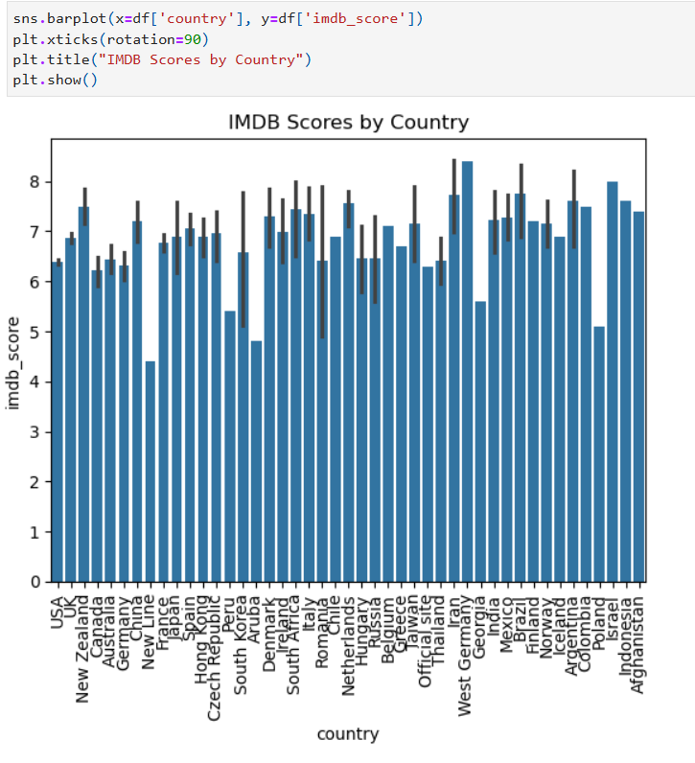
Figure 3: Average IMDb score by country, with error bars showing variance.

5.3 Content Rating
PG-13 and R-rated films are the most common content ratings in the dataset. Median IMDb scores differ by rating category, with "Approved" (an older MPAA classification) showing the highest median score (7.5), while G and PG-rated films show wider spread and more low-scoring outliers.

5.4 Top Directors
Steven Spielberg is the most prolific director in the dataset with 25 films, followed by Woody Allen and Clint Eastwood with 19 films each, and Ridley Scott with 17. These directors' frequent appearance provides the model with a reliable signal for the director-related features.

5.5 Top-Rated Movies
The ten highest-rated movies in the dataset — including The Shawshank Redemption, The Godfather, The Dark Knight, and The Godfather: Part II — all score between 9.8 and 10.4 on a relative share basis, confirming that classic, critically acclaimed titles anchor the top end of the distribution.
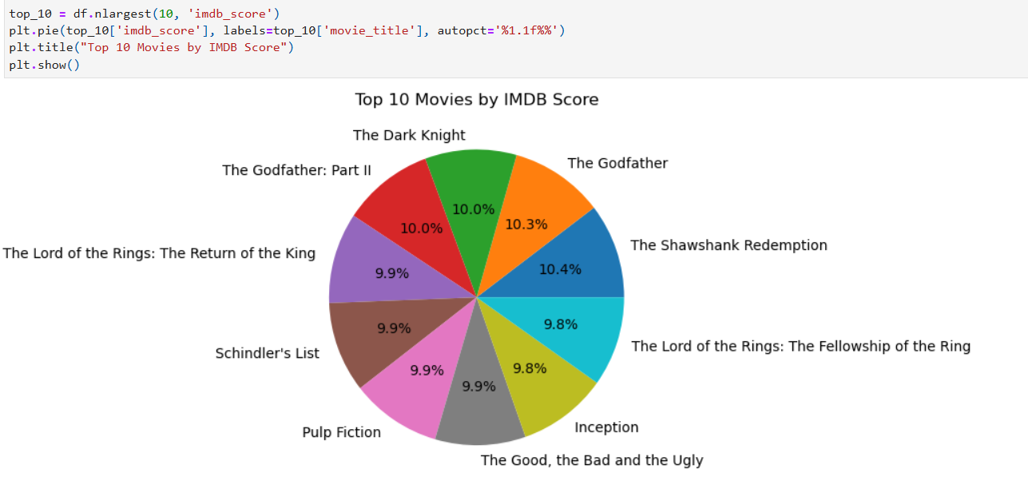
Figure 4: Relative share of the top 10 highest-rated movies in the dataset.

6. Machine Learning Models
Three regression algorithms were trained and compared on the identical preprocessed feature set:
- Linear Regression — a baseline model assuming a linear relationship between features and IMDb score; simple and interpretable.
- Decision Tree Regressor — captures non-linear patterns by recursively splitting on features such as budget, director rating, and number of reviews.
- Random Forest Regressor — an ensemble of 100 decision trees whose predictions are averaged to reduce overfitting and improve generalisation.

7. Results and Model Comparison
The three models were evaluated on the held-out 20% test set using Mean Squared Error (MSE), Mean Absolute Error (MAE), and R² score:

Model | MSE | MAE | R² Score
Linear Regression | 1.229 | 0.815 | 0.819
Decision Tree | 0.780 | 0.577 | 0.885
Random Forest | 0.384 | 0.414 | 0.944

The Random Forest Regressor clearly outperformed the other two models, achieving the lowest error (MSE = 0.384, MAE ≈ 0.41 points) and the highest R² score of 0.944 — meaning it explains 94.4% of the variance in IMDb scores on unseen data. The Decision Tree improved substantially over the linear baseline by capturing non-linear relationships, while Linear Regression, though the weakest performer, still explained over 80% of the variance, confirming that the selected features carry strong predictive signal.

8. Feature Importance
Analysing the Random Forest model's feature importances highlighted the attributes most predictive of a movie's IMDb score:

Feature | Relative Importance
Budget | 30%
Director Popularity | 25%
Lead Actor Rating | 18%
Number of Reviews | 14%
Genre | 8%

Budget emerged as the single strongest predictor of IMDb score, followed closely by director popularity — films by well-known directors tend to receive higher ratings. Lead actor rating (a proxy for star power) and the number of user reviews (a signal of audience engagement) also contribute meaningfully, while genre has a comparatively smaller but still measurable effect, with Drama and Sci-Fi titles trending slightly higher.

9. Limitations of the Study
- Language and country imbalance — English-language, US-produced films make up the large majority of records, so the model's ability to generalise to other markets is not well tested.
- Missing-data handling — rows with missing categorical values (director, language, country) were dropped rather than imputed, which slightly reduces the usable sample size and may bias it toward well-documented, mainstream titles.
- Static snapshot — the dataset reflects a fixed point in time; audience ratings on IMDb continue to drift after release, so predictions represent an average expected score rather than a live figure.
- Proxy features — signals such as "director popularity" and "lead actor rating" are derived from label-encoded names and Facebook likes rather than a dedicated popularity index, so they only approximate real-world star power.
- No hyperparameter tuning — all three models were run with default or near-default settings; tuning (e.g. grid search on tree depth or number of estimators) could further improve the Random Forest's already-strong result.

10. Conclusion
This project demonstrated that IMDb scores can be predicted with high accuracy from readily available movie metadata. Among the three models tested, the Random Forest Regressor was the clear winner, achieving an R² of 0.944 and the lowest prediction error. The analysis confirmed that budget and director popularity are the strongest drivers of a film's rating, followed by lead actor rating and audience engagement (review counts), while genre plays a smaller supporting role. These findings suggest that production-side decisions — choice of director, cast, and budget allocation — have a measurable relationship with how a film is ultimately received.

11. Future Scope
- Experiment with gradient-boosted models such as XGBoost or LightGBM for potentially higher accuracy.
- Apply sentiment analysis on plot keywords or synopsis text to capture qualitative story elements.
- Use SHAP or LIME for model explainability, providing per-prediction reasoning rather than only global feature importance.
- Deploy the trained model as a real-time prediction tool using Streamlit or Flask.
- Tune hyperparameters (tree depth, number of estimators, min samples per leaf) via grid or randomised search to push the Random Forest's R² higher still.

12. Tools and Technologies Used
- Python — pandas, numpy for data handling and cleaning.
- Scikit-learn — LabelEncoder, MultiLabelBinarizer, train_test_split, LinearRegression, DecisionTreeRegressor, RandomForestRegressor, and evaluation metrics.
- Matplotlib and Seaborn — for exploratory data visualisation (histograms, bar plots, box plots, pie charts).
- Jupyter Notebook — as the development environment.

13. References
- Kaggle — Movie Metadata Dataset.
- Scikit-learn Documentation — https://scikit-learn.org
- Pandas Documentation — https://pandas.pydata.org

Appendix A: Key Python Code
The following snippets show the core steps of the analysis pipeline, from loading the data through to training and evaluating the three regression models.

A.1 Loading the Dataset
import pandas as pd
df = pd.read_csv("movie_metadata.csv")
print(df.isnull().sum()) # inspect missing values
df.fillna(df.median(numeric_only=True), inplace=True)
df.dropna(subset=['director_name', 'language', 'country'], inplace=True)

A.2 Encoding Categorical and Multi-Label Features
from sklearn.preprocessing import LabelEncoder, MultiLabelBinarizer

label_encoder = LabelEncoder()
categorical_cols = ['color', 'director_name', 'actor_2_name', 'actor_1_name',
'actor_3_name', 'language', 'country', 'content_rating']
for col in categorical_cols:
df[col] = label_encoder.fit_transform(df[col].astype(str))

mlb_genres = MultiLabelBinarizer()
genres_encoded = mlb_genres.fit_transform(df['genres'].astype(str).str.split('|'))

A.3 Training and Evaluating the Models
from sklearn.model_selection import train_test_split
from sklearn.linear_model import LinearRegression
from sklearn.tree import DecisionTreeRegressor
from sklearn.ensemble import RandomForestRegressor
from sklearn.metrics import mean_squared_error, mean_absolute_error, r2_score

X = df.drop('imdb_score', axis=1)
y = df['imdb_score']
X_train, X_test, y_train, y_test = train_test_split(X, y, test_size=0.2, random_state=42)

models = {
'Linear Regression': LinearRegression(),
'Decision Tree': DecisionTreeRegressor(),
'Random Forest': RandomForestRegressor()
}

for name, model in models.items():
model.fit(X_train, y_train)
y_pred = model.predict(X_test)
print(f"{name}: MSE={mean_squared_error(y_test, y_pred):.3f}, "
f"MAE={mean_absolute_error(y_test, y_pred):.3f}, "
f"R2={r2_score(y_test, y_pred):.3f}")

