
SCHOOL OF ENGINEERING AND TECHNOLOGY
A Project Report
On
"City Water Pipeline Pressure & Leak Detection Sentinel"
Project ID: 04
GitHub Repository Link: https://github.com/tejas32-hub/Pipeline.git
Submitted in partial fulfillment of the requirements of the course
OBJECT ORIENTED PROGRAMMING USING JAVA & KOTLIN (4CTGC2011)
BACHELOR OF TECHNOLOGY (III SEMESTER)
IN
COMPUTER SCIENCE AND TECHNOLOGY
SUBMITTED BY
TEJAS.P – 25BBTCG069
ROSHAN JADHAV – 25BBTCG050
GUIDED BY
Dr.SUDHARSHAN
Associate professor
Dept. of CST]
SoET, CMRU, Bangalore.
Department of Computer Science and Technology
Off Hennur – Bagalur Main Road,
Near Kempegowda International Airport, Chagalahatti,
Bangalore, Karnataka 562149
2026–2027

SCHOOL OF ENGINEERING AND TECHNOLOGY
Chagalahatti, Bengaluru, Karnataka 562149
Department of Computer Science and Technology
CERTIFICATE
This is to certify that the Project entitled "City Water Pipeline Pressure & Leak Detection Sentinel" ([Project 04]) has been successfully carried out by TEJAS.P 25BBTCG069 and ROSHAN JADHAV 25BBTCG050 in partial fulfillment of the requirements of the course Object Oriented Programming using Java & Kotlin (4CTGC2011) of the Bachelor of Technology programme in Computer Science and Technology of CMR University, Bengaluru during the academic year 2026–2027. The project report has been approved as it satisfies the academic requirements in respect of project work prescribed for the said course.

Signature of the Guide  ______________________  Dr.SUDHARSHAN  Associate professor  Dept. of CST  SoET, CMRU, Bangalore. | Signature of HOD  ______________________  DEVI PRASHAD  Head of the Department  Dept. of CST  SoET, CMRU, Bangalore.

ACKNOWLEDGEMENT
The satisfaction that accompanies the successful completion of this project would be incomplete without the mention of the people who made it possible. We are thankful to CMR University and the School of Engineering and Technology for giving us the opportunity to apply the concepts of Object Oriented Programming using Java & Kotlin to a real engineering problem: protecting a city water pipeline from bursts.
We express our sincere thanks to DEVI PRASHAD Head of the Department, Computer Science and Technology, School of Engineering and Technology, CMR University, Bangalore, for the encouragement and the laboratory facilities that made this work possible.
We are grateful to our course instructor and project guide Dr.SUDHARSHAN Associate professor, Computer Science and Technology, for the patient guidance, timely feedback and constant support given throughout the project.
We also thank the faculty members and lab staff of the department, and our friends and family, for their encouragement and for the discussions that helped us refine the design of this project.

TEJAS.P 25BBTCG069
ROSHAN JADHAV 25BBTCG050

ABSTRACT
Water distribution networks lose water, pressure and public safety when a pipe fractures and the failed segment is not isolated quickly. This project implements a City Water Pipeline Pressure & Leak Detection Sentinel in Java that monitors one pipeline segment and closes its valve automatically when a burst is detected. The system consists of five cooperating classes: PipelineSegment (data model), PipelineMonitor (shared monitor), PressureSensorThread, ValveActuatorThread and a custom checked exception, PipelineBurstException. Encapsulation, inheritance from Thread, method overriding and exception abstraction are applied throughout. Concurrency is handled with two threads that coordinate through Java's intrinsic monitor: the actuator blocks in wait() inside a while loop, and the sensor wakes it with notifyAll() the moment a breach is found, while every access to shared state is synchronized. Detection combines a gradient rule (more than 4.5 bar lost within 2 seconds) with a fracture rule (outlet below 2.0 bar after a drop of at least 3.0 bar), because the simulated fracture from 5.2 to 1.8 bar is only 3.4 bar. Finally blocks guarantee that the actuator is always released and that the valve ends closed after an emergency. In tests on Java 21, the burst scenario was isolated about 300 ms after detection, inside the 500 ms requirement, and the normal scenario produced no false alarm.

Keywords: Java, Multithreading, wait() and notifyAll(), Custom Exception, Water Pipeline Monitoring

TABLE OF CONTENTS
Sl. No. | Title
 | Abstract
 | List of Figures
1 | Introduction
1.1 | Problem Statement
1.2 | Objectives
1.3 | Scope
2 | Requirements
2.1 | Functional Requirements
2.2 | Hardware and Software Requirements
3 | System Design
3.1 | System Architecture
3.2 | UML Class Diagram
4 | Implementation
4.1 | OOP Concepts Used
4.2 | Code Snippets
5 | Results
5.1 | Execution Snapshots
6 | Conclusion and Future Scope
7 | References

LIST OF FIGURES
Fig. No. | Title
3.1 | System architecture of the Pipeline Sentinel
3.2 | Thread interaction (sequence) during a burst
3.3 | UML class diagram of the Pipeline Sentinel
5.1 | Console output: normal (no-leak) scenario
5.2 | Console output: burst scenario

1. INTRODUCTION
Water utilities move treated water through hundreds of kilometres of buried pipes that are kept under steady pressure. When a pipe fractures, the pressure downstream collapses within seconds, large volumes of treated water are lost, roads and basements flood, and customers lose supply. The faster the damaged segment is isolated by closing its valves, the smaller the loss. Modern utilities therefore combine pressure sensors with automatic shut-off valves, which are usually supervised by a SCADA (Supervisory Control and Data Acquisition) system [1].
This project builds a small but complete simulation of such a sentinel in Java. One thread plays the pressure sensor, another plays the valve actuator, and a shared monitor object connects them. The project is also a practical exercise in the topics of the course: classes and objects, encapsulation, inheritance, custom exceptions and, above all, multithreading with the wait/notify mechanism [2][3].

1.1 Problem Statement
A segment of a city water main (SEG-A7, Main St to 5th Ave) normally runs at about 5.2 bar. A pipe fracture makes the outlet pressure fall sharply. The system must detect the abnormal pressure gradient from sensor readings, raise a clear error, and close the segment valve fully within 500 ms of detection, without wasting processor time while nothing is happening and without ever leaving a failed segment open.

1.2 Objectives
The objectives of the project are:
- To model a pipeline segment as a class with private state, validated access and thread-safe methods.
- To simulate a pressure sensor that produces a reading every 200 ms, with an optional pipe fracture.
- To detect a burst from the pressure gradient over a 2-second sliding window.
- To signal the burst with a custom checked exception, PipelineBurstException, that carries useful data.
- To make a valve actuator thread sleep in wait() and wake instantly through notifyAll() when the burst is signalled.
- To isolate the segment within 500 ms of detection and to guarantee a fail-safe outcome even if a thread is interrupted or ends abnormally.
- To show correct behaviour in both a burst scenario and a normal (no-leak) scenario.

1.3 Scope
In scope: one pipeline segment, one pressure sensor thread and one valve actuator thread; a time-window gradient rule and a fracture rule; stepped valve closure; timestamped console logging; a command-line switch (normal) for the no-leak scenario.
Out of scope: real hardware or SCADA protocols, multiple segments and valve networks, flow-rate or acoustic leak detection, persistent storage, and a graphical interface. These are listed as future work in Chapter 6.

2. REQUIREMENTS

2.1 Functional Requirements
Each requirement is identified by a code so that it can be traced to the implementation and to the tests in Chapter 5.
- FR1: Model a pipeline segment with inlet pressure, outlet pressure, valve opening (0 to 100 %) and an isolated flag.
- FR2: Run a sensor thread that submits one reading every 200 ms.
- FR3: Keep the readings of the last 2 seconds and compute the pressure drop inside that window.
- FR4: Declare a burst when the drop exceeds 4.5 bar within 2 s (gradient rule), or when the outlet pressure falls below 2.0 bar after a drop of at least 3.0 bar in the window (fracture rule).
- FR5: On a burst, throw PipelineBurstException carrying the segment id, the pressure drop and the window length.
- FR6: Keep the valve actuator thread blocked in wait() until an emergency is signalled; wake it with notifyAll().
- FR7: Close the valve in steps to 0 %, mark the segment isolated, and finish within 500 ms of detection.
- FR8: Support a normal scenario with no false alarm and make sure both threads always terminate.
- FR9: Reject invalid values (negative pressure, valve percentage outside 0 to 100) with IllegalArgumentException.
- FR10: Log every reading and event with a timestamp and the thread name.
Non-functional requirements: thread safety (all shared state accessed under a lock), responsiveness (no busy waiting, isolation time of at most 500 ms), reliability (fail-safe closure), and readability (private fields, small single-purpose classes).

2.2 Hardware and Software Requirements
The program is plain Java with no external libraries, so almost any computer can run it.
Item | Specification
Processor | Any dual-core processor (1.5 GHz or better)
Memory | 4 GB RAM or more
Operating system | Windows 10/11, Linux or macOS
Language and JDK | Java; developed and tested with OpenJDK 21 (Java 11 or later is enough to run the single file)
Tools | Command line, or an IDE such as IntelliJ IDEA / VS Code; Git and GitHub for version control
Run command | java PipelineSentinel.java (burst scenario) or java PipelineSentinel.java normal

Table 2.1: Hardware and software used

3. SYSTEM DESIGN

3.1 System Architecture
The system follows an event-driven producer and consumer design around one shared monitor object. The sensor thread is the producer of readings; the monitor analyses them; the actuator thread is the consumer of the emergency event. The main thread only creates the objects, starts the two threads and joins them (Fig. 3.1).
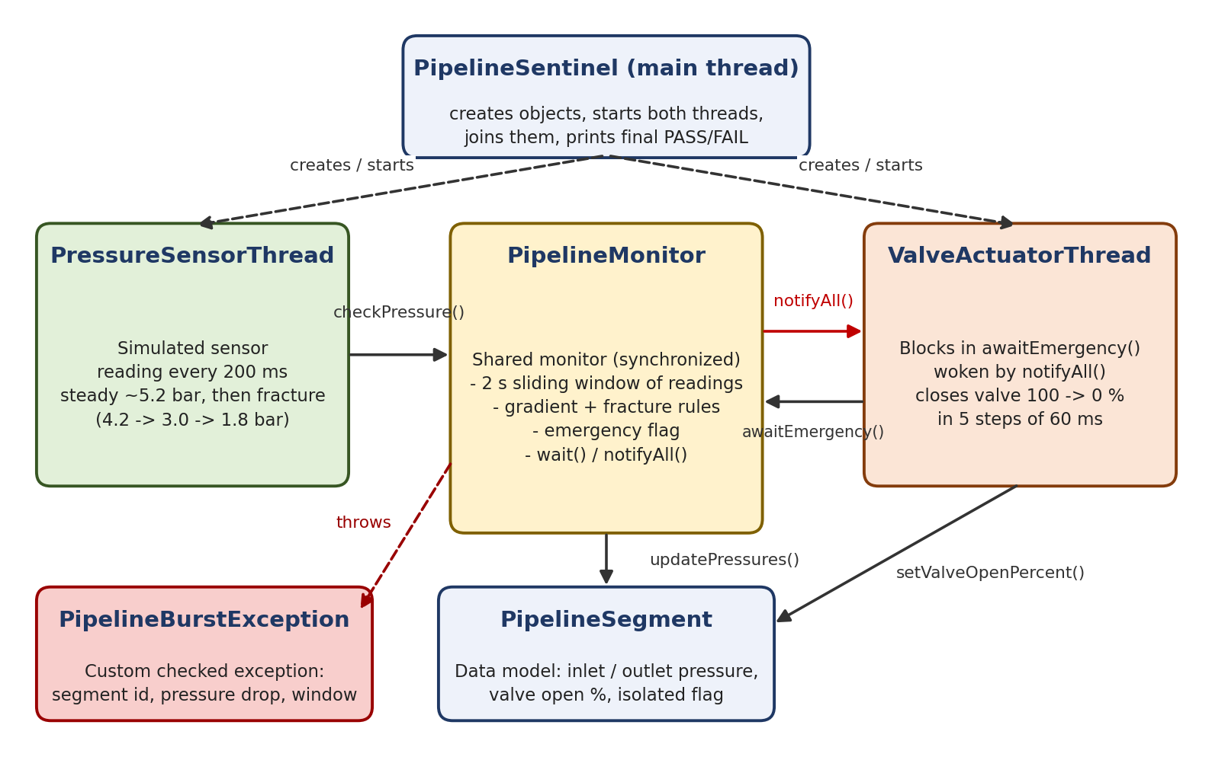
Fig. 3.1: System architecture of the Pipeline Sentinel
The sequence of events during a burst is shown in Fig. 3.2. The actuator calls awaitEmergency() first and goes to sleep inside wait(), which releases the monitor lock. The sensor then submits readings through checkPressure(). When a rule is breached, the monitor sets the emergency flag and calls notifyAll() before the exception is thrown, so the valve starts closing even if the sensor thread fails while handling the exception. The actuator closes the valve in five steps and records the isolation time.
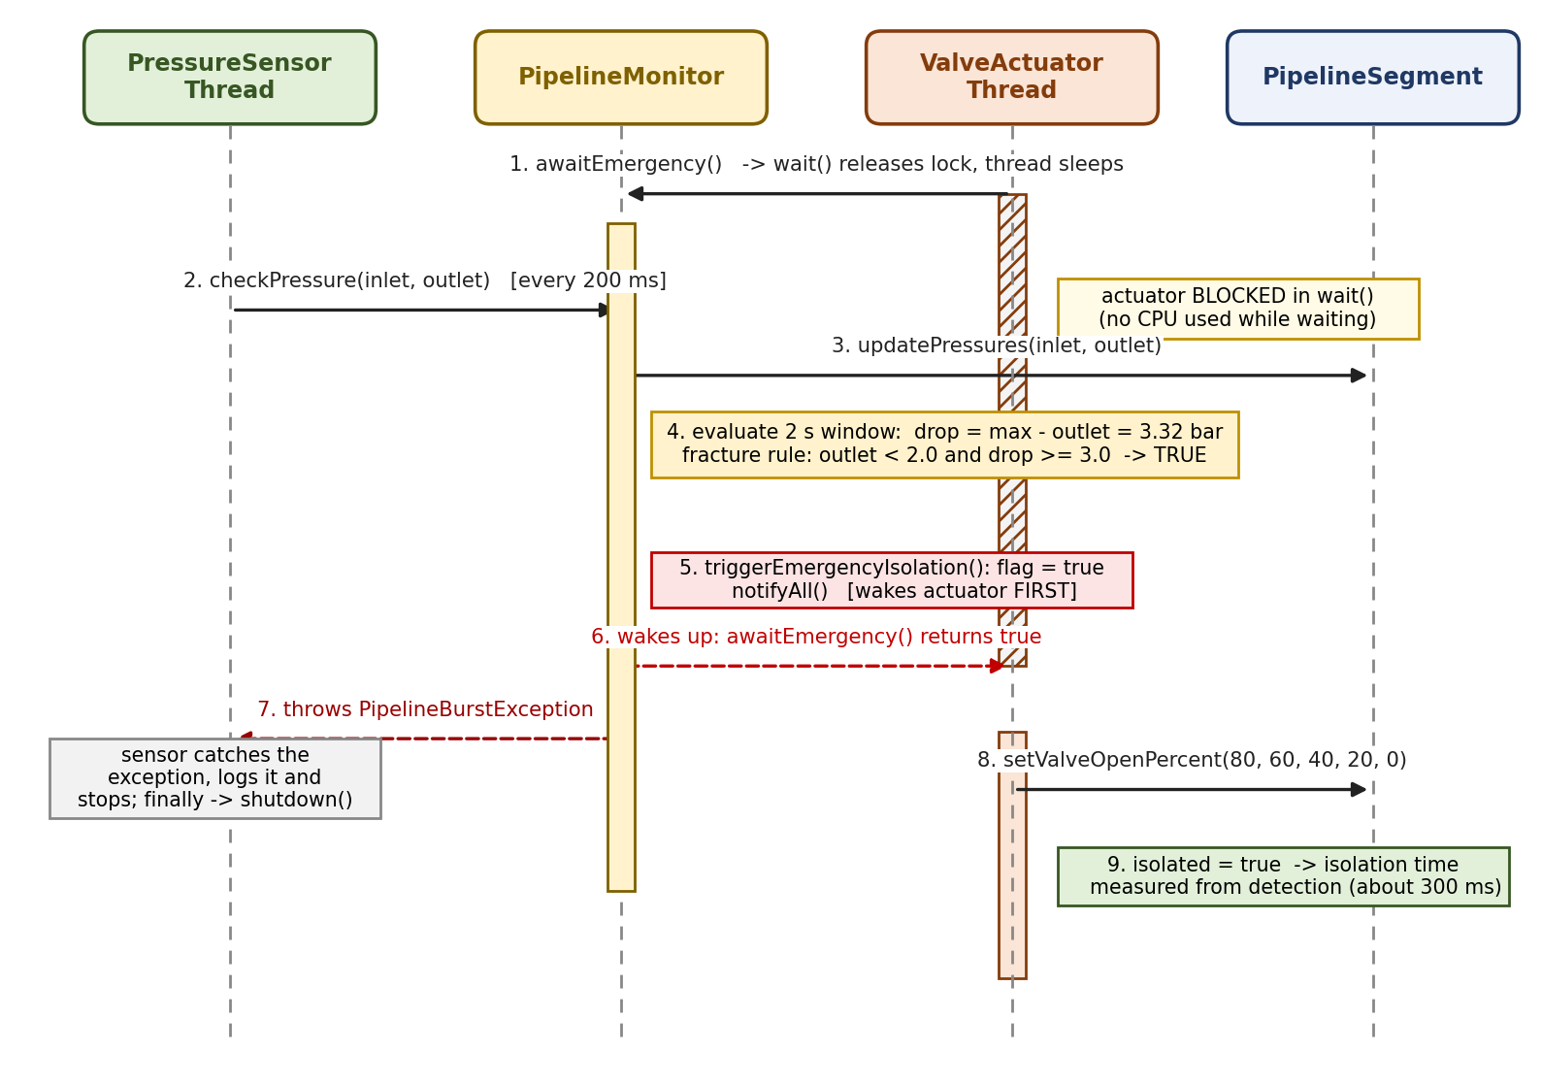
Fig. 3.2: Thread interaction (sequence) during a burst

3.2 UML Class Diagram
Fig. 3.3 shows the classes of the project and their relationships. PressureSensorThread and ValveActuatorThread inherit from Thread, and PipelineBurstException inherits from Exception. PipelineMonitor holds one PipelineSegment (association) and is shared by both threads. The dashed arrows show dependencies: the main class creates the objects, the monitor throws the exception, the monitor writes through PipelineSensorLog, and the actuator closes the valve on the segment.
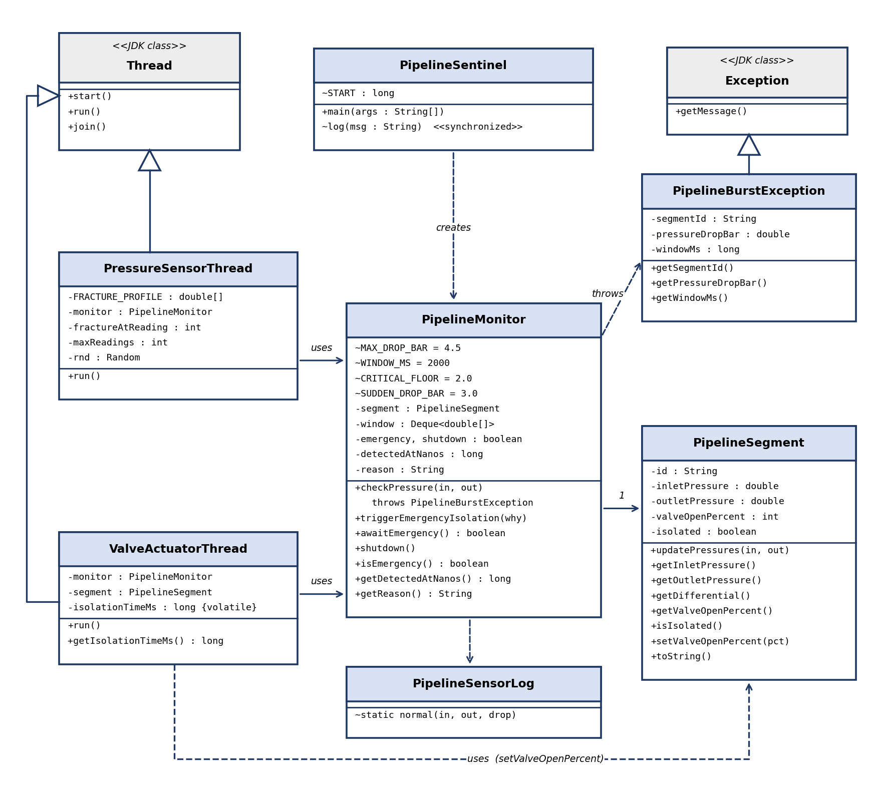
Fig. 3.3: UML class diagram of the Pipeline Sentinel
Class | Responsibility
PipelineSegment | Data model: pressures, valve opening and isolated flag. Validates every change.
PipelineMonitor | Shared monitor: sliding window, burst rules, emergency flag, wait()/notifyAll().
PressureSensorThread | Simulates the sensor and the fracture; handles PipelineBurstException.
ValveActuatorThread | Waits for the emergency, closes the valve in steps, applies the fail-safe.
PipelineBurstException | Checked exception with segment id, pressure drop and window length.
PipelineSensorLog, PipelineSentinel | Reading logger; entry point with a thread-safe timestamped log() method.

Table 3.1: Classes and their responsibilities

4. IMPLEMENTATION

4.1 OOP Concepts Used
The following object oriented concepts are used in the project.
Concept | Where it is used | How it is used
Encapsulation | PipelineSegment, PipelineMonitor, PipelineBurstException | All fields are private (many final). They are reached only through synchronized getters and setters, and the setters validate their input.
Inheritance | Sensor and actuator extend Thread; the exception extends Exception | Subclasses reuse the thread life cycle (start, join) and the exception mechanism.
Polymorphism | run(), toString(), getMessage() | Overriding: when start() is called, the JVM executes the run() of the subclass.
Abstraction | Public API of PipelineMonitor | The threads call checkPressure() and awaitEmergency() without knowing about the window, the rules or the lock.
Association | Monitor holds a segment; threads hold the monitor | Models the real-world "has-a" relations between parts of the system.
Custom exception | PipelineBurstException, try/catch/finally | A checked exception forces the caller to deal with a burst; finally guarantees clean-up.
Multithreading | synchronized, wait(), notifyAll(), volatile | Thread-safe shared state and event-driven wake-up instead of polling.
Static and final members | MAX_DROP_BAR, WINDOW_MS, START, log() | Thresholds are named constants in one place; the logger is a static synchronized method.
Collections | Deque<double[]> (ArrayDeque) | Sliding window of the latest readings with cheap add and remove at both ends.

Table 4.1: OOP concepts used in the project

4.2 Code Snippets
The important parts of PipelineSentinel.java are shown below. Logging statements are shortened in some places; the complete source is in the GitHub repository given on the title page.
(a) Custom checked exception
class PipelineBurstException extends Exception {
private final String segmentId;
private final double pressureDropBar;
private final long windowMs;

public PipelineBurstException(String segmentId, double pressureDropBar,
long windowMs, String message) {
super(message);
this.segmentId = segmentId;
this.pressureDropBar = pressureDropBar;
this.windowMs = windowMs;
}
public String getSegmentId() { return segmentId; }
public double getPressureDropBar() { return pressureDropBar; }
public long getWindowMs() { return windowMs; }
}

Because the exception extends Exception (not RuntimeException), the compiler forces checkPressure() and its callers to declare or handle it. The extra fields let the handler report what happened without parsing the message.
(b) Encapsulated data model
class PipelineSegment {
private final String id;
private double inletPressure = 5.2; // bar
private double outletPressure = 5.1; // bar
private int valveOpenPercent = 100; // 0..100
private boolean isolated = false;

public synchronized void updatePressures(double inlet, double outlet) {
if (inlet < 0 || outlet < 0)
throw new IllegalArgumentException("Pressure cannot be negative");
this.inletPressure = inlet;
this.outletPressure = outlet;
}

public synchronized void setValveOpenPercent(int pct) {
if (pct < 0 || pct > 100)
throw new IllegalArgumentException("Valve % must be 0..100");
this.valveOpenPercent = pct;
if (pct == 0) this.isolated = true;
}
// ... other synchronized getters
}

Fields are private and every method that reads or writes them is synchronized, so the two threads always see a consistent segment. The setters reject invalid values. Setting the valve to 0 % also sets the isolated flag, so the two can never disagree.
(c) Gradient detection with a sliding window
public synchronized void checkPressure(double inlet, double outlet)
throws PipelineBurstException {
long now = System.currentTimeMillis();
segment.updatePressures(inlet, outlet);

window.addLast(new double[]{now, outlet});
while (!window.isEmpty() && now - (long) window.peekFirst()[0] > WINDOW_MS)
window.removeFirst(); // keep only the last 2 s

double max = outlet;
for (double[] r : window) max = Math.max(max, r[1]);
double drop = max - outlet; // fall inside the window

boolean gradientBreach = drop > MAX_DROP_BAR; // > 4.5 bar
boolean fractureBreach = outlet < CRITICAL_FLOOR && drop >= SUDDEN_DROP_BAR;
if (gradientBreach || fractureBreach) {
String why = String.format("Pressure fell %.2f bar within %d ms "
+ "(outlet now %.2f bar)", drop, WINDOW_MS, outlet);
triggerEmergencyIsolation(why); // wake the actuator FIRST (fail-safe)
throw new PipelineBurstException(segment.getId(), drop, WINDOW_MS, why);
}
}

Each reading is added to a deque and readings older than 2000 ms are removed. The drop is the largest outlet pressure in the window minus the current outlet pressure. Two rules are checked: the gradient rule from the specification (more than 4.5 bar) and a fracture rule (outlet below 2.0 bar after a drop of at least 3.0 bar). The monitor wakes the actuator before it throws the exception.
(d) wait() and notifyAll() hand-off
public synchronized void triggerEmergencyIsolation(String why) {
if (emergency) return; // idempotent
emergency = true;
reason = why;
detectedAtNanos = System.nanoTime();
notifyAll(); // wake every waiting actuator
}

public synchronized boolean awaitEmergency() throws InterruptedException {
while (!emergency && !shutdown) { // loop guards against spurious wakeups
wait(); // releases the lock while waiting
}
return emergency;
}

public synchronized void shutdown() { shutdown = true; notifyAll(); }

awaitEmergency() tests the condition in a while loop, because a thread can wake up without a notification (a spurious wakeup) [2]. wait() releases the lock, so the sensor can still enter checkPressure(). triggerEmergencyIsolation() is idempotent, which prevents a second notification from overwriting the detection time.
(e) Sensor thread with try / catch / finally
@Override
public void run() {
try {
for (int i = 0; i < maxReadings; i++) {
double inlet = 5.2 + (rnd.nextDouble() - 0.5) * 0.06;
double outlet = inlet - 0.10;
if (fractureAtReading >= 0 && i >= fractureAtReading) {
int k = Math.min(i - fractureAtReading,
FRACTURE_PROFILE.length - 1);
outlet = FRACTURE_PROFILE[k]; // 4.2 -> 3.0 -> 1.8 bar
}
monitor.checkPressure(inlet, outlet);
Thread.sleep(200);
}
} catch (PipelineBurstException e) {
PipelineSentinel.log("!!! PipelineBurstException: " + e.getMessage());
} catch (InterruptedException e) {
Thread.currentThread().interrupt();
} finally {
monitor.shutdown(); // always release the actuator
}
}

The sensor generates steady readings near 5.2 bar and, from reading number 10 (after about 2 s), follows the fracture profile of 4.2, 3.0 and then 1.8 bar. Whatever happens, the finally block calls shutdown() so that the actuator can never wait forever.
(f) Valve actuator with fail-safe clean-up
@Override
public void run() {
try {
if (monitor.awaitEmergency()) {
for (int pct = 80; pct >= 0; pct -= 20) { // 5 steps of 60 ms
segment.setValveOpenPercent(pct);
Thread.sleep(60);
}
isolationTimeMs =
(System.nanoTime() - monitor.getDetectedAtNanos()) / 1_000_000;
}
} catch (InterruptedException e) {
Thread.currentThread().interrupt();
} finally {
// FAIL-SAFE: an emergency must always end with a closed valve
if (monitor.isEmergency() && segment.getValveOpenPercent() != 0)
segment.setValveOpenPercent(0);
}
}

The valve is closed in five steps of 60 ms each: 80, 60, 40, 20 and 0 %. The isolation time is measured with System.nanoTime() from the instant the monitor detected the burst. The finally block force-closes the valve if an emergency was raised but the valve is still open, for example after an interruption.

5. RESULTS

5.1 Execution Snapshots
The program was run on OpenJDK 21 in both scenarios. Both runs finished normally, which shows that neither thread was left waiting.
Scenario 1: normal operation (java PipelineSentinel.java normal)
[t= 9ms][main ] === Pipeline Sentinel starting: SEG-A7 (Main St -> 5th Ave) ===
[t= 33ms][ValveActuator ] Waiting for emergency signal (wait())...
[t= 139ms][PressureSensor] Reading: inlet=5.21 bar, outlet=5.11 bar, dP=0.10, 2s-drop=0.00 bar
[t= 341ms][PressureSensor] Reading: inlet=5.21 bar, outlet=5.11 bar, dP=0.10, 2s-drop=0.00 bar
... 11 more readings omitted ...
[t= 2758ms][PressureSensor] Reading: inlet=5.19 bar, outlet=5.09 bar, dP=0.10, 2s-drop=0.03 bar
[t= 2959ms][PressureSensor] Reading: inlet=5.18 bar, outlet=5.08 bar, dP=0.10, 2s-drop=0.04 bar
[t= 3160ms][PressureSensor] Reading: inlet=5.21 bar, outlet=5.11 bar, dP=0.10, 2s-drop=0.02 bar
[t= 3361ms][PressureSensor] Monitoring period finished, no anomalies.
[t= 3362ms][ValveActuator ] Shutdown without emergency; actuator standing down.
[t= 3363ms][main ] === FINAL STATE === SEG-A7 (Main St -> 5th Ave) | inlet=5.21 bar, outlet=5.11 bar, valve=100%, isolated=false
[t= 3363ms][main ] No emergency occurred; system stayed in normal operation.

Fig. 5.1: Console output: normal (no-leak) scenario
The sensor submitted all 16 readings. The 2-second drop stayed at 0.04 bar or less, so no rule was triggered. At the end the sensor called shutdown(), the actuator stood down, and the segment remained at valve = 100 %, isolated = false.
Scenario 2: pipe burst (java PipelineSentinel.java)
[t= 8ms][main ] === Pipeline Sentinel starting: SEG-A7 (Main St -> 5th Ave) ===
[t= 79ms][ValveActuator ] Waiting for emergency signal (wait())...
[t= 184ms][PressureSensor] Reading: inlet=5.21 bar, outlet=5.11 bar, dP=0.10, 2s-drop=0.00 bar
[t= 386ms][PressureSensor] Reading: inlet=5.21 bar, outlet=5.11 bar, dP=0.10, 2s-drop=0.00 bar
... 7 more normal readings omitted ...
[t= 1995ms][PressureSensor] Reading: inlet=5.22 bar, outlet=5.12 bar, dP=0.10, 2s-drop=0.01 bar
[t= 2196ms][PressureSensor] *** SIMULATED PIPE FRACTURE BEGINS ***
[t= 2197ms][PressureSensor] Reading: inlet=5.23 bar, outlet=4.20 bar, dP=1.03, 2s-drop=0.92 bar
[t= 2398ms][PressureSensor] Reading: inlet=5.20 bar, outlet=3.00 bar, dP=2.20, 2s-drop=2.12 bar
[t= 2598ms][PressureSensor] Reading: inlet=5.21 bar, outlet=1.80 bar, dP=3.41, 2s-drop=3.32 bar
[t= 2601ms][ValveActuator ] WOKEN by notify! Reason: Pressure fell 3.32 bar within 2000 ms (outlet now 1.80 bar)
[t= 2601ms][ValveActuator ] Executing EMERGENCY VALVE CLOSURE...
[t= 2601ms][ValveActuator ] Valve now 80% open
[t= 2606ms][PressureSensor] !!! PipelineBurstException: Pressure fell 3.32 bar within 2000 ms (outlet now 1.80 bar) [segment=SEG-A7 (Main St -> 5th Ave), drop=3.32 bar]
[t= 2606ms][PressureSensor] Sensor signalled actuator via notifyAll(); sensor stopping.
[t= 2662ms][ValveActuator ] Valve now 60% open
[t= 2722ms][ValveActuator ] Valve now 40% open
[t= 2783ms][ValveActuator ] Valve now 20% open
[t= 2844ms][ValveActuator ] Valve now 0% open
[t= 2910ms][ValveActuator ] Segment ISOLATED. Closure took 306 ms from detection.
[t= 2911ms][main ] === FINAL STATE === SEG-A7 (Main St -> 5th Ave) | inlet=5.21 bar, outlet=1.80 bar, valve=0%, isolated=true
[t= 2914ms][main ] Detection -> valve fully closed: 306 ms [PASS: within 500 ms]

Fig. 5.2: Console output: burst scenario
The fracture started with reading number 10. The outlet pressure fell to 4.20 bar, then 3.00 bar, and the drop inside the window reached 3.32 bar when the outlet read 1.80 bar. That met the fracture rule, and the monitor raised the emergency. The actuator was woken within a few milliseconds and closed the valve to 0 %. The result is summarised in Table 5.1 and the timeline in Table 5.2.
Scenario | Expected | Observed | Result
Normal | No alarm; valve stays 100 %; threads terminate | Max 2 s drop 0.04 bar; valve 100 %; isolated = false; both threads ended | Pass
Burst | Burst detected; segment isolated within 500 ms | Detected at 1.80 bar (drop 3.32 bar); valve 0 %; isolated = true; isolation time 306 ms | Pass

Table 5.1: Test results for the two scenarios
Event | Outlet (bar) | 2 s drop (bar) | Action
Fracture begins | 4.20 | 0.92 | Below both limits; no alarm
Second reading | 3.00 | 2.12 | Below both limits; no alarm
Third reading | 1.80 | 3.32 | Fracture rule met; notifyAll(); exception thrown
+ a few ms | 1.80 | 3.32 | Actuator wakes; valve at 80 %
+ 300 ms (approx.) | 1.80 | 3.32 | Valve at 0 %; segment isolated (306 ms in this run)

Table 5.2: Timeline of the burst scenario
Discussion. The isolation time is dominated by the five 60 ms closing steps (5 x 60 ms = 300 ms), plus the time to start the thread step and print the log. It was 306 ms in this run and 308 ms in an earlier run, comfortably below the 500 ms limit. The simulated fall from 5.2 bar to 1.8 bar is 3.4 bar, which is less than 4.5 bar, so the gradient rule alone would never fire in this scenario. The additional fracture rule closes that gap, and the 4.5 bar rule is kept for even larger drops.

6. CONCLUSION AND FUTURE SCOPE
The City Water Pipeline Pressure & Leak Detection Sentinel was implemented as a Java program in which a sensor thread, a shared monitor and a valve actuator thread cooperate through synchronized, wait() and notifyAll(). In the burst scenario the segment was isolated about 300 ms after detection, within the 500 ms requirement. In the normal scenario there was no false alarm and both threads ended cleanly. The project showed how encapsulation, inheritance, custom exceptions and the monitor mechanism fit together in one small but realistic system, and how finally blocks give a fail-safe guarantee.
Limitations. The sensor is simulated with fixed values and a fixed random seed; there is one segment; the thresholds are constants in the code; and the project has no automated unit tests.
Future scope:
- Read real sensor data, for example from an MQTT or Modbus gateway, instead of the simulation.
- Monitor many segments, with one sensor and one actuator per segment managed by an ExecutorService.
- Replace the intrinsic lock with ReentrantLock and Condition, or use a BlockingQueue between sensor and monitor [4][5].
- Add JUnit tests for the rules and for the thread hand-off, and make the thresholds configurable.
- Add flow-rate and acoustic data, or a learned anomaly detector, to catch small leaks.
- Port the project to Kotlin with coroutines, and add a dashboard and SMS or e-mail alerts.

7. REFERENCES
[1] Oracle, "The Java Language Specification, Java SE 21 Edition," Oracle Corp., 2023. [Online]. Available: https://docs.oracle.com/javase/specs/jls/se21/html/index.html
[2] Oracle, "Guarded Blocks," in The Java Tutorials: Concurrency. [Online]. Available: https://docs.oracle.com/javase/tutorial/essential/concurrency/guardmeth.html
[3] Oracle, "Class Object," Java Platform, Standard Edition 21 API Specification. [Online]. Available: https://docs.oracle.com/en/java/javase/21/docs/api/java.base/java/lang/Object.html
[4] B. Goetz, T. Peierls, J. Bloch, J. Bowbeer, D. Holmes, and D. Lea, Java Concurrency in Practice. Upper Saddle River, NJ, USA: Addison-Wesley, 2006.
[5] J. Bloch, Effective Java, 3rd ed. Boston, MA, USA: Addison-Wesley, 2018.
[6] Oracle, "Lesson: Exceptions," in The Java Tutorials. [Online]. Available: https://docs.oracle.com/javase/tutorial/essential/exceptions/
[7] M. Fowler, UML Distilled: A Brief Guide to the Standard Object Modeling Language, 3rd ed. Boston, MA, USA: Addison-Wesley, 2003.

