Name: Roshan R
Registration Number: 26BCE1814
Email ID: roshan.r2026@vitstudent.ac.in
Problem Statement:
Build a Smart Document Knowledge Assistant using Retrieval-Augmented Generation (RAG) for first-year college students.
Why I Chose This Problem Statement:
I chose this problem because students often spend time searching through long notes for specific information, and keyword search (Ctrl+F) cannot follow a concept across synonyms or pages. A document assistant can make that information easier to find while showing the original passages, so students can check every answer against their own notes.
Approach / Proposed Solution:
This website is the user interface of the Smart Document Knowledge Assistant. A student uploads PDF and TXT files using a drag-and-drop zone, and each file appears in a knowledge base list with its size, token count, indexing progress, and the number of chunks indexed. When the student asks a question, the interface shows each retrieval stage (searching the vector index, extracting the top chunks, generating the response), retrieves the four most relevant passages, and builds an answer only from those passages.
Each answer contains inline citations such as [Source 1]. Expandable source cards show the source file, page, relevance match score, and the exact retrieved passage with the matching terms highlighted. Hovering over a citation highlights its source card. If nothing relevant is found, the assistant says so instead of guessing. In this version, retrieval and answer generation are simulated in the browser using word-overlap scoring, so the full interaction can be demonstrated without a server; the same interface is designed to be connected to a backend that performs real embedding search and LLM generation.
Technologies / Tools Used:
- HTML5, CSS, and vanilla JavaScript in a single self-contained file.
- Tailwind CSS (via CDN) for layout and styling, with custom CSS for glassmorphism, animations, and focus effects.
- JavaScript File API (FileReader) for reading and chunking uploaded TXT files.
- Plus Jakarta Sans and JetBrains Mono from Google Fonts.
- Hand-written inline SVG icons (no icon font or external images).
- GitHub for source-code hosting.
Key Features / Functionality:
- Drag-and-drop upload and management of multiple PDF and TXT documents, with delete option.
- Indexing status for each file: progress bar, file size, token count, and chunks indexed.
- RAG control metrics: chunks processed, embedding model (text-embedding-3), and search threshold (Top 5).
- Chat interface with a visible retrieval pipeline and streaming answers.
- Inline [Source n] citations linked to expandable source cards.
- Source cards showing file, page, match score bar, and highlighted retrieved passage.
- Citation hover effect that highlights the matching source card.
- Prompt suggestion chips such as Summarize page 4, Extract key formulas, and Compare lab manual vs lecture.
- Sample files for instant demonstration, and a safe fallback message when no relevant passage exists.
- Responsive dark interface with keyboard focus states and reduced-motion support.
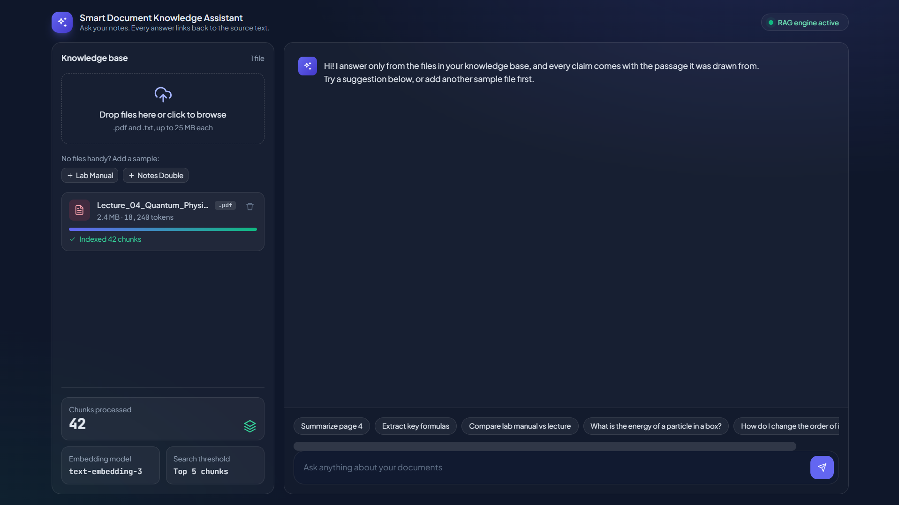
GitHub Repository Link:
[https://github.com/roshanr2902-cmyk/Smart-Document-Knowledge-Assistant]
Other Relevant Information:
This website is a front-end prototype that runs entirely in the browser. Uploaded TXT files are read and chunked locally and nothing is sent to any server. Retrieval and answers are simulated, and uploaded PDF files are indexed by size only because PDF text extraction is handled by a backend. It is a single HTML file that needs no installation, and it is not yet deployed as a public multi-user website.

