JMETER

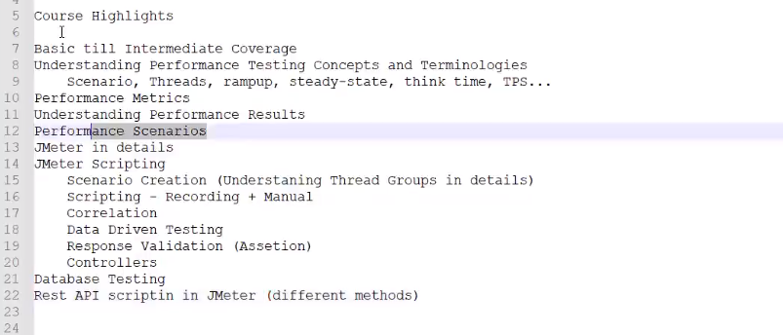

­­­

Performing testing :

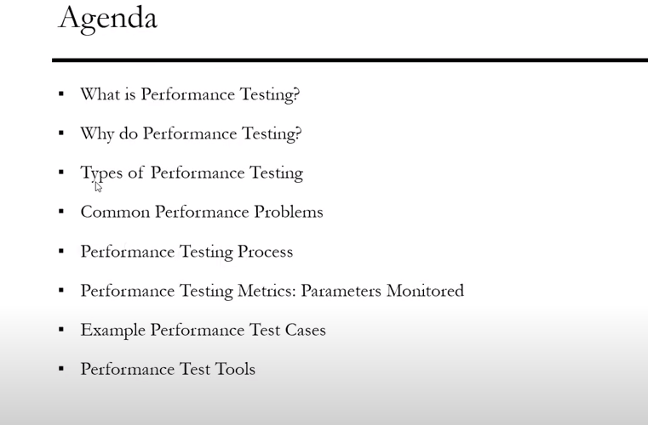

What is performance testing?

*Defined as type of **nonfunctional** software testing

*Applications will perform well under expected workload like (**response time, reliability, resource usages, scalability)**

*The goal of performance testing is not find bugs but to eliminate performance **bottlenecks** (particular some point significantly data transfer is slow).

*The focus of performance testing is checking a software program’s   
**\*Speed  
*Scalability(**maximum user load the software application can be handle **)  
*Stability(**application is stable under varying loads **)**

**\***Performance testing is popularly called “Perf testing”.

2.Why we need performance testing

*software need speed, scalability,stability,

3.Type of performance testing

*Load testing

how the system behaves during normal and high loads and determines if a system

*Street testing(extreme workload, how handle high traffic and data processing )

*Endurance testing(software handle the expected load over a long period of time )

*Spike testing (software reaction to sudden large spikes in load generated by user )

*volume testing (under volume testing large number of data is populated in the database and overall software system behavior is monitored )

4.Common performance problems

* Long load time
* Poor response
* Poor scalability
* Bottlenecking
* Common performance
* Common performance bottlenecks
* CPU utilization
* Memory utilization
* Network utilization
* Operation utilization
* Disk usage

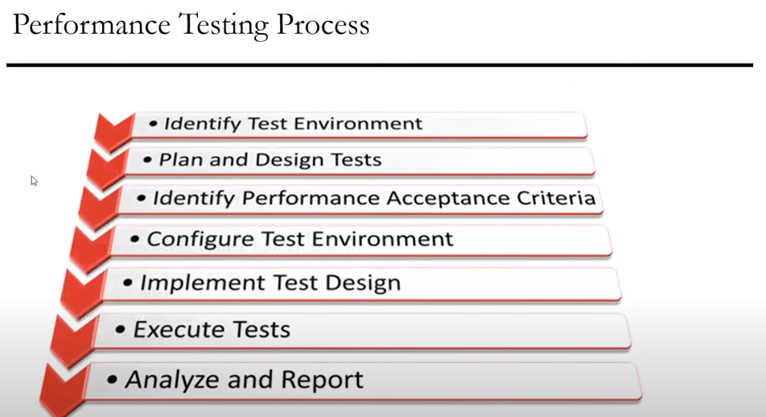

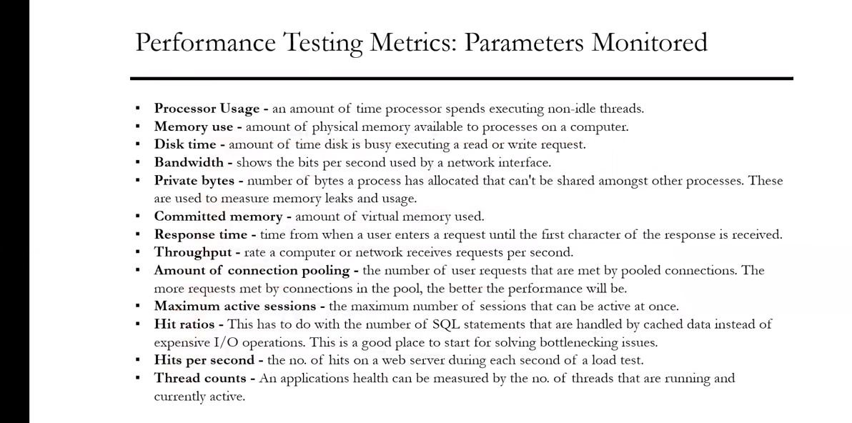

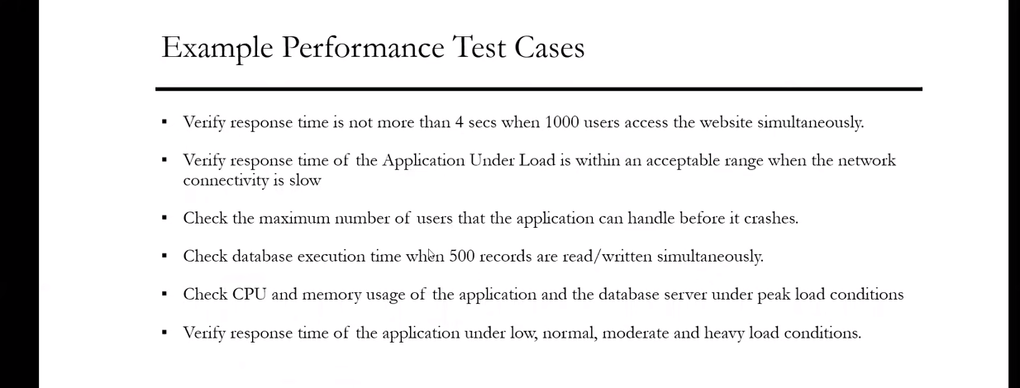

Street testing Endurance testing Load testing

Spike testing

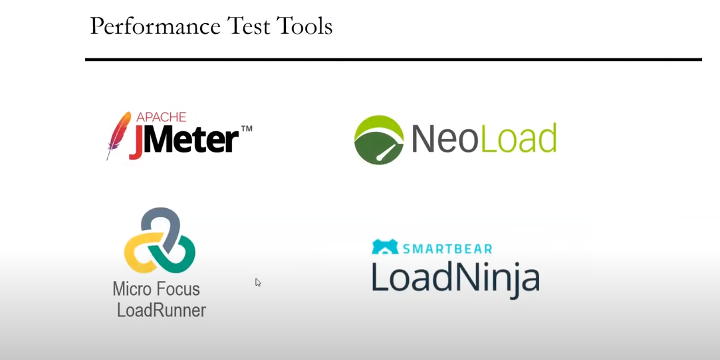

JMETER

* Free , open sources, platform independent
* Easy to Script (UI based)
* Pluggable samplers allow unlimited testing capabilities
* Data analysis and visualization plugins

Jemeter designed to load test functional behavior and measure performance.

Jemeter download

url = <https://jmeter.apache.org/>

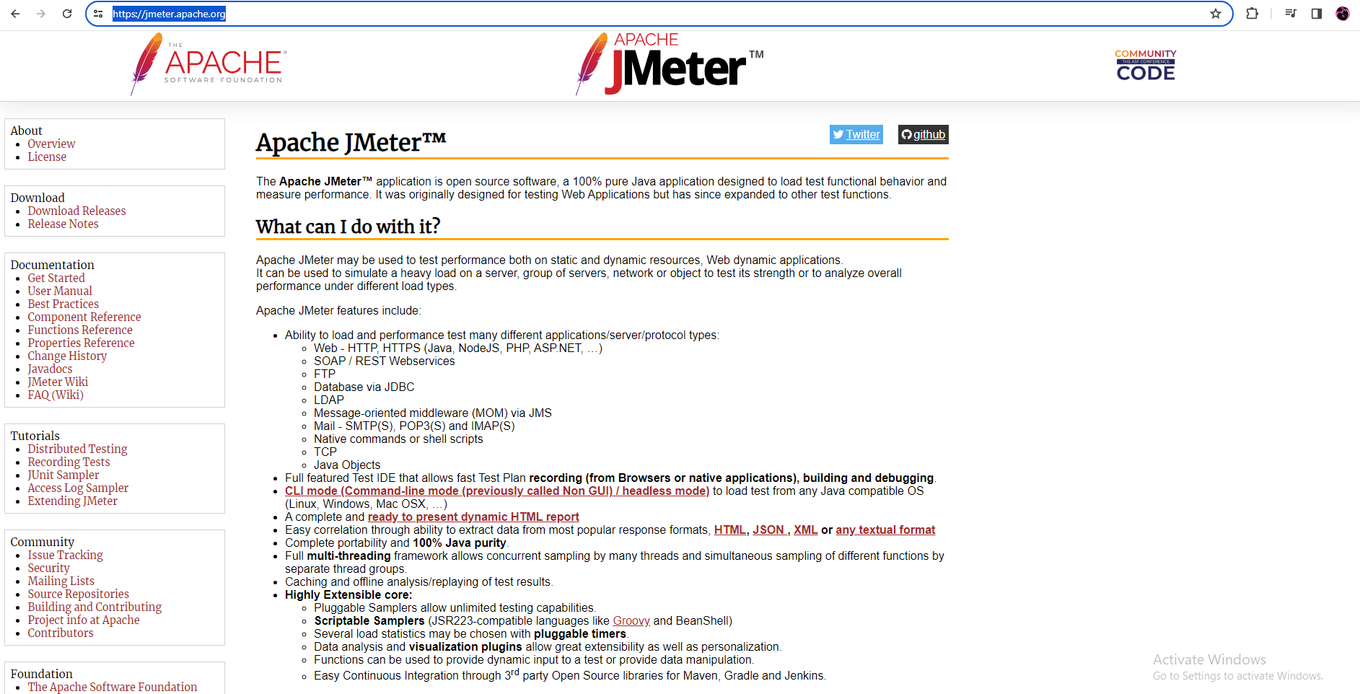

Click the download option

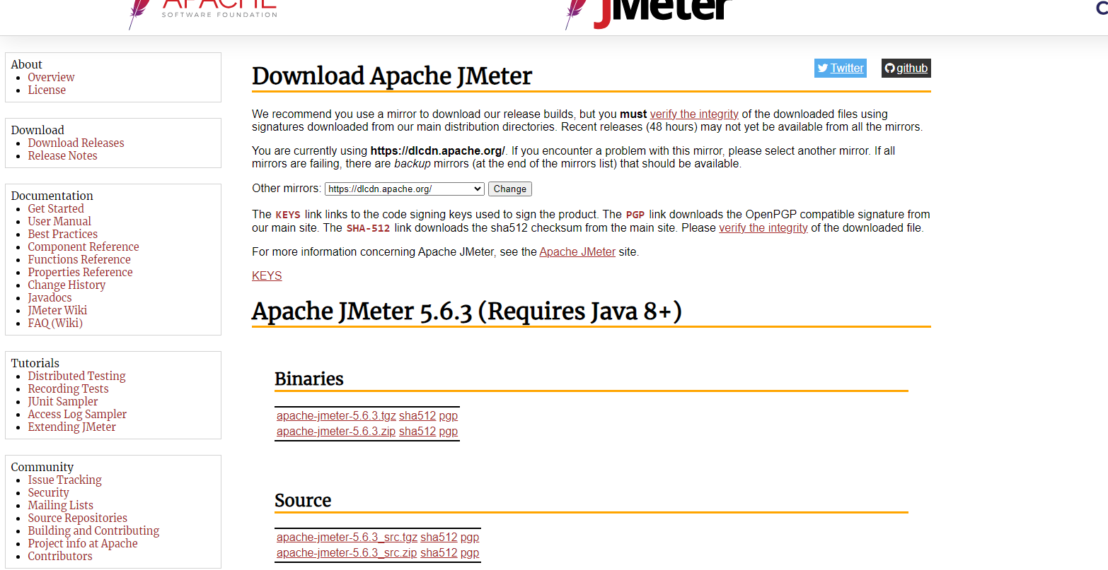

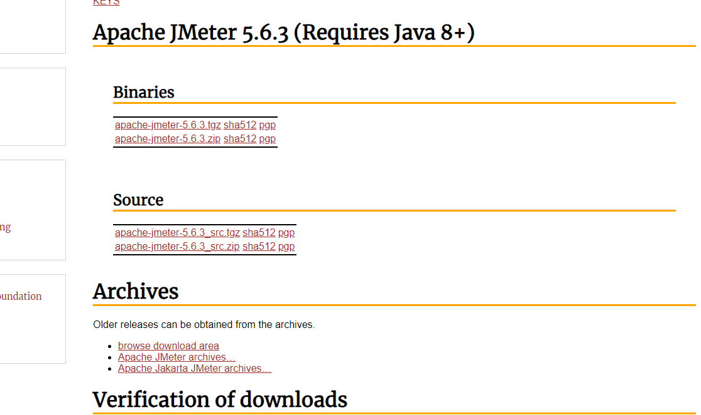

Click the zip file for windows

* unzip the folder

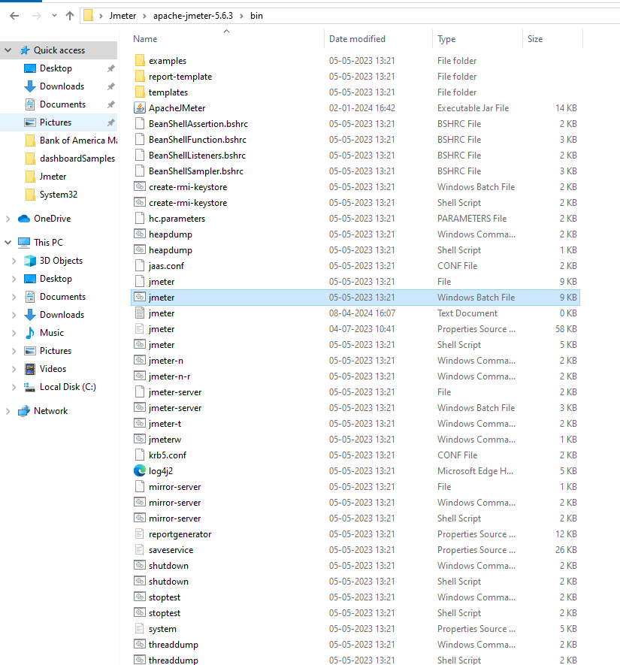

Bin path = C:\Users\C2TA\Desktop\Jmeter\apache-jmeter-5.6.3\bin

Click the jmeter windows batch file

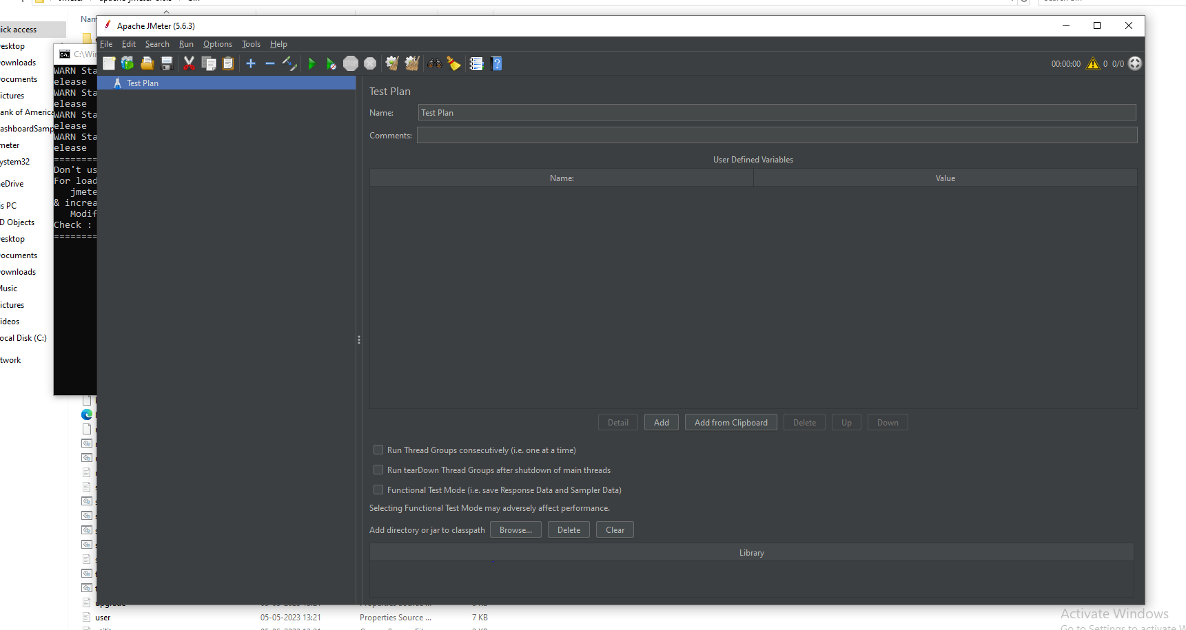

Jmeter UI is open