**­­­­Exercise No : 1**

Date : 10/10/2020

**Aim:**

To write a Python program to print the calendar of a given month and year.

**Python Program:**

import calendar as cal

month = int(input("Enter Month:"))

year = int(input("Enter Year:"))

if(year>999 and year<10000):

if(month>=1 and month<=12):

print(cal.month(year,month))

else:

print("Invalid Input")

else:

print("Invalid Input")

**Link:**

<mailto:http://103.53.53.18/mod/vpl/view.php?id=229>

**Output :**

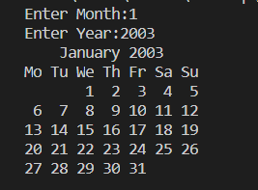

**Result :**

The above program is executed and the output is verified.