TorShield: A Kernel-Level Network Traffic Obfuscation System
V. S. Roshan  Amrita Vishwa Vidyapeetham  Chennai, India  roshansrikanth21@gmail.com | S. UdhayaKumar  Amrita Vishwa Vidyapeetham  Chennai, India  s_udhayakumar@ch.amrita.edu

Abstract—Network traffic analysis tools have become increasingly sophisticated, enabling various entities to monitor, classify, and restrict certain types of network communications. While application-level encryption protects content, metadata and traffic patterns often remain exposed to analysis. This paper presents TorShield, a Linux kernel module that obfuscates network traffic by applying XOR encryption to packet payloads at the kernel level. Operating transparently within the Linux Netfilter framework, TorShield intercepts and modifies TCP and UDP packets to protect them from basic inspection techniques. The system features dynamic key management with automatic rotation and a simple interface for manual key configuration. Performance evaluation shows minimal impact on system resources, with only 1% additional CPU usage under normal load and 0.5 ms additional processing time per packet. While not designed to replace comprehensive encryption solutions, TorShield demonstrates how kernel-level traffic obfuscation can complement existing security measures to enhance network privacy without requiring application-level modifications.

Index Terms—network security, traffic obfuscation, kernel modules, Linux, Netfilter
I. Introduction
The proliferation of sophisticated network traffic analysis techniques has significantly affected online privacy. Organizations, service providers, and other entities routinely inspect, classify, and potentially block or throttle specific types of network traffic, raising concerns about communication privacy and the ability to use network services without restriction or surveillance.
Although encryption protocols such as TLS secure the content of communications, they still expose metadata and traffic patterns that can reveal significant information about user activity. Some networks also block encrypted protocols outright or apply deep packet inspection (DPI) to analyze supposedly secure traffic. These challenges motivate supplementary approaches to protecting network communications.
This paper introduces TorShield, a lightweight kernel-level obfuscation mechanism that makes traffic analysis more difficult without requiring changes to applications. By transparently obfuscating packet payloads in the kernel, TorShield adds a layer of protection that complements existing encryption methods.
A. Problem Statement
Application-level encryption secures content but leaves metadata and traffic patterns exposed, which can be analyzed to determine the nature of a communication. Modern networks often employ aggressive monitoring, with some blocking encrypted protocols entirely or using DPI to analyze and restrict encrypted traffic.
Many existing obfuscation tools require application modifications or specialized configuration, which limits their accessibility and creates barriers to adoption, especially where users have limited control over the applications they use. The overhead of comprehensive encryption can also be prohibitive on resource-constrained devices or in high-throughput environments.
Furthermore, traffic fingerprinting techniques can identify applications from their communication patterns, such as packet timing, size distribution, and protocol behavior, even when the content is encrypted. TorShield aims to address these challenges with a kernel-level approach that operates transparently to applications while providing basic protection against traffic analysis.
B. Contributions
The main contributions of this work are as follows. First, we design and implement a Linux kernel module for transparent network traffic obfuscation that protects all applications on a system without application-level modifications or per-application configuration. Second, we integrate the module with the Linux Netfilter framework for efficient packet interception and modification in the kernel. Third, we provide dynamic key management with automatic key rotation, intended to reduce the effectiveness of statistical analysis and pattern recognition. Fourth, we evaluate the performance of the approach and analyze its security strengths and limitations in the context of modern network monitoring, clarifying where TorShield fits within a broader security strategy.
II. Related Work
Network traffic obfuscation has been an active area of research, with various approaches proposed to address privacy concerns and circumvent traffic analysis.
A. Application-Level Obfuscation
Tor [1] uses layered encryption and a network of relays to anonymize Internet connections, providing strong protection against many forms of surveillance. However, research has shown that Tor traffic can be identified through statistical analysis [2], enabling its detection and blocking in restrictive networks. Pluggable transports [3] extend Tor with obfuscation techniques that disguise its traffic as other protocols, but they typically require configuration that can be challenging for non-technical users. While these approaches provide strong protection, they often require users to change their workflow or adopt specialized client software.
B. Protocol Obfuscation
Protocol obfuscation disguises traffic to avoid detection and filtering. Tools such as obfs4 [4] and ScrambleSuit [5] modify protocol signatures to evade detection but require both client and server support. Format-transforming encryption [6] transforms encrypted data to resemble other protocols so that it appears benign to analysis tools, but it must be deployed as a proxy or pluggable transport at both ends of a connection. These approaches provide strong protection against detection but require coordinated deployment across endpoints, which limits their use when users control only one end of a communication channel.
C. Network-Layer Approaches
Closer to our work, several approaches operate at the network layer. IPsec [7] secures IP packets through encryption and authentication, but it focuses on encryption rather than obfuscation, and its distinct protocol signatures can be identified and blocked by restrictive networks. Traffic morphing [8] modifies packet size distributions to mimic benign traffic, but often requires complex implementation that may introduce significant overhead or compatibility issues. In-kernel encrypted tunnels such as WireGuard [9] provide strong authenticated encryption at near-native speed, but they establish a distinct tunnel between fixed endpoints rather than transparently obfuscating existing application flows.
TorShield differs by providing a lightweight, transparent obfuscation mechanism designed to minimize performance impact while protecting against basic traffic analysis. Because it operates in the kernel without application awareness, it offers a practical compromise between ease of deployment and traffic protection where transparency and performance are critical.
III. System Design
TorShield is a Linux kernel module that integrates with the Netfilter framework to intercept and modify network packets. It obfuscates TCP and UDP traffic by applying XOR encryption to packet payloads.
A. Architecture Overview
Fig. 1 shows the TorShield architecture and how it integrates with the Linux networking stack. The system comprises four functional components.
First, the Hook Function registers with Netfilter to intercept packets at the POST_ROUTING hook, after routing decisions have been made but before packets leave the system. This placement lets TorShield process all outgoing packets regardless of their source application while remaining compatible with existing applications.
Second, the Packet Handler identifies whether an intercepted packet is TCP or UDP and extracts its payload. It validates header formats, payload lengths, and protocol compliance to prevent crashes or vulnerabilities when manipulating packets at such a low level.
Third, the XOR Engine applies a byte-by-byte XOR with the current active key to each payload. While cryptographically simple, XOR prevents simple pattern matching and content inspection with minimal performance impact, and the original content is restored by applying the same operation again with the same key.
Finally, the Key Management component provides a Key Rotation Timer that changes the XOR key at defined intervals and a proc file interface (/proc/xor_key) for manual key configuration, combining the benefits of regular key changes with administrative control.
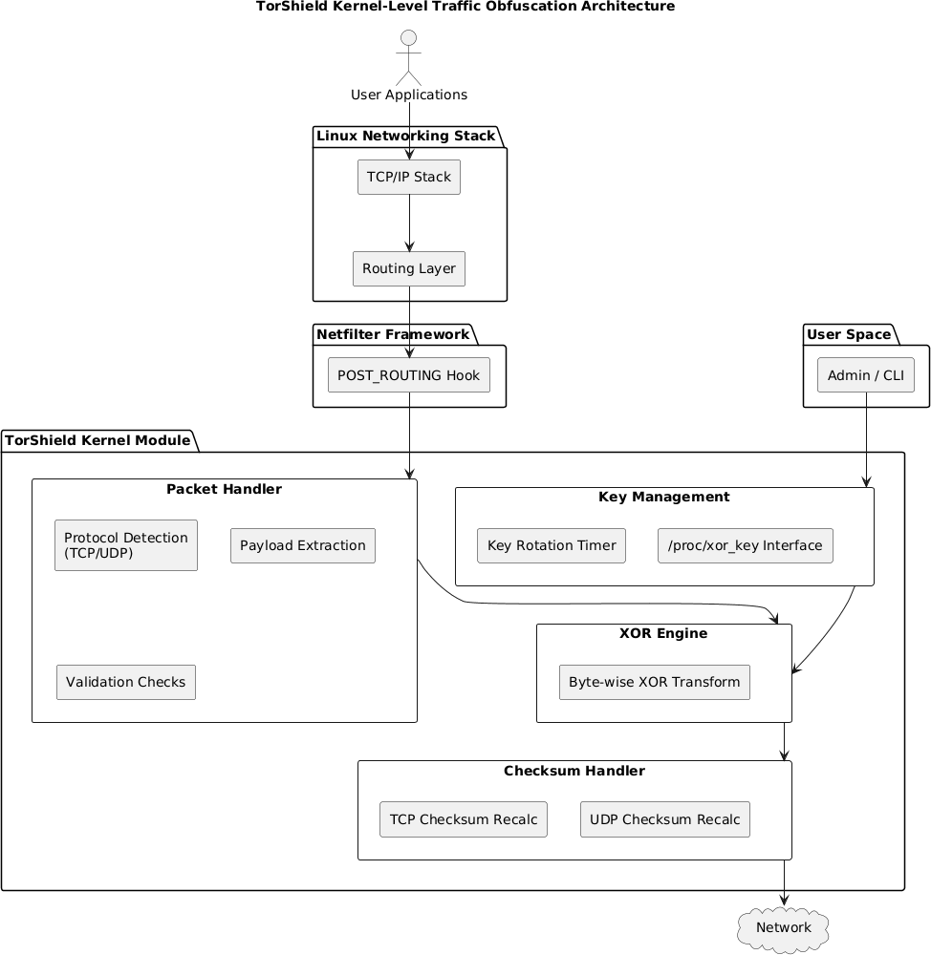
Fig. 1. TorShield kernel-level traffic obfuscation architecture and component data flow.
B. Data Flow
User applications generate traffic through standard interfaces, with no changes to their code or configuration. Packets traverse the Linux networking stack, including the IP and TCP/UDP layers, as usual. When they reach the Netfilter POST_ROUTING hook, TorShield intercepts them and checks their protocol: TCP and UDP packets are processed, and all other protocols pass through unmodified to preserve compatibility.
For TCP and UDP packets, TorShield extracts the payload, applies XOR encryption with the current key, and updates checksums as needed to ensure proper delivery. At destination systems that run TorShield with a matching key, the same XOR operation restores the original payload. This symmetry enables transparent end-to-end obfuscation when TorShield is deployed on both systems, and also allows one-sided deployment in which only the originating system obfuscates outgoing traffic against local monitoring.
IV. Implementation
TorShield is implemented as a loadable kernel module for Linux kernel version 5.10 and above, using the Netfilter framework to intercept and modify packets efficiently.
A. Core Components
The Netfilter hook registration integrates TorShield with the networking stack by registering a hook at POST_ROUTING, as shown in Listing 1. Module initialization also starts the key rotation timer and creates the proc interface, and the exit routine releases these resources.
Listing 1. Netfilter hook registration
static struct nf_hook_ops nfho;

static int __init xor_obfuscation_init(void)
{
int ret;
/* Initialize the hook structure */
nfho.hook = hook_func;
nfho.hooknum = NF_INET_POST_ROUTING;
nfho.pf = PF_INET;
nfho.priority = NF_IP_PRI_FIRST;
/* Register the hook */
ret = nf_register_net_hook(&init_net, &nfho);
if (ret < 0) {
printk(KERN_ERR "TorShield: Failed to "
"register netfilter hook\n");
return ret;
}
/* Initialize key rotation timer */
timer_setup(&key_rotation_timer, rotate_key, 0);
mod_timer(&key_rotation_timer,
jiffies + KEY_ROTATION_INTERVAL * HZ);
/* Create proc interface for key management */
proc_entry = proc_create("xor_key", 0644, NULL,
&proc_fops);
if (!proc_entry) {
printk(KERN_ERR "TorShield: Failed to "
"create proc entry\n");
nf_unregister_net_hook(&init_net, &nfho);
return -ENOMEM;
}
printk(KERN_INFO "TorShield: Module loaded "
"with initial key: 0x%02X\n", xor_key);
return 0;
}

static void __exit xor_obfuscation_exit(void)
{
/* Clean up resources */
del_timer_sync(&key_rotation_timer);
proc_remove(proc_entry);
nf_unregister_net_hook(&init_net, &nfho);
printk(KERN_INFO "TorShield: Module unloaded\n");
}

module_init(xor_obfuscation_init);
module_exit(xor_obfuscation_exit);

The hook function is the entry point for packet processing. It identifies packets of the target protocols, obfuscates their payloads, and recalculates checksums, as outlined in Listing 2.
Listing 2. Hook function implementation
Function hook_func(priv, skb, state):
Declare ip_header, tcp_header, udp_header, payload
Declare payload_len = 0
// Basic validation
If skb is NULL: Return NF_ACCEPT
ip_header = extract_ip_header(skb)
If ip_header is NULL: Return NF_ACCEPT
// Process only TCP and UDP packets over IPv4
If ip_header.protocol == TCP:
tcp_header = extract_tcp_header(skb)
If tcp_header is NULL: Return NF_ACCEPT
payload = get_tcp_payload_pointer(tcp_header)
payload_len = calculate_tcp_payload_length(
ip_header, tcp_header)
If payload_len > 0:
Apply_XOR_Transformation(payload, payload_len)
// Recalculate TCP checksum
Reset tcp_header.checksum
skb.csum = Compute_Partial_Checksum(
tcp_header)
skb.ip_summed = CHECKSUM_PARTIAL
skb.csum_start = Compute_Checksum_Start(
tcp_header, skb)
skb.csum_offset = Get_Checksum_Offset(TCP)
Else If ip_header.protocol == UDP:
udp_header = extract_udp_header(skb)
If udp_header is NULL: Return NF_ACCEPT
payload = get_udp_payload_pointer(udp_header)
payload_len = calculate_udp_payload_length(
udp_header)
If payload_len > 0:
Apply_XOR_Transformation(payload, payload_len)
// Recalculate UDP checksum if present
If udp_header.checksum != 0:
Reset udp_header.checksum
udp_header.checksum = Compute_UDP_Checksum(
ip_header, udp_header)
// Ensure non-zero checksum
If udp_header.checksum == 0:
udp_header.checksum = CSUM_MANGLED_0
Return NF_ACCEPT

The XOR encryption/decryption function is the core obfuscation routine, transforming payloads with minimal computational overhead (Listing 3).
Listing 3. XOR encryption/decryption function
static u8 xor_key = 0x5A; /* Default XOR key */

static void xor_encrypt_decrypt(unsigned char *data,
unsigned int len)
{
unsigned int i;
/* Safety check for NULL data or zero length */
if (!data || len == 0)
return;
/* Apply XOR transformation to each byte */
for (i = 0; i < len; i++)
data[i] ^= xor_key;
}

To add temporal key variation, the key rotation timer changes the XOR key at configurable intervals (Listing 4).
Listing 4. Key rotation function
#define KEY_ROTATION_INTERVAL 300 /* in seconds */
static struct timer_list key_rotation_timer;

static void rotate_key(struct timer_list *t)
{
/* Simple rotation: prime number addition */
xor_key = (xor_key + 17) % 256;
printk(KERN_INFO "TorShield: XOR key rotated "
"to: 0x%02X\n", xor_key);
/* Reschedule timer for next rotation */
mod_timer(&key_rotation_timer,
jiffies + KEY_ROTATION_INTERVAL * HZ);
}

For administrative control, the proc file interface allows the key to be read and set manually (Listing 5).
Listing 5. Proc file interface for key management
static struct proc_dir_entry *proc_entry;

static ssize_t proc_read(struct file *file,
char __user *buffer, size_t count,
loff_t *pos)
{
char buf[16];
int len;
if (*pos > 0)
return 0;
/* Format current key value as hexadecimal */
len = snprintf(buf, sizeof(buf), "0x%02X\n",
xor_key);
/* Copy to user space */
if (copy_to_user(buffer, buf, len))
return -EFAULT;
*pos += len;
return len;
}

static ssize_t proc_write(struct file *file,
const char __user *buffer, size_t count,
loff_t *pos)
{
char buf[4];
unsigned long key_val;
/* Limit input size */
if (count > 3) return -EINVAL;
/* Copy from user space */
if (copy_from_user(buf, buffer, count))
return -EFAULT;
buf[count] = '\0';
/* Parse hexadecimal value */
if (kstrtoul(buf, 16, &key_val)) return -EINVAL;
if (key_val > 255) return -EINVAL;
/* Update key */
xor_key = (u8)key_val;
printk(KERN_INFO "TorShield: XOR key manually "
"set to: 0x%02X\n", xor_key);
return count;
}

/* Proc file operations */
static const struct proc_ops proc_fops = {
.proc_read = proc_read,
.proc_write = proc_write,
};

B. Safety Features
The implementation includes several features to ensure system stability. Boundary validation checks packet length fields against actual buffer sizes and carefully computes payload positions, so that packet data is always accessed within valid bounds and buffer overruns are prevented. Error handling checks the result of every critical operation, including memory operations, null pointers, and unexpected packet formats, so that failures are handled gracefully. Finally, checksum handling recalculates TCP and UDP checksums after payload modification, so that transformed packets remain valid according to protocol specifications and are not rejected by receiving systems.
V. Evaluation
We evaluated TorShield’s functionality, performance impact, and security characteristics.
A. Functionality Testing
Module loading tests confirmed that the module loads and initializes successfully on Ubuntu 20.04, CentOS 8, and Debian 11 with kernel versions 5.4, 5.10, and 5.15. Functionality tests verified that TCP and UDP payloads were correctly transformed by the XOR operation, that checksums were correctly recalculated, and that non-target protocols were unaffected. Stability tests ran the module continuously for over 72 hours under various network loads without degradation. End-to-end tests confirmed successful communication between systems running TorShield with matching keys, verifying the bidirectional nature of the obfuscation and its transparency to applications. All tests were successful.
B. Performance Analysis
Table I summarizes the performance impact. Owing to the lightweight XOR algorithm, the overhead was negligible for most common usage scenarios.
TABLE I
Performance Metrics Under Load
Metric | Impact | Notes
CPU Usage | Low | +1% usage (normal load)
Memory Usage | Minimal | 50 KB kernel footprint
Latency | 0.5 ms | Per-packet processing
Throughput | −5% | Under heavy load (1 Gbps+)
Conn. Setup | None | No extra delay

Fig. 2 compares throughput with and without TorShield. The impact remains minimal across load levels and becomes noticeable only at the highest traffic volumes. The performance impact also remains relatively constant regardless of the number of connections, making TorShield suitable for workloads ranging from light interactive use to high-throughput servers.
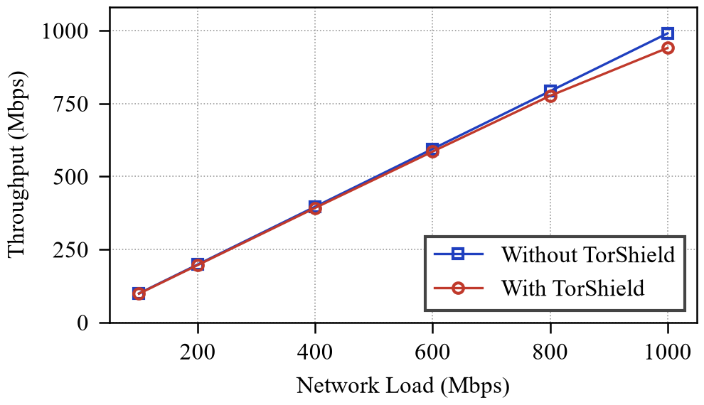
Fig. 2. Throughput comparison with and without TorShield under varying network loads.
C. Security Analysis
We analyzed TorShield’s security characteristics against its intended threat model to understand both its capabilities and its limitations.
1) Strengths: TorShield works without application awareness, so it can protect traffic from applications that lack built-in security features or cannot be modified, which is valuable in enterprise environments with legacy applications that handle sensitive data. Automatic key rotation limits the effectiveness of statistical analysis that might otherwise identify patterns in obfuscated traffic and complicates attempts to reverse-engineer the obfuscation. Kernel-level integration also makes TorShield difficult to detect or bypass from user space, providing protection against application-level local monitoring tools.
2) Limitations: Single-byte XOR is vulnerable to known-plaintext attacks, so an attacker who can predict portions of the original content may recover the key. Packet headers remain unmodified and visible, exposing metadata such as the timing and volume of communications. Key distribution lacks a secure channel and requires manual coordination of matching keys, which is challenging when systems are geographically distributed or managed by different teams. Because the same key is used for encryption and decryption, the system also cannot provide different levels of access to different communication partners.
Strongly obfuscated payloads also raise traffic entropy, and censorship systems have begun flagging high-entropy, fully encrypted flows with lightweight heuristics [10]. Obfuscation that blends with permitted protocols, rather than merely randomizing payloads, is therefore required to resist such detection.
TorShield is designed to protect against basic packet inspection and traffic classification, simple DPI systems, and passive network monitoring. It is not designed to protect against sophisticated cryptanalysis, targeted attacks by adversaries with knowledge of the obfuscation system, or endpoint compromise.
VI. Project Output
Fig. 3 shows TorShield in operation, including module loading, automatic key rotation, and a manual key update through /proc/xor_key.

# insmod torshield.ko
TorShield: Module loaded with initial key: 0x5A
# dmesg | grep TorShield
[42187.305612] TorShield: Module loaded with initial
key: 0x5A
[42487.425318] TorShield: XOR key rotated to: 0x6B
[42787.538421] TorShield: XOR key rotated to: 0x7C
# cat /proc/xor_key
0x7C
# echo "8A" > /proc/xor_key
# dmesg | grep TorShield
[43125.684932] TorShield: XOR key manually set to:
0x8A
Fig. 3. TorShield module output demonstrating load, key rotation, and manual key update via /proc/xor_key.
VII. Deployment Considerations
A. Installation Requirements
TorShield has modest requirements: a Linux kernel version 4.4 or newer, root access to install and configure the module, standard build tools such as gcc and make, and kernel headers matching the running kernel.
B. Deployment Patterns
TorShield supports several deployment patterns. In end-to-end deployment, it is installed on both client and server with matching keys, protecting the entire channel between them. In gateway deployment, it runs on network gateways to protect internal traffic as it crosses potentially monitored external networks, without installation on individual endpoints. In mixed deployment, obfuscated tunnels are created between specific systems to selectively protect sensitive channels within a larger infrastructure.
C. Security Recommendations
We recommend the following practices: periodic manual key updates in addition to automatic rotation, to mitigate long-term statistical analysis; combining TorShield with application-level encryption such as TLS for layered protection; limiting deployment to controlled environments where endpoints can be secured, since compromised endpoints expose the keys; and introducing randomized delays or padding to obscure timing and size characteristics.
VIII. Future Directions
A. Short-Term Improvements
Near-term improvements include more sophisticated key rotation algorithms to improve resistance to statistical analysis; selective filtering by source or destination address, protocol, or other criteria to focus processing on sensitive traffic; support for protocols beyond TCP and UDP; and a procfs statistics interface for runtime monitoring and tuning.
B. Long-Term Research
Longer-term directions include support for stronger obfuscation algorithms than XOR, integration with secure key exchange to automate key distribution between endpoints, variable-length traffic padding to obscure traffic patterns, and partial header obfuscation to reduce exposed metadata, all while preserving transparent kernel-level operation.
IX. Conclusion
This paper presented TorShield, a Linux kernel module that obfuscates network traffic by applying XOR encryption to packet payloads. Built on the Linux Netfilter framework, TorShield demonstrates a practical approach to improving privacy against basic traffic analysis while remaining compatible with existing applications and protocols. Our evaluation shows that it provides transparent obfuscation with minimal performance impact. While not a replacement for strong encryption, TorShield offers an additional layer of protection that complements other security measures, and its open design provides a foundation for further research on kernel-level traffic obfuscation.
References
[1] R. Dingledine, N. Mathewson, and P. Syverson, “Tor: The second-generation onion router,” in Proc. 13th USENIX Security Symp., 2004, pp. 303–320.
[2] X. Bai, Y. Zhang, and X. Niu, “Traffic identification of Tor and Web-Mix,” in Proc. 8th Int. Conf. Intelligent Systems Design and Applications (ISDA), 2008, vol. 1, pp. 548–551.
[3] D. Fifield, N. Hardison, J. Ellithorpe, E. Stark, D. Boneh, R. Dingledine, and P. Porras, “Evading censorship with browser-based proxies,” in Proc. Privacy Enhancing Technologies Symp. (PETS), 2012, pp. 239–258.
[4] Y. Angel, “obfs4 (The obfourscator) specification,” 2014. [Online]. Available: https://gitlab.com/yawning/obfs4
[5] P. Winter, T. Pulls, and J. Fuss, “ScrambleSuit: A polymorphic network protocol to circumvent censorship,” in Proc. 12th ACM Workshop on Privacy in the Electronic Society (WPES), 2013, pp. 213–224.
[6] K. P. Dyer, S. E. Coull, T. Ristenpart, and T. Shrimpton, “Protocol misidentification made easy with format-transforming encryption,” in Proc. ACM SIGSAC Conf. Computer and Communications Security (CCS), 2013, pp. 61–72.
[7] S. Kent and K. Seo, “Security architecture for the Internet Protocol,” RFC 4301, Dec. 2005.
[8] C. V. Wright, S. E. Coull, and F. Monrose, “Traffic morphing: An efficient defense against statistical traffic analysis,” in Proc. Network and Distributed System Security Symp. (NDSS), 2009.
[9] J. A. Donenfeld, “WireGuard: Next generation kernel network tunnel,” in Proc. Network and Distributed System Security Symp. (NDSS), 2017.
[10] M. Wu et al., “How the Great Firewall of China detects and blocks fully encrypted traffic,” in Proc. 32nd USENIX Security Symp., 2023, pp. 2653–2670.

