**1. Xserver Side setup on ubuntu platform:**

------------------------------------------------------------

Copy the server-side files to a folder and assign them execute permission with below command.

below are the files needed for server-side container.

docker-chrome-xserv

**dockerfile**

**run_chrome_container.sh**

cd docker-chrome-xserv

chmod -R 777 *

Right now, whenever we are connecting to ubuntu server we are starting the container and redirecting the browser app via ssh to client.

So best way to achieve this we can configure above scripts to run whenever client connects to the ubuntu server. So, we need to do below changes to make this happen.

put these two files.

**run_chrome_container.sh**

**dockerfile**

in the /etc/profile.d/

with execute permission. so, whenever client connection connects then docker container is started. (This is workaround solution when we don't want to execute commands to run the container script from client side .bat file)

and update the ipaddress in the

run_chrome_container.sh file on this statement

export DISPLAY = 10.0.0.5:10.0

replace this entry with correct client side ipaddress so that linux apps are redirected to specific client.

and 10.0 is the desktop number which will be configured in the xming app on the client side in the windows machine.

Now with this configuration whenever user connects to this ubuntu server with ssh, docker container with browser is started and display is redirected to above mentioned ipaddress. so if you are seeing multiple browser session popped up on the client side then reason will be due to this profile based script execution.

Since this is ssh based redirection client side need to be configured first before executing server-side script. Otherwise we get standard error cannot be connected to X display.

If we don't want script need to be executed on each ssh connection, then we are free to configure as per your need.

**2. Client-side windows configuration:**

--------------------------------------------------

Files needed on the client side.

**DockerXstart.bat**

software’s need to be installed on the windows 10 machine.

xming for rendering the GUI

<https://sourceforge.net/projects/xming/>

Putty for doing X11 forwarding connection

<https://www.putty.org/>

Once xming is installed, configure the xming to start desktop number 10.0 for rendering the GUI, as shown below.

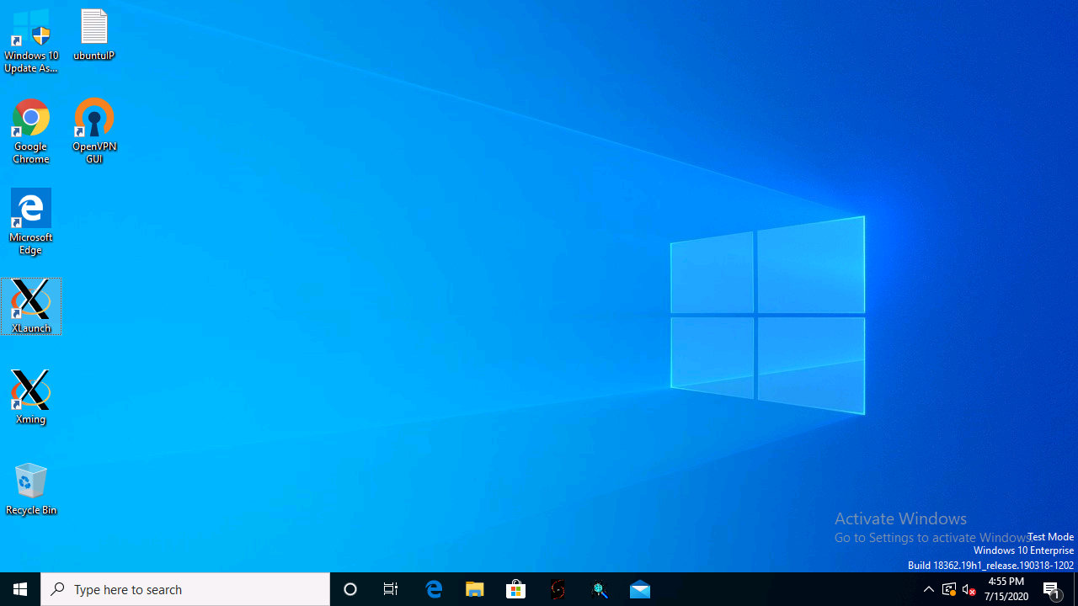

Launch xlaunch and specify desktop number 10 as it is specified in the server side desktop. If we changed this value in the script then we can update the same here.

export DISPLAY = 10.0.0.5:10.0

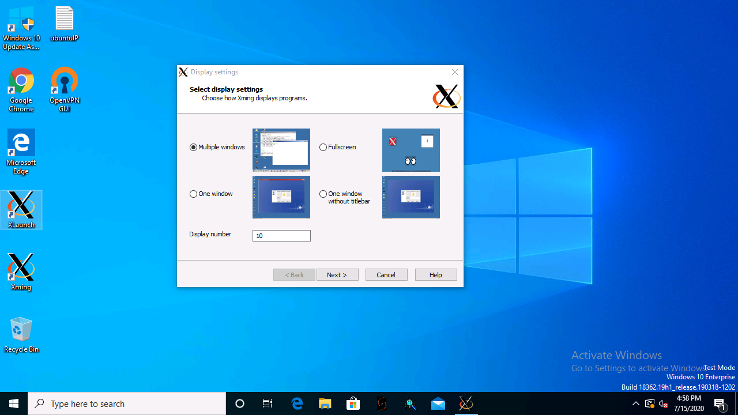

Click next and make sure below selection is made.

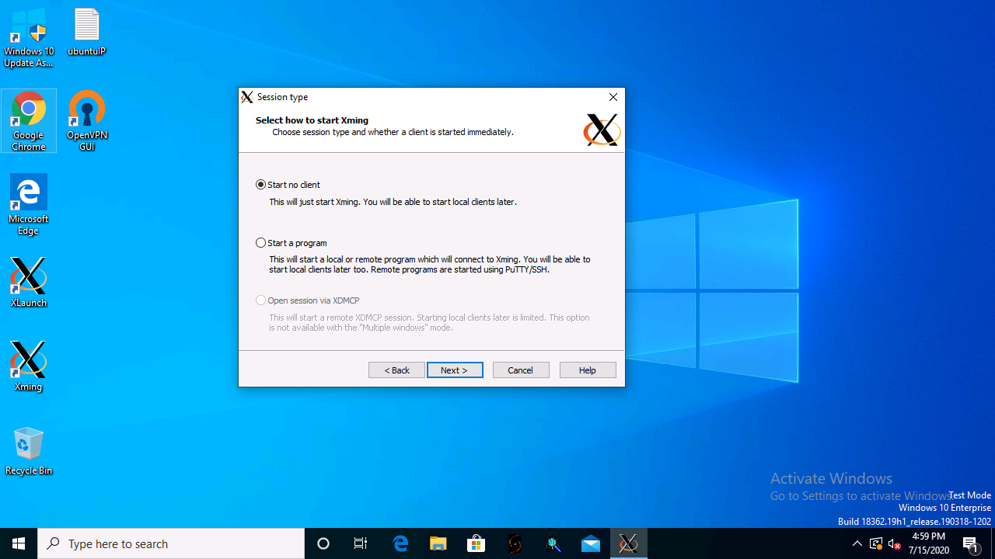

Select No access control option on this page as shown below.

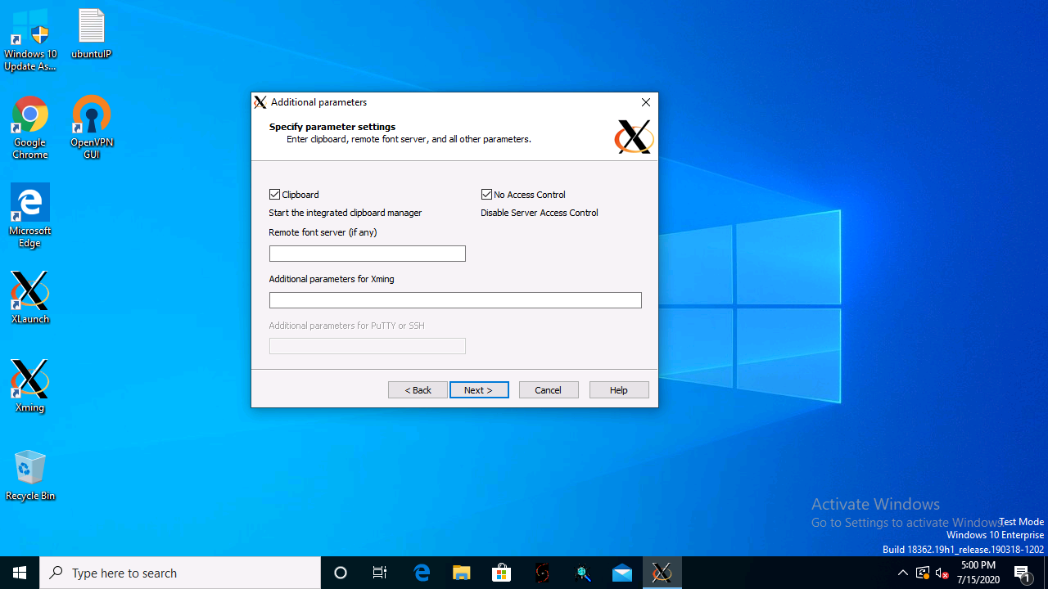

Click finish and there will be tray icon showing running of xming client.

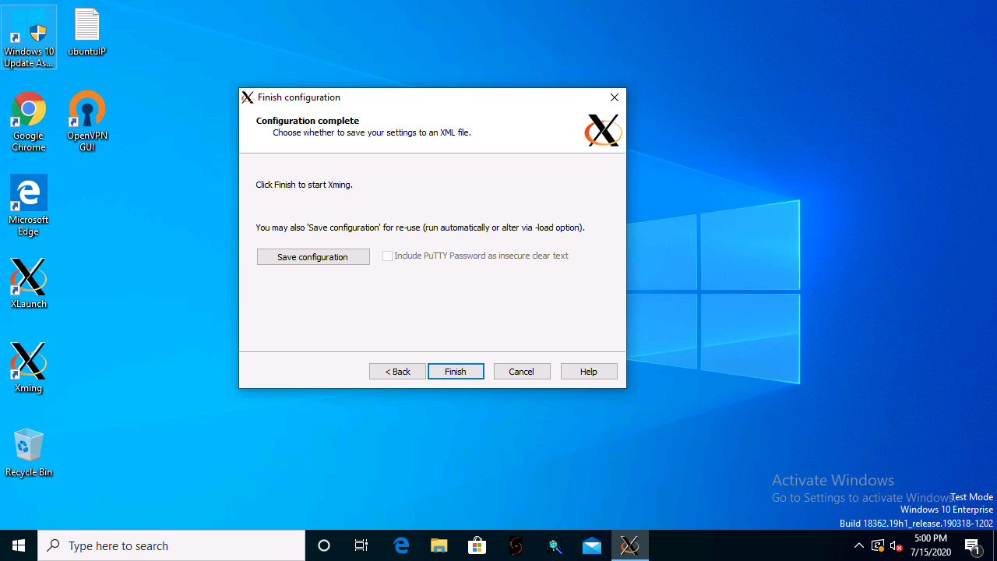

Now once xming server is running, now we need to connect using ssh with x11 forwarding, so need to click on the dockerXstart.bat file.

And basically, it executes below command internally. If server is different than the one specified, then need to edit the bat file and specify the same.

"C:\Program Files\PuTTY\putty.exe" -ssh -X 52.249.178.57 -l demo -pw password321#

Then this will initial ssh connection with X11 forwarding using putty and then server prompts for the password. So, for this 52.249.178.57 machine password is

Password321#

So current bat file connects to this specific machine. So, if it asks for the password again please enter the same password again.

Once everything is good then you should see container started and browser showing up on the screen in the xming window. Then you can browse to the any URL and work on the same and it runs with same performance as the browser running on the local machine.

**Xming window rendering youtube session looks like below.**

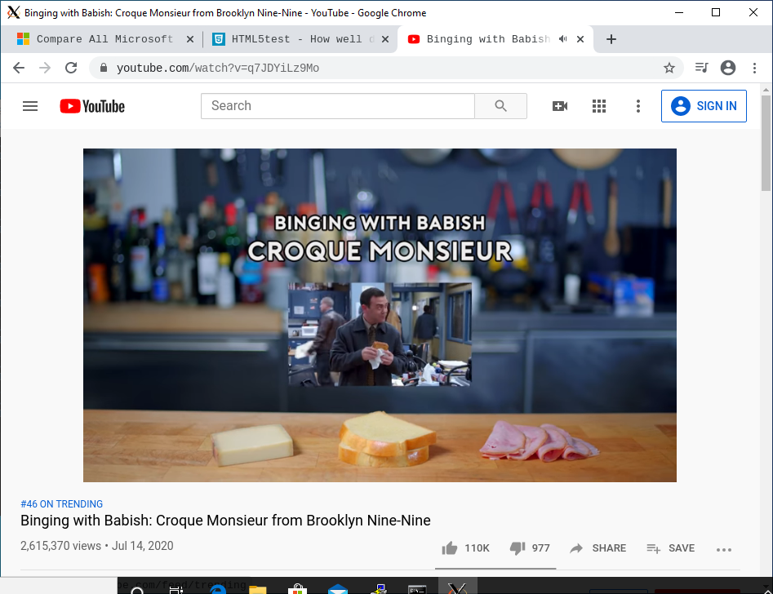

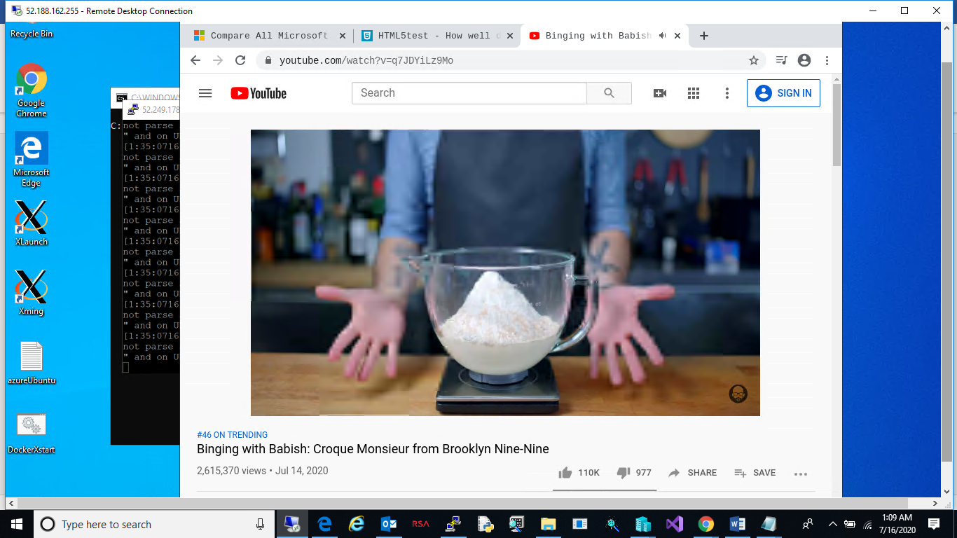

For office 365 apps login need to use the below URL for login with account details’

<https://www.office.com/?auth=1>

Microsoft account details:

[dellwysedemo@gmail.com](mailto:dellwysedemo@gmail.com)

Wyse#123

For Google docs can use below URL’s and accounts.

<https://drive.google.com/drive/my-drive>

[dellwysedemo@gmail.com](mailto:dellwysedemo@gmail.com)

Wyse#123

And existing setup available on these azure machines to try out.

Ubuntu Server

52.249.178.57

demo

Password321#

Windows machine as client – since we cannot access our local machine from azure without VPN this is assumed as client to Ubuntu server.

52.188.162.255

Demo

Password321#

After connecting to above windows machine, we can follow the beginning of the document to try the complete setup.

Along with docker container with browser we can launch other linux app, after logging in to putty session on ubuntu server and setting DISPLAY parameter properly we can launch apps from the command line like this.

gedit &

firefox &

similar for other apps.

**Additional Info:**

Details of how xming and putty works can be seen I nthe forum.

follow the procedure mentioned here to launch putty and configure xming client.

<https://www.youtube.com/watch?v=YLAYfwUPj7s>

or

<https://www.youtube.com/watch?v=QRsma2vkEQE>

**Source Code and Scripts:**

All the setup configuration and script files are available in this path.

<https://git.cpgswtools.com/projects/CCSW/repos/roshan/browse/Container/AltOS/Scripts/docker-chrome-xserv>