

Veg. Snacks

Aloo Sadheko ………………………………………………….150

Aloo Tikka ……………………………………………………….200

French Fries ……………………………………………………150

Soyabean Chilly ………………………………………………220

Chips Chilly ……………………………………………………..150

Mustang Aloo …………………………………………………150

Cheese Balls ……………………………………………………200

Mushroom Chilly …………………………………………….300

Paneer Chilly …………………………………………………..300

Pakoda ……………………………………………………………150

Plain Peanuts ………………………………………………….100

Peanuts Sadheko …………………………………………….150

Dry Papad …………………………………………………………80

Fried Papad ………………………………………………………80

Masala Papad …………………………………………………150

Kaju Fried ……………………………………………………….275

Garlic Poleko …………………………………………………..130

Garlic Fried ……………………………………………………..150

Sadheko Bhatmas …………………………………………..150

APPETIZERS

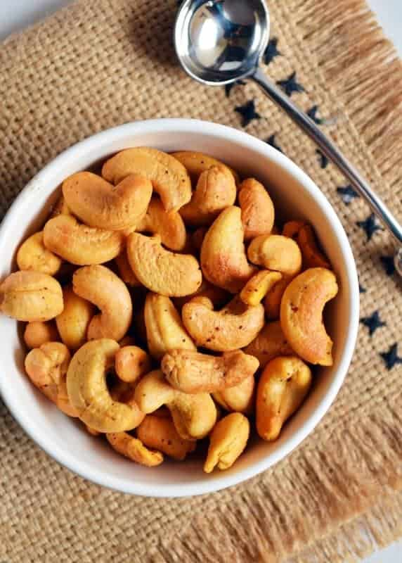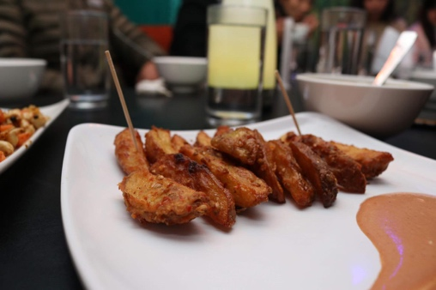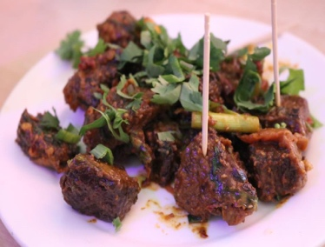

Non-Veg

Buff Snacks

Buff Sekuwa /Tass /Sukuti ……………………………………170

Buff Choila …………………………………………………………..170

Buff Chilly …………………………………………………………….250

Buff Sausage (4 pcs) …………………………………………….180

Sausage Chilly ………………………………………………………200

Sukuti Sadheko ……………………………………………………200

OPEN: SUN-SAT 6AM-10PM

LIVE MUSIC: EVERY FRIDAY AND SATURDAY 6PM-9PM

Milantole, Bich Bazzar, Dhading Bensi, Dhading,

Bagmati Province, Nepal

010-520 392

+977 9841546941

+977 9860426028

pajulounge@gmail.com

**FOOD MENU**

PAJU LOUNGE AND FAMILY RESTAURANT