

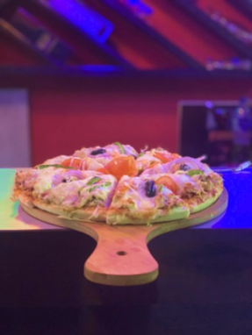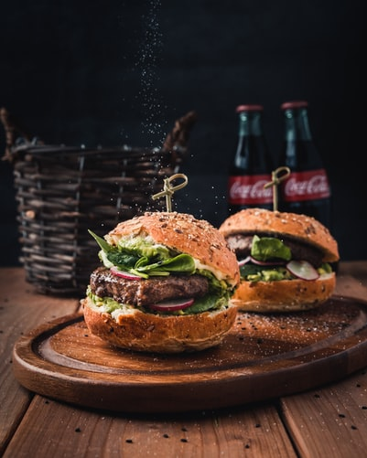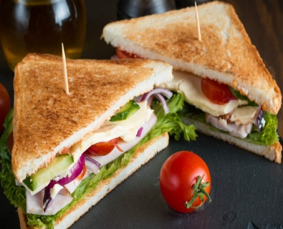

PIZZA

Veg. Pizza ………………………………………………………….…...450

Mushroom Pizza …………………………………………………….450

Sausage Pizza …………………………………………………………450

Salami Pizza ……………………………………………………………500

Cheese Pizza …………………………………………………………..450

Mix Pizza ………………………………………………………………..500

(served with Tabasco sauce)

(addition of extra cheese 50)

..

BURGER

Veg. Burger …………………………………………………………150

Egg Burger ……………………………………………………..…..160

Chicken Burger ……………………………………………………160

Cheese Burger …………………………………………………….180

Salami Burger ……………………………………………………..200

*(served with fries)*

..

CHEESE, BREAD & BUN

SANDWICHES

Veg. Sandwich ………………………………………………....150

Chicken Sandwich …………………………………………….180

Egg Sandwich ……………………………………………………180

Veg. Sauté ………………………………………………………..180

.

OPEN: SUN-SAT 6AM-10PM

LIVE MUSIC: EVERY FRIDAY AND SATURDAY 6PM-9PM

Milantole, Bich Bazzar, Dhading Bensi, Dhading,

Bagmati Province, Nepal

010-520 392

+977 9841546941

+977 9860426028

pajulounge@gmail.com

**FOOD MENU**

PAJU LOUNGE AND FAMILY RESTAURANT