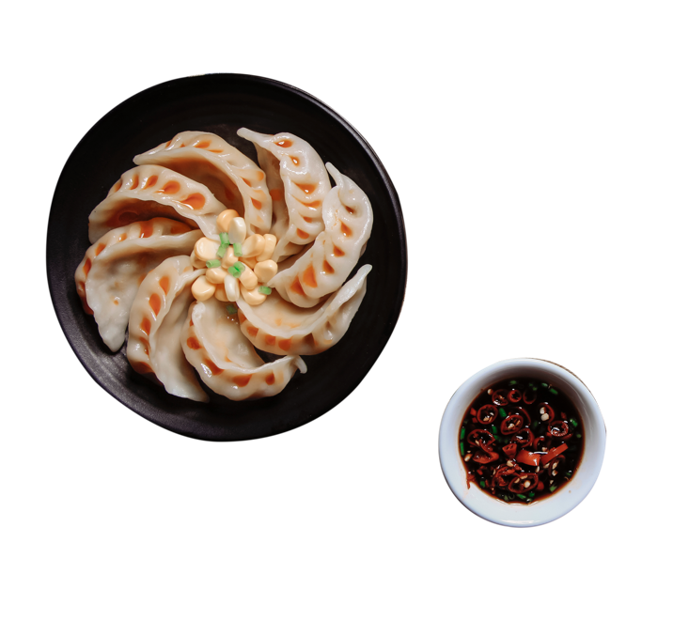

MAIN COURSE

K.F.C Chicken ...........................................300

Crispy Chicken .........................................300

Chicken 65 (special) .................................350

*Served with salad*

Grilled Chicken ........................................500

*Served with salad*

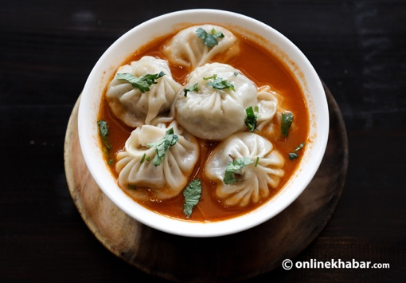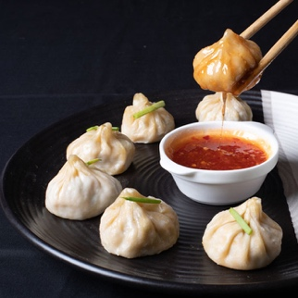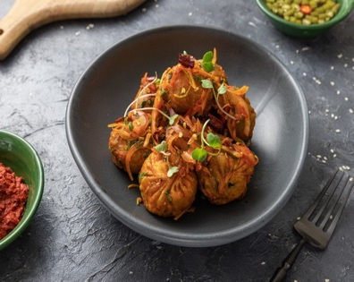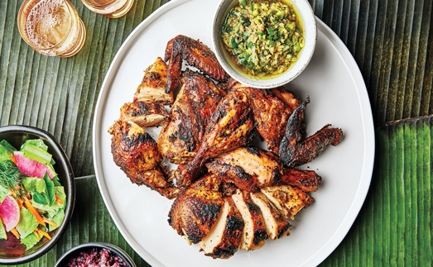

Buff Momo

Steam Momo .........................................................140

Fried Momo ...........................................................160

Steam C. Momo .....................................................170

Fried C. Momo .......................................................180

Sadheko Momo .....................................................180

Jhol Momo .............................................................150

Chicken Momo

Steam Momo .........................................................140

Fried Momo ...........................................................160

Steam C. Momo .....................................................170

Fried C. Momo .......................................................180

Sadheko Momo ......................................................180

Jhol Momo .............................................................150

MO:MO

Veg. Momo (Paneer)

Steam Momo ..........................................................140

Fried Momo ............................................................160

Steam C. Momo ......................................................170

Fried C. Momo ........................................................180

Sadheko Momo ......................................................180

Jhol Momo ..............................................................150

OPEN: SUN-SAT 6AM-10PM

LIVE MUSIC: EVERY FRIDAY AND SATURDAY 6PM-9PM

Milantole, Bich Bazzar, Dhading Bensi, Dhading,

Bagmati Province, Nepal

010-520 392

+977 9841546941

+977 9860426028

pajulounge@gmail.com

**FOOD MENU**

PAJU LOUNGE AND FAMILY RESTAURANT