M Abdullah Roshaan
Section: A
Web-Lab #10
------------------------------------
Task 1:
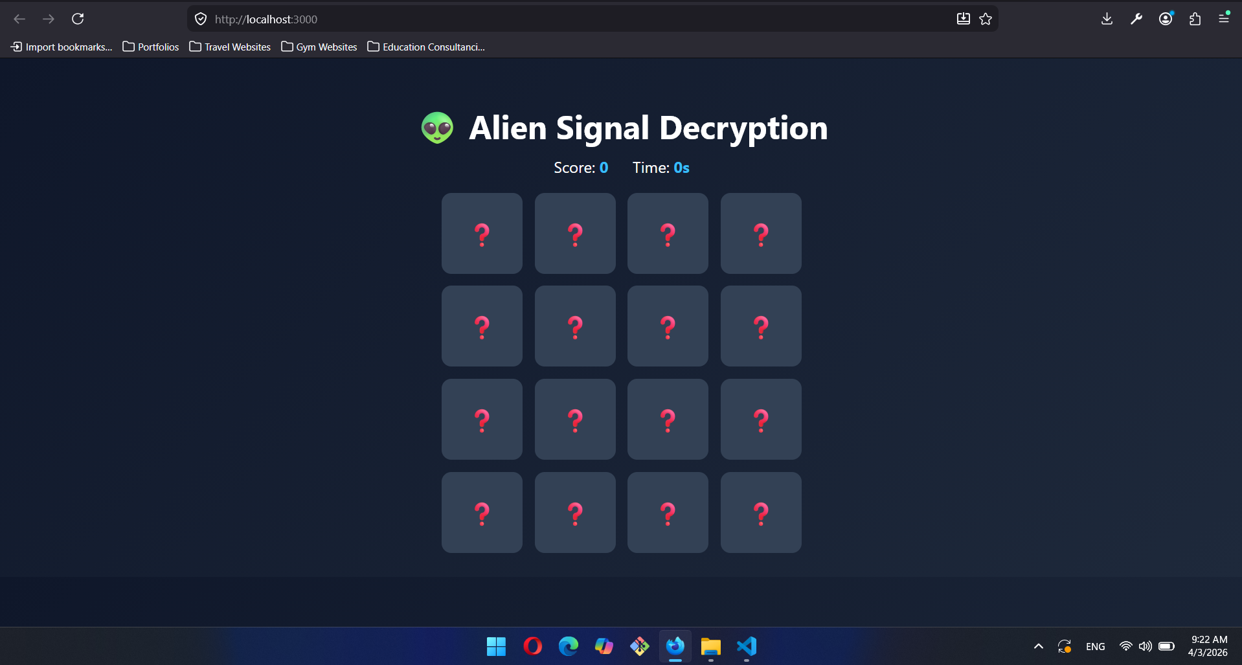
App.Js:
import React, { useState, useEffect } from "react";
import Card from "./Card";
import "./App.css";

function App() {
const [cards, setCards] = useState([]);
const [flippedCards, setFlippedCards] = useState([]);
const [matchedCards, setMatchedCards] = useState([]);
const [score, setScore] = useState(0);
const [time, setTime] = useState(0);
const [gameStarted, setGameStarted] = useState(false);

useEffect(() => {
const signals = ["👽", "🛸", "🌌", "🔭", "🪐", "☄️", "🚀", "🌠"];

const duplicated = [...signals, ...signals];

const shuffled = duplicated
.map(signal => ({ id: Math.random(), signal }))
.sort(() => Math.random() - 0.5);

setCards(shuffled);
}, []);

const handleCardClick = (card, index) => {
if (
flippedCards.length === 2 ||
flippedCards.includes(index) ||
matchedCards.includes(card.signal)
) {
return;
}

if (!gameStarted) setGameStarted(true);

setFlippedCards(prev => [...prev, index]);
};

useEffect(() => {
if (flippedCards.length === 2) {
const [first, second] = flippedCards;

if (cards[first].signal === cards[second].signal) {
setMatchedCards(prev => [...prev, cards[first].signal]);
setScore(prev => prev + 100);
setFlippedCards([]);
} else {
setScore(prev => prev - 10);

setTimeout(() => {
setFlippedCards([]);
}, 800);
}
}
}, [flippedCards, cards]);

useEffect(() => {
let timer;
if (gameStarted) {
timer = setInterval(() => setTime(prev => prev + 1), 1000);
}
return () => clearInterval(timer);
}, [gameStarted]);

useEffect(() => {
if (matchedCards.length === 8) {
alert(`🚀 Decryption Complete!\nScore: ${score}\nTime: ${time}s`);
}
}, [matchedCards]);

return (
<div className="app">
<h1 className="title">👽 Alien Signal Decryption</h1>

<div className="stats">
<div>Score: <span>{score}</span></div>
<div>Time: <span>{time}s</span></div>
</div>

<div className="grid">
{cards.map((card, index) => (
<Card
key={card.id}
card={card}
onClick={() => handleCardClick(card, index)}
isFlipped={flippedCards.includes(index)}
isMatched={matchedCards.includes(card.signal)}
/>
))}
</div>
</div>
);
}

export default App;
App.css:
body {
margin: 0;
font-family: "Segoe UI", sans-serif;
background: linear-gradient(135deg, #0f172a, #1e293b);
color: white;
}

.app {
text-align: center;
padding: 30px;
}

.title {
font-size: 2.5rem;
margin-bottom: 10px;
}

.stats {
display: flex;
justify-content: center;
gap: 30px;
margin-bottom: 20px;
font-size: 1.2rem;
}

.stats span {
color: #38bdf8;
font-weight: bold;
}

.grid {
display: grid;
grid-template-columns: repeat(4, 100px);
gap: 15px;
justify-content: center;
}
Card.css:
.card {
width: 100px;
height: 100px;
perspective: 1000px;
cursor: pointer;
}

.card-inner {
width: 100%;
height: 100%;
position: relative;
transition: transform 0.5s;
transform-style: preserve-3d;
}

.card.flipped .card-inner {
transform: rotateY(180deg);
}

.card-front,
.card-back {
position: absolute;
width: 100%;
height: 100%;
border-radius: 12px;
display: flex;
justify-content: center;
align-items: center;
font-size: 30px;
backface-visibility: hidden;
}

.card-front {
background: #334155;
}

.card-back {
background: #0ea5e9;
transform: rotateY(180deg);
}

.card.matched .card-back {
background: #22c55e;
box-shadow: 0 0 15px #22c55e;
}
Card.js:
import React from "react";
import "./Card.css";

function Card({ card, onClick, isFlipped, isMatched }) {
return (
<div
className={`card ${isFlipped || isMatched ? "flipped" : ""} ${isMatched ? "matched" : ""}`}
onClick={onClick}
>
<div className="card-inner">
<div className="card-front">❓</div>
<div className="card-back">{card.signal}</div>
</div>
</div>
);
}

export default Card;

index.js:
import React from "react";
import ReactDOM from "react-dom/client";
import App from "./App";

const root = ReactDOM.createRoot(document.getElementById("root"));
root.render(
<React.StrictMode>
<App />
</React.StrictMode>
);

Task #2:
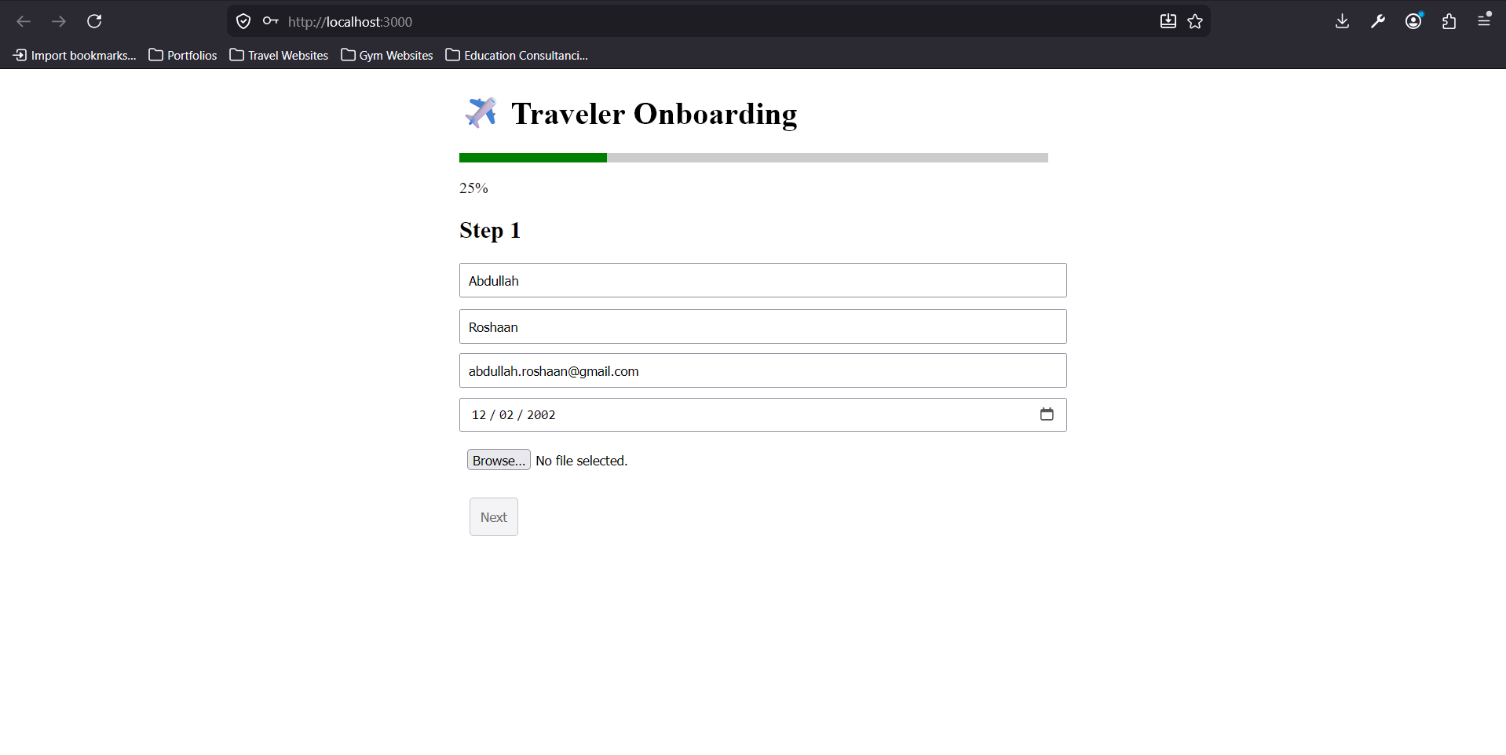
Files in Codebase
Task #3:
