
PROJECT PAPER

Explainable Vision Transformer for Urban Heat Island Detection Using Satellite Imagery
INFORMATION VISUALIZATION

IBSA303L

SUBMITTED BY:
P.Roshiga Jelin (24MIA1103)
C.A.Sailasri (24MIA1122)

CONTENTS

1. Introduction
2. Project Objectives
3. Tool and Technology Description
4. Dataset Description
5. Project Workflow
6. Data Preparation and Feature Engineering
7. Relative Thermal Label Generation
8. Vision Transformer Model
9. Experimental Setup and Results
10. Explainable AI Approach
11. Web Application and API Integration
12. Results and Discussion
13. Limitations and Future Enhancements
14. Conclusion
15. References

Explainable Vision Transformer for Urban Heat Island Detection Using Satellite Imagery

1. INTRODUCTION
Urban areas can often be warmer than their surrounding rural areas due to the urban heat island (UHI) effect. Urban areas having less tree coverage and more buildings have different surface temperature distributions. The different materials such as asphalt, concrete and roofs absorb and retain more solar energy than plant life and moist soil. Due to large area that is being processed, satellite data allows to observe large-scale surface temperature patterns, whereas ground stations can only provide data for a few points.
We have performed this project, ‘Explainable Vision Transformer for Urban Heat Island Detection Using Satellite Imagery’, using Landsat 8 imagery. By extracting several spectral bands, vegetation and built-up indices, and labels from the thermal band we have trained a Vision Transformer (ViT) to classify patches of the image into four classes of relative thermal intensities: Low, Moderate, High, Very High.
A small web application to go with the model is created with this. The model predictions and heatmap points are returned via the FastAPI backend, and visualised using the React frontend. We have investigated the attention tensors within the model.
It is important to note that our four classes are relative to the scene based on Band 10. As we did not have the calibration metadata, we are unable to report Land Surface Temperature (LST) in degrees Celsius. Therefore, our classes are just prototype classes.

2. PROJECT OBJECTIVES
- Investigate the Landsat 8 raster data and create a repeatable preprocessing pipeline.
- Calculate NDVI/NDBI to provide context to the model.
- Create relative thermal classes from the thermal band.
- Create 64x64 patches with 8 input channels.
- Train a Vision Transformer and evaluate how well it can distinguish between our four thermal classes.
- Try attention based visualisations.
- Link the prediction/heatmap results with the FastAPI backend and React frontend.
- Report the results as-measured, and identify any further data needed for calibrated LST.

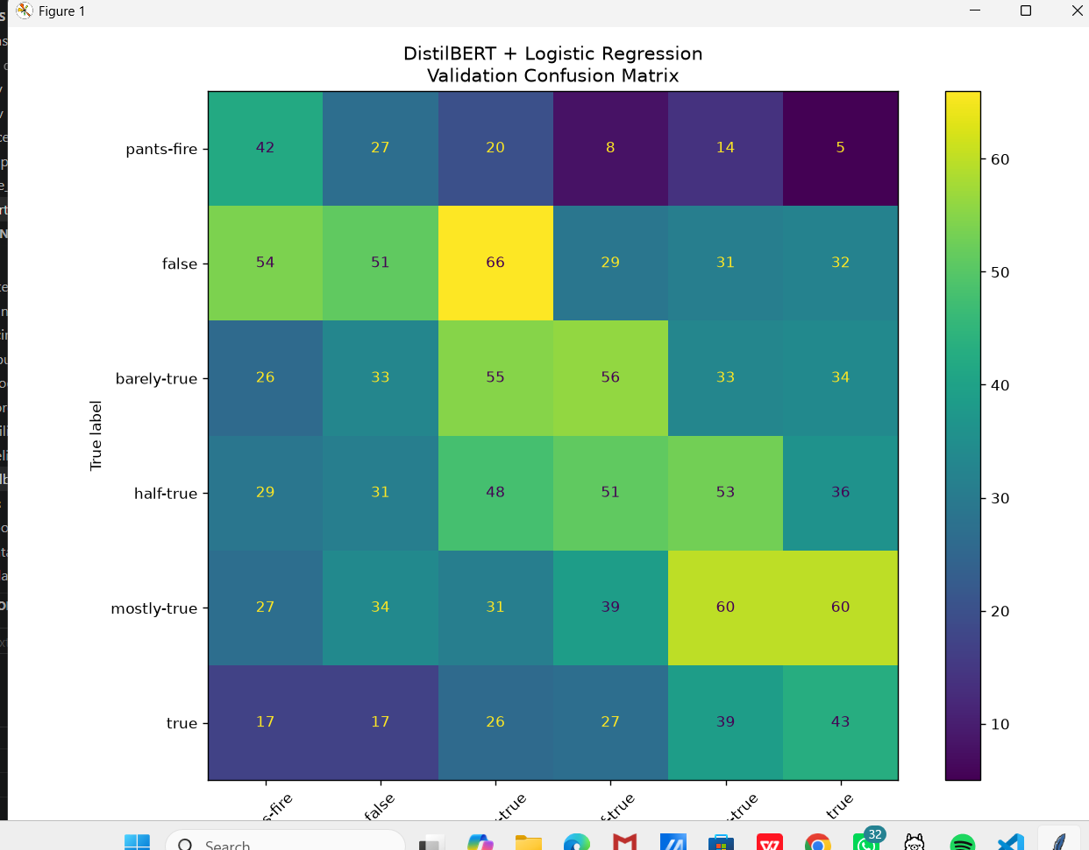

3. TOOLS USED

3.1 Landsat 8 Satellite Imagery
We are using multispectral and thermal infrared imagery captured by Landsat 8. The feature stack is made up of Bands 2 to 7, and Band 10 is reserved for the thermal classes. The data choosen, comes in GeoTIFF format meaning it contains the coordinate reference system and pixel size.

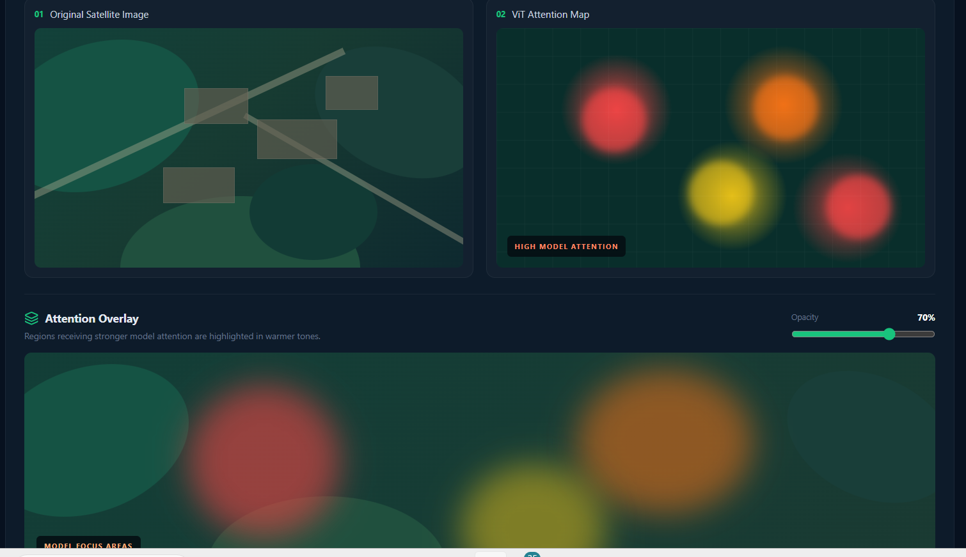
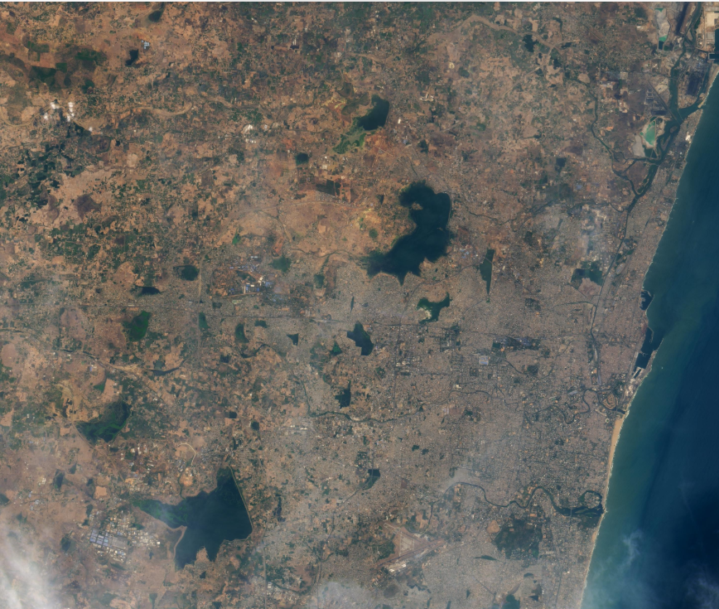

3.2 Python
Using Python we have investigated the rasters, calculated the indices, masked our invalid pixels, created our thermal classes, and prepared our training data. This relies on the georeferenced data in the GeoTIFFs, and correctly handling the NoData values. In a real scientific pipeline, we would first convert the raw digital numbers using the product metadata.

3.3 PyTorch
The Vision Transformer is implemented and evaluated using PyTorch. This network takes an 8 channel patch and outputs one of our 4 classes. During inference, the saved checkpoint and training the normalisation statistics are loaded.

3.4 FastAPI/React
FastAPI will provide endpoints to check health, predict patch classes, and return the heatmap points. Our interface has been created using React, and Leaflet to display the map. The frontend should also display the true coordinates of the raster, and also indicate that the classes are relative thermal intensities.

4. DATA

4.1 Data Description
The data consists of Landsat 8 GeoTIFFs containing multiple bands.There are Bands 1 to 7, Band 9, Band 10, and Band 11. Our rasters are approximately 7,561 x 7,721 pixels and are stored as unsigned 16-bit values.
Property | Description
Sensor | Landsat 8
File Type | GeoTIFF (.TIF)
Dimensions | ~7561 x 7721 pixels
Resolution | 30m
Data Type | uint16
CRS | EPSG:32620 (UTM Zone 20N)
Model Inputs | B2, B3, B4, B5, B6, B7, NDVI, NDBI
Thermal Classes | Band 10 (Relative Intensity)

4.2 Coordinate Reference System
The CRS of the raster data is EPSG:32620. However, this is not the correct UTM zone for Chennai. It needs to be confirmed about the scene location using the original Landsat scene ID and metadata. The map should also be displayed using the true raster coordinates. If we display a map for Chennai we should ensure we can confirm the scene is for Chennai.
As this data is stored as digital numbers (DN), and we do not have the MTL calibration file, the NDVI/NDBI values and Band 10 classes are exploratory. Do not interpret these as calibrated reflectance values.

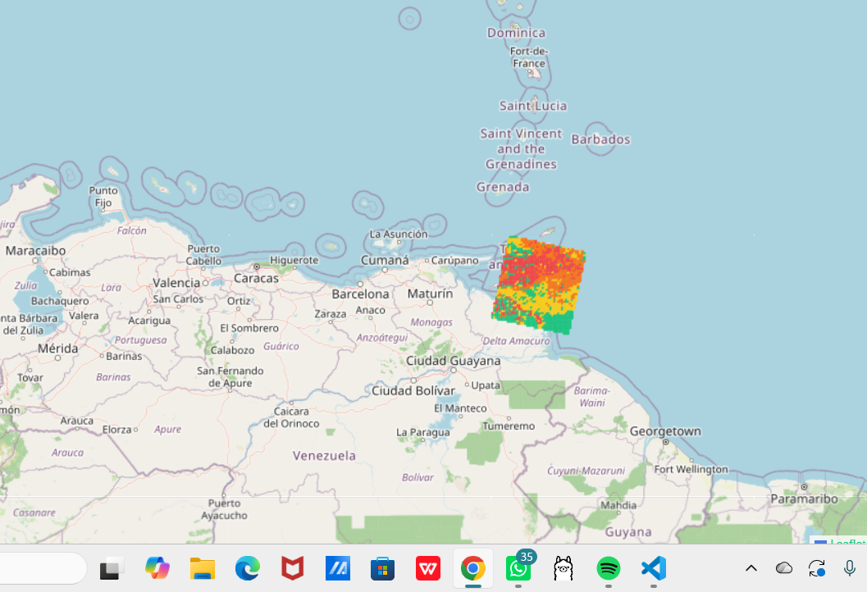

4.3 Data Overview
We have six spectral bands (B2-B7). Two additional layers have been calculated (NDVI/NDBI). Band 10 is not used as input to the model as it is used to create our target classes. This reduces the chance of direct label leakage. However, our classes are still proxy classes.

5. PROJECT PIPELINE
The pipeline takes satellite rasters and creates patches ready for our model to run. We then return our predictions using FastAPI, and have a web interface. Our pipeline includes:
- Investigate our raster files. It needs to get confirmed about the dimensions of each band, CRS, and any invalid pixels.
- Calculate NDVI/NDBI.
- Mask invalid Band 10 pixels. Create relative thermal intensity classes.
- Stack the B2-B7 bands with NDVI/NDBI. This creates an 8-channel feature raster.
- Extract non-overlapping 64x64 patches. Assigning each patch a dominant class based on the valid thermal pixels.
- Check and split the data into training, validation, and test sets spatially.
- Calculate training set normalisation statistics. Using these during inference.
- Train and evaluate Vision Transformer.
- Return the predictions for patches and geospatial heatmap data using FastAPI.
- Visualise results using React interface. Include any limitations.
Fig 1: End to end pipeline.

6. DATA PREPROCESSING & FEATURE ENGINEERING

6.1 Normalised Difference Vegetation Index (NDVI)
The NDVI is a widely used index to measure how green and healthy vegetation is. We have Band 5 (Near Infrared) and Band 4 (Red). The formula is:
NDVI = (B5 – B4) / (B5 + B4)
NDVI ranges from -1 to +1. Higher values generally indicate more vegetation. Lower values can be seen over bare ground, water, etc. This is not a temperature measurement. In our prototype our minimum value was -1.0000, max value 1.0000, and average value 0.0307.

6.2 Normalised Difference Built-up Index (NDBI)
The NDBI can help highlight built-up surfaces. Using Band 6 (Short Wave Infrared) and Band 5 (Near Infrared) from Landsat 8. The formula is:
NDBI = (B6 – B5) / (B6 + B5)
In our prototype our min was -1.0000, max 1.0000, and average value of -0.0626. This does not indicate the percentage of built-up in the scene. To perform serious analysis, you should recalculate your indices using a calibrated reflectance, and handle zeros and invalid pixels.

6.3 Thermal Masking
During our investigation of the thermal data we masked Band 10 pixels that were zero or invalid. We have 40,577,327 valid pixels. 17,801,154 pixels were either NoData or masked. A percentile stretch was applied to make the image easier to view. This is a relative intensity image. It is not an LST product.

6.4 Patches
We have 8-channel data (B2, B3, B4, B5, B6, B7, NDVI, NDBI). 64x64 patches were extracted using a 64 pixel stride. Any patches with at least 90% valid pixels in their label were kept. The patch was assigned the dominant class of valid pixels.
Patch Property | Value
Dimensions | 64x64
Stride | 64
Channels | 8
Total Patches | 9750
Valid Pixel % | ≥90%
Patch Class | Dominant Valid Class

6.5 Data Splitting and Normalisation
The enhanced spatial split has given us 6844 training patches, 1454 validation patches and 1452 test patches. The normalisation statistics from the training data have been saved and used during inference. It is important that our inputs are the same scale as our model was trained on. A random split would cause adjacent patches with similar structures to be in different sets. Using a spatial split will help reduce this.

7. RELATIVE THERMAL CLASSES
Band 10 was used to create a relative thermal intensity raster. Zero/invalid pixels have been masked. A percentile stretch was applied to help visualise the distribution. Quartiles have been used to create four classes (Low, Moderate, High, Very High).
Class | Number of Patches | Explanation
Low | 2307 | Lower relative thermal intensity.
Moderate | 2359 | Second relative intensity class.
High | 2366 | Higher relative thermal intensity.
Very High | 2718 | Top relative thermal class.
Total | 9750 | All patches have been kept.
Fig 2: Relative thermal class distribution.

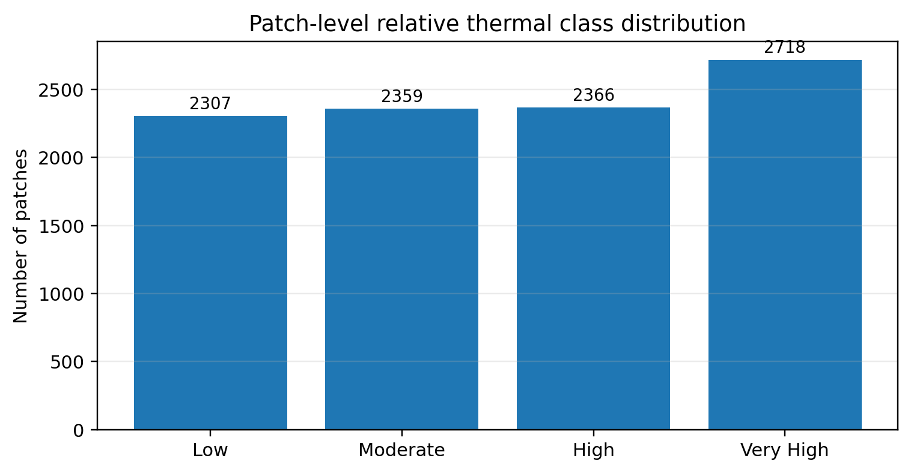
These classes are based on the thermal values in this scene. They are not based on specific temperature values. As they are based on Band 10 they are proxy classes.

7.1 Land Surface Temperature
Land Surface Temperature (LST) is the true temperature of the surface. This is normally provided in °C or K. To get LST from the thermal data, correct calibration should take place. This includes radiometric conversion and emissivity correction. Or a documented Level-2 Surface Temperature product. As we did not have the metadata we cannot call our outputs calibrated LST, they are relative thermal intensity classes.

7.2 Why Band 10 Was Not Used
Band 2-7, NDVI and NDBI were input into the model. Band 10 was used to create the target classes. As it was not input into the model it will reduce the risk of direct label leakage. However, the model is predicting a class that was based on thermal data. The score does not indicate the model can independently detect real UHI events.

8. VISION TRANSFORMER

8.1 Input & Patch Embedding
Our sample is 64x64 pixels. The image is broken down into 16x16 pixel tokens. This gives us 4x4 spatial tokens. Each token is embedded into a 128 dimensional vector. Positional information and classification token has been added.
Fig 3: Simplified Vision Transformer Architecture.

8.2 Configurations
Component | Configuration
Input Size | 64x64x8
Patch Size | 16x16
Patch Token Grid | 4 × 4 = 16 image tokens
Embedding Dimension | 128
Attention Heads | 4
Encoder Layers | 4
MLP Dimension | 256
Output Classes | 4 relative thermal classes
Compute | CPU Based

8.3 Prediction
The patch goes through the embedding and transformer layers. The classification head converts the learned representations into 4 class scores. The highest score is our predicted class. All 4 scores can be viewed in the application. As we haven’t tested the probability calibration we should refer to them as scores.

9. EXPERIMENTAL DESIGN & RESULTS

9.1 Data Split
The enhanced spatial split has given us 6844 training samples, 1454 validation samples and 1452 test samples. The model has been evaluated using the test set. All patches are from one scene, so the model does not show how it would perform elsewhere.

9.2 Test Accuracy
The enhanced Vision Transformer checkpoint has correctly predicted 856 out of 1452 test patches. This gives us a test accuracy of 58.95%.
Test | Value
Samples | 856
Accuracy | 58.95%
Target | Relative Thermal Classes

9.3 Interpretation
This indicates our model has picked up some patterns related to our derived classes. However, a large amount of our test samples were incorrectly classified. Using only accuracy we cannot see which classes are the hardest to separate. A full evaluation would include a confusion matrix, precision and recall per class, macro-F1, and balanced accuracy. We would also compare with basic baselines and traditional ML techniques to see if the ViT has helped.
This is not an accuracy for calibrated surface temperature. We are using proxy classes based on Band 10. We have not tested how well the model will generalise to other scenes/cities.

9.4 Recommended Evaluation Metrics
Metric | Description
Accuracy | Percentage of correct class predictions.
Precision | Percentage of patches predicted as a class that are truly that class.
Recall | Percentage of true members of a class the model identified.
Macro-F1 | Average F1 score across all classes. All classes have equal weighting.
Confusion Matrix | Shows which classes are confused.
Balanced Accuracy | Average recall across all classes.

10. EXPLAINABLE AI

10.1 Attention
We can view the attention tensors from the model. We have used the attention rollout technique. This involves averaging across the attention heads, adding identity connections, normalising the matrices and multiplying across the layers. Then we can reshape the attention for the classification token to 4x4 and upscale to overlay on top of the original patch.

10.2 Interpretation
As each token is 16x16, it will result in a coarse map. Attention can help us understand how the model works. However, just looking at the attention values does not prove what pixels caused the prediction. This could be compared to occlusion sensitivity, perturbations, or gradient based explanations. Only the visualisations from the true implementation should be shown.

11. WEB APPLICATION & API

11.1 Backend
We have a FastAPI backend. The trained Vision Transformer checkpoint and normalisation statistics have been loaded. We have a health endpoint, patch prediction endpoint, and heat map endpoint. The patch prediction endpoint takes a patch ID, loads the patch, and applies the training normalisation. It then returns the predicted class and scores. The heat map endpoint loads the thermal classes raster, samples valid cells, and converts the raster coordinates to geographic coordinates. It then returns points on the map.

11.2 Frontend
We have a React frontend. The heatmap page requests data from the backend. Points are plotted on the map using the class colours. There is also a patch analysis page showing the predicted class and model scores. The application should show the scene ID, and that the classes are relative thermal intensities.



11.3 Geospatial
The raster has a CRS of EPSG:32620. This is not the expected UTM zone for Chennai. We should confirm the scene location before displaying any city specific maps. The map should be centred and labelled with the true raster coordinates. If the map is incorrectly labelled it will give a false impression of where the results are applicable.

12. RESULTS
We have 9750 patches with 8 input channels.
Our relative thermal classes have 2307 Low, 2359 Moderate, 2366 High, and 2718 Very High patches.
The enhanced ViT has a test accuracy of 58.95%. 856 patches were correctly predicted.
This indicates agreement with the proxy classes derived from Band 10. It does not indicate agreement with measured LST or independent UHI classes.
The web application provides a pathway from model inference to geospatial visualisation. The scene coordinates and limitations should be shown accurately.
Overall the project has brought together geospatial preprocessing, machine learning, explainable AI, API creation, and frontend visualisation. Any scientific claims should be based on the data and evaluation.

13. LIMITATIONS & FUTURE WORK
- Ensure we have the correct scene metadata, or a documented Landsat Level-2 Surface Temperature product, to enable analysis of calibrated LST.
- Confirm the scene ID and location.
- Recalculate NDVI/NDBI using calibrated reflectance.
- Use independent reference data or validated classes to evaluate UHI classes.
- Include metrics per class, confusion matrix, macro-F1, and balanced accuracy.
- Test generalisation across multiple scenes, dates, and locations.
- Compare attention visualisations to perturbation or gradient based explanations.
- Ensure we never display any fake temperature values, or any unsupported historical trends.

14. CONCLUSION
The project is a prototype pipeline for classifying relative thermal intensities in Landsat 8 imagery. We have used 6 spectral bands, NDVI, and NDBI. We have extracted 64x64 patches and classified them into 4 thermal intensity classes. The enhanced model achieved an accuracy of 58.95% on 1452 test patches. We have a FastAPI backend with a React frontend to return the predictions and show the class information on a map.
The results should be interpreted carefully. The classes are based on Band 10, and are not independent UHI classes. We should always check the CRS and ensure we are not assigning a city. Future work will focus on calibrated thermal data, and have confirmed geospatial data.

15. REFERENCES
[1] D. Zhou et al., "Satellite Remote Sensing of Surface Urban Heat Islands: Progress, Challenges, and Perspectives," Remote Sensing, vol. 11, no. 1, Art. no. 48, 2019. [Online]. Available: https://doi.org/10.3390/rs11010048
[2] H. Shi, G. Z. Xian, R. F. Auch, K. Gallo and Q. Zhou, "Urban heat island and its regional impacts using remotely sensed thermal data—A review of recent developments and methodology," Land, vol. 10, no. 8, Art. no. 867, 2021. [Online]. Available: https://doi.org/10.3390/land10080867
[3] A. Dosovitskiy et al., "An Image is Worth 16×16 Words: Transformers for Image Recognition at Scale," in Proc. International Conference on Learning Representations (ICLR), 2021.
[4] S. Jain and B. C. Wallace, "Attention is not Explanation," in Proc. 2019 Conference of the North American Chapter of the Association for Computational Linguistics: Human Language Technologies, 2019, pp. 3543-3556. [Online]. Available: https://doi.org/10.18653/v1/N19-1357
[5] U.S. Geological Survey, "Landsat Collection 2 Level-1 Data", [Online]. Available: https://www.usgs.gov/landsat-missions/landsat-collection-2-level-1-data

