Predictive Anlysis of Income

Kaustubh Padhya (305861379) – kpadhya@calstatela.edu
Manali Joshi (305861366) – mjoshi@calstatela.edu
Mittal Vaghela (305829282) – mvaghela@calstatel.edu
Roshik Ganesan (305641224) – rganesa@calstatela.edu
Department of Information Systems, California State University Los Angeles
Mentor: Dr. Jongwook Woo

Abstract: The analysis is on the data about the employee salary information of 3 major cities in United States of America which includes their Basic Pay, Gross Pay, Overtime Pay and many more features. Based on these features we have predicted the salaries of people who would work in the specific places in future. The dataset has more than 20 million records. We have used a few regression and classification models for predicting the lables and checking its accuracy for better performance.

- Introduction
Dataset we used for this project are as following:
- LA County Employee Salary
- Employee Compensation SF
- Salary Information of State Authorities-NY

Dataset is in CSV format and size is about 210MB.
This dataset contains employee salary information of 3 major cities in the United States namely Los Angeles, San Francisco, and New York. Sample features in the dataset are Department, Job Role, Basic Pay, Gross Pay, Overtime Pay, Medical Benefits etc. The aim of our project is to predict the Income and Department of an employee based on the available features from the dataset by utilizing Machine Learning Algorithms and build accurate models using Azure ML, Spark ML.
The Machine Learning Algorithms we used are:
- Boosted Decision Tree Regression
- Decision forest Regression
- GBT Regression
- Multiclass Logistic Regression
- Multiclass Neural Networks.

2. Services
Services used in this project are Azure ML, Databrics community edition, Spark ML, Python and Tableau. We used Apache spark Version – Spark 2.1(Auto-updating, Scala 2.10), which has Memory 6 GB(0.88 cores, 1DBU). We also used Data Bricks File System.

3. Work Flow
3.1 AzureML
To start with, we first loaded the data to Azure ML, then we selected the columns, which is also a part of data cleaning as we took only columns which we are going to use further. Then went on with clipping the outliers.
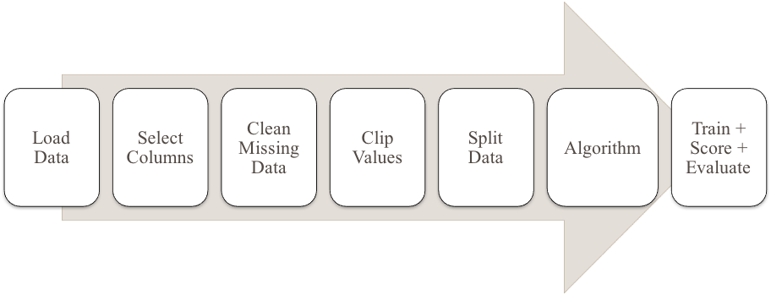
After that we used Clip Values module to remove the outliers. Thereafter to split the data into training set and testing set we used Split Data module. As mentioned earlier we have used different algorithm to proceed further. Lastly, we Train, Score, and Evaluate the model to find the best model.

3.2 SparkML
The first step in Workflow of SparkML is to load the data. Then we have imported Spark Libraries, followed by extracting features from raw data, Removing Outliers and splitting data for training and testing, performing Decision Tree Regression and GBT regression. Post that we did Cross Validation, and training the model so that testing can be performed on it. Last step includes Evaluation in the workflow of SparkML.

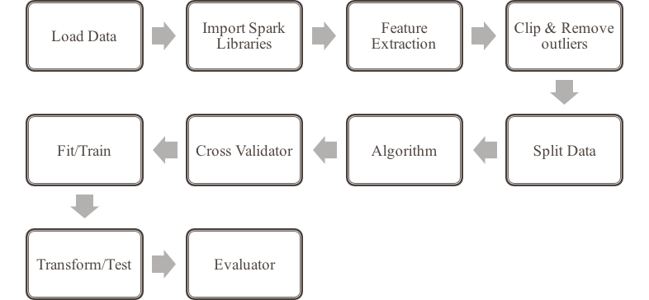

4. Background Work
We have used datasets to analyze the features that act as major factors affecting the total compensation of the employee’s state wide. Based on these factors we have come up with model which would help in predicting the Total Compensation of the employees working at Los Angeles and San Francisco. Based on these factors we develop a regression model to predict Total Compensation. We have also analyzed features that would help in predicting the department of the employees working in New York and help us develop a classification model.

5. Analysis and Visualization

5.1 Feature selection Analysis: Tableau
We have used three scatter plots using tableau for LA city which has three different columns like LTD Life and Medical, Medical dental Vision and Pension Contribution for features selection analysis.
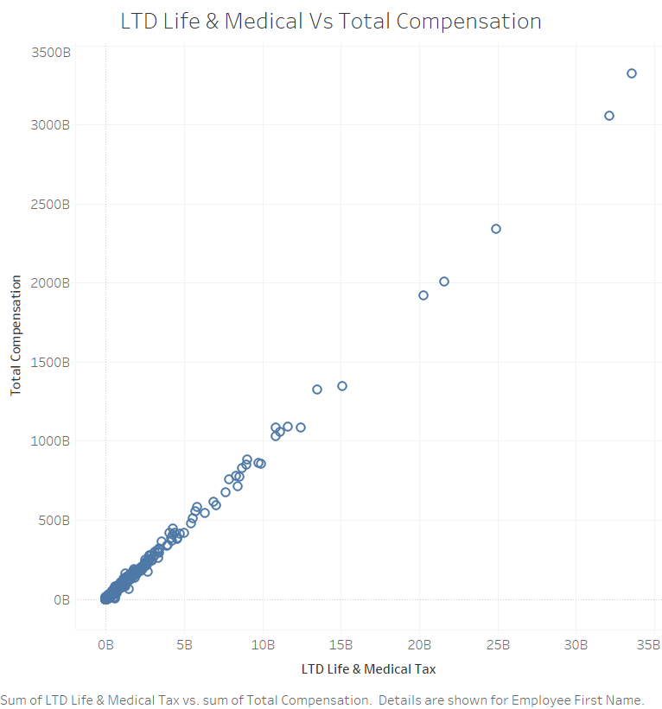

Likewise, we have used only two columns which are Health/Dental, Retirement for San Francisco city.

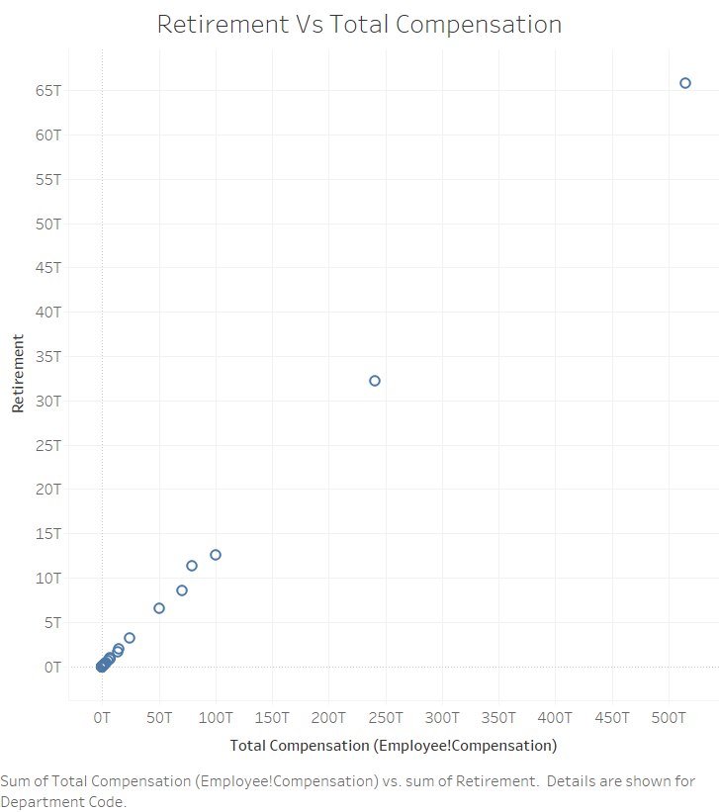
5.2 Analysis of the data (Los Angeles): AzureML
Boosted Decision Tree Regression-1: Boosted Decision Tree Regression module is used to create an ensemble of regression trees using boosting. Boosting means that each tree is dependent on prior trees, and learns by fitting the residual of the trees that preceded it. Thus, boosting in a decision tree ensemble tends to improve accuracy with some small risk of less coverage. We have used Total Compensation, Medical/Dental/Vision and Pension Contributions columns and clip values like 90th Percentile upper threshold & 20th Percentile lower threshold to remove outliers. Result we got for RMSE is 9487.7977 and COD is 0.947578.
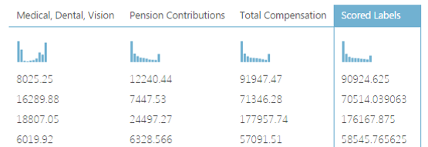
Decision Forest Regression: Decision Forest Regression module is used to create a regression model using an ensemble of decision trees. After configuration of the model, we must train the model using a labeled dataset and the Train Model module. The trained model can then be used to make predictions. Alternatively, the untrained model can be passed to Cross-Validate Model for cross-validation against a labeled data set. We have used Total Compensation, Medical/Dental/Vision, LTD Life &MedicalTax and Pension Contributions columns and clip values like 90th Percentile upper threshold & 20th Percentile lower threshold to remove outliers. Result we got for RMSE is 8756.679146 and COD is 0.955346.

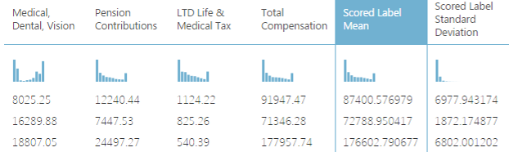

Boosted Decision Tree Regression-2: We have used Total Compensation, Medical/Dental/Vision, LTD Life &MedicalTax and Pension Contributions columns and clip values like 90th Percentile upper threshold & 20th Percentile lower threshold to remove outliers. Result we got for RMSE is 8210.2372 and
COD is 0.960745.

5.3 Analysis of the data (San Francisco): AzureML

Boosted Decision Tree Regression: We have used Retirement, Salaries, Health/Dental and Total Compensation columns and clip values like 90th Percentile upper threshold & 20th Percentile lower threshold to remove outliers. Result we got for RMSE is 8571.7595 and COD is 0.979861.

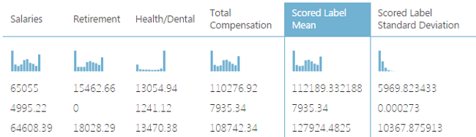

Decision Forest Regression: We have used Retirement, Salaries, Health/Dental and Total Compensation columns and clip values like 90th Percentile upper threshold & 20th Percentile lower threshold to remove outliers. Result we got for RMSE is 8577.69122 and COD is 0.979788.
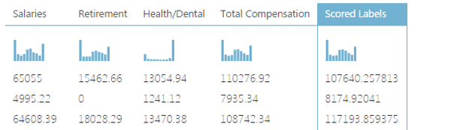

5.4 Analysis of the data (New York) : AzureML
Multiclass Logistic Regression: Multiclass Logistic Regression module is used to create a logistic regression model that can be used to predict multiple values. Classification using logistic regression is a supervised learning method, and therefore requires a labeled dataset. the label column can contain multiple values. It trains the model by providing the model and the labeled dataset as an input to a module such as Train Model or Tune Model Hyperparameters. We have used Group, Title, base-sal columns.
Overall accuracy | 0.894895
Average accuracy | 0.964965
Micro-averaged precision | 0.894895
Macro-averaged precision | 0.855637
Micro-averaged recall | 0.894895
Macro-averaged recall | 0.713172
Multiclass Neural Networks : Multiclass Neural Network module is used to create a neural network model that can be used to predict a category that has multiple values. For example, neural networks are frequently used in complex computer vision tasks, such as digit or letter recognition, document classification, and pattern recognition. We have used Group, Title, base-sal columns.
Overall accuracy | 0.91391
Average accuracy | 0.971303
Micro-averaged precision | 0.91391
Macro-averaged precision | 0.878639
Micro-averaged recall | 0.91391
Macro-averaged recall | 0.797034

Multiclass Neural Networks Vs Multiclass Logistic Regression

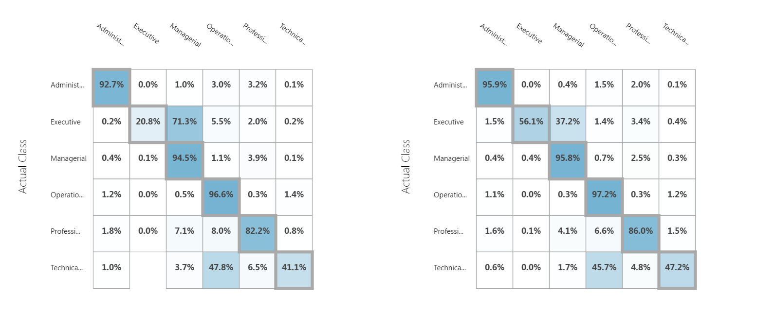
5.5 Spark ML Model- LA city Income
Apache Spark is a fast and general-purpose cluster computing system. It provides high-level APIs in Java, Scala and Python, and an optimized engine that supports general execution graphs. We have used Decision Tree Regressor and GBT Regressor algorithms. Features used in the modelling are Pension, MedicalDentalVision and LTDLifeMedicalTax. Predicted label is Total Compensation.

Decision Tree Regressor – RMSE: The Root Mean Square Error (RMSE) of LA city incomes using Decision Tree Regressor Algorithm is 7405.053.

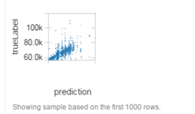

GBT Regressor RMSE: The R Mean Square Error (RMSE) of LA city incomes using GBT Regressor Algorithm is 7189.508.

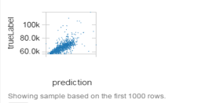

5.6 Spark ML Model- SF city Income
We have used Decision Tree Model and GBT Regressor algorithms. Features used in the modelling are Salaries, Retirement and Health/Dental. Predicted label is Total Compensation. Similar model we have used for San Francisco city as well.
Root Mean Square Error (RMSE) for Decision Tree Model is 8609.04. Root Mean Square Error (RMSE) for GBT Regression is 8442.032.
GBT Regression is better than the Decision Tree Regressor. Hence, we choose this model for the purpose of Income Prediction.

6. Summary and Conclusion
Based on selected features predictive analytics was conducted to predict the Total Compensation of employees working in following cities.
- Los Angeles
- LTD Life and Medical
- Medical,Dental,Vision
- Pension Contribution

- San Francisco
- Health/Dental
- Retirement

Using the title and the base compensation the department of the employee in New York is predicted. Comparison between models in Azure ML and Spark ML is done and it is found that Spark’s GBT Provides the best predictive values.

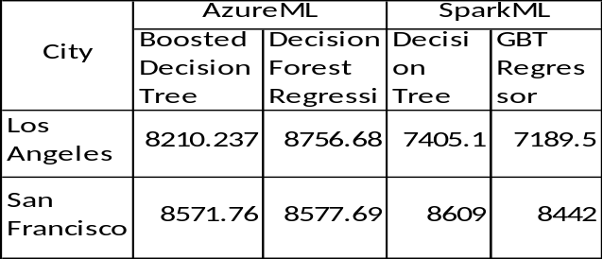

7. Limitations & Challenges Faced

- Azure ML doesn’t allow to specify the schema after uploading the data.
- Using Neural Network for classification takes a long time to train the model though it gives better prediction.
- Spark ML does not provide a clip value module as done by Azure ML: A custom module was developed with appropriate logic to clip the 90th and 10th percentile values.

Dataset URL

- https://data.lacounty.gov/Operations/LA-County-Employee-Salaries/8rdv-6nb6
- https://catalog.data.gov/dataset/employee-compensation-53987
- https://data.ny.gov/Transparency/Salary-Information-for-State-Authorities/unag-2p27

GitHub URL

https://github.com/roshik2016/CIS5560

References

- https://spark.apache.org/docs/2.1.0/ml-classification-regression.html
- https://docs.microsoft.com/en-us/azure/machine-learning/machine-learning-model-progression-experiment-to-web-service
- https://docs.microsoft.com/en-us/azure/machine-learning/machine-learning-evaluate-model-performance
- https://datasciencedojo.com/building-classification-model-azure-machine-learning-studio/

