AWS Cloud Deployment
Task Completion Screenshots
Project: aws-demo-app
Region: Asia Pacific (Mumbai) — ap-south-1
September 2026

1. Database (Amazon RDS)
a. Launched in a private subnet
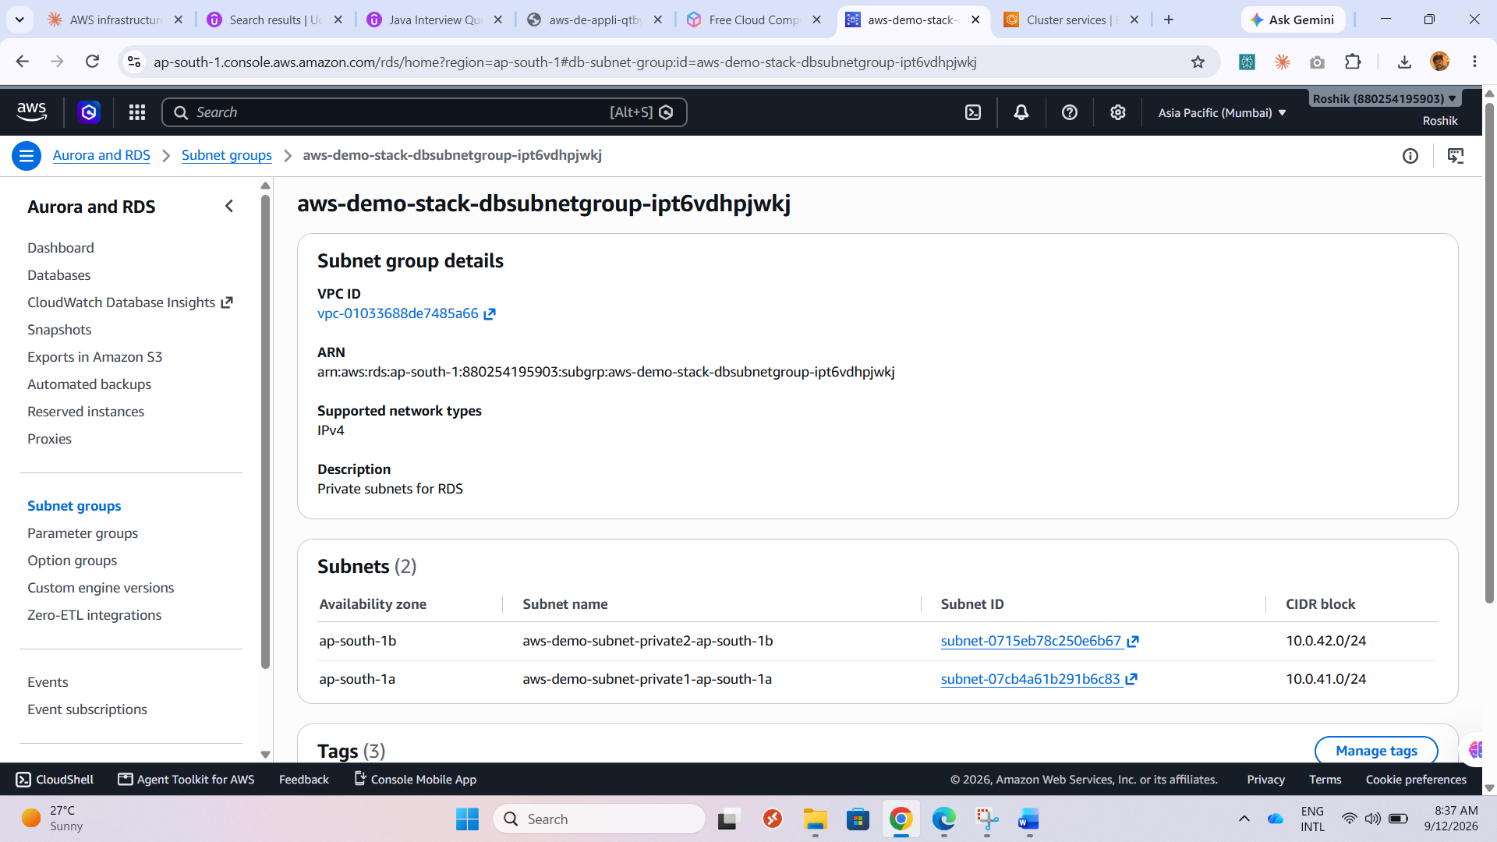
Fig. 1 — DB subnet group with two private subnets (ap-south-1a, ap-south-1b) — no public route.
b. Access restricted to the web tier only
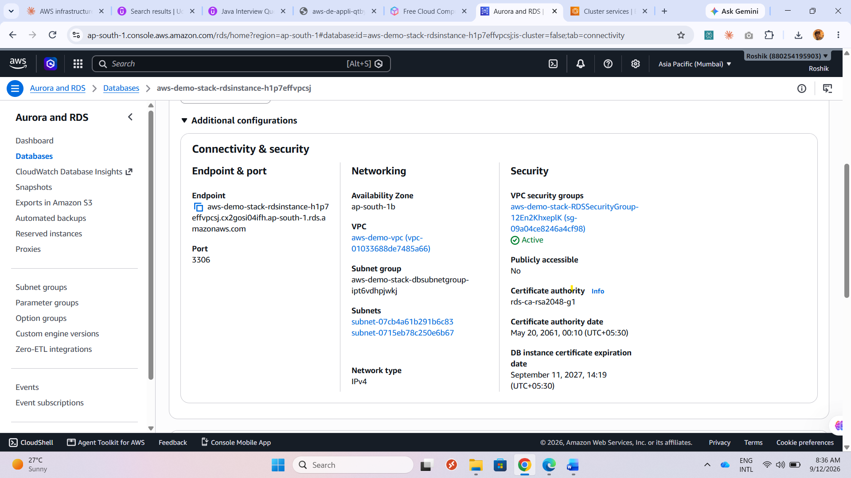
Fig. 2 — Publicly accessible: No — security group scoped to the web/application tier only.
c. Automated backups enabled, retention noted
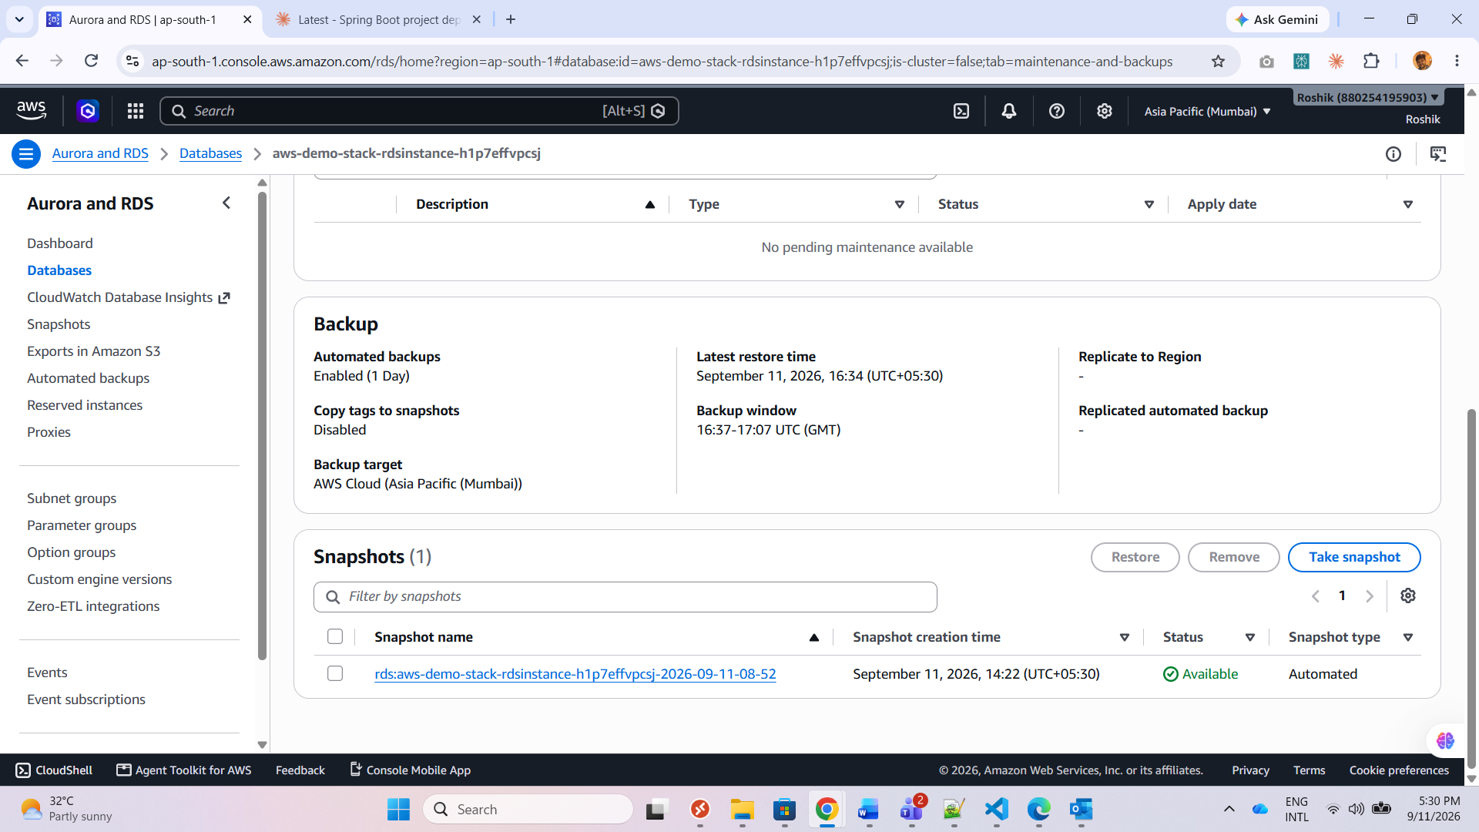
Fig. 3 — Automated backups enabled, 1-day retention window.

2. Container Deployment (ECS Fargate)
a. Docker image built and pushed to ECR
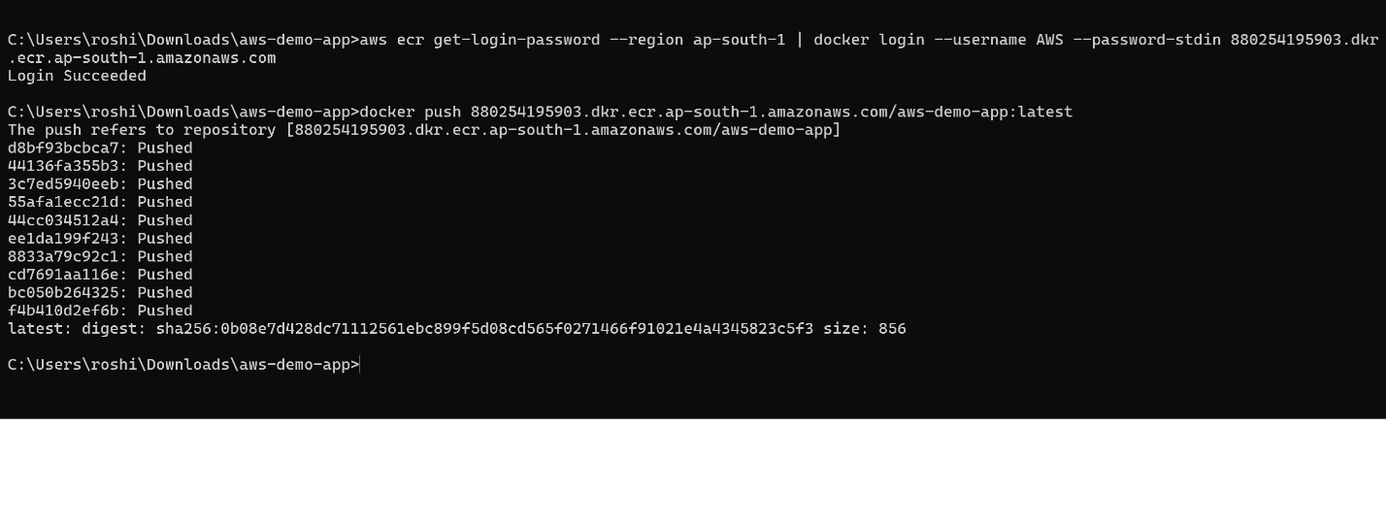
Fig. 4 — docker push output — all layers uploaded, digest returned.
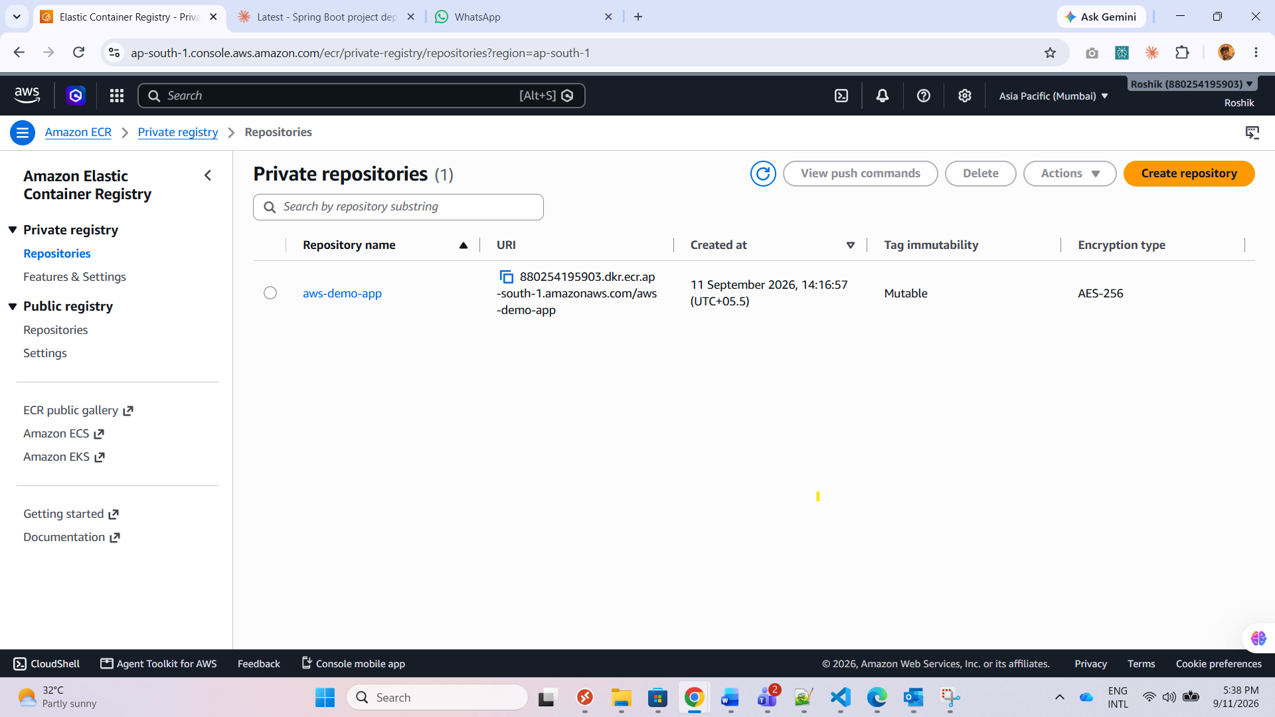
Fig. 5 — ECR repository showing the pushed image tag.
b. ECS cluster + Fargate Task Definition created
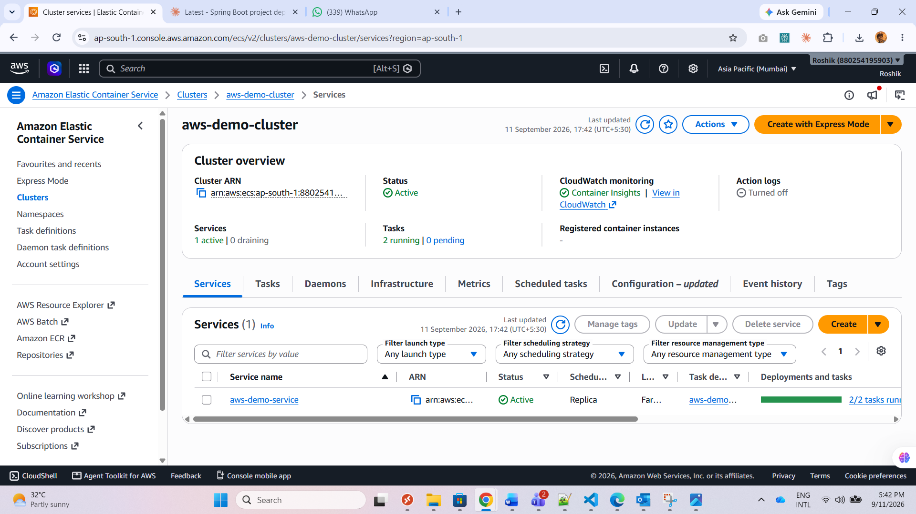
Fig. 6 — aws-demo-cluster / aws-demo-service — 2/2 tasks running on Fargate.
c. Service running behind an Application Load Balancer
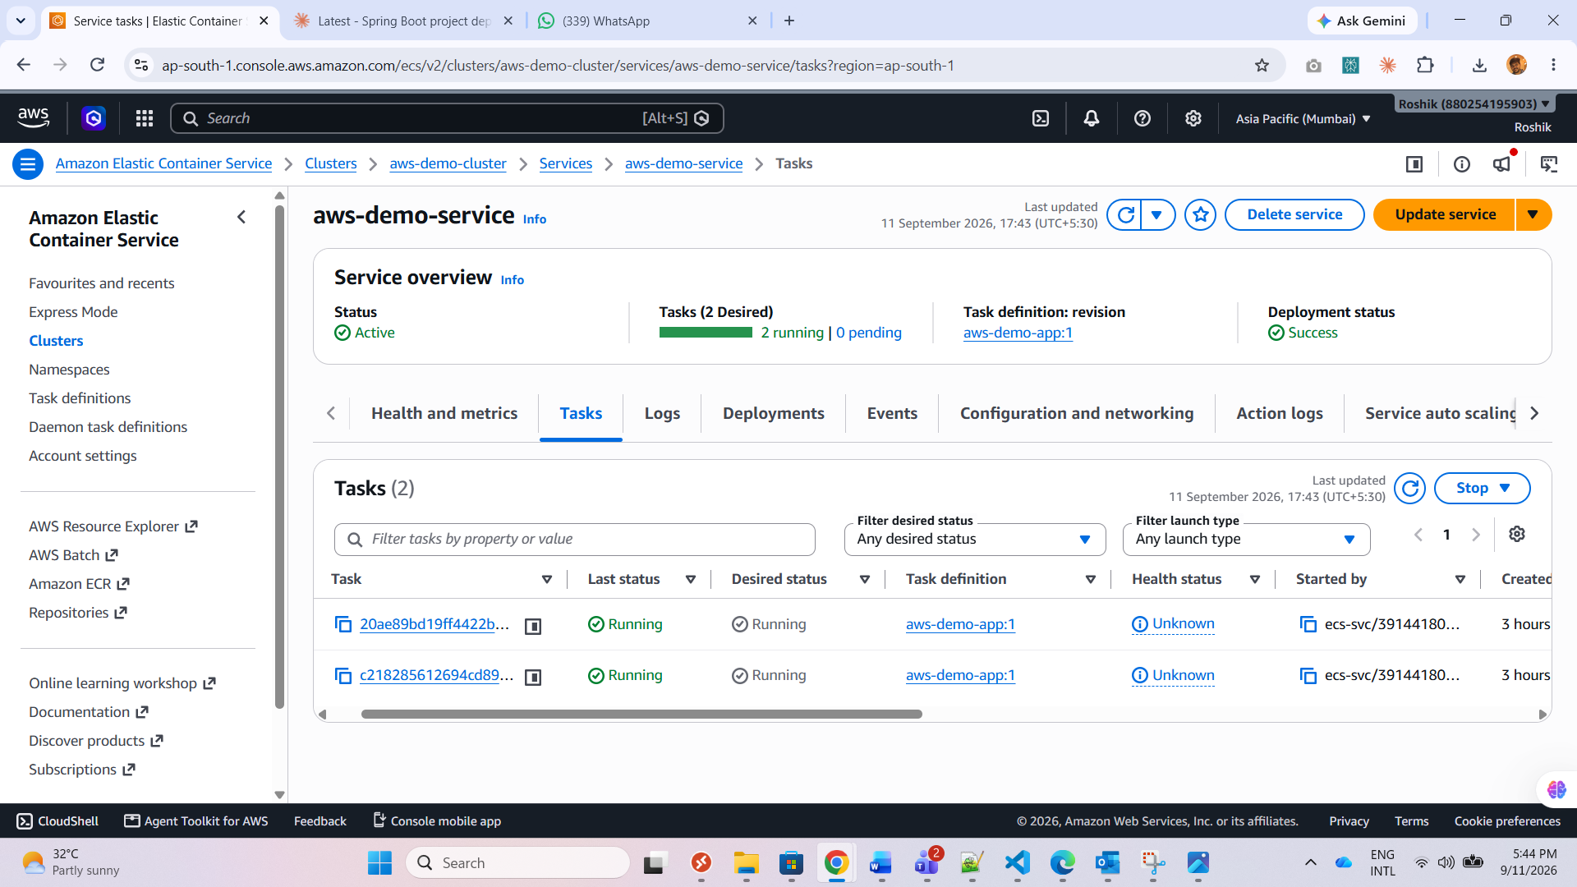
Fig. 7 — Both tasks reporting RUNNING status.
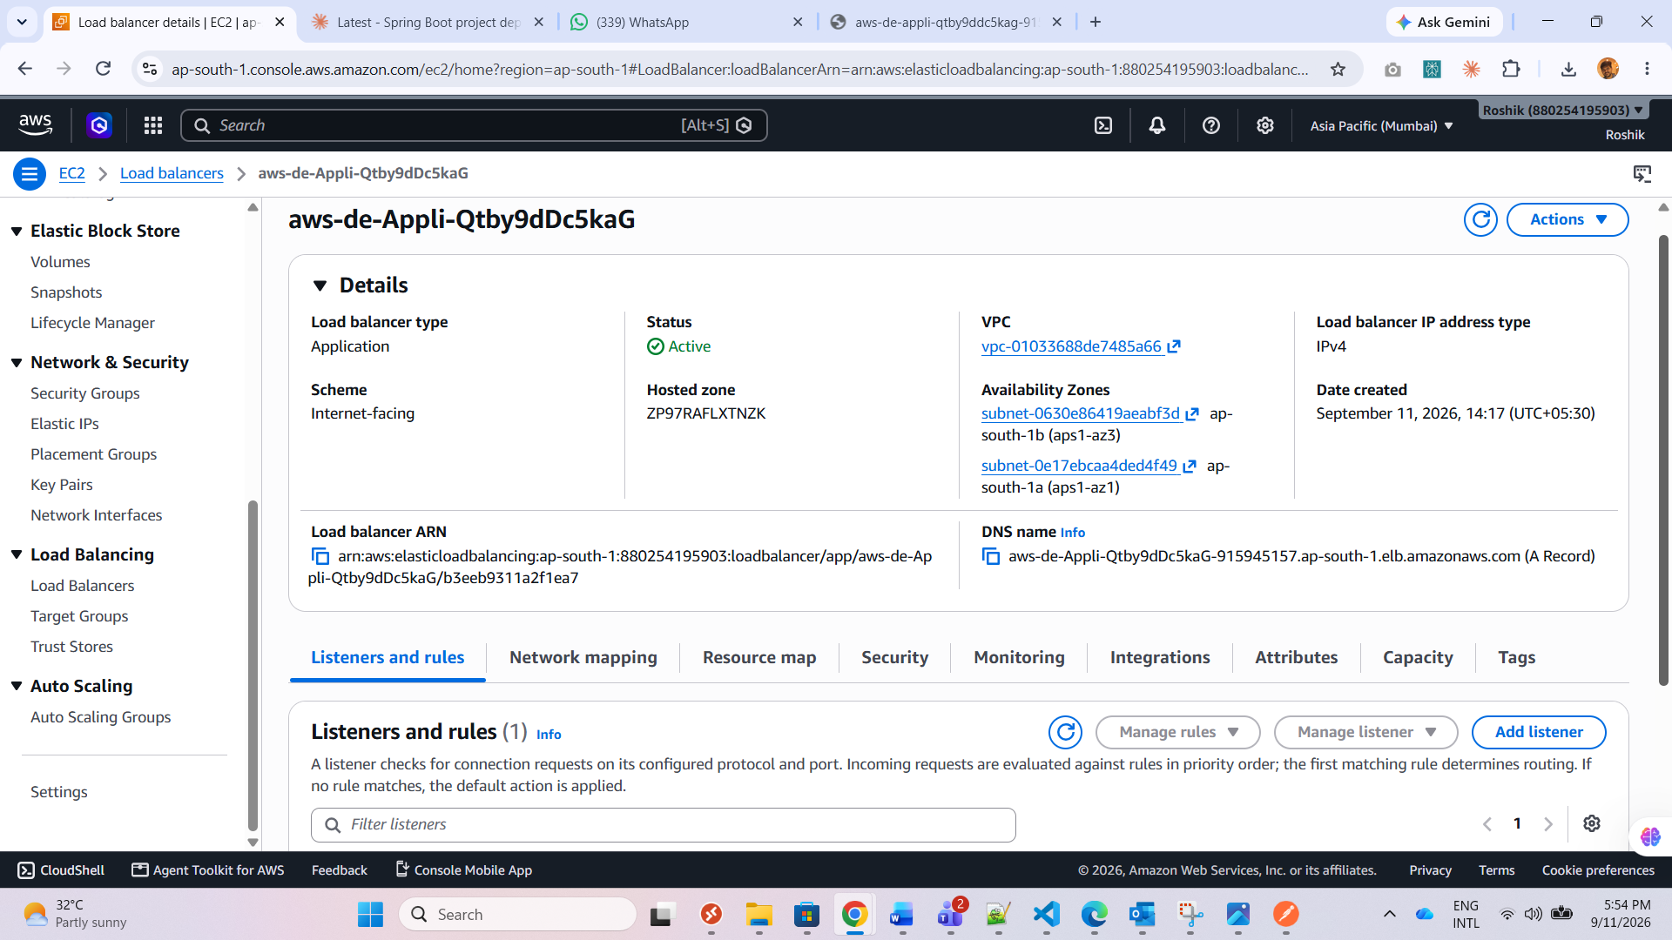
Fig. 8 — Load balancer details in the EC2 console.
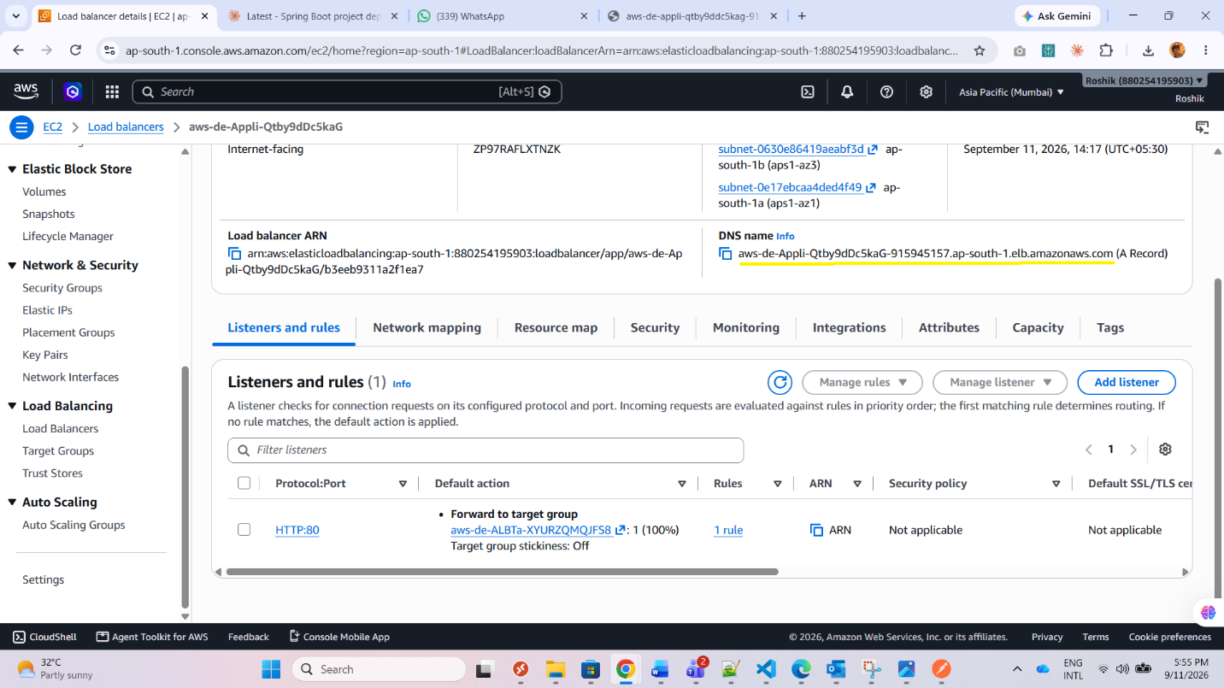
Fig. 9 — Load balancer DNS name and listener configuration.
d. ALB URL opened in browser — app confirmed loading
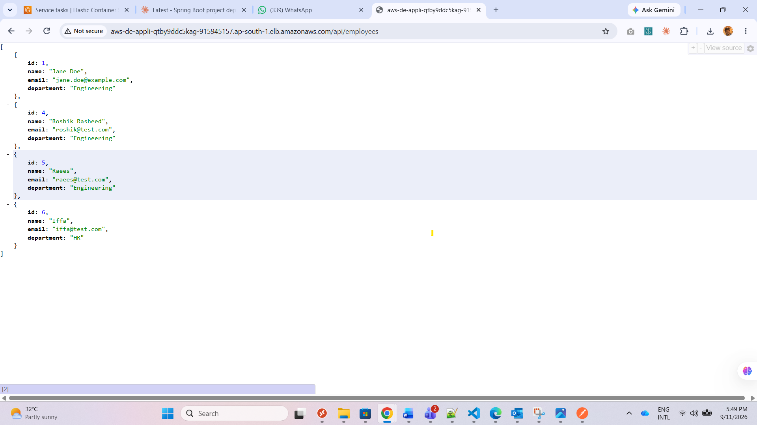
Fig. 10 — JSON response from /api/employees via the ALB URL.
ALB URL: aws-de-appli-qtby9ddc5kag-915945157.ap-south-1.elb.amazonaws.com
Test request: http://aws-de-appli-qtby9ddc5kag-915945157.ap-south-1.elb.amazonaws.com/api/employees
e. Desired task count changed (2 → 4), service updated
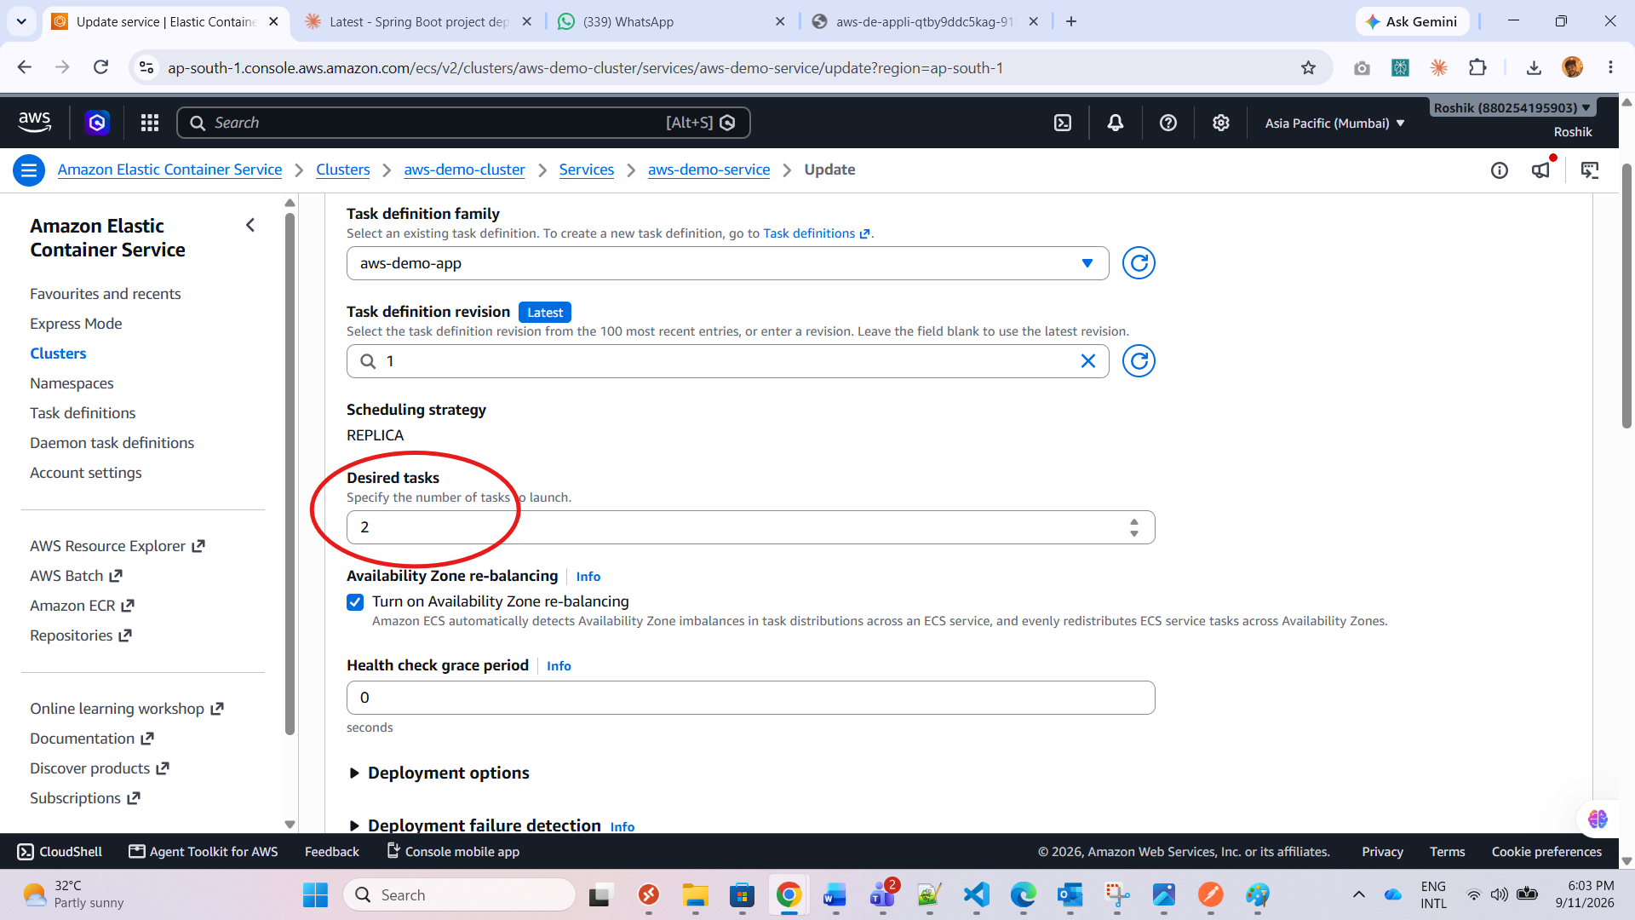
Fig. 11 — update-service action changing desired count to 4.
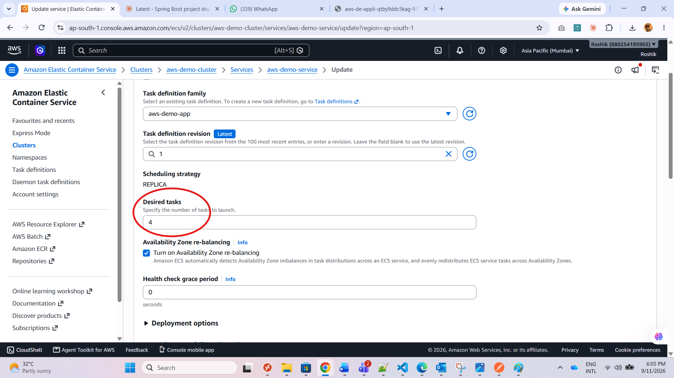
Fig. 12 — New tasks in PROVISIONING/PENDING.
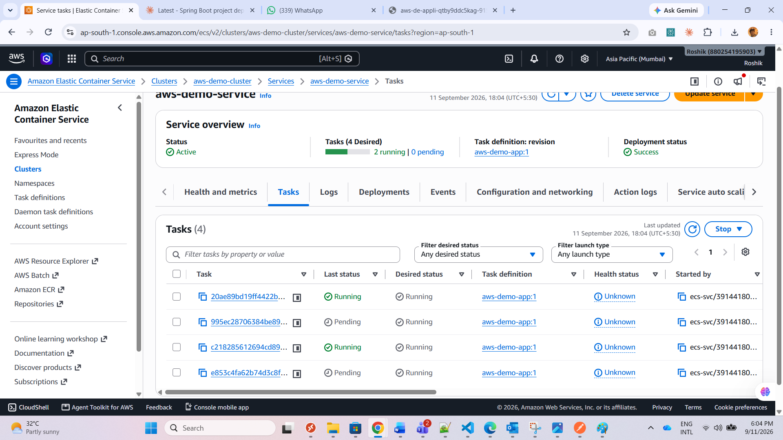
Fig. 13 — All four tasks RUNNING after scale-out.
f. Service/cluster deleted after verification
Service scaled to 0 and deleted, cluster removed — no screenshot, resources no longer exist.

3. Infrastructure as Code (CloudFormation)
a. RDS + ECS recreated via CloudFormation template
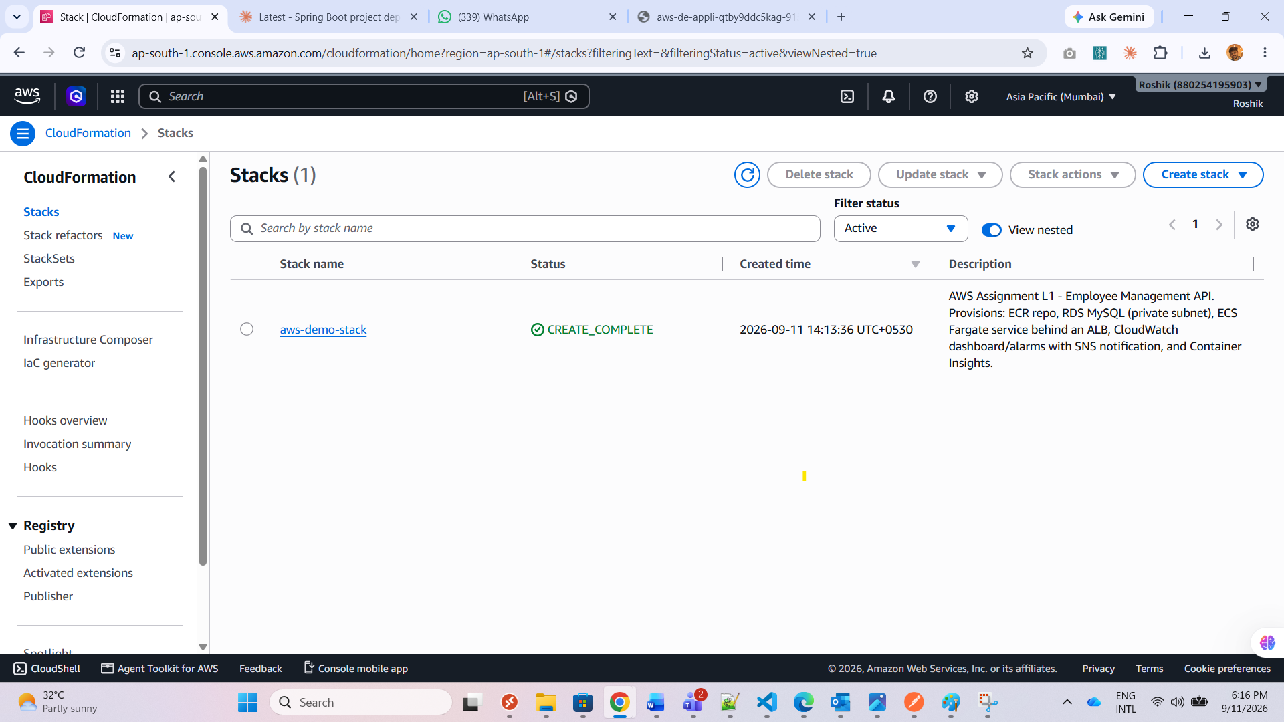
Fig. 14 — CloudFormation stack overview — aws-demo-stack (CREATE_COMPLETE).
b. Instance/task size and region parameterized
Template parameters expose RDS instance class, ECS task CPU/memory, and region.
c. Change set reviewed before deploying
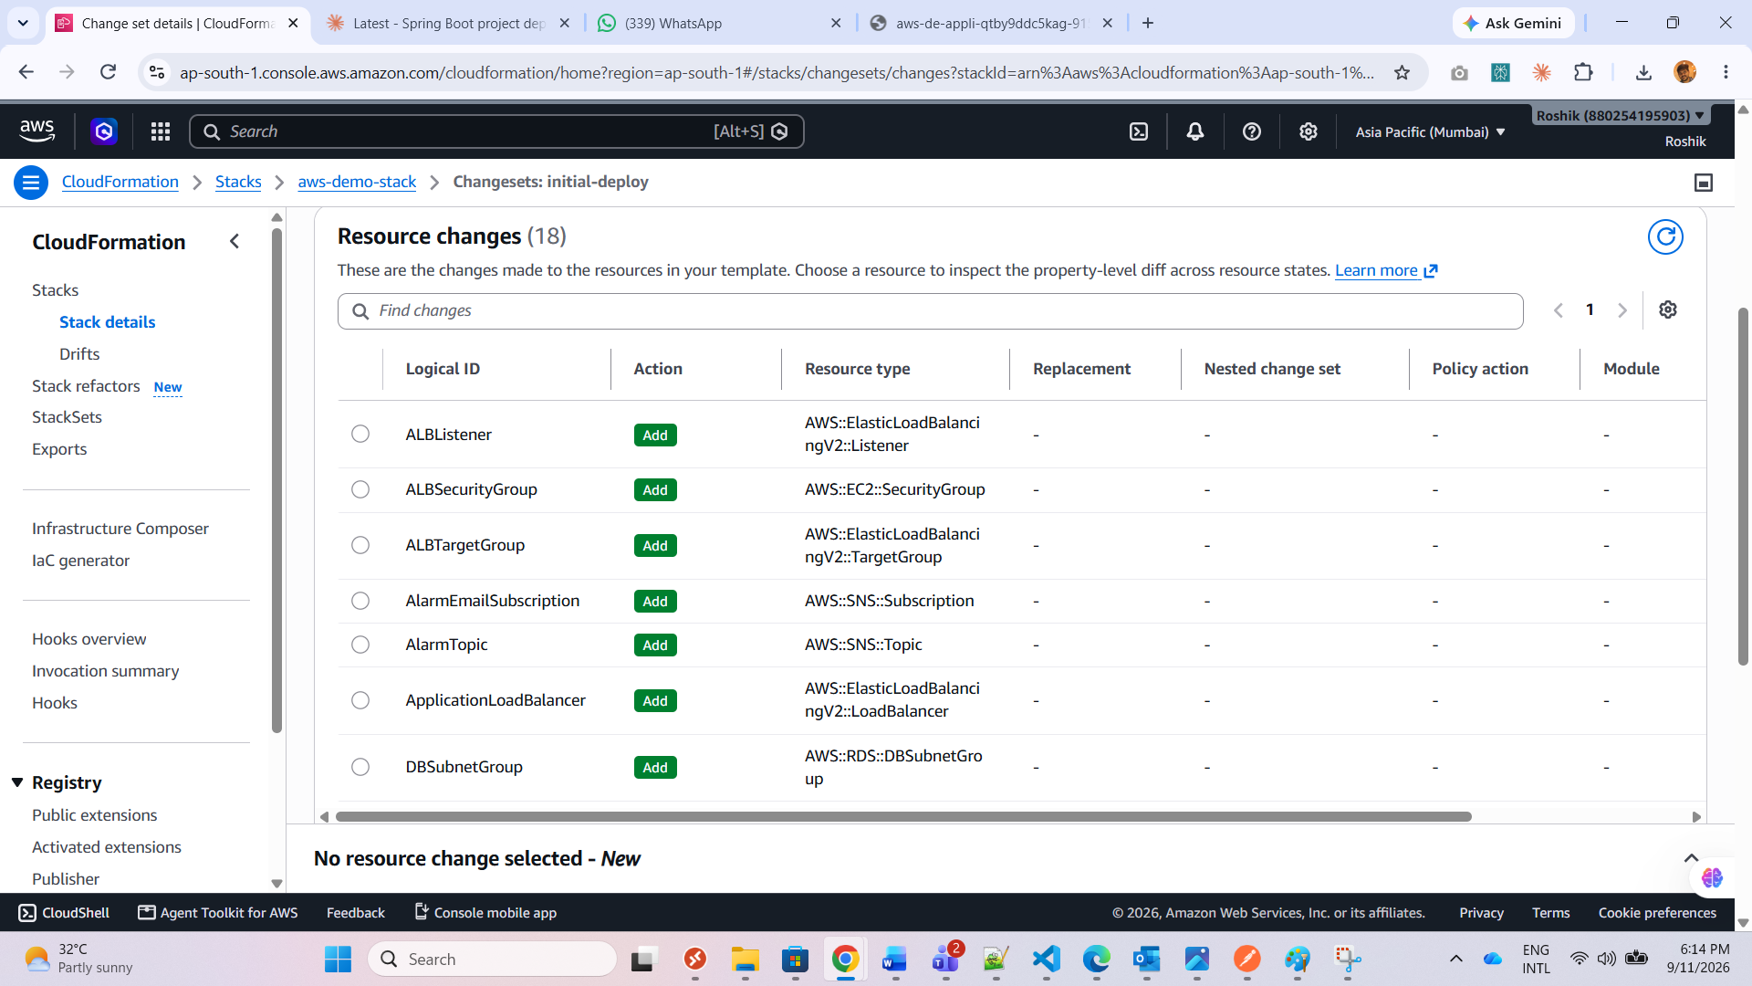
Fig. 15 — Change set listing resources to be added, reviewed before execution.
d. ECR repository managed through the same template
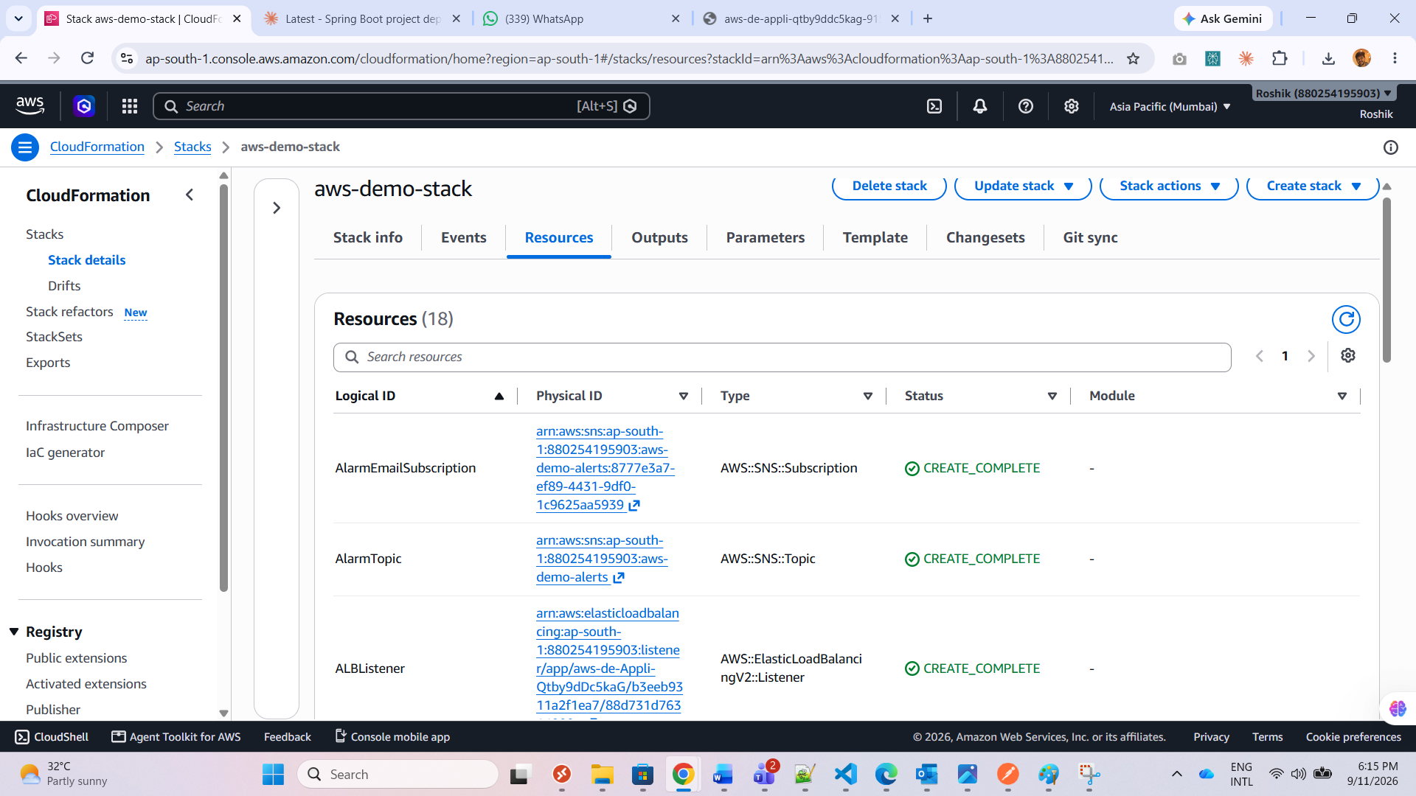
Fig. 16 — Stack events — all resources, including the ECR repo, reached CREATE_COMPLETE.

4. Monitoring & Observability
a. CloudWatch dashboard with ECS + RDS metrics
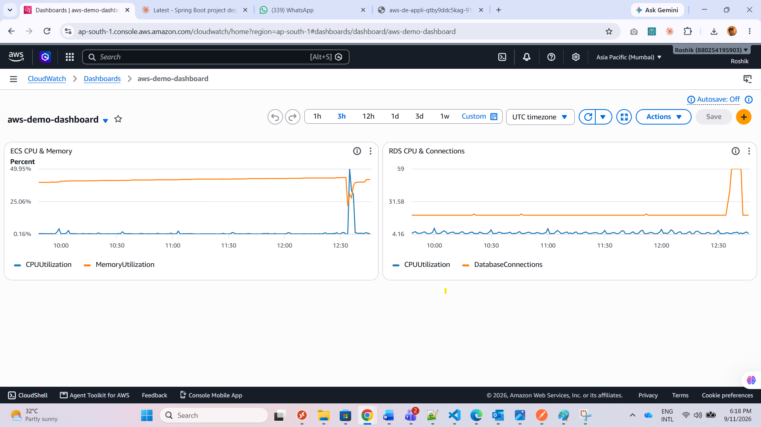
Fig. 17 — aws-demo-dashboard — ECS CPU/memory and RDS CPU/connections.
b. Alarm triggering an SNS email notification
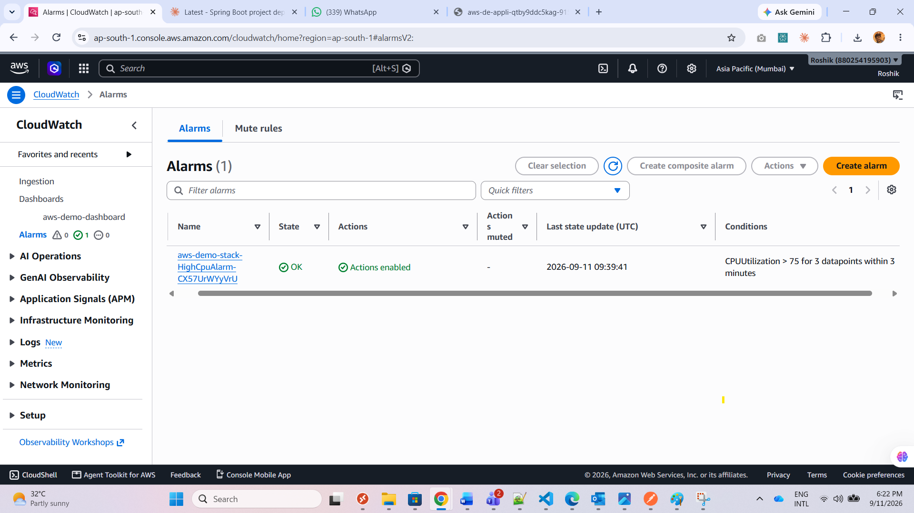
Fig. 18 — HighCpuAlarm state and threshold configuration.
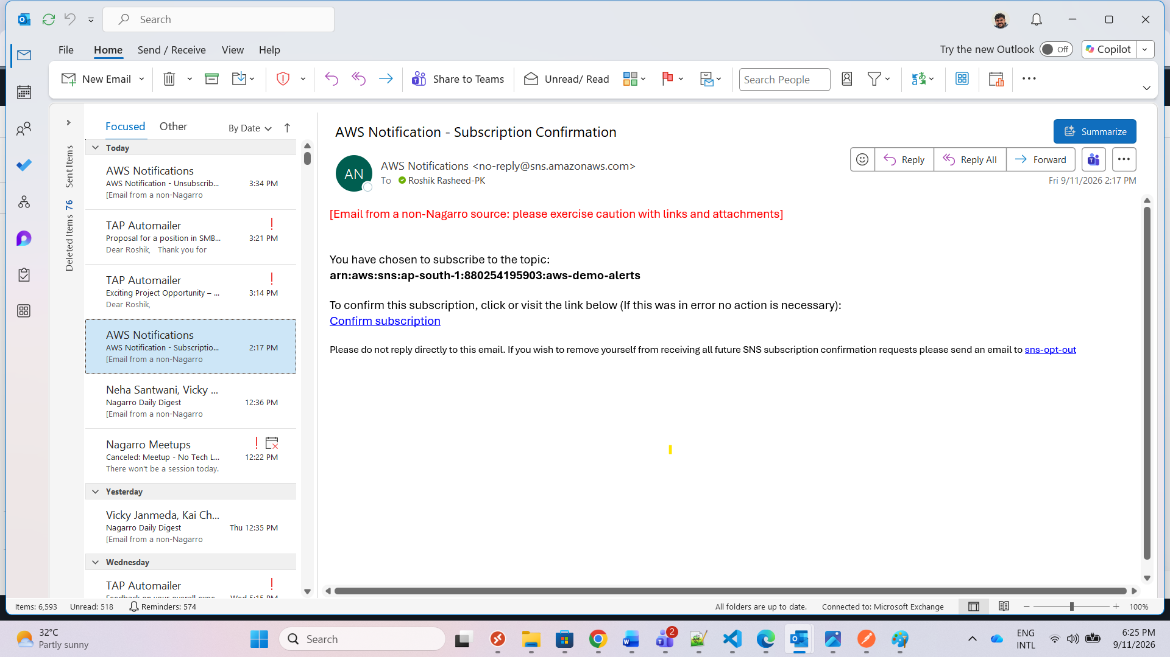
Fig. 19 — SNS notification email confirming an active subscription.
c. Container Insights enabled on the ECS cluster
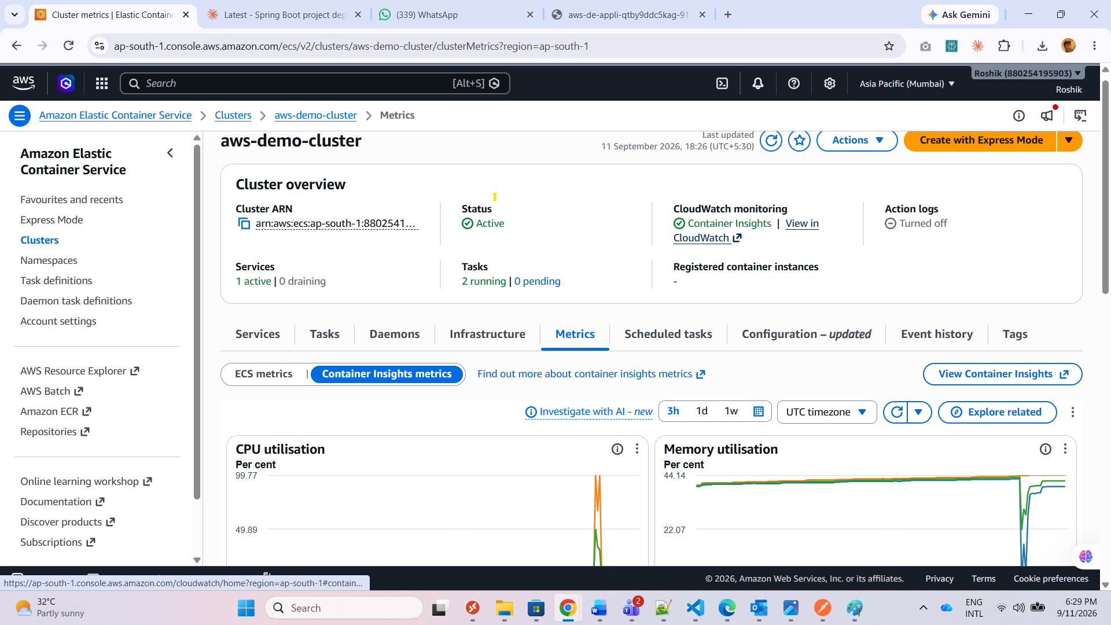
Fig. 20 — Container Insights — CPU and memory metrics.
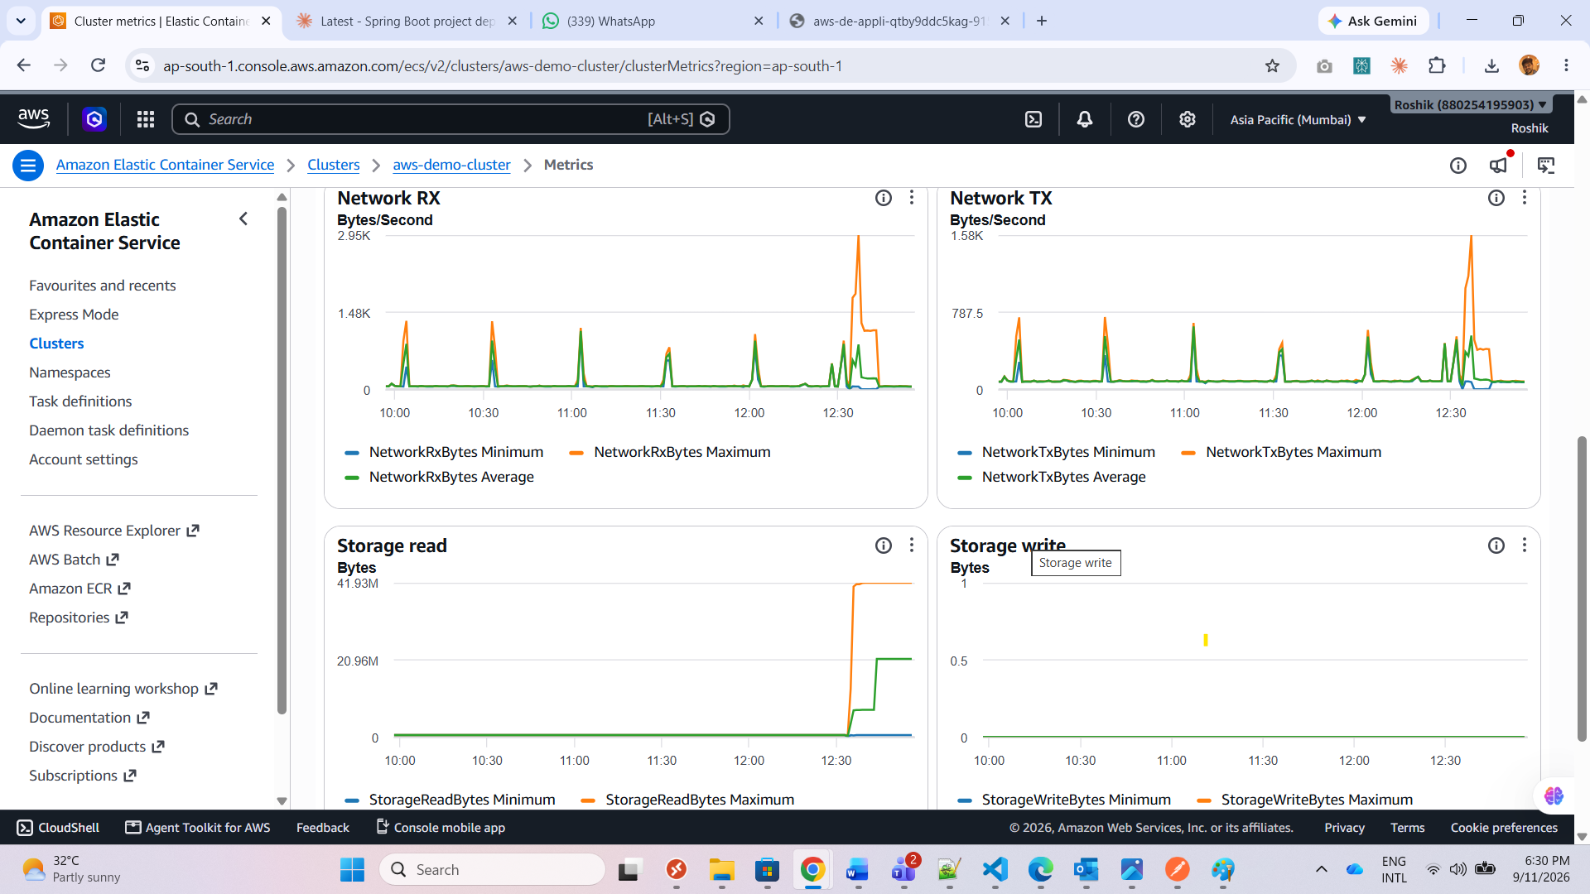
Fig. 21 — Container Insights — network metrics.

Appendix: Application Logging (extra evidence)
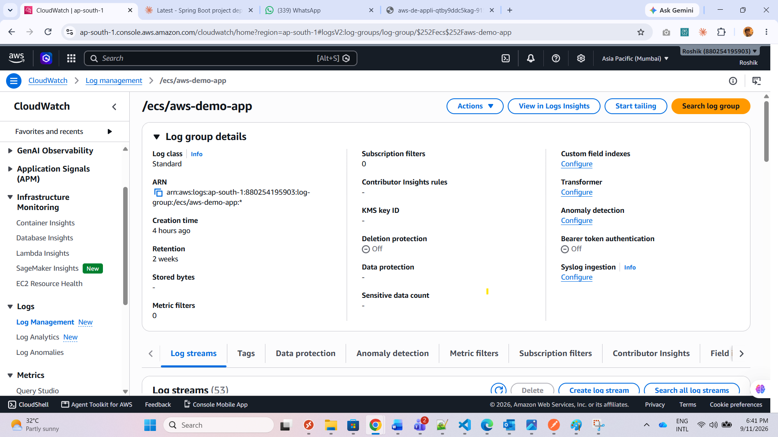
Fig. 22 — CloudWatch log group /ecs/aws-demo-app.
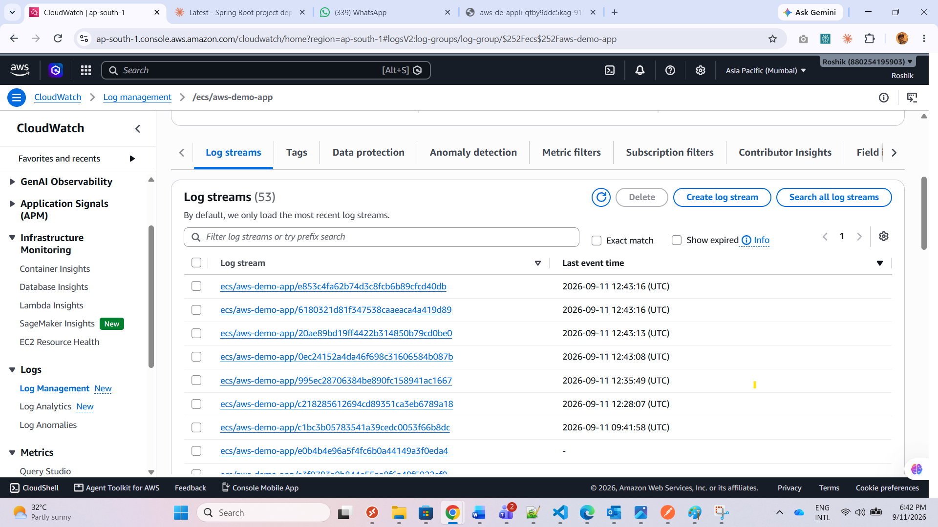
Fig. 23 — Latest log stream listing.
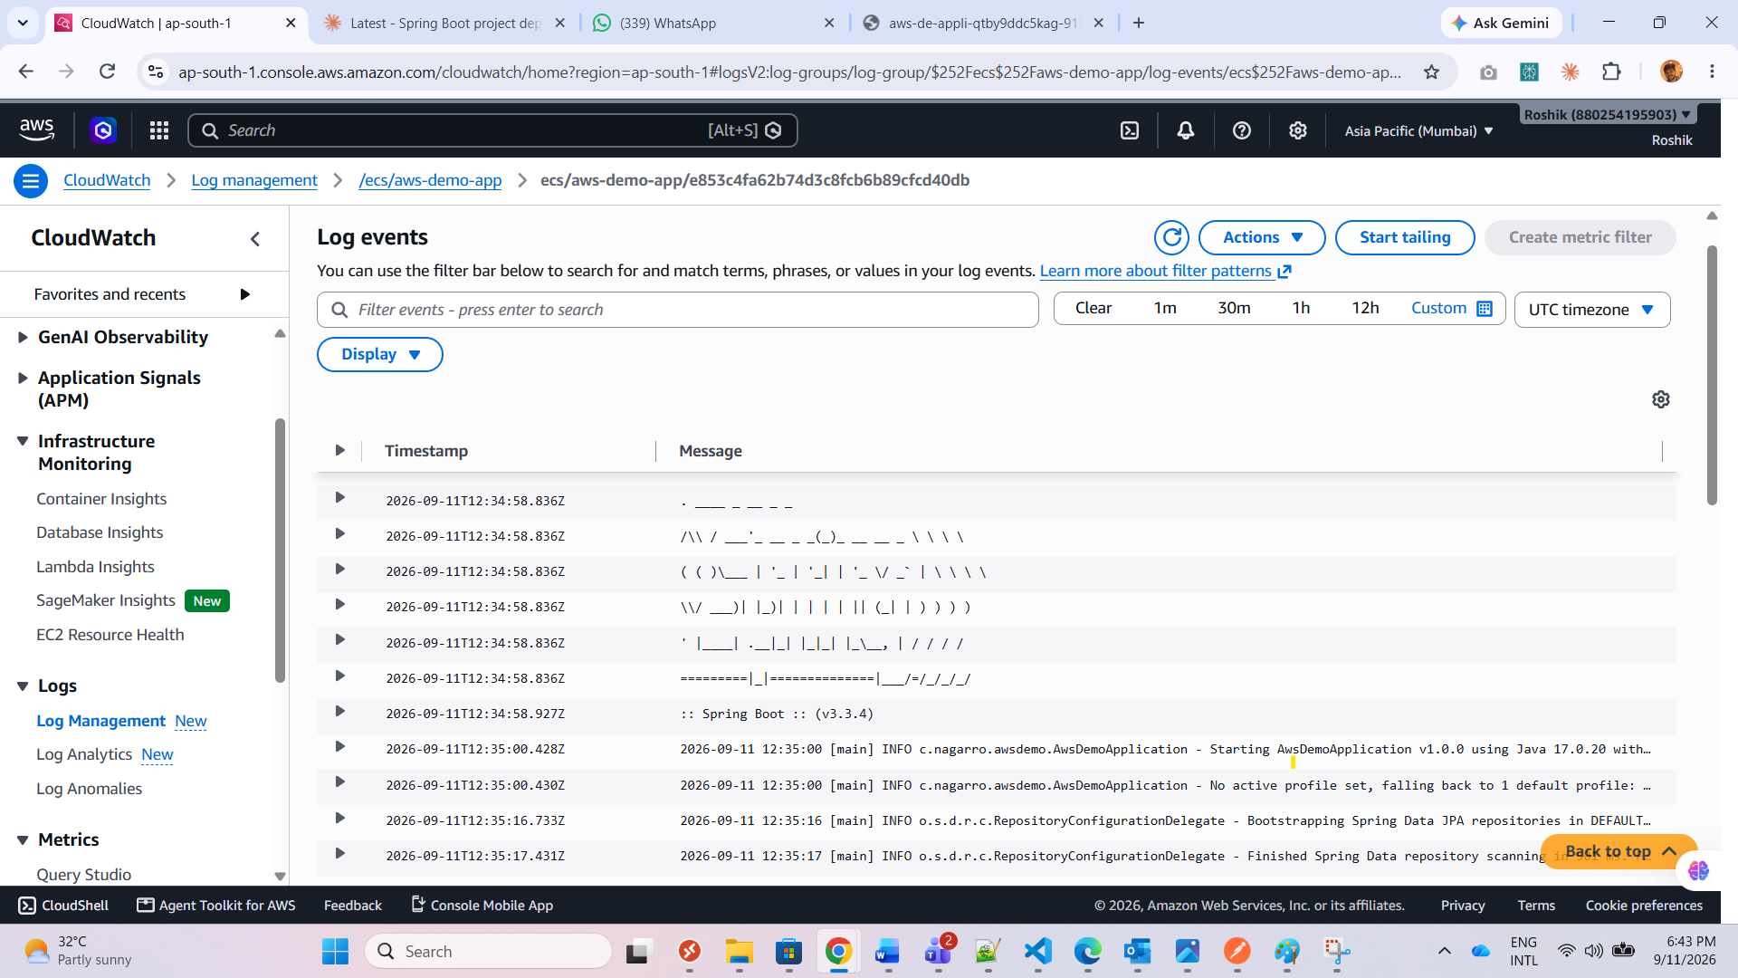
Fig. 24 — Application log output confirming request handling.

