**Instance ScreenShot**

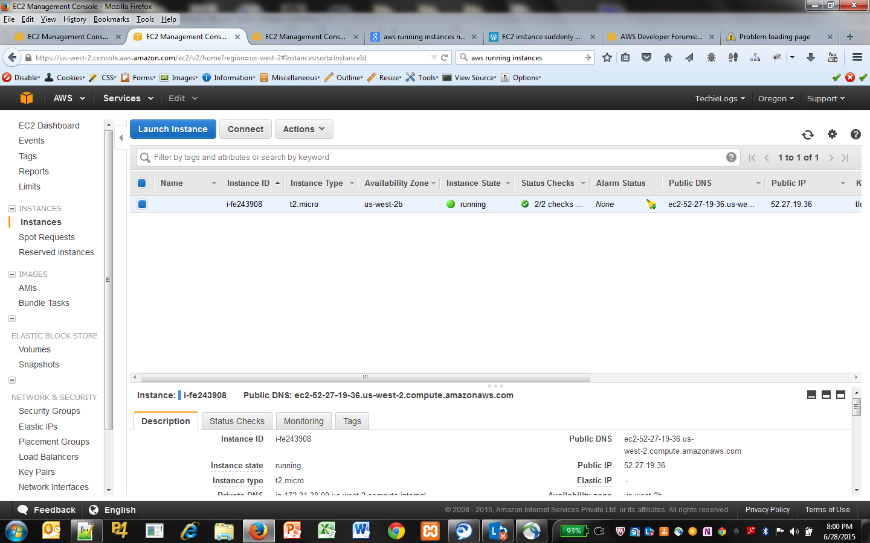

**Create Elastic IP**

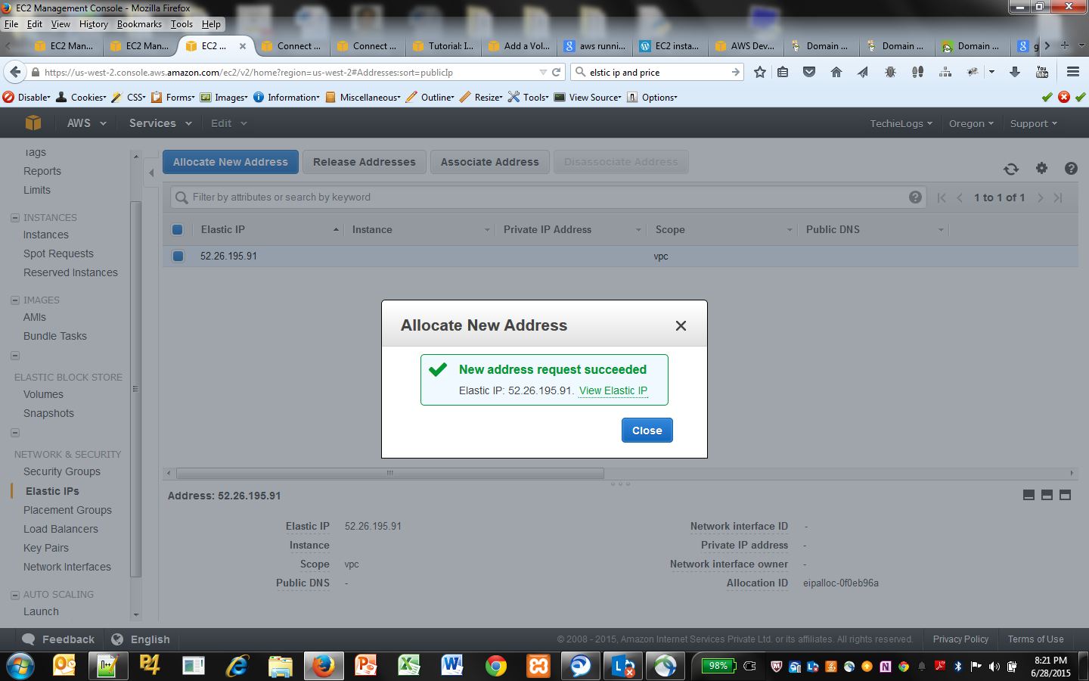

Click **Associate Address** and select the corresponding instance

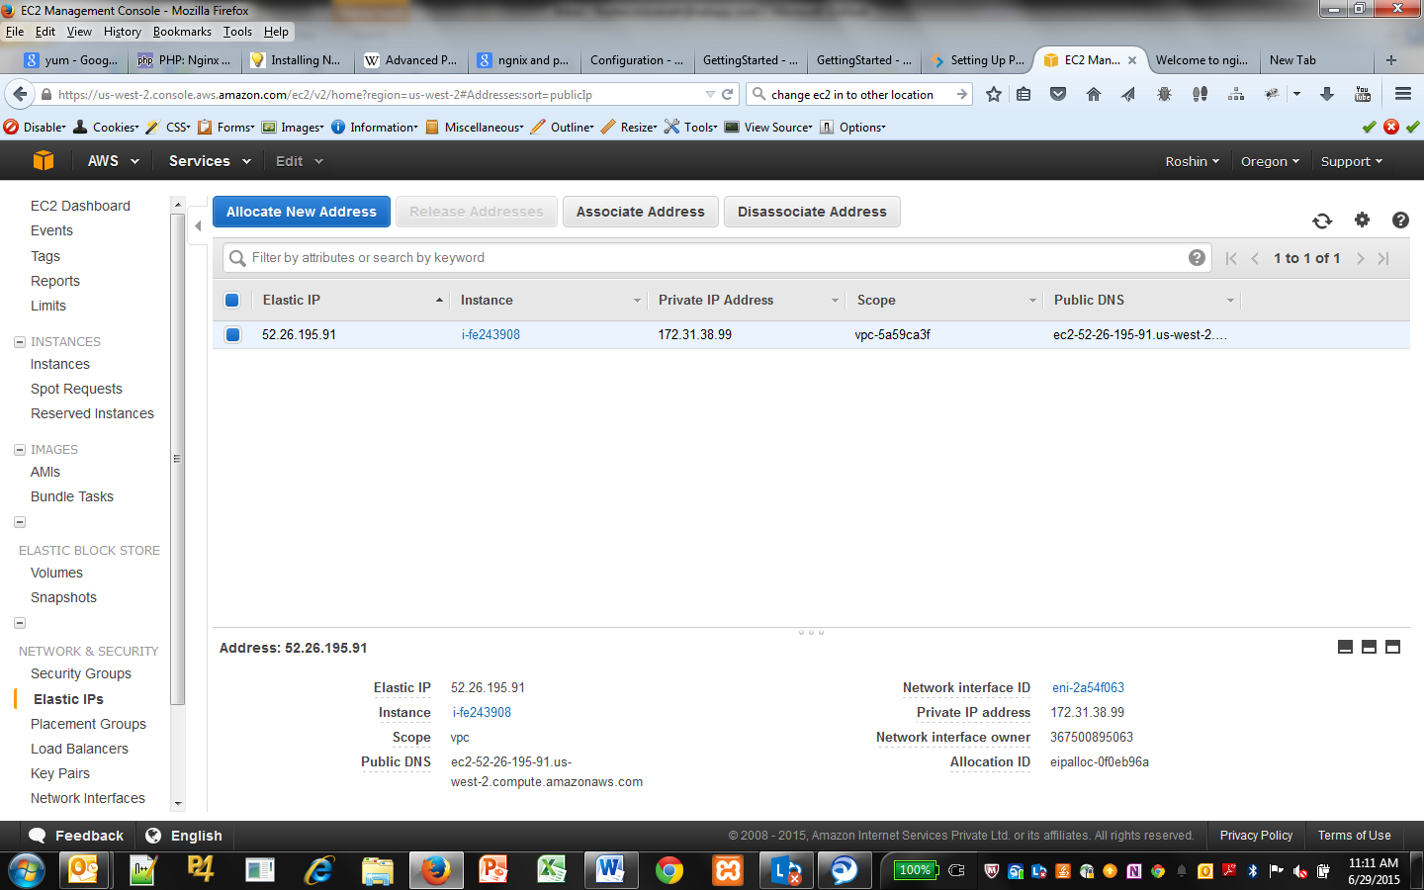

**pointing-godaddy-domain-to-an-aws-ec2**

<https://andnovar.wordpress.com/2014/05/03/pointing-godaddy-domain-to-an-aws-ec2/>

**Assign Security group for the instances**

Need to add SSH and HTTP for correct port

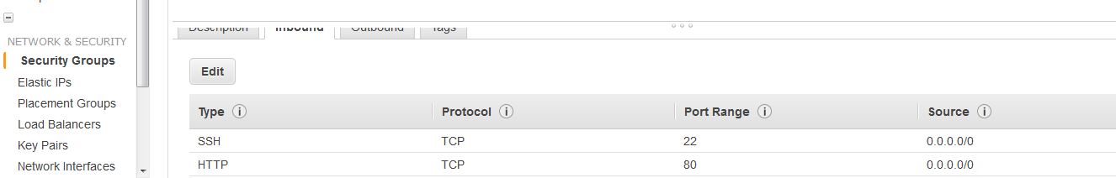

**Connecting Putty and WinSCP**

<http://docs.aws.amazon.com/AWSEC2/latest/UserGuide/putty.html>

**Nginx installation**

<http://theglassicon.com/computing/web-servers/install-nginx-amazon-linux-ami>

Used : <http://nginx.org/download/nginx-1.8.0.tar.gz>

**OR**

Yum install nginx

**Nginx document path can find here** /usr/share/nginx/html

**Nginx conf file** /etc/nginx/ngnix.conf

**Virtual HOST setup** - /etc/nginx/conf.d/ - just create .conf file inside the folder

**PHP FPM installation**

<https://gist.github.com/sumardi/5559803>

<http://stale.coffee/ec2-micro-instance-adventure-nginx-php-mysql.html>

<http://stackoverflow.com/questions/20533436/php-fpm-error-on-ec2-the-process-manager-is-missing-static-dynamic-or-ondema>

# PHP-FPM Configuration

sudo vi /etc/php-fpm.d/www.conf

sudo vi /etc/php.ini - **INI FILE**

**Virtual HOST setup** - /etc/nginx/conf.d/ (just create .conf file inside the folder)

sudo service php-fpm start

sudo service nginx restart

**TO INSTALL PHP 5.6 FPM**

yum install php56-fpm

(before thet remove all dependencies using yum remove …

yum remove php-fpm

yum remove php-process php-common

etc..

)

**MongoDB installation**

<http://docs.mongodb.org/manual/tutorial/install-mongodb-on-amazon>

1. Create a /etc/yum.repos.d/mongodb-org-3.0.repo file so that you can install MongoDB directly, using yum.

*[mongodb-org-3.0]*

*name=MongoDB Repository*

*baseurl=https://repo.mongodb.org/yum/amazon/2013.03/mongodb-org/3.0/x86_64/*

*gpgcheck=0*

*enabled=1*

1. To install the latest stable version of MongoDB, issue the following command:

sudo yum install -y mongodb-org

1. The MongoDB instance stores its data files in **/var/lib/mongo** and its log files in **/var/log/mongodb** by default. You can specify alternate log and data file directories in **/etc/mongod.conf**
2. **Start MongoDB**.

You can start the mongod process by issuing the following command:

**sudo service mongod start**

1. You can optionally ensure that MongoDB will start following a system reboot by issuing the following command:

**sudo chkconfig mongod on**

**MongoDB and Robomongo ?**

**testing**