**TITLE OF THE PROJECT**

METRO TICKET RESERVATION SYSTEM.

MINI PROJECT REPORT

Submitted in partial fulfillment of the

requirements for the award of the degree of

**BACHELOR OF ENGINEERING**

IN

**INFORMATION TECHNOLOGY**

By

<Roshini Joga>< 1602-19-737-035>

<Asha Kommu ><1602-19-737-005>



**Department of Information Technology**

**Vasavi College of Engineering (Autonomous)**

**(Affiliated to Osmania University)**

**Ibrahimbagh, Hyderabad-31**

**2020.**

**VASAVI COLLEGE OF ENGINEERING(AUTONOMOUS)**

**(AFFILIATED TO OSMANIA UNIVERSITY)**

**HYDERABAD - 500 031**

**Department of Information Technology**



**DECLARATION BY CANDIDATE**

I, <>**,** bearing hall ticket number, **<**1602-19-737-0**>**,

hereby declare that the project report entitled **<**” Metro ticket reservation system”**>**Department of Information Technology, Vasavi College of Engineering, Hyderabad, is submitted in partial fulfillment of the requirement for the award of the degree of **Bachelor of Engineering** in **Information Technology**.

This is a record of bonafide work carried out by me and the

results embodied in this project report has not been submitted to

any other university or institute for the award of any other degree

or diploma.

**<Roshini Joga>**

**<1602-19-737-035>**

**<Asha Kommu>**

**<1602-19-737-005>**

**TABLE OF CONTENTS**

1. ACKNOWLEDGEMENT

2. ABSTRACT

3. INTRODUCTION

4. TECHNOLOGY

5. PROPOSED WORK

6. RESULTS

7. ADDITIONAL LEARNING

8. DISCUSSION AND FUTURE WORK

9. REFERENCES

**ACKNOWLEDGEMENT**

It gives us immense pleasure to thank the Department of INFORMATION TECHNOLOGY, for introducing the subject “mini-project” in BE third semester, that let us learn and explore more features in “C programming language”.

I would also like to show my appreciation to our honorable principal, Dr. S V RAMANA sir, for supporting us and our beloved mini-project lecturer, Mrs. LEELAVATHI mam, for letting us properly understand the process of doing the mini-project using c and for providing insight and expertise that greatly assisted the project.

My parents were my first teachers and they have provided me with such a great exposure that has helped me bloom. My family and friends will always be loved for sticking by me through thick and thin. THANK YOU!

**ABSTRACT**

This whole system is based on a concept to reserve train tickets of various destinations .Here, as the program is executed, there’s a registration system then the user has to choose between reserving a ticket, viewing all the available trains , cancel the metro ticket with refund,displaying the registered users,changing the day of boarding. By

choosing reservation of ticket, user has to enter the name, number of tickets and then choose by which train to travel according to their destination. Then the system will ask for ticket confirmations. User can also view full list of all the trains available. After reserving a metro ticket you can also cancel your reservation**.**

We designed this project because, at times like covid. It would be way too much difficult to stand in the queue for the ticket and taking the risk of covid safety measures. Where users can directly book their ticket from their respective mobile phones and make this metro journey a little more easier and time saving.

**INTRODUCTION**

In today’s era, the public transportation has become a crucial travelling method. Comparatively, back in the days, the travelling of man from one location to the next would take months or even years, and there was very little assistance from technology or tools of communication . At present time however, within only a fraction of time like hours or days, man could travel thousands of miles with the assistance of effective and efficient transportation method and communication device. In many countries, particularly the third world countries, people prefer travelling on buses and train, from one place to another. At present time, the use of electronic ticketing is becoming popular for train or bus users. As explained by Ferreira et al., in electronic ticketing system comprises the system of ticketing that utilizes technology of self-service as application base to assist users in booking a ticket on their own.

The recent introduction and evolution of applications on smartphones have changed the behavioral habits of consumers in terms of goods and services buying power .The online purchases made by consumers via mobile application have increased on a global level, with no limits. Now, using simple mobile phone app and online pay method, consumers or the public can book, purchase, validate and retrieve their transport ticket . The application and use of mobile phones among consumers have greatly expanded from just to communicate to various other tasks including music, gaming, navigating and so forth.

So, we designed this system to make metro journeys easier and worth travelling.

**TECHNOLOGY**

To implement any project successfully, there will be technological requirements which can either be software or hardware requirements

**a)Software requirements:**

Since our project was supposed to be based on the C programming language, it is a bare necessity to have the knowledge and syntaxes of the language and a proper compiler and a text editor to run and write the programs.

Compiler

Many of the C compilers include:

1. Borland Turbo C
2. Tiny C compiler
3. Portable C compiler
4. GCC compiler
5. Clang

Text editor

To actually write and complete a code in any language, a text editor is important. Some of the famous text editors are:

1. Vim editor
2. Notepad

From the above text editors, we chose vim text editor to write our code and execute it properly as it is user friendly in a Linux environment.

**b) Hardware requirements:**

For the hardware requirements the SRS specifies the logical characteristics of each interface b/w the software product and the hardware components. It specifies the hardware requirements lie memory restrictions, cache size, the processor, RAM size etc..those are required for the software to run.

**Minimum hardware requirements:**

Processor Pentium III.

Hard disk drive.

RAM 128MB.

Cache 512mb.

**PROPOSED WORK**

1. **DESIGN:**

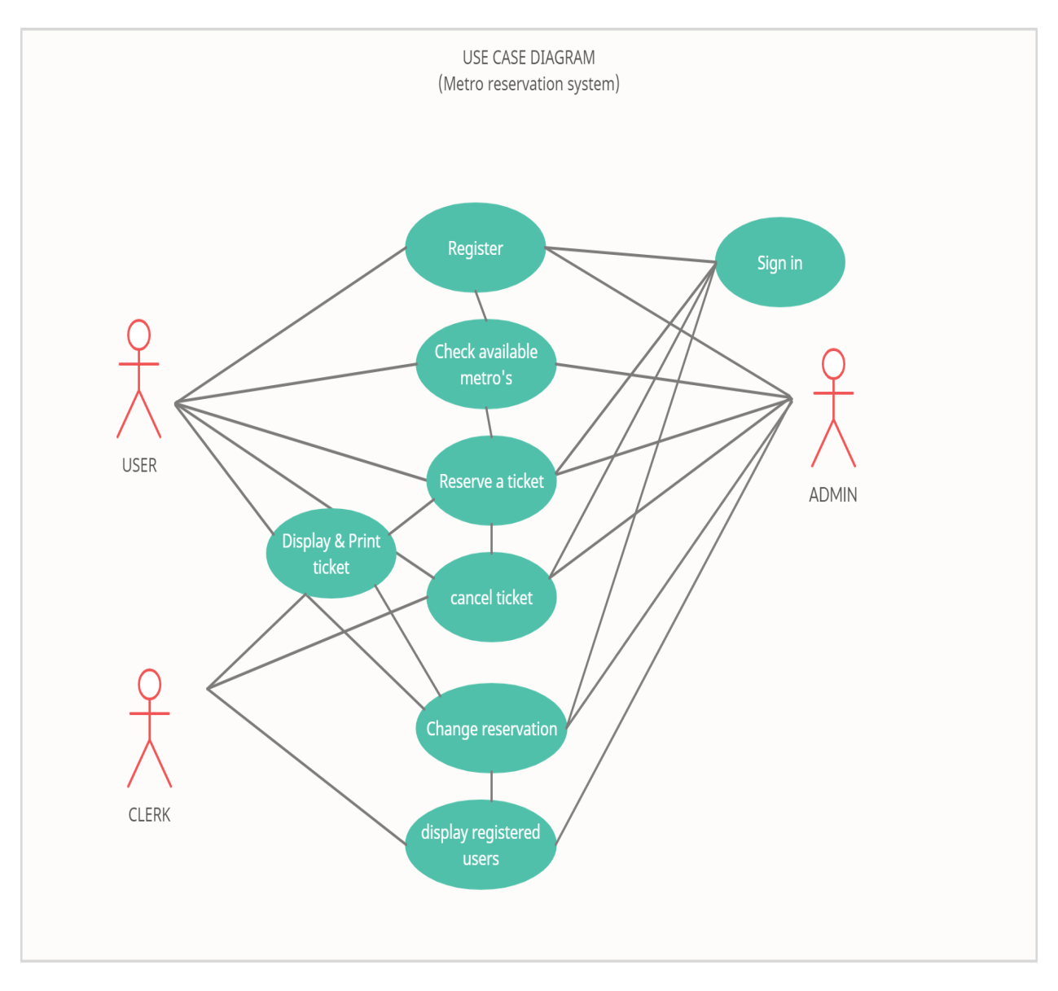

**MAIN FLOW:**

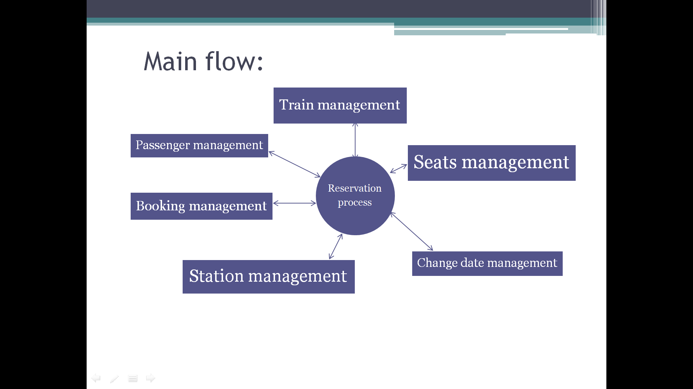

1. **IMPLEMENTATION:**

The modules/classes/components present are:

.**Registration:**

This module allows user to get registered into their accounts with their desired credentials and gets the user successfully registered into the system.

**.Reservation of the ticket:**

This allows user to reserve their ticket of their selected destination and asks for the date and number of tickets the user wants to take and reservation is successfully done.

.**Displaying the ticket:**

This module allows the user to display the ticket after reserving the ticket in case if the user forgets to print their ticket after reservation. This allows the user to view their ticket whenever they want.

**.Viewing all available metro stations:**

This module allows user to view all the metro stations available at the moment and shows the ticket price for each station.

**.Cancelling the ticket:**

Thisallowsthe user to cancel their ticket after reserving it .

**.Displaying all registered users:**

This allows the admin user to view all the registered users in this application.

**.Changing the date of boarding:**

This allows the user to change their ticket of boarding from one their present date to another particular date and can travel as they wish. And the system prints a new ticket to the user.

void registration();

void reservation(void);

void viewdetails(void);

void cancel(void);

void printticket(char name[],int,int,float,char date[]);

void specificmetro(int);

float charge(int,int);

void display_all();

void change_reservation();

void viewdetails(void)

{

system("cls");

printf("-----------------------------------------------------------------------------");

printf("\nTr.No\tName\t\t\tDestinations\t\tCharges\n");

printf("-----------------------------------------------------------------------------");

printf("\n1\tMiyapur to JNTU college: Rs.10/-");

printf("\n2\tMiyapur to KPHB colony: Rs 15");

printf("\n3\tMiyapur to Kukatpally: Rs 25");

printf("\n4\tMiyapur to Kukatpally Y junction: Rs 30");

printf("\n5\tMiyapur to Moosapet: Rs 30");

printf("\n6\tMiyapur to Bharat Nagar: Rs 30");

printf("\n7\tMiyapur to Erragadda: Rs 35");

printf("\n8\tMiyapur to ESI Hospital: Rs 35");

printf(" \n9\tMiyapur to SR Nagar: Rs 40");

printf(" \n10\tMiyapur to Ameerpet: Rs 40");

printf("\n11\tMiyapur to Punjagutta: Rs 40");

printf("\n12\tMiyapur to Erramanzil: Rs 40");

printf("\n13\tMiyapur to Khairatabad: Rs 45");

printf("\n14\tMiyapur to Lakdi-Ka-Pool: Rs 45");

printf("\n15\tMiyapur to Assembly: Rs 45");

printf("\n16\tMiyapur to Nampally: Rs 45");

printf("\n17\tMiyapur to Gandhi Bhavan: Rs 50");

printf("\n18\tMiyapur to Osmania Medical College: Rs 50");

printf("\n19\tMiyapur to MG Bus Station: Rs 50");

printf("\n20\tMiyapur to Malakpet: Rs 50");

printf("\n21\tMiyapur to New Market: Rs 50");

printf("\n22\tMiyapur to Musarambagh: Rs 55");

printf("\n23\tMiyapur to Dilukhnagar: Rs 55");

printf("\n24\tMiyapur to Chaitanyapuri: Rs 55");

printf("\n25\tMiyapur to Victoria Memorial: Rs 60");

printf("\n26\tMiyapur to LB Nagar : Rs 60");

}

void registration()

{

FILE *fp;

struct details d;

char user[10];

fp=fopen("roshini.txt","a+");

printf(" please enter the details below: ");

first:

printf("\n\n\n enter username: ");

scanf("%s",user);

while(1)

{

fread(&d,sizeof(d),1,fp);

if(feof(fp))

{

break;

}

if(strcmp(d.name,user)==0)

{

printf("\n\n\n this username already exists . please try again!!");

goto first;

}

}

strcpy(d.name,user);

printf("\n enter password :");

scanf("%s",d.password);

d.res=0;

fwrite(&d,sizeof(d),1,fp);

fclose(fp);

printf("\n\n\t\t\t registration succesful ");

printf("\nPress any key to go back to Main menu!\n\n");

getch();

}

void reservation(void)

{ printf("\n\n\n Enter the DATE of travelling in dd-mm-yyyy format :");

scanf("%s",date);

strcpy(d.date,date);

printf("\n\n\nEnter Number of seats:> ");

scanf("%d",&d.num_of_seats);

printf("\n\n>>Press Enter To View Available metro stations<< ");

getch();

system("cls");

viewdetails();

printf("\n\nEnter metro number:> ");

stard1:

scanf("%d",&d.metro_num);

if(d.metro_num>=1 && d.metro_num<=26)

{

d.charge=charge(d.metro_num,d.num_of_seats);

d.res=1;

system("cls");

printticket(d.name,d.num_of_seats,d.metro_num,d.charge,d.date);

}

else

{

printf("\n\nInvalid metro Number! Enter again--> ");

goto stard1;

}

fwrite(&d,sizeof(d),1,fp1);

printf("\n\n\n\n==================================");

printf("\n Reservation Done\n");

printf("==================================");

printf("\nPress any key to go back to Main menu");

}

else

{

fwrite(&d,sizeof(d),1,fp1);

}

}

fclose(fp);

fclose(fp1);

if(found==0)

{

printf(" YOU ARE NOT A REGISTERED USER\n\n");

printf("\n\n press any key to go to main menu \n");

}

else

{

fp=fopen("roshini.txt","w+");

fp1=fopen("copy.txt","r+");

while(1)

{

fread(&d,sizeof(d),1,fp1);

if(feof(fp1))

{

break;

}

fwrite(&d,sizeof(d),1,fp);

}

}

fclose(fp);

fclose(fp1);

getch();

}

void printticket(char name[],int num_of_seats,int metro_num,float charges,char date[])

{

//system("cls");

printf("---------------------------------------------\n");

printf("\tTICKET\n");

printf("--------------------------------------------\n\n");

printf("Name:\t\t\t%s",name);

printf("\nNumber Of Seats:\t%d",num_of_seats);

printf("\nmetro Number:\t\t%d",metro_num);

specificmetro(metro_num);

printf("\nCharges:\t\t%.2f",charges);

printf("\n DATE OF TRAVELLING : %s",date);

}

void cancel()

{ char name[20],pass[20];

FILE *fp,*fp1;

struct details d,d1;

int found=0,count=0;

fp=fopen("roshini.txt","r");

fp1=fopen("copy.txt","w");

printf("\n\n\nenter username and password of the user whose ticket you want to cancel : ");

printf("\nENTER USERNAME: ");

scanf("%s",name);

printf("\nENTER PASSWORD :");

scanf("%s",pass);

while(1)

{

fread(&d,sizeof(d),1,fp);

if(feof(fp))

{

break;

}

if((strcmp(d.name,name)==0)&&(strcmp(d.password,pass)==0))

{

found=1;

printf("\n\nYOUR TICKET WAS : \n\n\n");

printticket(d.name,d.num_of_seats,d.metro_num,d.charge,d.date);

d.num_of_seats=0;

d.metro_num=0;

printf("\n\n The ticket has been cancelled !! \n\n");

printf("\n amount refunded = %f ",d.charge);

d.charge=0;

d.res=2;

fwrite(&d,sizeof(d),1,fp1);

}

else

{

fwrite(&d,sizeof(d),1,fp1);

}

}

fclose(fp);

fclose(fp1);

if(found==0)

{

printf("\n user not found ");

}

else

{

fp=fopen("roshini.txt","w");

fp1=fopen("copy.txt","r");

while(1)

{

fread(&d,sizeof(d),1,fp1);

if(feof(fp1))

{

break;

}

fwrite(&d,sizeof(d),1,fp);

}

}

fclose(fp);

fclose(fp1);

getch();

}

void view_ticket()

{

int ctr=0;

char name[20],pass[20];

FILE *fp;

struct details d;

fp=fopen("roshini.txt","r");

printf("\n\nENTER USERNAME: ");

scanf("%s",name);

printf("\nENTER PASSWORD :");

scanf("%s",pass);

while(1)

{

fread(&d,sizeof(d),1,fp);

if(feof(fp))

{

break;

}

if((strcmp(d.name,name)==0)&&(strcmp(d.password,pass)==0))

{

if(d.res==1)

{

ctr=1;

printticket(d.name,d.num_of_seats,d.metro_num,d.charge,d.date);

}

else if(d.res==2)

{

ctr=1;

printf(" \n\nyour ticket was cancelled ");

}

else

{

ctr=1;

printf("\n\nreservation not done");

}

}

}

fclose(fp);

if(ctr==0)

{

printf("\n\n\t\t\t\t you are not a registered user\n\n\n\n");

}

}

void display_all()

{

FILE *fp;

struct details d;

fp=fopen("roshini.txt","r+");

printf("\t\t\t ALL REGISTERED USERS :\n\n\n");

printf("--------------------------------------------\n\n");

while(1)

{

fread(&d,sizeof(d),1,fp);

if(feof(fp))

{

break;

}

printf("\nName:\t\t%s",d.name);

}

printf("\n***********************************************************************\n\n");

fclose(fp);

}

void change_reservation()

{

char new_date[20];

int ctr=0; //counter

char ch;

char name[20],pw[20];

FILE *fp,*fp1;

struct details d;

fp=fopen("roshini.txt","r");

fp1=fopen("copy.txt","w");

printf("**********************CHANGING THE DATE OF BOARDING***************************\n\n");

printf("\n\n\nPlease enter the username and password of the user whose date you want to change : ");

printf("\n\nENTER USERNAME: ");

scanf("%s",name);

printf("\nENTER PASSWORD :");

scanf("%s",pw);

while(1)

{

fread(&d,sizeof(d),1,fp);

if(feof(fp))

{

break;

}

if((strcmp(d.name,name)==0)&&(strcmp(d.password,pw)==0))

{

ctr=1;

printf("\n\n previous date of boarding was : %s",d.date);

printf("\n\n\n please enter the new date of boarding in dd-mm-yyyy format :");

scanf("%s",new_date);

strcpy(d.date,new_date);

fwrite(&d,sizeof(d),1,fp1);

printf("\n\n new date of boarding is : %s",d.date);

printf("\n\n\nyour ticket after changing the date is : \n\n\n");

printticket(d.name,d.num_of_seats,d.metro_num,d.charge,d.date);

}

else

{

fwrite(&d,sizeof(d),1,fp1);

}

}

fclose(fp);

fclose(fp1);

if(ctr==0)

{

printf("\n\nuser not found !!\n\n");

}

else

{

fp=fopen("roshini.txt","w");

fp1=fopen("copy.txt","r");

while(1)

{

fread(&d,sizeof(d),1,fp1);

if(feof(fp1))

{

break;

}

fwrite(&d,sizeof(d),1,fp);

}

}

fclose(fp);

fclose(fp1);

}

c) GITHUB LINKS:

<https://github.com/roshini-joga/roshini.git>

<https://github.com/kommuasha/kommuasha.git>

GITHUB FOLDER STRUCTURE: README.md

**TESTING:**

**1)** If you try to login with wrong credentials. The system shows that you are not a registered user.

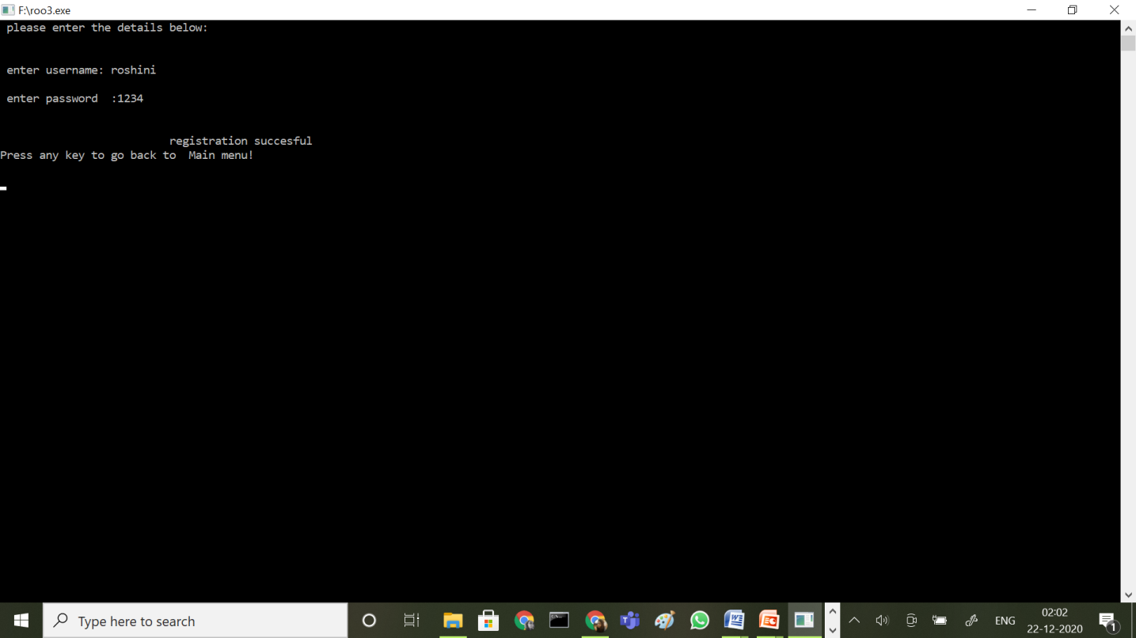

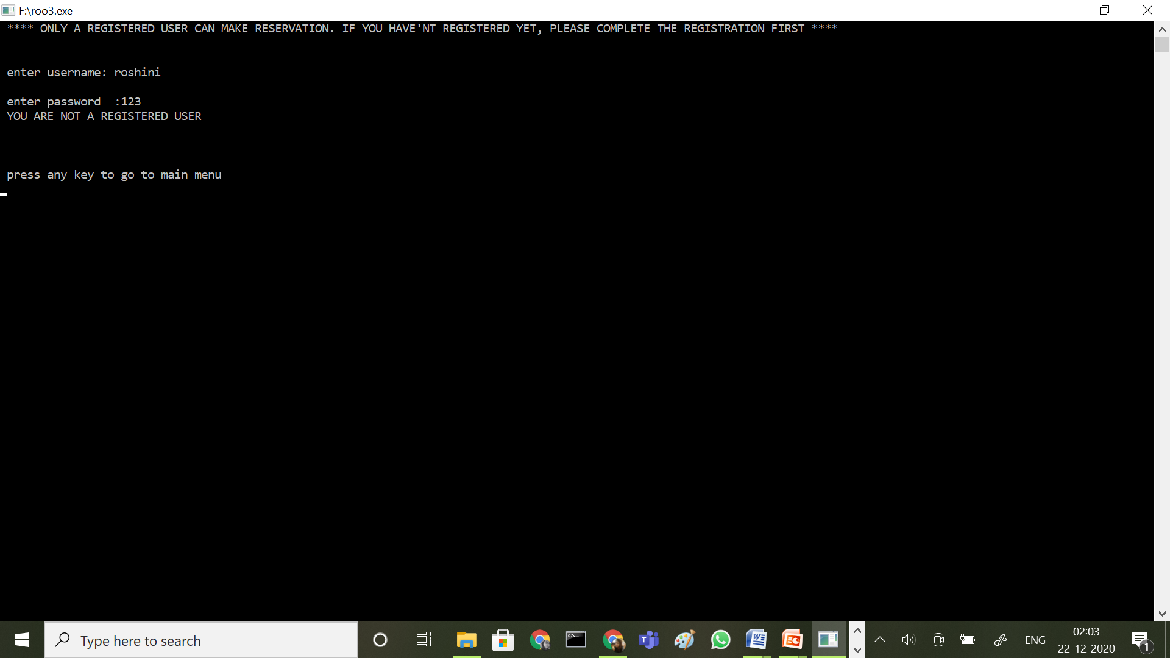

**2)**

Whenyou enter the wrong station number it shows you that it isn’t a valid station number and asks the user to enter it again.

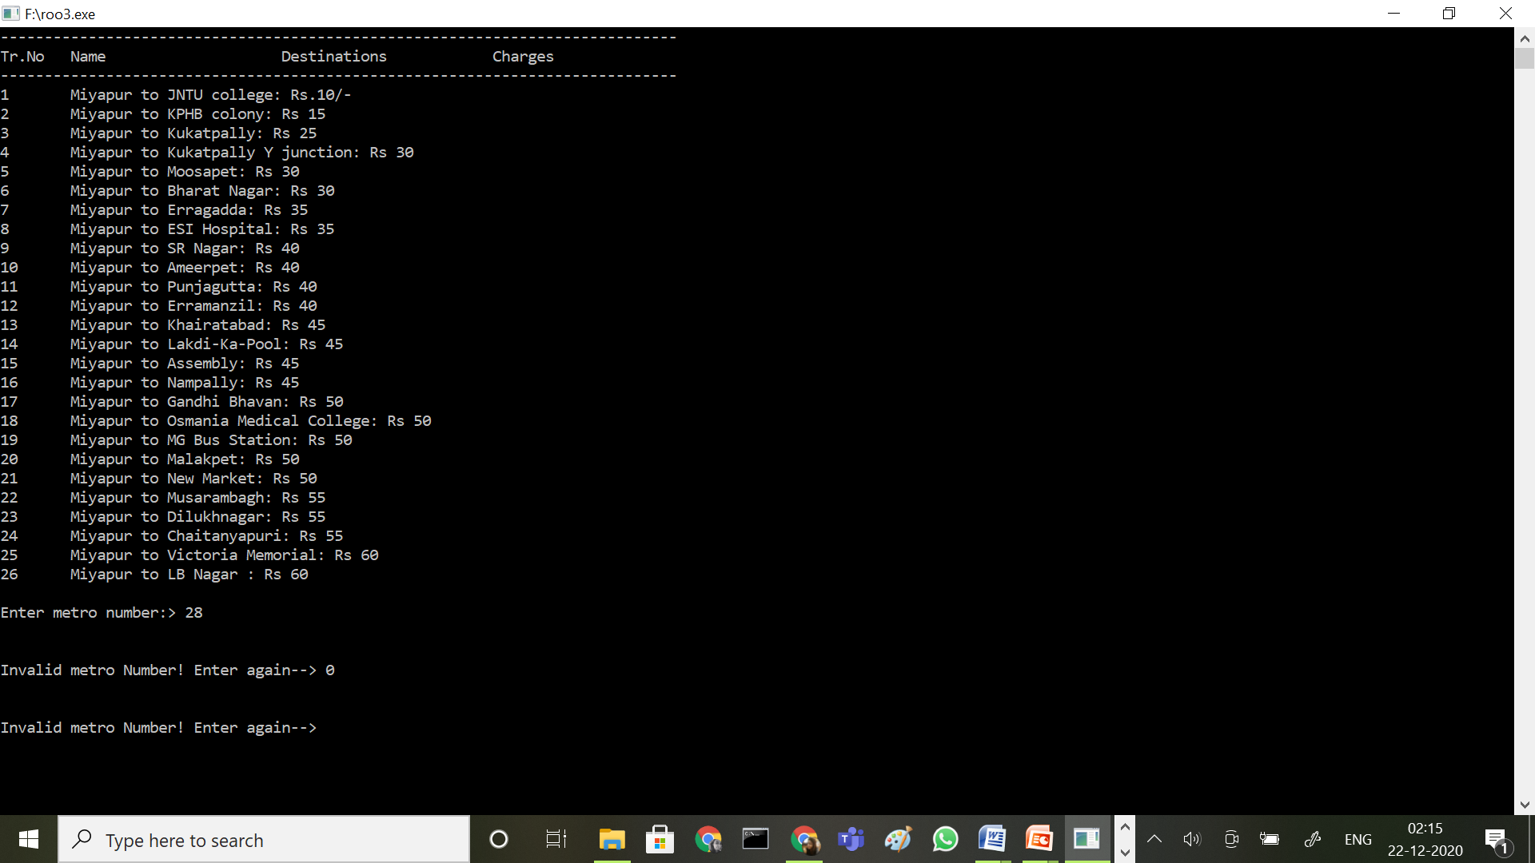

**RESULTS**

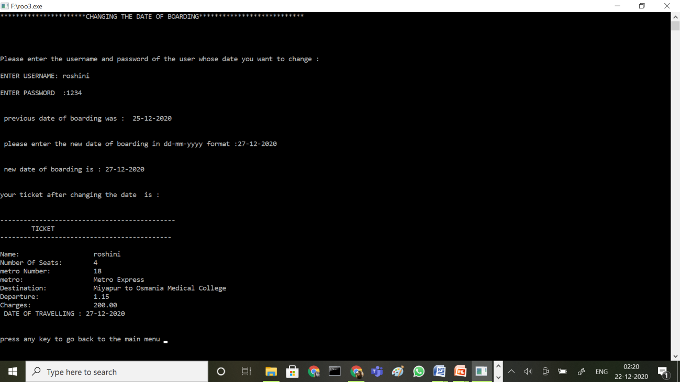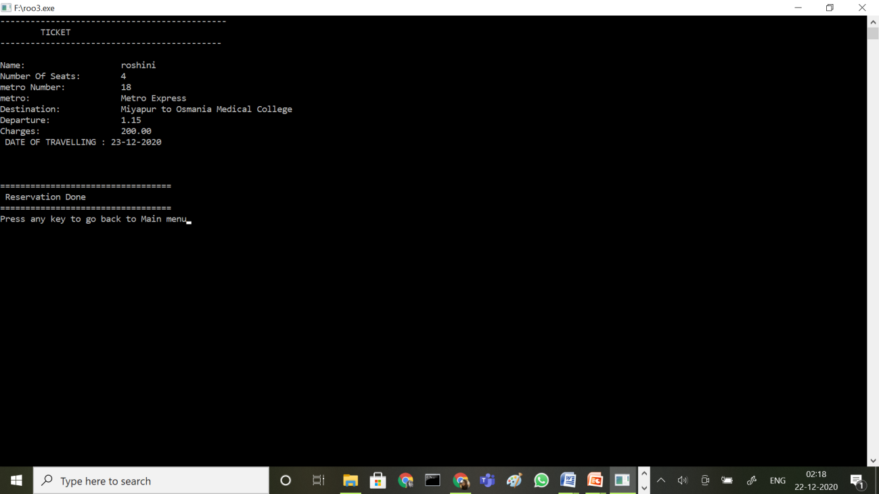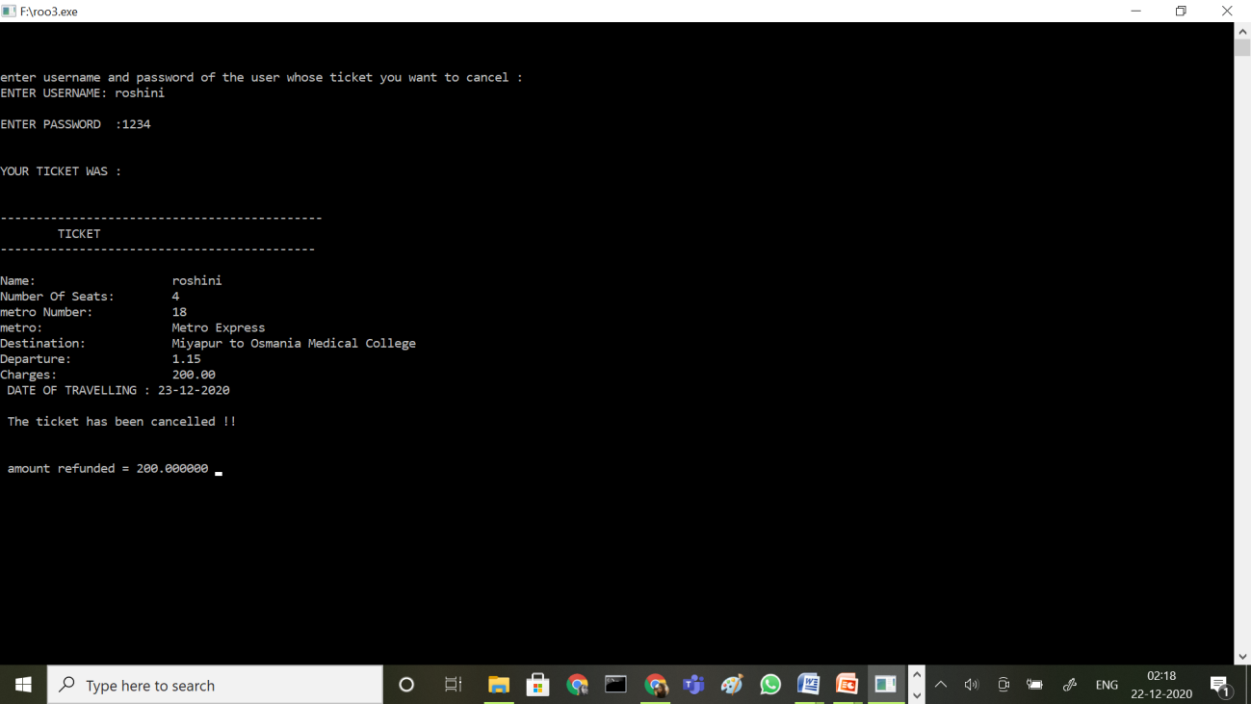

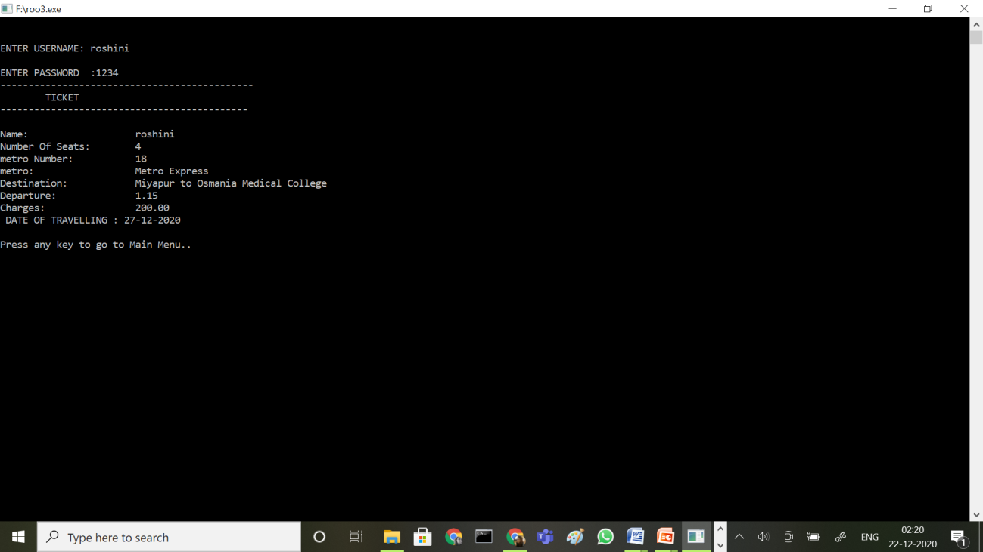

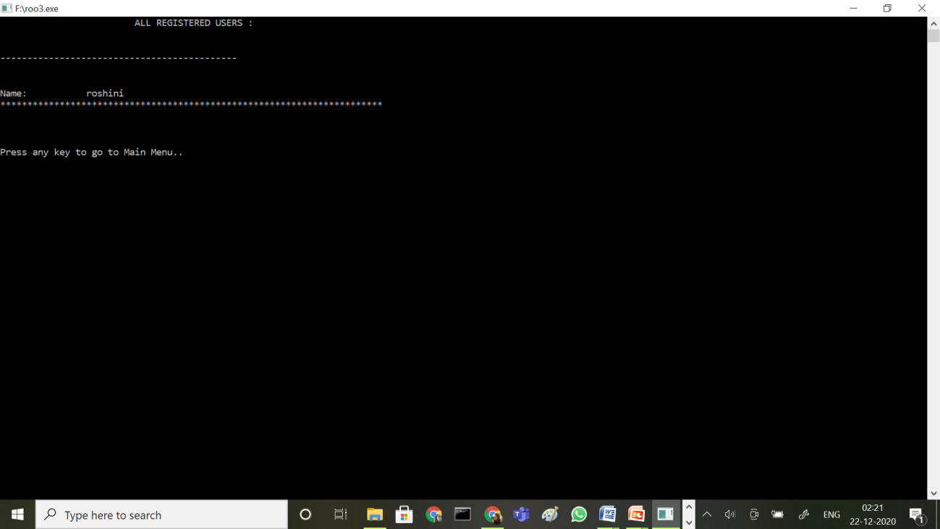 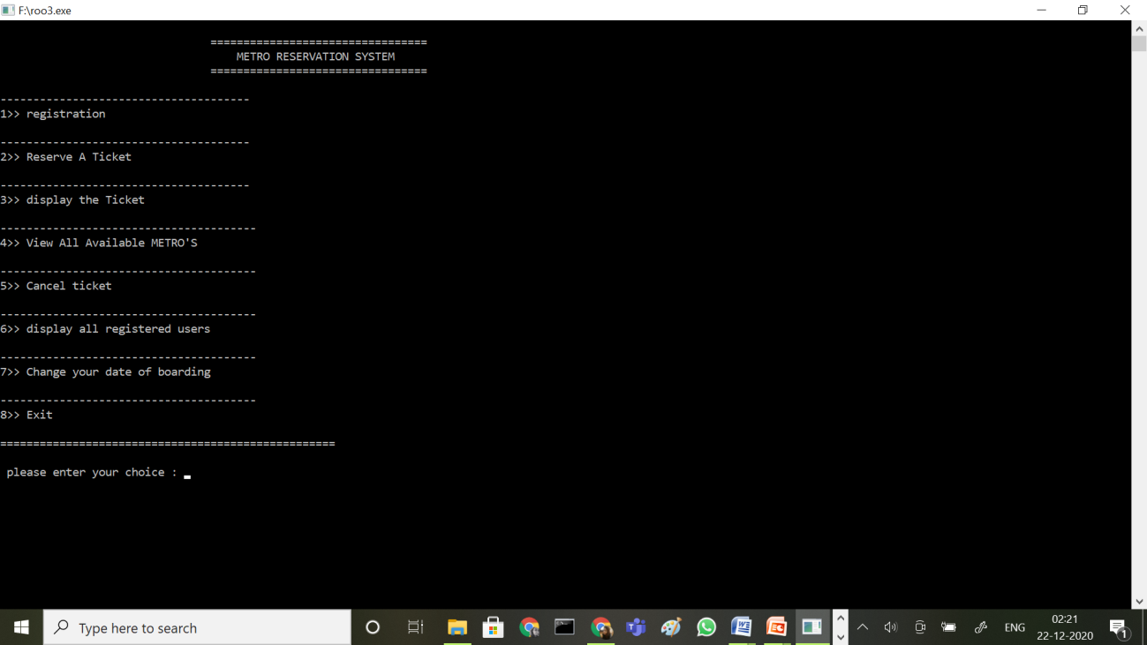

**ADDITIONAL LEARNING**

This project helped both of us to put our interest in coding in a certain work and really helped it to grow. Not only time but also the workload had to be managed a lot because some of the assignments weren’t that time taking but were mentally really exhausting. Both of us had an amazing experience working together and we really understood the importance of teamwork which is something that helps you to increase your spread of thoughts due to various opinions help the work to complete in less time, in a more efficient manner.

Self-learning is another important aspect which we needed to explore in ourselves as there were few things which we didn’t know and we needed to take the help of google and needed to learn them by ourselves online. And this made the understanding of our project a lot easier and helped us to be more creative in various steps of its development. We also had to revise a lot of concepts regarding programming in C, which made our basics even stronger and is helping us to be even more confident.

Finally, i have understood the importance of team work and the efficiency and power of the quality work that can be done with team work with various idealogies we can come up with and I have received a bigger perspective regarding the skills present in coding. This mini project teached us a lot because of the practical implementation we are undergoing here.

**DISCUSSION AND FUTURE WORK**

We have pretty much so much in our minds to implement this project into a best one. The idea which we would like to add and successfully implement in this project is QR CODE GENERATOR for the ticket data. Which can be scanned through and pass the metro station.

A few factors that direct us to develop a better system are givem below:

1. Faster system

2. Accuracy

3. Reliability

4. Informative

5. Reservations and cancelations from anywhere to any place.

**REFERENCES**

1. We received some support and ideas from our seniors and used some textbook knowledge and searched the web to solve some errors which came across in our source code.

2. https://10to8.com/blog/how-to-create-an-online-booking-system-free-guide/