RAJALAKSHMI ENGINEERING COLLEGE
RAJALAKSHMI NAGAR, THANDALAM 602 105


CS23333
OOPS Using Java
Laboratory Record Note Book
Name :
Year / Branch / Section :
University Register No. :
College Roll No. :
Semester ;
Academic Year :


RAJALAKSHMI ENGINEERING
COLLEGE
An Autonomous Institution
BONAFIDE CERTIFICATE
Name: ……………………………………………………………………………
Academic Year: …………… Semester: …………… Branch: ………………
Register No.
Certified that this is the bonafide record of work done by the above student in
the..........................................................................................................Laboratory
during the academic year 2025- 2026
Signature of Faculty in-charge
Submitted for the Practical Examination held on……………………………
Internal Examiner External Examiner

INDEX
EX.NO | DATE | NAME OF THE EXPERIMENT | GITHUB QR
1 |  | I/O, Data Types, Operators
2 |  | Control Structures
3 |  | Arrays
4 |  | Strings
5 |  | Classes & Objects
6 |  | Inheritance
7 |  | Interface
8 |  | Exceptions
9 |  | Collections
10 |  | Collections
11 |  | Project
12 |  | Lambda

ABSTRACT

The TimeBank System addresses the need for structured volunteer management and skill exchange within an academic or community setting. Traditional volunteer tracking often lacks transparency, real-time feedback, and efficient skill matching. This project develops a full-stack desktop application using Java Swing for the front-end and MySQL with JDBC for robust data management. The main objective is to establish a points-based economy where mentors contribute time and skills, and students can seek help and log their resulting learning activities. The system features separate dashboards for Mentors and Students, includes real-time communication, tracks activity completion and reward redemptions, and generates reports. This platform provides efficient service matching by displaying mentor skills and availability, thereby encouraging community engagement and formalizing the value of mentorship.

ACKNOWLEDGEMENT

We express our sincere thanks to our beloved and honorable chairman MR. S. MEGANATHAN and the chairperson DR. M.THANGAM MEGANATHAN for their timely support and encouragement.
We are greatly indebted to our respected and honorable principal
Dr. S.N. MURUGESAN for his able support and guidance.
No words of gratitude will suffice for the unquestioning support extended to us by our Head Of The Department Dr. E.M. MALATHY and our Deputy Head Of The Department Dr. J. MANORANJINI for being ever supporting force during our project work
We also extend our sincere and hearty thanks to our internal guide Dr. B.DEEPA , for her valuable guidance and motivation during the completion of this project.
Our sincere thanks to our family members, friends and other staff members of computer science engineering.
1. ROSHINI S
2.SAJINE SANTHAKUMAR

TABLE OF CONTENTS
CHAPTER NO. TITLE PAGE NO
1 INTRODUCTION 7
1.1 INTRODUCTION 7
1.2 SCOPE OF THE WORK 7
1.3 PROBLEM STATEMENT 7
1.4 AIM AND OBJECTIVES OF THE PROJECT 8

2 SYSTEM SPECIFICATIONS 9
2.1 HARDWARE SPECIFICATIONS 9
2.2 SOFTWARE SPECIFICATIONS 9

3 MODULE DESCRIPTION 10

4 CODING 11

5 SCREENSHOTS 16

6 CONCLUSION AND FUTURE ENHANCEMENT 22
REFERENCES 23
LIST of figures

FIGURE NO. | TITLE | PAGE NO.
5.1 | LOGIN PAGE | 16
5.2 | MENTOR REGISTER PAGE | 17
5.3 | STUDENT REGISTER PAGE | 17
5.4 | STUDENT DASHBORAD | 18
5.5 | MENTOR DASHBORAD | 19
5.6 | DATABASE CREATION | 21

CHAPTER 1
INTRODUCTION
  - INTRODUCTION
The TimeBank System project addresses the limitations of manual volunteer tracking by providing a centralized, transparent platform for skill exchange. It formalizes mentorship and volunteer activities through a digital points-based economy.

  - SCOPE OF THE WORK
The system provides role-based access for Mentors (to contribute time and earn points) and Students (to seek mentorship and log learning progress). The primary scope is focused on secure user authentication, efficient data retrieval using JDBC, and real-time activity/points tracking. The application is designed as a standalone desktop GUI application suitable for local area network deployment.
  - PROBLEM STATEMENT
The current process for tracking mentorship and volunteer hours is often informal, leading to inconsistent records and an inability to recognize high-contributing mentors. Students lack a clear interface to match with available mentors based on specific skills or expertise.

  - AIM AND OBJECTIVES OF THE PROJECT
The main objective is to develop a functional TimeBank System that allocates available mentors based on stated skills and availability. Specific objectives include:
- Secure registration and login for Student and Mentor roles.
- Real-time calculation and tracking of Mentor points.
- Provision of a communication channel for mentor-student interaction.
- Generation of detailed activity and redemption reports.

CHAPTER 2
SYSTEM SPECIFICATIONS
2.1 HARDWARE SPECIFICATIONS
Processor | : | Intel Core i5
Memory Size | : | 8GB RAM (Minimum)
HDD/SSD | : | 256 GB (Minimum)

2.2 SOFTWARE SPECIFICATIONS
Operating System | : | WINDOWS 10
Front – End | : | Java Swing
Back - End | : | MySQL
Language | : | Java, SQL
Database Connectivity | : | JDBC (Java Database Connectivity)

CHAPTER 3
MODULE DESCRIPTION
3.1 Mentor Module
- Login/Registration: Secure access and profile creation.
- Activity Logging: Mentors record time (hours) spent on activities, which are auto-converted to points (Hours $\times 10$).
- Leaderboard: Displays top mentors based on points and hours.
- Redemptions: Allows points to be exchanged for rewards defined in the Rewards table.
- Student Interactions: A dedicated interface to view and reply to messages from students who have selected them.
3.2 Student Module
- Login/Registration: Secure access and profile creation.
- Explore TimeBank: Browsing of Mentor profiles (skills, availability) and recent activities.
- Log Activity: Students record their completed tasks, which are tracked for performance metrics.
- View Performance: Displays a summary of completed activities and certificates earned.

CHAPTER 4
SAMPLE CODING
// Method within the MentorDashboard class for adding a new volunteer activity.
private void addVolunteerActivity(String name, String type, String date, double hours) {
if (hours <= 0) {
JOptionPane.showMessageDialog(this, "Hours must be greater than zero.", "Input Error", JOptionPane.WARNING_MESSAGE); return;
}
// 1. Calculate points (Business Logic)
int points = (int) (hours * 10);
// 2. SQL to insert the activity (Data Logging)
String sqlActivity = "INSERT INTO MentorActivities " + "(mentor_id, activity_name, activity_type, activity_date, hours, points)” + "VALUES (?, ?, ?, ?, ?, ?)";
// 3. SQL to update the mentor's total points (State Update)
String sqlPoints = "UPDATE Mentors SET points = points + ? WHERE mentor_id = ?";
try (Connection conn = TimeBankApp.getConnection();
PreparedStatement psActivity = conn.prepareStatement(sqlActivity);
PreparedStatement psPoints = conn.prepareStatement(sqlPoints))
// Execute Activity Insertion
psActivity.setInt(1, parent.currentUserId);
psActivity.setString(2, name);
psActivity.setString(3, type);
psActivity.setDate(4, java.sql.Date.valueOf(date)); // Correct date conversion
psActivity.setDouble(5, hours);
psActivity.setInt(6, points);
psActivity.executeUpdate();
// Execute Points Update
psPoints.setInt(1, points);
psPoints.setInt(2, parent.currentUserId);
psPoints.executeUpdate();
JOptionPane.showMessageDialog(this, "Activity Added! Earned " + points + " points.", "Success", JOptionPane.INFORMATION_MESSAGE);
// Refresh the dashboard data
loadDashboardData();
} catch (SQLException ex) {
JOptionPane.showMessageDialog(this, "Database Error: " + ex.getMessage(), "Error", JOptionPane.ERROR_MESSAGE);
} }

SAMPLE 1
Sample 1 depicts the Mentor Activity Logging and Point Calculation feature. It first validates the input hours and calculates the points (hours multiplied by ten). Then, using JDBC PreparedStatements, it executes two critical database updates: logging the activity in the MentorActivities table and simultaneously increasing the mentor's point total in the Mentors table.

// Method within the HomePage (or StudentDashboard) class to fetch mentor data.
public void loadMentorData(String filter) {
mentorsModel.setRowCount(0); // Clear old data
String sql = "SELECT name, skills, availability, contact_no FROM Mentors ";
// Add filtering capability based on user input (name or skill)
if (!filter.isEmpty()) {
sql += "WHERE name LIKE ? OR skills LIKE ? ";
} sql += "ORDER BY name ASC"; // Sort alphabetically
try (Connection conn = TimeBankApp.getConnection();
PreparedStatement pstmt = conn.prepareStatement(sql)) {
if (!filter.isEmpty()) {
// Apply the filter string to both name and skills columns
pstmt.setString(1, "%" + filter + "%");
pstmt.setString(2, "%" + filter + "%");
}try (ResultSet rs = pstmt.executeQuery()) {
while (rs.next()) {
// Prepare data for the JTable display
String contact = rs.getString("contact_no");
// Mask contact number for public viewing (privacy feature)
String partialContact = (contact != null && contact.length() > 4) ? "***" + contact.substring(contact.length() - 4) : "N/A";
mentorsModel.addRow(new Object[]{
rs.getString("name"),
rs.getString("skills"),
rs.getString("availability"),
partialContact
}); } }
} catch (SQLException ex) {
System.err.println("Database Error loading mentor data: " + ex.getMessage());
}
}

SAMPLE 2
It constructs a parameterized SQL query capable of filtering results by either the mentor's name or their stated skills, ensuring efficient matching. The application uses a JDBC PreparedStatement to execute the query securely, iterating through the results using a ResultSet.

CHAPTER 5
SCREEN SHOTS
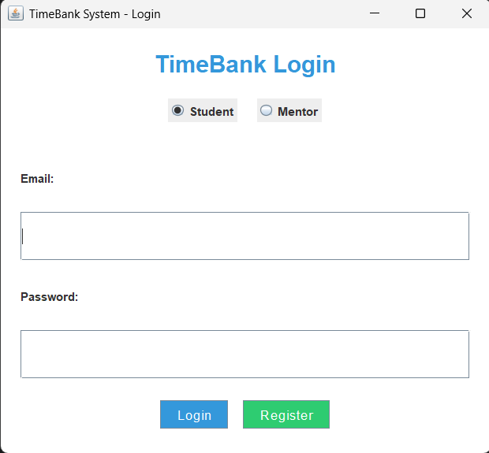
Fig 5.1 login page (student/mentor)
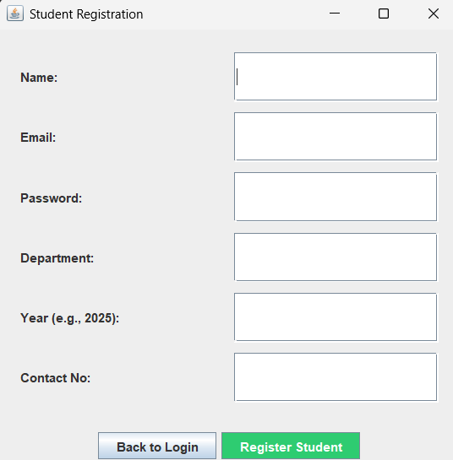
Fig 5.2 student registration page
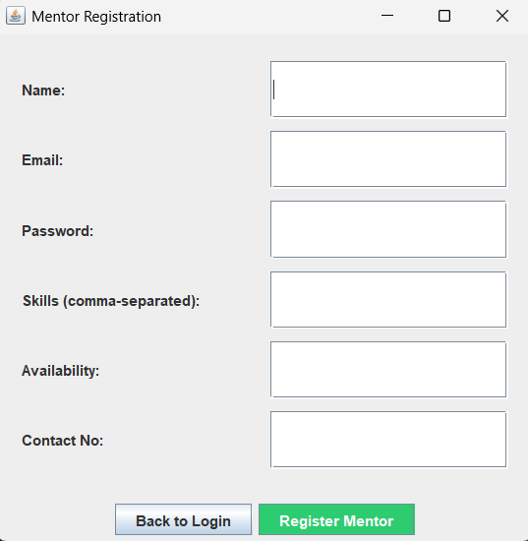
Fig 5.3 mentor registration page
5.4 student dashboard
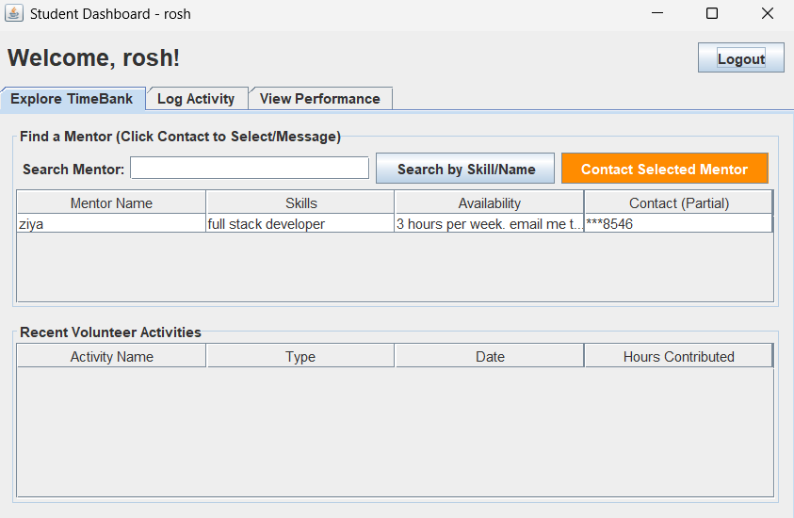
Fig 5.4.1 explore timebank
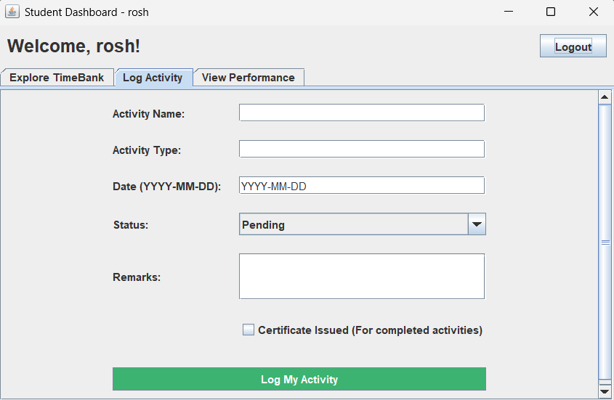
Fig 5.4.2 log activity
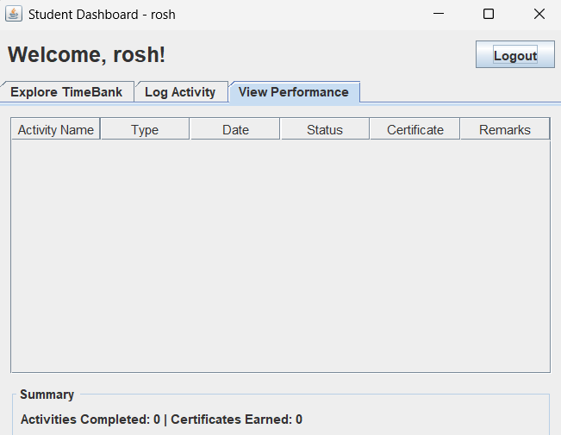
Fig 5.4.3 view performance
5.5 Mentor dashboard
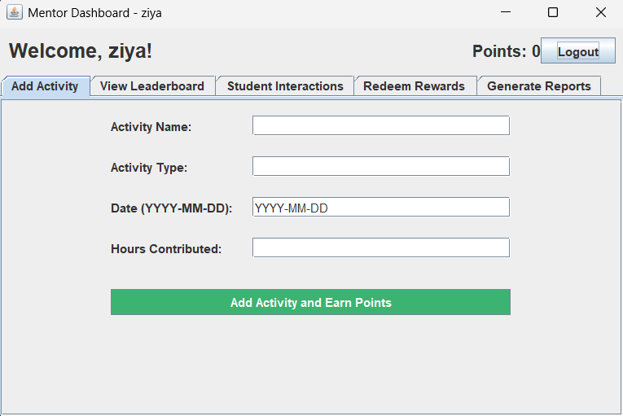 Fig 5.5.1 add activity
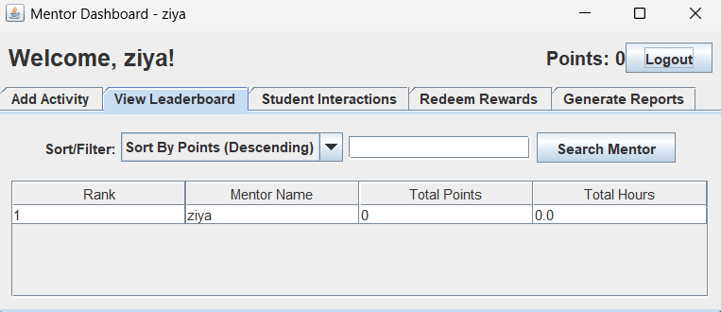
Fig 5.5.2 view leaderboard

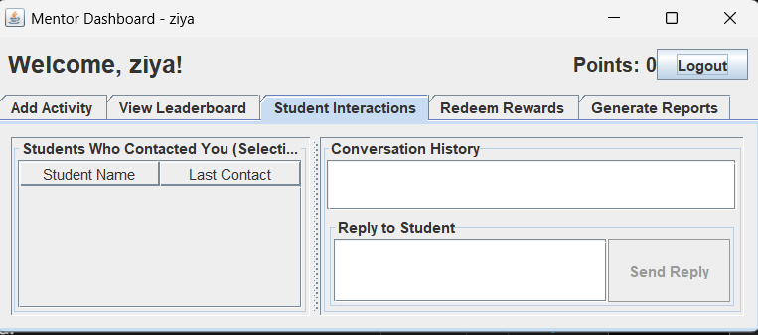
Fig 5.5.2 student interactions

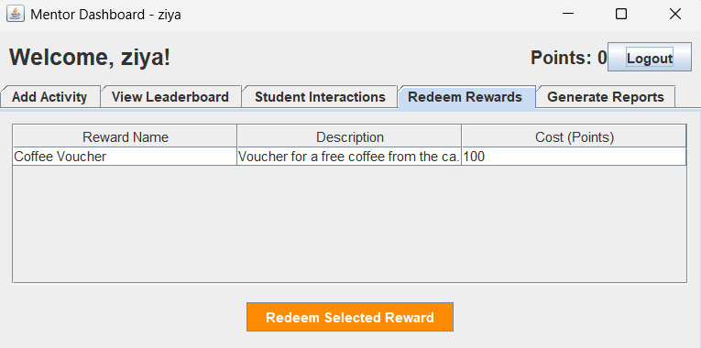Fig 5.5.3 redeem rewards
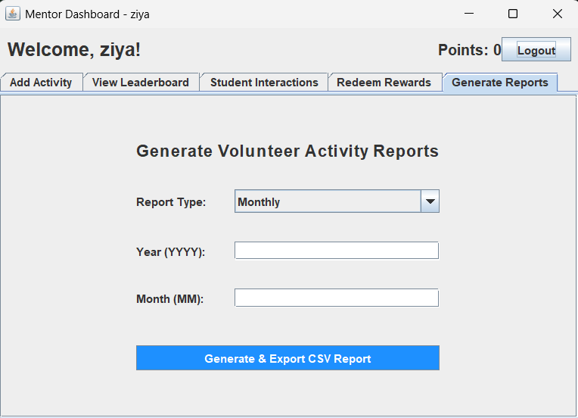
Fig 5.5.4 generate reports
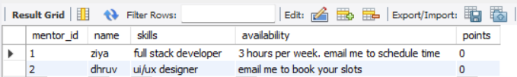Fig 5.6 database creation

CHAPTER 6
CONCLUSION AND FUTURE ENHANCEMENT
6.1 Conclusion
The TimeBank System successfully provides a robust, multi-user solution for managing volunteer time, skill exchange, and academic activities. The Java Swing front-end offers a stable desktop interface, while the MySQL backend ensures data integrity and transactional consistency. All core objectives, including points calculation, reporting, and secure role-based access, have been met.
6.2 Future Enhancement
- Web/Mobile Integration: Migrate the Java Swing front-end to a modern web framework (like React or Angular) to allow mobile access and broader deployment.
- Automatic Matching: Implement a recommendation algorithm to automatically match students to mentors based on skill tags and current mentor availability/load.
- Real-Time Notifications: Integrate a service (like Firebase Cloud Messaging) to send push notifications for new messages or activity approvals, improving engagement.

REFERENCES
- https://docs.oracle.com/javase/tutorial/uiswing/

- https://docs.oracle.com/javase/tutorial/jdbc/

- https://www.w3schools.com/sql/

- https://dev.mysql.com/doc/connector-j/en/

- https://www.tutorialspoint.com/java/

