# Step 6: Performance Testing

## Project Title:

Cosmetic Insights: Navigating Cosmetics Trends and Consumer Insights with Tableau

## Objective:

To ensure that Tableau dashboards and story views perform efficiently, load quickly, and offer a seamless user experience when embedded in a web application.

## 1. Data Optimization

Cleaned raw Excel sheets by removing:  
- Unused columns  
- Blank rows  
- Repetitive or irrelevant fields

Uploaded only necessary data tables to Tableau.

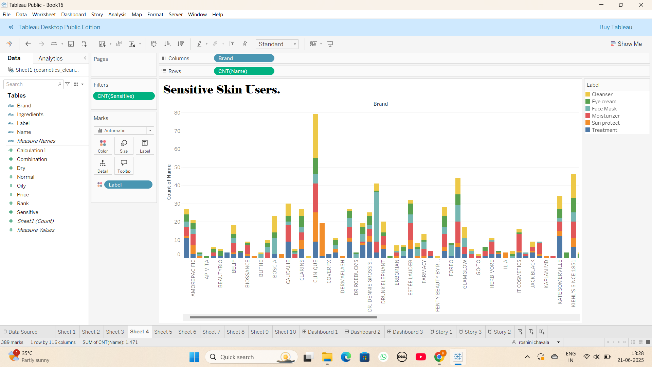

## 2. Calculation & Filter Optimization

Avoided overusing complex calculated fields.

Used only essential filters such as:  
- Product Category  
- Skin Type  
- Year Range

Aggregated data wherever applicable.

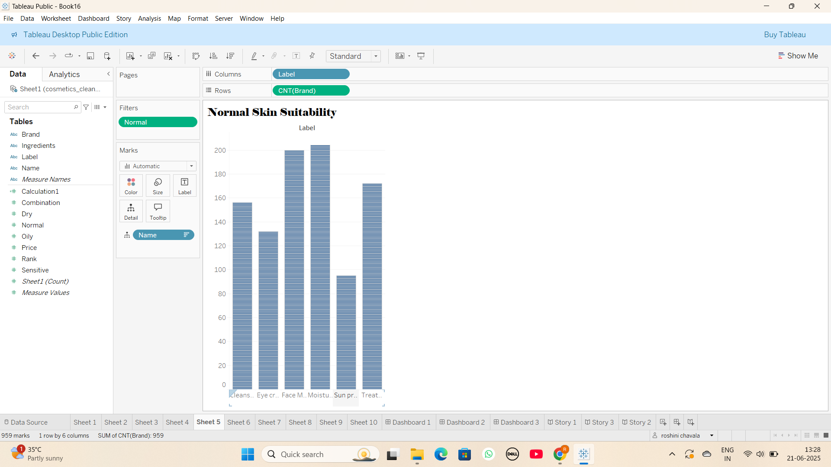

## 3. Dashboard Design Optimization

Used a limited number of visual elements per dashboard.

Simplified views with top 10 or summarized KPIs.

Avoided high-cardinality fields and custom shapes.

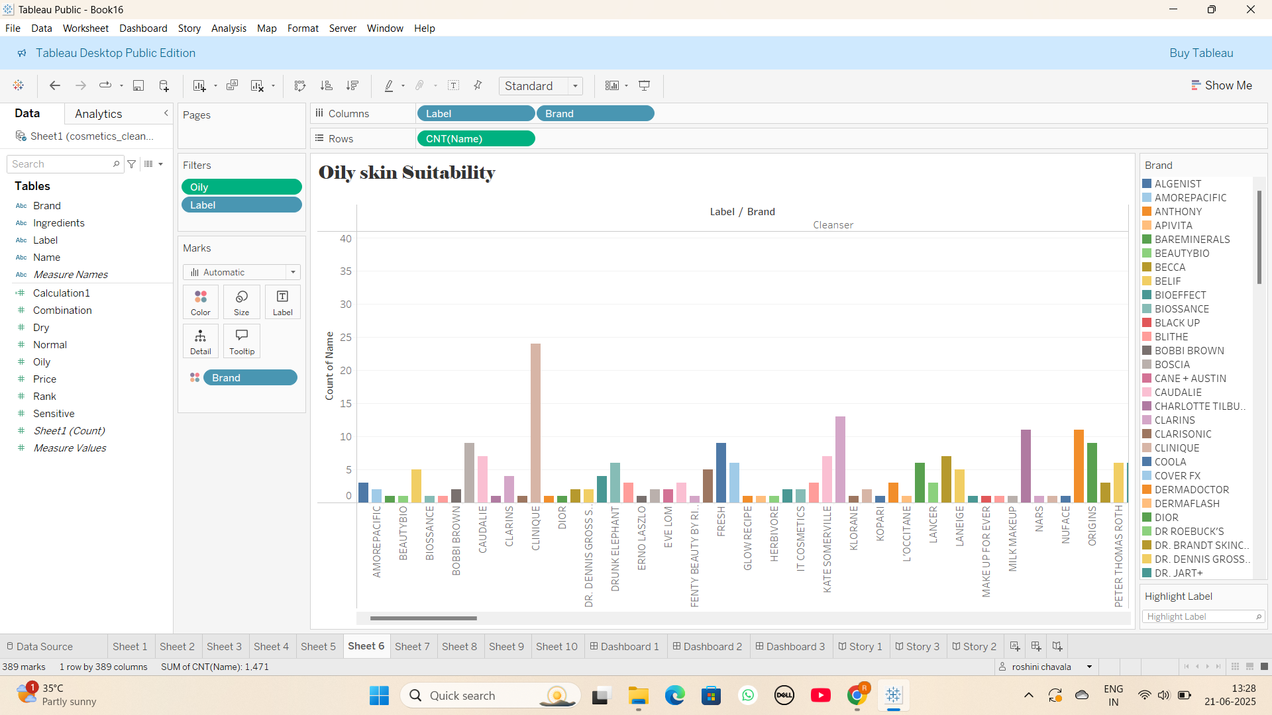

## 4. Story Navigation Testing

Created a Tableau story with multiple scenes:  
- Overview  
- Product Category Insight  
- Customer Feedback  
- Innovation Trend

Clicked through each scene to verify transition speed and clarity.

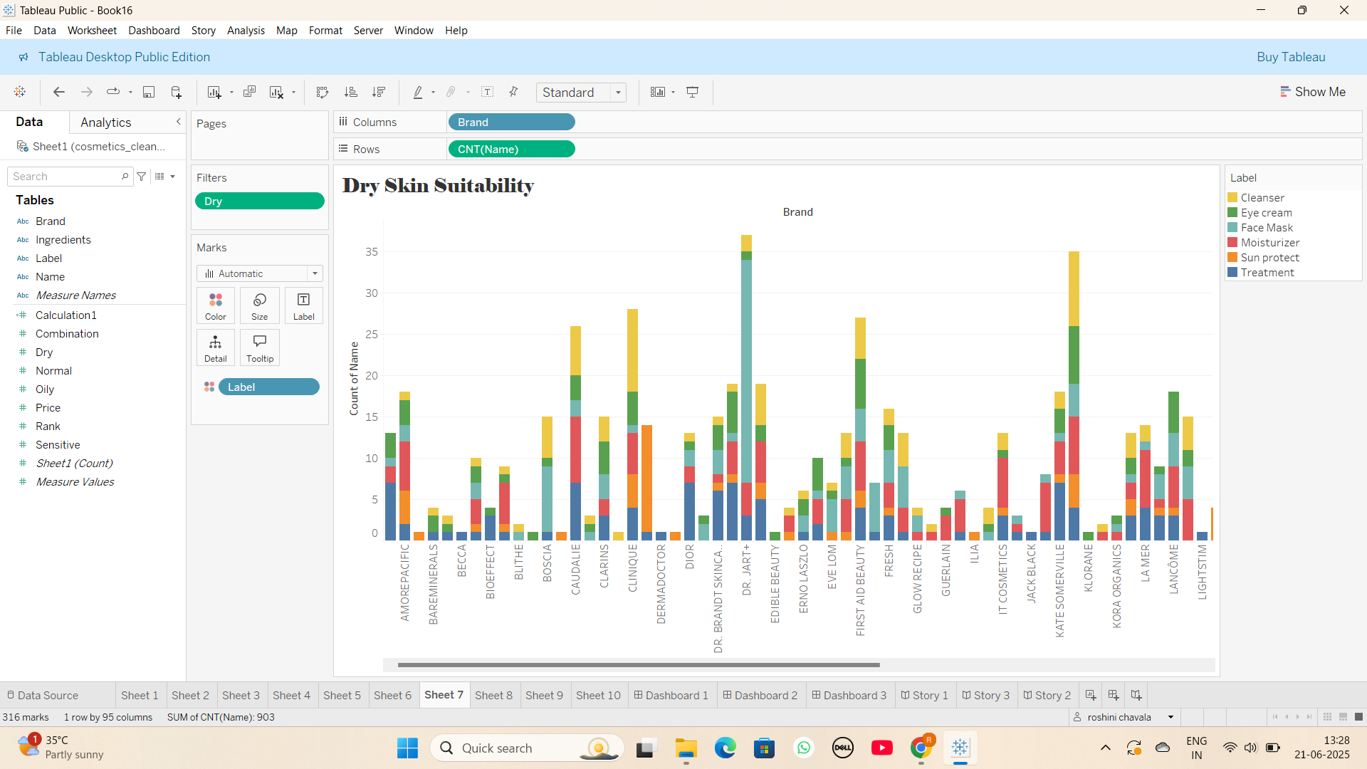

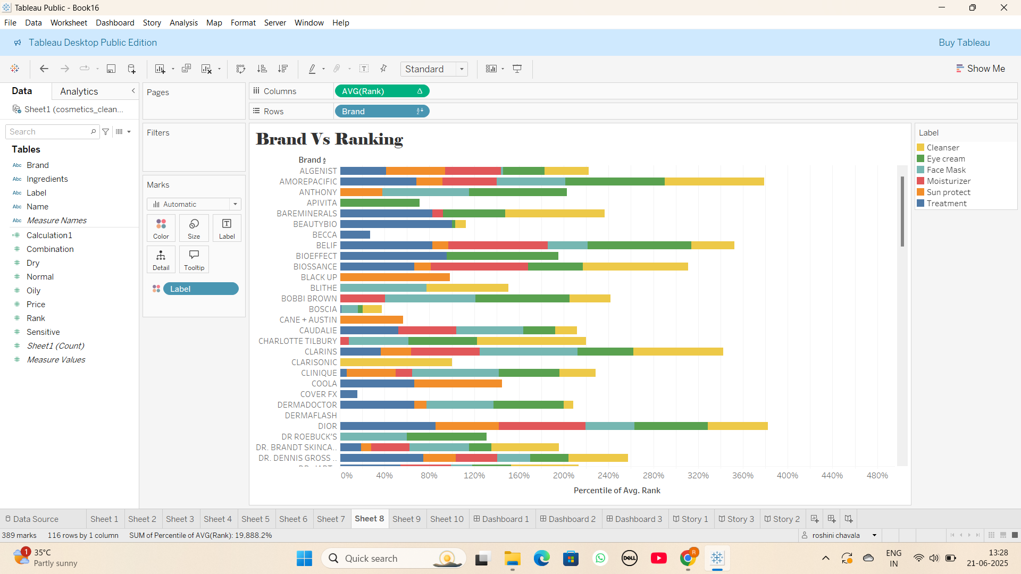

## 5. Performance Recorder Analysis

Activated Tableau Performance Recorder:  
Help > Settings and Performance > Start Performance Recording

Interacted with all charts and filters.

Stopped recording and reviewed metrics.

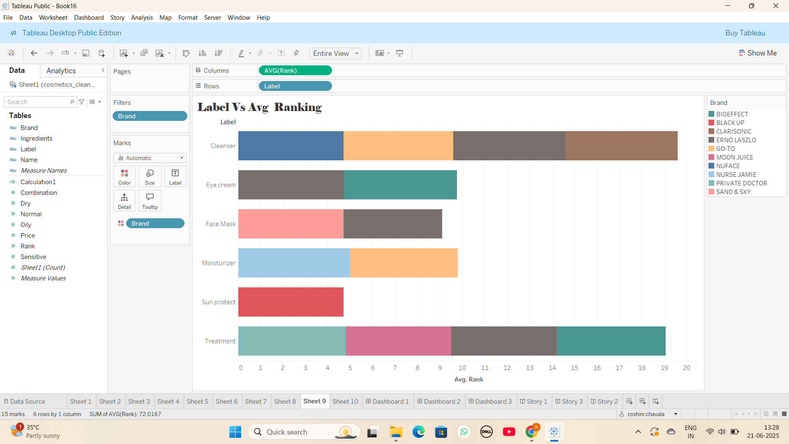

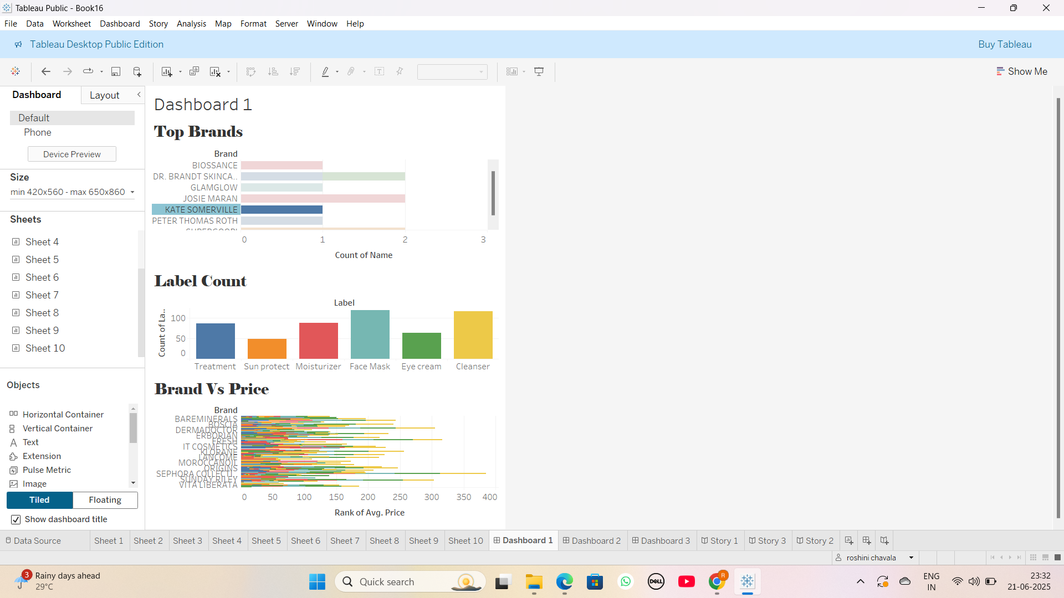

## 6. Web Embedding Test

Embedded Tableau Public story into a sample Flask HTML page.

Checked rendering speed, interaction, and resizing on browser.

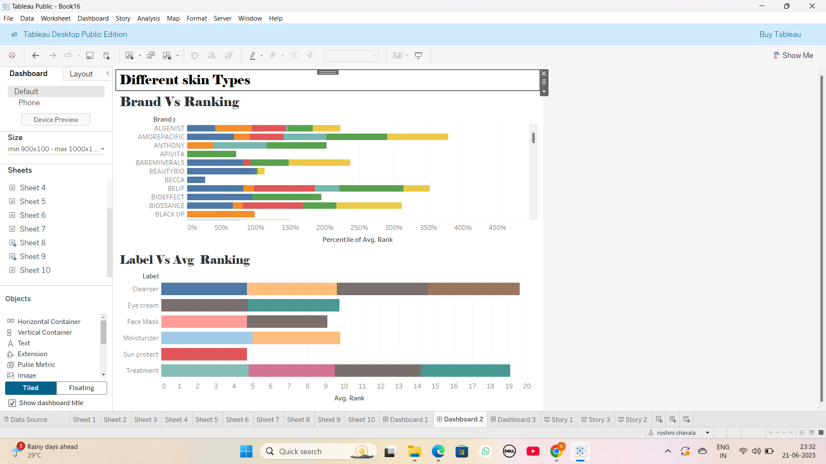

## 7. Mobile Responsiveness

Opened Tableau story from a mobile browser.

Verified auto-scaling and filter functionality.

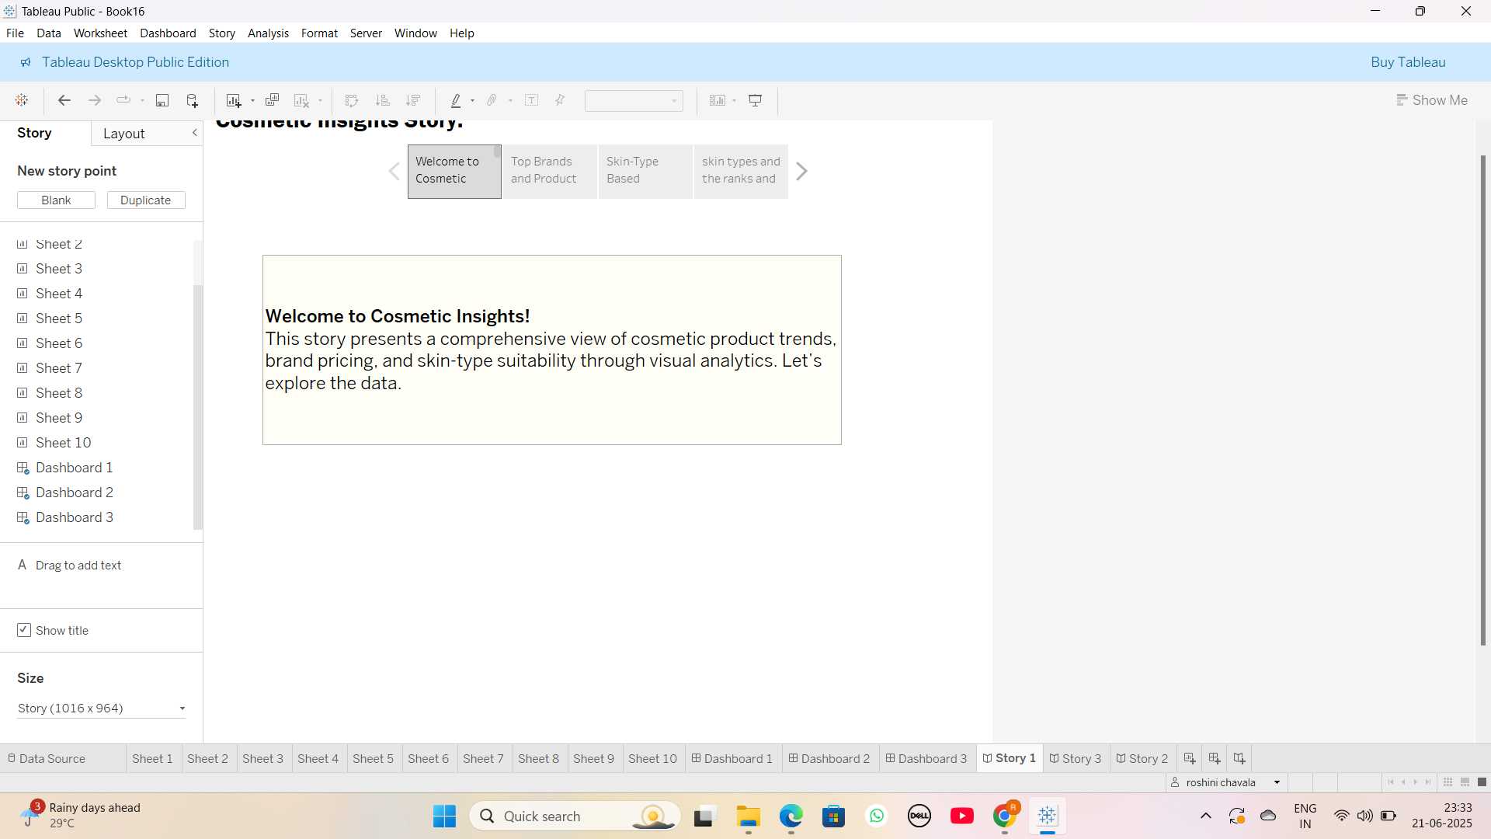

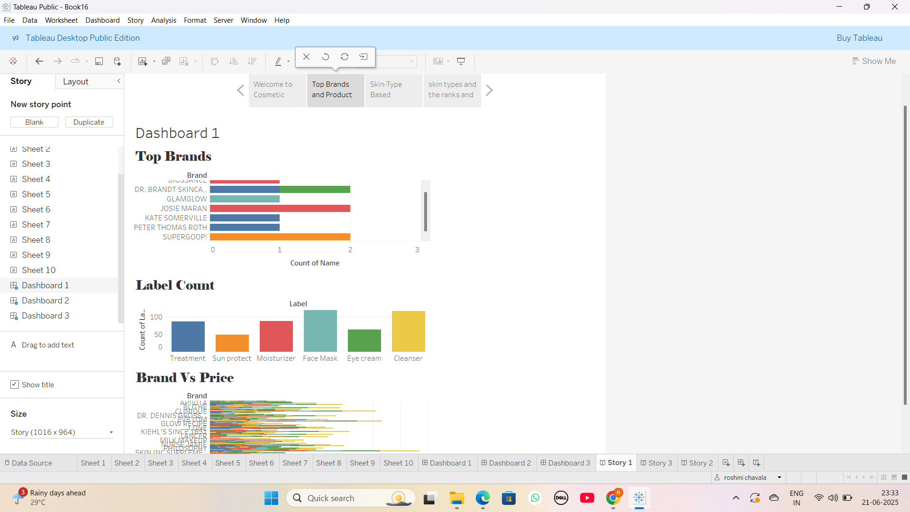

## 8. Summary Table

|  |  |
| --- | --- |
| Metric | Result |
| Average Dashboard Load | 2–3 seconds |
| Filter Delay | <1 second |
| Story Scene Switch Time | <2 seconds |
| Web Load Test (Flask) | Smooth with spinner support |
| Mobile Experience | Responsive and accessible |

## Conclusion

Performance testing confirmed that all Tableau dashboards and stories were optimized for speed, minimal load time, and smooth web interaction. These visuals are now fully ready for web integration via Flask.