Step 1: register into github to push all our code into it:

1. Navigate to <https://github.com/>.
2. Click Sign up by entering email address, password, and username
3. Now we will get the verification link to our mentioned email address, verify it

Step 2: creating the new repository in github account by clicking create repository as follows:

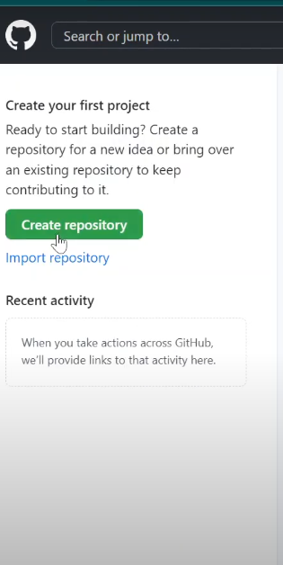

1. Enter new repository name(bash_project)
2. Select the repository should be public or private
3. Select add a README file if you need
4. Click create repository

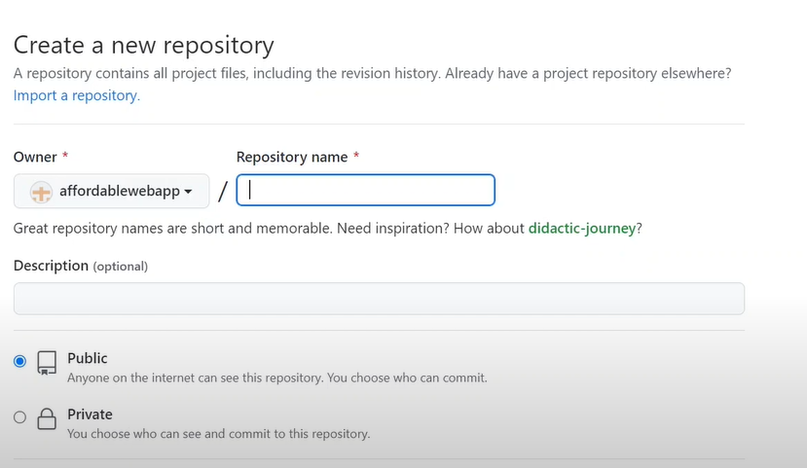

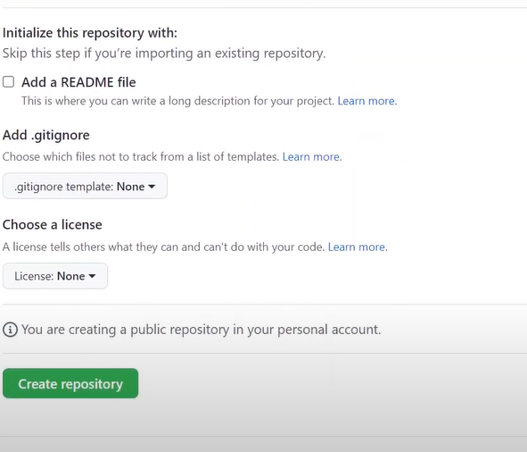

Step 3: cloning the git repository:

1. Copy the repository https link from github and paste it in the git bash:

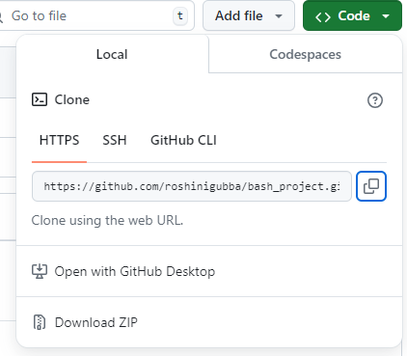

1. Copy that https link as following in git bash for cloning:

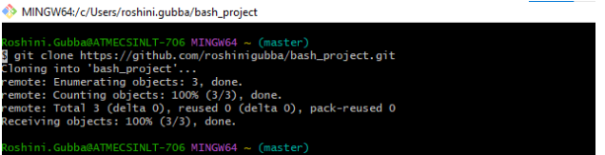

1. We will clone that repository into our git bash to update the repository from our computer by pushing code, files, creating branches through git bash

Step 4: we will list all the directories, to find our git repository in our local computer:

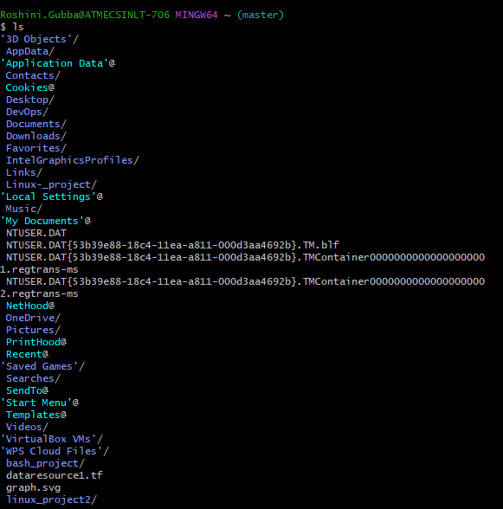

Step 5: we will change directory to bash_project directory to add or update the files or code, or creating directories:



Step 6: creating a directory name as scripts to push all the scripts into it:



Step 7: Go to scripts directory and create the collector file as file1:



Step 8: initialize git by using git init:

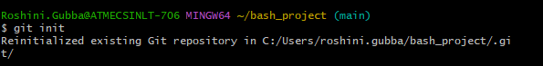

Step 9: After that we should add that directory into git by using **git add filename :**



**add . : to add/update all the files at the time.**

Step 10 : After adding file, we get staged file, now we have to commit the staged file:

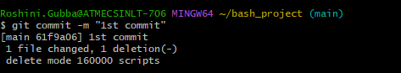

Step 11: push that committed file/directory into git:

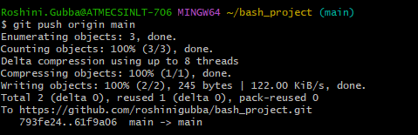

After creating the scripts directory, creating the file inside that directory and pushing into git , it gets updated in git as follows:

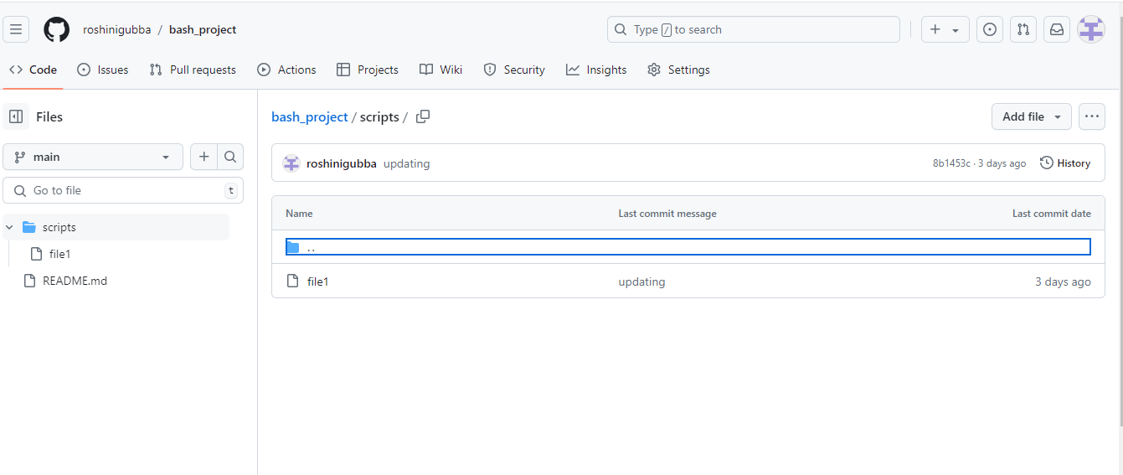

Step 12: open the file in vs code or any editor, write the script and save it, and do the following steps again after writing and saving the script:

1. git init
2. git add filename (or) git add .
3. Git commit -m “message of the file what we have updated”
4. git push origin main

Find the location of bash_project directory in our computer and edit that file or write the script in that file by going into that location of the file:

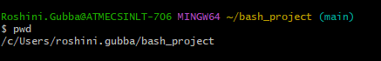

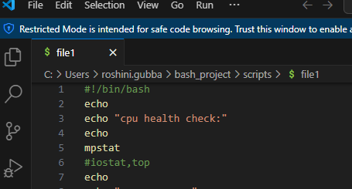

Save the file after writing the script, then follow the steps like, init, add, commit, push

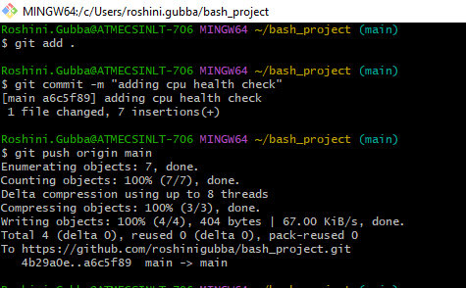

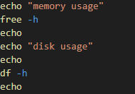 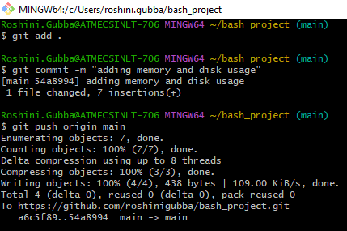

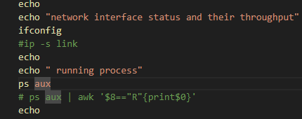

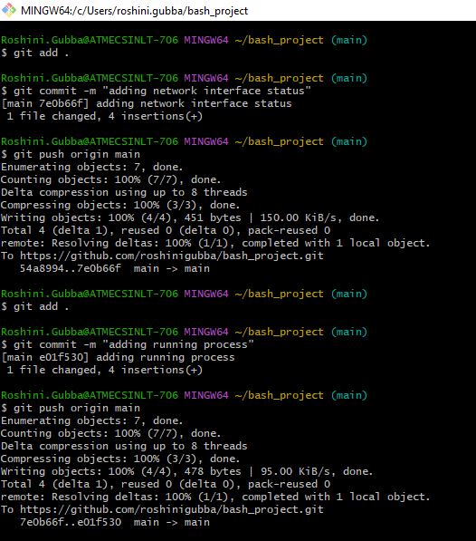

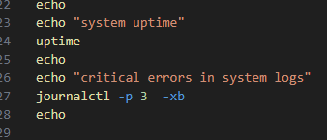

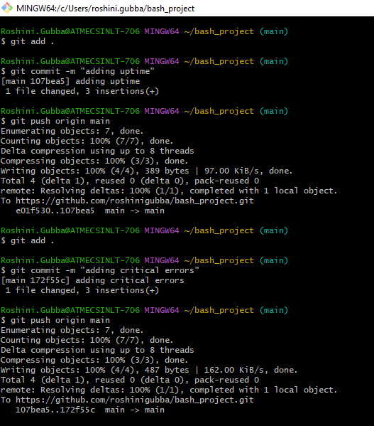

Step by step it is updated in git after pushing that code into the git repository as follows:

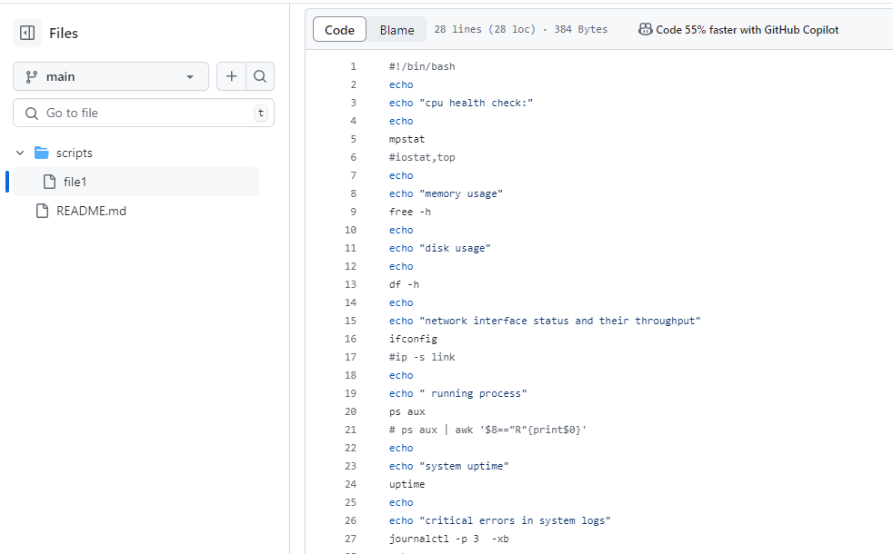

It also list all the commits whatever we have done:

