LAB FINAL PROJECT REPORT
NAME: Roshini Pininti
REG NO: 23BCE5129
- Project Title:
AgriBuddy - Smart Crop Scheduling & Advisory Web Application

- Abstract:
Agriculture is critical to sustaining economies as well as providing food security, especially in developing countries, including India. The difficulty for farmers in determining what crop they should grow, when to water their crops, and how to utilise resources can lead to serious problems for farmers and ultimately affect the economy and food security of the country, as weather conditions are not predictable and there are limited agricultural assistance systems for farmers.
This project creates a smart crop scheduling and advisory web-based application called "AgriBuddy" that provides farmers with intelligent choices for crop scheduling by using historical agricultural data and environmental parameters. By using machine learning, the system can analyse user input regarding soil nutrient composition, temperature, humidity and rainfall amounts, and predict what type of crop is best suited to be planted and will also provide recommendations on how to optimise their schedule for planting that crop.

The AgriBuddy application will be built on a responsive web platform that will use frontend technologies, backend APIs, and a MongoDB database to provide scalability and usability for users of AgriBuddy. The goal of the AgriBuddy system is to improve productivity, reduce resource waste, and help farmers use sustainable practices within agriculture.

- Introduction and Background:
Traditionally, agriculture has been based on human experience, seasonal cycles, and a reliance on expert advice. However, given the new reality of issues like climate change, soil erosion and depletion, and dwindling water supplies, agriculture requires new approaches to work smarter through technology and to use data to make informed decisions.
Thanks to the recent advances in machine learning and data analytics, there is now the potential to create an agricultural environment that incorporates predictive modelling and optimisation through the use of digital agriculture solutions to improve how farmers can make decisions by providing them access to large amounts of data and customised insights.
The purpose of this project is to create a smart agricultural advisory system that enables farmers to:
- Pick which crop to grow
- Plan out agricultural activities
- Optimising resource usage
AgriBuddy will help facilitate the connection between technology and agriculture to create smarter farming practices.

3.1 Challenges facing traditional agriculture

- Dependent on input rather than data
- No personalised advice provided
- Water and fertilizer used inefficiently
- Climate conditions are unpredictable.

3.2 Types of existing systems

Current agriculture advisory systems are:

- Web-based government advisory sites
- Mobile agriculture applications
- Rule-based crop systems

3.3 Issues with current systems

- Static recommendations provided
- No real-time adaptability provided.
- The user interface has serious limitations.
- Very little integration of machine intelligence into current systems.

3.4 Reason for creating AgriBuddy

The reason for creating AgriBuddy is:

- To be able to make data-driven recommendations.
- To have improved decision-making accuracy.
- To provide an easy-to-use and accessible platform.
- To enable agricultural solutions that are scalable.

- Proposed System

4.1 Overview
AgriBuddy is a Smart Crop Scheduling and Advisory application, fully-developed using the MERN stack (MongoDB, Express.js, React.js, Node.js) that runs on the web. The goal of AgriBuddy is to provide information to small and marginal farmers in India. To achieve this, the app combines: 1) real-time weather data; 2) inputs for each farm; and 3) structured crop-scheduling in one easy place. Farmers have access to the system, as do Agricultural Experts and Administrators, but each user has a different interface that includes the correct data access restrictions based on the user type. AgriBuddy does not provide generic advice to farmers — it provides localised, real-time agricultural advice that takes into account the specific location, soil type, crop variety, and current weather conditions for that farmer’s field.

4.2 Key Features:

User/Farm Management - Farmers register and sign in using a secure JWT-based authentication, enabling them to create and manage multiple farm profiles (e.g. farm location, size (acres), soil type, irrigation type). Specifically, role-based access ensures that agricultural experts see a different user experience (e.g. dashboards and functionality) than farmers.

Crop Scheduling - Farmers create and manage a crop schedule by farm, specifying the crop name, variety, planting date, and estimated harvest date. Crop schedules keep track of the current status of each crop (i.e. planned, planted, growing, harvested, failed), giving farmers a real-time view of the growing cycle of the crops on their farm(s).

Activity Logging (Crop Diary) - Farmers log daily farm activity (i.e., i.e. irrigation, fertiliser application, pest management, other field maintenance) that corresponds to specific crop schedules (per farm). Each log includes the type, description, date, and cost of the activity, allowing for a comprehensive digital record of farm activity by season.

Weather Integration - The platform integrates with OpenWeatherMap API to provide real-time data on weather conditions (i.e. temperature, humidity, wind speed, pressure and visibility). Farmers can view a 5-day weather forecast, which includes the probability of rain, to help plan for future irrigation and field maintenance activities. Additionally, the platform generates weather alerts that will be automatically directed to farmers (i.e. advise farmers to cover crops during expected rain).

Advisory System: Agricultural specialists can produce and distribute notices that correspond to crops, farm locations and levels of importance (for instance, Low, Medium/Limited, High and Critical). Weather-based alerts for pest extermination, fertiliser application, etc., qualify as particularly time-sensitive messages. Therefore, farmers may be able to gain information about these advisory notifications via either their mobile device or through participating in person with an agricultural specialist via an Expert Connect group.

Expert Connect Module (short for Expert Consultation): Farmers may post any number of questions about anything related to their experience farming, for example, pests, how to facilitate crop disease recovery, or how to solve problems associated with soils used on their farm. When a reply is received for a question asked, the farmer will be able to see that reply via their Citizenship Alerts module and also by posting information to the Expert Connect group.

Analytics Dashboard: Farmers can see a comprehensive view of their business performance, including total revenue and profits earned during a specified period, as well as yield in kilograms and total profit margin. The analytics dashboard will also have a Yield vs Revenue Trend chart, a Pie Chart to show a total Crop Distribution, a visual representation of where costs are (e.g. Seed, Fertiliser, Water, Labour, Equipment) and how each of these costs is growing or declining vs. an associated target benchmark. Similar to these, there will also be a progress bar representing Efficiency Metrics for Water Use, Fertiliser Efficiency, Yield/Acre and Cost.

Multi-Language and Multi-Platform Compatible UI: The user interface will be responsive for mobile devices, tablets and desktop computer platforms and should allow for support of multiple languages with support for 9 regional languages (of India), to facilitate rural and semi-urban farmers who have little to no technical expertise.

  - System Workflow
The AgriBuddy system implements a RESTful client-server architecture and a typical workflow of how a farmer interacts with the system is described in the following steps.
- A farmer registers or authenticates through the React client application. Authorisation is done using JWT and validated with the MongoDB database. Once a user is authenticated, they are routed to their own custom dashboard (UI) displaying farm data such as: farm statistics, a yield trend chart, and current weather data provided through the OpenWeatherMap API.
- Once on their dashboard, the farmer can then view, create, edit, and delete records associated with their farms and farm activity through the My Farms section of the application using the Express.js REST APIs, referring back to the MongoDB database for all farm-related data.
- All farm-related activities (i.e. crop schedules) are created against specific farms, with daily activities being logged against each crop schedule. All farm-related activity data is persisted to the back-end database (MongoDB).
- Weather and crop schedule-related data are processed by the back-end advisory logic to provide relevant alerts and recommendations to the farmer through push notifications in that application.
- Farmers can raise an Expert Connect request for expert advice if they need to. The request will be assigned to an available agricultural expert for follow-up.
- The Analytics Dashboard aggregates all farm, crop, activity, and cost-related data together and visually presents performance and improvement opportunities for the farmer.
4.4 Contribution and Originality
The main contribution of AgriBuddy is the development of an integrated platform for farmers that includes farm management, real-time weather advice, crop scheduling, activity tracking and access to expert advice, specifically designed for small and marginal farmers in India.

Three key differences between the AgriBuddy and current agricultural tools are:
A Dual-Role Architecture: Most agricultural applications are geared toward farmers only. AgriBuddy has developed an Agricultural Expert with his/her own Consultation Management Dashboard that enables both individual consultations and expertise to be delivered directly to farmers at a large scale.
Integrated Digital Farming Record: AgriBuddy has developed a single system that combines crop schedules, daily activity logs and cost records into a digital record of all farming activities that is longitudinal. This digital record will enable small farmers to utilise the history of their farm operations to
a) establish historic patterns of operation.
b) optimise inputs to enhance productivity.
c) improve productivity through the season, since small farmers have previously documented their farm records using paper or memory only.
Weather Driven Advisory Logic: Instead of providing a static list of suggested crops to plant, AgriBuddy will provide advisory guidance based on real-time weather and the associated estimated productive life of crops. The AgriBuddy Advisory will also contain contextual alerts (e.g., if there is an expected rainfall, then there will be an automated alert to remove the cover from sensitive crops or to stop irrigation). As such, the AgriBuddy Advisory will be dynamic and responsive.
Accessibility-First Design: The design of the platform is rooted in the needs of rural communities and includes elements such as mobile-friendly design, ease of use and multiple language support, all designed to fill the digital gap when it comes to agricultural solutions used in rural India today.
Modular MERN Architecture: The platform is built using a modular architectural approach; a separate client, API and data will allow it to be easily extendable to incorporate future features such as an AI-based crop recommendation engine, direct integration of market pricing information, and offline capabilities during future enhancements.
- System Architecture
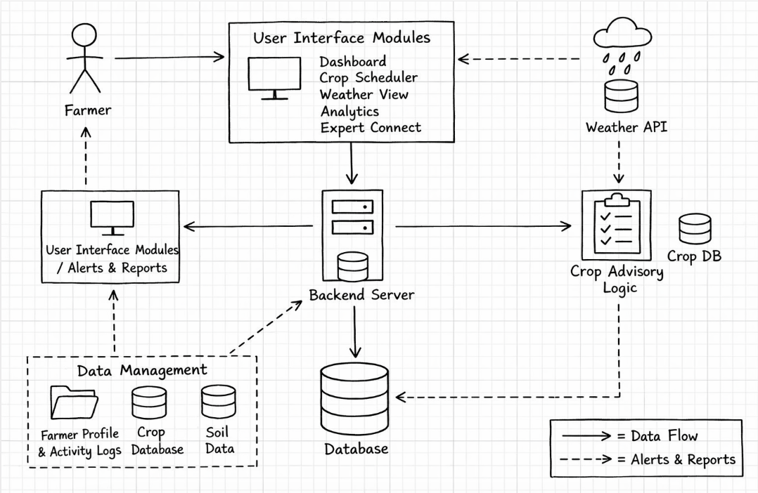
The AgriBuddy system follows a layered client-server architecture where each component has a specific role and communicates with others through clearly defined data flows. The diagram uses solid arrows to represent direct data flow and dashed arrows to represent alerts and reports being sent back to the user.
The Farmer is the main user in this system and will access the platform through a web browser on either their mobile phone or a computer. When they perform an action, such as checking the weather, logging a crop operation, or asking an expert a question, their request will go through the frontend (the UI) to reach the server for processing. The cloud-based server will also send alerts or advisory messages back to the Farmer via the dashed paths (return paths) shown in the diagram above.
The User Interface Modules make up the front end of the application, which was built using React.js to provide an easy-to-navigate interface with five different sections: the Dashboard, which provides general information about the Farmer's Fields and their Current Weather; the Crop Scheduler, which helps the Farmer plan when to plant and harvest crops; Weather View, which describes the current conditions of the Weather as well as Alerts; Analytics, which has information about Yield or Profit Trends as well as Efficiency Metrics; and Expert Connect, where Farmers can post a question to an Agricultural Expert and receive responses. All of the actions performed by the Farmers in this layer are sent as requests to the Backend Server at the data centre.
The Core of the Application is a backend server using Node.js and Express.js. This is where all of the data in the application flows through, and it coordinates all communication between each part of the application. The core server receives requests from the frontend, verifies the identity of users via JWT authentication, implements business rules, and routes information to the appropriate modules. The server reads from and writes to the database, requests weather data from third-party services, and sends completed farm and weather data to the Crop Advisory Logic engine for generating both recommendations and alerts for farmers.
The Database is connected to the backend server and serves as the storage for all data of the application that must be retained/ persisted beyond individual server instances. Types of persistent data stored in the database include user profiles, farm/ crop details, schedule of farming activity, history of farming activity, history of weather activity, advisories, and notifications. The core server reads from the database and writes to the database depending on what operation is being performed. The database serves as the authoritative source of truth for the entire application.
At the lower left of the graph, the Data Management section outlines three different types of data stored by the system. The first category is the Farmer Profile and Activity Log, which contains a farmer’s private details as well as their daily activities on the farm; Crops DB, which shows all types of crops, what soil conditions they require, how much water they need, how long they take to grow, etc.; and Soil Data, which reflects the soil type and condition for each specific farm. These categories of data will be used by the system’s backend and database layer to generate and schedule advisory content.
The Weather API (located in the top right quadrant on a cloud with raindrops) will communicate with the Weather API from the OpenWeatherMap service. The system’s backend server will extract real-time weather data, including current temperature and relative humidity, as well as forecasted precipitation and wind speed from this API. This same real-time weather data will be used to display current and future forecasted weather information to the farmer through the user interface (UI) for the purpose of generating irrigation and fertiliser alerts using the Crop Advisory Logic engine.
The Crop Advisory Logic is the intelligence behind the system. It takes into account data from both the Crop Database (relating to crops) and the Weather API (relating to weather), combining them through input such as current weather, soil type, crop variety, and schedule status to generate actions for recommendation. Examples of recommendation types include: causing alerts for irrigation, recommending fertiliser applications, warning of pests or diseases, and suggesting optimum harvest timing. These are sent back to the backend via dashed arrows, showing either alerting or reporting back to farmers.
The User Interface Modules/Alerts and Reports component on the left side of the diagram shows the routing path that all alerts and recommended outputs are sent back to the farmer. Whether generated through the Crop Advisory Logic or triggered through the Notification System, these will then go back through the backend to be displayed for the farmer's reference, either on their dashboard or delivered via e-mail or SMS. This completes the cycle of operation from the input by the farmer to the generation of intelligent recommendations back to the farmer.
The architecture is designed to provide a clear separation of responsibilities, with each layer of architecture fulfilling its own responsibility. Specifically, the front end provides user interaction; the back end executes business logic; the database stores data; and the advisory engine creates decisions based on intelligent analysis. These layers communicate with each other through clearly defined data flows and alert paths.
- Protocol Stack

Layered Architecture

The AgriBuddy platform's architecture has a multi-tiered architecture, which allows each layer to have specific responsibilities and only communicate with the layers directly above and below itself. By having this architectural structure, changes made to one layer do not affect the operation of any other layers. The system remains modular, maintainable, and scalable. The five separate layers form the complete Protocol Stack of the AgriBuddy application.

Layer 1 - Farmer Interaction Layer (Presentation)

The top layer of the Protocol Stack is the Farmer Interaction Layer (Presentation Layer). This layer is where the farmer or agricultural professional interacts with the platform by viewing and using the components of the platform. The Farmer Interaction Layer is developed using React.js as the front-end technology; therefore, all user interface components that will be visible to users will be rendered on top of this layer (e.g., Dashboard, Crop Scheduler, Weather View, Analytics, and Expert Connect). In addition to rendering visual user interface components, this layer has the responsibility of taking the "raw" data received from the layer(s) below it and transforming that data into a format that is visually meaningful to users. This transformation process includes converting data into charts, weather cards, farm statistics, and advisory messages. This layer also captures user input (e.g., adding a Farm, recording a Crop Activity, and posting a Query) and then sends that user input to the next layer of the Protocol Stack for processing. The user interface has been designed to be mobile and tablet-friendly, offer multiple language capabilities, and have a minimal number of user interface components, so that farmers with little or no technical experience can successfully use the AgriBuddy platform.
Layer 2 — Communication and Request Layer (Application)
The Application Layer serves as a mediator between the user of the application, in this case the farmer who is using the Application Frontend, and the Application logic running on the Application Backend. Each action that takes place at the application frontend (e.g. logging in [post authentication request to create a session], submitting farm data [post farm data], querying your weather data [get current weather], etc.) uses a structured format such as an HTTP/HTTPS request for data. The Application Layer is responsible for communicating these requests from the Application Frontend to the Application Backend and then communicating from the Application Backend to the Application Frontend any JSON responses, once they have been validated through the JWT token at the Application Layer. Response validation through JWT token at this layer also serves to validate the request/response lifecycle of all applications.

Layer 3 — Business Logic and Advisory Layer (Processing)
This is the brain or intelligence behind AgriBuddy, which is also the most important part of the overall system. This layer is developed using Node.js and Express.js and is responsible for processing structured requests that come from the Communication Layer. The business rules that govern the operation of the system are contained in this layer, including crop scheduling logic, irrigation advisory logic, fertiliser recommendation thresholds, and pest warning logic. When a farmer's farm-specific information is blended with the current weather data obtained from OpenWeatherMap API, the Crop Advisory Engine uses input from both sources to develop tailored actionable recommendations for farmers. The Business Logic/Advisory Layers will also be responsible for generating notifications when something happens, routing inquiries received by experts to the appropriate party, and keeping track of all activity. Once generated, the results will either be sent back up for display or down for storage and retrieval.
Layer 4 — Data Persistence Layer (Storage)

The AgriBuddy uses a MongoDB-based database as its primary source of information. The database contains structured collections for all 8 of the system's core entities: User, Farms, Crops, Crop Schedules, Crop ActivityLogs, Weather Data, Advisories and Notifications. Each time the Business Logic Layer saves activity logs, retrieves a farmer's crop schedule, updates the status of an advisory, or retrieves past weather data, it will reach out to the Data Persistence Layer. The database follows normalisation principles in order to remove redundant data and preserve the integrity of data in each of the collections. The Analytics Dashboard uses the Data Persistence Layer to retrieve historical data to perform trend analysis and generate performance reports.

Layer 5 - Network and External Integration Layer (Transport)
This is the lowest level of communication and the basis for all forms of communication accessed by different parts of the system and outside sources. All data transportation within AgriBuddy- including data transferred from the frontend to the backend, from the backend to the database, and from the backend to the external API- utilises this layer via HTTPS protocols; therefore, communication between the frontend, backend, database, and external API will always be encrypted and secure. Additionally, this layer is responsible for integrating with the OpenWeatherMap API, performing API key authentication, rate limit checking (how often calls can be made), error checking, and retrying an API call in case of an error. Delivery of notifications via SMS and email through SMTP (email) and various third-party sources will occur on this layer. Data will reliably (i.e. not lost, tampered with, etc.), securely (i.e. encrypted), and quickly arrive at their intended locations even when the user has only limited bandwidth due to living/living in a rural area (as is common in Rural USA).
Benefits of the Layered Architecture
AgriBuddy has several benefits due to its layered architecture. It increases the possibility of the platform being reliable and able to be maintained over a long time.
Each layer in this architecture can be developed, tested and maintained separately without any impact on other layers. This allows for a complete redesign of the front-end without any effect on back-end business logic, or moving a database to another system without an impact on the advisory engine.
When debugging, it is easy to narrow down where to start looking when you know which layer the error occurred in, which helps save a great deal of development time. For example, if an API fails to return a value, the source of the problem will be in the network layer; if the recommendation is incorrect, the source will be in the business logic layer; if there is an error displayed on screen, the source will be in the presentation layer.
The architecture is also highly scalable. As more farmers begin to use the platform, each of the layers, such as the back-end server or the database, can be horizontally scaled without having to fully redesign the system. If a new feature needs to be implemented (for example, using satellite imaging for soil monitoring in the Processing Layer or adding AI to predict bushel yields), this can be done by implementing the new features as new modules within the processing layer, resulting in no disruption to existing functionality.
The flexibility of this architecture also allows for technology updates at individual layer levels when superior options arise. For example, by switching from the React.js front-end to a native mobile application, or replacing MongoDB with PostgreSQL, you can easily do so without having to completely redevelop the entire system — this means the AgriBuddy will always be able to adapt to changing agricultural technologies
7 . Testbed / Experimental Setup
AgriBuddy was built and deployed using a laptop running Windows 11 with 8GB of RAM and an Intel Core I5 CPU. The React front end of AgriBuddy served through the Vite dev server. The application’s Node and Express back end ran locally on port 5000 of the development machine. All of the API endpoints were tested before integration with the front end. The MongoDB database is managed locally with MongoDB Compass, allowing for local inspection of data in the development environment. All web browsers used for testing — Google Chrome and Mozilla Firefox — passed compatibility testing. Weather data included in AgriBuddy was obtained using an OpenWeatherMap free-tier API Key, which allows 100 calls a day. The cloud-hosted deployment of AgriBuddy was tested on the Render platform.
Methodology:
Data Collection Process
AgriBuddy gathers two types of data for use in its service. Data on farms comes from farmers who submit an application form that includes their farm's location, soil type, farm size, type of irrigation, and current crops planted. Weather data, including temperature, relative humidity, chance of rain, wind speed, and atmospheric pressure are pulled in real time from Open Weather Map's API according to the location of each registered farm. Additionally, AgriBuddy obtains crop reference data such as ideal soil type, crop watering needs, and crop length of time to grow based on the Indian agricultural guidelines outlined in the MongoDB crop collection.

Data Preparation
Incoming raw weather data from the API is received in a nested manner (JSON) and then parsed and flattened before being stored on the backend and includes only the fields relevant for use in producing a recommendation to farmers. The farm data submitted by farmers through the online application form has two types of validation applied to it. Validation on the frontend of the application's React form is used to ensure that all required input fields are filled out correctly. In addition to the frontend validation applied to the farm's data, the Express.js middleware on the backend enforces the data types and sanitises the user-inputted information for security against SQL Injection methods. If a generic value is required for either a field or type of data (such as missing soil pH data), AgriBuddy will use regional generic average(s) to continue producing appropriate recommendations to farmers without interruption.
Advisory Logic Processing
The Crop Advisory Engine utilises a rules engine that processes weather information, soil type, crop growth stages, and recent activity logs to create an advisory. Irrigation alerts will be triggered when the probability of rainfall is less than 20% and the temperature exceeds 32°C; fertilization reminders will trigger based on the total days that have passed since the last recorded fertilization was made compared to crop-pesticide specific intervals; and pest warnings will trigger when the relative humidity is above 80%, and the temperature has remained between 20°-30° Celsius for 3 consecutive days. A rule-based system was selected over a machine learning approach because there are well-known established thresholds for agriculture, and every advisory needs to have a complete explanation to a farmer.
Model Integration
The advisory logic is integrated directly into the Express.js backend as a processing module and will run automatically each time new weather data is retrieved and new crop activity is logged by a farmer. The generated advisories will be stored in the Advisory collection and will, at the same time, create six linked Notification documents on the farmer's dashboard in real time.
System Interaction
The React.js client interacts with the Node.js server using VARCHAR RESTful call links and Axios. Server connection to MongoDB is achieved via Mongoose through the use of Mongoose schemas to handle all eight of the data entities. The server sends back a JSON Web Token (JWT) as a Bearer Token to each subsequent client API request from an initial login request. Middleware checks the JWT for authentication and authorisation purposes on each request made by the client, thus providing role-based access control (RBAC) throughout the system.
Algorithms Used:
- Rule-Based Advisory Logic: The Crop Advisory Engine uses conditional threshold logic based on weather forecasts, soil type, crop growth stage and history of activities to generate irrigation alerts, fertilisation reminders and pest alerts. Each output is able to be traced back to a specific condition, ensuring that the recommendations generated by the engine are transparent and can be trusted by farmers.

- Role-Based Access Control: Upon user login, the user's role (farmer or agricultural expert) is associated with the user's JWT token. Each backend route checks the user's role prior to processing any requests made by the user. Farmers have access to farm management, crop diary, weather, and analytics. Agricultural experts have access to the consultation dashboard and response query panel. Any attempts at unauthorised access will generate a response code of 403 Forbidden.

- Weather Triggered Alert Algorithm: On every weather data extraction, the input parameters are checked against predetermined thresholds. When the temperature is greater than 35°C, and there has not been any rainfall, a heat stress alert is triggered. When the likelihood of rainfall is greater than 70%, irrigation reminders will be replaced with rain alerts. When wind speeds are greater than 40 km/h, field activity alerts are triggered. Each alarm is stored as a Notification associated with the appropriate farm and user.

Implementation Details
Implementation of the Front-end of the System: The front-end is a React single-page application built with a component-based architecture. Each page of the application can be considered an individual React component. Each of these components manages its own state through the use of the useState and useEffect hooks. The application uses the React Router to implement seamless client-side navigation across all pages of the application. All of the forms in the application are implemented as controlled components with two levels of validation. All API requests are made using Axios, and JWT tokens are added to the API requests via the use of interceptors. All charts displayed on the Analytics Dashboard are built using Recharts. The user interface for the entire application maintains a consistent green agricultural theme.
Implementation of the Back-end of the System: The back-end of the system is built using Node.js with Express.js as the server framework, with the Express application organised based on the Model-View-Controller (MVC) architectural pattern. The MVC structure defines separate folders for Routes, Controllers, Models, and Middleware. Each Feature within the application has a route file created. Passwords are hashed before they are stored in a database by using the Bcrypt library to ensure their security. The application uses the JSON Web Token package to implement JWT authentication. API requests to third-party weather services are made from the back end of the application using the Axios library. The middleware for error handling returns a consistent JSON response with a corresponding HTTP status code for each request made, regardless of what the endpoint is.
Database Implementation: MongoDB has eight collections (users, farms, crops, crop schedules, crop activity logs, weather data, advisories, and notifications). Each collection is defined by a Mongoose schema that enforces data types, required fields, and default values. Collections can reference other collections by their MongoDB Object Id and through Mongoose's populate functionality. Thus, documents from multiple collections can be retrieved in a single query based on document relationships.
Notification and Advisory Integration: Whenever an advisory is generated, it also creates a linked notification document in MongoDB. Unread notifications will appear on the dashboard during the initial load and will be displayed as coloured alert cards (red for urgent notifications, yellow for moderate notifications, and green for informational notifications). This helps ensure that farmers are aware of the most urgent actions they need to complete on their farm.
Tools Used
Software Used:
- Python
- MongoDB
- Flask / Node.js

Hardware
- Laptop with 8GB RAM

Dataset Features
- Temperature
- Humidity
- Rainfall
- Soil nutrients

Screenshots:
a)Landing Page:
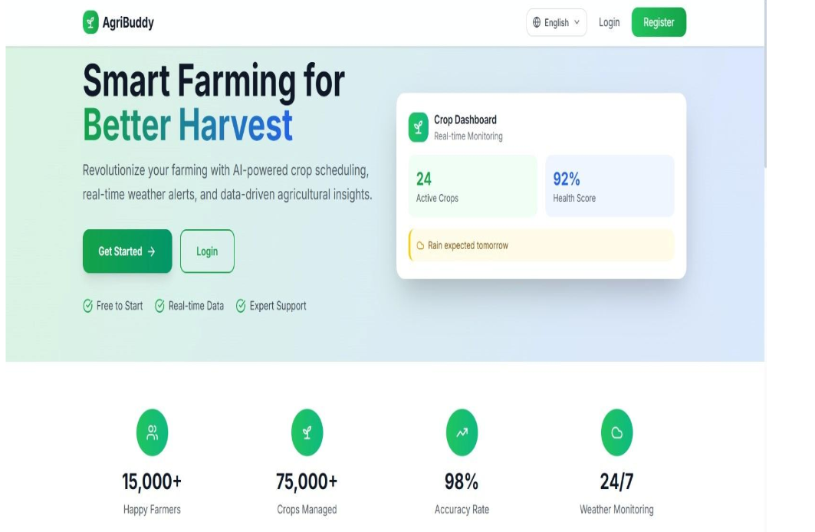
The main page of the AgriBuddy is the public front-end for the app, with the main display area featuring the tag line "Smart Farming for Better Harvest," plus a live Crop Dashboard widget showing the current status of 2 active crops that are at an overall health score of 92% and have a rain warning for these two crops. Just beneath this area, four specific platform stats highlight the significance of the platform's presence and performance; the stats are as follows: 15,000+ happy farmers, 75,000+ crops managed, 98% accuracy rate, and 24/7 weather alert capabilities. This information provides new users with confidence about the benefits and capabilities of the platform.
b) Features Section (Why Choose AgriBuddy):
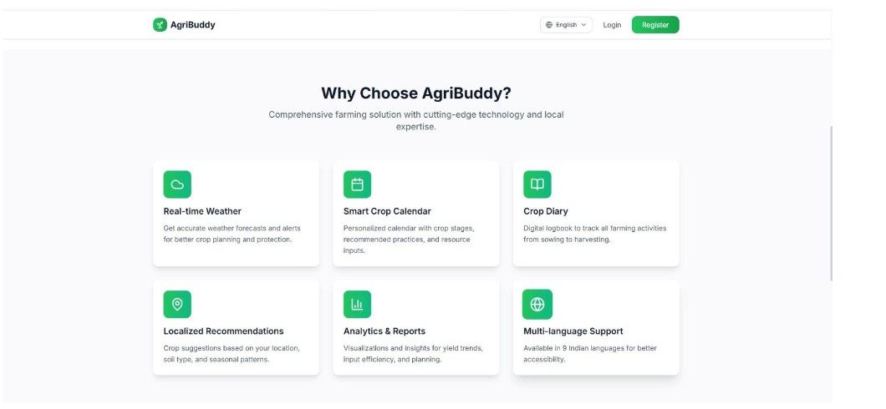
This Landing Page Element showcases the six main features of AgriBuddy in a card-based layout featuring a grid. The six features highlighted are: Real-time Weather - Accurate forecasts and alerts for crop planning; Smart Crop Calendar - Personalized crop stage tracking with resources; Crop Diary - Electronic logbook from planting to harvesting; Localized Recommendations - Crop recommendations based on the user's location and soil; Analytics & Reports - Visual insights to understand yield trends and input efficiency; and Multilingual Support - Multi-language support for 9 languages from India. Each feature has a distinct green icon, which will help make the interface visually intuitive and easy for rural farmers to navigate.
c) Login Page (User Authentication):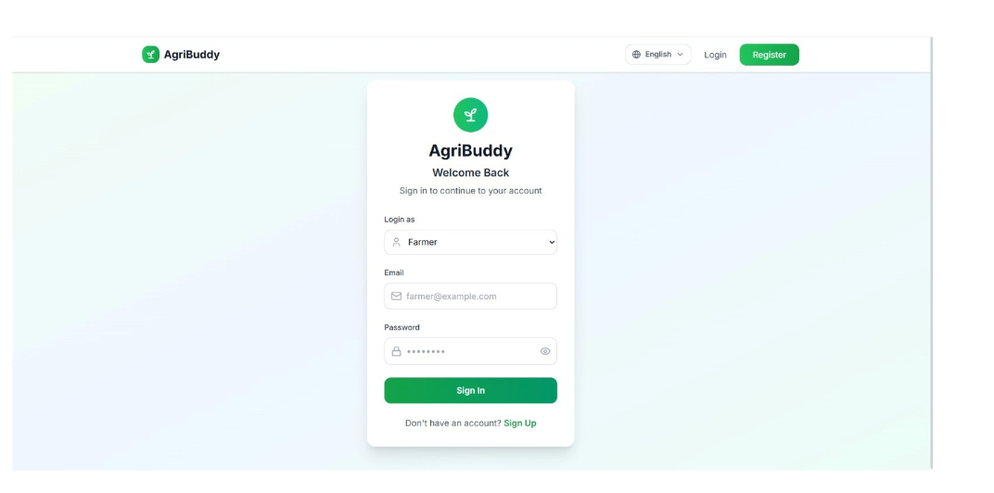
The AgriBuddy Login page provides a secure method for AgriBuddy to authenticate its users based on their roles. Users can click a "Login as" dropdown to choose either "Farmer" or "Agri-Expert," then enter their email address and password using an option to reveal their passwords. The user will then click the green "Sign In" button to submit their login credentials and will be redirected to the Sign Up page if they are not currently registered with AgriBuddy via a link located at the bottom of the page. The layout of the Login page consists of a centrally-aligned card with a soft gradient background that allows AgriBuddy to maintain its brand identity throughout the application.
d) Registration Page(Create Account):
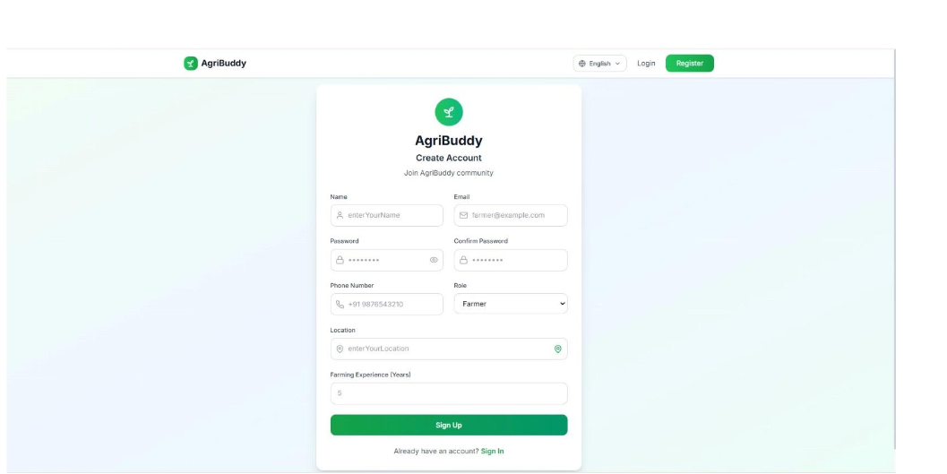
New users can create a new AgriBuddy account through the registration page by entering their Name, Email, Password, Confirm Password, Phone Number, Role (Farmer/Expert), Location and Years of farming experience into the Registration Form. This is essential user profile data necessary to customise the farming advice received by the user. A "Sign Up" button submits the form. In addition, users who have already registered can go to the Sign In area via the link at the bottom of the form. The registration form has a two-column format to allow users a clean and orderly way to enter data, and is in accordance with the overall application style.

e) Farmer Dashboard:
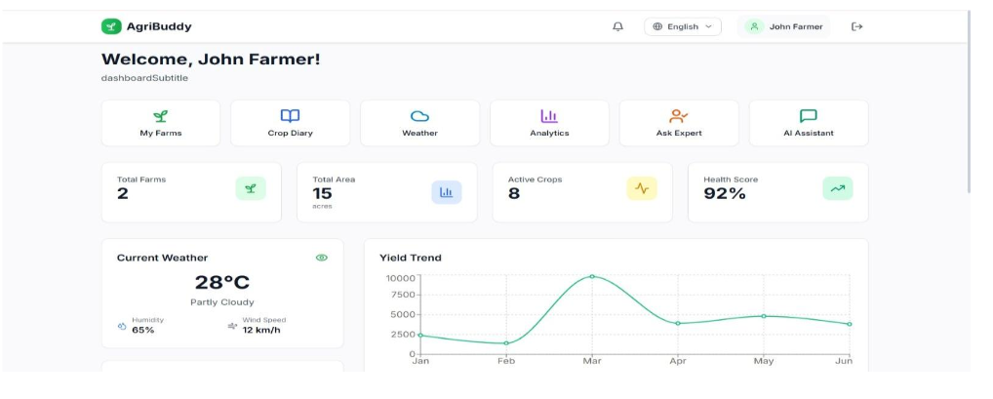
Farmer Dashboard is the place where farmers can log in and see everything happening on their farm, along with being able to access all features of the system via six navigation modules located at the top of the farmer dashboard: My Farms, Crop Diary, Weather, Analytics, Ask Expert, and AI Assistant. In addition, there are total number of farms (2), total area under cultivation (15 total acres), number of crops currently grown (8), and general health score of the farm (92%) displayed under Key Farm Statistics. There is a live weather widget indicating current weather conditions of 28C, parts, humidity 65% and wind speed 12km/h. A Yield Trend line graph charting the crop yield for each month within the date range of January through June, with a maximum yield of around 10,000 units being Y's in March, gives farmers a visual means of tracking their overall farm productivity over time.
f) My Farms Page – Farm Management:
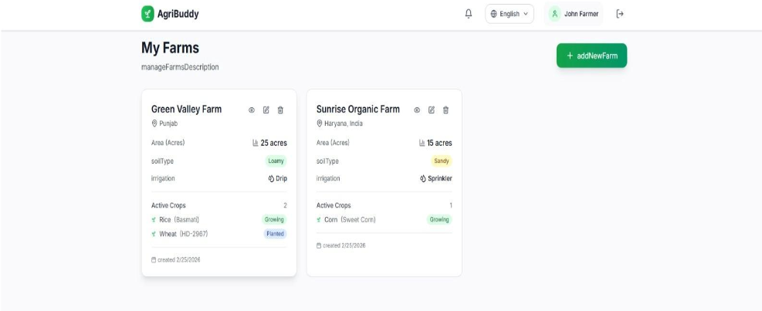
In the My Farms section of the app, all registered farms belonging to the current user are displayed using a card format for easy viewing. Two example farms are shown: Green Valley Farm (located in Punjab, has a size of 25 acres, contains loamy soil, and utilizes drip irrigation) currently has two crops (Rice Basmati which is Growing, and Wheat HD-2967 which has been Planted), whereas Sunrise Organic Farm (located in Haryana, has a size of 15 acres, contains sandy soil, and utilizes sprinkler irrigation) has one crop (Sweet Corn is currently Growing). Each farm card contains action icons for viewing, editing, and deleting farms. There is also a green "+ Add New Farm" button located at the top right corner of the screen for users to register more farms in the app.
g) Weather Module (Real Time Weather and Forecast)
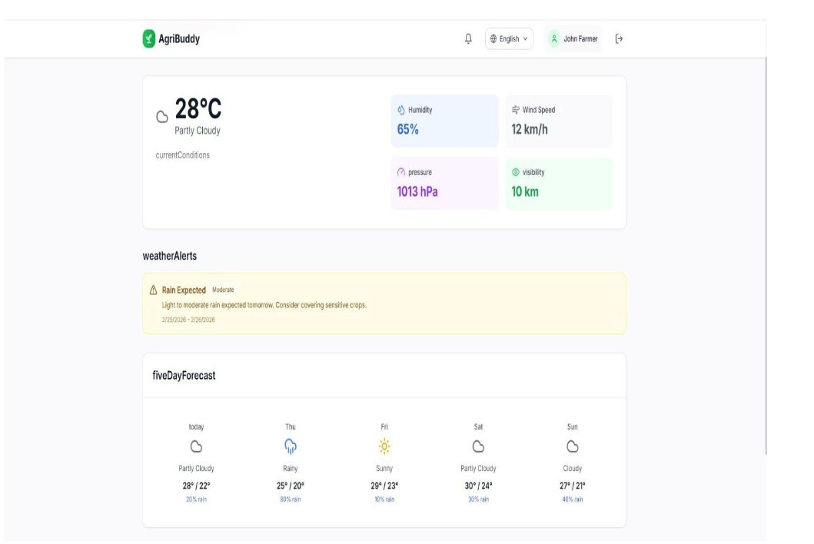
Farmers can access real-time weather information via the Weather page to help them make decisions about how best to manage their crops. The current weather information panel will show that today’s conditions are 28c and partly cloudy, along with the following weather data: humidity (65% ), wind speed (12 km/h), pressure (1013 hPa ), and visibility (10 km). There will also be a weather alert section that shows if there is an upcoming weather event, such as a moderate rain prediction, which would read as follows: "Moderate/Light Rain (Tomorrow)" due to the fact that the recommendation to cover sensitive crops would be included. Also, below this is the 5-day forecast section with the weather icons/forecast temperatures and the possibility of rain for each of the five days from today through Sunday to assist farmers in planning for irrigation or fieldwork.

h) Analytics Dashboard (Farm Performance Insights):
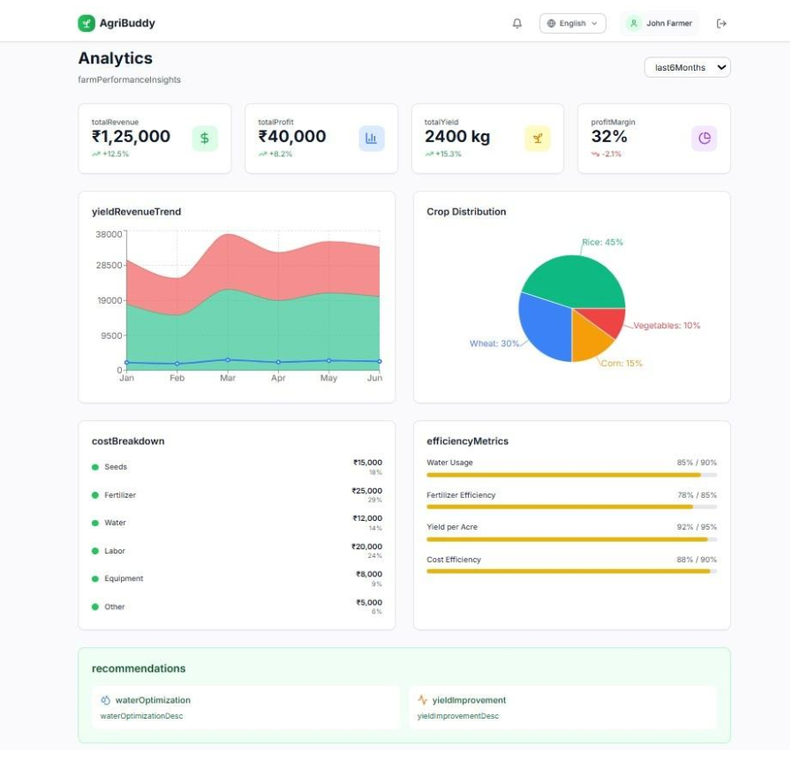
The Analytics Dashboard provides farmers with an end-to-end financial and operational summary of their operations within the last six months. The overview consists of four high-level summary cards: Total Revenue (₹1,25,000, +12.5%), Total Profit (₹40,000, +8.2%), Total Yield (2400 kg, +15.3%), and Profit Margin (32%).
A Yields & Revenues Trend area chart illustrates a rolling monthly performance from January to June and a Crop Distribution pie chart displays the farmer's Crop Distribution percentage by Crop Type: Rice (45%), Wheat (30%), Corn (15%), and Vegetables (10%).
The overall cost of the farmer's operations is broken down by Category (Seeds, Fertilizer, Water, Labour, Equipment, Other), and each of the farmer's Efficiency Metrics (Water Use Efficiency, Fertilizer Efficiency, Yield per Acre, Cost Efficiency) will have either a YTD target value or a current/future forecasted value indicated by the relative progress bar for each measure.

- Expert Connect Module: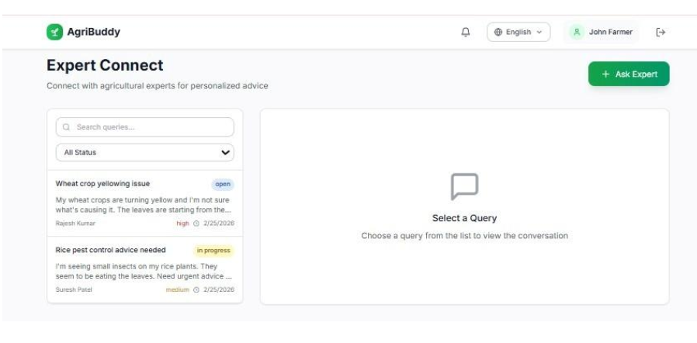
Through Expert Connect, farmers now have a simple way to communicate with experts about their specific crop needs. Farmers can ask questions about any disease affecting the health of their crops, how to prevent and control pests, or any other agricultural-related issue. Tracking the progress of submitted requests is easy. Each request shows its current status (i.e., Open/In Progress), along with the request's priority, when it was submitted and who submitted it. With this information, experts can efficiently answer farmer requests via a simple, chat-type interface.
j) Expert Dashboard - Agricultural Expert home dashboard:
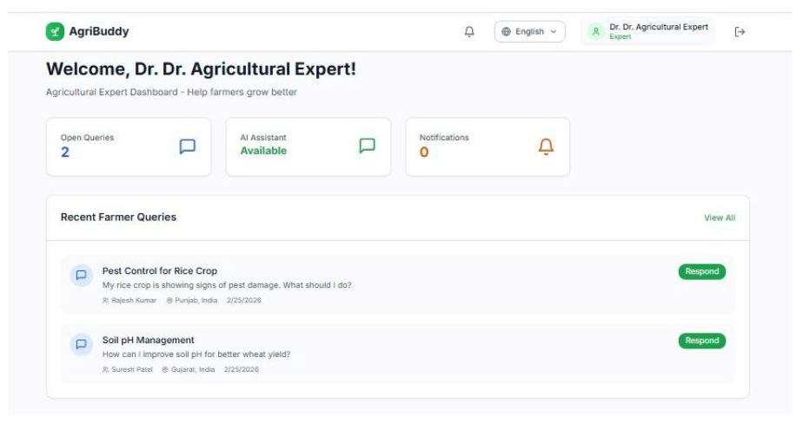
Upon logging into the Expert Dashboard, the Agricultural Expert sees a snapshot of outstanding farmer inquiries, as well as general information about the state of the system. In addition to how many open queries (there are currently 2), whether the AI Assistant is available (there's currently an AI Assistant), and whether there are any notifications (there are currently no notifications), summary cards provide the Expert with all of this information at one time.

Within the section “Recent Farmer Queries,” Experts find 2 currently open requests for assistance from farmers—Rajesh Kumar (Punjab) has a request titled “Pest Control for Rice Crop”, while Suresh Patel (Gujarat) has requested assistance relating to “Soil PH Management.” Both of these requests will include a date of inquiry (25/02/2026), as well as a “Respond” button to enable immediate responsiveness in assisting the farmers.
k) Expert Dashboard – Consultation Management Panel:
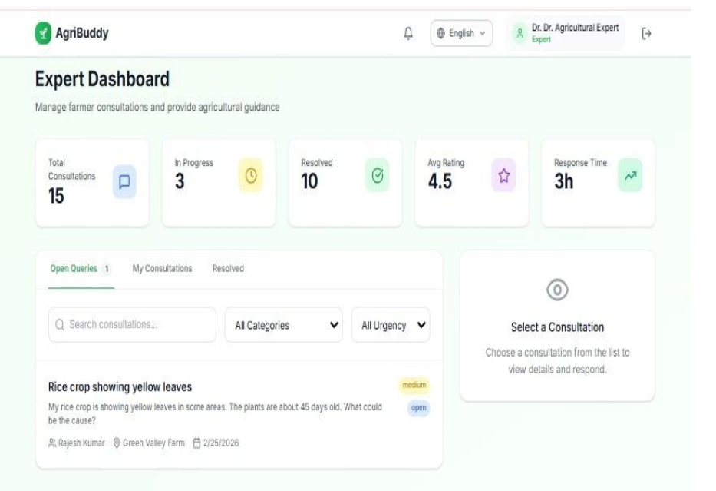
The agricultural expert's consultations are displayed on the Expert Dashboard, which gives a broad view of all farmer consultations handled by the agricultural expert. The summary contains five cards displaying summary metrics, such as: Total Consultations (15), In Progress (3), Resolved (10), Average Rating (4.5), and Average Response Time (3 Hours). The tabbed search section allows the expert to freely navigate through the Open Queries, My Consultations and Resolved tabs, with a selected Open Query currently being reviewed and reviewed for response by the agricultural expert. In this instance, the active open query is RM1_Rajesh_Kumar_Green_Valley_Farm_Medium, with the issue being that the rice crop is exhibiting yellow leaves.

l) Expert Dashboard-My Consultations & Query Response Panel :
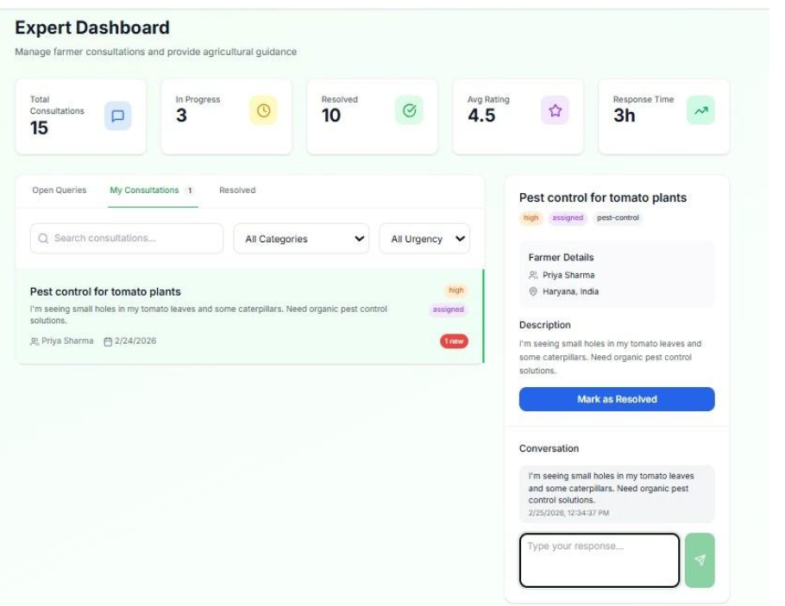
The open consultation's questions assigned to the consultant are displayed in the 'My Consultations’ box, including an open case -High Priority, Assigned "Pest Control for Tomato Plants". The expert has all the information they need, including the farmer's full information, the question description, and a live chat log providing the consultant with the ability to provide input and send responses to the farmer. The expert has the ability to close the consultation through the 'Mark As Resolved' button, allowing the entire question resolution process to function without interruption.
m) AI Assistant page(for farmers):
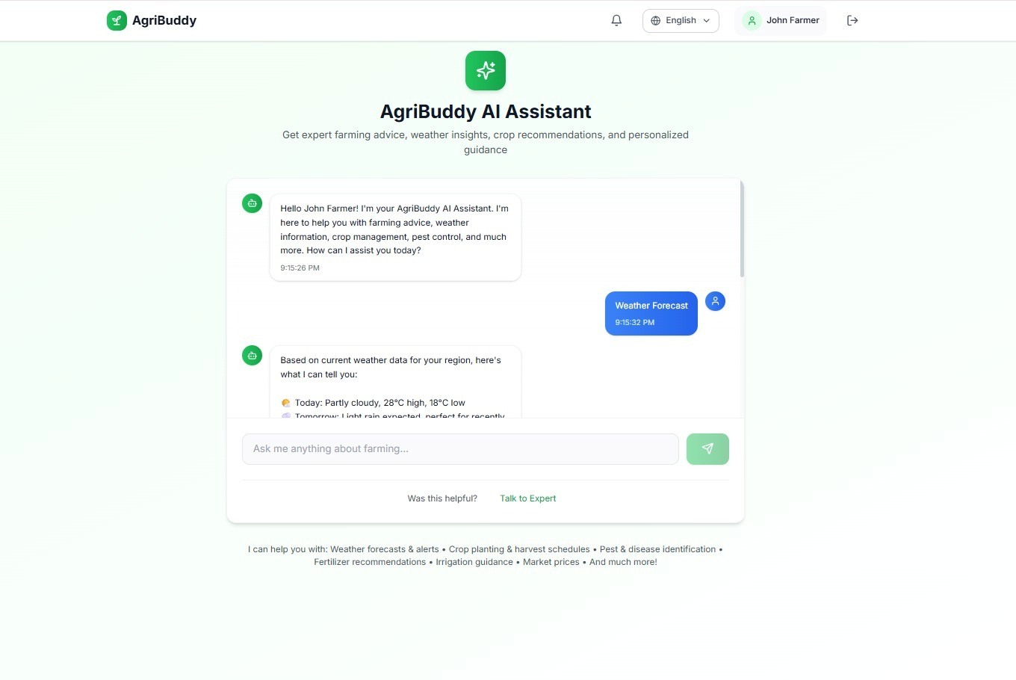
With the help of an AI assistant for agriculture, farmers now have access to a user-friendly chat interface that allows them to ask questions in real-time. As an example, when a farmer asks the assistant about the weather forecast, it will reply right away with its current weather data; example, 28 degrees Celsius, Partly Cloudy, rain anticipated. Additionally, there is an option for the farmer to communicate with an actual expert on agricultural issues through the use of the 'Talk To Expert' feature.
n) Crop Diary Page
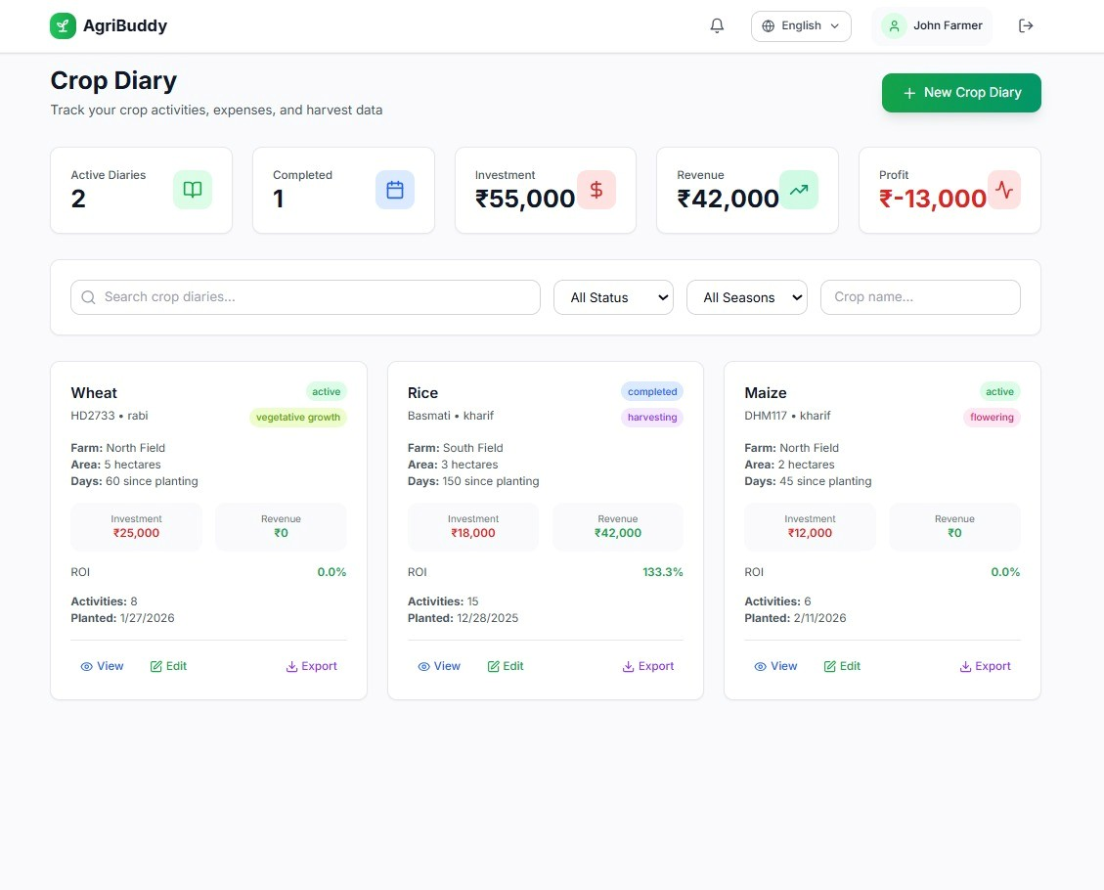
Farmers can manage their entire crop history in one place thanks to the Crop Diary module, which tracks all crop activity, expenses, and harvest information. The top of the diary screen contains a summary bar that shows two active diaries, one completed diary, total investment of ₹55,000, total revenue of ₹42,000 and a negative net of ₹13,000.
The Crop Diary shows three crop cards - Wheat (HD2733) planted during the Rabi season (currently in vegetative growth), 60 days after planting with an ROI of 0%); Rice (Basmati) planted during the Kharif season (completed harvesting), 150 days after planting, with an ROI of 133.3%) and Maize (DHM117) also planted during the Kharif season (currently in flowering), 45 days after planting with an ROI of 0%. The information displayed on each of these cards includes: farm name; area; investment; revenue; activity count; planting date; view; edit; and export options for each of the three crop cards.

o) AI Assistant page (for Agricultural expert):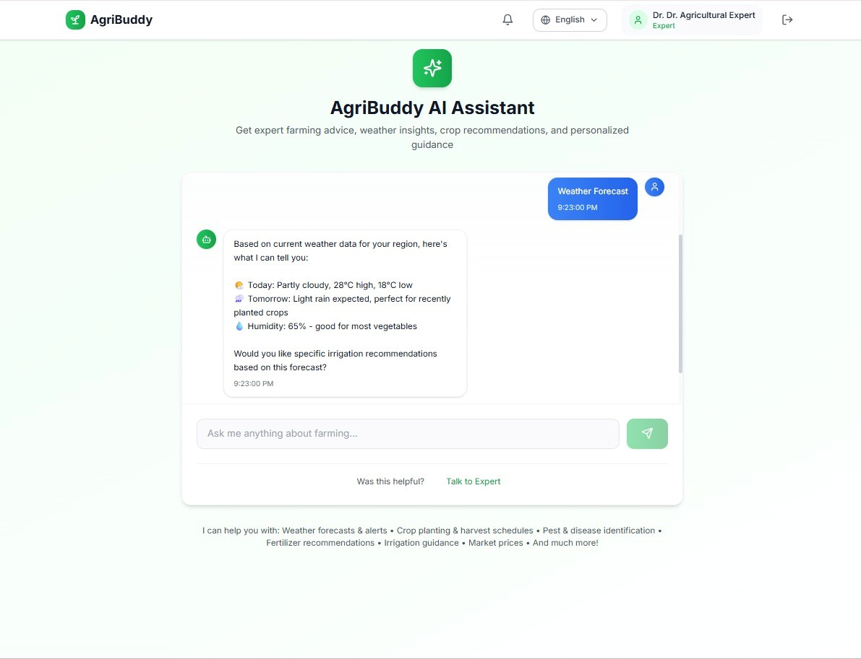
The screenshot shows a view of the Agricultural Expert's account as they interacted with an AgriBuddy AI Assistant. The Expert asked for a weather forecast, and the AgriBuddy Assistant generated a Weather Report for today's Conditions in that region, which shows a high of 28 degrees, a low of 18 degrees, and that there is a chance of light rain tomorrow. The AgriBuddy Assistant also provided the ideal Conditions for the newly seeded crops and for most Vegetable Crops. The AgriBuddy Assistant further inquired if Specific-Irrigation Advice was required due to the Weather Forecast; Both the "Talk to Expert", and "Provide Feedback" remain the same on both the Expert and the Farmer sides. The operator also sees that the AgriBuddy AI Assistant's interface is similar.
Github code Link:
https://github.com/roshinipininti2027/D2_23BCE5129_RoshiniPininti/tree/main/final-agribuddy
Demo Vedio Link: https://drive.google.com/file/d/1dYGHDAmXyjHmgW23EgJMp3mwriMeMKN/view?usp=drive_link

