autonomous public transport

Project Group 7D

*By: edu haivas, iris aksunger & roshini ramasamy*

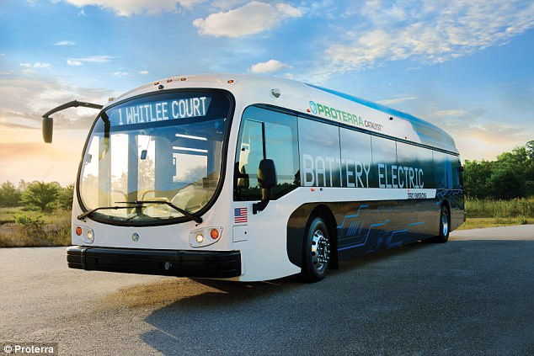

Table of contents

introduction…………………………………………………………………Page 3

schedule & task division…………………………………………………Page 4

literature study…………………………………………………………….Page 5

concept of operations……………………………………………………Page 8

system requirments……………………………………………………… Page 10

system design………………………………………………………………..Page 12

testing………………………………………………………………………….Page 15

evalutation…………………………………………………………………..Page 17

bibliography………………………………………………………………… Page 19

Introduction & Motivation

**Our idea is to create a design that uses color-coded implementation to power the idea of self-driving public transportation. The idea is to use different colors to represent different aspects of road structure. For instance, the color green can be used to detect parks and playgrounds, the colors black and white can be used to detect the lanes and driving rules of the current road. Using sensors in our transport design will help identify different regions and structures, where each color can be extracted through its values and can be used for a different representation. To identify any possible hazards, an ultrasound can be included in the design, alerting the software system about any possible obstacles or vehicles around the transportation vehicle.**

**This idea will help eliminate man-power for the use of public transport, offer the safety of sensor-aware and smart vehicles, reduce the cost of labor, improve standards of public transportation, and increasing overall public resources and economy.**

Possible Risks of Implementation

Possible risks regarding implementation of the design include correctly collecting the measurements for color detection, correctly using ultrasound detection to avoid obstacles, switching lanes and keeping the vehicle centralized on the lane during movements, passing the design and draft to real life.

Schedule & Task division

|  |  |
| --- | --- |
| date | task allocation |
| 23/11/17 | original project presentation |
| 29/11/17 | new project idea |
| 6/12/17 | working on the board and matlab code (details) |
| 7/12/17 | continuing to work with the lego mindstorm and the code (details) |
| 13/12/17 | finalizing details regarding the board |
| 14/12/17 | presentation |

Literature study

While working on this project, different articles were considered regarding software-controlled public transportation. The first article provided below supports the idea of using autonomous vehicles for public transportation, and focuses on a real-life case, which support the core idea of this project. The literature by Daniel J.Fagnant and Kara M.Kockelman gives an analysis of the idea with respect to economical and business aspects, focusing how such project would benefit the society overall. Last article included expands the idea of color vision machines for autonomous vehicles and offers in-depth explanation of how to design and create such vehicle in real life.

#### Sensable Guide to Amsterdam by *Cardona, I., Hasoloan, J., Liu, Y., Kennedy, L., Marshall, D., Qadri, R., Qiu, W., Tolgay, S.*

#### The first literature gives support to the idea of using autonomous vehicles for public transport. The idea is to have a fleet of autonomous boats in Amsterdam that are capable of monitoring their surroundings and providing public transportation. As self-driving cars hit the road, it would only make sense to take this idea a step further and make use of autonomous vehicles as a mean of public transportation. The idea will contribute to smart urban development, improve standards of living for humankind in the near-future and offer a logistic platform for people and goods.

Another possibility the article offers with the use of such vehicles is data collection. In addition to improving infrastructure and transport, with the use of sensors, such autonomous vehicles can create opportunities for environmental sensing. Arjan van Timmeren, professor and scientific director at AMS, states that “ROBOAT will also deploy environmental sensing to monitor water quality and offer data for assessing and predicting issues related to public health, pollution, and the environment.”. The same idea could be implemented to design of ground-transportation vehicles, where data collection could include the ability of communication with navigation satellites, provind prompt and continuous data flow for current road hazards, availability and weather conditions, as well as with current traffic.

Ultimately, this paper provides a general perspective on how the society could make use of autonomous vehicles to improve urban-life standards.

Transportation Research Part C: Emerging Technologies by *Daniel J.Fagnanta and Kara M.Kockelman*

Environmental and economic benefits of a projects are the key to get investors, stakeholders and governments involved during early stages of projects development. Even though the article provides evalutions based on shared vehicles, public transportation can easily be fit into this category, thus offering the same benefits in environmental and energy aspects. The article provides an overall outlook on how autonomous vehicles, in general, could maximize the environmental benefit for the society. There are many reasons to why one should consider implementing such public transportation system. Although a counter argument could be the fact that such implementation would be costly, with the current technology, self-driving cars are already on the stage. Implementing this idea to public transport would cut down the cost of labor while increasing the hours of operation. Besides lowering the consumption of energy, such transportation vehicle will also reduce emission, as well as with reduction in parking and vehicle ownership needs. Such transportation method would also contribute to overall quality of travel and safety, by eliminating the need for human controlled driving, thus minimizing human-error.

Algorithm and hardware implementation for visual perception system in autonomous vehicle by *Weijing Shi, Mohamed Baker Alawieh, XinLi, Huafeng Yu*

The last article provides the most important information regarding technical details of such implementation. The article focuses on different aspects regarding design, and how visual perception algorithm can best be applied to such vehicle systems. In this project, sensors readings and color detection is used to detect road curves and lane markers, as well as with different regions and zones. Obstacle detection is achieved through the use of ultrasound sensor. The literature provides detailed information regarding analysis of vehicle’s environment and how the visual perception algorithms can be applied. The article states that “A visual perception algorithm must accurately recognize the obstacles of interest. In addition to obstacle detection, visual perception is also used for drivable surface detection, where an autonomous vehicle needs to detect possible drivable space even when it is off-road (e.g. in a parking lot) or when the road is not clearly defined by road markers (e.g. on a forest road).”

The idea of the project is to make use of color machine vision and visual algorithms to design an autonomous public transport vehicle. Thus, this article is a very good pivot point for referral and ideas, since it offers detailed explanations on various aspects of what such vehicle would require. The article also offers comparisons of the cameras and systems used previously for detection of roads and hazards and how each of those components affected the design.

Ultimately, this paper provided us technical ideas and implementation details to start our project.

Concept of operations

Mission Statement

To design an autonomous public transport vehicle that would improve overall quality and safety of public transportation and have a positive reflection on overall economy and infrastructure of urban development.

Stakeholders

The designers and creaters of the project

The University and the Teachers, As well as with Teacher Assistants

The users/reviewers of the project

Scenarios

* The idea of autonomous public vehicle could be applied to many areas:
* Could be used a smart transportation vehicle in big cities reduce traffic load
* The vehicle could be extended to collect data, regarding road conditions, traffic load and any possible hazards

the implementation could be further extended with the ability to communicate with navigation satellites

* Could be designed specifically for safe transportation purposes to offer secure delivery for bank transactions, Prisoner transport vehicle are possible examples
* The design could also be extended to include disabled citizens, offer special means of transport and assistance.
* The autonomous vehicle could be designed as a school bus, with a software addition that allows parents to monitor their kids during transport

The idea of creating a smart public vehicle could be implemented into many aspects of the society.

Block Diagram

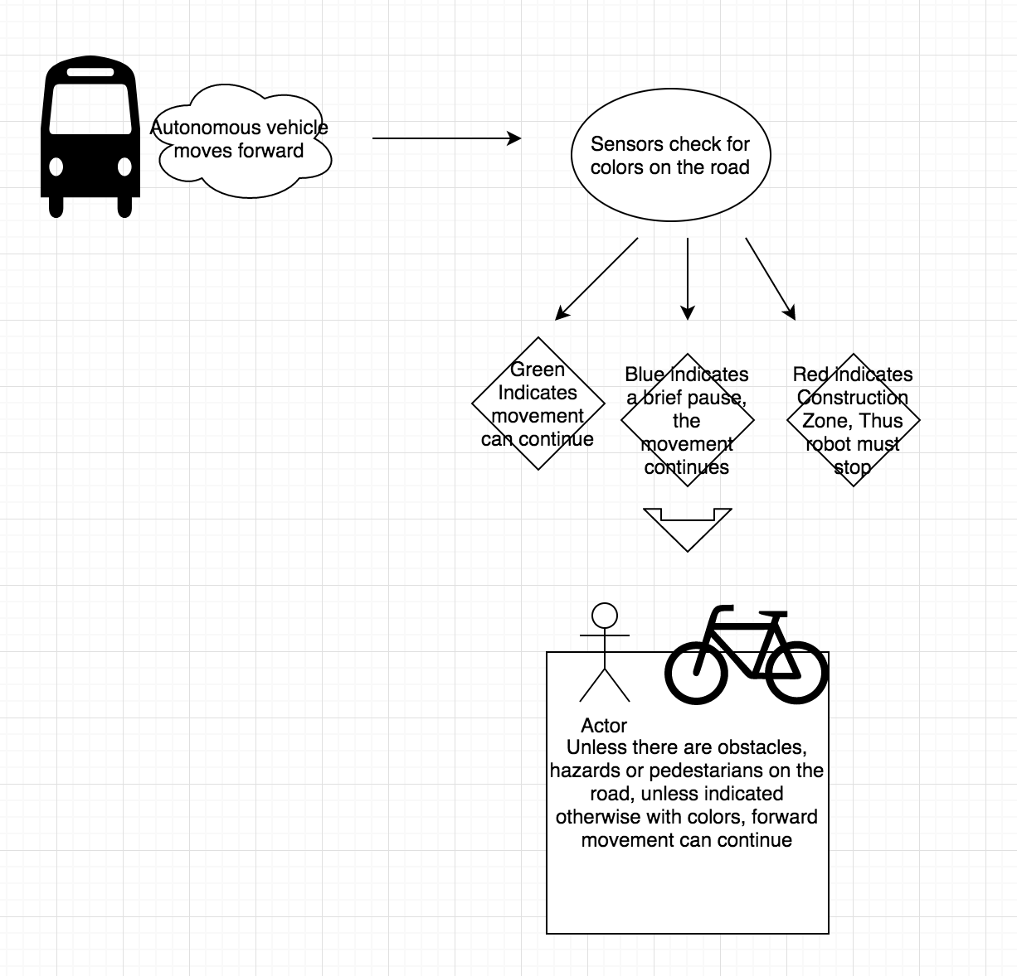

Use Case Diagram

There is actually no need for a Use Case Diagram, the project is based on public transport, thus the same instructions apply. Passengers get on the vehicle and the vehicle starts moving.

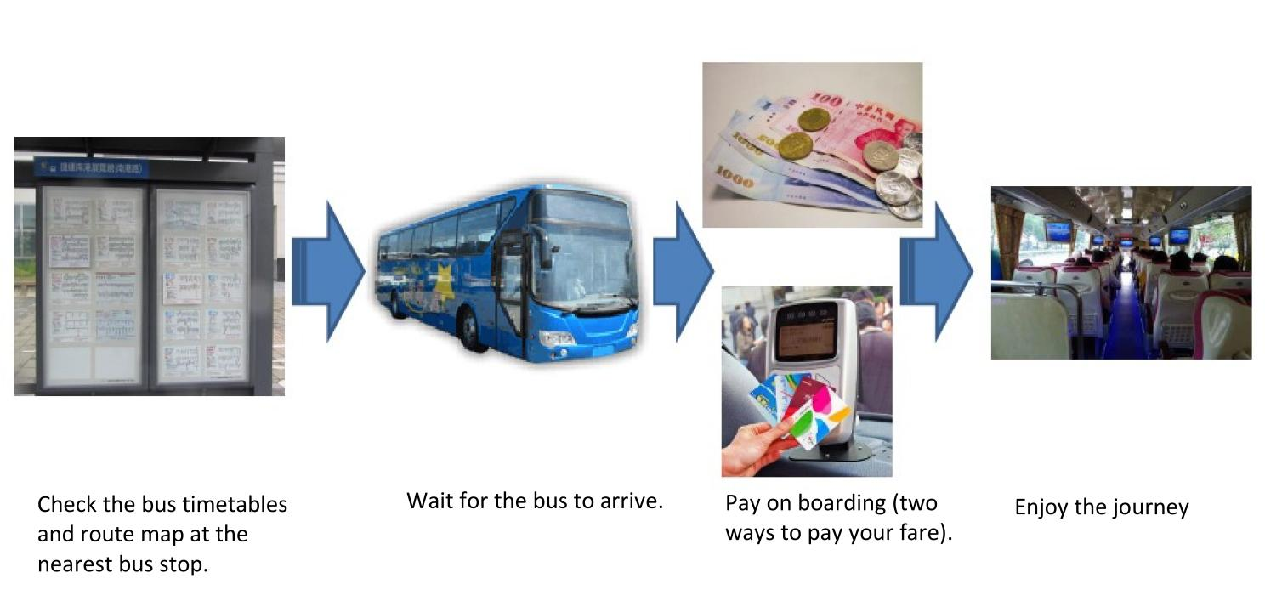

System Requirements

The requirements for the project are hard to achieve, since designing an autonomous vehicle requires high level technical skills combined with year of experience. Thus, our goal was to design a simplified version of the public transport idea, implement the very basics of color machine algorithms and ultrasound readings.

User End Goal

The users will be the public itself in general. Anyone who uses public transport as a method of transit can benefit from this project.

Functional Requirements

Although simplified, the design should still be able to reflect the main structure of a self-driving vehicle.

*The design must have:*

* An autonomous device that represents the idea of self-driving public transport
* The ability to detect the lanes accurately, make turns and curves.
* Make use of ultrasound scanning to detect and avoid any possible obstacles, thus avoiding any hazards that might occur during real-life traffic.
* Ability to detect and read different colors through sensors, react to traffic lights and its surroundings

*The design will not have:*

* Advanced features such as data collection, satellite communication, navigation etc.

Non-Functional Requirements

*The design must have:*

* Ability to identify different colors through image scanning
* Ability to brake when the vehicle spots a red light
* The right conditions for the vehicle to move and perform necessary tasks to fully represent an autonomous transport device:
* The board must include roads, enough space for turns and brakes, as well as with curves
* Hazards for the ultrasound to detect
* Lights for color readings to brake/move the vehicle

*The design should have:*

* The ability to respond to any kind of obstacle
* The ability to switch to an empty lane, take curves, turn around, forward and backwards-movement skills
* The design should perform these tasks within a certain amount of time, without pausing too much in between, following a smooth motion flow

*The design could have:*

* Wider variety of obstacles
* Different regions and zones for the vehicle to spot through color readings
* A possible addition for the device to collect data from its surroundings during movement

Constraints

The programming must be done in MATLAB

The project has to be completed by 13.12.2017

System Design

As expected, the autonomous vehicle is controlled through software, which is written using MATLAB. The code itself is attached as a file. Below you can find the important implementation details of the code.

Introduction

First, we gathered the research documents and came up with a draft for our idea. Later on, we thought more thoroughly about how we could simplify such a complex system and finish the project within the given deadline. Once we felt confident with the simplicity and achievability of the project, we started moving the idea to the MATLAB and working on coding aspect.

Preparation

The analysis of the project included deciding how to implement the parkour for the vehicle, and how to shift the concepts of driving and monitoring to matlab. We decided to use light sensors for color detection. The colors were chosen carefully, making sure no color will be within the range of others’, so that the accuracy of color detection is maximized.

We used colored papers to take measurements, recorded each reading to decide what range each color fall into.

At this stage, we also decided the design for our board, activated the ultrasound and the motors to see if all the equipment is working properly.

(include code snippet for color reading)

implementation

Once the design of the board was complete and the measurements were taken, we started to actually implement the code on MATLAB. We started with activating the NXT Robot, which represent the autonomous vehicle in the project. Then, the light sensors and ultrasound is activated to detect the colored-signals and obstacles around the vehicle.

If the ultrasound detects an obstacle within the set range, then the vehicle moves backwards, brakes, and switches to the nearest empty line.

(include code snippet here)

The code also enables the robot to detect different colors through light sensors and react differently to each color. Below is the code that determines the behavior of the vehicle when it encounters “traffic lights”. If the light sensors detect the color range to be within the color green, vehicle continues to move forwards. For the color red, there is a brake first before continuing along the marked path.

(include code snippet here)

Ultimately, our goal was to create a simplified software for an autonomous vehicle, that is capable of sensing its surroundings, make sense of the data readings and react differently to each requirement constrained by the code. At the end, the code implementation for the light sensors help the vehicle detect areas on the board, such as parks, roads, residential zones. The ultrasound implementation helped achieve the task of spotting hazards like crashed building, pedestrians walking and so on.

Please see the attached MATLAB file to access the complete code.

Activity Diagram

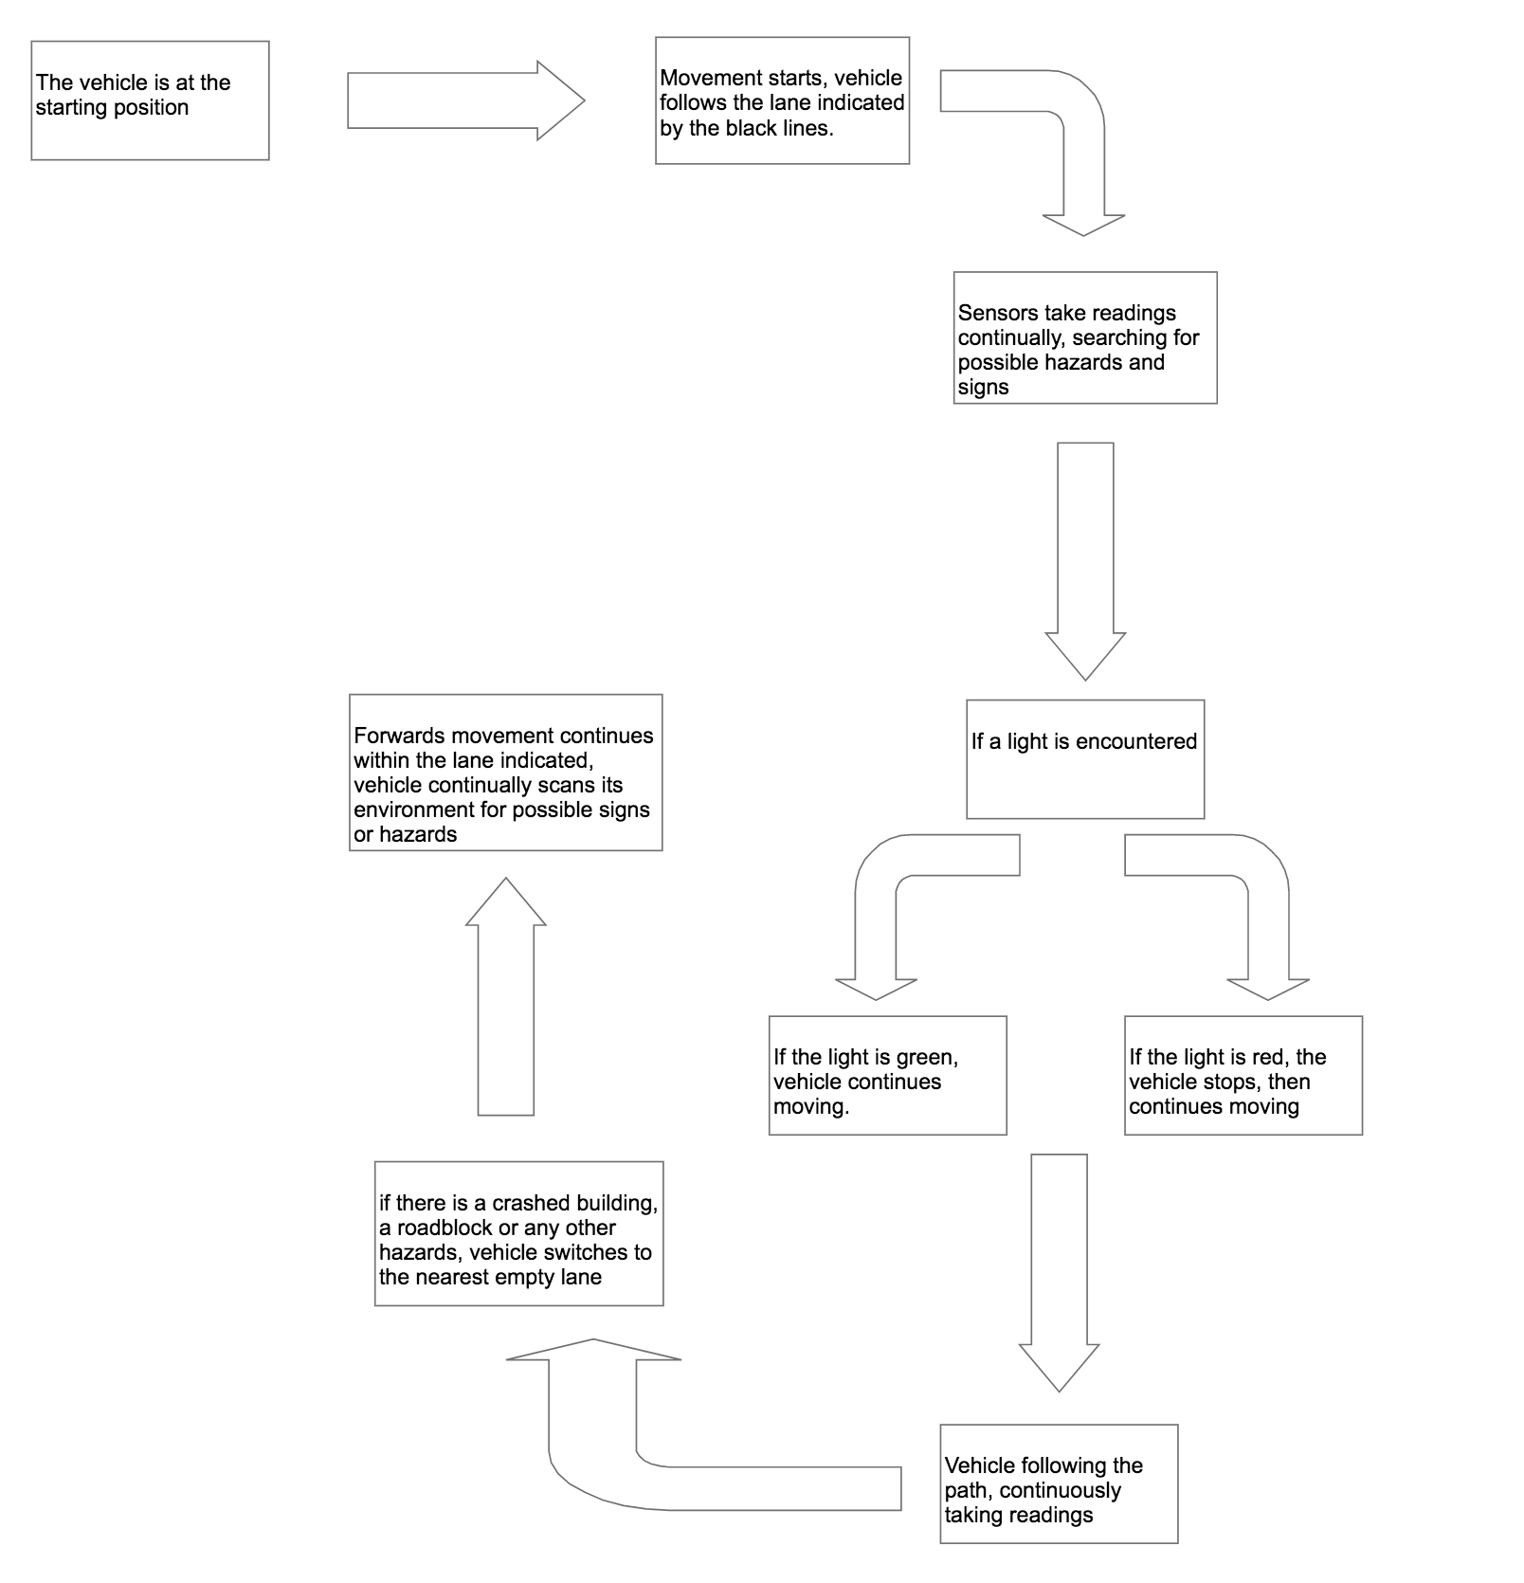

Testing

The testing phase of the project mainly involved finding the right distances for light reflection, in order to maximize the accuracy of measurements. During this phase, we also focused on improving motor movements of the robot, and tried different values for the motor power and pause. Our goal was to find the best values for the vehicle to follow the marked path as smoothly as possible.

(include testing picture here-robot)

The testing process also helped us determine what details we could add into our parkour for the vehicle, and how we could possible get creative with the project design to improve overall outlook

(include design of the board here)

Ethics and Policies

The concept of autonomous vehicles is relatively new. Just like any recent technological enhancement, it has positives and negatives one must consider while working on such project.

So far, our main focus has been how one could benefit from this idea. However, we must also mention that fully integrating the concept of autonomous public transport will raise many questions, besides providing benefits.

First of all, the ethics need to be addressed, with respect to what happens in a situation that involves a human driver and a autonomous vehicle, involved in a car crash. How should the legal system be updated to cover such circumstances.

Another issue to bear in mind is the policies and insurance, how can the insurance system be optimized to include such vehicles.

More questions rise when it comes to safety, as in what happens if there is a software malfunctioning, who is to be held responsible in such situations, how can the companies guarantee a secure software system to prevent outside-access to autonomous transport vehicles. All these questions are beyond this project, however should still be mentioned in this document since the concept are main core issues involving autonomous vehicles. Thus, we wanted to mention, although briefly, that these are some of the cases one must consider before marketing such vehicles.

Evaluation and Conclusion

Overall, the project development was satisfactory. The code we implemented for the driving worked well with the NXT robot, movements were accurate and as smooth as possible, however we ran into some difficulties when it came to recognizing colors.

The black and white light sensors record the colors on grey scale. Thus, whenever there was a reflection of light or too much shadow, the range changed drastically. Therefore we were not able to take readings for each color, since the values changed with each location.

Thinking the implementation of the code thoroughly and not rushing into the code helped us develop the project much faster, with the minimum number of roadblocks. The only difficulty we had was the color readings, everything else seemed to work as anticipated.

As we developed the code, we commented all the details while working on the code, which helped keep track of each step and made it easy for all members to comprehend the project software fully.

The performance of the overall design was well structured, the board was complete, it had the necessary color-signals and obstacles setup for the vehicle to reflect the performance of the code, ultrasound and movement implementation was working well, although the sensors did not recognize the color patterns.

The code design was simple, but achievable, while still reflecting the key features of the concept of autonomous vehicle.

There could be further improvements to this project, much can be added to the system. A bigger board can be designed with more complications, and thus requiring a more structured and complex code behind. The accuracy of the readings could be improved by replacing the components, the ultrasound and the light sensors, with more advanced versions.

The problem of taking measurements for each color could be solved with a simple switch to RGB Color Sensors. However, we thought that the time we had was not sufficient to make such a change, also when we first took the measurements for the colors, everything seemed to be working. Which prevented us from seeing that the location was a factor that affected each reading.

The code could be extended to adopt the idea of self-driving vehicle even more.

However, with the given amount of time and equipment, the overall project went quite well. Everything was completed in time, and thanks to long but effective planning, implementation went as successfully as it could.

Ultimately, we believe that autonomous public vehicles will be the future of urban development. Our goal with this project to show the possibilities of how this idea could be extended, how it could be fit into many real-life scenarios.

In the end, this project was interesting to work on, pushed us to use our creativity and helped gain more confidence about our achievements and ideas

Bibliography

Ratti, Carlo. “Senseable City LabC.” RoBOAT Amsterdam, senseable.mit.e http://www.sciencedirect.com/science/article/pii/S0968090X13002581

“The Travel and Environmental Implications of Shared Autonomous Vehicles, Using Agent-Based Model Scenarios.” Transportation Research Part C: Emerging Technologies, Pergamon, 23 Jan. 2014

Ratti, Carlo. “A New Transportation.” MIT Senseable City Lab, [www.sciencedirect.com/science/article/pii/S0968090X13002581du/roboat/](http://www.sciencedirect.com/science/article/pii/S0968090X13002581du/roboat/).

Vrije Universiteit Amsterdam. Physical Computing 2017, MATLAB Instruction Guide

“Algorithm and Hardware Implementation for Visual Perception System in Autonomous Vehicle: A Survey.” Integration, the VLSI Journal, Elsevier, 29 July 2017, www.sciencedirect.com/science/article/pii/S0167926017303218.