IoT Based Air Pollution Monitoring System

A Project report submitted in partial fulfilment of the requirements for the degree of B.Tech Information Technology

By

M.ROSHINI (513221205016)

# Under the supervision of

Professor & HOD Department of

Computer Science and Engineering

AIR QUALITY MONITORING SYSTEM

PHASE 3: DEVELOPMENT PART – 1

Climate change has been causing significant impacts on people’s living conditions, stability, and socio-economic development status in the Lower Mekong River Basin day by day. Besides, due to population growth, the rapid increase of industrialization, as well as indiscriminate use of chemical fertilizers and pesticides in agriculture, are causing serious impacts on the environment, climate, and public health. Air quality is getting worse noticeably, especially in urban areas where high population density and many industrial parks. World Health Organization (WHO) announced that there are approximately 4.2 million premature deaths globally are linked to ambient air pollution [1]. Air Quality Index is a metric to assess how polluted the air is. Recently, air pollution levels in Hanoi and Ho Chi Minh City have reached alarming levels [2]. According to Vietnam's AQI ranking (see Table I), the index reaches a threshold of over 150 indicating that air quality is harmful to health. In order to mitigate the negative impacts of industrialization and pollution on both the environment and public health, growing community consciousness and applying science and technology is one of the sustainable solutions. Many environmental monitoring applications based on the Internet of Things (IoT) have been applied successfully in many countries.

These projects were employed shortrange communications, for example, Zigbee, Wi-Fi, for implementing real-time air quality, both indoor and outdoor, monitoring systems [3]−[7]. With the rapid development of integrated electronic devices and communication technologies (such as low power long-distance wireless communication technology) which allows deploying the distributed sensing systems on a wide-area and reducing maintenance costs as well [8]. Consequently, the objective of this research is to develop large-scale environmental monitoring by adopting IoT-based systems with the advantages of long-distance wireless communication and innovative sensor technology. A lot of research on air quality has been conducted to reflect the current state of air quality in Vietnam.

**Data Collection**

A LoRa star network is deployed to collect environmental data to a gateway from many sensing nodes distributed in a wide area . Sensing data at sensor nodes, with data formation as illustrated in Fig. 7, needs to be sent to the gateway reliably so that a trick scheduling communication must be programmed. At the gateway, air quality factor values collected from sensing nodes are uploaded to a cloud server either through Wi-Fi or the Internet. The obtained data are inserted into a Firebase real-time database and the calculation are executed for AQI values. the payload structure of a LoRa frame for gathering data in the EnMoS system. For instance, illustrates a flow chart of the routine in Python programming language for reading and then calculating PM2.5 and PM10 values.

* CInput: input concentration of pollutant
* CHigh: the concentration breakpoint value that is greater than or equal to CInput
* CLow: the concentration breakpoint value that is less than or equal to CInput
* AQIHigh: the AQI value corresponding to CInput
* AQILow: the AQI value corresponding to B

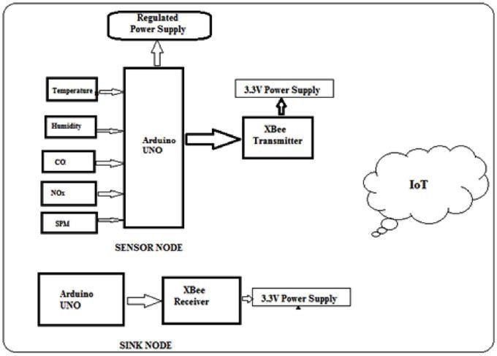

**Web Application**

The web page at address https://enmos-ctu.web.app/ is built in order to provide an interactive map along with the corresponding graphs for air quality parameters. It is convenient for people to access the information from any web browser running on a variety of hardware platforms and operating systems. The level of pollutants in the air, such as PM2.5, PM10, and CO2 are presented on separate graphs to observe easily. For instance, PM2.5 values (in µg/m3 ) measured by the SDS011 sensor were depicted in a graph. Such graphs are automatically refreshed whenever the Firebase database is updated in real time. It not only allows governors to observe, analyze, and assess the variation of air pollution level but also raises public awareness about environmental pollution.

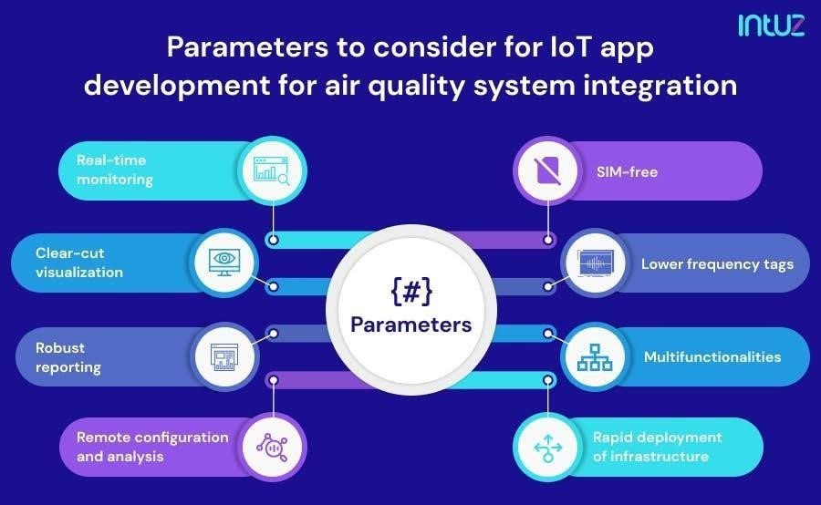

## Python

For the development of this prototype, Python Language is used to program the microcontroller. Python is a high-level, allpurpose programming language that is interpreted. Its design philosophy places a strong emphasis on code readability through the usage of substantial indentation. Its language constructs and objectoriented methodology are intended to aid programmers in creating clean, comprehensible code for both little and big projects. Python uses garbage collection and has dynamic typing. It supports a variety of programming paradigms, including procedural, object-oriented, and functional programming, as well as structured programming (particularly procedural).

Python programming language is used since it has a large set of libraries. From the given datasheets of the MQ sensors, the appropriate curve for each gas is implemented in the program. This ensures that the sensors measure the accurate amount of the respective gas present in the atmosphere. First, the sensing resistance of the sensor is calibrated in the program by averaging the value of several sensing resistance values after measuring them in each trial in normal conditions. Thereafter, the sensors start measuring the amount of each gas present in the atmosphere and give us the data. The datasheet of MQ sensors contains the resistance ratio (*R*O to *R*S ratio) for a given amount of particular gases present. Since only for a considerable amount of increase in the PPM value, the *R*O to *R*S ratio increases slightly, a logarithmic scale is used to view the values. An antilog function at the end of the program is used to get the actual PPM value. The PM sensor data are also transmitted to the cloud platform. Using the urllib library in Python, we upload the data collected using the sensors to the ThingSpeak Cloud Platform.

***Check your Air Quality according to the data :***

# Traverse the air quality

res_quality = soup.find(class_="DonutChart--innerValue--2rO41 AirQuality-

extendedDialText--2AsJa").text

# traverse the content air_data = soup.find_all(class_="DonutChart--innerValue--2rO41 AirQuality--

pollutantDialText--3Y7DJ")

air_data=[data.text for data in air_data]

print("Air Quality :", res_data) print("O3 level :", air_data[0]) print("NO2 level :", air_data[1]) print("SO2 level :", air_data[2]) print("PM2.5 level :", air_data[3]) print("PM10 level :", air_data[4]) print("co level :", air_data[5])

***OUTPUT :***



Air Quality : 85



O3 level : 67



NO2 level : 22



SO2 level : 13



PM2.5 level : 30



PM10 level : 45



co level : 479

