UNIVERSITY ACADEMIC MANAGEMENT SYSTEM
A DBMS Capstone Project Report submitted in partial fulfillment of the requirements for the award of the degree of
BACHELOR OF TECHNOLOGY
in
ARTIFICIAL INTELLIGENCE AND MACHINE LEARNING
Submitted By
B. DHARANI SRI -25B11AI170
J.SAI DEEKSHITHA - 25B11AI418
B. TARAK RAJESH -25B11AI094
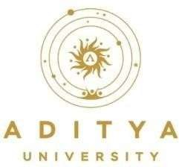
K. ASHOK -25B11AI479
Under the esteemed guidance of
Mrs .G L NARASAMBA VANGURI M.Tech (Ph.D)
Assistant Professor
DEPARTMENT OF ARTIFICIAL INTELLIGENCE AND MACHINE LEARNING
ADITYA UNIVERSITY
(Formerly Aditya Engineering College (A))
Aditya Nagar, ADB Road, Surampalem, Andhra Pradesh, India 2026 – 2027

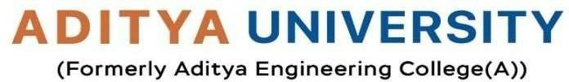
Aditya Nagar, ADB Road, Surampalem, Andhra Pradesh, India
DEPARTMENT OF ARTIFICIAL INTELLIGENCE AND MACHINE LEARNING

CERTIFICATE

This is to certify that the DBMS Capstone Project report entitled “ UNIVERSITY ACADEMIC MANAGEMENT SYSTEM ” is being submitted B. DHARANI SRI (25B11AI170) J.SAI DEEKSHITHA (25B11AI418), B. TARAK RAJESH( 25B11AI094) And K. ASHOK (25B11AI479) in partial fulfillment of the requirements for the award of the B.Tech. degree in Artificial Intelligence and Machine Learning. The work documented in this report was carried out as part of the Capstone Project for the course Database Management Systems (2501IT05) during the academic year 2026–2027, and records the database design, implementation, and documentation undertaken by the team.

Project Guide Head of the Department
G L NARASAMBA VANGURI M.Tech(Ph.D) Dr. K. Naga Bhargavi, M. Tech, Ph.D.
Associate professor Associate Professor & HOD

External Examiner
DECLARATION

We hereby declare that the DBMS Capstone Project entitled “ UNIVERSITY ACADEMIC MANAGEMENT SYSTEM ” is a genuine work carried out by us. The database design, SQL implementation, queries and documentation presented in this report are our own work, completed under the guidance of Mrs .G L NARASAMBA VANGURI Department of Artificial Intelligence and Machine Learning, Aditya University, Surampalem. We further declare that this work has not been submitted, in full or in part, for the award of any degree of this or any other educational institution.

Project Associates
B. DHARANI SRI 25B11AI170
J.SAI DEEKSHITHA 25B11AI418
B. TARAK RAJESH 25B11AI094
K. ASHOK 25B11AI479

Date: 14 September 2026
Place: Surampalem

ACKNOWLEDGEMENT

It is with immense pleasure that we express our indebted gratitude to our project guide Mrs. G L NARASAMBA VANGURI , Department of Artificial Intelligence and Machine Learning, who guided us throughout the capstone project. We are thankful for the constant encouragement and valuable suggestions received at every review stage.
We are grateful to Dr. K. Naga Bhargavi, Head of the Department, for inspiring us and for arranging the facilities and resources needed for this project.
We extend our sincere thanks to the Management, Dr. M. Sreenivasa Reddy, Deputy Pro-Chancellor, Dr. M. B. Srinivas, Vice-Chancellor, and Dr. A. Ramesh, Pro Vice-Chancellor (Engineering & Sciences), for providing an excellent academic environment.
Not to forget, we thank the Teaching and Non-Teaching Staff, our parents and our friends, who have directly or indirectly supported us in completing this project on time.

Project Associates
B. DHARANI SRI 25B11AI170
J.SAI DEEKSHITHA 25B11AI418
B. TARAK RAJESH 25B11AI094
K. ASHOK 25B11AI479

