ADITYA UNIVERSITY
Surampalem
Department of ________AI&ML______________
DBMS CAPSTONE PROJECT
Project Documentation Report
Project Title: UNIVERSITY ACADEMIC MANAGEMENT SYSTEM.
Submitted by:
S.No | Student Name | Roll Number
1. | B.DHARANI SRI | 25B11AI170
2. | J.SAI DEEKSHITHA | 25B11AI418
3. | B. TARAK RAJESH | 25B11AI094
4. | K.ASHOK | 25B11AI479
Course: Database Management Systems (DBMS) Course Code:
Faculty Coordinator: V.G.L NARASAMBA
Academic Year: 2026-27 Date of Submission:
GitHub Repository Link: https://github.com/roshinisaideekshitha-prog/c-programs.git

TABLE OF CONTENTS
(This table updates automatically when the document is opened in Microsoft Word. If it appears empty, right-click it and choose "Update Field".)
TABLE OF CONTENTS 1
1. ABSTRACT 1
2. INTRODUCTION 1
2.1 Background 1
2.2 Purpose of the Database 1
3. PROBLEM STATEMENT 1
4. OBJECTIVES 1
5. TOOLS & TECHNOLOGIES USED 1
6. DATABASE DESIGN 1
6.1 Identified Entities 1
6.2 Entity Attributes 1
6.3 ER Diagram 1
6.4 Relationships & Cardinality 1
6.5 Relational Database Schema 1
6.6 Normalization 1
7. DATABASE IMPLEMENTATION 1
7.1 DDL — Database and Table Creation 1
7.2 Sample Data — DML 1
7.3 Constraints & Data Integrity 1
7.4 SQL Operations & Queries 1
7.5 Sample Outputs / Screenshots 1
8. MODULES & FUNCTIONALITIES 1
9. GITHUB REPOSITORY & TEAM RESPONSIBILITIES 1
10. ENHANCEMENTS & FUTURE IMPROVEMENTS 1
11. CONCLUSION 1
12. REFERENCES 1
APPENDIX 1
A. Complete SQL Script 1
B. Additional Screenshots / Outputs 1

1. ABSTRACT
The University Academic Management System is a database-based system designed to manage and organize academic information within a university. In the academic domain, large amounts of data related to students, faculty, courses, departments, attendance, examinations, and grades are generated and maintained. Managing this information manually can be time-consuming, difficult, and prone to errors.
The main purpose of this database is to provide a centralized and structured system for storing, updating, and retrieving academic information efficiently. It helps maintain accurate records and reduces data duplication and manual paperwork.
The major functionalities of the system include student registration, faculty management, course and department management, attendance tracking, examination and marks management, and generation of academic records and reports. The system also allows authorized users to access relevant information quickly and maintain data consistency.
The key outcome of the project is an organized and reliable academic database that improves efficiency, accuracy, and accessibility of university records. Overall, the system supports better academic administration and provides a foundation for effective management of university activities.

2. INTRODUCTION

2.1 Background

The University Academic Management System is a database-based project developed to manage and organize the academic activities and information of a university. A university handles a large amount of data related to students, faculty members, departments, courses, attendance, examinations, marks, and academic records. Managing such information manually or through separate files can lead to data duplication, errors, difficulty in updating records, and delays in retrieving information.
A database is required to store all academic information in a structured and centralized manner. It provides an efficient way to add, update, delete, and retrieve records whenever required. The database also helps maintain data consistency, accuracy, security, and relationships between different academic entities. For example, student records can be connected with their courses, attendance, examinations, and grades.
The proposed system aims to simplify academic data management by providing a reliable and organized database structure. It supports efficient record maintenance and quick access to information, thereby improving the overall management of university academic activities.

2.2 Purpose of the Database
Purpose of the Database
The purpose of the University Academic Management System database is to provide a centralized and organized platform for managing the academic information of a university. It solves the problem of maintaining large amounts of academic data manually or in separate files, which can result in data duplication, errors, difficulty in updating records, and delays in accessing information.
The database is mainly used by administrators, faculty members, and authorized academic staff to store, update, retrieve, and manage academic records efficiently. Students may also access relevant academic information through the system, depending on their permissions.
The database manages important information such as student details, faculty details, departments, courses, subjects, attendance, examinations, marks, grades, and academic records. It maintains relationships between these entities so that information can be accessed accurately and efficiently.
Overall, the database helps improve data accuracy, consistency, security, and accessibility while reducing manual work. It provides a reliable foundation for managing university academic activities and generating useful academic reports whenever required.

3. PROBLEM STATEMENT

Universities generate and maintain a large amount of academic data related to students, faculty, departments, courses, attendance, examinations, marks, and grades. In a traditional system, this information may be maintained using paper records, spreadsheets, or separate files. Managing data through these methods can be time-consuming and may lead to data duplication, incorrect entries, loss of records, and difficulty in retrieving information quickly. It can also be difficult to maintain relationships between different academic records and ensure that the information remains consistent and up to date.
The existing approach has limitations in terms of data organization, accuracy, accessibility, security, and efficient record management. Generating reports and updating academic information may also require considerable manual effort.
The proposed University Academic Management System addresses these problems by providing a centralized database for storing and managing academic information. It organizes data into related tables and maintains relationships between students, faculty, courses, attendance, examinations, and grades. The system enables authorized users to efficiently add, update, retrieve, and manage records while reducing duplication and improving data consistency. This results in faster information retrieval, better record maintenance, and more efficient academic administration.

4. OBJECTIVES
• Objective 1: To develop a centralized database for storing and managing university academic information efficiently.
• Objective 2: To maintain accurate records of students, faculty, departments, courses, attendance, examinations, and grades.
• Objective 3: To reduce data duplication and manual errors by organizing academic information into related database tables.
• Objective 4: To provide quick and efficient access to academic records and generate useful reports when required.
• Objective 5: To improve data consistency, security, and overall efficiency in managing university academic activities.

5. TOOLS & TECHNOLOGIES USED
Category | Tool / Technology Used
Database Server
  Oracle Database
Query / Admin Tool
  Oracle SQL Developer
Front-end (if any)
  Not Applicable / None
Operating System
  Windows
Version Control | GitHub

6. DATABASE DESIGN

6.1 Identified Entities
Minimum: 6 entities. Provide a short description of each entity.
S.No | Entity Name | Description
1.
  Student
  Stores details of students such as student ID, name, contact information, department, and enrollment details.
2.
  Faculty
  Stores information about faculty members, including faculty ID, name, department, designation, and contact details
3.
  Department
  Represents the academic departments in the university and stores department-related information.
4.
  Course
  Stores information about courses offered by the university, including course ID, course name, credits, and department.
5.
  Enrollment
  Records the courses registered by each student and maintains the relationship between students and courses.
6.
  Attendance
  Maintains student attendance records for the courses or subjects in which they are enrolled.

6.2 Entity Attributes

List the attributes of each entity. Mark Primary Keys (PK) and Foreign Keys (FK).
Entity | Attribute | Data Type | Key (PK/FK/—) | Attribute Type
Student | Student_ID |  | PK
  NUMBER
  Simple
Student | Student_Name |  | ---
  VARCHAR2(100)
  Simple
Faculty | Faculty_Name |  | ---
  VARCHAR2(100)
  Simple
Faculty | Email |  | ----
  VARCHAR2(100)
  Simple
 | Department_ID | NUMBER | PK
  Department
  Simple
Department | Department_Name | VARCHAR2(100) | ---
  Simple
Course | Course_ID | Number | PK
  Simple
Course | Course_Name | VARCHAR2(100) | ---
  Simple
Enrollment | Enrollment_ID | NUMBER | PK
  Simple
Enrollment | Student_ID | NUMBER | FK
  Simple
Attendance |  | NUMBER | FK
  Student_ID
  Simple
Attendance |  | NUMBER | FK
  Course_ID
  Simple
Examination |  | NUMBER | PK
  Exam_ID
  Simple
Examination |  | NUMBER | FK
  Course_ID
  Simple
Attribute Type: Simple / Composite / Multi-valued / Derived

6.3 ER Diagram
Insert the complete ER diagram showing entities, attributes, relationships, and cardinalities.
[ Paste ER Diagram Here ] 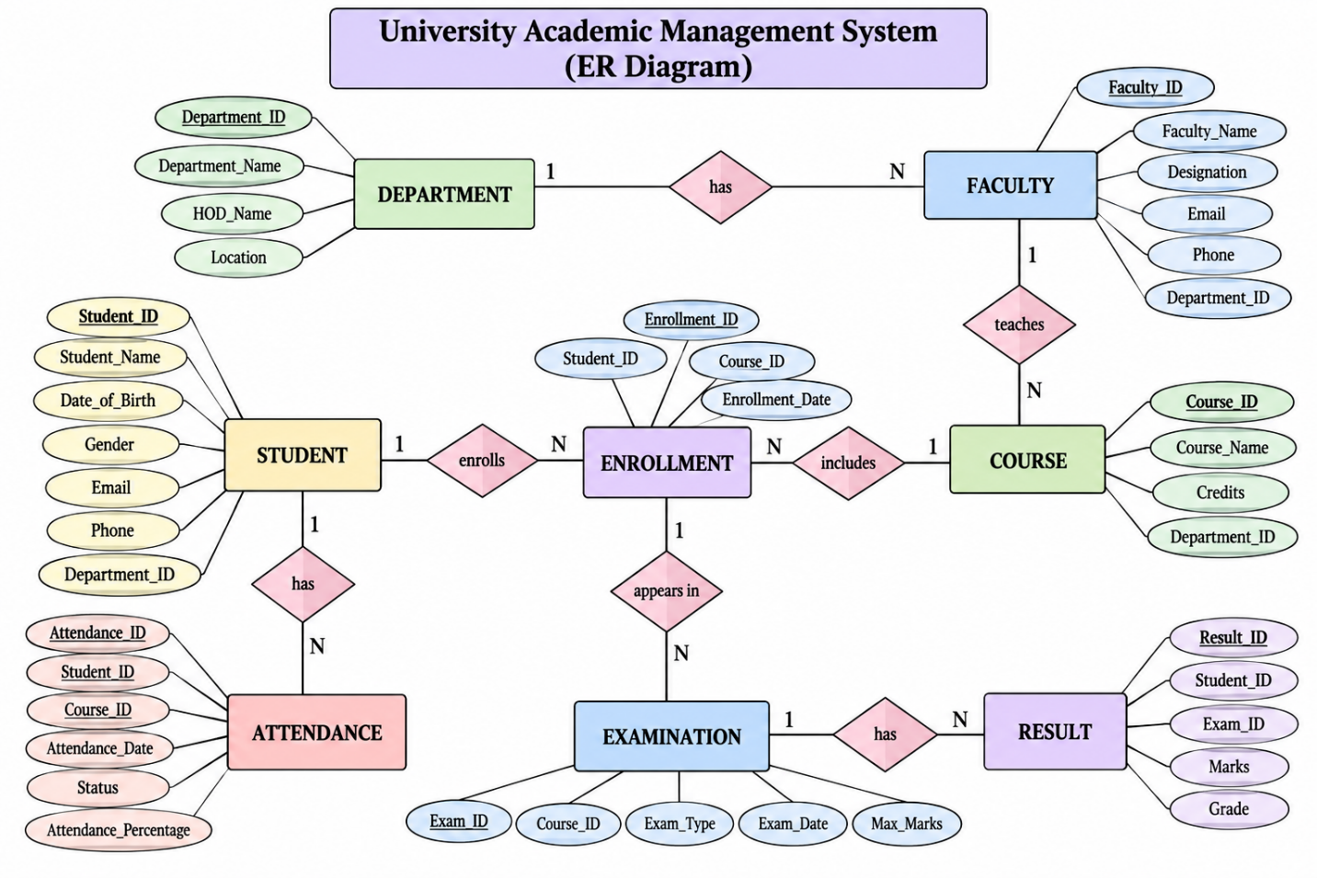

6.4 Relationships & Cardinality
Entity 1 | Relationship | Entity 2 | Cardinality (1:1 / 1:N / M:N)
Student | Belongs to |  | N:1
  Department
Student | Has | Enrollment | 1
Faculty | Belongs to |  | N:1
  Department
Faculty | Teaches | Course | 1
Course | Offered by | Student | 1
Course | Includes | Course | 1
Enrollment | Belongs to |  | N:1
  Department
Enrollment | For | Enrollement | 1
Department | Has | Student | N:1
Department | Offers | Course | N:1

6.5 Relational Database Schema
List every table, its columns, data types, and identify PK/FK columns.
Table Name | Column Name | Data Type | PK/FK/— | Constraints
Student |  |  | PK | PRIMARY KEY, NOT NULL
  Student_ID
  NUMBER
Faculty |  |  | PK | PRIMARY KEY, NOT NULL
  Faculty_ID
  NUMBER
Department |  |  | PK | PRIMARY KEY, NOT NULL
  Department_ID
  NUMBER
Courses |  |  | PK | PRIMARY KEY, NOT NULL
  Course_ID
  NUMBER
Enrollement |  |  | PK | PRIMARY KEY, NOT NULL
  Enrollment_ID
  NUMBER
Attendance |  |  | PK | PRIMARY KEY, NOT NULL
  Attendance_ID
  NUMBER
Examination |  |  | FK
  Course_ID
  NUMBER
  REFERENCES COURSE(Course_ID)
Result |  |  | FK
  Student_ID
  NUMBER
  REFERENCES STUDENT(Student_ID)

6.6 Normalization
Normalization
Normalization is the process of organizing data in a database to reduce data redundancy and avoid insertion, deletion, and update anomalies. In the University Academic Management System, normalization helps maintain accurate and consistent academic information by dividing large tables into smaller related tables.
UNF → 1NF → 2NF → 3NF
• UNF (Unnormalized Form):
Initially, student, department, course, attendance, examination, and result information may be stored together in a single table. This can result in repeated values, duplicate records, and difficulty in maintaining data.
• 1NF (First Normal Form):
The data is converted into 1NF by ensuring that every attribute contains a single, atomic value and there are no repeating groups. Each record is uniquely identified using a primary key.
• 2NF (Second Normal Form):
The database is converted into 2NF by removing partial dependencies. Attributes that depend only on a part of a composite key are separated into appropriate tables. Student, Course, Enrollment, Attendance, and other entities are separated to ensure proper dependency.
• 3NF (Third Normal Form):
The database is converted into 3NF by removing transitive dependencies. Non-key attributes depend only on the primary key of their respective table. For example, department details are stored in the Department table instead of repeating them in Student and Faculty tables.
The final database structure in 3NF reduces data redundancy and prevents common update, insertion, and deletion anomalies. It improves data consistency, maintains clear relationships between entities, and makes the database easier to manage and maintain.

7. DATABASE IMPLEMENTATION

7.1 DDL — Database and Table Creation
Paste CREATE DATABASE / CREATE TABLE statements and include constraints such as NOT NULL, UNIQUE, CHECK, DEFAULT, PRIMARY KEY, and FOREIGN KEY.
[ Paste SQL Script / Screenshots Here ]

7.2 Sample Data — DML
Insert sufficient sample data into all tables. Include INSERT, UPDATE, and DELETE examples where applicable.
Table | No. of Records | Sample Data / Screenshot Reference

7.3 Constraints & Data Integrity
List the constraints and validations applied to keep the data accurate and consistent (no duplicate IDs, valid values, referential integrity).
Constraint / Validation | Applied On | Purpose | Evidence / Screenshot

7.4 SQL Operations & Queries
Include representative examples of DDL, DML, DQL, CRUD, Joins, Aggregate Functions, GROUP BY / HAVING, Subqueries, Views, and other relevant queries.
S.No | Operation / Query | Purpose | SQL Query / Screenshot Ref.

7.5 Sample Outputs / Screenshots
Paste important execution screenshots with a short caption. Screenshots should clearly show the query and its output.
Figure 1: ___________________________________________
[ Insert Screenshot Here ]
Figure 2: ___________________________________________
[ Insert Screenshot Here ]
Figure 3: ___________________________________________
[ Insert Screenshot Here ]
Figure 4: ___________________________________________
[ Insert Screenshot Here ]

8. MODULES & FUNCTIONALITIES
Explain the major modules/features of the system and what each module does.
S.No | Module Name | Functionality

9. GITHUB REPOSITORY & TEAM RESPONSIBILITIES
Provide the repository link and clearly mention each team member's contribution.
Repository Link: ____________________________________________
Student Name | Roll Number | Role / Responsibility | Contribution Status

10. ENHANCEMENTS & FUTURE IMPROVEMENTS
Mention planned or implemented enhancements such as additional modules, security, performance improvements, reporting, UI integration, or scalability.

11. CONCLUSION
Summarize the project outcomes, key learnings, database features implemented, and how the objectives were achieved.

12. REFERENCES
List textbooks, articles, documentation, websites, or other resources referred to during the project.
- ___________________________________________
- ___________________________________________
- ___________________________________________
- ___________________________________________
- ___________________________________________

APPENDIX

A. Complete SQL Script
Attach / paste the final SQL script, or provide the repository path.

B. Additional Screenshots / Outputs
Insert any additional evidence if required.

