|  |  |
| --- | --- |
|  | **ULTRA COLLEGE OF ENGINEERING AND TECHNOLOGY,MADURAI** |
| **DEPARTMENT OF ELECTRICAL AND ELECTRONICS ENGINEERING**  **NAAN MUDHALVAN**  **BLOCKCHAIN TECHNOLOGY**  **ASSIGNMENT** |
|  |  |



1.Go To The Chrome And Open Remix Platform

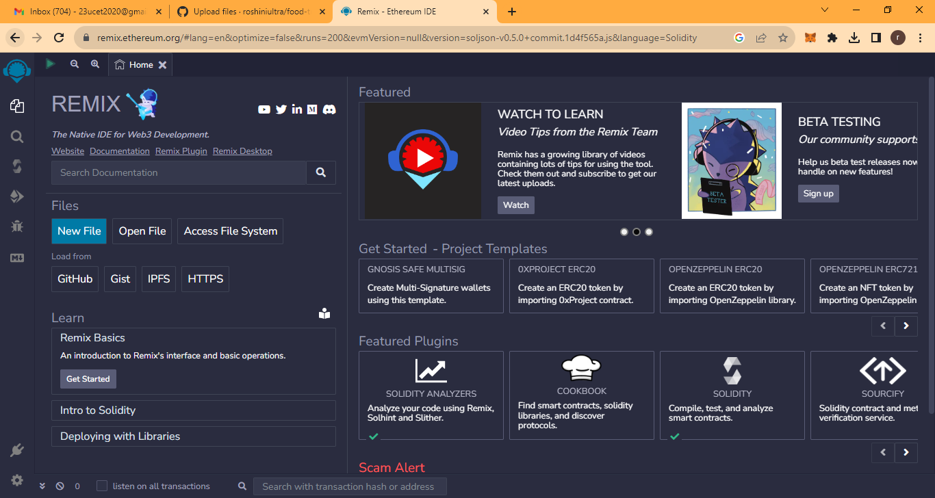

2.Open Remixplartform Page And Create A New File

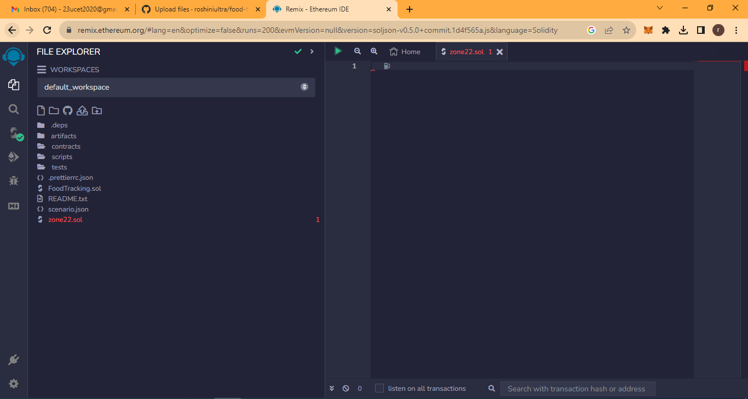

3.Write A Code For Return A String In Remix Platform

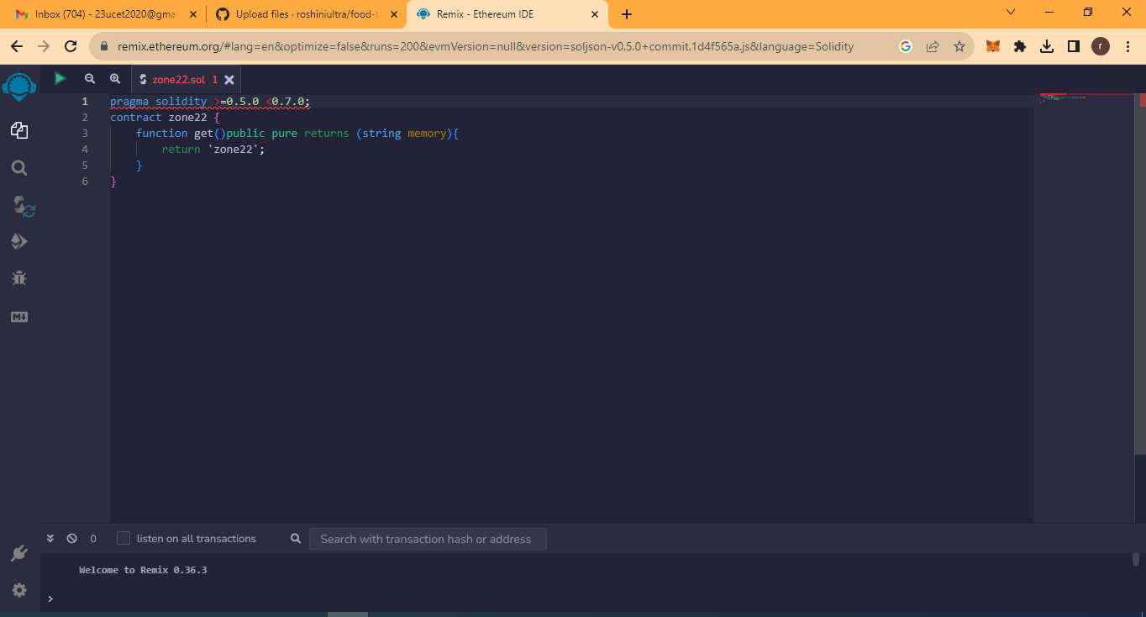

4.Compile And Run The Code

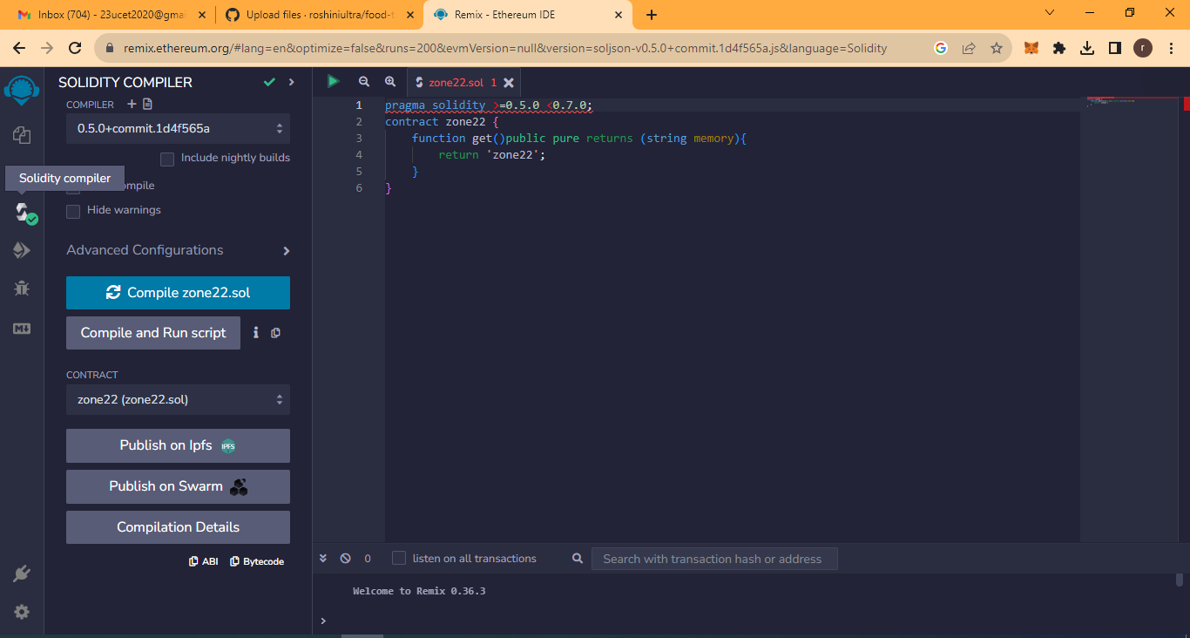

5.Deploy And Run The Transaction

