Organization Chart Plug-in for BIRT
User Guide
V1.0

Author: Ramesh S
Version History

Date | Version No | Comments
30-Apr-2013 | 1.0 | First version of the Organization Chart developed for BIRT 3.7.2
Table of Contents

Introduction 4
Prerequisites 4
Installation 4
Designing Sample Report 5
Possible Enhancements 14

Introduction

Organization Chart BIRT Eclipse Plug-in allows the user to design and generate BIRT report for any hierarchical data in a tree (graphical) form.

This chart can be useful for both business and personal purpose.

Areas like,

- Organization Structure
- Family Tree
- Geographical Location Tree
- Etc.

Prerequisites

- We need to download ‘Eclipse BIRT Report Designer All-in-One 3.7.2’

Installation

Organization Chart BIRT Eclipse Plug-in has the following binaries

- OrgChartDesigner_1.0.0.201304300636.jar
- OrgChartRuntime_1.0.0.201304300636.jar

We need to copy the above mentioned jar files to the following folder
- birt-report-designer-all-in-one-3_7_2\eclipse\plugins
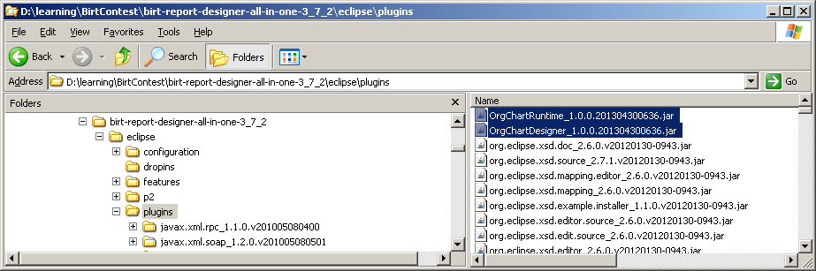

Designing Sample Report

Input data set

Organization chart plug-in requires the following mandatory columns in the data set.

Node Data (String Data Type)
- Every tree node will have the Node Data
Node Id (Integer Data Type)
- Every node should have unique Id
Parent Node Id (Integer Data Type)
- Except the root node(Root node parent id should be 0), every other node should have non zero parent node id

Sample Input File

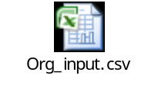

Steps to design and generate organizational chart

- Create the sample report design using ‘Eclipse BIRT Report Designer All-in-One 3.7.2’

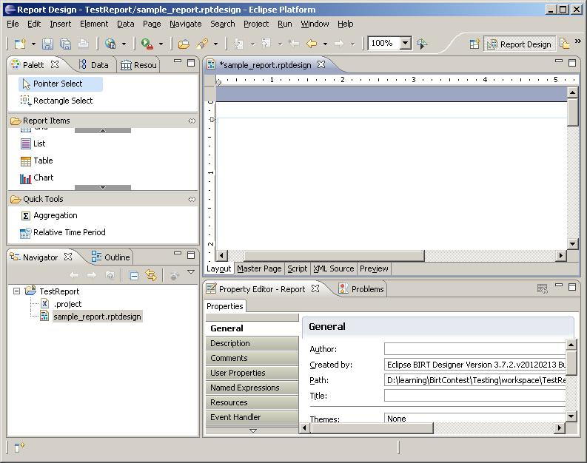

- Drag and drop the Chart Report Item to sample_report.rptdesign

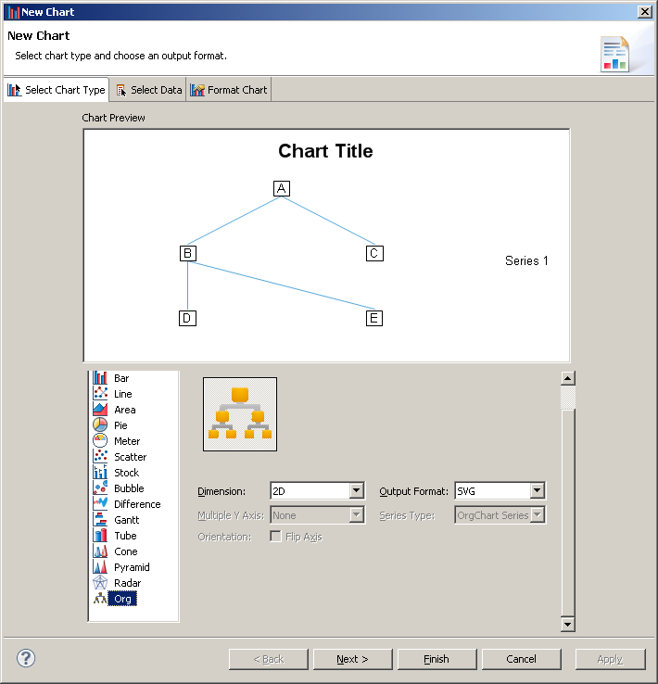

- Click on the Next button to configure the data set

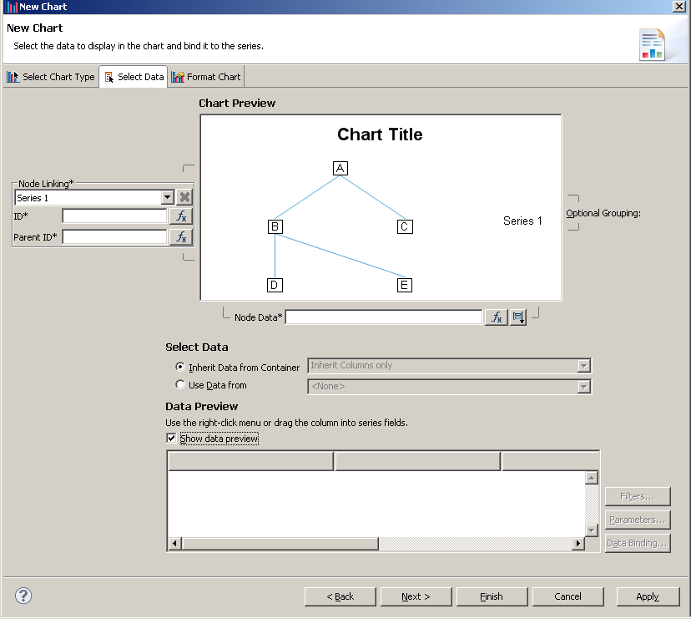

- Select Use Data From option and configure the Data Set
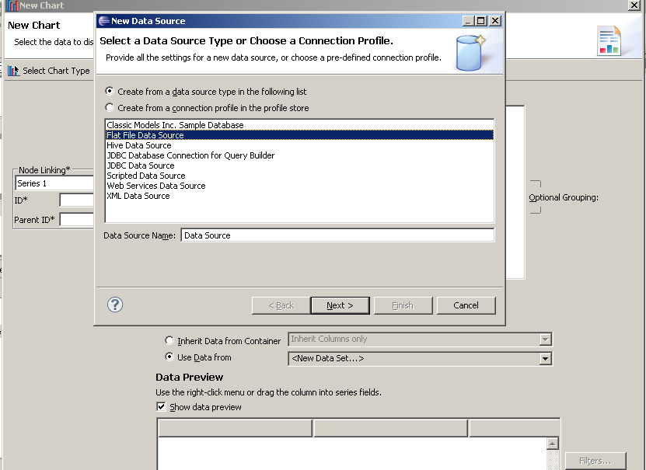

- Select the required columns and set the appropriate column type

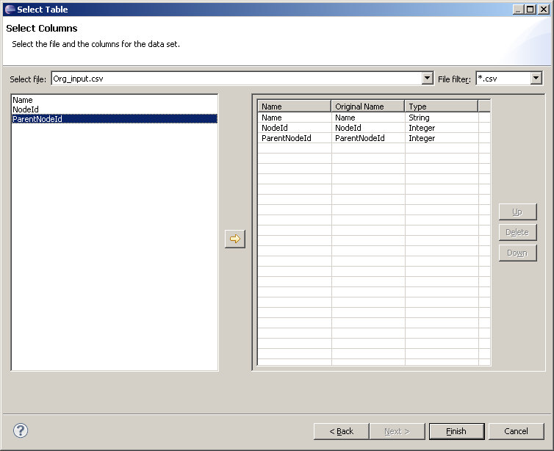

- Associate the data to the following columns
  - Node Data
  - ID
  - Parent ID

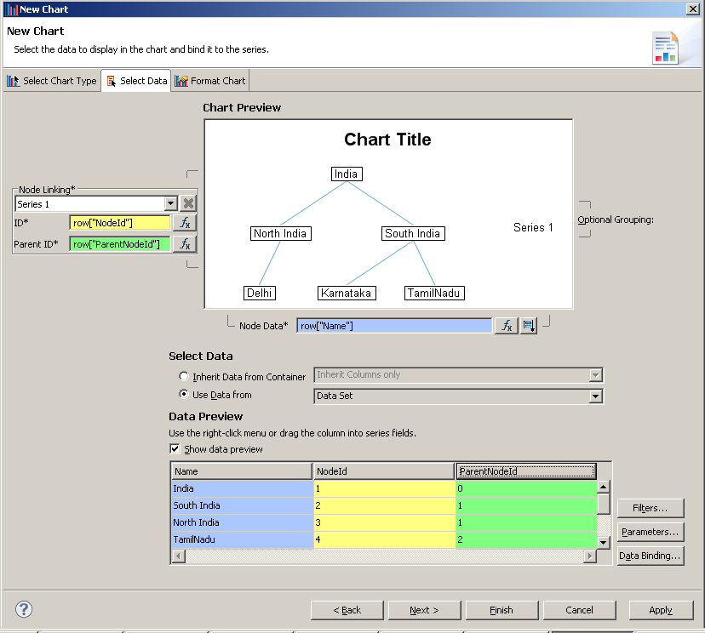

- Click next and configure the display settings for the chart.

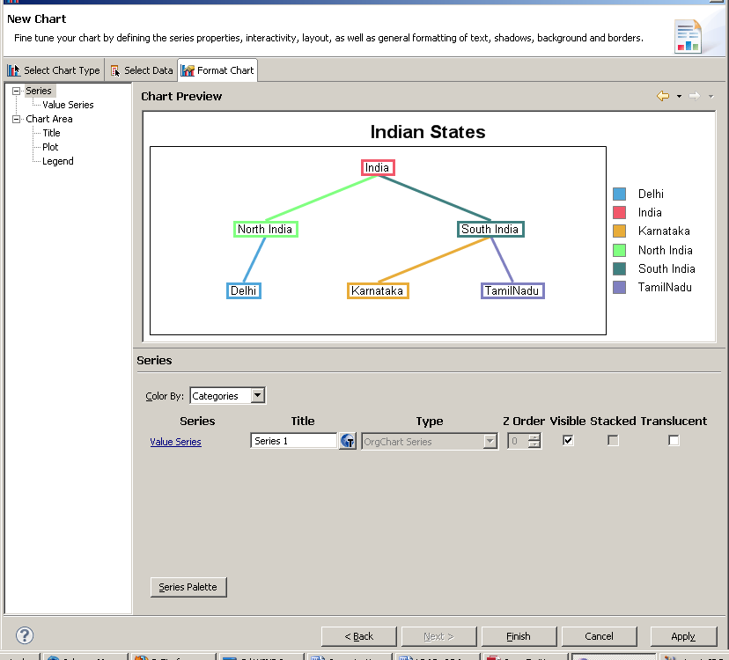

- After formatting Click on Finish and Try to view as PDF.

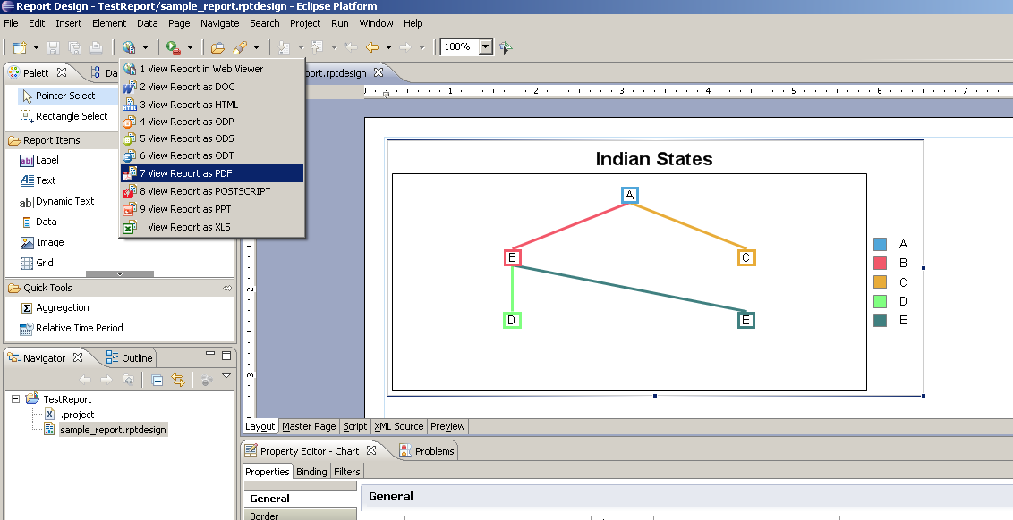

- You get to see the following report.

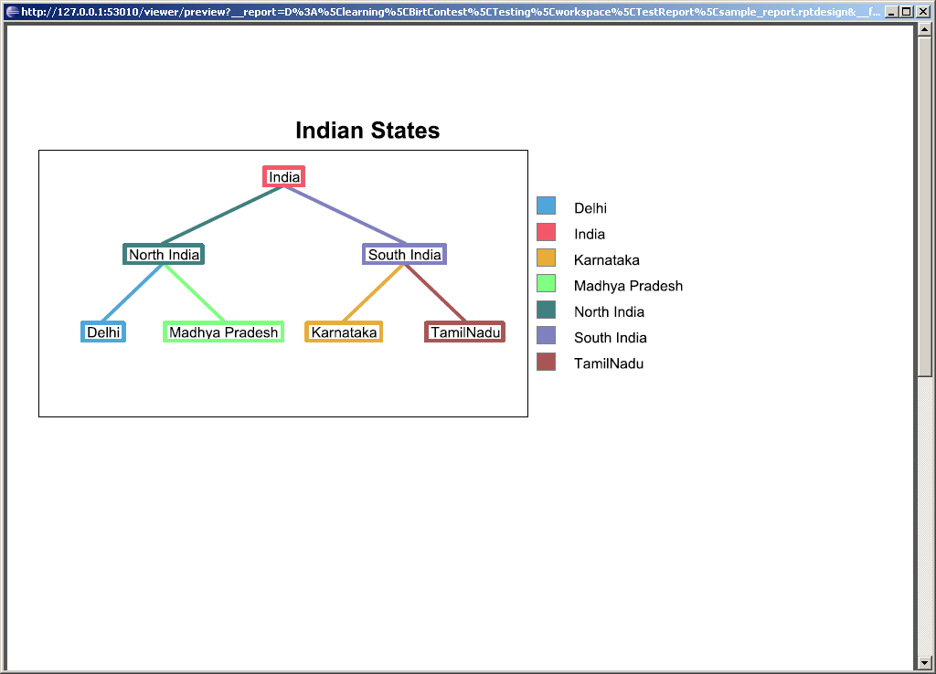

Possible Enhancements

- Currently we have only one column for capturing Node Data, This can be extended.
- If the number of nodes in a single row exceeds the chart width, Currently Nodes are getting overlapped. But we can enhance the tree rendering algorithm to handle this scenario.

