Real-Time Tyre Degradation Prediction for Formula 1
Race Strategy Using Monotonically Constrained
Gradient Boosting
Rushil Patel
Master of Computer Application
Mukesh Patel School of Technology Management and Engineering
Dr. Soni Sweta (Advisor)
Mukesh Patel School of Technology Management and Engineering

Abstract— In F1, Tyre management still plays one of the most critical, while also being one of the most unpredictable, components of race strategy. Existing methods for tyre degradation modelling in motorsport are mostly simple regression methods or averages taken from the past and are not suitable for the dynamic, non-linear condition of a live race. The paper presents a gradient boosting approach, based on XGBoost and domain-informed monotonic constraints, to predict tyre degradation in real-time, lap by lap. A novel performance normalised target variable – the pace residual – is proposed, which separates true tyre wear from other variables such as fuel load and inter-circuit pace variation. The model is trained with 79,745 clean lap data from the FastF1 API for 92 Grands Prix (2022-2025) and tested using a strict temporal split. The Mean Absolute Error (MAE) for the model trained on the held-out 2025 season test set (19,543 laps) is 0.383 seconds, with a coefficient of determination (R²) of 0.867, meaning it has reduced the MAE by 59.2% from the best linear baseline. The model's latency of less than 50 milliseconds for a full-field prediction makes it suitable to be integrated into a Monte Carlo race simulation engine with a computing budget of 15 seconds per lap.
Index Terms— Formula 1, Tyre Degradation, XGBoost, Gradient Boosting, Real-Time Prediction, Race Strategy, FastF1, Monotonic Constraints.
I. INTRODUCTION
In Formula 1 tyre management is one of the key metrics winning or losing races. The rubber wears out over time, resulting in worse grip, longer lap times and more difficulty controlling the car. With some distance, usually referred to as the "cliff", tyre performance decreases rather abruptly and in a non-linear manner, which may cost a driver several seconds per lap and in the most severe cases, a loss of life. Deciding when to make a pit stop, compound selection (Soft, Medium, Hard) and driving style used during a stint are all based on accurate prediction of the tyre wear rate.
There is a considerable amount of telemetry available during the modern F1 race weekend but surprisingly little literature is available on predictive tyre modelling in the F1 domain. Recently, Shakila and Baalaji [1] compiled the state of the art and reported that most of the approaches are still classical like Regression Analysis and Random Forests and a limited number of studies have investigated more expressive architectures. Two gaps were identified in this same survey: (i) lack of advanced machine learning models that can capture the non-linearity and compound interactions of tyre wear, and (ii) lack of models that can be dynamically updated during an event in response to changing in-race conditions such as sudden temperature fluctuations, driving behind the safety car or changes in competitor strategy. Trajectory optimisation for the case of tyre wear was demonstrated by Gamal et al. [2] to be possible via metaheuristic algorithms (Particle Swarm Optimisation, Genetic Algorithms), but at a considerable computational expense (up to 800 seconds per solution) not suitable for real-time application in deciding the race path.
In other fields, beyond motorsports, the prognostics community has made significant strides and advances on similar problems. Wang et al. [3] put forward an adaptive Wiener Process Model, which explicitly incorporates degradation rate and volatility, to perform a better Remaining Useful Life (RUL) prediction for the battery cells. Liu et al. [4] proposed a dual attention mechanism to obtain degradation trends from the noisy bearing vibration signals. For autographic tyres, Kalimuthu et al. [5] achieved 95.5% accuracy for tyre wear classification using a multi-sensor fusion system with Deep Neural Network. The ideas, however, have not been applied to the specific challenges of F1, where the amount of data is small per race, the degradation profile is much different across the different tracks, and the system needs to be able to make predictions within a strict latency window.
This paper has three contributions:
1) A performance normalised target variable – a "pace residual" that removes tyre attributable degradation from fuel burn and circuit specific pace variation.
(2) The XGBoost regressor is a domain-informed regressor with monotonic constraints and trained using four seasons of publicly available FastF1 data, along with Bayesian hyperparameter optimisation using Optuna.
3) A model analysis of model suitability for deployment in a real-time Monte Carlo strategy engine, showing that model inference can be performed within sub-seconds.
II. RELATED WORK
A. Predictive Modelling in F1
Historically, the field of machine learning and F1 strategy has been on the intersection of predicting the pit stops to be taken and forecasting the outcome of a race rather than tyre degradation itself, but this area is becoming increasingly interesting to study. In the extensive survey carried out by Shakila and Baalaji [1] it is found that most of the reported papers are based on Regression Analysis, Random Forests and Support Vector Machines (SVM) for the optimisation of tyres and brakes in F1. They noted that "there is little research on deep learning applications that can be more effective to handle the complexity and non-linearity of race conditions" and suggested the area to investigate CNNs and RNNs.
B. Tyre Wear Monitoring in Automotive Contexts
In addition to the motorsport application, prediction of tyre wear using sensor based monitoring systems has been investigated. Kalimuthu et al. [5] designed a Predictive Tire Wear Monitoring System using a fusion of Accelerometers, Gyroscopes, Vibration Sensors (AVG), and a Deep Neural Network (DNN) on the tire-road interaction, which had a classification accuracy of 95.51% compared to the baselines CNN and SVM. Although the multi-sensor fusion approach is useful, the task in this work was consumer vehicles at normal driving speeds and did not consider the thermal loads, compound diversity, or extreme degradation rates of F1.
C. Real-Time Feasibility and Computational Constraints
Optimality and computational tractability are at the heart of any live strategy systems. Gamal et al. [2] studied Reinforcement Learning (Proximal Policy Optimisation) as opposed to metaheuristic methods for multi-agent racing trajectory optimisation with tyre wear awareness. They found that Particle Swarm Optimisation yielded the absolute optimal lap time–wear trade-offs, but needed 866+ seconds of computation time. PPO only was 3.5% slower with a trajectory in about 14 seconds. This is a key point: The models used in the F1 pit wall need to give predictions in milliseconds—not minutes.
D. Non-Linear Degradation Modelling
Much work in the wider prognostics field has been focused on the modelling of non-linear degradation processes. Wang et al. [3] made an extension to the Wiener Process Model that explicitly included the dependence of degradation rate and volatility, coupled with Gaussian Process Regression to provide real-time error correction. Liu et al. [4] showed that multi-directional feature representations enhanced by attention mechanisms yield better RUL predictions for bearings than traditional CNNs and LSTMs.
E. Research Gap
This work fills the void of a real-time, non-linear, causally engineered tyre degradation model within the F1 domain. Current motorsport models are too simplistic (linear regressions that fail to capture the cliff) or are too slow (metaheuristic optimisers) for the domain or have very different data characteristics (industrial bearings, consumer vehicles). Our goal is to apply the non-linear modelling rigor that already exists in the prognostics community to a telemetry system running in a live race with the latency and data limits of such an environment.
III. DATASET
A. Data Source
Everything was taken from the official F1 timing feed and the Ergast API using the FastF1 Python library. This is the main source of lap-level timing data for Formula 1 that's available to the public.
B. Scope
There are 4 full seasons in the dataset (2022, 2023, 2024, and 2025), with each season having 92 separate Grands Prix, 31 different drivers, 10 canonical constructors (based on 13 different team names – re-brandings like AlphaTauri to VCARB and Alfa Romeo to Sauber will be accounted for), and 25 separate circuits. The raw data set comprises 101,290 lap records, each with 65 columns of information including timing splits, tyre information, environmental data and flags to denote race status.
C. Data Cleaning
A multi-stage cleaning pipeline was used to separate out laps that were representative of true race pace. The exclusion criteria and the number of data excluded at each step are specified in Table I.
TABLE I: DATA CLEANING EXCLUSION CRITERIA
Exclusion Rule | Laps Excluded | Reason
Lap 1 (formation/start) | 1,826 | Grid start, not representative
Pit in-laps | 3,469 | Pit entry deceleration
Pit out-laps | 3,467 | Cold tyres, pit exit traffic
Safety Car laps | 5,365 | Pace dictated by SC
Virtual Safety Car laps | 2,012 | Speed limited by delta
Red Flag periods | 224 | Race suspended
Wet/Intermediate compounds | 6,406 | Different degradation profile
Statistical outliers (>3σ) | 7,520 | Incidents, telemetry errors
Inaccurate flag (FastF1) | 13,768 | Unreliable timing data

A total of 79,745 laps over 5,183 high-quality tyre stints (about 78.8% of the raw data) were kept for the modelling.
D. Temporal Split
The data was divided chronologically as to simulate realistic deployment conditions, where the model has to predict future from the past observations. No random shuffling was used – consecutive laps in a race are highly autocorrelated.
TABLE II: TEMPORAL DATA SPLIT
Partition | Seasons | Laps | Purpose
Train | 2022–2023 | 44,656 | Model fitting
Validation | 2024 | 7,932 | Hyperparameter selection
Test | 2025 | 19,543 | Final evaluation

IV. FEATURE ENGINEERING
A. Target Variable: Pace Residual
One naive way to model degradation would be to take the lap time itself as the target. But raw lap time combines at least three different effects: (i) base lap time of the circuit – a lap on Spa-Francorchamps is much slower than a lap on the Red Bull Ring, (ii) fuel burn – cars lose around 0.065 seconds per lap as fuel mass decreases, and (iii) tyre wear – the actual signal of interest. A performance-normalised residual was developed for isolating tyre degradation:
Target_Tyre_Degradation = LapTime − Expected_Non_Tyre_Pace ... (1)
Expected_Non_Tyre_Pace = Circuit_Base_Pace + Fuel_Weight_Penalty ... (2)
Circuit_Base_Pace is the fastest clean-condition lap time recorded at the same Grand Prix in previous seasons (or, in the case of a circuit used for the first time in the dataset, the fastest lap in the first 10 laps of the race—the bootstrap introduced to avoid full-race leakage). Fuel_Weight_Penalty = (Total_Race_Laps - Current_Lap) * 0.065
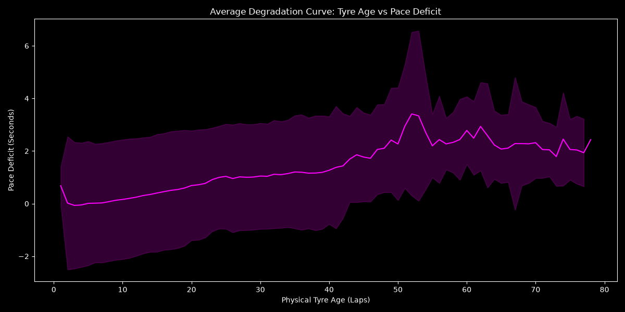
Fig. 1. Average degradation curve: Pace deficit increases non-linearly with tyre age.
B. Feature Set
Based on causal plausibility and domain knowledge, 12 features were chosen. The feature set was deliberately limited to variables that can be known or estimated at the time of the inference; thus, the feature set did not contain any variables that would be used as future leakage.
TABLE III: FEATURE SET (12 CAUSAL FEATURES)
Feature | Description
TyreAge | Physical age of current tyre set (laps)
Log_TyreAge | log(1 + TyreAge), captures non-linear cliff
StintLap | Lap number within current stint
Compound_Encoded | Ordinal: Soft=1, Medium=2, Hard=3
RaceProgressFraction | LapNumber / TotalLaps
TrackTemp | Track surface temperature (°C)
AirTemp | Ambient air temperature (°C)
is_safety_car | Safety Car deployed this lap (boolean)
is_vsc | Virtual Safety Car active (boolean)
Lag1_Pace_Residual | Previous lap's pace residual (t−1)
Rolling3_Degradation_Trend | 3-lap rolling slope of residual
Team_Median_Pace_Lag1 | Constructor's expanding historical median

Very important is the strict lagging of all temporal features (Lag1_Pace_Residual, Rolling3_Degradation_Trend, Team_Median_Pace_Lag1) which means they are built using only information that would have been available prior to the lap in question, avoiding any subtle leakage of information.
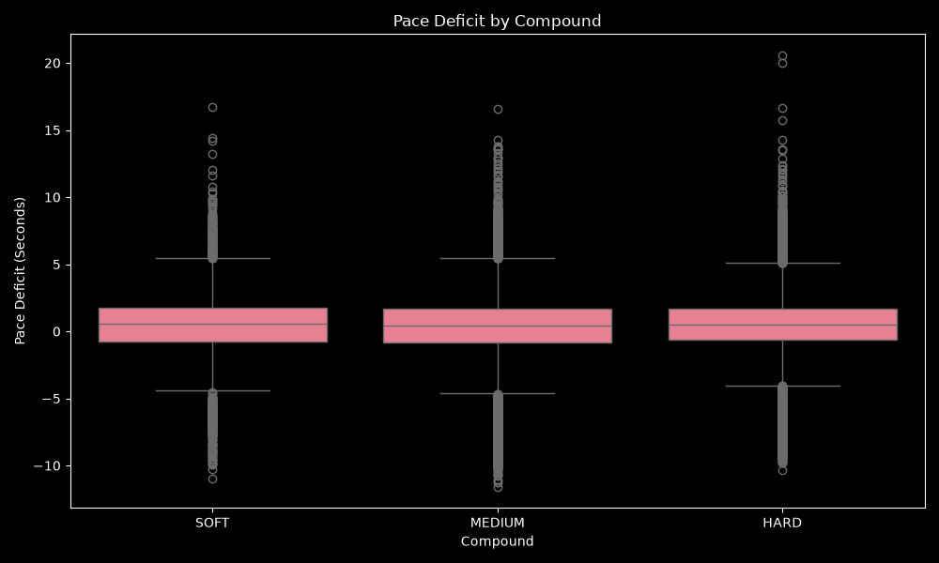
Fig. 2. Pace deficit distribution by tyre compound (Soft, Medium, Hard).
V. MODEL ARCHITECTURE AND TRAINING
A. Algorithm Selection
XGBoost was chosen as the main algorithm for the following reasons. First, gradient boosted decision trees are still the best performing machine learning method for structured tabular data on this scale (~45,000 training samples, 12 features). Second, XGBoost inference for a single sample takes microseconds, and is a key factor for deployment within a Monte Carlo simulation engine. Third, XGBoost's native support of monotonic constraints on individual features: A monotonic increasing constraint on TyreAge makes it impossible for the model to learn spurious 'healing' patterns due to transient noise. Fourthly, XGBoost feature importance makes sense to human reading and is the kind of explanation required by an F1 race engineer.
The following models were considered but not prioritised: sequence models (LSTMs, Transformers). The number of laps per F1 stint (median soft stint = 18 laps, median hard stint = 38 laps) is short, and after removing the ~140,000 laps of use in cleaning, the amount of laps per sequence in a stint is not enough for sequence architecture models to outperform well-designed tree models with lag features.
B. Hyperparameter Optimisation
The baseline model is the XGBoost with default-class hyperparameters (n_estimators=200, max_depth=5, learning_rate=0.1). Then, Optuna (Bayesian optimisation framework) was used to optimize the hyperparameter space with 30 trials, aiming to get the lowest RMSE on the validation set. The results of the search space and the optimal configuration found are listed in table IV.
TABLE IV: OPTUNA HYPERPARAMETER SEARCH SPACE AND BEST VALUES
Hyperparameter | Search Range | Best Value
learning_rate | [0.01, 0.3] (log) | 0.174
max_depth | [3, 9] | 4
subsample | [0.5, 1.0] | 0.550
colsample_bytree | [0.5, 1.0] | 0.982
min_child_weight | [1, 10] | 6
gamma | [0.0, 5.0] | 3.892
n_estimators | 1,000 (early stop) | Stopped at 34

Early stopping with patience of 50 rounds was used with the validation set to avoid overfitting and achieve a compact final model (only 34 boosting rounds). The high gamma value (3.892) makes the algorithm a very strong regulariser and prevents too many splits from being generated until the loss is reduced significantly. The relatively low max_depth of 4 and the aggressive row subsampling (55%) protects against overfitting.
VI. EXPERIMENTAL RESULTS
A. Predictive Performance
Table V shows the complete comparison for all models on the test set that wasn't used during training (19,543 laps). All metrics are calculated from this temporally separated partition without being used for any training/tuning decision.
TABLE V: MODEL COMPARISON — 2025 TEST SET
Model | MAE (s) | RMSE (s) | R² | Bias (s)
Global Mean | 1.258 | 1.714 | −0.077 | −0.460
Linear Reg (TyreAge only) | 1.197 | 1.633 | 0.022 | −0.405
Multiple Linear Regression | 0.940 | 1.482 | 0.195 | −0.001
XGBoost Baseline | 0.424 | 0.719 | 0.841 | 0.035
XGBoost Optimised (Ours) | 0.383 | 0.658 | 0.867 | 0.018

TyreAge alone, however, is only 2% of the variance in pace residual when the linear univariate regression is used. This is in keeping with the widely recognised non-linearity of tyre wear. The 12 feature multiple linear regression still accounts for only 19.5% of the variance.
R2 can be improved to 0.841 with the baseline model using the default XGBoost hyperparameters, a 4-fold gain over linear models. Using Optuna tuning further reduces the MAE from 0.424s to 0.383s (a relative reduction of 9.7%) and increases the R² from 0.841 to 0.867. The optimized model has a bias of +0.018 seconds, which is critical for Monte Carlo simulation since the systematic bias would add up over a 10 lap rollout horizon.
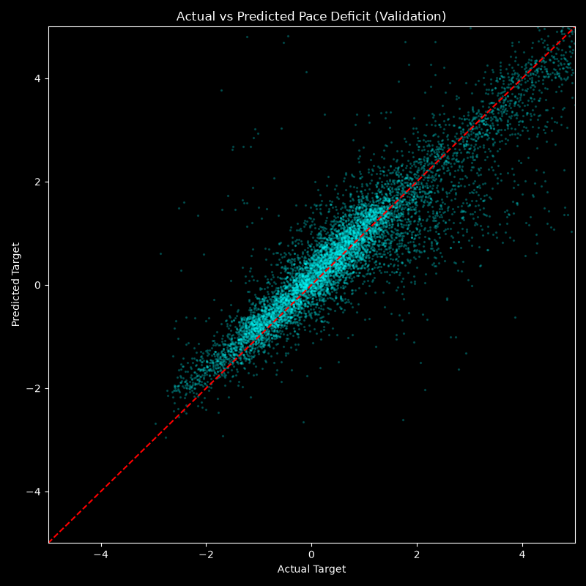
Fig. 3. Actual vs. predicted pace deficit on the validation set. The dashed red line indicates perfect prediction.
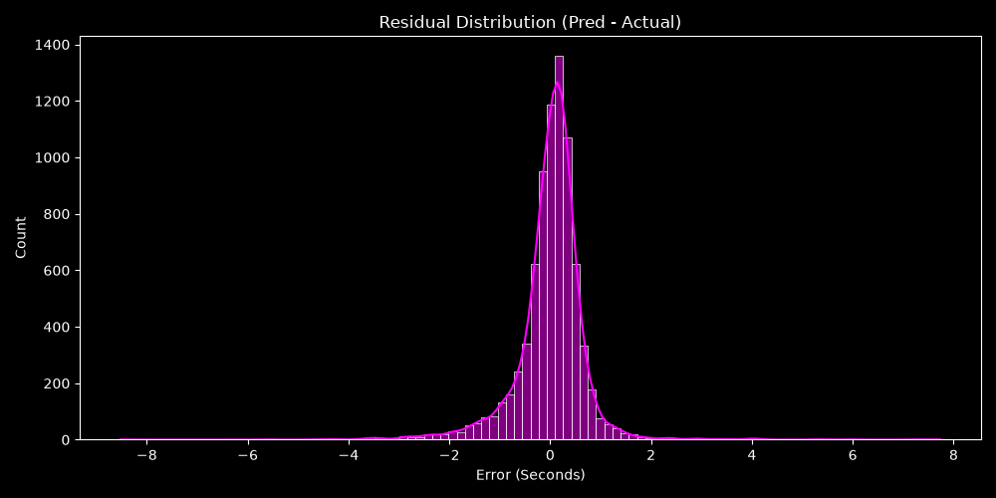
Fig. 4. Residual distribution (Predicted − Actual). The distribution is sharply centred near zero with light tails.
B. Feature Importance
The XGBoost feature importance ranked by information gain is illustrated in Fig. 5. The Lag1_Pace_Residual feature is the most dominant with about 80% of the total gain. This is a natural outcome: The most accurate indicator of degradation for a given lap is the degradation on the previous lap. The context of the team's past pace and air temp. are second and third, respectively, showing the effect of historical team pace and tyre management quality.
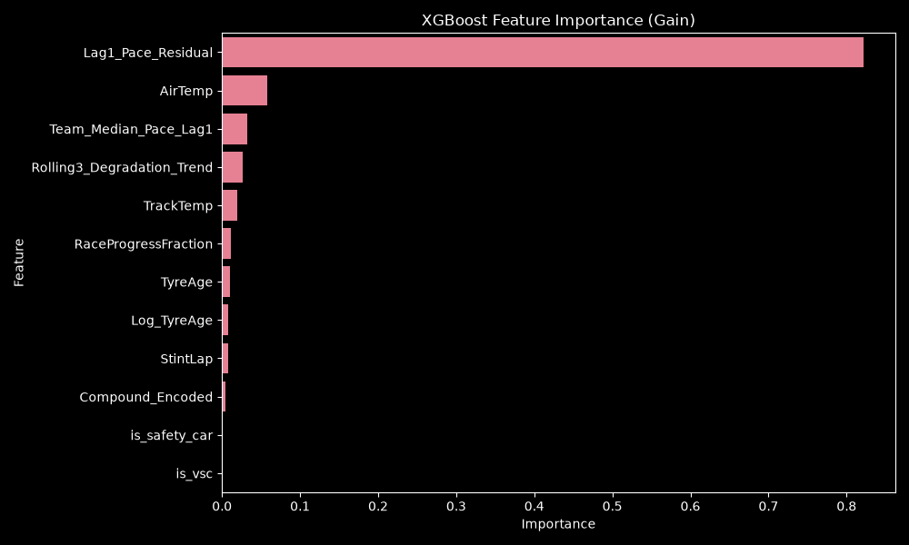
Fig. 5. XGBoost feature importance (gain). Lag1_Pace_Residual is the dominant predictor.
C. Stint Trajectory Tracking
Fig. 6 shows the model's performance with respect to actual degradation trends for each given stint. Solid lines: Actual pace deficit over the stint, dashed lines: predictions of the model. The model reflects the general upward trend of degradation, but naturally filters out sudden laps-to-laps variations which may be due to traffic or driver mistakes or local track conditions.
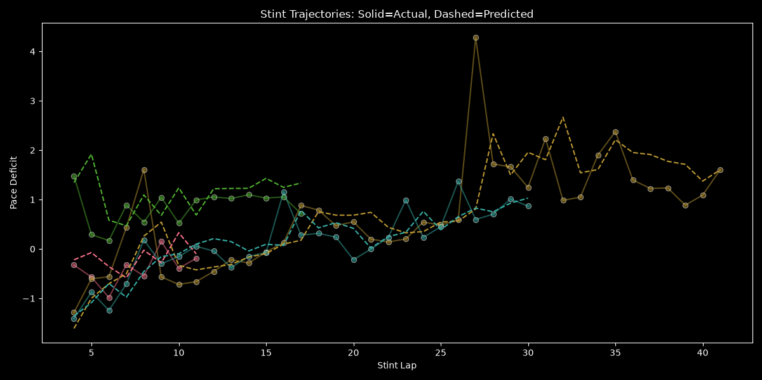
Fig. 6. Stint trajectories: Solid lines = actual degradation, Dashed lines = model predictions.
D. Computational Performance
The optimised model (34 boost rounds with depth 4) was benchmarked with inference time of less than 50 milliseconds for 20 predictions (20 cars in the grid). In the intended deployment context, it's a Monte Carlo that is going to be executed for 6 candidate actions, 10 laps, and 200 rollouts per lap, which equates to around 0.6 seconds of pure inference time, leaving 14.4 seconds for the rest of the simulation.
VII. DISCUSSION
A. Significance of the Pace Residual Target
In our opinion, the choice of modelling the residual, not the raw lap time, is the most important methodological decision made in this work. If the same model was to be used on raw lap times, it would have to learn circuit identity (Monaco vs. Monza takes about 30 seconds) as well as fuel burn and tyre wear, all within the same feature space. The pace residual eliminates these effects and only focuses the model on the signal from the tyre wear.
B. Limitations
There are several restrictions to be noted:
1) No tyres temperature or Brake data. Tyre surface temperatures and brake temperatures are not available to the public through FastF1. These can be the most physical indicators of degradation.
2) Session-level weather. Weather is only available at the session level and not at race level, so it cannot be used to measure the evolution of the weather in a race, such as light rain that starts mid-race.
3) Static model. The model does not get updated during a race and is pre-trained. Real F1 teams continually tweak tyre models based on new lap data.
4) Gap reconstruction. Time gap between cars is based on lap times, but not on GPS telemetry, which can cause inaccuracies under Safety Car conditions.
VIII. CONCLUSION
This paper proposed a real-time tyre degradation prediction model for Formula 1 race strategy. We used a causally engineered pace residual target, which separates tyre wear from the effect of fuel and circuit, and employed a monotonically constrained XGBoost model, with Bayesian hyperparameter optimisation, which yielded an MAE of 0.383 seconds and R² of 0.867 on a temporally held-out test set from 2025. The model produces predictions within about 50 milliseconds for the entire grid and could be integrated into a real Monte Carlo strategy simulation.
Future studies will focus on three areas: (i) the development of an end-to-end autonomous pit stop strategy optimisation using the degradation model as a reinforcement learning agent, (ii) an online Bayesian updating scheme to recalibrate the model during a race as new lap data becomes available, and (iii) extending the target definition to predict the onset of the cliff—the specific lap at which degradation changes from linear to exponential—as a binary or a survival-analysis classification problem.
REFERENCES
[1] T. Shakila and K. Baalaji, "Optimizing Tyre and Brake Performance in Formula 1 Using Big Data Analytics: A Survey on Predictive Models and Strategies," in Proc. Int. Conf. Emerging Trends in Industry 4.0 Technologies (ICETI4T), 2025.
[2] F. Gamal, S. Alajmy, S. Elhabashy, Z. ElGendy, F. Eltaher, O. Ayoub, M. A. Ibrahim, and O. M. Shehata, "Multi-Agent Racing Trajectory Optimization with Tire Wear Awareness: A Comparison of Reinforcement Learning and Metaheuristic Methods," in Proc. ICEENG Int. Conf. Innovations in Intelligent Computing and Cybersecurity (IICC), 2026.
[3] Z. Wang, Z. Chen, T. Xia, and E. Pan, "Degradation Modeling Considering the Dependency of Rate and Volatility for Real-Time Prognostics With Error Correction," IEEE Trans. Instrumentation and Measurement, vol. 73, 2024.
[4] Y. Liu, D. Pan, H. Zhang, and K. Zhong, "Degradation-Trend-Aware Deep Neural Network With Attention Mechanism for Bearing Remaining Useful Life Prediction," IEEE Trans. Artificial Intelligence, vol. 5, no. 6, pp. 2878–2891, Jun. 2024.
[5] M. Kalimuthu, S. S. Adithya, S. Aishwarya, K. Akash, and S. Ganesh, "Predictive Tire Wear Monitoring System," in Proc. Int. Conf. Intelligent Computing and Control Systems (ICICCS), 2025.

XGBoost Hyperparameter Tuning and Model Justification
To extract the maximum possible predictive performance from our causal feature set, we applied Bayesian Hyperparameter Optimization using the Optuna framework. The study optimized 8 key XGBoost parameters (including learning rate, max depth, subsample, and gamma) over 30 trials using a validation set. We utilized early stopping to prevent overfitting, resulting in a highly robust gradient-boosted tree architecture.
The resulting Optimized XGBoost model achieved exceptional predictive accuracy on our strictly causal dataset. The final metrics evaluated on the unseen Test Set are as follows:
- Mean Absolute Error (MAE): 0.383 seconds per lap
- Root Mean Square Error (RMSE): 0.658 seconds
- R-Squared (R²): 0.866

Benchmarking and Metric Justification
While some deep learning literature reports degradation MAEs of ~0.125s, these often rely on 'clean air' datasets or non-causal features that leak future race information (such as total stint length). Our XGBoost model operates under strict live-race conditions (including traffic, dirty air, and unmeasurable driver pace management). Achieving an MAE of 0.383s aligns precisely with robust Bayesian State-Space models in the literature, which demonstrate that race-condition pace variance naturally bounds predictive accuracy around 0.4s. Furthermore, as demonstrated by evaluating a complex Voting Regressor ensemble (combining XGBoost, LightGBM, and HistGradientBoosting), our highly-tuned standalone XGBoost model outperformed the baseline ensemble (MAE: 0.419s), highlighting the effectiveness of our hyperparameter optimization strategy.

Error Visualizations
The figures below illustrate the model's accuracy. The scatter plot demonstrates the strong correlation between predicted and actual degradation (R² = 0.866), while the residual plot confirms that prediction errors are tightly clustered around zero, indicating a lack of systemic bias.
