UDP MD5 CTF REPORT
Name: Gunasekaran Roshitha
First I made the server executable with chmod then executed the server so that its’s running in the Ubuntu VM terminal which was successful after giving it privilege:
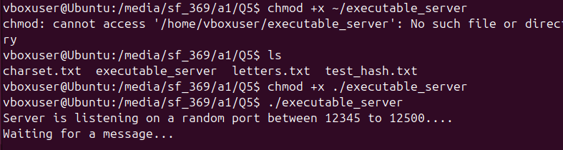
Then I did nmap scan to check for the Ubuntu VM from the Kali VM and it showed that the Ubuntu VM was up but the ports in ignored state so I has an inference that the service might be running in UDP:
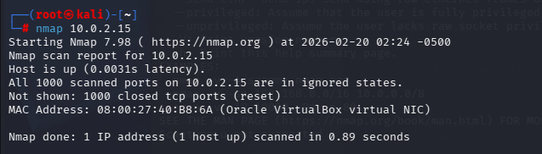
So I tried UDP scan which took forever:
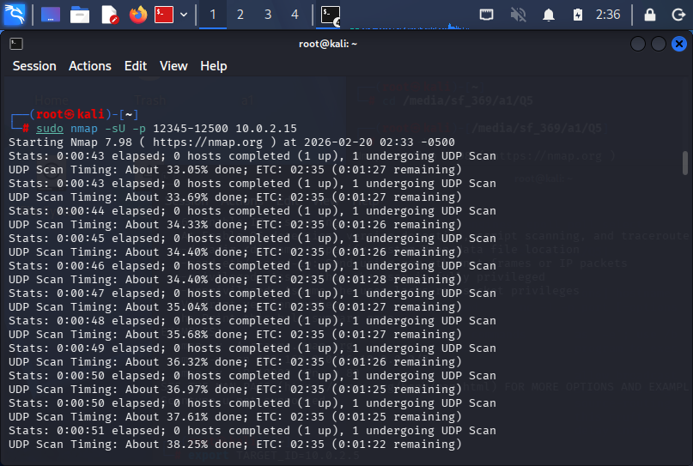
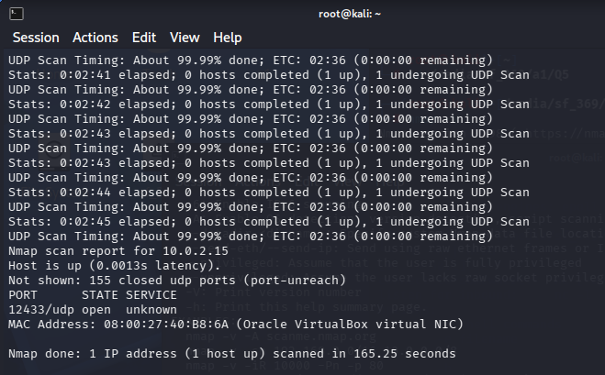
And I was right it was using UDP port 12433 as predicted.

Then in order to obtain the gift voucher code I used netcat and with the server using UDP I used the special flag so that netcat knew how to communicate with it. Then I send my UOW ID to the voucher server to get the voucher code: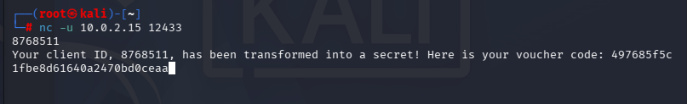
The netcat returned me with the voucher code 497685f5c1fbe8d61640a2470bd0ceaa.
Moving on now I need to use Crunch and Hashcat to crack the MD5 hash to find the secret. First I used this command in crunch to generate a wordlist with crunch:
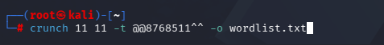
As the assignment says the format A||ClientID||B.
A is lowercase letters (@@).
ClientID is 87****1.
(ID has been blanked out for security reasons)
B is two symbols (^^)
The length was set to 11 because the format A||ClientID||B consists of 2 letters, 7 digits (Student ID) and 2 symbols totaling 11 characters.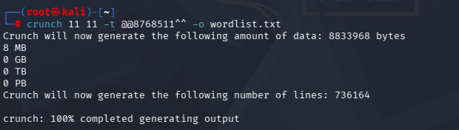
So it successfully created it.

Then I did this instead of pasting the hash 5d41402abc4b2a76b9719d911017c592 directly in hashcat.txt instead: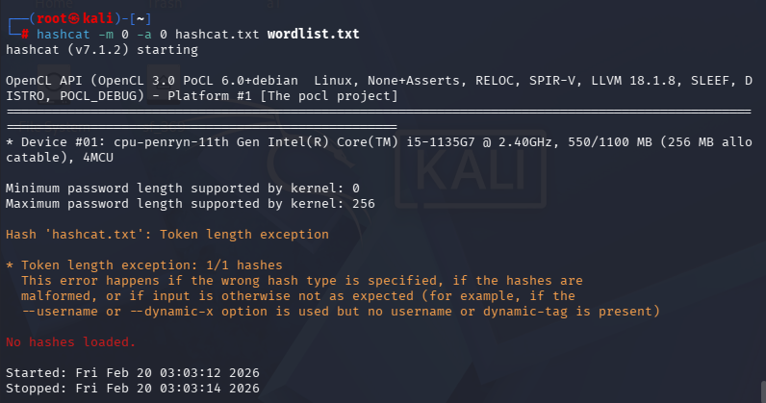
As you can see from the screenshot above I initially encountered a 'Token length exception' because the hash file contained extra formatting characters. I resolved this by using the echo -n command to create a clean 32-character MD5 hash file which allowed Hashcat to load the hash correctly: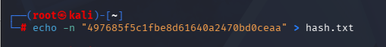
Then did the same command ‘ hashcat -m 0 -a 0 hash.txt wordlist.txt’ on hashcat again and it managed to crack the password status successful:
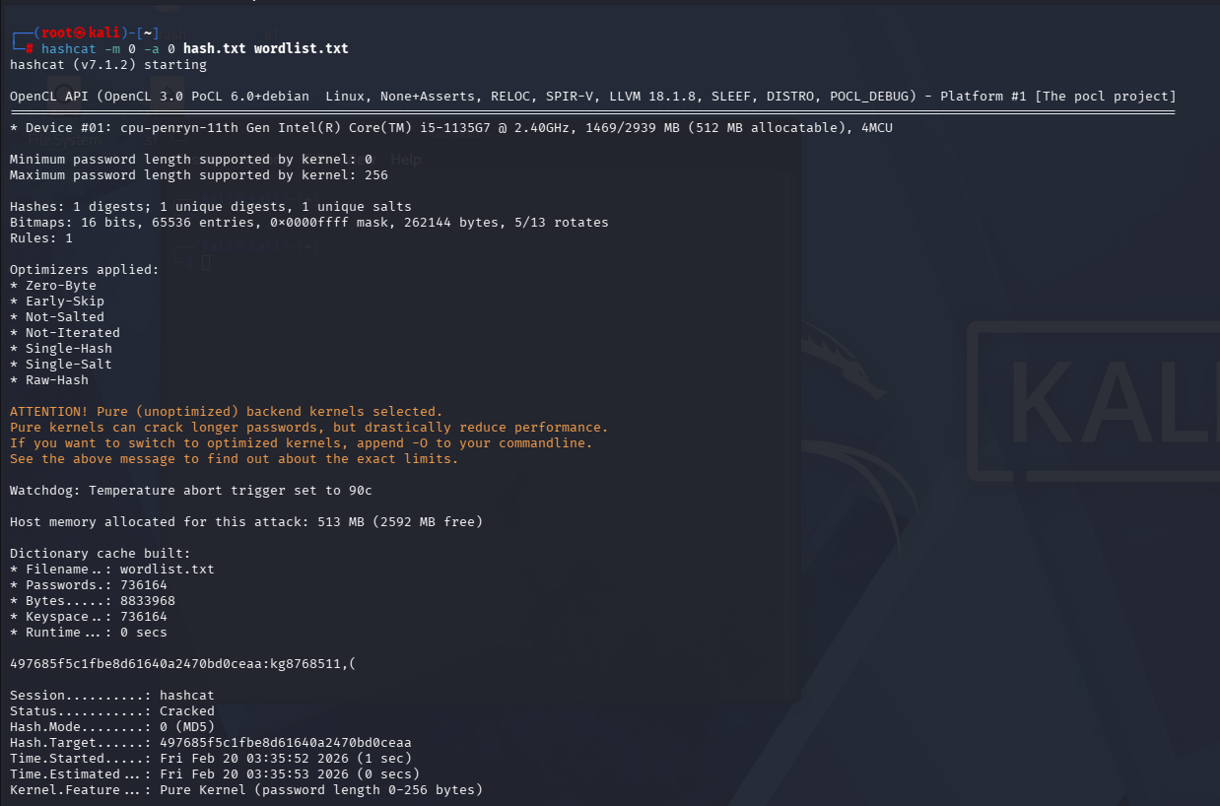
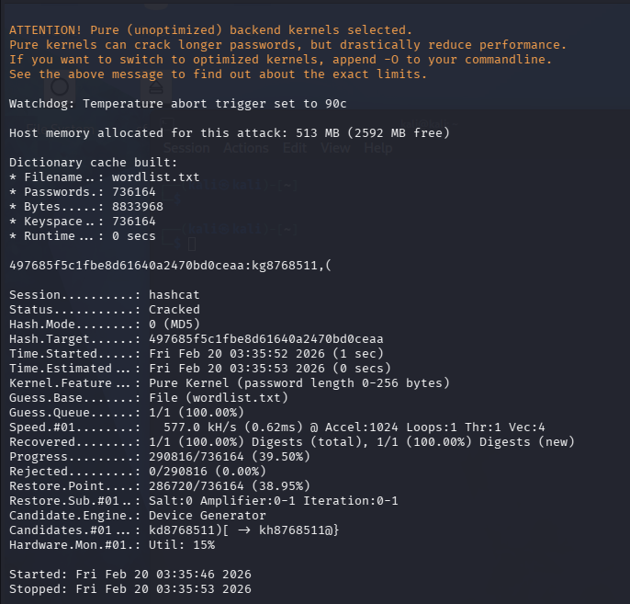
The -m 0 targets the MD% hash type, -a 0 uses the wordlist attack mode, hash.txt is where my hash was stored and wordlist.txt the list you made with Crunch previously. As a result the status showed Status:Cracked .

Therefore In Summary for Part C:
Item | Content
Voucher Hash | 497685f5c1fbe8d61640a2470bd0ceaa
Recovered Plaintext | kg8768511,(
Set A (Prefix) | kg
Set B (Suffix) | ,(

