HR ANALYTICS FOR MUTUAL FUNDS
Employee Performance, Compensation, Attrition, and Succession Analysis

Project Details
Program: Data Analytics
Project Title: HR Analytics for Mutual Funds: Talent Performance and Retention Analysis
Project Type: Data Analytics Project (Excel-Based)
Dataset Used: IBM HR Analytics Dataset with Mutual Fund HR Metrics
Tools Used: Microsoft Excel (Pivot Tables, Charts, Dashboard, Formulas)
A Beginner-Level Data Analytics Project Report Prepared Using Microsoft Excel
Submitted by: Roshitha
March–April 2026

TABLE OF CONTENTS
Chapter 1 Executive Summary
Chapter 2 Introduction to HR Analytics
2.1 Meaning of HR Analytics
2.2 Importance of HR Analytics
2.3 HR Analytics in the Mutual Fund Industry
Chapter 3 Industry Overview
3.1 What is a Mutual Fund?
3.2 Role of Asset Management Companies
3.3 Importance of Human Capital in Mutual Funds
Chapter 4 Project Objectives
Chapter 5 Dataset Description
5.1 IBM HR Analytics Dataset
5.2 Mutual Fund-Specific Field Additions
5.3 Data Cleaning Process
Chapter 6 Tools and Techniques Used
Chapter 7 Attrition Analysis
Chapter 8 Performance Analysis
Chapter 9 Compensation Analysis
Chapter 10 Succession Planning Analysis
Chapter 11 Dashboard Development
Chapter 12 Key Findings and Insights
Chapter 13 Recommendations
Chapter 14 Challenges Faced
Chapter 15 Learning Outcomes
Chapter 16 Conclusion
Chapter 17 References

CHAPTER 1 – EXECUTIVE SUMMARY
This project, titled "HR Analytics for Mutual Funds: Talent Performance and Retention Analysis," was undertaken with the objective of applying data analytics techniques to human resource management within the context of the asset management and mutual fund industry. The project demonstrates how data-driven decision-making can significantly improve HR outcomes such as employee retention, performance management, compensation fairness, and leadership succession planning.
The foundational dataset used in this project is the IBM HR Analytics Employee Attrition and Performance dataset, sourced from Kaggle. This dataset was further enriched with mutual fund-specific financial fields including Alpha, Fund Return, Benchmark Return, Bonus, and Assets Under Management (AUM). The entire analysis was conducted using Microsoft Excel, leveraging Pivot Tables, Conditional Formatting, Scatter Plots, formula-driven calculations, and an interactive Dashboard. The dataset comprises 1,470 employee records across a wide range of roles, departments, salary bands, and experience levels.
Key findings are as follows. The overall employee attrition rate stands at 16%, with Sales Representatives recording the highest attrition rate of nearly 39.76%. High performers were found to be underpaid relative to their contribution. Approximately 70% of employees fall under the ‘Fair’ compensation category, while 230 employees are underpaid and 208 are overpaid. Succession planning analysis reveals that only 227 employees are ‘Ready Now’ for leadership roles, while 778 employees are ‘Not Ready’.

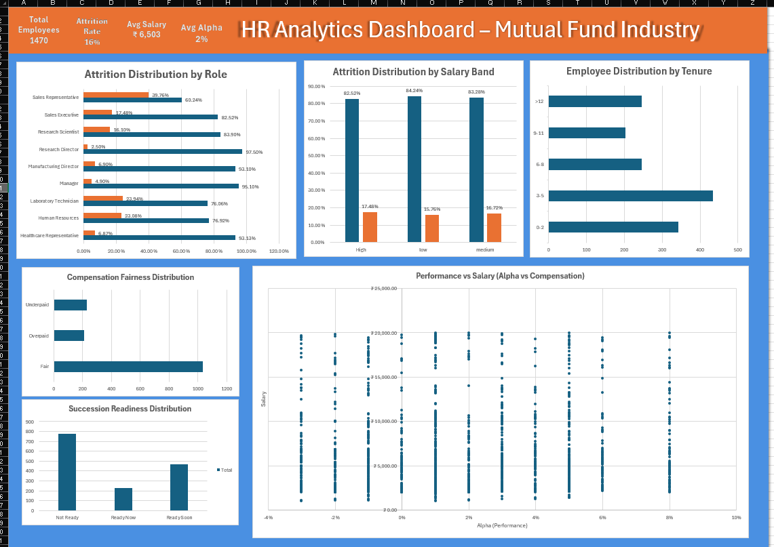
CHAPTER 2 – INTRODUCTION TO HR ANALYTICS

2.1 Meaning of HR Analytics
Human Resource Analytics, commonly referred to as HR Analytics or People Analytics, is the systematic application of data analysis and statistical methods to human resource data in order to support evidence-based decision-making in workforce management. Rather than relying on intuition or traditional HR instincts, HR Analytics transforms raw employee data into actionable insights that guide strategy across hiring, retention, performance management, compensation planning, and organisational development.
HR Analytics can be broadly classified into four progressive levels of maturity. The first is Descriptive Analytics, which summarises past HR data—for example, understanding how many employees left the organisation last year. The second level is Diagnostic Analytics, which explains why something happened—for instance, understanding why Sales Representatives left at higher rates than other roles. The third level is Predictive Analytics, which forecasts future outcomes such as identifying which employees are most likely to resign in the next six months. The fourth and most advanced level is Prescriptive Analytics, which recommends specific management actions—for example, determining what compensation changes would reduce high-performer attrition. This project primarily operates at the descriptive and diagnostic levels, which are most appropriate for a beginner-to-intermediate analytics project in Excel.

2.2 Importance of HR Analytics
The growing relevance of HR Analytics in today’s organisations can be attributed to several critical business needs. Employee costs represent one of the largest expenditure items on any company’s balance sheet. In knowledge-intensive sectors like finance, asset management, and consulting, human capital is often the single most important competitive differentiator. Losing a high-performing fund manager, senior analyst, or experienced sales professional is not merely an HR inconvenience—it is a direct and measurable business risk.
Talent scarcity in specialised financial fields means that recruiting, training, and retaining the right people is increasingly difficult and expensive. HR Analytics helps organisations identify flight risks early, understand what drives employee satisfaction, and take proactive retention measures before problems escalate. Furthermore, in an era of growing regulatory scrutiny and corporate governance, data-backed HR decisions are inherently more defensible and equitable than subjective ones.

2.3 HR Analytics in the Asset Management and Mutual Fund Industry
The mutual fund and asset management industry operates in one of the most competitive, high-stakes, and talent-dependent environments in the financial sector. The performance of a mutual fund—measured in terms of investment returns generated, risk management discipline, and client satisfaction—is fundamentally tied to the quality, motivation, and continuity of its human capital.
HR Analytics in this context takes on special strategic significance. Alpha generation—the excess return a fund generates over its benchmark—is directly linked to the skill, experience, and motivation of fund managers and research analysts. Sales force attrition directly impacts the firm’s ability to raise new Assets Under Management (AUM), which is the primary revenue driver for AMCs. Regulatory compliance roles require deep institutional knowledge, and attrition in these areas can expose the firm to regulatory penalties. Finally, succession planning is critical because senior fund managers carry proprietary investment strategies, long-standing client relationships, and team morale.

CHAPTER 3 – INDUSTRY OVERVIEW

3.1 What is a Mutual Fund?
A mutual fund is a professionally managed financial instrument that pools money from a large number of investors and invests it in a diversified portfolio of securities such as equities, bonds, government securities, and money market instruments. Each investor owns units proportional to their investment, and the value of these units is referred to as the Net Asset Value (NAV), which fluctuates daily based on the performance of the underlying portfolio. In India, mutual funds are regulated by the Securities and Exchange Board of India (SEBI), which sets strict guidelines for fund operations, disclosures, investor protection, and fund manager qualifications. The Indian mutual fund industry has grown exponentially over the past decade, with total industry AUM surpassing ₹0 lakh crore, reflecting growing retail investor participation.

3.2 Role of Asset Management Companies (AMCs)
Asset Management Companies (AMCs) are the financial institutions responsible for designing, launching, and managing mutual fund schemes. Some well-known AMCs in India include HDFC AMC, SBI Mutual Fund, ICICI Prudential AMC, Nippon India AMC, and Axis AMC. An AMC’s operations span several critical functional areas: Fund Management (portfolio construction and stock selection), Research (fundamental and quantitative analysis), Sales and Distribution (AUM mobilisation and channel management), Operations and Compliance (KYC, NAV calculation, SEBI reporting), Risk Management (portfolio risk monitoring), and Client Servicing (investor relationship management). Each of these functions is critically dependent on skilled, experienced, and motivated human capital.

3.3 Importance of Human Capital in Mutual Funds
In mutual fund companies, human capital is one of the most valuable assets. Senior fund managers carry deep investment knowledge, strong corporate relationships, and investor trust built over many years. Replacing such talent is difficult and time-consuming. Similarly, sales team attrition can directly impact Assets Under Management (AUM) growth. HR Analytics plays a critical strategic role in improving retention, succession planning, and overall performance.

CHAPTER 4 – PROJECT OBJECTIVES
This project was designed with five core objectives that collectively demonstrate the practical application of HR Analytics within the mutual fund industry. Each objective addresses a specific HR challenge that is particularly relevant to asset management organisations.
Objective 1: Attrition Analysis. To analyse the overall attrition rate and identify specific roles, salary bands, and tenure groups that exhibit the highest employee turnover. The aim is to understand the key drivers of attrition and their implications for business continuity in a mutual fund context.
Objective 2: Performance Analysis. To evaluate individual and group-level performance using the concept of Alpha (excess return generated over a benchmark), and to understand how performance correlates with compensation and bonuses, identifying whether high performers are being adequately recognised and rewarded.
Objective 3: Compensation Benchmarking. To assess whether employees across different roles and performance levels are being compensated fairly, by classifying employees as Fair, Underpaid, or Overpaid using a data-driven Comp Ratio methodology, and to identify compensation misalignment that could pose retention risks.
Objective 4: Succession Planning. To evaluate the organisation’s leadership readiness by classifying employees into Ready Now, Ready Soon, and Not Ready categories, helping identify critical gaps in the leadership pipeline and potential key-person risks.
Objective 5: Dashboard Development. To consolidate all analytical findings into a visually appealing, professional, and informative HR Analytics Dashboard in Microsoft Excel, serving as a decision-support tool for HR professionals and senior management.

CHAPTER 5 – DATASET DESCRIPTION

5.1 The IBM HR Analytics Dataset
The primary dataset used in this project is the IBM HR Analytics Employee Attrition and Performance dataset, publicly available on the Kaggle data science platform. Originally created by IBM data scientists for exploring predictive modelling of employee attrition, this dataset is one of the most widely used benchmark datasets in the HR analytics domain. The dataset comprises 1,470 employee records and 35 original columns, spanning a comprehensive range of HR variables across demographics (Age, Gender, MaritalStatus, DistanceFromHome), job details (JobRole, Department, JobLevel, JobInvolvement), compensation (MonthlyIncome, HourlyRate, PercentSalaryHike, StockOptionLevel), performance (PerformanceRating, JobSatisfaction, WorkLifeBalance), experience (TotalWorkingYears, YearsAtCompany, YearsInCurrentRole), development (TrainingTimesLastYear, YearsSinceLastPromotion), and attrition (Attrition Yes/No, OverTime, BusinessTravel). This dataset contains no missing values and is structurally clean, making it ideal for academic and training purposes.

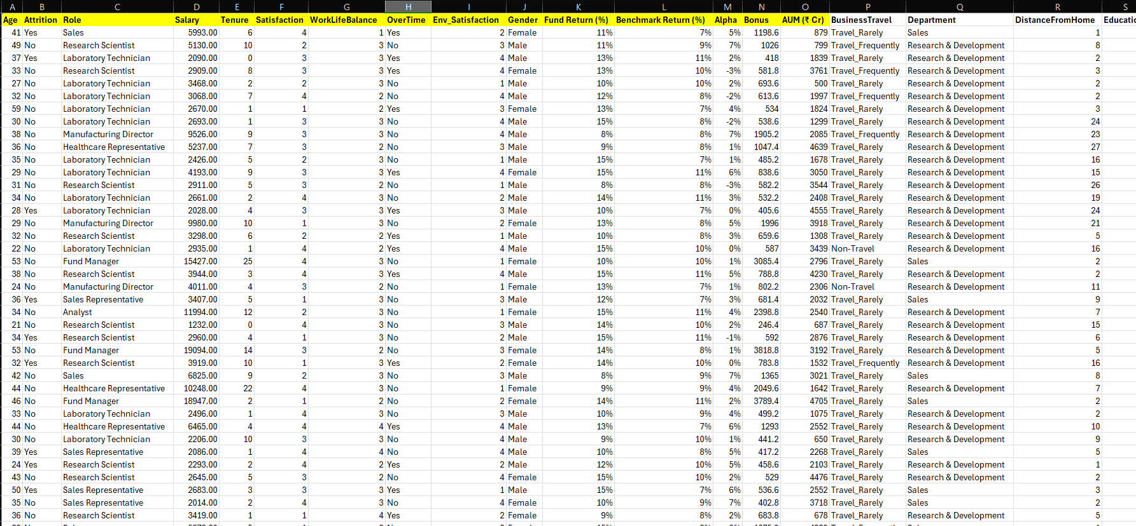

5.2 Mutual Fund-Specific Field Additions
Since the original IBM dataset is industry-neutral, additional columns were engineered and added to make it contextually relevant to the mutual fund and asset management industry. The new fields added include: Fund Return (%) —the annualised return generated by the employee’s managed portfolio; Benchmark Return (%) —the relevant market benchmark return; Alpha (%) —calculated as Fund Return minus Benchmark Return, representing the core performance measure; Bonus (₹ —the annual performance-linked variable pay; AUM (₹rore) —Assets Under Management linked to the employee’s role; Salary Bands —High, Medium, or Low classification; Performance Level —High, Average, or Low based on Alpha thresholds; Market Salary —estimated fair market value for the role; Comp Ratio —Actual Salary divided by Market Salary; Comp Level —Fair, Overpaid, or Underpaid; and Succession Level —Ready Now, Ready Soon, or Not Ready. These additions transform the dataset into a mutual fund industry-specific HR analytics dataset, making findings meaningful and actionable for an AMC leadership team.

5.3 Data Cleaning Process in Excel
Before proceeding with analysis, the dataset was subjected to a structured data cleaning process. Step 1 involved removing duplicates using Excel’s Remove Duplicates function. Step 2 involved checking for missing values using the =COUNTBLANK() formula across all columns—no significant missing values were found. Step 3 standardised all column headers by removing spaces and special characters. Step 4 validated data types, confirming numeric columns were formatted as numbers and text columns as strings. Step 5 added all calculated columns using Excel formulas, including Alpha, Comp Ratio, Performance Level, Comp Level, and Succession Level. Step 6 classified employees into salary bands using nested IF statements. Step 7 performed a final validation by manually reviewing a sample of 50 rows to verify the accuracy of all new fields.

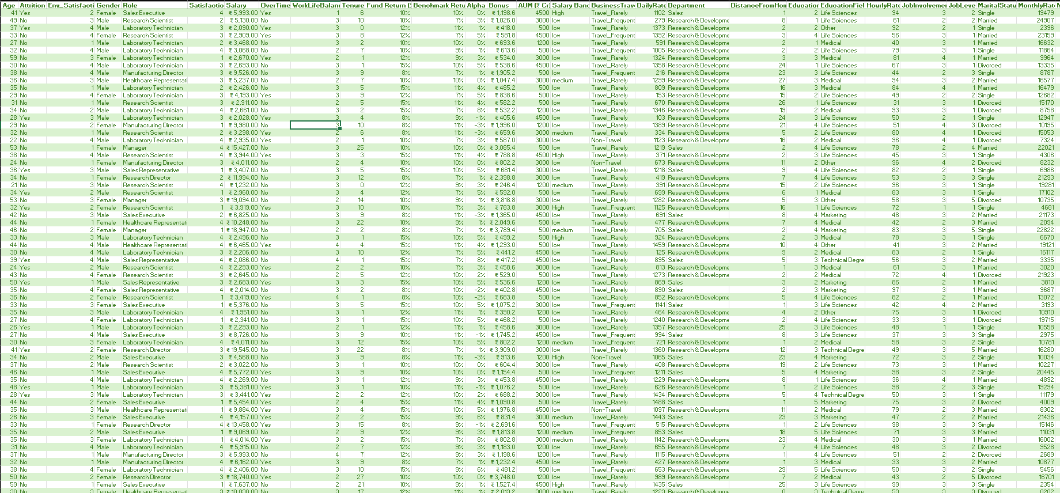
CHAPTER 6 – TOOLS AND TECHNIQUES USED
The entire project was executed using Microsoft Excel, chosen for its powerful built-in analytical features, intuitive interface, and suitability for HR analytics at the descriptive and diagnostic levels. For a beginner data analytics student, Excel provides an ideal environment to develop core analytical competencies without the steep learning curve of programming languages such as Python or R.
Pivot Tables were the primary data summarisation tool used throughout this project. They were used to calculate attrition rates by role, salary band, and tenure; summarise performance distributions; analyse average salary and bonus by performance level; compute succession readiness counts; and generate the compensation fairness distribution.
Multiple chart types were used: Horizontal Bar Charts for Attrition by Role, Clustered Bar Charts for Attrition by Salary Band, Bar Charts for Succession Readiness and Compensation Fairness, Histogram-Style Charts for Tenure Distribution, and a Scatter Plot for Performance vs Salary alignment analysis. Conditional Formatting was applied to key columns—red for attrition, traffic-light coding for performance levels, and colour bands for compensation categories.
The following key Excel formulas were central to the analytical framework: Alpha was calculated as =Fund Return – Benchmark Return. Compensation fairness used =IF(Comp_Ratio<0.9,"Underpaid",IF(Comp_Ratio>1.1,"Overpaid","Fair")). Attrition rate used =COUNTIF(range,"Yes")/COUNTA(range). Succession level used a nested IF formula combining PerformanceRating and YearsAtCompany. Average metrics by category used =AVERAGEIF(). Cross-referencing used =VLOOKUP(). Missing value detection used =COUNTBLANK().

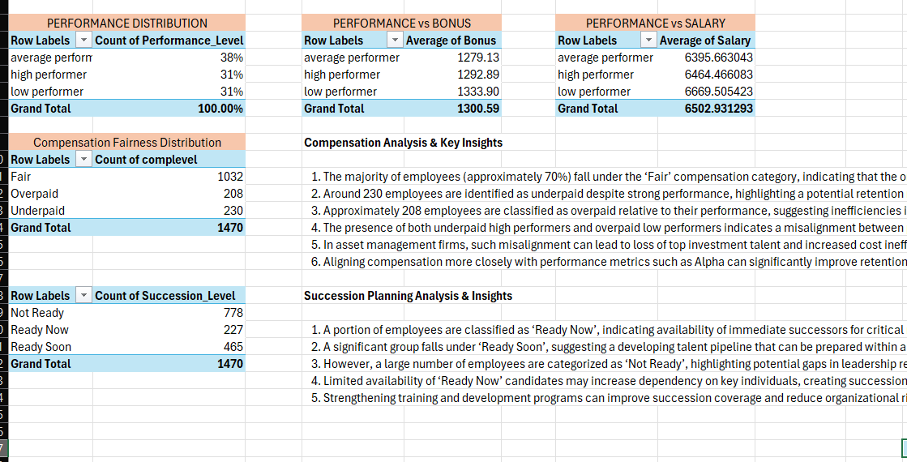
CHAPTER 7 – ATTRITION ANALYSIS

7.1 Overview of Attrition
Employee attrition refers to the gradual reduction of a workforce due to employees leaving the organisation voluntarily or involuntarily. In this project, attrition was analysed across three key dimensions: Job Role, Salary Band, and Tenure. The overall attrition rate in the dataset stands at 16.12%, meaning that out of 1,470 employees, 237 left the organisation while 1,233 remained. In a mutual fund context, a 16% attrition rate represents a meaningful and ongoing source of operational and financial risk, particularly when concentrated in high-value roles.

7.2 Attrition by Role
The breakdown of attrition by job role reveals significant variation across different functions. Sales Representatives record the highest attrition rate of approximately 39.76%—more than double the organisational average. Human Resources (23.08%) and Laboratory Technicians (23.94%) also exhibit elevated attrition. In sharp contrast, senior roles including Research Directors (2.5%), Managers (4.9%), and Manufacturing Directors (6.9%) show very low attrition, indicating that career progression and leadership responsibility are powerful retention motivators.
Business Interpretation: High attrition among Sales Representatives is particularly damaging in the mutual fund industry because sales professionals carry personal relationships with financial advisors, distributors, and institutional investors. When they leave, client relationships often follow to competitor AMCs, resulting in direct AUM outflows and revenue loss.

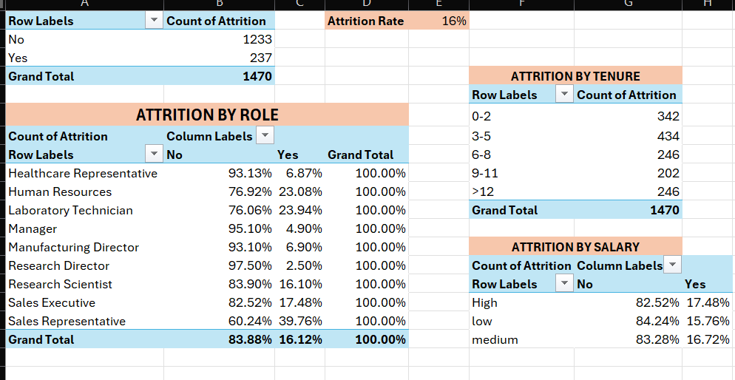

7.3 Attrition by Salary Band
Attrition rates are remarkably uniform across all salary bands: High salary band at 17.48%, Medium at 16.72%, and Low at 15.76%. Importantly, employees in the High salary band show the highest attrition rate. This counterintuitive finding directly challenges the assumption that higher pay automatically leads to better retention.
Business Interpretation: In the asset management industry, top-earning professionals are constantly targeted by competing AMCs and global investment managers offering not just higher salaries but superior fund mandates, greater investment autonomy, equity participation, and international opportunities. Monetary compensation alone is therefore an insufficient retention lever.
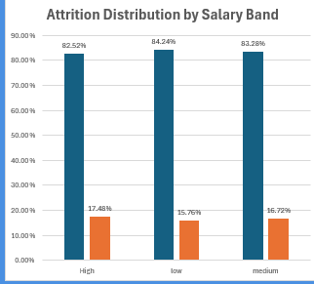

7.4 Attrition by Tenure
The highest concentration of employees—776 out of 1,470 (52.8%)—falls within the 0–5 year tenure range, indicating a relatively young and early-career workforce. Early tenure employees in the 0–2 year bracket carry the highest attrition risk due to adjustment challenges, initial role expectation mismatches, and the relative ease of switching employers early in one’s career.
Business Interpretation: Early-career attrition in an AMC creates persistent recruitment and training cycles. Investment knowledge—market understanding, portfolio management experience, and industry relationship networks—accumulates over years. Every early departure represents lost institutional potential and a return to zero on the learning curve for that role.
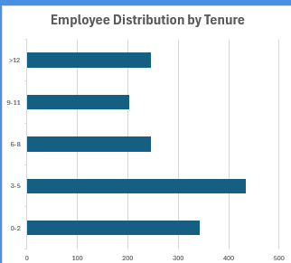
CHAPTER 8 – PERFORMANCE ANALYSIS

8.1 Measuring Performance Through Alpha
In the mutual fund industry, employee performance cannot be adequately captured by generic numerical ratings alone. The most financially meaningful measure of a fund manager’s contribution is their ability to generate Alpha—returns in excess of a specified market benchmark. In this project, each employee’s performance was measured using the formula:
Alpha (%) = Fund Return (%) – Benchmark Return (%)
A positive Alpha indicates outperformance. A negative Alpha signals underperformance. An Alpha near zero suggests the employee is merely replicating benchmark performance without adding active management value. Using this formula, employees were classified: Alpha > 2% as High Performer, Alpha between 0% and 2% as Average Performer, and Alpha < 0% as Low Performer.

8.2 Performance Distribution
The performance classification yielded a balanced distribution: Average Performers at 38%, High Performers at 31%, and Low Performers at 31%. The 31% of High Performers represents a significant talent pool that should be strategically prioritised for retention, development, and compensation review.

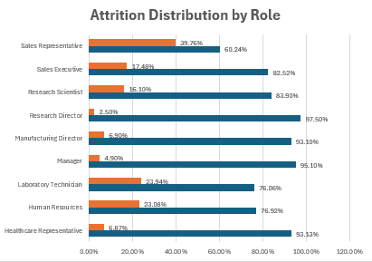

8.3 Performance vs Salary
The Pivot Table analysis of average salary by performance level reveals a striking finding. Low Performers have the highest average monthly salary at ₹,669, while High Performers earn an average of ₹,464 and Average Performers ₹,395. This is a fundamental structural misalignment: high performers are earning less than their underperforming peers, creating an acute and potentially consequential retention risk.
Business Interpretation: A fund manager who consistently generates positive Alpha but earns less than a colleague generating negative Alpha is highly likely to become disengaged and eventually accept a competing offer. Each instance of underpayment of a high performer represents a measurable risk to fund performance, investor confidence, and long-term AUM stability.

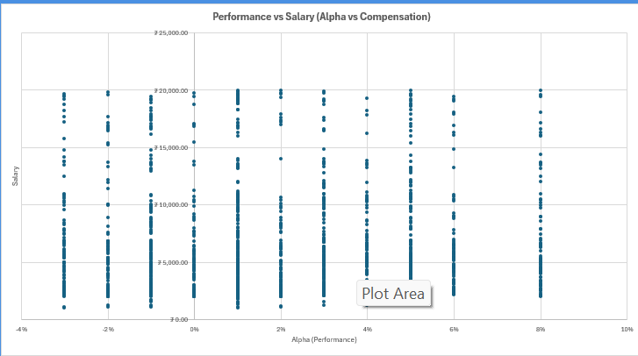8.4

Performance vs Bonus
The bonus analysis reinforces the compensation misalignment. Low Performers receive the highest average bonus at ₹,333.90, while High Performers receive the lowest at ₹,292.89. When bonuses are distributed in inverse proportion to performance, they lose their motivational power entirely and become merely a tenure-linked entitlement rather than a genuine performance incentive.

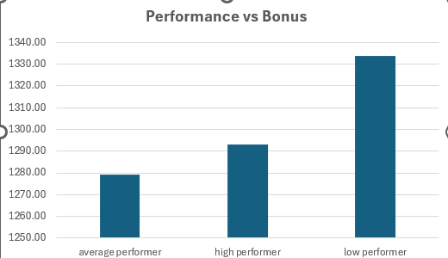
CHAPTER 9 – COMPENSATION ANALYSIS

9.1 What is Compensation Fairness?
Compensation fairness refers to the degree to which an employee’s actual total compensation aligns with the market-equivalent value of their role, experience level, and performance contribution. When employees are paid significantly below market equivalents, they are classified as Underpaid—creating a retention risk. When employees are paid significantly above market without commensurate performance, they are classified as Overpaid—creating a cost efficiency problem. In this project, compensation fairness was measured using the Compensation Ratio (Comp Ratio): Actual Monthly Salary divided by Market Equivalent Salary. Employees with Comp Ratio below 0.9 were classified as Underpaid, between 0.9 and 1.1 as Fair, and above 1.1 as Overpaid.

9.2 Compensation Fairness Distribution
The classification exercise across all 1,470 employees produced the following findings. 1,032 employees (70.2%) are classified as Fair, indicating that the organisation’s overall compensation structure is broadly aligned with market benchmarks. However, 230 employees (15.6%) are Underpaid and 208 employees (14.2%) are Overpaid, representing a significant 30% minority requiring structured attention.

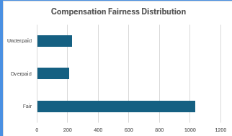

9.3 The Underpaid Problem
The 230 underpaid employees represent the most acute retention risk in the organisation, particularly where these individuals simultaneously fall into the High Performer category. In the asset management industry, underpaid high performers are prime targets for competitor recruitment. Investment banking groups, foreign AMCs, alternative investment funds, and portfolio management service providers actively scout for proven performers who may be undervalued at their current employer.

9.4 The Overpaid Problem
The 208 overpaid employees represent a material cost efficiency problem, particularly in an industry environment where AMCs face growing fee compression and declining expense ratios. If overpaid employees are simultaneously low performers—earning above-market salaries while generating negative Alpha—this represents a compound inefficiency that erodes fund performance, investor value, and organisational cost competitiveness.

9.5 Implications for Compensation Strategy
Based on these findings, a formal salary review should be conducted for all Underpaid employees, with immediate priority given to High Performers. A performance-differentiated pay structure should be formally introduced, ensuring salary increments, promotions, and bonus allocations are explicitly linked to measurable metrics such as Alpha, AUM growth, and client satisfaction. For Overpaid employees, a structured performance improvement and pay recalibration programme should progressively align variable pay with demonstrated performance rather than tenure alone.

CHAPTER 10 – SUCCESSION PLANNING ANALYSIS

10.1 What is Succession Planning?
Succession Planning is the systematic HR process by which an organisation identifies, develops, and prepares internal candidates to assume key leadership and critical operational roles in the future. In the context of an AMC, succession planning is an operational necessity. Key roles such as the Chief Investment Officer (CIO), Portfolio Manager, Head of Sales, and Head of Compliance cannot be left vacant even temporarily without triggering significant operational disruption, investor concern, and potential regulatory implications. In this project, employees were classified into three readiness tiers: Ready Now (strong performance and experience, can assume a higher role immediately), Ready Soon (strong potential but requires additional 1–2 years of development), and Not Ready (early career or significant development gaps before advancement).

10.2 Succession Readiness Distribution
The succession analysis produced the following findings across 1,470 employees. 778 employees (52.9%) are Not Ready—representing over half the total workforce and revealing a significant leadership pipeline gap. 465 employees (31.6%) are Ready Soon—a meaningful talent pipeline in development and the organisation’s most investable succession asset. Only 227 employees (15.4%) are Ready Now—meaning the organisation has a relatively slim pool of immediately deployable succession candidates.

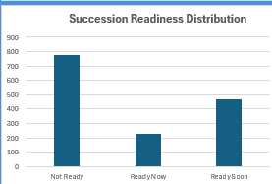

10.3 Key-Person Risk in Mutual Funds
The succession findings become especially significant through the lens of key-person risk—the risk that the departure of a single critical individual causes material disruption to the business. In AMCs, this risk manifests most acutely in roles such as the Star Fund Manager (whose departure may trigger investor redemptions and AUM decline), the Top Sales Leader (whose exit can disrupt distribution channels), and the Chief Investment Officer (whose departure affects the entire firm’s investment strategy and governance). The finding that only 15.4% of employees are Ready Now means the organisation lacks immediately deployable internal successors for many critical roles, substantially increasing key-person dependency.

10.4 Strengthening the Leadership Pipeline
To address the succession gap, the organisation should implement formal Leadership Development Programmes combining executive education and real-world project leadership, establish mentoring relationships between Ready Now seniors and Ready Soon candidates, create cross-functional rotation assignments exposing high-potential employees to multiple departments, develop transparent Individual Development Plans with clear milestones for each succession candidate, and conduct quarterly Talent Review Meetings to dynamically track pipeline progress.

CHAPTER 11 – DASHBOARD DEVELOPMENT

11.1 Purpose and Importance of the Dashboard
An HR Analytics Dashboard is a visual management tool that consolidates all key HR metrics, analytical findings, and strategic trends into a single, coherent interface. For senior management and HR directors, the dashboard functions as a workforce intelligence cockpit—providing at-a-glance visibility into talent health, risk areas, and strategic priorities. In this project, the dashboard was built entirely within Microsoft Excel, demonstrating that powerful analytical visualisation does not require expensive enterprise software.

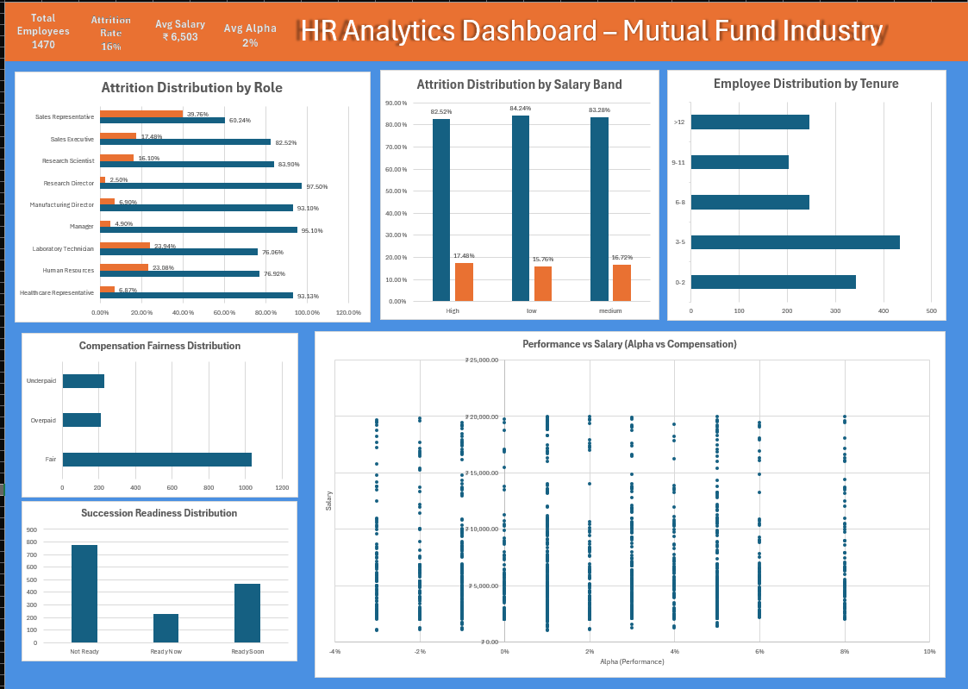 11.2 Dashboard Components
The dashboard is structured around eight key components. The KPI Header Bar displays four headline metrics: Total Employees (1,470), Attrition Rate (16%), Average Monthly Salary (₹,503), and Average Alpha (2%). The Attrition by Role Chart uses a horizontal bar format to immediately highlight the Sales Representative attrition crisis. The Attrition by Salary Band Chart demonstrates that salary level does not linearly predict retention. The Tenure Distribution Chart emphasises the early-tenure concentration risk. The Compensation Fairness Chart provides a clear visual summary of pay alignment. The Succession Readiness Chart makes the leadership pipeline gap immediately visible. The Performance vs Salary Scatter Plot confirms compensation misalignment by showing the absence of a positive performance-pay correlation. Finally, the Key Insights Panel summarises the three most critical findings in plain language.

11.3 Design Principles Applied
The dashboard was designed following professional data visualisation principles. Clarity was ensured through bold chart titles, labelled axes, and visible data labels. Colour consistency was maintained using navy blue for stable metrics and orange for risk indicators. Visual hierarchy places KPI cards at the top and detailed charts in the body. Adequate white space between components prevents visual clutter. Every element was designed to answer a specific named business question rather than display data for its own sake. The entire dashboard was designed to fit within a single screen for rapid executive review.
Appendex:-
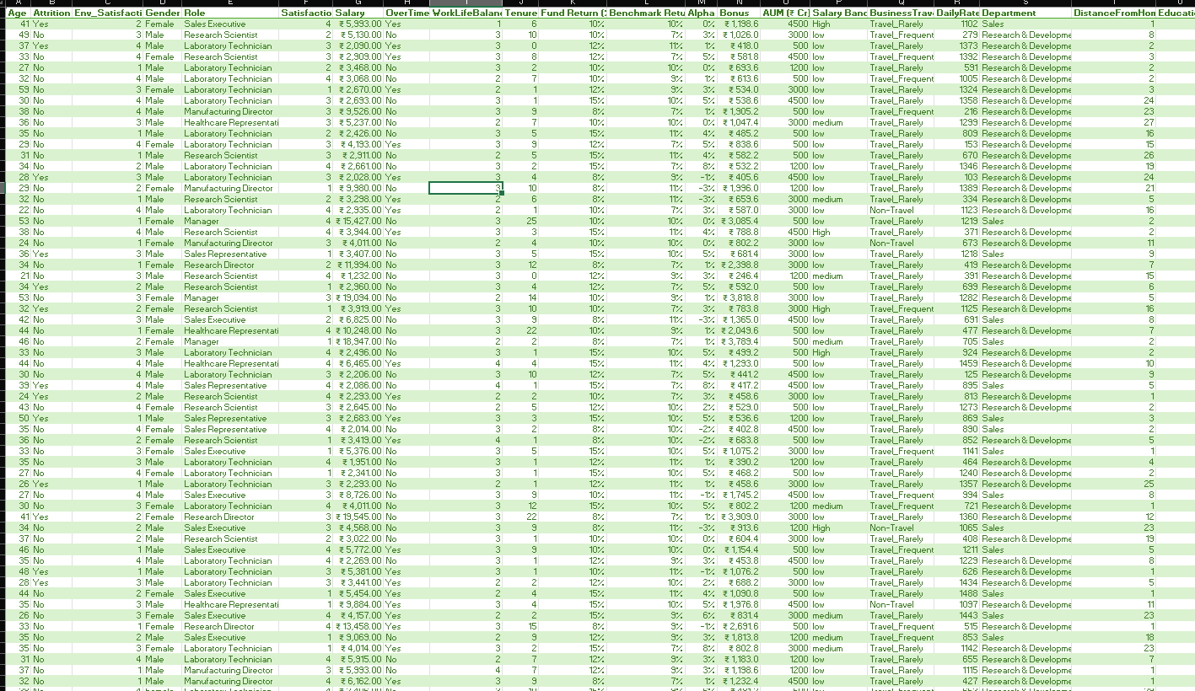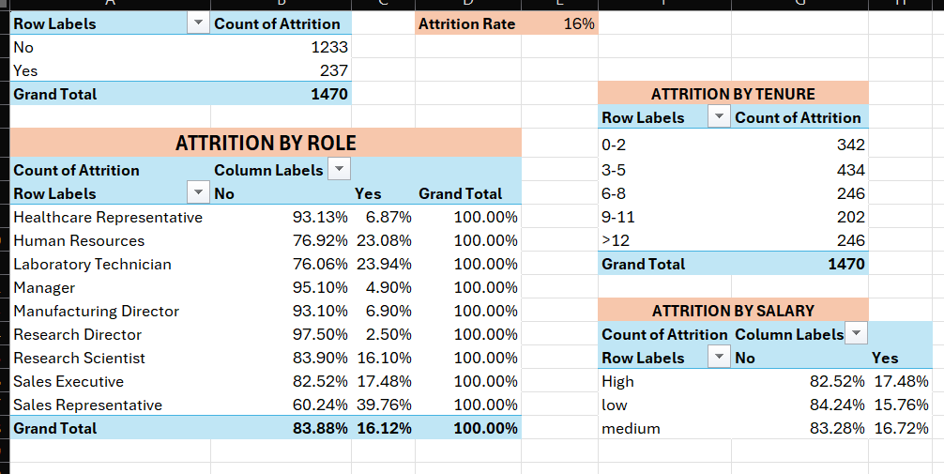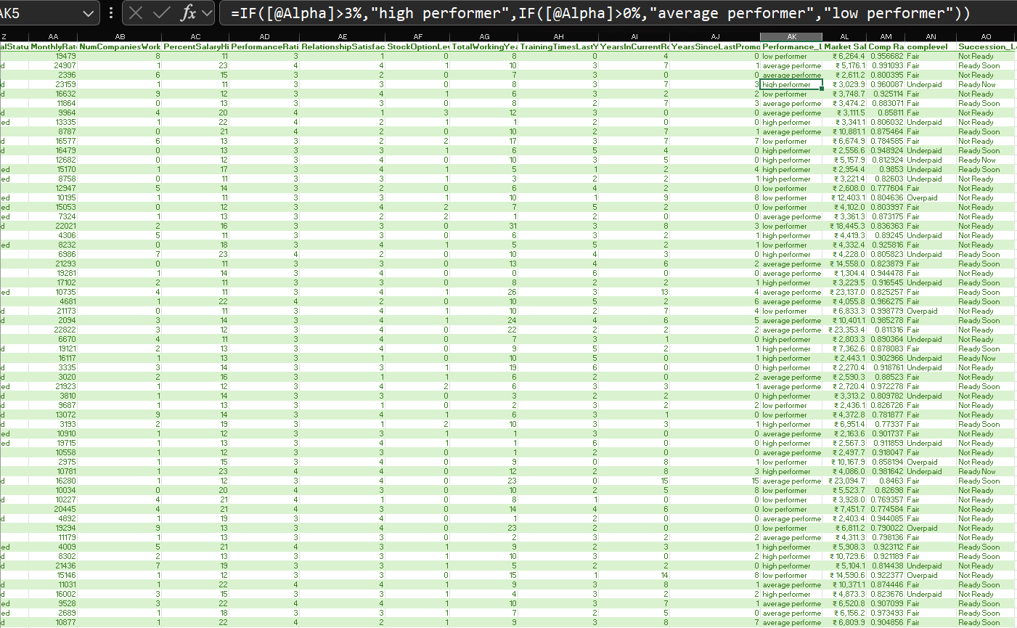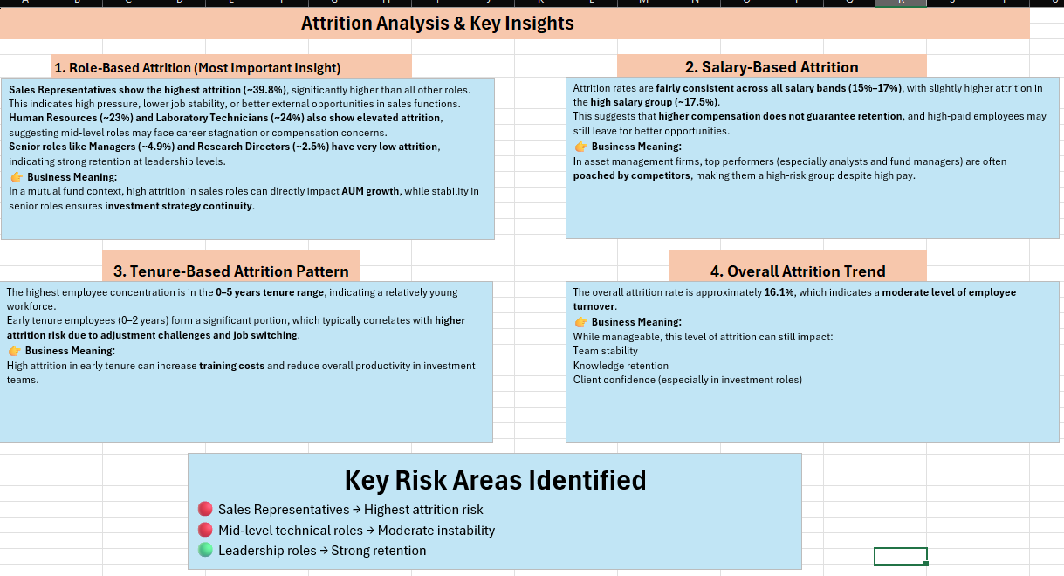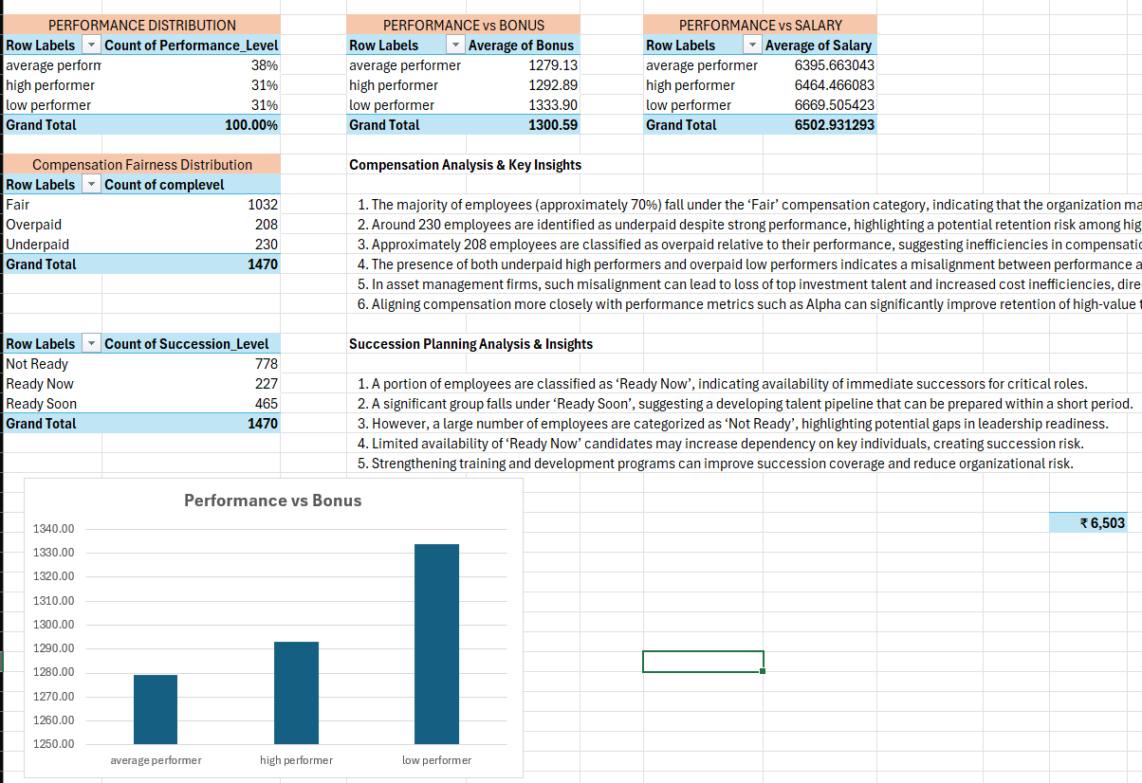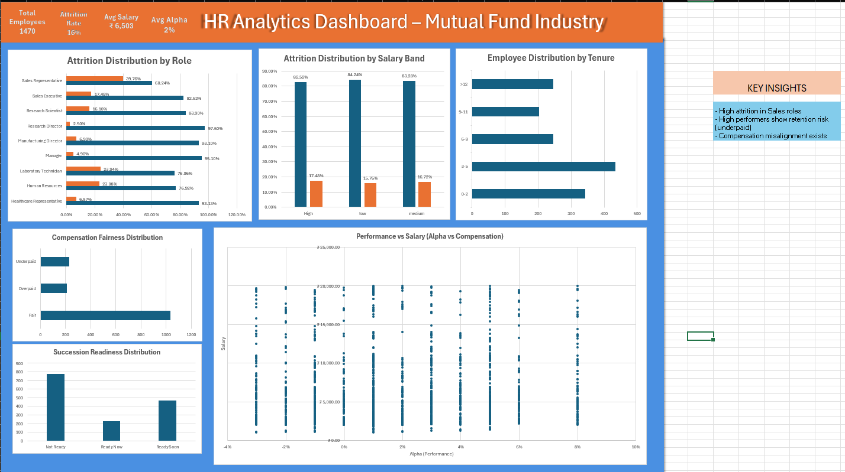

CHAPTER 12 – KEY FINDINGS AND INSIGHTS
Finding 1 – High Attrition Among Sales Representatives. The most critical attrition risk lies within the Sales Representative role, with an attrition rate of 39.76%—approximately 2.5 times the overall organisational average. This directly threatens AUM growth, distributor relationship continuity, and revenue generation capacity.
Finding 2 – Leadership Roles Demonstrate Strong Retention. Managerial and director-level roles exhibit attrition below 7%, confirming that career progression and leadership responsibility are powerful retention motivators at senior levels.
Finding 3 – Early Tenure Represents the Highest Attrition Risk Period. The 0–5 year tenure group represents 52.8% of the workforce and historically the highest attrition risk, indicating the need for stronger onboarding and early career development investment.
Finding 4 – Higher Salaries Do Not Guarantee Higher Retention. Attrition rates are nearly uniform across all salary bands, with the High salary band recording the highest attrition (17.48%), confirming that financial compensation alone is an insufficient retention strategy.
Finding 5 – Compensation is Not Aligned With Performance. Low Performers earn the highest average monthly salary (₹,669) and highest average bonus (₹,333.90), while High Performers earn less in both categories. This fundamental misalignment demoralises top talent.
Finding 6 – 230 Employees Are Underpaid Relative to Market. Representing 15.6% of the workforce, underpaid employees—particularly those who are also high performers—represent the highest flight risk and most financially consequential retention challenge.
Finding 7 – Succession Pipeline Has a Critical Readiness Gap. Only 15.4% of employees (227 individuals) are classified as Ready Now, while 52.9% (778 employees) are Not Ready, representing a significant vulnerability in business continuity and leadership resilience.
Finding 8 – Overall Compensation Structure is Broadly Market-Competitive. 70.2% of employees are fairly compensated, indicating the compensation framework requires targeted recalibration rather than wholesale redesign.

CHAPTER 13 – RECOMMENDATIONS

Recommendation 1: Implement a Targeted Sales Retention Programme
Given the critically high attrition rate of 39.76% among Sales Representatives, the organisation should develop a dedicated, multi-pronged retention strategy. This should include a structured career progression framework within the sales function (Sales Representative to Senior Sales Executive to Territory Manager to Regional Business Head), AUM-linked performance incentives that directly reward revenue contribution, quarterly engagement conversations between sales managers and each team member to identify dissatisfaction signals early, and retention bonuses for high-performing sales professionals who achieve defined tenure milestones of two and four years.

Recommendation 2: Redesign Compensation to Reflect Performance
The most structurally important change required is the redesign of both the fixed salary increment framework and the bonus allocation methodology. The organisation should introduce a Performance-Linked Salary Band Matrix where high performers are placed in higher increment brackets during annual reviews. The bonus pool should be restructured to create a meaningful spread between performer tiers, targeting a 2x to 3x difference between High Performer and Low Performer bonus outcomes. An immediate Underpaid Employee Salary Review should be conducted, prioritising correction of cases where high performers are below market compensation parity.

Recommendation 3: Develop and Accelerate the Leadership Pipeline
To address the succession planning gap, the organisation should identify the top 20–25% of Ready Soon employees and assign senior executive mentors to each. A formal Future Leaders Programme should be initiated combining rotational assignments, formal training, and stretch project ownership. Regular 9-Box Talent Review Meetings should assess both performance and potential quarterly. Formalised Succession Maps should document primary and backup candidates, readiness timelines, and development gaps for all critical roles.

Recommendation 4: Invest in Early-Tenure Employee Engagement
To reduce attrition risk in the 0–5 year tenure group, the organisation should implement a comprehensive 90-day structured onboarding programme, formal 30-60-90 day manager check-ins with all new joiners, access to professional development resources including NISM certifications and CFA study support, and a Buddy Programme pairing new employees with experienced colleagues for informal guidance and cultural integration.

Recommendation 5: Leverage Non-Monetary Retention Strategies
Since salary increases alone have demonstrated insufficient power to prevent attrition, the organisation must invest in non-monetary retention levers. These include flexible and hybrid work arrangements, public recognition platforms that celebrate high performer achievements, annual career development conversations where employees and managers discuss aspirations and development needs, and a clearly articulated Employee Value Proposition (EVP) that defines the organisation as an employer of choice in the asset management industry.

CHAPTER 14 – CHALLENGES FACED
Completing this HR Analytics project was a comprehensive and demanding undertaking. The following challenges were encountered and overcome during the course of the project.
Challenge 1 – Domain Knowledge Gap. As a student without prior professional experience in the mutual fund industry, understanding the business significance of concepts such as Alpha, AUM dynamics, expense ratio pressures, and SEBI’s regulatory landscape required substantial self-directed learning alongside the technical analytics work.
Challenge 2 – Dataset Engineering and Simulation. The IBM HR Analytics dataset is industry-neutral. Simulating realistic mutual fund-specific fields including Alpha, Fund Return, Benchmark Return, AUM, and Market Salary required making well-reasoned assumptions about data ranges and distributions. These engineered fields add crucial contextual relevance but are simulated values and should not be treated as empirically validated industry data.
Challenge 3 – Excel Formula Complexity. Building derived analytical columns using nested IF statements, VLOOKUP functions, AVERAGEIF calculations, and Comp Ratio formulas across 1,470 rows required significant care and multiple iterations. Systematic validation was a critical and time-consuming discipline.
Challenge 4 – Professional Dashboard Design. Creating a visually professional dashboard in Excel—balancing chart sizing, colour schemes, data label placement, spacing, and overall layout—was considerably more complex and time-intensive than anticipated and required multiple redesign iterations.
Challenge 5 – Translating Data into Business Narrative. The most intellectually demanding aspect was translating quantitative findings into meaningful, contextually relevant business interpretations for a mutual fund audience—learning to connect each data point to a specific business consequence and then to a concrete management recommendation.

CHAPTER 15 – LEARNING OUTCOMES
This project has been a transformative learning experience that simultaneously developed technical data analytics skills, industry domain knowledge, and professional business communication capabilities.
Technical Skills Developed. The project built meaningful proficiency across Microsoft Excel’s advanced features: Pivot Table construction for multi-dimensional analysis, professional chart creation and formatting for business reporting, formula writing for calculated and derived metrics, Conditional Formatting for data-driven visual alerts, and structured dashboard design for executive-level visualisation.
Analytical Thinking and Problem Solving. The project fundamentally strengthened the discipline of approaching business problems through data—formulating testable hypotheses, verifying them against evidence, and drawing defensible, evidence-based conclusions. The habit of separating assumption from observation and correlation from causation is a core analytical mindset developed throughout this work.
Financial Services Domain Knowledge. Working on a mutual fund industry-specific project required developing genuine understanding of financial concepts including Alpha generation, AUM dynamics, benchmark comparison, fee structures, and SEBI’s regulatory framework for AMCs. This domain knowledge is directly applicable to future analytical roles within financial services.
Business Communication and Reporting. The process of writing this project report developed the critical skill of communicating complex analytical findings in clear, structured, and business-relevant language. The ability to produce a well-organised, professionally formatted report with executive summary, methodology, findings, and recommendations is a foundational competency for any data analyst or business professional.
Project Management. Managing a multi-phase project spanning data cleaning, feature engineering, multi-dimensional analysis, dashboard development, and report writing within a defined timeframe required sustained planning, prioritisation, and personal discipline that are directly transferable to professional environments.

CHAPTER 16 – CONCLUSION
This project successfully demonstrates the application of HR Analytics to a mutual fund industry context using Microsoft Excel as the primary analytical and visualisation platform. By working through a structured, end-to-end process—from dataset acquisition and data cleaning through feature engineering, multi-dimensional analysis, dashboard development, and strategic reporting—this project delivers a comprehensive and actionable view of the workforce dynamics and talent risks within an AMC-type organisation.
The overarching takeaway is that data-driven HR management has direct, quantifiable, and consequential implications for business performance in the mutual fund industry. The 39.76% attrition rate among Sales Representatives is not merely an HR statistic—it is an AUM growth risk. The underpayment of high performers is not merely a compensation oversight—it is an Alpha-generation risk. The thinness of the succession pipeline is not merely a future planning gap—it is a present-day key-person dependency and governance vulnerability.
Equally important is the demonstration that Microsoft Excel, when applied with analytical discipline and business intention, is a capable platform for generating sophisticated and decision-relevant HR insights. The analytical framework developed in this project represents a valuable foundation for mature, data-driven human capital management. The natural next step would be to extend this framework into predictive analytics using tools such as Python, R, or Power BI, enabling the organisation to proactively model attrition risk, forecast succession readiness timelines, and simulate the financial impact of compensation restructuring before problems materialise.
This project has reinforced not only technical Excel proficiency but, more meaningfully, a deep appreciation for the strategic, financial, and human significance of the connection between effective people management and sustained business performance in the financial services industry.

CHAPTER 17 – REFERENCES
1. IBM HR Analytics Employee Attrition and Performance Dataset. Kaggle – Open Dataset Repository. Available at: https://www.kaggle.com/datasets/pavansubhasht/ibm-hr-analytics-attrition-dataset
2. Securities and Exchange Board of India (SEBI). Mutual Fund Regulations, Circulars, and AMC Governance Guidelines. Available at: https://www.sebi.gov.in
3. Morningstar India. Fund Performance Analytics and Benchmark Research. Available at: https://www.morningstar.in
4. Value Research India. Mutual Fund Data and Industry Reports. Available at: https://www.valueresearchonline.com
5. Association of Mutual Funds in India (AMFI). Industry AUM Data and Monthly Fact Sheets. Available at: https://www.amfiindia.com
6. Financial Stability Board (FSB). Principles for Sound Compensation Practices in Financial Institutions. Available at: https://www.fsb.org
7. Fitz-enz, J. (2010). The New HR Analytics: Predicting the Economic Value of Your Company’s Human Capital Investments. AMACOM Publishing.
8. Cascio, W. F. & Boudreau, J. W. (2011). Investing in People: Financial Impact of Human Resource Initiatives. FT Press / Pearson Education.
9. Microsoft Corporation. Microsoft Excel Documentation – Pivot Tables, Charts, and Data Analysis. Available at: https://support.microsoft.com/en-us/excel
10. Bersin, J. (2013). The Datafication of HR. Deloitte Insights. Available at: https://www2.deloitte.com
— End of Report —

