**Process Report**

**Group 2**

**Zinema**

Claudiu Rediu 266129

Dominika Kubicz 266148

Nikita Roskovs 266900

Andrei Cioanca 266105

Stefan Harabagiu 266116

**Supervisors:**

Jakob Knop Rasmussen

Jan Otto Munch Pedersen

**[Number of characters]**

**Software Engineering**

**Semester 3**

**19.12.2018**

**Table of content**

1 Introduction 1

2 Group Description 3

2.1 Belbin Roles 3

2.2 SWOT Analysis 4

2.3 Cultural Difference 7

2.4 The Group 8

3 Project Initiation 9

4 Project Description 10

5 Project Execution 12

5.1 Scrum Planning 12

5.1.1 SCRUM Roles 12

5.1.2 Sprint Planning 12

5.1.3 Group Meetings 13

5.1.4 Sprint Backlogs 13

5.1.5 Burndown chart 20

5.2 Unified Process (UP) 21

5.2.1 Inception 21

5.2.2 Elaboration 21

5.2.3 Construction 22

5.2.4 Transition 22

5.2.5 Distribution between effort and schedule: 22

6 Personal Reflections 23

7 Supervision 27

8 Conclusions 28

Appendices

# Introduction

For this semester project we formed a group of five people, who agreed to work together in order to create a functional system. Three team members already worked on a project together before.

The idea for the project depended on us. We received requirements that we had to meet. From three concepts we had for the project we picked the one that fit us most, which was a cinema system.

Before we were able to work efficiently on the project we had to go through stages of team formation1, such as forming, storming, norming and preforming. Even though most of the team already knew how to work with each other, the new team member brought into the group new energy, which had to be accurately managed.

To properly organize the group work we used UP and the SCRUM framework. Claudiu Rediu was the SCRUM Master while Dominika Kubicz the Product Owner. We had before every sprint a planning meeting and after every sprint review and retrospective meetings. From the beginning of the project until the 5th of December we had daily SCRUM meeting once or twice a week, while during the project period the meetings were held on daily basis.

In order to evenly share the work we used services provided by [www.trello.com2](http://www.trello.com2). All the tasks were posted there, and assigned to certain group members. When a member fulfilled his responsibility, he updated the information on trello, so the other team mates were aware of the done tasks. Thanks to that website the whole team was able to keep track of the progression [1]of the project.

Because we sometimes lacked the knowledge to fulfill the requirements, we had a number of meetings with our supervisors. During that time they helped us with our problems, so that we could continue with the work.

In conclusion, we spend during the past four months the total of XXX hours on implementing and documenting the project. The group worked together in peace, united by the common goal of creating the possible best system for Zinema. After all the effort put in building the software and documenting the process, the whole operation turned out to be a success.

# Group Description

The group consists of five team members from three different nationalities.

## Belbin Roles[2]

According to Belbin team roles each member of a group shows a certain “tendency to behave” while cooperating with others.

**Claudiu Rediu** (Romania)

**Sharper** – keeps the team focused on the work, and helps them stay motivated. The risk is that he might by accident offend someone’s feelings.

**Co-ordinator** – divides work between all group members and stays focused of the teams goal. On the other hand some people might see him as manipulative.

**Nikita Roskovs** (Latvia)

**Implementer** – feels most comfortable when his work is planned and he can follow his strategy. It might be hard for him to adapt to new possibilities, or to change his plan.

**Complete finisher** – is the best at giving work a “final touch” and return it in the possible best condition. On the other hand, can get unduly careful with the details.

**Dominika Kubicz** (Poland)

**Complete finisher** – scrutinizes the teams work for errors and fixes them. Is known for being conscientious and anxious.

**Specialist** – brings knowledge and skills in a one specialized area. Has tendency to concentrate only on the one chosen area.

**Andrei Cioanca** (Romania)

**Sharper** – is good at challenging other members, thrives under pressure. On the other hand can be prone to provocation.

**Plant** – has unique ways of solving problems, is known for his creativity. Can be forgetful, and absent-minded.

**Stefan Harabagiu** (Romania)

**Monitor Evaluator** – has a logical eye on things, is able to make impartial judgment. Might be overly critical and lacks ability to inspire others.

**Plant** – has a tendency to solve upcoming problems in a creative way, comes up with a lot of different ideas for the project. May pay too much attention to communicate in the most effective way.

## SWOT Analysis

Each team member made a SWOT analysis of himself, so we could know each other better. Bellow we attached a diagram for each team member and also one for the whole team.

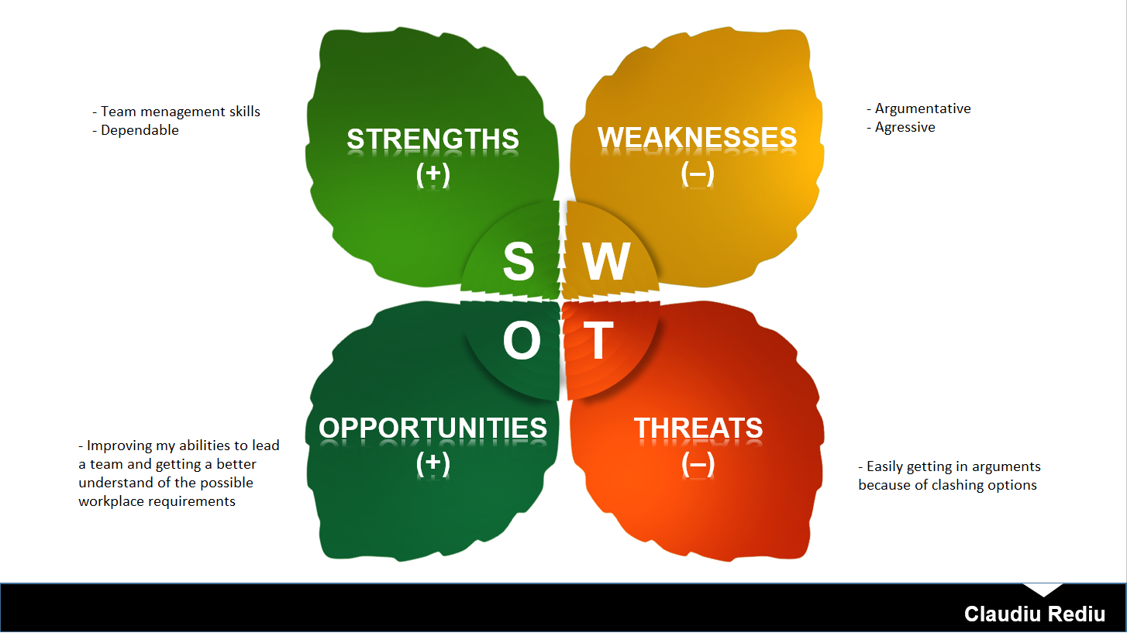

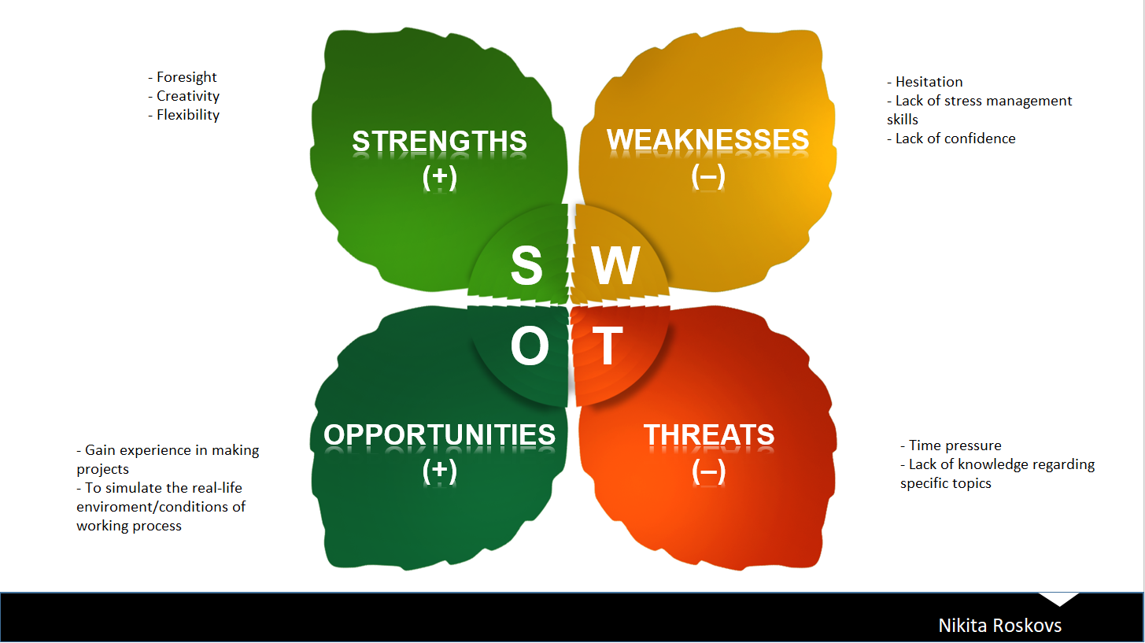

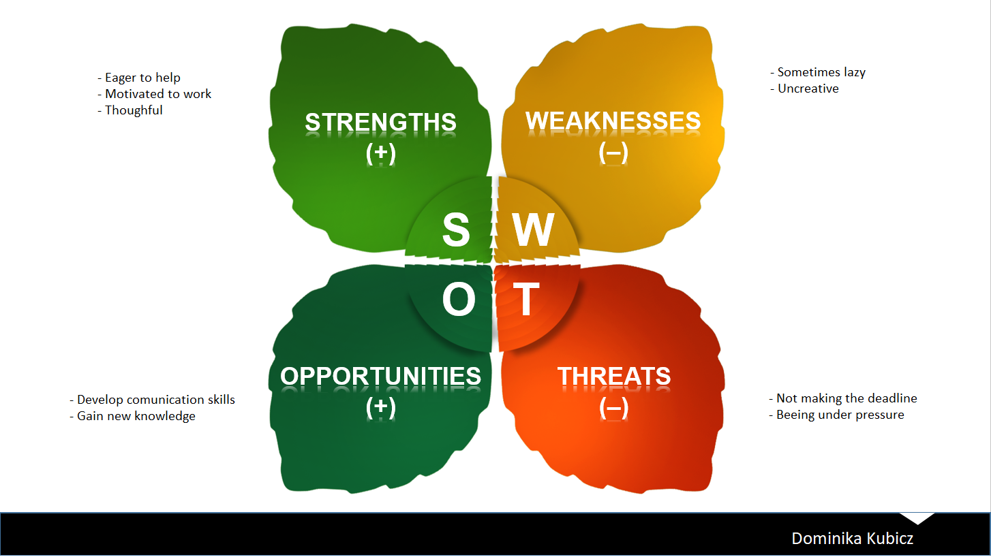

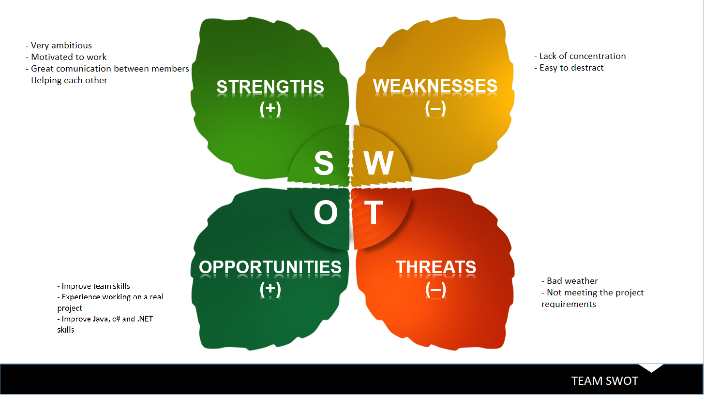

## Cultural Difference[3]

Between all five team members we share the total of three different nationalities, such as Romania, Latvia and Poland. All countries scored a certain amount of points for different dimensions. The received scores are shown on the figure 1.

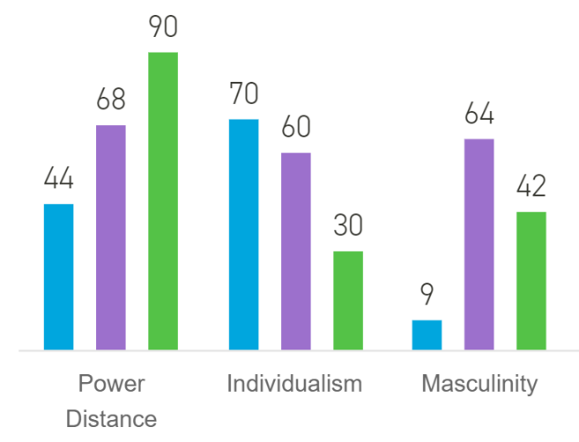

*Figure 1*

**Latvia**

In the power distance dimension Latvia scored lowest from all three countries. That means that Latvian people prefer to work as a team and with equality between the team members, although they still show respect towards the authorities.

Individualism is also very popular in Latvia. Children from the beginning are taught that it is important to take responsibility for their action. Also, they tend to speak their mind, and are very tolerant towards other.

Latvians motivation is that they do what they like. They don’t feel comfortable with praising and are very careful not to offend anybody. All of that is because they have very low masculinity.

**Romania**

Because Romania scored very high in the power distance dimension, that means that the people are used to a hierarchy and accept their place. They are used to others telling them what to do.

The score of individualism shows that in Romania there is a collectivistic society. That means that they take group responsibility very seriously, and they also take very serious relationships between group members.

Romania has a Feminine society, which means that people “work in order live”. They value equality and solidarity. The conflicts between them are solved very easily.

**Poland**

Just like Romanian society Poland also is a hierarchal society, because of its high power distance score. People agree to their place in the hierarchical order and are used to being told what to do.

In the Individualism dimension Poland scored quite high, meaning that they care about themselves and the closest family. In such society offence causes a loss in self-esteem and guilt. The promotions and hiring are based not on the relationship but on merit.

Poland is considered a Masculine society. That means that people “live in order to work”. The conflicts are settled by fighting them out.

## The Group

All team members have experienced group work in previous semesters. Nikita, Claudiu and Dominika worked together on a project last semester. All three of them accepted the new team members, which brought to the group new approach towards the project.

Even though our cultural backgrounds were different we managed to work together. The team members often challenged each other’s ideas in the process of striving for excellence. All decisions made during the meetings were talked through with all members. Everyone was aware of the progression of the project.

In our group we had members with Belbin roles from each of the following dimensions:

* Action Oriented Roles (Nikita – implementer, Andrei Cioanca - shaper)
* People Oriented Roles (Claudiu – Co-ordinator)
* Thought Oriented Roles (Dominika – specialist, Stefan – monitor evaluator)

Thanks to the fact that we had all the three dimensions covered, our work together was very pleasant and everyone had an important role to play. That caused our group to have a high performance rate.

# Project Initiation

The team we formed for this semester had some new members, which gave the group a new character. Everyone had to find their new position in the team. Because of that process we went through the four team formation stages, which are Forming, Storming, Norming, and Performing[4]. In the first stage all members were explained about the upcoming challenge and what was expected from them. Storming phase was quite noticeable. There were many discussions in the beginning of our work together. Members tried to implement their solution to the project, but in a polite way, without any fights. After that we finally reached the norming phase, which let us work together as a group. Preforming phase came quickly after norming and our progression was visible.

The most important document for us was the group contract. We established some ground rules we expected each other to follow. To prove our will to work on the project, everyone agreed to the rules from the contract and signed it. All team members through the duration of our work together did their best to respect the regulations.

All of our meetings were held at the university. There was a possibility of having meetings through the internet, but there was no need for that. Setting the meetings was quite challenging. Because all of the members had extra activities like a part-time job or some extra lessons, it was very hard to set a date that fits everyone. That is why on some of the meetings not everyone was present. Apart from couple of meetings with one or two members missing the attendance was very good.

At the very beginning of the semester the supervisors explained us what requirements they expect our project to fulfil. We could pick a case that was to our liking. We discussed three different ideas, such as a flight booking system, hotel booking system and a cinema system. After a voting, the majority of our team voted for a cinema system, which we proceeded to work with.

On order to organize our work in the best possible way we decided to use UP and SCRUM framework. We picked a SCRUM master and a product owner in order to respect all required roles of a SCRUM team. Claudu Rediu was the SCRUM master and Dominika Kubicz the product owner. The rest of the group members (Andrei, Stefan, Nikita) were the team. Through the duration of the project we had the appropriate meetings such as retrospective, planning, review and a daily SCRUM meetings during every sprint iteration.

# Project Description

We wrote the project description, so that we can share our vision of the project with other people. Thanks to our previous experience with other projects we worked on we were able to pass our idea for the system in a simple and understandable way.

First we formulated the background description. We used reliable sources to support our project, so the readers were convinced of the need for our system. We included statistics showing the decrease in Danish cinema activity to show that the market needs a boost. Defining the purpose was challenging as usual. We did our best to pick the right words that catch the essence of our project. In the problem statement we stated couple of question we expected to answer while completing the project. Because we already had the idea in our heads it wasn’t hard to put these questions on paper. The delimitations include some features that at this point of our education we were not able to implement. To show how we plan to work on the project we established in the “Choice of models and methods” frameworks we were planning to use and explained why we decided on them. In the “Risk Assessment” we discussed about the possible risks that we might come across. To each risk we assigned one person to make sure that this exposure will not affect our project work. The goals we set up worked well for us. We managed to implement everything we wanted to. Because of the previous experience we knew our potential and we set goals suitable for our skills.

To conclude the Project Description phase went smoothly, without any big problems. Having had some previous experience we were able to stand up to the challenge and do our best to properly introduce our project.

# Project Execution

# Personal Reflections

**Claudiu Rediu**

//

**Nikita Roskovs**

My overall experience of the semester project group work has been satisfying. There was friendly atmosphere in the team and all my group mates have been ready to help and open to discuss any ideas or issues cropped up.

Team used panning tools and had regular meetings, so everyone always stayed updated and aware of the overall process of the project. Everybody was free to choose tasks dependent on what they want to implement or know the most about. All the parts always been discussed during the meetings, so everyone was clear with the tasks they had to fulfill. In the beginning we tried to split tasks equally, however it did not work out perfectly, because as soon as we moved to coding part, it was quite hard to split the code of the components between multiple group members by reason of longer implementing and testing process.

Planning was done well. We managed to stick to schedule we set and almost always achieved all we planned to achieve during the particular sprint without being too overwhelmed.

Comparing to the last semester, this time I’ve been trying to delve into the coding parts made by other group mates in order to understand the mechanism of created system more detailed.

All in all, I enjoyed working with my group and want to thank all of them for that experience

**Dominika Kubicz**

I really liked that my group mates were very helpful. Whenever I needed help with a problem they were keen to help. I also enjoyed that the group work was well organized. Every week we agreed on tasks that have to be done by the next meeting. All members had responsibilities which they scrupulously fulfilled. I really appreciated the fact that whenever I missed a part of the meeting, the group shared with me what was done and what decisions were made. Other pros were the numerous discussions during the meeting. The team had a lot of ideas and they were always discussed so we could pick the best one.

On the other hand, I found some of the discussions pointless. We, sometimes, during the discussion changed the topic and weren’t talking about the important details anymore. Also, whenever a meeting was scheduled, very often other members didn’t say if the date fit their schedule and if they will attend the meeting.

In conclusion, previous months with my group was enjoyable. The team mates were friendly and helpful. Thanks to them I gained team work skills and learned more about Java and c#.

**Stefan Harabagiu**

//

**Andrei Cioanca**

//

# Supervision

//

# Conclusions

//

**Appendices**

1. 1. <https://www.mindtools.com/pages/article/newLDR_86.htm>
   2. https://trello.com/?truid=tr1a198c-8292-7afe-4d0a-9de8ba56c48a

  
2. <http://www.belbin.com/media/1336/belbin-for-students.pdf>
3. https://www.hofstede-insights.com/country-comparison/denmark,latvia,poland/
4. https://www.mindtools.com/pages/article/newLDR_86.htm