The SQL Server is responsible for the storage of all data recorded by the sensors and for warehousing that data as well. The data is taken from the MongoDB and stored in a transactional database that serves as the source database for the ETL process.



Figure - Source Transactional Database

The source database follows the structure shown in the figure above and based on it the dimensional model is going to be created. For the temperature reading process the fact grain of the dimensional model is the value of the temperature itself. For displaying the temperature, it is also needed the information about the date and time of the recording and the device that recorded it. Therefore, the following dimensional model was created:

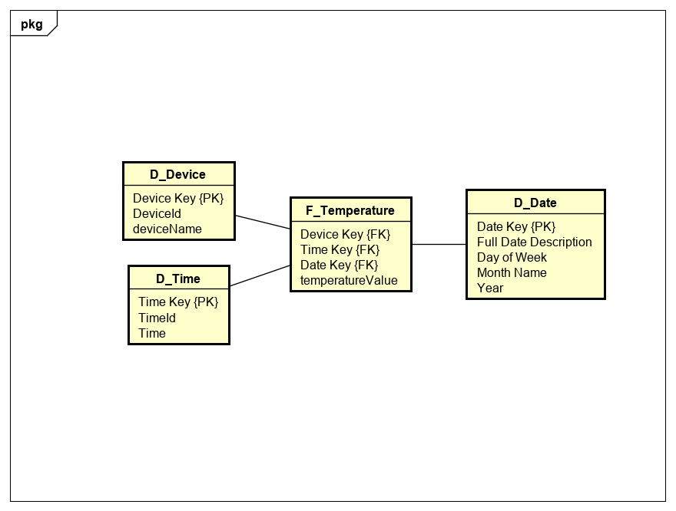

Figure - Temperature Dimensional Model

The date dimension allows for grouping of data by either a specific date or by more specific parameters such as the day of a week (e.g.: all Mondays), the moth or year. The time dimension is separate from the date in order to allow more in-depth analysis based on the value of the temperature at specific hours, as the temperature changes quite frequently. The device dimension allows to identify the specific piece of equipment that took the measurement.