**CSEE 5590-0002/COMP-SCI 490-0002: Web/Mobile Programming**

**Web Lab - Source Code – Lab1**

**Team id – 4**

**Team Members – Roshna Toke (23)**

**Manaswini(24)**

**Yamini(3)**

**Task-2: Snake Game**

**A] Introduction:**

Developing a basic Snake game using Angular, Typescript and Html. In this game user can select one of the three type. Score we are saving to check overall best score.

**B] Objective:**

Main Objective of this game is to get knowledge of Angular and Typescript by making this basic Snake game. Following are some instructions to play the game.

1. Player can use arrow keys for playing snake game in given square container. (Up/down/left/right)
2. There are three levels. (1. Classic, 2. No Walls, 3. Obstacles)
3. In classic game, player should not touch the walls of the container, if he/she touches then game will be over.
4. In No Walls game, there is not restrictions of the wall. Player can move anywhere on the board but, only snake should not touch itself otherwise game will be over.
5. In Obstacles mode, there are number of square obstacles on container, if snake touches that or itself or to the walls then game will be over.

**C] Approaches/ Methods:**

1. In component.html file we have created container and board view of game.

Also, the schema of view with the div elements.

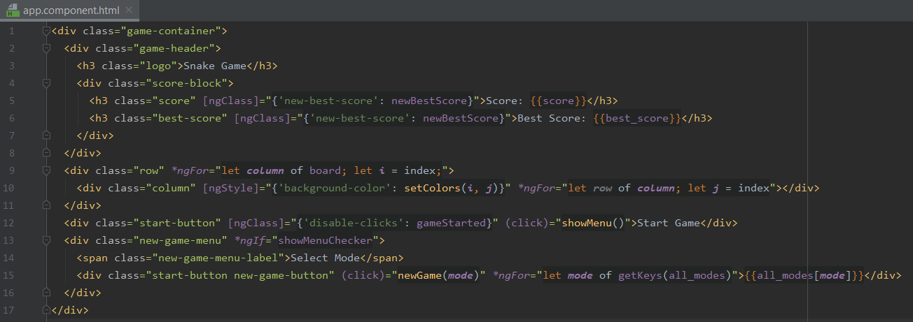

2. Based on players key event its next direction will get decided and next direction shouldn’t be in opposite direction of current way of snake.

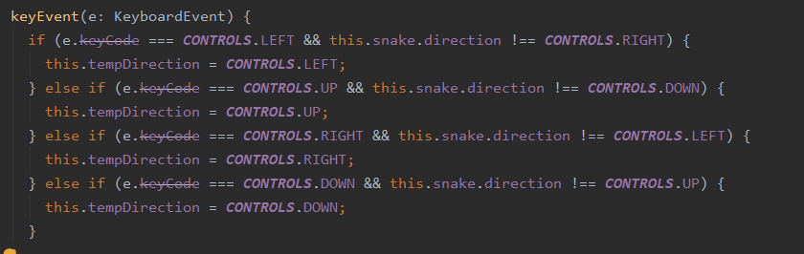

3.

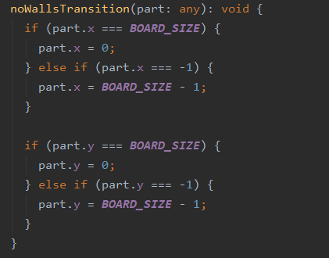

4. We added obstacles based on random number generation.

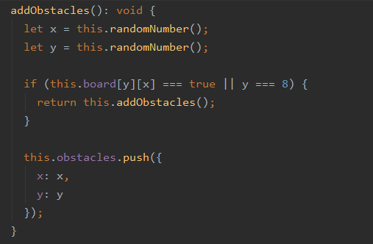

5. When player touches the walls or touches itself or collide with obstacles then following code will work.

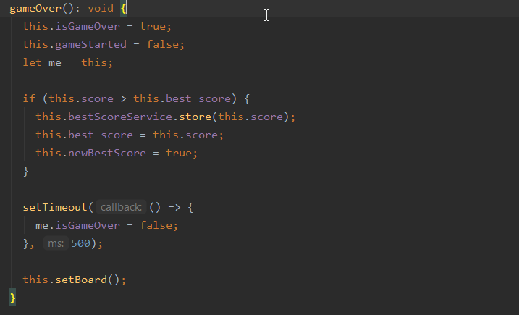

6.When user is making best score then previous best score gets updated. And, this code is written in service file so that other components also can use the same best score.

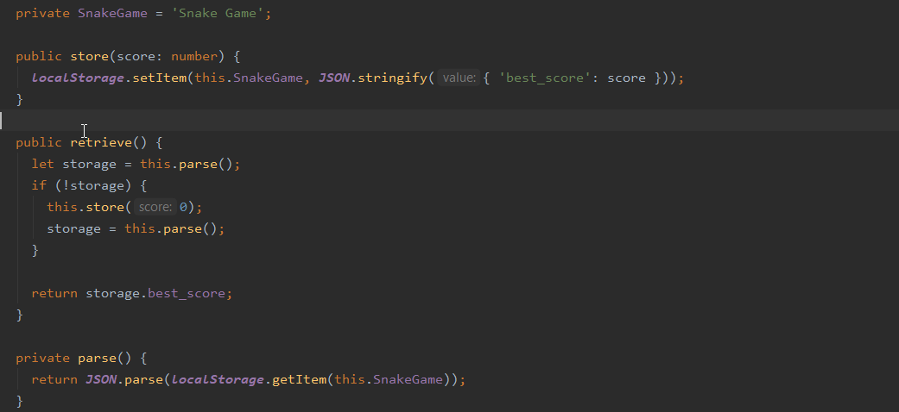

**D] Workflow:**

1. User Interface of Game:

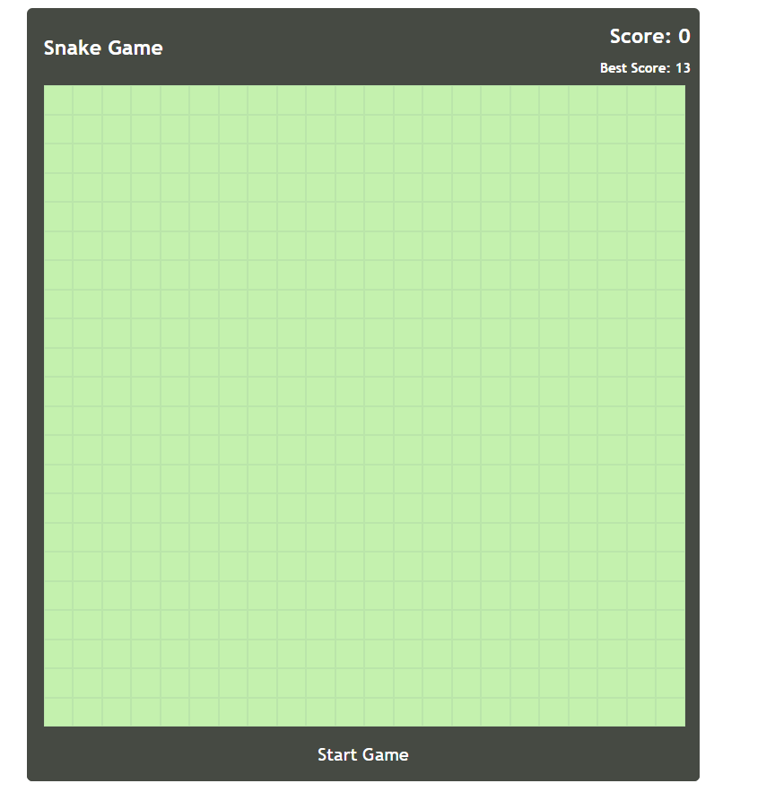

2. After Cling on start game, player can see three modes:

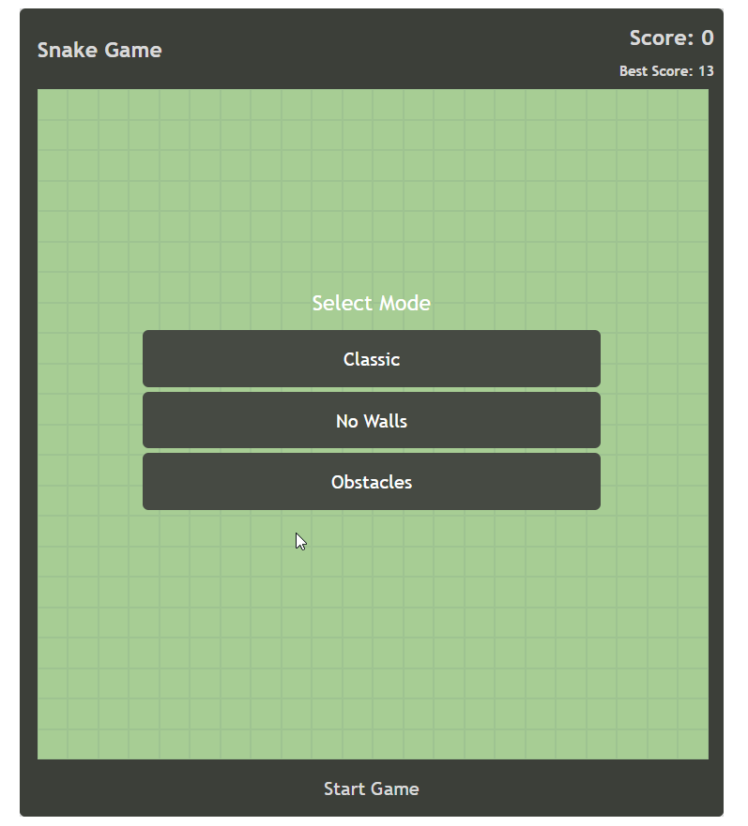

3. Classic Mode: When player touches the walls then game will be over.

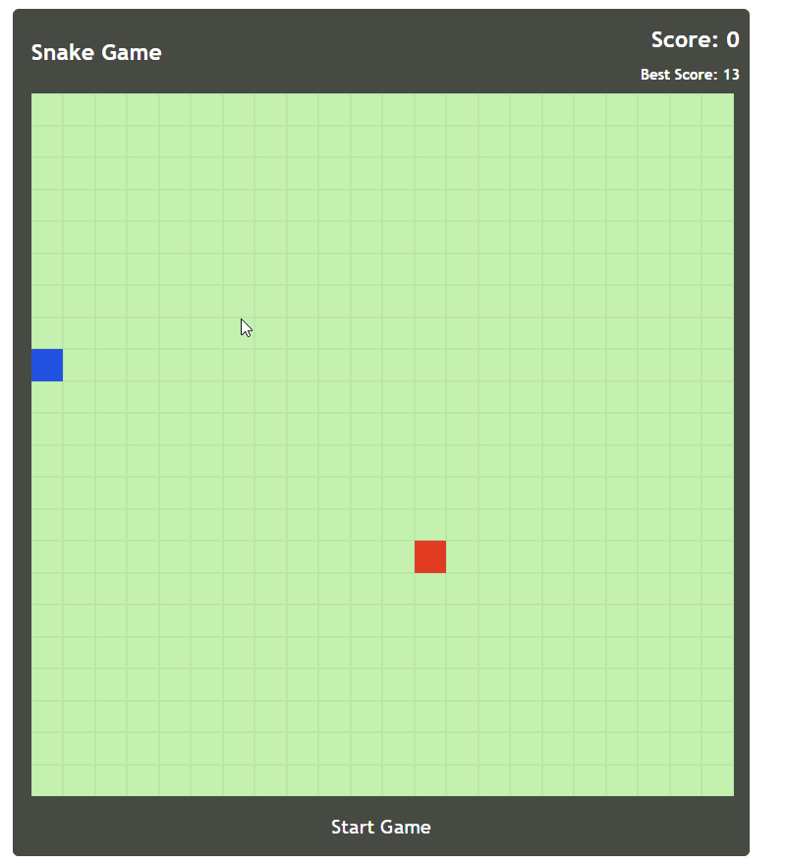

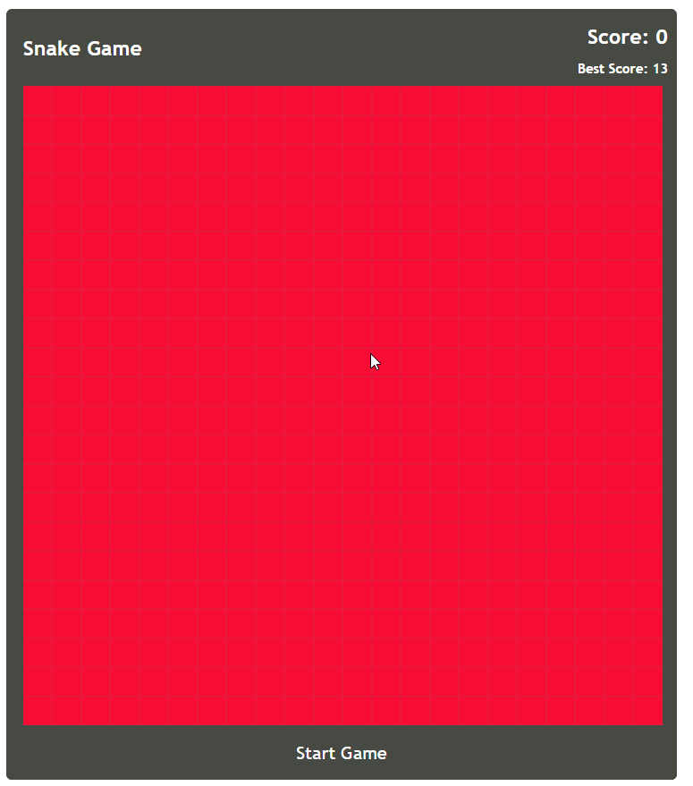

4. No walls: No restriction of walls but if it touches itself then game will be over.

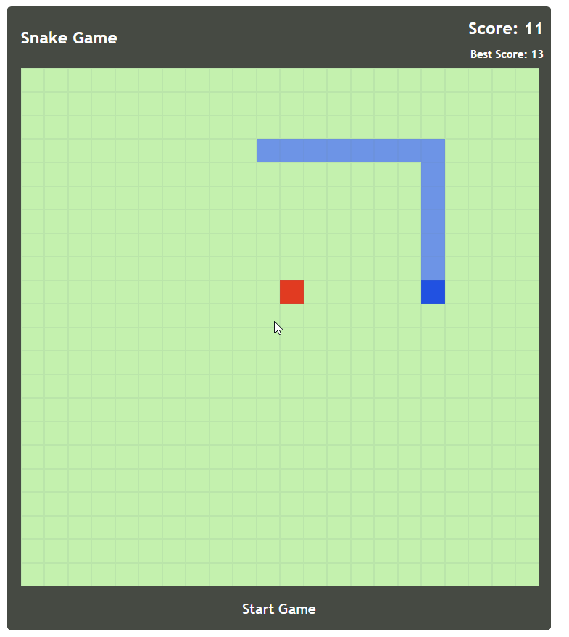

5.Obstacles mode: Snake should not touch walls and obstacles and itself, then game will be over.

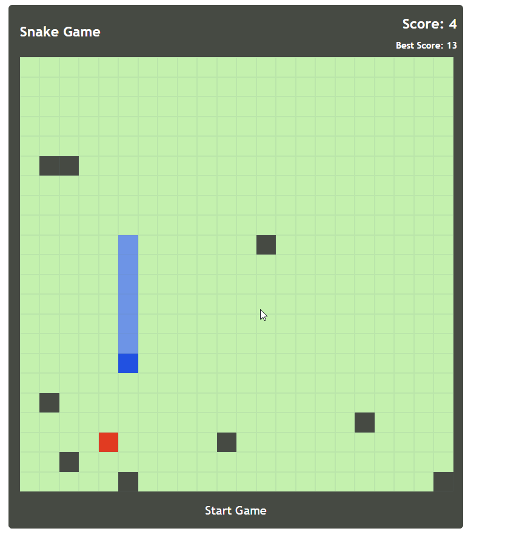

**E] Dataset and Parameters:**

We are using keycodes of arrow keys for snake movements (up/down/left/right).

Best Score is storing in local storage of Angular.

**F] Evaluation and Discussion:**

**Future Scope:** We will improve the design of snake, obstacles and by giving different fruit image for each level. Making page responsive by adding meta viewport tag.

**G] Conclusion:**

While developing this game, we got advance knowledge of Angular and its implementation in typescript. Also, learnt Snake game different functionalities.

**H] Links:**

Source Code:

<https://github.com/roshna1924/Web-Programming/tree/master/Lab1/SnakeGame/src>

Documentation:

<https://github.com/roshna1924/Web-Programming/wiki/Lab1>