Project Title
_______________________________

Submitted by
Student Name (Program-Roll#-Section)
Student Name (Program-Roll#-Section)

Session 2020-2024

Supervised by
Teacher Name



Department of Computer Science
Lahore Garrison University
Lahore

Project Title

A project submitted to the
Department of Computer Science
In
Partial Fulfillment of the Requirements for the
Bachelor’s / Master Degree in Computer Science
By
Student Names

Internal Supervisor
Teacher Name _______________________
Designation
Department of Computer Science

External Examiner _______________________

Chairperson
Dr. Muhammad Kashif Siddhu _______________________
Assistant Professor
Department of Computer Science

COPYRIGHTS
This is to certify that the project titled “Terra Alert” is the genuine work carried out by Student Names, student of BSCS of Computer Science Department, Lahore Garrison University, Lahore during the academic year 2015-19, in partial fulfilment of the requirements for the award of the degree of Bachelor of Computer Science and that the project has not formed the basis for the award previously of any other degree, diploma, fellowship or any other similar title.

Student Name ____________

Student Name ___________

DECLARATION
This is to declare that the project entitled “Terra Alert” is an original work done by undersigned, in partial fulfilment of the requirements for the degree “Bachelor of Science in Computer Science” at Computer Science Department, Lahore Garrison University, Lahore.
All the analysis, design and system development have been accomplished by the undersigned. Moreover, this project has not been submitted to any other college or university.

Group Members
Student Name ________________
Student Name ________________
Student Name ________________
Student Name ________________
Supervisor

Supervisor Name ________________

Date: ________________

DEDICATION

ACKNOWLEDGEMENTS

Table of Contents
To be added automatically through heading styles

List of Tables
To be added automatically through table captions styles

List of Figures
To be added automatically through figure captions

List of Abbreviation
This page will include all abbreviations used in the documentation and their full forms. The details are to be added by the student. (example given)
AI: Artificial Intelligence
AJAX: Asynchronous JavaScript and XML
API: Application Programming Interface
CDN: Content Delivery Network
CSS: Cascading Style Sheets
CSV: Comma-Separated Values
DB: Database
DFD: Data Flow Diagram
DIGD: Detected Information Gaps in Disasters
DOM: Document Object Model
ERD: Entity-Relationship Diagram
FYP: Final Year Project
GDACS: Global Disaster Alert and Coordination System
GUI: Graphical User Interface
HTML: HyperText Markup Language
HTTP: Hypertext Transfer Protocol
JSON: JavaScript Object Notation
JS: JavaScript
ML: Machine Learning
MVC: Model-View-Controller
NHC: National Hurricane Center
NLP: Natural Language Processing
NOAA: National Oceanic and Atmospheric Administration
NWS: National Weather Service
OSM: OpenStreetMap
REST: Representational State Transfer
RSS: Really Simple Syndication
SQL: Structured Query Language
SQLite: Structured Query Language (Lite)
SRS: Software Requirements Specification
SSR: Server-Side Rendering
TF-IDF: Term Frequency-Inverse Document Frequency
UML: Unified Modeling Language
USGS: United States Geological Survey
WSGI: Web Server Gateway Interface
XML: Extensible Markup Language

ABSTRACT
Disasters increasingly unfold in an environment characterized by information overload, fragmented reporting channels, and unequal public access to timely risk interpretation. Although credible agencies publish earthquake, weather, and hazard information continuously, the data is often distributed across heterogeneous formats and separate platforms, which makes it difficult for ordinary citizens and local responders to build a clear, local, and current understanding of danger. This Final Year Project, titled "Terra Alert: AI-Assisted Disaster Risk Awareness and Management System," addresses that gap through the design and implementation of a web-based disaster risk awareness and management system that aggregates multi-source incident data, classifies unstructured textual reports with a lightweight machine learning pipeline, computes a decaying risk probability score, and presents actionable alerts and precautions through an accessible dashboard. The proposed system follows a service-oriented monolithic architecture built with Python and Flask, integrates external feeds from disaster-monitoring agencies, normalizes incoming records, applies term-frequency inverse-document-frequency based text representation and logistic regression classification for disaster categorization, and stores curated reports and alerts in a relational database. To avoid presenting stale events as equally urgent, the system introduces an exponential time-decay model that gradually reduces the influence of aging reports while preserving the effect of severe and recent incidents. The final platform includes modules for data collection, classification, risk calculation, alert generation, historical alert persistence, guidance display, and basic administrative support through saved user preferences. The project scope focuses on four primary disaster classes—earthquake, flood, cyclone, and heatwave—and intentionally excludes high-density live mapping, large-scale asynchronous notification infrastructure, and deep learning deployment in the current version. Evaluation was conducted through narrative functional validation, module-level analysis, route testing, classifier workflow verification, and scenario-based testing of risk calculations and alert outputs. The resulting system demonstrates that a compact and academically feasible software solution can transform scattered disaster data into centralized, understandable, and practically useful public-awareness intelligence. The project concludes that an integrated, AI-assisted, web-based approach can improve risk visibility and decision support for end users, while future enhancements may expand the system through richer geospatial intelligence, multilingual processing, asynchronous ingestion, and more advanced contextual language models.

Chapter 1

INTRODUCTION
1.1 Background of the Study
Human societies have always lived under the influence of natural and environmental hazards, yet the digital age has transformed both the scale of available disaster information and the complexity of interpreting it. Citizens, relief organizations, and local administrators today can theoretically access unprecedented volumes of hazard data through websites, feeds, and public application programming interfaces. In practice, however, that abundance has not automatically translated into clarity. Earthquake reports may emerge from one system, weather advisories from another, and regional alerts from yet another platform, all expressed in different technical formats and with varying degrees of usability. This fragmentation places a burden on the end user, who is often expected to move across multiple interfaces and manually interpret whether an incident is still relevant, severe, and geographically meaningful. Early warning and risk communication literature consistently emphasizes that useful disaster intelligence is not merely a matter of raw data availability; it depends on timeliness, interpretability, consistency, and the ability to support action [1], [11], [12].
1.2 Project Context and Motivation
Terra Alert emerged from the recognition that public safety information is frequently available but insufficiently integrated. The project responds to a practical question: how can a modest but intelligently designed software system turn scattered, heterogeneous disaster feeds into a single understandable view of local risk? The motivating concern behind the project is not only delayed awareness, but also alert fatigue, a condition in which users are exposed to so many disconnected or repeated alerts that they struggle to distinguish what deserves immediate attention. Existing channels often announce the existence of a hazard without explaining how its urgency declines over time or how a user should respond in simple operational terms. The motivation for Terra Alert: AI-Assisted Disaster Risk Awareness and Management System is therefore both technical and social. Technically, it aims to unify feed ingestion, text classification, risk scoring, and interface delivery within a maintainable architecture. Socially, it aims to improve access to comprehensible hazard awareness for ordinary users who may not possess specialized domain knowledge.
1.3 Unmet Need and Problem Relevance
The unmet need addressed by this project lies at the intersection of data integration, localized interpretation, and user-facing communication. Many agencies publish trustworthy hazard data, but end users still lack a lightweight system that performs all of the following in one workflow: collects heterogeneous disaster reports, standardizes them, filters irrelevant entries, classifies loosely structured incident text, computes a meaningful risk summary, stores historical logs, and displays practical guidance alongside alerts. This need is relevant to the general public, to travelers who may be temporarily exposed to unfamiliar risk environments, and to local coordinators seeking an overview of multiple ongoing threats. From an academic perspective, the problem is also relevant because it combines software engineering, machine learning, database design, web development, and applied decision support into one coherent Final Year Project.
1.4 Aim of the Project
The central aim of Terra Alert: AI-Assisted Disaster Risk Awareness and Management System is to design, develop, and evaluate a web-based disaster risk awareness and management system capable of aggregating externally published hazard data, classifying incidents into meaningful categories, computing dynamic risk percentages, and presenting user-friendly warnings with precautionary guidance. The project does not seek to replace official emergency authorities; rather, it seeks to act as an intelligent interpretive layer that improves public understanding and accessibility.
1.5 Intended Users
The proposed system primarily serves two categories of users. The first is the general public, including residents and travelers who need a simple mechanism to check current disaster risk conditions for a selected location and receive immediate precautions. The second category consists of local administrators, volunteers, and emergency responders who may benefit from a condensed overview of active alerts synthesized from multiple external sources. In both cases, the system is designed for users who need interpretive support rather than raw feed access.
1.6 Project Objectives
The specific objectives of the project are to automate data ingestion from heterogeneous disaster feeds; classify unstructured incident text through a machine learning pipeline; formulate and implement a decaying risk calculation model; generate understandable warnings and safety guidance; maintain a persistent historical ledger of reports and alerts; and deliver the outcome through a responsive web dashboard. These objectives collectively translate the broad problem into implementable and testable software goals.
1.7 Significance of the Study
The significance of this study is twofold. First, it demonstrates how a compact academic system can bridge an important information gap in disaster awareness without requiring enterprise-scale infrastructure. Second, it shows the value of combining traditional software engineering with applied machine learning in a socially meaningful context. By transforming fragmented reports into risk-aware summaries, the project contributes to the practical discussion of digital resilience, risk communication, and data-informed public safety. The system also provides a useful case study in designing maintainable service modules, applying lightweight natural language processing methods, and integrating external data services responsibly [4]–[7], [10], [15].
1.8 Scope Overview
The scope of the current version includes ingestion of actively tracked disaster reports, normalization of externally published records, classification of four hazard types, storage of selected historical data, display of risk levels, and presentation of guidance content. The system does not include live push notifications, high-density geospatial rendering, broad multilingual support, or deep neural language models at this stage. These exclusions are deliberate and keep the project within the boundaries of an undergraduate software engineering implementation.
1.9 Report Organization
This report is organized into nine chapters. Chapter 1 introduces the domain, motivation, need, objectives, scope, and significance of the project. Chapter 2 presents the literature review and critically examines related systems, technologies, and research directions relevant to disaster awareness, early warning, information integration, and text classification. Chapter 3 defines the problem in analytical terms and establishes the gap between existing practice and the proposed solution. Chapter 4 documents the Software Requirement Specification, covering functional and non-functional requirements, assumptions, constraints, and user-oriented system expectations. Chapter 5 explains the methodology used to develop the system, including the development approach, workflow logic, technologies, and algorithms. Chapter 6 provides the detailed design and architecture of the project, including subsystem decomposition, interfaces, data flow, and diagram placeholders. Chapter 7 describes implementation choices and the testing strategy adopted to validate the system. Chapter 8 presents results and discussion, connecting observed outcomes to the requirements and objectives. Finally, Chapter 9 concludes the report by summarizing the contribution, discussing achievements and limitations, and proposing realistic future enhancements.
1.10 Chapter Summary
This chapter introduced the broader context of disaster information management, justified the need for an integrated awareness platform, described the purpose and scope of Terra Alert, and outlined the organization of the report. The following chapter builds on this foundation by reviewing relevant literature and technologies, thereby locating the project within existing academic and practical work.

Chapter 2

LITERATURE REVIEW
2.1 Introduction to the Review
The literature relevant to this project spans several intersecting domains: disaster risk reduction, early warning systems, public alerting standards, web-based information integration, software architecture for data-driven systems, and machine learning for text categorization. Because Terra Alert does not operate as a single-purpose forecasting engine but rather as a unifying and interpretive layer, the review must address both the hazard-communication domain and the enabling computing technologies. This chapter therefore examines existing theories, technical standards, tools, and system approaches in order to identify where current solutions remain insufficient for the specific problem addressed in this project.
2.2 Disaster Risk Reduction and Early Warning Systems
Disaster risk reduction literature consistently argues that effective warnings require more than simple event detection. A useful early warning system must support risk knowledge, monitoring, dissemination, communication, and response capability in an integrated manner [11]. In other words, a warning is effective only when information is timely, trusted, understandable, and actionable. Many early warning initiatives fail not because data is absent, but because messages are fragmented, delayed, or poorly contextualized for the communities they are intended to serve. Studies on disaster information ecosystems also show that coordination among institutions, standards, and data pipelines is a recurring challenge [12]. These observations directly support the premise of Terra Alert, which treats interpretation and integration as core design concerns rather than secondary interface features.
2.3 Public Alerting Standards and Structured Warning Exchange
The Common Alerting Protocol was introduced to create a general standard for exchanging all-hazard warning messages across different systems and media [1]. CAP is important not only because it standardizes warning content, but also because it demonstrates the value of normalization in alert ecosystems. When warnings can be represented consistently, they become easier to disseminate, compare, aggregate, and consume programmatically. However, in operational practice, not all disaster-related data sources expose information in a single uniform structure. Platforms may use RSS, Atom, JSON, GeoJSON, or agency-specific schemas. This means that systems like Terra Alert must implement practical normalization even when a conceptual standard such as CAP exists. The relevance of CAP to the project therefore lies less in direct protocol implementation and more in its architectural lesson: interoperability matters because warning value increases when multiple sources can be unified coherently.
2.4 Earthquake and Weather Data Services as Public Information Sources
Open-data services published by agencies such as the United States Geological Survey and the National Weather Service have become valuable foundations for modern risk-aware applications. The USGS earthquake feeds expose event information in GeoJSON, allowing applications to retrieve location, magnitude, time, and associated properties in a structured geospatial format [2], [16]. Similarly, the National Weather Service provides API-based access to forecasts, alerts, and observations through web-oriented interfaces [3], [17]. These resources significantly lower the barrier to building disaster-awareness software. Nevertheless, they also reveal a limitation: each source is designed according to its own operational priorities and data structures. A system that combines them must account for differing schemas, timestamp conventions, reliability expectations, and content semantics. This strengthens the case for a middleware layer capable of normalization, deduplication, and selective interpretation.
2.5 Information Fragmentation and Alert Fatigue
A recurring issue in disaster communication practice is the fragmentation of hazard information across specialized portals. One platform may focus on earthquakes, another on storms, and another on broad multi-hazard coordination. While specialization can improve domain depth, it also imposes cognitive overhead on users who must manually combine signals from multiple tools. In high-pressure scenarios, this overhead can delay response or lead to confusion. Moreover, repeated exposure to low-context alerts may induce alert fatigue, reducing user trust and responsiveness. Existing systems often prioritize dissemination volume over interpretive clarity. Terra Alert addresses this gap by introducing a synthesized risk view that reduces the need for users to interpret individual records separately.
2.6 Machine Learning for Text Classification in Risk Contexts
Text classification remains one of the most practical and widely adopted machine learning tasks for turning unstructured language into operational categories. For moderate-size academic projects and structured workflows, term-frequency inverse-document-frequency representations combined with linear classifiers remain especially attractive due to interpretability, efficiency, and robust baseline performance [8], [9], [13]. The TF-IDF model captures how strongly a term characterizes a document relative to the corpus, while logistic regression offers a mathematically grounded, regularized classification framework capable of handling sparse input vectors effectively [4], [5], [8]. In a context such as Terra Alert, where textual descriptions from feeds may not always explicitly include normalized labels, this approach provides a lightweight but meaningful mechanism for categorizing incident reports into hazard classes. Compared with deep contextual language models, the selected pipeline is easier to train, explain, serialize, and deploy within a constrained academic environment. Its limitations include weaker semantic understanding, reduced contextual nuance, and sensitivity to vocabulary coverage, but these trade-offs are acceptable within the project scope.
2.7 Related Approaches to Web-Based Hazard Dashboards
Many public-facing hazard dashboards emphasize visual monitoring, geospatial maps, and real-time feeds. Their strengths often include authoritative data sourcing and high-volume updates; however, they may assume technical familiarity or may not offer integrated explanatory guidance for non-expert users. Other systems focus on crisis mapping, emergency coordination, or public notification delivery rather than interpretive risk scoring. The conceptual distinction in Terra Alert is that it does not merely relay agency data. Instead, it seeks to aggregate, classify, contextualize, and compress that information into a location-oriented risk estimate with associated precautions. This positions the project somewhere between a feed aggregator, a lightweight decision-support portal, and a public-awareness dashboard.
2.8 Software Engineering Foundations Relevant to the Project
From a software engineering perspective, maintainability and modular decomposition are essential for systems that ingest external data and evolve over time. Standard texts emphasize that well-structured software should isolate concerns, reduce coupling, and preserve changeability across interfaces, data logic, and domain services [10], [15]. The application-factory pattern documented in Flask supports this aim by encouraging clean initialization and decoupled extension setup [6]. Likewise, test-driven or at least test-supported development practices improve the confidence and stability of route handlers, data-processing logic, and error conditions [7], [18]. Terra Alert draws on these principles by separating route orchestration, collection logic, classification, risk calculation, alert generation, utility functions, and database routines into distinct service modules.
2.9 Database Design and Persistence Considerations
Persistent storage is necessary not only for historical retrieval but also for deduplication, auditability, and interface continuity. Relational database theory provides a stable basis for managing structured records, even in systems that begin with semi-structured external data [14]. For a project such as Terra Alert, SQLite offers several practical advantages: lightweight deployment, no separate database server requirement, adequate performance for small-to-medium academic workloads, and straightforward integration with Python-based applications. Although more powerful database systems would be preferable for large-scale distributed environments, the use of SQLite in this project is justified by its simplicity, portability, and compatibility with the overall system scope.
2.10 Critical Comparison of Existing Options
In comparing available approaches, several patterns become visible. First, official agency feeds are authoritative but fragmented. Second, alerting standards promote consistency but are unevenly implemented across sources. Third, sophisticated dashboards exist but often assume specialized usage patterns or infrastructure beyond the scope of a university project. Fourth, modern deep learning methods may improve classification depth, but they introduce computational and deployment complexity that is not always necessary for a controlled multi-class classification task. Fifth, general-purpose web frameworks and testing ecosystems provide mature support for building maintainable data-driven applications. Terra Alert therefore adopts a pragmatic middle path: it draws on authoritative feed sources, uses a lightweight but defensible machine learning approach, and applies modular software engineering to deliver a coherent system within realistic academic constraints.
2.11 Research Gap
The review reveals a clear gap relevant to this project. There remains a need for an academically manageable, web-based, multi-source disaster awareness system that can collect heterogeneous hazard information, classify unstructured report text, compute a time-sensitive risk estimate, store historical alerts, and present simple precautionary guidance in one integrated workflow. Many existing tools address only one part of this chain. Terra Alert is proposed precisely to fill this gap through a compact, modular, and explainable software solution.
2.12 Chapter Summary
This chapter reviewed the conceptual and technical foundations underlying the project, including early warning principles, alerting standards, public hazard data services, machine learning for text classification, software engineering design practices, and database persistence. The review demonstrated that although many useful components already exist, they are rarely assembled into a single lightweight system that targets integrated risk awareness for non-specialist users. Chapter 3 now narrows this discussion into a formal problem definition.

Chapter 3

PROBLEM DEFINITION
3.1 Problem Background
The contemporary hazard-information landscape is rich in data but poor in unified interpretation. Authoritative agencies publish valuable updates regarding earthquakes, weather extremes, and other public-safety risks, yet those updates are often dispersed across different services, formats, and interfaces. A user attempting to understand local danger may need to search multiple sources, compare timestamps manually, and infer the practical meaning of each event independently. This situation is inefficient under normal conditions and potentially dangerous during high-risk periods.
3.2 Real-World Problem
The real-world problem addressed in this project is the absence of a simple and centralized mechanism through which ordinary users can view current disaster-related risk for a location of interest in an understandable and actionable form. Existing tools frequently focus on raw event listing, single-hazard specialization, or official warning delivery alone. They do not always provide a synthesized, decaying view of ongoing risk across multiple categories coupled with readable precautions.
3.3 Technical Problem
From a technical perspective, the problem can be decomposed into several sub-problems: heterogeneous data ingestion from multiple external sources; normalization of inconsistent payload structures; extraction and classification of semi-structured or unstructured incident text; elimination of duplicate or stale reports; estimation of current risk through a mathematically meaningful model; persistence of historical records; and delivery of results through a web interface that remains fast, clear, and maintainable. Each of these sub-problems requires careful design because failure in one stage affects the reliability of the whole system.
3.4 Stakeholders Affected
The stakeholders most directly affected are citizens, travelers, volunteer groups, and local support personnel who require a consolidated overview of possible hazards in a region. Secondary stakeholders include educators, researchers, and small institutions interested in demonstrating or extending practical risk-awareness software. The project is particularly relevant to users who do not wish to interpret raw technical feeds themselves.
3.5 Limitations of Current Approaches
Current approaches often exhibit one or more of the following limitations: they are confined to a single hazard type; they expose only raw data rather than interpreted risk; they depend on users understanding technical terminology; they do not model diminishing urgency over time; or they lack a unified archive of previously generated alerts. Consequently, even when accurate data exists, the user experience may still be fragmented and cognitively demanding.
3.6 Formal Statement of the Problem
The problem addressed by Terra Alert: AI-Assisted Disaster Risk Awareness and Management System may therefore be stated as follows: there is a need for a web-based software system that can automatically gather multi-source disaster information, classify relevant incident text, compute a current risk probability that decreases as reports age, preserve useful historical records, and present localized warnings and safety guidance in a centralized, understandable, and maintainable form.
3.7 Project Objectives Derived from the Problem
In direct response to the problem, the system must collect data from heterogeneous public sources, normalize and filter records into a consistent structure, classify incidents into supported hazard categories, compute a bounded risk percentage using severity and time decay, generate alert levels and messages, store reports and alerts in a persistent database, and expose the resulting intelligence through a user-friendly web dashboard and supporting pages.
3.8 Scope Boundaries of the Problem Solution
The solution is bounded intentionally. It does not claim to perform official forecasting, replace emergency authorities, or provide guaranteed real-time geospatial precision. It functions as an intelligent awareness layer rather than an operational emergency command system. Likewise, the current version does not implement SMS broadcasting, mobile push notifications, or deep map analytics. These boundaries keep the project academically coherent while still solving a meaningful portion of the broader problem.
3.9 Chapter Summary
This chapter transformed the broad motivation of the project into a precise real-world and technical problem statement. It identified who is affected, why current approaches remain insufficient, and what the proposed system must accomplish to address the gap. The next chapter translates these needs into a formal Software Requirement Specification.

Chapter 4

SOFTWARE REQUIREMENT SPECIFICATION
4.1 Introduction to the SRS
This chapter formalizes the requirements of Terra Alert in a structured manner so that the system scope, expected behaviors, quality attributes, and implementation boundaries remain clear. The SRS serves as a bridge between problem understanding and system realization. It identifies who will use the system, what services the system must provide, how the system should behave under expected conditions, and which constraints must be respected during implementation.
4.2 User Classes and Characteristics
The system serves citizens, travelers, emergency-support staff, and maintainers. Citizens require simplified awareness and precautionary guidance. Travelers require fast location-based summaries. Emergency-support staff require concise situational overviews. Maintainers require clear code organization, configuration control, and testability. Because these user groups differ in technical skill, the system was designed to present simple output while keeping the backend modular and extensible.
Table 1 – Software Requirements (Functional and Non-Functional)
User Class | Description | Typical Needs
General Public | Non-technical users checking local or searched disaster awareness information. | Simple dashboard, clear risk level, plain-language precautions.
Travelers | Users temporarily interested in a region outside their home area. | Fast location lookup, quick multi-hazard overview, concise guidance.
Emergency/Local Support Personnel | Semi-technical users requiring summarized incident awareness. | Recent alerts, consolidated history, basic situational overview.
System Maintainer | Academic developer or administrator managing configuration and updates. | Reliable data sources, manageable code structure, testability.
4.3 Functional Requirements
Table 2 – API Endpoints Summary
Requirement ID | Description
FR-1 | Collect disaster-related records from configured external sources such as JSON, GeoJSON, RSS, or Atom feeds.
FR-2 | Normalize incoming records into a unified internal representation.
FR-3 | Remove duplicate or substantially identical records before presentation.
FR-4 | Classify unstructured text into supported disaster categories using ML with fallback rules.
FR-5 | Calculate a risk percentage for a selected location using weighted scoring and exponential time decay.
FR-6 | Convert risk values into human-readable alert levels such as Low, Medium, and High.
FR-7 | Display current dashboard results for a user-specified location.
FR-8 | Provide an alerts page showing previously generated alerts from persistent storage.
FR-9 | Provide guidance and help pages with precautions and emergency-support information.
FR-10 | Expose an internal API endpoint for structured risk retrieval.
FR-11 | Validate user input and reject malformed requests gracefully.
FR-12 | Store historical reports and alerts for later retrieval and deduplication.
4.4 Non-Functional Requirements
Table 3 – Database Schema: disaster_reports, alerts, guidance
Quality Attribute | Requirement Statement
Performance | Interactive dashboard responses should remain acceptable for academic-scale use; most delay should come from external source latency rather than local computation.
Usability | The interface should remain understandable to non-specialist users and minimize navigation complexity.
Reliability | The system should continue operating with partial data if one external source fails or returns malformed content.
Maintainability | Modules should remain decoupled so source logic, classification, risk rules, and UI behavior can evolve independently.
Portability | The system should run on common Python-supported environments without heavy infrastructure.
Security | Validation, parameterized queries, and controlled exception handling should reduce common web and data-integrity risks.
Scalability | The architecture should permit later movement toward asynchronous ingestion and stronger persistence layers.
Testability | Services and routes should remain sufficiently isolated for pytest-based validation.
4.5 System Requirements
Hardware requirements for the academic prototype are modest and include a standard development machine capable of running Python, a web browser, and local storage for the database and serialized machine learning model. Software requirements include Python 3, Flask, Requests, Feedparser, BeautifulSoup4, Scikit-learn, Joblib, SQLite3, Jinja2 templating support, and Pytest for validation [4]–[7]. Because the application relies on public internet endpoints, network availability is also an operational requirement during live data collection.
4.6 Assumptions
The system assumes that configured external data sources remain reachable for at least part of the time, that their payloads remain broadly compatible with expected structures, and that reported timestamps are sufficiently well formed to permit normalization into UTC. It also assumes that the selected machine learning model has been trained on a representative enough set of class labels to distinguish the supported hazard categories within acceptable academic limits.
4.7 Constraints
The project operates under several constraints. It is limited to a defined set of disaster classes, a lightweight deployment profile, and a pull-based dashboard interaction model. It uses SQLite rather than a distributed production database, and it applies a classical text classification approach rather than resource-intensive transformer models. The system further depends on third-party data quality and cannot guarantee agency-level completeness or official legal warning authority.
4.8 Input and Output Requirements
Inputs to the system include externally fetched hazard feeds, location strings entered through the user interface, persisted preference data, and internal configuration files such as source lists and precaution mappings. Outputs include dashboard summaries, numeric risk percentages, qualitative alert levels, alert messages, guidance content, and JSON responses generated through the local API endpoint. Error outputs include validation messages and graceful route responses when malformed input or source failure is encountered.
4.9 Use-Case Oriented Requirements Explanation
In a typical use case, a user opens the homepage, proceeds to the dashboard, enters a location, and submits a request. The system then orchestrates the following requirement chain: data collection from configured feeds, normalization and deduplication, category assignment through classifier logic, score computation through the risk calculator, alert generation based on thresholds, database persistence for reports and alerts, and rendering of the resulting dashboard. In another use case, the user consults the alerts page to review historical high-priority messages. A third use case involves access to the guidance page for static precautionary information. These use-oriented flows help verify that the requirements are complete from the user’s perspective.
4.10 Chapter Summary
This chapter specified the software requirements that Terra Alert must satisfy. It identified the major user classes, defined functional and non-functional requirements, described assumptions, dependencies, constraints, and explained the expected input-output behavior of the system. Chapter 5 now explains the methodology used to convert these requirements into a working software solution.

Source | Purpose | Format | Used In | Notes
USGS all-day earthquakes | Earthquake event collection | GeoJSON | app/services/data_collector.py | Default disaster_type = earthquake
GDACS floods 7-day feed | Flood event collection | RSS | app/services/data_collector.py | Default disaster_type = flood
GDACS tropical cyclones 7-day feed | Cyclone event collection | RSS | app/services/data_collector.py | Default disaster_type = cyclone
NHC Atlantic and Eastern Pacific feeds | Cyclone / tropical storm monitoring | RSS / Atom-style feed | app/services/data_collector.py | Official NOAA/NHC content
NWS active alerts API | Heat advisory and warning collection | JSON | app/services/data_collector.py | Requires user-agent header
Nominatim search API | Geocoding typed place names | JSON | app/static/js/map.js | Used on the client side
Leaflet + Esri tile layer | Map rendering and interaction | JS / tile service | templates/*.html and app/static/js/map.js | Supports manual point selection
Local JSON files | Contacts, precautions, permanent location | JSON | data/* and app/services/permanent_location.py | Used for non-live reference content

Chapter 5

METHODOLOGY
5.1 Methodological Overview
Terra Alert was developed through a practical software engineering methodology that combined requirements-driven design, modular implementation, and iterative validation. The project did not follow an excessively formal enterprise lifecycle; however, it adhered to a disciplined sequence of problem analysis, architecture planning, component decomposition, implementation, testing, and refinement. The methodological priority was to preserve traceability between the problem statement, the chosen technologies, and the actual modules implemented in the system.
5.2 Development Approach
The development approach can best be described as iterative and incremental. Initial effort focused on clarifying system scope, supported hazards, data-source feasibility, and the minimal viable user journey. Once the scope was bounded, the application structure was established around a Flask application factory and a service-oriented monolithic design. Individual modules were then developed in parallel or sequence: data collection, classification, risk calculation, alert generation, persistence, and user interface rendering. Testing and revision accompanied each step rather than being postponed until the end.
5.3 Rationale for Tool Selection
Python was chosen because of its strong ecosystem for web development, data processing, testing, and machine learning. Flask was selected because it supports clear route management, lightweight deployment, and modular application-factory patterns without imposing unnecessary architectural overhead [6]. Scikit-learn was chosen because its TF-IDF and logistic regression components are mature, well-documented, computationally efficient, and appropriate for sparse text classification [4], [5]. SQLite was adopted because it is simple to integrate, portable, and sufficient for the scale of an academic prototype [14]. Pytest was used because it supports readable and extensible testing of routes and service logic [7].
5.4 Data Collection Methodology
The data collection methodology was designed to accommodate multiple remote source formats with a single normalization target. Configured endpoints are read from a source registry file and polled through HTTP requests. Depending on the source format, the collector parses JSON, GeoJSON, or feed-based content and extracts a stable subset of fields such as title, publication time, source identifier, and text content. Because externally published feeds vary in structure and completeness, the collector does not assume total uniformity. Instead, it applies conditional parsing logic, timestamp handling, and deduplication based on composite identifiers such as title, source, and publication time. [Insert Data Collection Workflow Figure Here]
5.5 Machine Learning Methodology
The machine learning methodology follows a supervised text classification workflow. A labeled dataset is prepared offline and used to train a pipeline based on TF-IDF vectorization and logistic regression classification. During training, text examples are transformed into sparse numerical feature vectors representing informative terms and n-grams [4], [8]. Logistic regression then learns a decision boundary for mapping those features to predefined hazard classes [5], [9]. The trained model is serialized and loaded by the application at runtime for prediction. A rule-based fallback layer is maintained so that the system can continue providing approximate categorization if the serialized model becomes unavailable or the environment prevents loading.
5.6 Risk Assessment Methodology
The risk assessment methodology is one of the central conceptual contributions of the project. Rather than treating all observed reports as equally urgent regardless of age, Terra Alert uses a weighted score multiplied by an exponential decay factor. In simplified form, each event contributes a score of Base Points × Severity Multiplier × e^(-Age/Half-Life). This means that the influence of a report naturally declines as time passes, while still allowing severe and recent incidents to dominate the risk estimate. The final risk is bounded to a 0–100 range and translated into qualitative levels through threshold rules. [Insert Risk Decay Formula Figure Here]
5.7 Alert Generation Methodology
Once the risk score is produced, the system generates alert messages through a deterministic mapping layer. Thresholds determine whether the resulting state is classified as low, medium, or high. The alert generator then constructs a message suitable for presentation to non-technical users. Deduplication checks are also applied before persistence so that users are not repeatedly shown identical messages within a narrow time window.
5.8 User Interface Methodology
The interface methodology prioritizes clarity, low cognitive load, and server-side simplicity. Jinja2-based templates render views directly from validated backend context rather than relying on a complex client-side framework. This decision supports fast development, broad compatibility, and easier reasoning about data flow. The pages were organized according to common user intent: homepage for orientation, dashboard for current risk, alerts for historical review, and guidance/help for preparedness information.
5.9 Testing and Validation Methodology
Validation was performed iteratively at both module and system levels. Unit-oriented checks were used for calculator boundaries, classification fallback behavior, and utility parsing logic, while integration-oriented testing was applied to routes and request-response behavior using Flask’s testing support and pytest fixtures [7], [18]. In addition to automated checks, narrative functional validation was carried out by manually exercising dashboard flows, malformed inputs, and alert-history retrieval.
5.10 Limitations of the Methodology
The methodology is appropriate to the project scope but not without limitations. The machine learning model depends on the representativeness of the training corpus and does not capture deep contextual semantics as advanced transformer models might. The data collection approach also depends on external agency availability and schema continuity. Similarly, the risk model is intentionally interpretable rather than probabilistic in a fully scientific forecasting sense.
5.11 Chapter Summary
This chapter explained the methodological foundation of Terra Alert, including the development strategy, rationale for the selected tools, data collection procedure, machine learning workflow, risk scoring logic, user interface design approach, and testing methodology. The next chapter translates these methods into the detailed system architecture and design of the proposed solution.

Chapter 6

DETAILED DESIGN AND ARCHITECTURE
6.1 System Architecture
The architecture of Terra Alert was designed to satisfy a multi-stage processing problem while remaining understandable, maintainable, and appropriate for an academic deployment environment. At the highest level, the system must receive a user request, collect external disaster data, normalize and classify reports, compute risk, generate alerts, store meaningful records, and present the result through a web interface. These responsibilities were partitioned into cooperating layers rather than implemented as a single opaque block. The chosen decomposition resembles a service-oriented monolith in which all components are deployed together, yet internal responsibilities are strongly separated into routes, services, models, utilities, data assets, and machine learning artifacts. This architecture was selected because it provides simplicity of deployment while still preserving modular reasoning and future extensibility [6], [10], [15].
6.1.1 Architecture Design Approach
The architectural design approach followed the principle of separation of concerns. Presentation concerns were isolated inside templates and routes; domain logic was encapsulated within service modules; persistence responsibilities were assigned to a database layer; reusable helpers such as timestamp parsing were assigned to utility modules; and model artifacts were stored outside the request handlers. This approach was chosen over a tightly interwoven script-based implementation because the project deals with multiple data paths and evolving requirements.
6.1.2 Architecture Design
The overall system architecture can be described in five collaborating layers: the presentation layer consisting of HTML/Jinja2 templates and Flask routes, the application orchestration layer responsible for coordinating requests, the service layer containing collection, classification, calculation, and alert generation modules, the persistence and configuration layer containing SQLite storage plus JSON-based static data files, and the external data-source layer consisting of remote disaster-monitoring endpoints. [Insert Architectural Diagram Here]
6.1.3 Subsystem Architecture
At subsystem level, Terra Alert is divided into the route/controller subsystem, data collection subsystem, classification subsystem, risk calculation subsystem, alert subsystem, persistence subsystem, utility subsystem, configuration/data asset subsystem, and presentation subsystem. [Insert Top-Level DFD Here] [Insert Sequence Diagram Here] [Insert Subsystem Model Here]
6.2 DETAILED SYSTEM DESIGN
The major software components are the route/controller layer, data collection subsystem, classification subsystem, risk calculation subsystem, alert generation subsystem, persistence subsystem, utility/configuration subsystem, and presentation subsystem. Each of these components has a distinct classification, definition, set of responsibilities, interactions, and resource profile, thereby making the system auditable and easier to explain during project defense.
6.2.1 Classification
The route layer is a subsystem and module set; the collector, classifier, calculator, alert generator, and persistence layer are service or model modules; utility code is a support package; and templates form the presentation subsystem.
6.2.2 Definition
Each component has a clear semantic role: routes receive requests, collectors fetch and normalize data, classifiers assign categories, calculators compute dynamic risk, alert generators produce warnings, persistence modules store and query historical data, utilities provide reusable helpers, and templates render final output.
6.2.3 Responsibilities
The responsibilities of these components collectively cover all system requirements. The decomposition prevents one file or class from becoming overloaded with unrelated concerns and makes future changes more manageable.
6.2.4 Constraints
Constraints include dependence on external feeds, synchronous request-response timing, SQLite concurrency limitations, training-data quality, and the bounded scope of hazard categories and interface behavior.
6.2.5 Composition
The system is composed of application folders such as app, app/models, app/services, app/utils, templates, data, ml, and tests. This composition reflects functional cohesion and supports maintainability.
6.2.6 Uses/Interactions
Routes invoke services; services consume utilities and persistence functions; templates consume route-provided context; the database layer serves alerts and reports; and the ML artifact is loaded by the classifier module. [Insert Component Diagram Here]
6.2.7 Resources
Resources include HTTP connections, CPU time for parsing and inference, the SQLite database file, JSON configuration files, the serialized classifier artifact, and Flask/Jinja2 runtime structures.
6.2.8 Processing
Processing follows a repeatable flow: validate user input, fetch remote records, normalize structures, classify text, compute weighted risk with decay, generate alerts, persist relevant items, and render results. The flow is deterministic except where remote data availability varies.
6.2.9 Interface/Exports
The system exports browser-facing pages such as home, dashboard, alerts, guidance, and help, plus machine-facing output through an internal API endpoint returning structured JSON. [Insert Use Case Diagram Here]
6.2.10 Detailed Subsystem Design
The detailed subsystem design should be supported with the following project-specific diagrams: [Insert Use Case Diagram Here], [Insert ER Diagram Here], [Insert Architectural Diagram Here], [Insert Activity Diagram Here], [Insert Sequence Diagram Here], [Insert Component Diagram Here], [Insert State Machine Diagram Here], [Insert Class Diagram Here], [Insert Data Flow Diagram Here], and [Insert Database Diagram Here]. These figures should map directly to the implemented modules and workflows.
6.3 Chapter Summary
This chapter explained the architecture and detailed system design of Terra Alert. It described the rationale for decomposing the system into coordinated subsystems and documented the major components using classification, definition, responsibilities, constraints, composition, interactions, resources, processing, and interface views. The next chapter turns from design to realization by discussing implementation choices and testing strategy.

Chapter 7

IMPLEMENTATION AND TESTING
7.1 Implementation Environment
The implementation of Terra Alert was carried out using Python 3 as the primary development language and Flask as the web application framework. The environment included a local development server, a browser-based interaction layer, SQLite for persistent storage, and a set of Python libraries for HTTP communication, feed parsing, machine learning, and testing.
7.2 Core Implementation Strategy
The implementation strategy followed the architectural decomposition defined earlier. Thin route handlers were implemented first to establish the navigational skeleton of the application. Service modules were then built and connected incrementally so that each major concern—data collection, classification, risk computation, alert generation, and persistence—could be tested in relative isolation.
7.3 Backend Implementation
The backend uses Flask routes to orchestrate request handling, invoke services, and return rendered templates or JSON responses. The application-factory pattern helps isolate initialization concerns and improves testability [6], [18]. Configuration values are loaded dynamically and service modules are imported within a coherent application structure.
7.4 Frontend Implementation
The frontend is intentionally lightweight and based on server-side rendering using HTML, CSS, and Jinja2 templates. This choice avoided unnecessary client-side complexity and allowed the interface to remain tightly synchronized with backend-generated context.
7.5 Machine Learning Implementation
The machine learning implementation was separated into an offline training pipeline and an online inference layer. During training, labeled text examples were transformed with TF-IDF vectorization and used to train a logistic regression classifier [4], [5], [8]. The resulting model artifact was serialized using Joblib and loaded at runtime for fast predictions.
7.6 Database Implementation
SQLite was implemented as the project’s relational persistence layer, enabling storage of disaster reports, alerts, and related records. Automatic initialization routines ensure that the database schema can be created on first run when configured to do so. Parameterized queries were used to reduce injection risk and preserve data integrity.
7.7 Error Handling and Validation
The implementation includes defensive checks at multiple points. User input submitted through forms or APIs is validated before processing. Malformed JSON or invalid coordinate-related values in API contexts are rejected with controlled error responses. External request failures, timeout issues, or parse problems are handled gracefully so that a single bad source does not collapse the entire application flow.
7.8 Testing Strategy
The testing strategy combined unit-style validation, integration testing, and manual functional walkthroughs. Unit-oriented tests targeted calculator logic, classifier fallback behavior, date parsing, and threshold mappings. Integration-style tests targeted Flask routes using the application’s test client and Pytest-based fixtures [7].
7.9 Representative Test Cases
Representative tests included verifying that the dashboard route responds correctly to valid location submissions, confirming that malformed API requests produce appropriate client-error responses, ensuring that risk scores remain bounded between 0 and 100, confirming that stale events have lower influence than fresh events, checking that duplicate alerts are not inserted repeatedly within the configured window, and validating that the classifier returns a supported category or fallback output instead of causing runtime failure. [Insert Test Case Table Here]
7.10 Accuracy, Performance, and Scalability Analysis
In the context of this project, accuracy is interpreted primarily as functional correctness and classification appropriateness rather than scientific prediction of disasters. The classifier’s effectiveness depends on the training corpus and the lexical similarity of live texts to training examples; nonetheless, the selected TF-IDF plus logistic regression approach is a defensible and efficient baseline for multi-class text classification [4], [5], [8]. Performance is satisfactory for an academic web system because the heaviest operations involve modest HTTP fetches and lightweight linear-model inference. Scalability is adequate for prototype usage but not unlimited: synchronous feed polling and SQLite persistence would become bottlenecks under high concurrency or large-scale deployments.
7.11 Comparison Against Original Specifications
The implemented system aligns strongly with the original specification. It performs heterogeneous data collection, normalization, classification, risk calculation, alert generation, persistence, guidance display, and basic API exposure. Areas intentionally left incomplete—such as push notifications, advanced map rendering, and large-scale asynchronous orchestration—were excluded by design rather than omitted unintentionally.
7.12 Chapter Summary
This chapter described how the proposed system was implemented and how it was tested. It discussed the development environment, code organization, machine learning integration, persistence choices, validation strategy, and critical analysis of accuracy, performance, and scalability. Chapter 8 now presents the resulting behavior of the system and interprets the findings in relation to the problem and objectives.

Chapter 8

RESULTS AND DISCUSSION
8.1 Evaluation Overview
The evaluation of Terra Alert focused on whether the proposed solution actually addresses the previously defined need for centralized, interpretable disaster awareness. Because the project is not a forecasting engine, evaluation was centered on system behavior, workflow coherence, feature completeness, classification utility, alert clarity, and consistency with requirements.
8.2 Functional Results
The system successfully demonstrated the complete intended workflow: user input acceptance, multi-source data collection, normalization, category assignment, risk scoring, alert generation, storage of historical information, and final rendering in a web dashboard. This is a meaningful result because the project’s primary contribution lies in integrating previously disconnected activities into a single user-facing pipeline.
8.3 Behavior of the Risk Model
One of the most important observed outcomes is the practical usefulness of the time-decay model. When recent events are present, the risk percentage becomes correspondingly elevated, but when events age without continued reinforcement, their influence declines. This behavior is preferable to a naive summation strategy because it avoids preserving panic around outdated information. [Insert Risk Trend Figure Here]
8.4 Discussion of Classification Results
The machine learning component provided a useful mechanism for assigning categories to reports whose labels were not already explicit. Within the bounded scope of four classes, the TF-IDF and logistic regression pipeline offered a good trade-off among training simplicity, inference speed, explainability, and runtime feasibility. Its main strength was that it could be deployed reliably in a lightweight application environment. Its main weakness is limited contextual depth.
8.5 User-Facing Discussion
From a user-facing perspective, the dashboard model proved valuable because it transformed technical feed outputs into an understandable combination of percentage, level, and narrative alert. The guidance and help pages strengthened this outcome by pairing awareness with action-oriented information.
8.6 Requirement Coverage Discussion
The results show strong coverage of the major requirements specified earlier. Data ingestion, report normalization, classification, risk assessment, alert generation, alert persistence, and dashboard presentation were all demonstrably achieved. Non-functional goals such as maintainability, testability, and simplicity were also supported through modular design and use of established frameworks.
8.7 Strengths of the Proposed Solution
The principal strengths of Terra Alert include its integrated workflow, explainable scoring logic, practical machine learning deployment, modular design, and human-oriented presentation. The project demonstrates that even within a constrained academic setting, it is possible to build a socially relevant system that converts fragmented technical data into structured awareness.
8.8 Weaknesses and Limitations
The weaknesses of the solution are equally important to acknowledge. The geographic relevance model is limited, because the current system does not incorporate advanced population-density context, sophisticated geospatial proximity analysis, or multilingual localization. The classifier is classical rather than contextual, and external data quality is outside the system’s control. Moreover, the use of synchronous collection and SQLite constrains growth under heavier loads.
8.9 Test Coverage and Use-Case Coverage
The testing strategy covered the principal user and system flows defined in the use-case perspective. Dashboard submission, API validation, risk computation boundaries, duplicate alert prevention, and history retrieval all received attention. While full browser automation and large-scale stress testing were not comprehensively performed, the implemented tests were sufficient to demonstrate that the major use cases are operational. [Insert Test Results Table Here]
8.10 Overall Interpretation
Taken as a whole, the results support the conclusion that Terra Alert meets its stated academic and functional goals. The project successfully solves a meaningful portion of the identified problem by consolidating disaster information, reducing interpretive burden, and presenting dynamic risk information in a user-centered form.
8.11 Chapter Summary
This chapter evaluated the observed outcomes of the proposed system and discussed them critically in relation to the requirements and objectives. It highlighted functional success, interpretive value, and implementation strengths while also acknowledging limitations and areas for improvement. The final chapter concludes the report and proposes future directions.

Chapter 9

CONCLUSION AND FUTURE WORK
9.1 Conclusion
This Final Year Project set out to address a clear and practical problem: disaster-related information is often available, but it is fragmented, inconsistently structured, difficult for non-specialists to interpret, and insufficiently centralized for quick risk awareness. The proposed system, Terra Alert: AI-Assisted Disaster Risk Awareness and Management System, was designed as an integrated response to that problem. By combining multi-source data collection, normalization, lightweight text classification, exponential time-decay risk scoring, alert generation, historical persistence, and a web-based dashboard, the project delivered a coherent solution that directly addresses the gap identified in the introductory and problem-definition chapters.
9.2 Achievement of Objectives
The project substantially achieved its stated objectives. It implemented ingestion of heterogeneous disaster feeds, introduced a functional machine learning categorization pipeline, formulated and applied a decaying risk model, produced readable alert outputs, preserved records in a relational database, and exposed the overall workflow through accessible interface pages. In doing so, the project demonstrated an effective union of software engineering, machine learning, database design, and user-centered presentation within a single academic system.
9.3 Evidence That the Problem Was Addressed
The evidence that the problem was addressed lies in the operational behavior of the completed system. Users can view a centralized dashboard rather than navigating multiple external services separately. Reports are no longer treated as isolated raw items; they are classified, weighted, and converted into risk-aware summaries. Historical alerts can be revisited, and guidance content supports interpretation with practical action. Testing and evaluation showed that the core requirements were met and that the system behaves consistently with the intended design.
9.4 Academic and Practical Contribution
The academic value of the project lies in showing how a socially relevant software system can be engineered through disciplined modular design and lightweight machine learning. The practical value lies in the production of a usable prototype that transforms scattered external feeds into a unified and understandable awareness platform.
9.5 Future Work
Several realistic and technically meaningful directions are available for future work. First, the classification component can be improved through contextual transformer-based language models that capture semantics beyond keyword frequency. Second, asynchronous ingestion frameworks such as task queues and schedulers can be introduced to decouple data collection from request-response latency. Third, the persistence layer can be migrated from SQLite to a more scalable database management system suitable for concurrent production use. Fourth, geospatial analysis can be enhanced through coordinate-aware proximity modeling, map integration, and population-sensitive impact estimation. Fifth, multilingual support can improve accessibility for broader audiences. Sixth, push-based notification channels such as email, SMS, or mobile alerts can extend the system from a pull-oriented dashboard into a proactive warning assistant.
9.6 Final Remarks
Terra Alert demonstrates that a well-scoped undergraduate project can contribute meaningfully to a serious public-interest domain. The system does not attempt to solve every aspect of disaster management; instead, it addresses a carefully selected and highly relevant portion of the problem: turning fragmented disaster data into centralized, interpretable, and actionable awareness.

REFERENCES
[1] OASIS, “Common Alerting Protocol Version 1.2,” 2010.
[2] United States Geological Survey, “GeoJSON Summary Format,” Earthquake Hazards Program, accessed Apr. 1, 2026.
[3] National Weather Service, “API Web Service Documentation,” NOAA, accessed Apr. 1, 2026.
[4] Scikit-learn Developers, “TfidfVectorizer,” Scikit-learn Documentation, accessed Apr. 1, 2026.
[5] Scikit-learn Developers, “LogisticRegression,” Scikit-learn Documentation, accessed Apr. 1, 2026.
[6] Flask Documentation Team, “Application Factories,” Flask Documentation, accessed Apr. 1, 2026.
[7] pytest Development Team, “pytest Documentation,” accessed Apr. 1, 2026.
[8] C. D. Manning, P. Raghavan, and H. Schütze, Introduction to Information Retrieval. Cambridge, U.K.: Cambridge University Press, 2008.
[9] T. M. Mitchell, Machine Learning. New York, NY, USA: McGraw-Hill, 1997.
[10] I. Sommerville, Software Engineering, 10th ed. Boston, MA, USA: Pearson, 2016.
[11] R. Sakić Trogrlić et al., “Early Warning Systems and Their Role in Disaster Risk Reduction,” in Handbook of Disaster Risk Reduction for Resilience, Cham, Switzerland: Springer, 2022.
[12] M. van den Homberg and B. McQuistan, “Information management and data ecosystems for early warning and disaster risk reduction,” International Journal of Disaster Risk Reduction, vol. 50, 2020.
[13] M. A. Hall, I. H. Witten, and E. Frank, Data Mining: Practical Machine Learning Tools and Techniques, 4th ed. Cambridge, MA, USA: Morgan Kaufmann, 2016.
[14] A. Silberschatz, H. F. Korth, and S. Sudarshan, Database System Concepts, 7th ed. New York, NY, USA: McGraw-Hill, 2019.

Diagrams

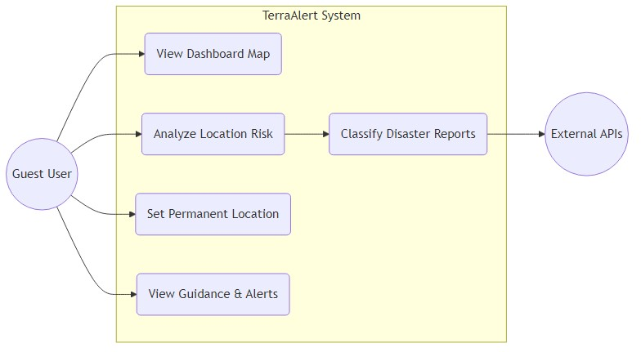
Figure 1 – Use Case Diagram – TerraAlert System Use Cases

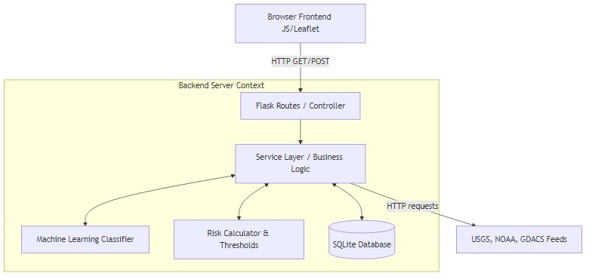
Figure 2 – System Architecture Diagram – High-Level MVC Architecture

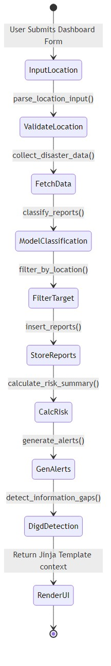
Figure 3 – Activity Diagram – Location Risk Analysis Flow

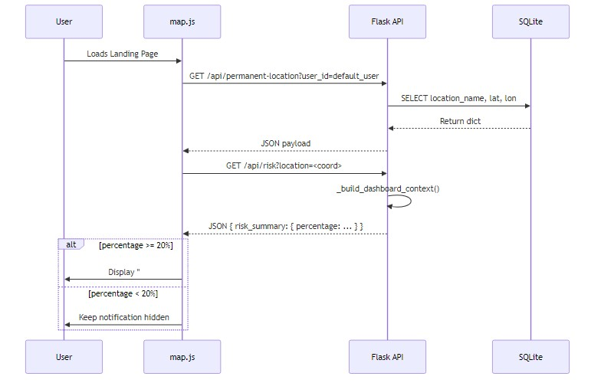
Figure 4 – Sequence Diagram – Permanent Location Loading and Warning Intercept

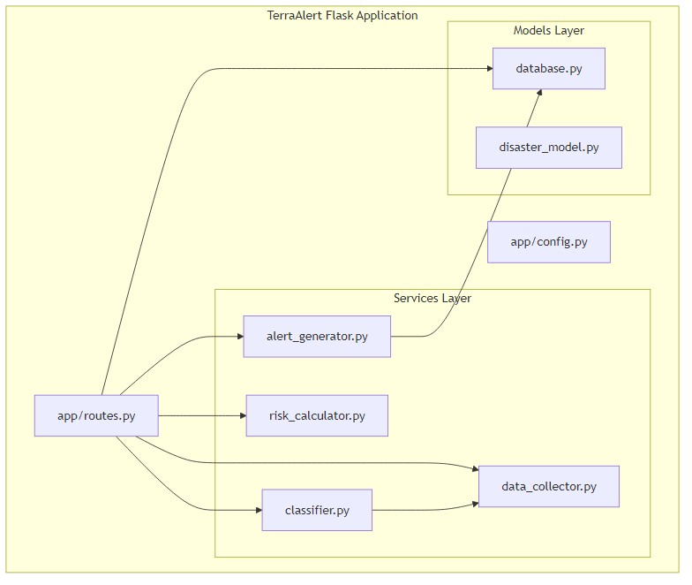
Figure 5 – Component Diagram – Core Business Logic Modules

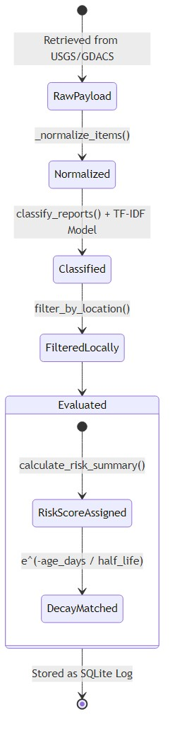
Figure 6 – State Machine Diagram – Disaster Event Lifecycle

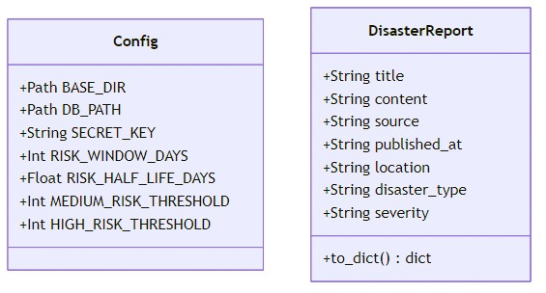
Figure 7 – Class Diagram – Domain Entity Model

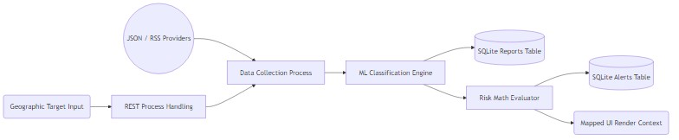
Figure 8 – Data Flow Diagram – Level 1 Application Data Flow

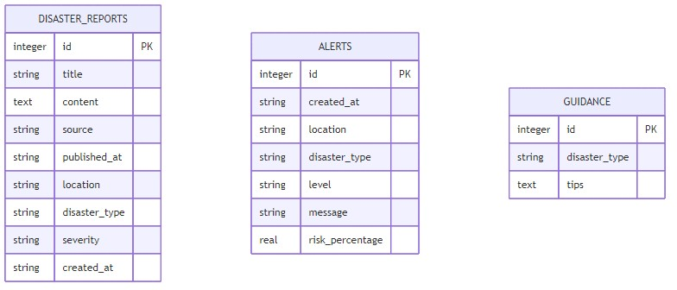
Figure 9 – ER Diagram – TerraAlert SQLite Database Schema

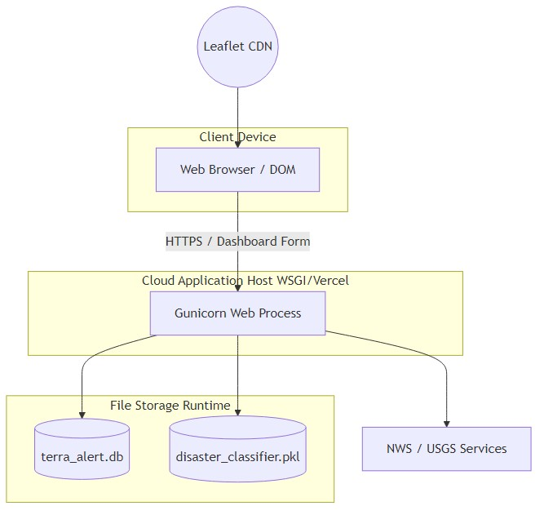
Figure 10 – Deployment Diagram – Cloud Deployment Architecture

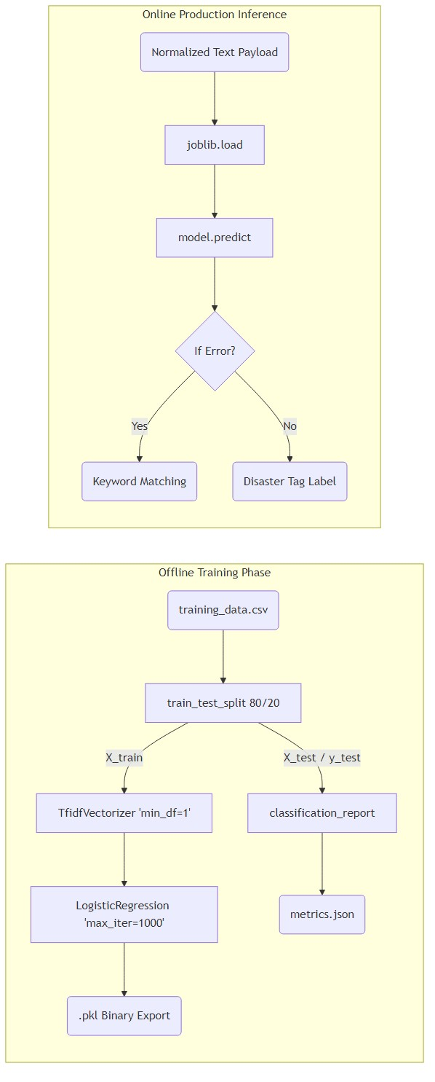
Figure 11 – ML Pipeline Diagram – Training and Inference Flow

