**Using the Application**

This document is a manual explaining how the game application works as well as the rules of the game. Click Play Game to begin the game.

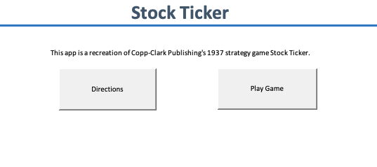

*Click Play Game to begin the game*

When you click Play Game, you'll be asked whether to open a new account by choosing "new User" or log into a current saved account by clicking "Existing User."

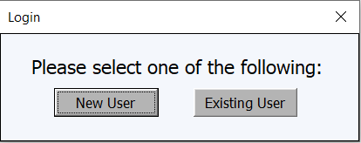

*Choose one of the two options*

When you establish a brand-new account, this screen will appear; if your username isn't yet in the database, a new account would be established.

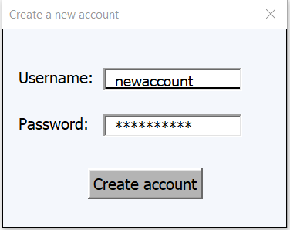

*A new account will be made with the username and password you enter*

If you are attempting to log into an existing account, you will be prompted to login instead.

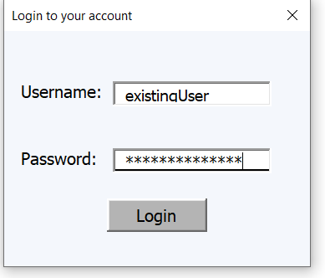

*If the username and password entered match the information stored in the database you be entered into your saved game.*

All passwords are hashed using the SHA-1 hashing algorithm and then stored securely inside an access database.

Passwords are stored securely in hashes instead of plain text.

Once you have created a new account or logged into an existing account (that still had time remaining) then you be directed into the game.

**Game Rules**

**Start**

A player begins the game with $5000 and has the option to buy any of the following six stocks in increments of 500, 1000, or 2000: gold, silver, bonds, oil, industrial, or grain. Each stock starts with a par value of 100 ($1 or 100 cents), and the user can acquire as many (or as few) stocks as they choose. You'll have 10 minutes to generate as much money as you can while attempting to beat the high score. Remember to buy low and sell high.

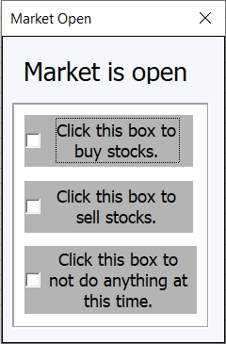

*Each time the market opens this menu will pop up, the first two options take you to identical screens to buy and sell stocks, the third simply returns you to the game.*

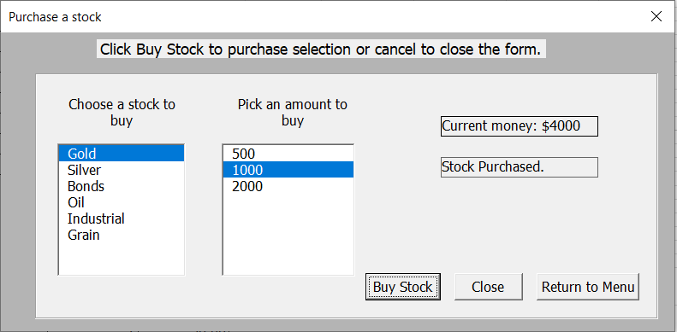

*To purchase a stock, first select the stock title and then the value. The stock will be acquired if you have sufficient money. The Close button will bring you to the game, and Return to Menu will take you back to the previous screen, where you may sell stocks as well.*

**The Play**

The activity of the stocks is governed by three dice rolls. The first die indicates the stock, the second the quantity (5, 10, or 20), and the third the action (up, down or dividend). The up and down motions of the defined stock are quite evident, with the defined stock moving in the given direction by the stated amount.

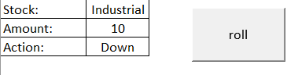

*On the left, results of the dice roll are displayed. The roll button rolls all 3 dice at once.*

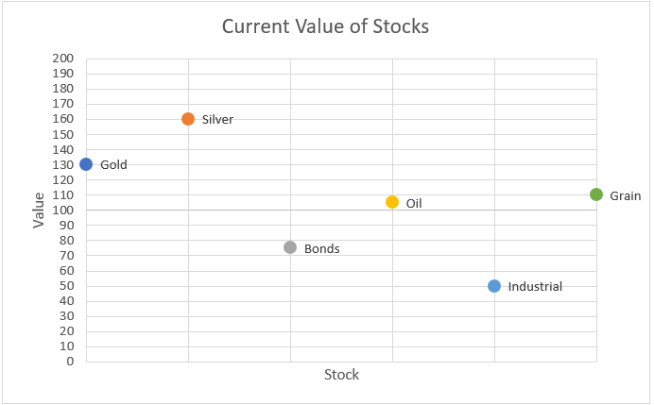

*The current values of stocks are displayed on this chart, which updates each time the dice are rolled.*

If a dividend is rolled and the stock's value is equal to or more than par (100), a dividend is paid to any player who owns that stock. The dividend is computed as a proportion of the quantity of shares owned by the player. For example, if the roll is Gold, 20, Dividend (with the value of Gold over par) and the player owns 1000 shares of Gold, the dividend will be 20% (the rolled amount) of 1000 (the quantity of stock the player owns), or $200. What is crucial to remember about dividends is that the amount paid does not change depending on the current value of the stock, thus a player will receive the same dividend whether the stock is worth 100 or 190.

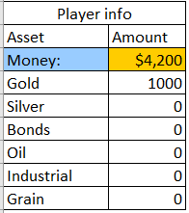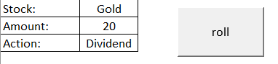

*When a dividend is rolled and the stock is above par, your money increases.*

A stock split is proclaimed when a stock achieves a value of $200. During a stock split, the stock's value is reset to 100, and any quantity owned by the player of that specific stock is doubled. For instance, if a player possesses 500 Industrial and its value reaches or surpasses 200, the worth of Industrial is reset to 100, and the player now owns 1000 shares of Industry.

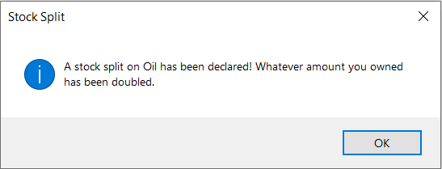

*A stock that’s value goes above 199 gets its value reset to 100 and any stock you owned is doubled*

When a stock approaches zero, bankruptcy is declared. If a stock becomes bankrupt, its value is reset to 100, and whatever amount the player owns of that stock is reset to 0. For example, if a player possesses 2000 Bonds and the value of the Bonds reaches or goes below zero, the value of the Bonds is reset to zero and the player now owns 0 shares of Bonds.

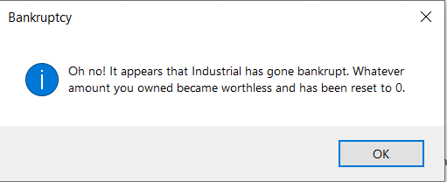

*A bankrupt stock gets its value reset to 100 but any stock you owned is reset to 0.*

The market opens every five turns. A player may purchase or sell stocks at this stage (and just at this point). Any stock with a worth other than nominal will have its price changed depending on its present value. For instance, if the price of gold has dropped to 90, 500 units will now value at $450 (90% of 500). In contrast, if Silver increases to 110, 500 shares will now be worth $550 (110% of 500).

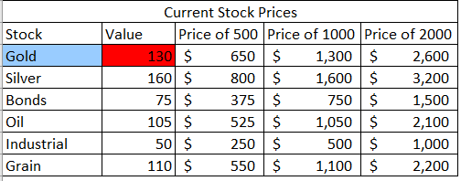

*This table shows the prices of each stock in each increment available for purchase.*

**Finishing the game**

Your total net worth is estimated at the conclusion of the time limit using the amount of money you have plus the current value of any equities you hold. A report is created that contrasts your score to the highest possible score.