**INSTALLATION GUIDE**

1. Extract and upload all subfolders of slide-in-form-plugins.zip file into the **/wp-content/plugins/**directory.
2. You Must have to Activate those plugins through the ‘Plugins’ menu in WordPress. List of Plugins Names.
   1. Contact Form 7 [ With Few Customizations in Few Files ]
   2. SlideIn Form [ Developed Customized Plugin By Using Reference of Sticky Popup Plugin ]
   3. Font Awesome
   4. Advanced CF7 DB
3. Once You will activate above 4 plugins from wordpress, You will find new menu in your WordPress admin panel. As mentioned below:
   1. Contact [Contact Form Integration Settings]
   2. Settings -> SlidIn Form [Slide In Popup Settings]
   3. Settings -> Font Awesome [Font Awsome Icons Settings]
   4. Advanced CF7 DB [ Here you will get List Of All Visitors Data ]

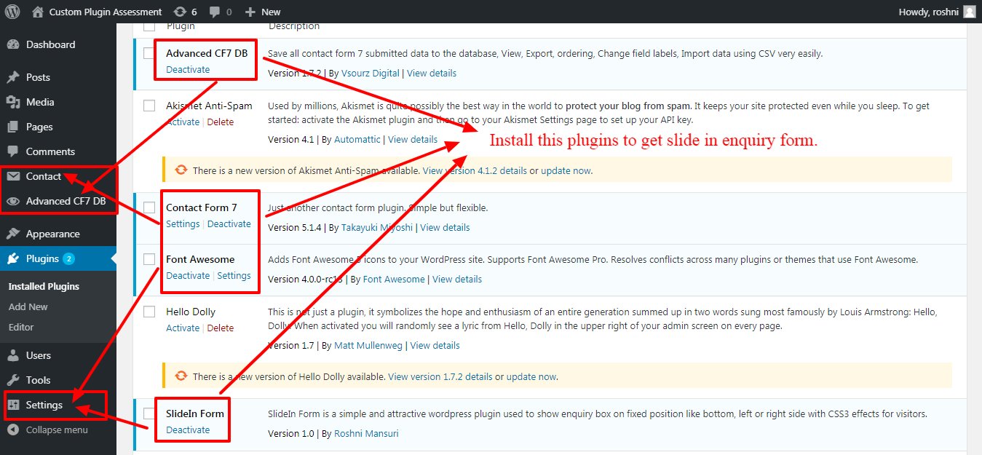

Let’s Check in more detail to setup of plugins:

1. **CONTACT MENU OPTIONS SETUP**
   1. You will get Default Contact Enquiry Form in list. You can Add/Edit/Delete form settings from the page below.

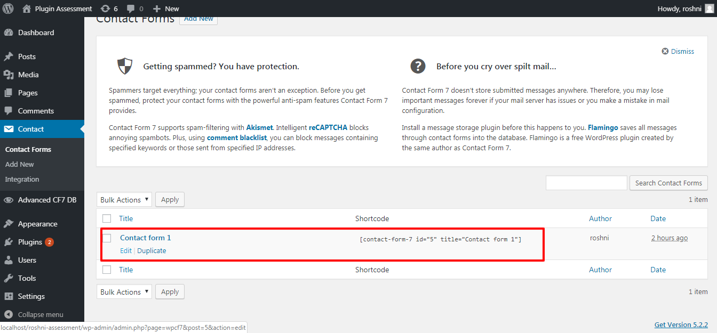

* 1. You can Edit Form and Email Content from Edit Action.

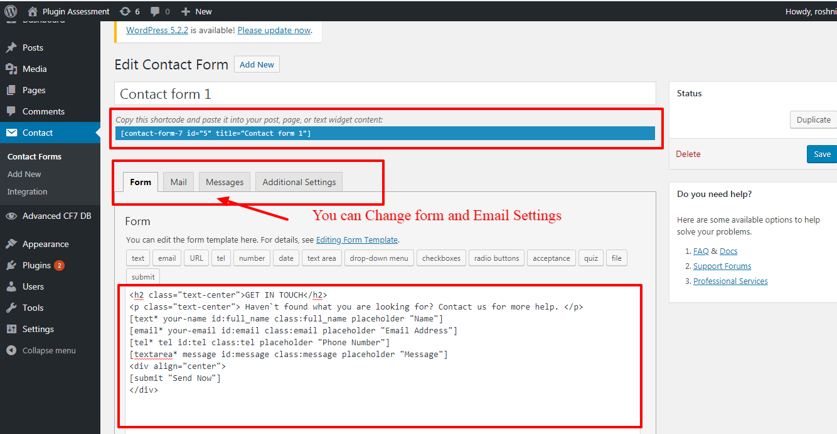

* 1. Above Default Contact Form Shortcode will be used in Slide In Popup Settings.
  2. Integrate Recaptcha For Contact Enquiry Forms.

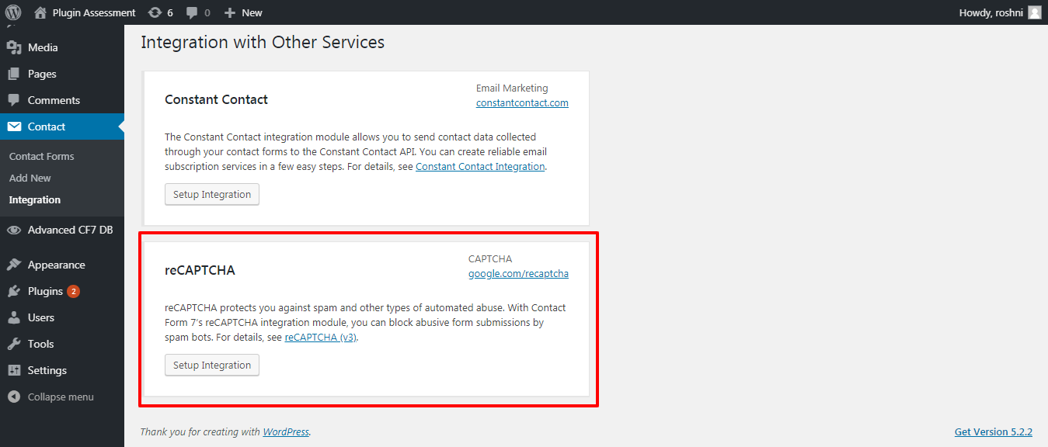

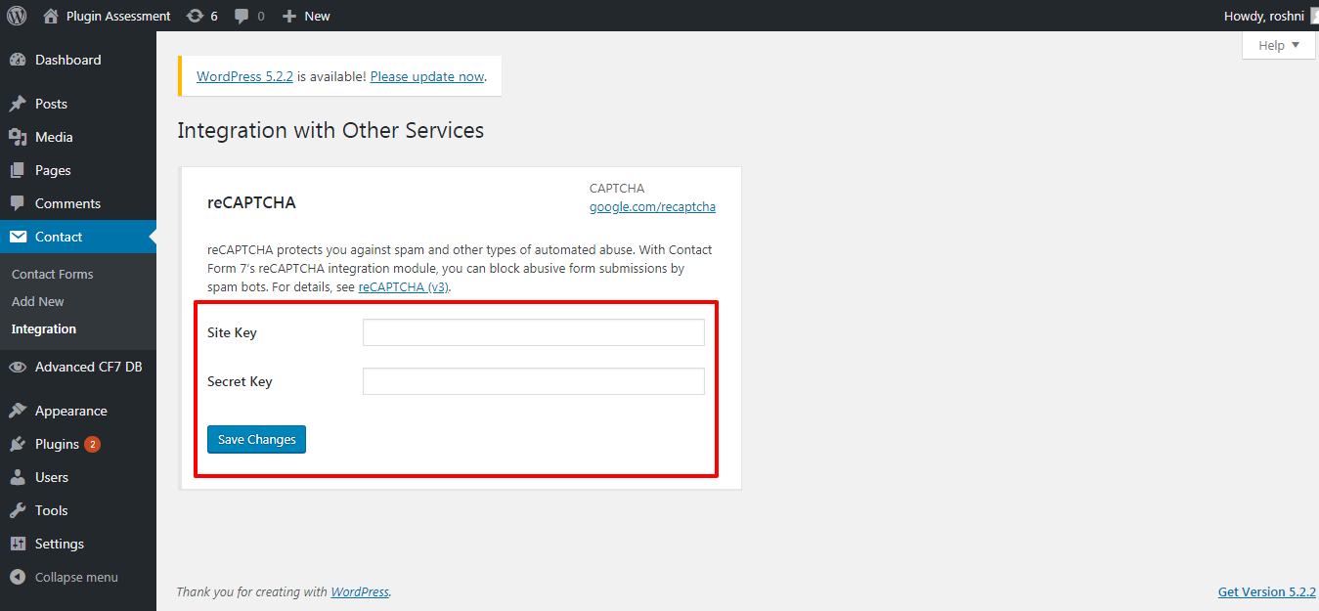

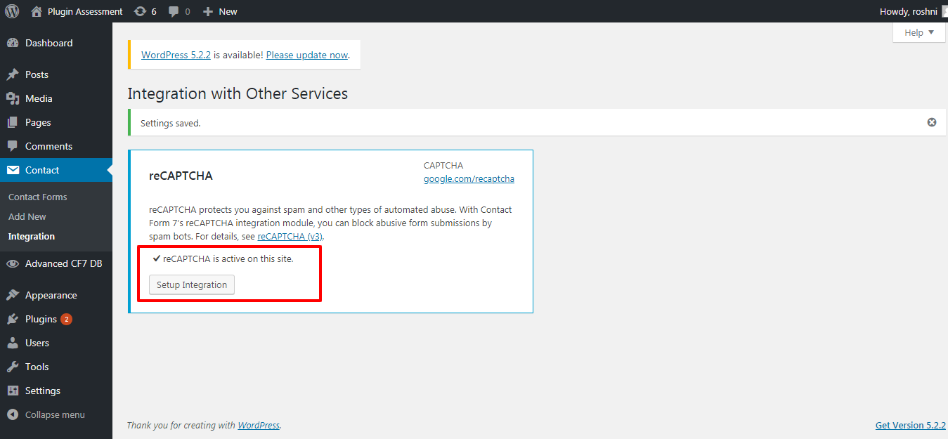

1. **Settings -> SlideIn Form**
   1. Enable and Set color, place, contact form shortcode as per below capture. Then You will get SlideIn Box

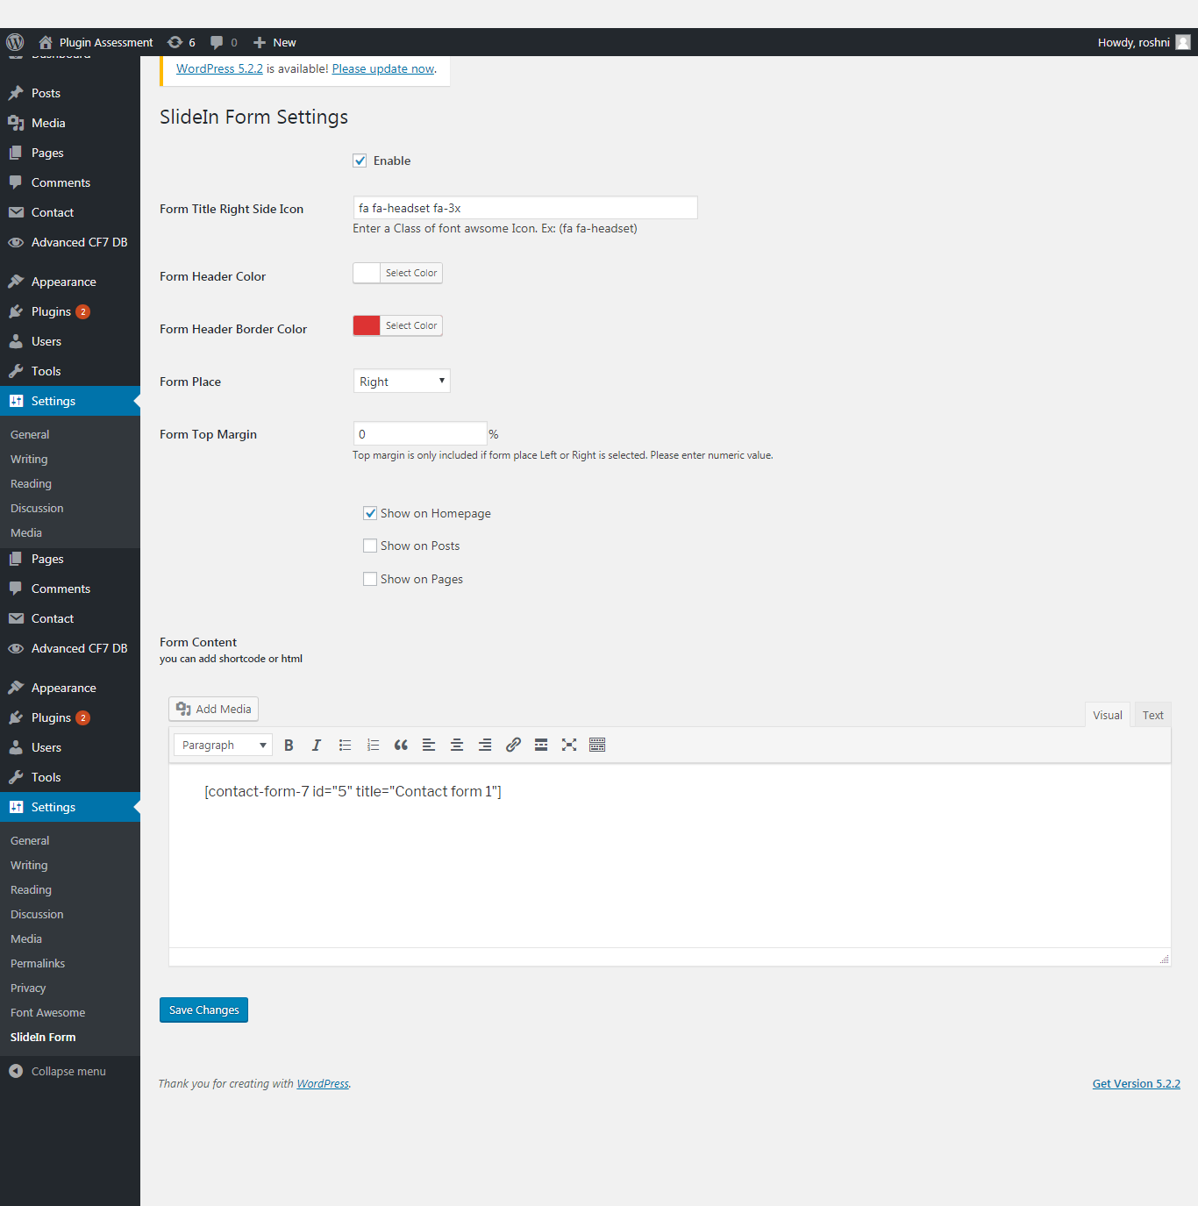

1. **Advanced CF7 DB**
   1. First, You will get list of visitors blank as below.

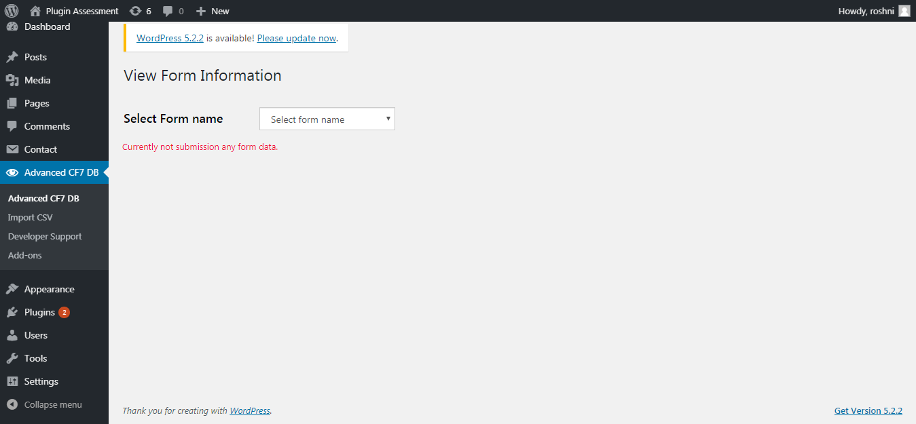

* 1. Once Any user will submit form, you will able to see below details

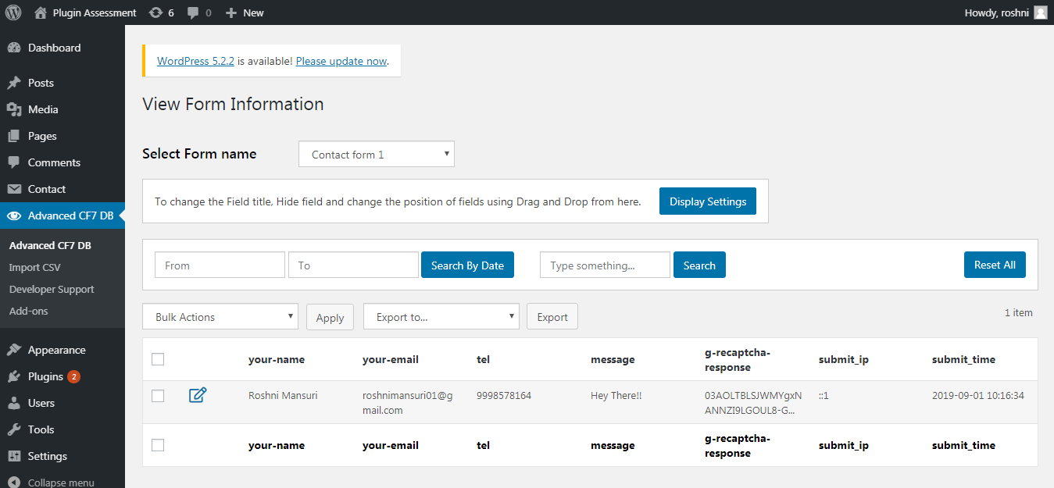

1. **Settings -> Font Awesome**
   1. You can change Fonts Settings If you want

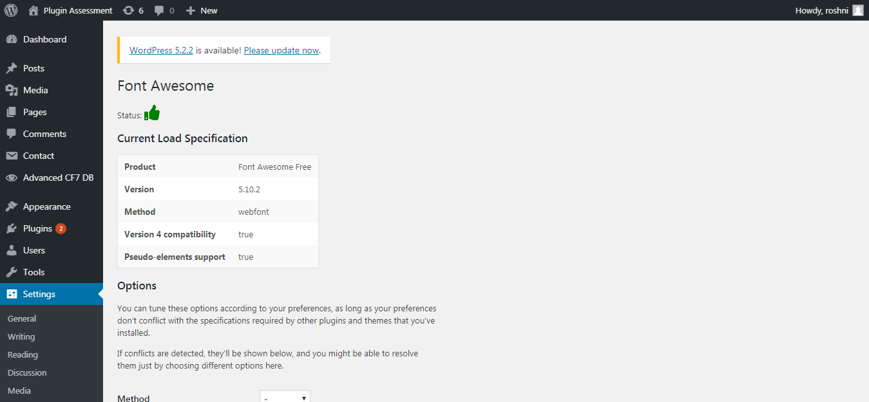

**Website ScreenShots**



