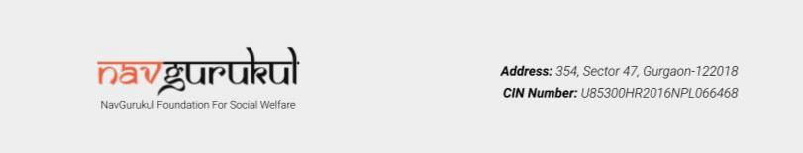

Certification of Donation

S. No: NGA-06-25

Date: 03/11/24

To,

Roshni Jha

Faridabad, Haryana

We would like to thank you for your generous contribution of INR Three Thousand Rupees with PAN number ABCDE1234U to NavGurukul Foundation for Social Welfare.

The amount will be used to teach programming to underprivileged students to better their employability and quality of life.

Thanking you

For NavGurukul Foundation of Social Welfare


Abhishek Gupta

Co-founder & CEO

____________________________________________________________________________________________________

________

Donations to NavGurukul Foundation for Social Welfare qualify for deduction u/s 80G(5) of the Income Tax Act 1961 Vide approval No. AAFCN4164JF20214 dt 31.05.2021. This receipt is invalid in case of non-realization of the money instrument or reversal of the credit/debit card charge or reversal of donation amount for any reason. IT PAN: AAFCN4164J

.

