**Write a program to convert the alphanumeric character to Ascii value:**

**Program snipet**

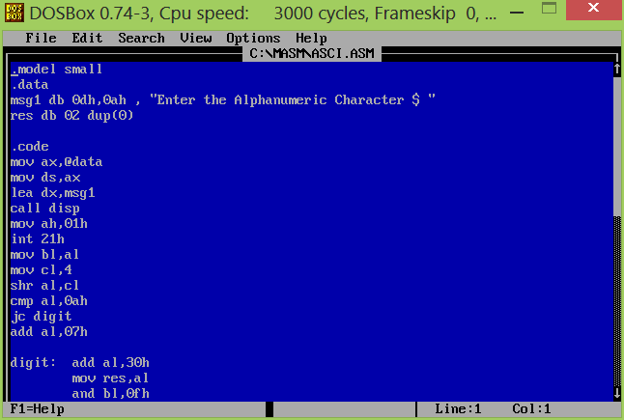

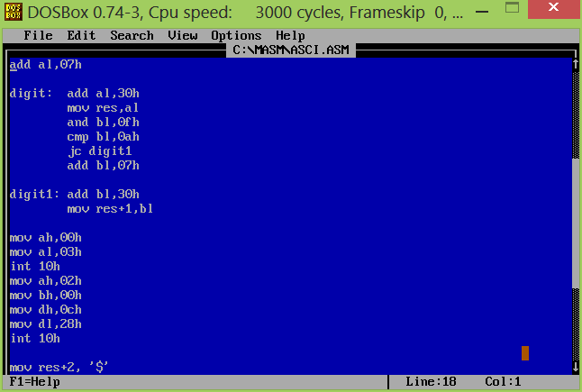

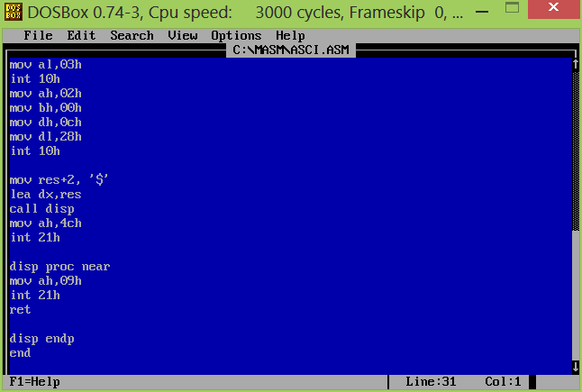

**OUTPUT SCREEN:**

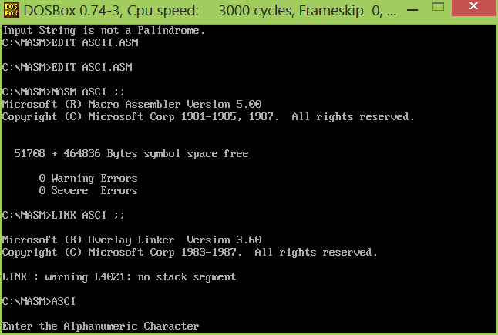

**TAKING THE INPUT AS THE**

**ALPHANUMARIC KEY =7**

**THE RESULT FOUND TO BE 37**

