**WRITE A PROGRAM TO FIND WEATHER THE GIVEN STRING IS PALINDRON OR NOT**:

**PROGRAM:**

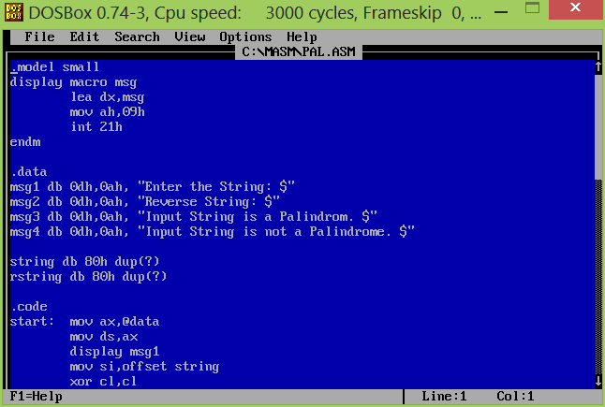

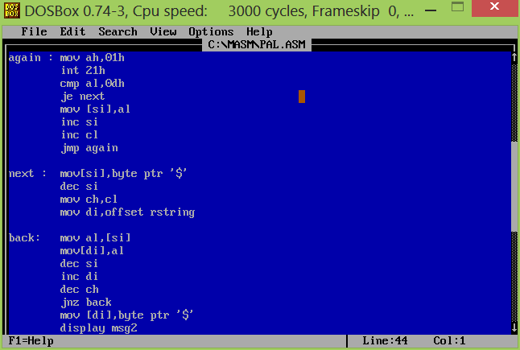

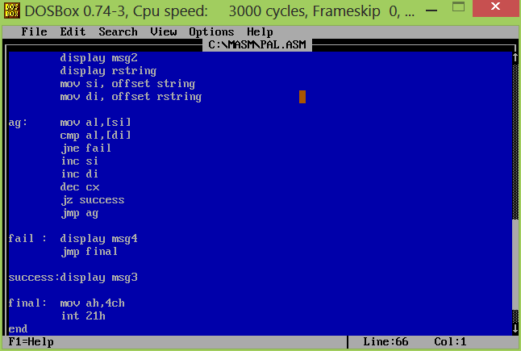

**OUTPUT SCREEN:**

