EX NO: 3 | Designing a Quarter wave transformer by varying following parameters  a) frequency  b) input impedance  c) characteristic impedance
DATE: 13/10/2026

Designing a Quarter wave transformer by varying following parameters d) frequency
e) input impedance
f) characteristic impedance
Experiment Number:7
Test Case 1:
Design a quarter-wave transformer for an input impedance (Z_{in}) of 50 ohms and a load impedance (Z_{L}) of 100 ohms. Analyze the transformer's performance as the operating frequency is varied across {100 MHz, 200 MHz, 300 MHz, 500 MHz}.
AIM: To design a quarter-wave transformer for an input impedance (Z_{in}) of 50 ohms and a load impedance (Z_{L}) of 100 ohms and to analyze the transformer's performance as the operating frequency is varied across {100 MHz, 200 MHz, 300 MHz, 500 MHz }.
SOFTWAREREQUIRED:
SCILAB
PROCEDURE:
● Open SCILAB software
● Open file-new
● Put the input values
● Typetheprogram
● Execute the program
● End the program
CALCULATION:
PROGRAM:
clear;clc;
Zr=100;s=9;d=0.1;
Zs=50;
Ro=sqrt(Zs*Zr);
f=500*(10^6);
r=d/2;
Zof=276*log10(s/r);
Zoq=sqrt(Zr*Zof);
L=300/(f*(10^-6));
printf("length of lambda/4 transformer = %f meters\n",L);
printf("characteristic impedance of quarter wave line = %f ",fix(Ro*10000)/10000);
OUTPUT:
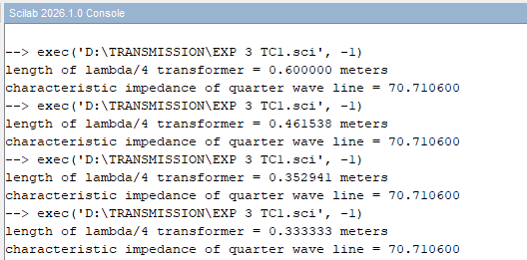
Z_{R}=100 ohms Zin =50 ohms
Z_{S} ohms | Z_{R} ohms | Ro ohms
50 | 100 | 70.7

Z_{R}=100 ohms Zin =50 ohms
Frequency (MHz) | Length of λ/4 transformer (meters)
500 | 0.600000 meters
650 | 0.461538 meters
850 | 0.352941 meters
900 | 0.333333 meters

RESULT: A quarter-wave transformer for an input impedance (Z_{in}) of 50 ohms and a load impedance (Z_{L}) of 100 ohms is designed and the transformer's performance is
analyzed for the varying operating frequency is varied across {100 MHz, 200 MHz, 300 MHz, 500 MHz }.
Test Case 2:
For a fixed operating frequency of 2 GHz and a load impedance (Z_{L}) of 100 ohms, design a quarter-wave transformer and evaluate its performance as the input impedance (Z_{in}) varies through {25 ohms, 50 ohms, 75 ohms, 100 ohms}. Validate that the transformer's characteristic impedance (Z_{transformer}= Ro= sqrt(Z_{in}⋅Z_{L}) changes with Z_{in}.
AIM: To design a quarter-wave transformer a ftixed operating frequency of 2 GHz and a load impedance (Z_{L}) of 100 ohms and evaluate its performance as the input impedance (Z_{in}) varied .To validate that the transformer's characteristic impedance (Z_{transformer}= Ro= sqrt(Z_{in}⋅Z_{L}) changes with Z_{in}.
SOFTWAREREQUIRED:
SCILAB
PROCEDURE:
● Open SCILAB software
● Open file-new
● Put the input values
● Typetheprogram
● Execute the program
● End the program
CALCULATION
PROGRAM:
clear;clc;
Zr=100; s=9; d=0.1;
Zs=50;
Ro=sqrt(Zs*Zr);f=100*(10^6);r=d/2;
Zof=276*log10(s/r);
Zoq=sqrt(Zr*Zof);
L=300/(f*(10^-6));
printf("length of lambda/4 transformer = %f lambda\n",L);
printf("characteristic impedance of quarter wave line = %f ",fix(Ro*10000)/10000);
OUTPUT:
ZR=100 ohms Variable :Zin
Z_{in} | Ro
50 | 70.710600
60 | 77.459600
70 | 83.666000
80 | 89.442700

RESULT: A quarter-wave transformer is designed at a fixed operating frequency of 2 GHz and load impedance (Z_{L}) of 100 ohms and its performance is evaluated for various input impedance values. The variation of transformer’s characteristic impedance with Zin is also validated..

