**Why CI/CD?**

To get the full benefits of CI, you will need to automate your tests to be able to run them for every change that is made to the main repository. To run tests on every branch of your repository and not just focus on the main branch. This way one would be able to capture issues early and minimize disruptions for your team.

Following are some of the tools available for CI/CD:

**CI/CD Tools**

1. **Codeship** 
   1. Advantage
      1. Ranked 1st as a CI tool.
      2. FTP, SFTP, SCP, RSYNC and SSH support
   2. Disadvantage
      1. Hosted service: Access code easily.
2. **Circle CI**
   1. Advantage
      1. Dedicated servers are not required.
      2. Tests can be parallelized (8 way parallelization) across many machines thus is preferred over Jenkins.
      3. More options for deployment tools as compared to Codeship.
      4. Supports multiple database like Cassandra and Solr. (Codeship doesn't support these two).
      5. Good customer support.
   2. Disadvantage
      1. Heavy pricing
      2. Works only with BitBucket and GitHub
   3. Other Details  
      1. The best suited tool as of stated above is Circle CI since the setup of the test environment can be easily done and it allows parallel test execution.
      2. It is one of the best tools for integration and supports many deployment tools like: AWS, Heroku, Firebase, NPM etc
      3. Pricing:
         1. The pricing depends upon the number of containers that are purchased. A single container can run 1 concurrent job with 1x parallelism which can be run across the organization.
         2. If the parallelism of the job needs to be increased then it can be achieved with the following cost  
            1. Build on Linux  
               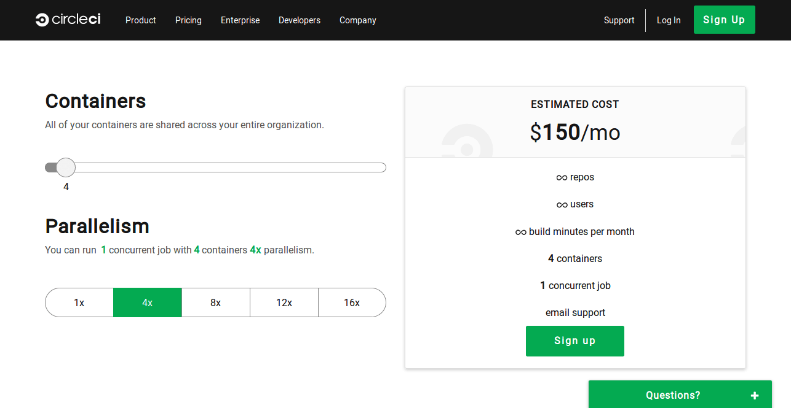   
                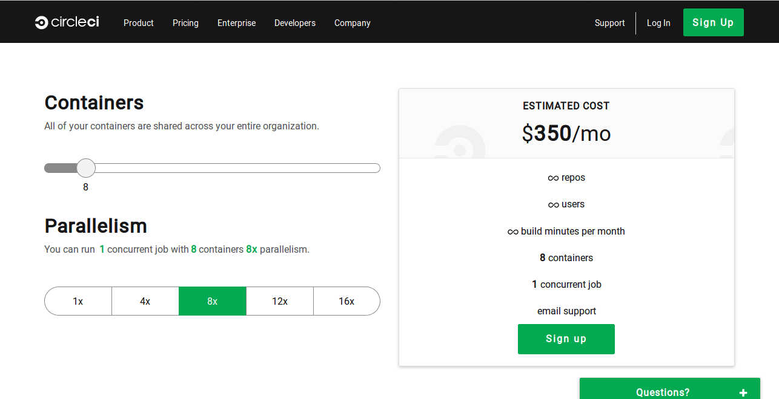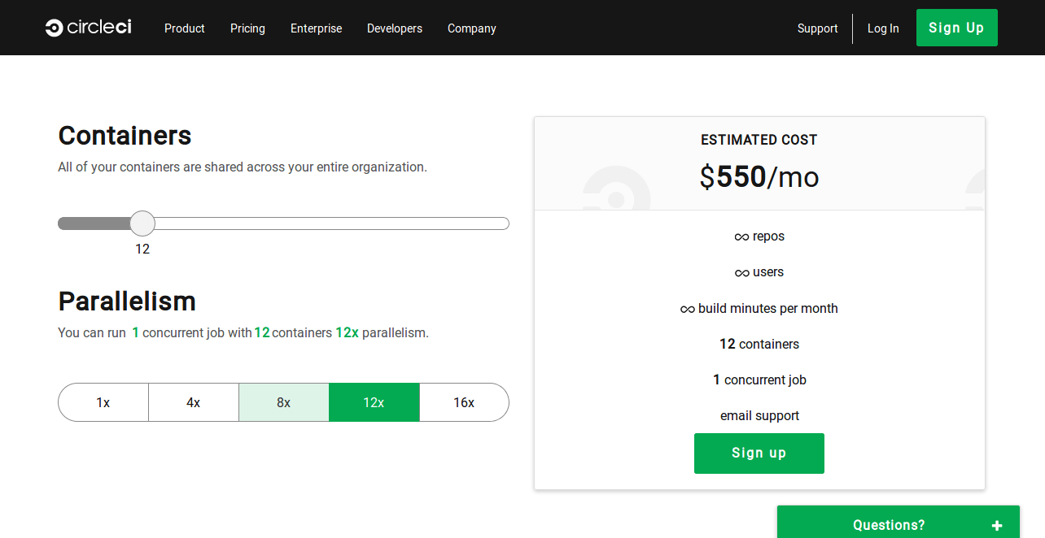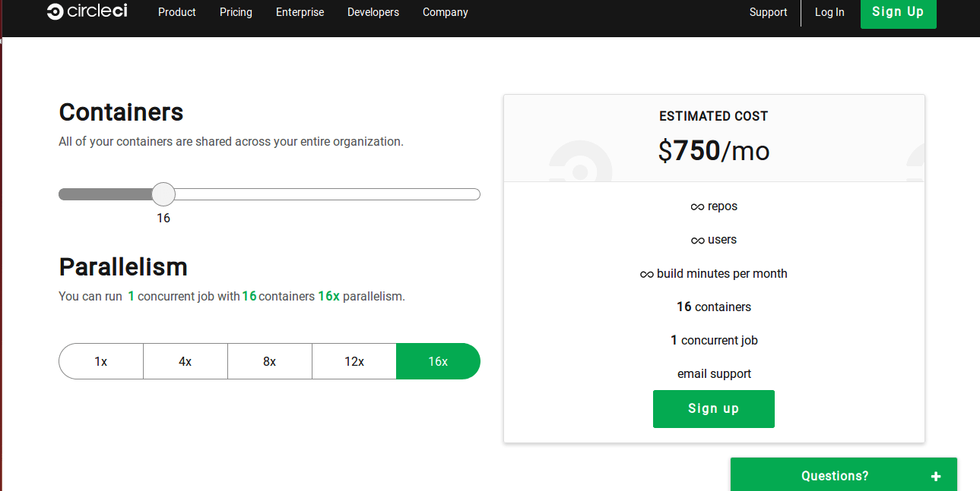
            2. Build on MAC OS  
                 
               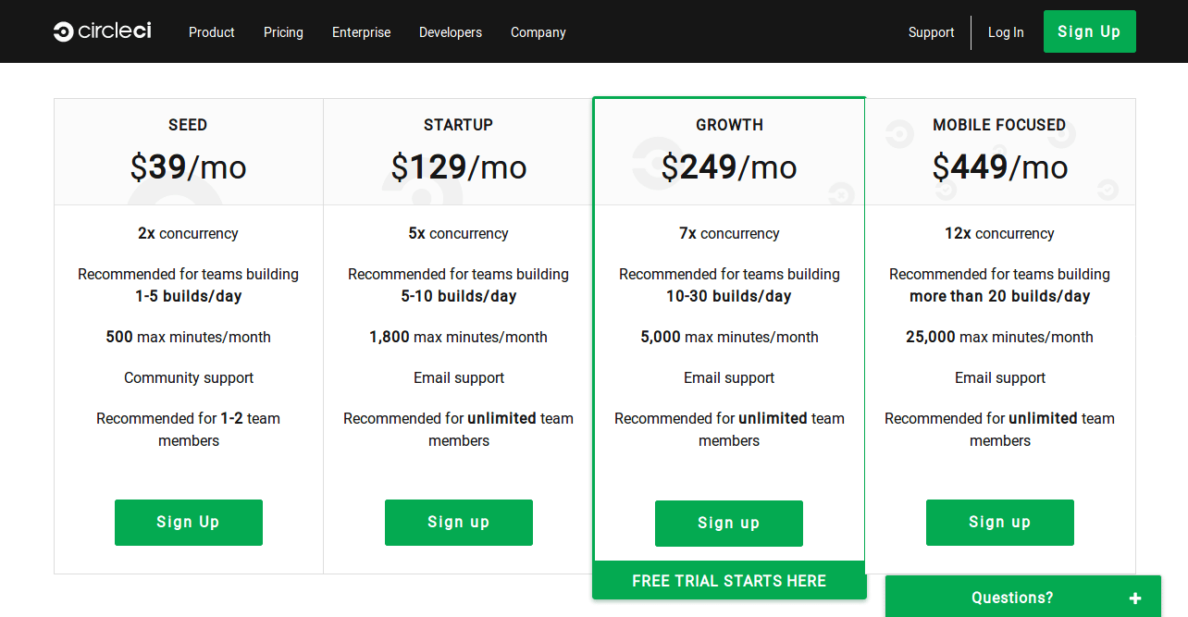
3. **Jenkins**
   1. Advantages
      1. Leading open source tool for CI/CD.
      2. Flexible because of feature extension using plugins (over 1000+ plugins).
      3. Jenkins "Blue Ocean" for improving UI/UX.
   2. Disadvantage
      1. Dedicated severs and time taking.
      2. Poor quality plugins that are difficult to combine.
4. **GitLab CI**
   1. Advantages
      1. Built-in CI/CD in GitLab
      2. Application Performance monitoring
      3. Preview changes with review apps
      4. Automatic retry for failed CI jobs: You can specify a retry keyword in your .gitlab-ci.yml file to make GitLab CI/CD retry a job for a specific number of times before marking it as failed.
   2. Disadvantage
      1. Details on duration of each command execution not present
      2. Cannot manage JUnit Reports
5. **Bamboo**
   1. Advantages
      1. Bamboo, Bitbucket, and JIRA Software are fully integrated and give us full traceability from the time a feature request is made all the way to deployment.
      2. If your code is hosted on Bitbucket Cloud you can use the Pipelines feature in your repository to run tests on every push without the need to configure a separate server or build agents, and with no restriction on concurrency.
   2. Disadvantages
      1. This tool is not free.
      2. It is not so easy to find other users to talk to or ask for help.
   3. Other Details
      1. A Bamboo Agent is a service that provides [capabilities](http://confluence.atlassian.com/display/BAMBOO40/capability) to run [job builds](http://confluence.atlassian.com/display/BAMBOO40/build). There are two types of Bamboo Agents:
         1. [Local Agents](https://confluence.atlassian.com/bamboo/creating-a-local-agent-289277175.html) actually run as part of the Bamboo server. Local Agents run in the server's process, i.e. run as separate threads in the same JVM as the Bamboo servers.
         2. [Remote Agents](https://confluence.atlassian.com/bamboo/bamboo-remote-agent-installation-guide-289276832.html) run on computers, other than the Bamboo server, that run the Remote Agent tool. Each Remote Agent runs in its own separate process, i.e. has its own JVM, and use JMS to communicate with Bamboo server.
      2. Pricing:
         1. Initial pricing: Your initial purchase entitles you to perpetual use of the software, and includes 12 months of software maintenance – access to new software releases/enhancements, world-class Support team, critical bug fixes, and security patches – from the date of purchase.   
              
            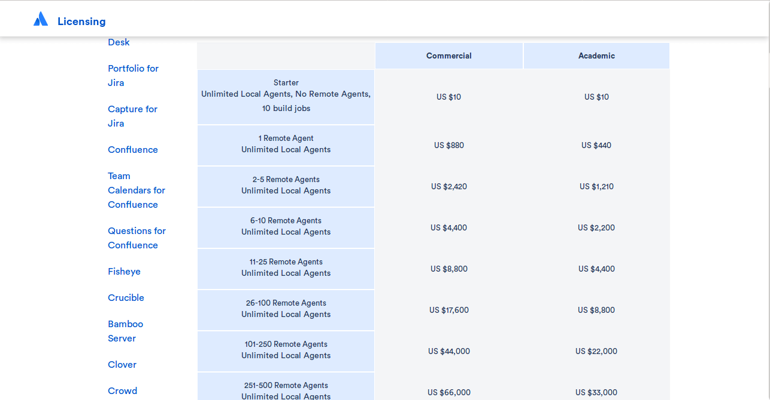
         2. Renewal Pricing: Beyond this initial period, renewing the software maintenance every 12 months at the renewal pricing.   
              
            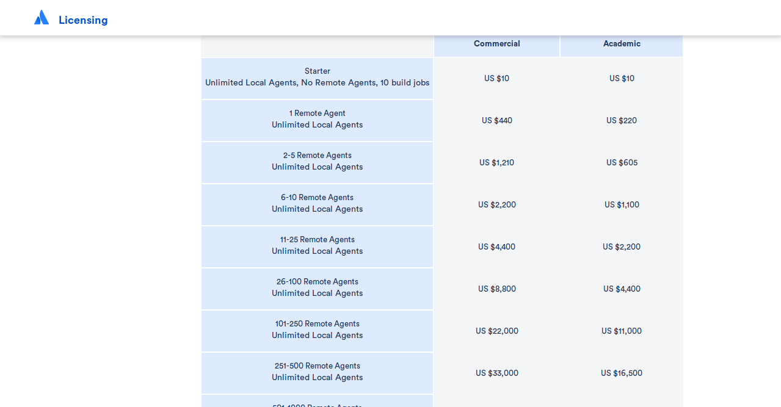
      3. Deploy to EC2 using AWS code deploy from Bitbucket pipelines (which can be integrated with bamboo)  
         <https://hackernoon.com/deploy-to-ec2-with-aws-codedeploy-from-bitbucket-pipelines-4f403e96d50c>From the Bitbucket pipelines settings, we can connect to the AWS EC2. CodeDeploy agent needs to be installed on the instance. This agent is how CodeDeploy actually makes changes on the EC2 instance.
6. **TeamCity**
   1. Advantages
      1. Easy to setup, use, and configure
      2. Widely-used and well documented
      3. Integration with a wide variety of tools and technologies
      4. Professional Server is free for up to 20 build configurations
   2. Other Details
      1. Pricing  
           
         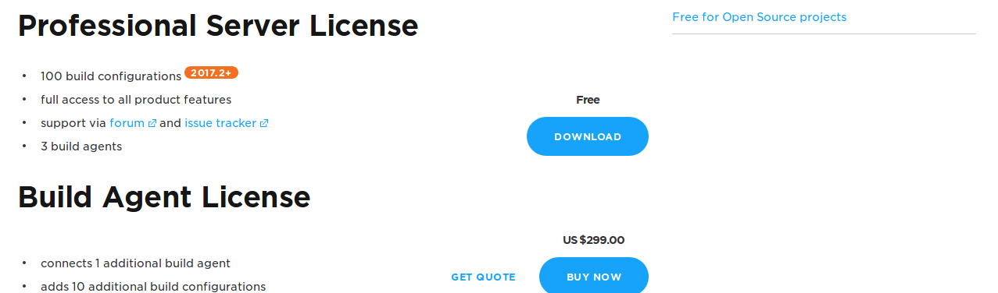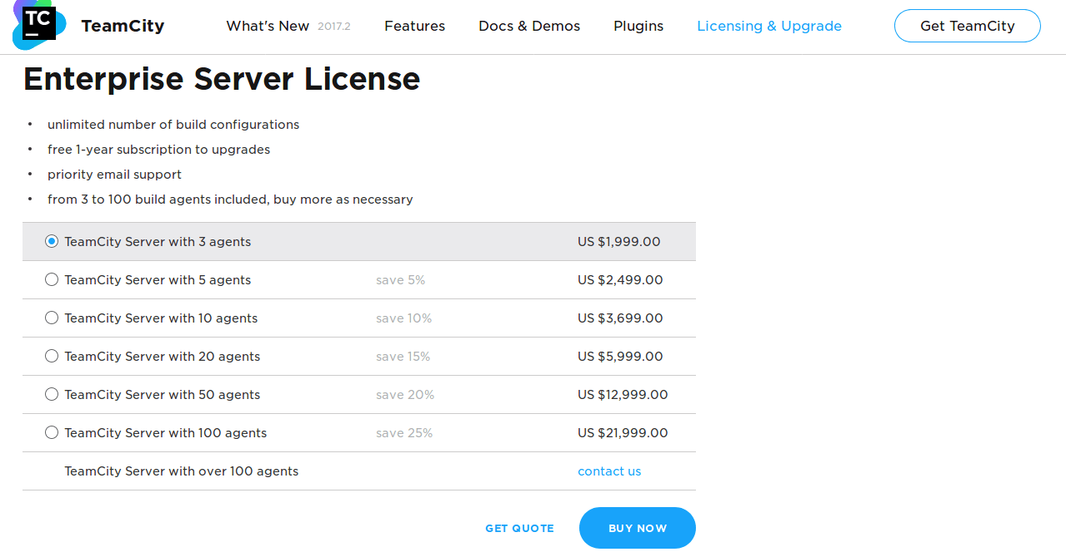

**Comparison**

1. CircleCI is recommended for small projects, where the main goal is to start the integration as fast as possible. But the pricing is a problem. It supports various databases like Solr and Cassandra. Also a quick setup can be done. Direct login from bitbucket then it automatically identifies the project environment and executes the tests.
2. Jenkins is recommended for the big projects, where you need a lot of customizations that can be done by usage of various plugins. You may change almost everything here, still this process may take a while. If you are planning the quickest start with the CI system Jenkins might not be your choice.
3. GitLabs CI can be fully integrated with GitLab. Quick project setup: Add projects with a single click, all hooks are setup automatically via the GitLab API.
4. Bamboo is recommended because Bamboo, Bitbucket, and JIRA Software are fully integrated and give us full traceability from the time a feature request is made all the way to deployment.

**Reference**

1. <https://hackernoon.com/continuous-integration-circleci-vs-travis-ci-vs-jenkins-41a1c2bd95f5>
2. <https://www.slant.co/versus/629/2477/~codeship_vs_jenkins>
3. <https://www.slant.co/versus/625/2477/~circleci_vs_jenkins>
4. <https://www.slant.co/topics/799/~best-continuous-integration-tools>
5. <https://about.gitlab.com/comparison/gitlab-vs-circleci.html>
6. <https://docs.gitlab.com/ee/ci/>
7. <https://circleci.com/pricing/>
8. <https://www.atlassian.com/continuous-delivery/how-to-get-to-continuous-integration>
9. <https://www.atlassian.com/licensing/bamboo#serverlicenses-3>
10. <https://confluence.atlassian.com/bamkb/difference-between-local-agents-and-remote-agents-457703602.html>
11. <https://alphasss.atlassian.net/wiki/spaces/ARTC/pages/1900643/Tool+Evaluation+Bamboo>
12. <https://www.jetbrains.com/teamcity/features/>
13. For deploying code from Bitbucket to AWS : <https://aws.amazon.com/blogs/apn/announcing-atlassian-bitbucket-support-for-aws-codedeploy/>